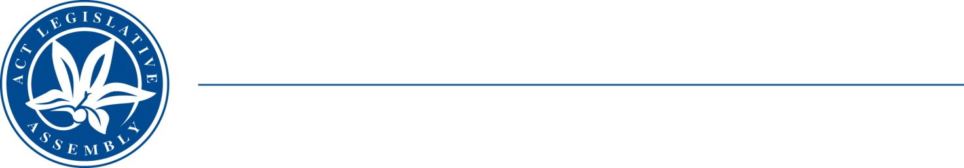
QoN No. 20
Committee Support
LEGISLATIVE ASSEMBLY
FOR THE AUSTRALIAN CAPITAL TERRITORY
Standing Committee on Choose an item.

Inquiry into Annual and Financial Reports 2021-2022

ANSWER TO QUESTION ON NOTICE

Asked by : Elizabeth Kikkert MLA: To ask the Minister for Early Childhood Development

Reference: Early Childhood Development, CSD Annual Report 2022, pp. 90–91

In relation to: Child Development Service Staffing

1. How many FTE speech pathologists, occupational therapists, physiotherapists, and social workers does the CDS have?
2. On average, how many clients are served by each of these in a year?

MINISTER Berry: The answer to the Member’s question is as follows:–

- The Child Development Service is currently funded for 8.8 FTE speech pathologists, 2.6 FTE occupational therapists, 2.2 FTE physiotherapists and 1.9 FTE social workers.

- As of November 2022, 938 children and their families are accessing speech pathology services, 274 children are accessing occupational therapy services, 183 are accessing physiotherapy services, and 81 are accessing social work services. An additional, 154 children and their families are accessing more than one allied health profession service within the Child Development Service.

Approved for circulation to the Standing Committee on Education and Community Inclusion

Signature: Date:

By the Minister for Early Childhood Development, Yvette Berry

