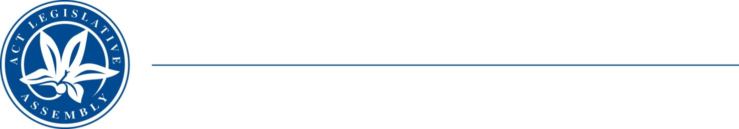
QoN No. 11
Committee Support
LEGISLATIVE ASSEMBLY
FOR THE AUSTRALIAN CAPITAL TERRITORY
Standing Committee on Education and Community Inclusion

Inquiry into Annual and Financial Reports 2021-2022

ANSWER TO QUESTION ON NOTICE

Elizabeth Kikkert MLA: To ask the Minister for Education and Youth Affairs

Ref: Youth Affairs, CSD Annual Report 2022, p. 53

In relation to: Young Canberra Citizen of the Year Awards

1. Considering that the annual report states that this awards program will be held in the second half of 2022 but no further information is available online, when will this program be held?

Minister Berry: The answer to the Member’s question is as follows:–

The Young Canberra Citizen of the Year Awards ceremony will be held on Friday 18 November 2022.

Approved for circulation to the Standing Committee on Education and Community Inclusion

Signature: Date:

By the Minister for Education and Youth Affairs, Yvette Berry MLA

