Julia Agostino
Committee Secretary
Legislative Scrutiny
Standing Committee on Justice and Community Safety
ACT Legislative Assembly
GPO Box 1020
Canberra ACT 2601

Dear Secretary,

Thank you for the consideration and feedback on my Bill, the Bail Amendment Bill 2021, and its associated explanatory statement contained in the Scrutiny Report No 8 2021.

The Committee notes that the explanatory statement recognises the human rights limitations of the Bill and provides a justification using the framework set out is section 28 of the Human Rights Act.

In relation to the examples of other offences contained within Schedule 1 of the Bail Act 1992, the Committee notes that:

“the grant of bail balances concerns over the administration of justice and protecting the safety and welfare of other persons against the interests of the person subject to be detained.

It is not clear to the Committee that the comparisons of the seriousness of offences included in the explanatory statement reflect these concerns. The Committee therefore requests further information from the Member as to the basis on which the comparisons included in the explanatory statement were selected, and how these comparisons reflect the legitimate concerns on which the Bail Act operates. Consideration should be given to amending the explanatory statement to include reference to this information.”

In response I offer the following.

The examples selected were intended to show the wide range of offences for which a presumption of bail currently does not apply. They were to illustrate that a broad range of offences are already covered, and this amendment is not, therefore, out of the ordinary within the range of offences already covered.

I acknowledge the further point made by the Committee, where it requests examples which go more directly to the point of balancing “concerns over the administration of justice and protecting the safety and welfare of other persons against the interests of the person subject to be detained.”

To that point, I refer the Committee to the offences of intentionally causing grievous bodily harm, (Schedule 1, Part 1.1, item 2) aggravated robbery (Schedule 1, Part 1.2, item 1), aggravated burglary (Part 1.2, item 2) and sexual assaults in the first or second degrees (Schedule 1, Part 1.1, items 5 & 6).

These offences are examples where the balance of protecting the safety and welfare of other persons is balanced against the interests of the accused, and all are included in the schedule as having no presumption for bail.

I will amend the explanatory statement in light of the Committee’s comments and will table that revised statement when the Bill is brought forward for debate.

Finally, I would like to thank the Committee for its consideration and feedback on this important legislation.

Yours sincerely,

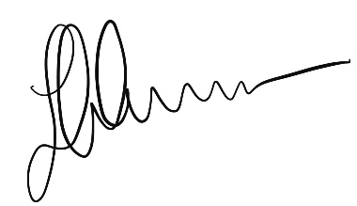

Jeremy Hanson, CSC, MLA

20 September 2021

