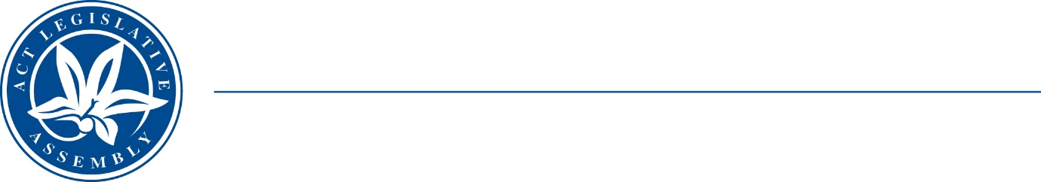
Standing Committee on justice and community safety
Mr Peter Cain MLA (Chair), Dr Marisa Paterson MLA (Deputy Chair),
Mr Andrew Braddock MLA
Ms Caroline Le Couteur MLA

LEGISLATIVE ASSEMBLY
FOR THE AUSTRALIAN CAPITAL TERRITORY

TERMS OF REFERENCE

Crimes Legislation Amendment Bill 2023

At its meeting on 2 December 2020 (amended 4 August 2022), the Legislative Assembly resolved that:

‘all bills presented to the Assembly stand referred to the relevant standing committee for inquiry and report within two months from the presentation of the bill, except for those bills introduced in the last sitting week of the calendar year where the committee shall report in two months. Within 21 days of the presentation of the bill in the Assembly, the committee must decide whether or not to undertake an inquiry, and shall inform the Speaker of its decision, the Speaker must then arrange for all members to be notified. In the event that the subject matter of the bill makes it unclear which committee it should be referred to, the Speaker will determine the appropriate committee.’

The Crimes Legislation Amendment Bill 2023 was presented in the Assembly on 26 October 2023 and referred to the Standing Committee on Justice and Community Safety (the Committee).

