Cost of Living Inquiry - Dissenting Report
Mr Johnathan Davis MLA

As Chair of the Cost of Living Inquiry, I received evidence from the community that more needs to be done to strengthen the ACT’s renters’ rights. The ACT is one of the most expensive places to rent in the country. Many Canberrans are facing severe rental stress, with some essential workers are paying up to 76% of their income on rent.
The following recommendations did not receive support from other Committee Members. The following recommendations call on the ACT Government to stand up for renters who have to choose between paying their rent or buying other basic essentials. Freezing rents, further restricting rent increases and prohibiting rent bidding in all circumstances would make Canberra a better place to be a renter.

Recommendation 1
Mr Davis recommends that the ACT Government explore ways to further regulate the price of rent in the private rental market, including the consideration of a freeze on rent increases and further caps on rent increases.
Recommendation 2
Mr Davis recommends that the ACT Government consider how rising rent prices impacts renters and consider further interventions to restrict rent increases when a property is vacated and rented to new tenants or between leases.
Recommendation 3
Mr Davis recommends that the ACT Legislative Assembly amend the Residential Tenancies Act 1997 to prevent landlords or real estate agents from accepting above-advertised rent.

Renting
  - In the public hearing on 13 April 2023, the Committee heard calls for the Government to take further intervention in the rental market to control rent increases, such as rent caps or rent freezes. ACTCOSS provided the confronting advice that Canberra 'is the least affordable jurisdiction in the country for people on low incomes’.
  - ACTCOSS for example in their submission stated:
To address the cost of living crisis the ACT Government should investigate the use of some sort of price mechanism that alleviates the high cost of renting in Canberra. This could take the form of further controls on rent above and beyond the current rent increase limits. Short term rent control would provide current renters protection from unaffordable rent increases and allow families to remain in place and build lasting connections in their local community.
  - Mr Davis is of the view that the ACT Government should, in light of the pressures on renters faced by rising rent, consider a rent freeze and price caps. If the Government does not do this, then it should consider further interventions to restrict rent increases, including when a property is vacated and rented to new tenants or between leases.
Recommendation 1
Mr Davis recommends that the ACT Government explore ways to further regulate the price of rent in the private rental market, including the consideration of a freeze on rent increases and further caps on rent increases.
Recommendation 2
Mr Davis recommends that the ACT Government consider how rising rent prices impacts renters and consider further interventions to restrict rent increases when a property is vacated and rented to new tenants or between leases.
  - The Committee also heard during the public hearing concerns over the practice known as ‘rent bidding’, in which prospective tenants try to secure an available rental by offering to pay rent above the advertised rental price.
  - The ACT Legislative Assembly has recently limited rent bidding through an amendment to the Residential Tenancies Act 1997 that prohibits landlords and real estate agents from inviting prospective tenants to offer more in rent than what is advertised.
  - The Act however specifically does not prevent a lessor from accepting an offer from a tenant for higher rental rate than advertised if the offer is made voluntarily, leaving open the possibility for rent bidding to continue.
  - In order to fully prohibit the practice of rent bidding, the ACT Assembly should amend the Residential Tenancies Act to specifically prohibit landlords and real estate agents from accepting rents that are above the advertised rental rate, even if they are voluntary.
Recommendation 3
Mr Davis recommends that the ACT Legislative Assembly amend the Residential Tenancies Act 1997 to prevent landlords or real estate agents from accepting above-advertised rent.

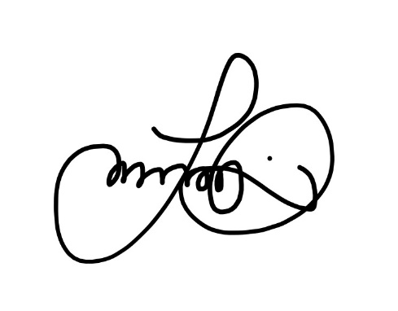
Johnathan Davis MLA
11 May 2023

Mx Jules Kelly, Australian Unemployed Workers Union, Proof Committee Hansard, 13 April 2023, p 119. Tomorrow Movement, Submission 28, p 2.
ACTCOSS, Submission 26, p 2.
ACTCOSS, Submission 26, p 4.
Residential Tenancies Act 1997, s 11AD(1).
Mr Schild, Proof Committee Hansard, 12 April 2023, p 96; Residential Tenancies Act 1997, s 11AD(2).

