Standing Committee on Justice and Community Safety

Inquiry into the Road Safety and Crimes Legislation Amendment Bills 2022

About the Committee

Establishing resolution
The Assembly established the Standing Committee on Justice and Community Safety on
2 December 2020.
The Committee’s areas of responsibility are:

- ACT Electoral Commission
- ACT Integrity Commission
- Gaming
- Minister of State (JACS reporting areas)
- Emergency management and the Emergency Services Agency
- Policing and ACT Policing
- ACT Ombudsman
- Corrective services
- Attorney-General
- Consumer affairs
- Human rights
- Victims of crime
- Access to justice and restorative practice
- Public Trustee and Guardian

You can read the full establishing resolution on our website.

Committee members
Mr Peter Cain MLA, Chair
Dr Marisa Paterson MLA, Deputy Chair
Mr Andrew Braddock MLA

Secretariat
Ms Kathleen de Kleuver, Committee Secretary
Ms Emma Weaver, Assistant Committee Secretary (until 3 February 2023)
Mr Alexander Hildyard, Administration Officer

Contact us
Mail Standing Committee on Justice and Community Safety
Legislative Assembly for the Australian Capital Territory
GPO Box 1020
CANBERRA ACT 2601
Phone (02) 6207 0524
Email LACommitteeJCS@parliament.act.gov.au
Website parliament.act.gov.au/parliamentary-business/in-committees

About this inquiry
The Crimes Legislation Amendment Bill 2022 makes several amendments including creating a new offence of unauthorised entry of a motor vehicle. The Road Safety Legislation Amendment Bill 2022 makes changes to amend the road safety legislation to improve road safety by strengthening the reporting and monitoring of driver licence holders’ fitness to drive and provide enhanced penalties to deter dangerous driving behaviours.
The Standing Committee on Justice and Community Safety (the Committee) decided to inquire into both Bills on 28 November 2022; however, the Committee only resolved to inquire into the aspect concerning a new offence of unauthorised entry to a motor vehicle in respect of the Crimes Legislation Amendment Bill 2022.
On 1 December 2022, the Assembly passed a motion to allow the Committee to present its report on the Road Safety Legislation Amendment Bill 2022 and the Crimes Legislation Amendment Bill 2022 by 24 February 2023.
The Inquiry was undertaken over a period in which the Committee was also undertaking a separate inquiry into Dangerous Driving.

Terms of Reference
At its meeting on 2 December 2020 (amended 4 August 2022), the Legislative Assembly resolved that:
‘all bills presented to the Assembly stand referred to the relevant standing committee for inquiry and report within two months from the presentation of the bill, except for those bills introduced in the last sitting week of the calendar year where the committee shall report in two months. Within 21 days of the presentation of the bill in the Assembly, the committee must decide whether or not to undertake an inquiry, and shall inform the Speaker of its decision, the Speaker must then arrange for all members to be notified. In the event that the subject matter of the bill makes it unclear which committee it should be referred to, the Speaker will determine the appropriate committee.’
The Road Safety Legislation Amendment Bill 2022 and Crimes Legislation Amendment Bill 2022 were presented in the Assembly on 23 November 2022, and referred to the Committee. The Committee resolved to undertake an inquiry into the Bills. However, in respect of the Crimes Legislation Amendment Bill 2022, the Committee resolved only to inquire into the aspect concerning a new offence of unauthorised entry to a motor vehicle.

Contents
About the Committee i
Establishing resolution i
Committee members i
Secretariat i
Contact us i
About this inquiry ii
Terms of Reference ii
Acronyms v
Recommendations vi
1. Conduct of the inquiry 1
2. Acknowledgements 1
3. Road Safety Legislation Amendment Bill 2022 2
Background to Bill 2
Scrutiny Committee 3
Fitness to drive 3
Aggravated offences 6
Licence suspensions and disqualifications 7
Vehicle seizures 10
4. Crimes Legislation Amendment Bill 2022 12
Background to Bill 12
Scrutiny Committee 13
Support for the new offence relating to unauthorised entry to a vehicle 13
Concerns with the new offence relating to unauthorised entry to a vehicle 14
5. Conclusions 15
Appendix A: Submissions 17
Appendix B: Exposure Draft – Road Transport (Driver Licensing) Amendment Regulation 2022 (No ) 18
Appendix C: Letter from Committee seeking advice on potential inconsistency relating to the offence for authorised entry to a vehicle 20
Appendix D: Letter from Attorney-General regarding burglary and the unauthorised entry of a vehicle 21

Acronyms
Acronym | Long form
ACT | Australian Capital Territory
ACTCOSS | ACT Council of Social Services
ADAC | Alcohol and Drug Awareness Course
AFPA | Australian Federal Police Association
ATODA | Alcohol Tobacco and Other Drug Association ACT
DNA | Deoxyribonucleic Acid
DPP | Director Public Prosecutions
JACS | Justice and Community Safety Directorate
MLA | Member of the Legislative Assembly
NSW | New South Wales
RTA | Road Transport Authority

Recommendations
Recommendation 1
The Committee recommends that the ACT Government explore information sharing arrangements to the ACT road transport authority (RTA) from interstate governments of heavy vehicle drivers on disclosures of medical problems.
Recommendation 2
The Committee recommends that the ACT Government continue to explore how oral fluid drug testing can be improved so as to correctly demonstrate driving incapacity.
Recommendation 3
The Committee recommends that the ACT Government explore additional provision of the Karralika drink and drug driving program (REVERSED) both in the Alexander Maconachie Centre and in the community.
Recommendation 4
The Committee recommends that the Assembly pass the Road Safety Legislation Amendment Bill 2022.
Recommendation 5
The Committee recommends that the ACT Government collect adequate data on the implementation of the measures in the Road Safety Legislation Amendment Bill 2022 and conduct an independent review after two years from commencement to ensure that vulnerable groups are not being adversely impacted by the reform.
Recommendation 6
The Committee recommends that the Assembly pass the Crimes Legislation Amendment Bill 2022.
Recommendation 7
The Committee recommends that the ACT Government collect adequate data on the implementation of the offence in the Crimes Legislation Amendment Bill 2022 in relation to a person entering a vehicle belonging to someone else without consent of the owner of the vehicle and consult and conduct a review after two years after commencement to ensure vulnerable groups are not being adversely impacted by the reform.

Conduct of the inquiry
  - The Committee issued a call for submissions on 29 November 2022, which closed on 12 December 2022. A total of 11 submissions were received by the Committee. A list of all the submissions is provided at Appendix A. The Committee did not hold a public hearing.
  - This inquiry was conducted during the period in which the Committee has also been conducting a self-referred inquiry into Dangerous Driving on related matters.
  - The Committee met on 22 February 2023 to consider the report, which was adopted, for tabling.

Acknowledgements
  - The Committee thanks everyone who participated in, or otherwise assisted, this inquiry, including ACT Government Ministers, directorate officials, statutory officers, Members of the Legislative Assembly, Members’ staff and those that made submissions to the inquiry.

Road Safety Legislation Amendment Bill 2022

Background to Bill
  - In his speech presenting the Road Safety Legislation Amendment Bill 2022, Mr Chris Steel MLA said that the Bill follows the ACT Government’s review into the ACT road transport penalties framework and is the first tranche of legislative changes the government intends to make to address dangerous driving. The Bill seeks to address issues that have arisen during the Committee’s Inquiry into Dangerous Driving:
As the public heard during the Standing Committee on Justice and Community Safety inquiry into dangerous driving, dangerous driving has tragic outcomes in the community. In their evidence to the inquiry, a number of road safety advocates called for stronger penalties to be applied to this behaviour. This bill addresses many of these proposals and follows ongoing engagement with police and other stakeholders about how to practically address dangerous behaviour on our roads.
  - The review also follows commitment from the ACT Government to Vision Zero – a national approach to aspire to zero road fatalities and serious injuries – and the ACT Road Safety Action Plan 2020-2023.
  - The Bill proposes a number of amendments to road safety legislation:
The amendments in this Bill:
- introduce a regulation making power which may require health practitioners to report information relating to a person’s fitness to drive to the road transport authority (RTA);
- introduce a regulation making power to allow the RTA to share information relating to an interstate licence holder’s fitness to drive with the issuing interstate licensing authority;
- introduce a mandatory requirement for ACT Policing to issue an immediate licence suspension notice for speeding more than 45km/h over the speed limit, for an aggravated offence of furious, reckless or dangerous driving or for refusing to provide an oral fluid sample;
- introduce automatic licence disqualification where a court convicts a person for speeding more than 45km/h over the speed limit;
- increase the maximum time allowable for a police officer to seize a vehicle after an offence under section 10C of the Road Transport (Safety and Traffic Management) Act 1999 from 10 to 30 days;
- inserts a new aggravated offence at section 5AA of the Road Transport (Safety and Traffic Management) Act 1999 for races, attempts on speed records, speed trials etc;
- amends the penalty for vehicle street races, attempts on speed records, speed trials, etc. to introduce an imprisonment penalty for repeat or aggravated offenders, increase the applicable penalty units for committing an offence and infringement notice penalty amount for non-repeat or aggravated offenders;
- increase the range of offences that would result in an offender being classified as a repeat or aggravated offender when a person is charged with offence under sections 5A or 5C of the Road Transport (Safety and Traffic Management) Act 1999; and
- introduce a discretionary power for ACT Policing to seize and impound a vehicle for speeding more than 45km/h over the speed limit or for an aggravated offence of furious, reckless and/or dangerous driving.

Scrutiny Committee
  - In Report 25 of the Standing Committee on Justice and Community Safety (Legislative Scrutiny Role) the Committee noted that the Bill will limit a number of rights under the Human Rights Act 2004 but that each of the limitations is recognised in the explanatory statement with a statement setting out why the limitations should be considered reasonable. The Committee noted that the statement was very comprehensive. The Committee drew this to the attention of the Assembly but did not require a response from the Minister.

Fitness to drive
  - Under new national standards which came into place on 22 June 2022, drivers must report health conditions that impact their fitness to drive to the relevant Driver Licensing Authority (i.e., Access Canberra in the ACT). Under these standards, if the health professional is aware that the driver is still driving and considers there is a serious risk to road users, there is an ethical responsibility (but not a legislative requirement) to notify the Driver Licensing Authority directly. In South Australia and the Northern Territory, there is legislation which requires the notification.
  - The Bill sets up the legislative framework to require a medical health practitioner to report issues to Access Canberra, with details to be addressed in regulations.
  - The ACT Government has since invited comments on the Exposure Draft Road Transport (Driver Licensing) Amendment Regulation 2022, with consultation open until 17 February 2023. Proposed new section 90B includes the requirement for health practitioners to report to the RTA where there is a reasonable belief that the person holds or is applying for a heavy vehicle licence (see Appendix B).
  - Legal Aid ACT told the Committee that the legislation needs to balance a person’s right to privacy against the promotion of public safety and this should be considered by the ACT Government when developing the regulations underpinning the changes in the Act.
  - At the Committee’s public hearing for the Inquiry into Dangerous Driving, Andrew Corney told the Committee that an accident involving a heavy vehicle is likely to be more dangerous and that if there is a health issue that might impact on the driver’s ability to drive safely, then this was a significant problem. This had been raised by the Coroner inquiring into the case involving the death of his son:
If the speed does not sound that great, if your vehicle weighs three times more, the force with which that vehicle hits you is considerably more. I think this has been acknowledged at the commonwealth level with respect to the severity of collisions involving trucks even where it is not the trucks fault, or truck drivers fault. I think there should be greater attention paid to perhaps the suitability of drivers for these vehicles. They are a more potentially lethal form of transport. So if you have a driver who has shown either health problems or a propensity to disregard the road rules then I think that should be looked at more closely by companies. I think part of that, especially around the health, was looked at by the Chief Coroner. Recommendations have been made in that respect. They could well apply to any road user but particularly where heavy vehicles can cause more damage.
  - In his submission, Andrew Corney told the Committee that it was important that medical professionals correctly reported as the proposed legislation intends:
…all aspects of the legislation should have relevant statistics collected and published so that the effectiveness of the legislation can be observed. My concern is that medical professionals will find reasons not to report and that where that is established no action will actually be taken. If that is the case, then clearly more will need to be done to make the legislation effective.
  - In her submission, Camille Jago told the Committee that she supported this proposed legislative change, but raised a possible loophole in relation to a person with a medical issue seeking treatment outside the ACT:
While reading the Explanatory Notes, one concern did come to mind. It is due to ACT’s proximity to the NSW Health System, and their requirements to report being different. I can see a potential loop hole where a person who suspects they may have a medical condition that may affect their driving ability might seek medical advice across the border.
  - The explanatory statement explains that the Bill will allow for regulations to introduce provisions that allow for information received by the RTA in the ACT relating to an interstate licence holder’s fitness to drive to be disclosed to the issuing interstate licensing authority. The position with sharing information from interstate authorities to ACT authorities (i.e., the reverse) is not as clear.
  - The Victims of Crime Commissioner also told the Committee that it strongly supports the proposed legislative change, noting that in the inquest to the death of Blake Corney, (R v Livas (No 2) [2020] ACTSC 116), the Coroner said that the current self-reporting of medical issues impacting the driving ability of heavy vehicles system is insufficient:
Chief Coroner Walker made a key public safety finding that there was insufficient information available to the Road Transport Authority (RTA) in respect to medical conditions of commercial drivers holding heavy vehicle licences. Indeed, Chief Coroner Walker acknowledged the deficiency of a system for heavy vehicle licencing which relied on self-reporting in respect to matters which would impact a person’s employment and income.

Committee comment
  - The Committee is supportive of the proposed legislative change noting the recommendations made by the Coroner in the case of R v Livas (No 2) [2020] ACTSC 116 and subsequent coronial recommendations. However, the potential loophole identified by Camille Jago due to the close proximity to NSW is of concern given that the proposed legislation defines a ‘relevant health practitioner’ as a person registered under the Health Practitioner Regulation National Law (ACT).
Recommendation
The Committee recommends that the ACT Government explore information sharing arrangements to the ACT road transport authority (RTA) from interstate governments of heavy vehicle drivers on disclosures of medical problems.

Aggravated offences
  - The proposed changes introduce new aggravated offences attracting higher maximum penalties:
    - Races, attempts on speed records, speed trials etc.
    - For vehicle street races, attempts on speed records speed trials etc. (by increasing the existing penalty for repeat and aggravated offenders).
    - Increase the range of offences that would result in an offender being classified as a repeat or aggravated offender when a person is charged under sections 5A or 5C of the Road Transport (Safety and Traffic Management) Act 1999.
  - Legal Aid ACT told the Committee in their submission that many of the circumstances which are elements to the new aggravated offences are already matters considered by the courts under section 33 of the Crimes (Sentencing) Act 2005, and that that courts have applied harsher penalties as appropriate. They also told the Committee that this is against government policy set out in the JACS Guide for Framing Offences and that the ACT Court of Appeal warned in 2016 against higher penalties for re-offenders which are disproportionate to the offence.
  - In their submission, ACT Council of Social Service (ACTCOSS) reiterated their concerns in their original submission to the Committee’s Dangerous Driving inquiry that increasing aggravated offences disproportionately impacted vulnerable groups:
We wish to emphasise our concerns that widening the net of what is classified as a repeat or aggravated offence carrying an associated heavier penalty up to and including custodial sentences will also continue to disproportionately impact vulnerable groups who already overrepresented in the justice system, Aboriginal and Torres Strait Islander people in particular.
  - Andrew Corney favoured identifying repeat offenders under the law. The Australian Federal Police Association supported the Bill. ACT Policing also supported the new aggravating offences, citing the seriousness of the offences, consistency with other jurisdictions, and how the offences will act as a deterrent. They told the Committee that many offenders were repeat offenders:
Over the last five years, approximately half of the drivers charged with negligent or dangerous driving were driving whilst their licence was disqualified or under the influence of drugs and/or alcohol, and a third driving in an unregistered vehicle. Increasing the offences will assist in keeping dangerous drivers off the road, creating a safer environment for all Canberrans.
ACT Policing’s Operation TORIC, formed to address an increase in motor vehicle thefts and associated dangerous driving and other crimes in the ACT, has resulted in the arrest of 122 people who have been charged with 310 offences including aggravated and dangerous driving, driving at police, taking a motor vehicle without consent, drug driving and firearms offences. Of those charged, 39 were on bail for other offences, 16 were on good behaviour orders, five were on intensive corrections orders and eight were on parole.

Licence suspensions and disqualifications
  - The Bill introduces a mandatory requirement for ACT Policing to issue an immediate licence suspension notice for:
    - Speeding more than 45 kilometres per hour over the speed limit;
    - For an aggravated offence of furious, reckless or dangerous driving; or
    - For refusing to provide an oral fluid sample.
  - The Bill also introduces an automatic licence disqualification where a court convicts a person for speeding more than 45 kilometres per hour over the speed limit.
  - The Australian Federal Police Association (AFPA) told the Committee that speeding was of serious concern in the ACT requiring further intervention:
To date, 18 people have died on ACT roads in 2022, and the AFPA believes this bill will assist ACT Policing in removing dangerous drivers and their vehicles from the road.
Recent media coverage has shown that Canberra drivers continue to speed excessively and drive dangerously, despite public education campaigns undertaken by ACT Policing and other first responder agencies: Recent examples include:
• 2 December 2022 - Motorist detected at 110km/h in a 60km/h zone
- 5 December 2022 – Two suspended motorists driving dangerously
• 29 November 2022 – Two motorists caught speeding at over 162km/h
• 20 November 2022 – Police stop four high-range speeders
• 17 November 2022 – Police detect motorist travelling at 148km/h in a 100km/h zone
In all of these incidents, attending police did not have the power to stop the offending driver from driving (apart from the intoxicated driver on bail at the time of the dangerous driving).
  - ACT Policing told the Committee that they believed that the new penalties would help police address significantly dangerous speeds, noting that a total of 19,448 drivers were identified exceeding the speed limit over the last five financial years.
  - Legal Aid ACT suggested amendments to the Road Transport (Safety and Traffic Management) Act 1999 to allow for better handling of intoxicated driving offences as repeat offences without having to prove both charges in the one instance:
The Commission suggests that it may be opportune to make amendments defining sSA and s7A driving offences aggravated by presence of a prescribed drug or alcohol as 'relevant offences' at s4F Road Transport (Alcohol and Drugs) Act. This could be done in a manner similar to the inclusion of culpable driving as a 'relevant offence' at s4F(3)(c).
  - A confidential submission received by the Committee stated that the proposed licence suspensions are harsher than all other states except NSW and that the Bill lacks any stated time in which the repeat offences must be committed in contrast to most other states. It also said that an instant licence suspension was unreasonable as it did not allow the driver to contest the notice, and if it were overturned, there would be no compensation for time and inconvenience caused.
  - ACTCOSS raised concerns about the impact for people from vulnerable groups refusing to provide an oral fluid sample:
While automatic licence suspension for refusal to provide a roadside oral fluid sample may be characterised as a deterrent to driving under the influence of drugs or alcohol, ACTCOSS has serious concerns about the use of this power to target vulnerable road users, including people with disabilities and Aboriginal and Torres Strait Islander people. Refusal to provide an oral fluid sample is not an admission of guilt or proof of a driving offence, and we believe that the powers police have to arrest and detain individuals who refuse a lawful direction are more than stringent enough to protect public safety.
  - The Alcohol Tobacco and Other Drug Association ACT (ATODA) also raised concerns and told the Committee that there was insufficient evidence that the presence of drugs being detected in blood alcohol concentration results in a person’s driving ability being impaired.
As detailed in ATODA’s submission to the Inquiry into Dangerous Driving, presence does not equate to impairment, and the ACT Government has acknowledged concerns regarding the lack of impairment testing as part of the ACT’s drug driving framework. In contrast to a well-established link between blood alcohol concentration and impairment, there is not a clear link between the presence of other drugs and impairment.
  - ATODA also noted that licence suspension has significant ramifications, and that the new penalty would apply before the person had been given a trial and convicted of an offence. They also said that the explanatory statement overstated the prevalence of drugs in the ACT by presenting targeted drug test results.
  - ATODA recommended that the ACT Government review the Territory’s drink and drug driving scheme against best practice models and consult with experts and the community on the effectiveness of the scheme and potential reforms.
  - The Committee noted a submission received as part of it’s Inquiry into Dangerous Driving from Karralika Programs that there are human rights and proportionality concerns with a zero-tolerance approach and pointed to the benefits of an education or intervention approach to driving and illicit drug use. Karralika is an approved provider of the extended ADAC (Alcohol and Drug Awareness Course) for mid-high range and repeat offenders and has been delivering the REVERSED program:
There is good evidence to confirm that higher risk drivers require more intensive programs combined with therapeutic support. Karralika Programs is pleased to be able to deliver this program and recommend that greater priority be placed on courses provided by specialist AOD treatment services such as the REVERSED program of Karralika.
  - However, they also told the Committee that:
It is challenging however for organisations like ours to meet the increasing demand when service capacity is limited.

Committee Comment
  - The Committee notes that unlike alcohol where penalties apply where a blood alcohol of a driver exceeds a certain level, penalties apply for driving with the presence of any amount of drugs detected. The Committee considers that given that there is no strong evidence that the presence of drugs being detected in a person’s blood system is linked to the person’s driving ability being impaired and the consequences that a licence suspension can have that there should be further investigation of how testing can be improved to demonstrate how it impairs driving ability.
  - In addition, the Committee notes that given the lack of solid evidence on the link between the presence of drugs being detected in a person’s blood system and a person’s driving ability being impaired, options to increase awareness should be considered including increased use of the Karralika drink and drug driving program.
Recommendation
The Committee recommends that the ACT Government continue to explore how oral fluid drug testing can be improved so as to correctly demonstrate driving incapacity.
Recommendation
The Committee recommends that the ACT Government explore additional provision of the Karralika drink and drug driving program (REVERSED) both in the Alexander Maconachie Centre and in the community.

Vehicle seizures
  - The Bill introduces changes to current powers for police to seize vehicles:
    - To increase the maximum of time of 10 days to 30 days for seizing a vehicle for certain offences (including racing, attempts on speed records, speed trials, improper use of a motor vehicle, failing to stop for police).
    - To introduce a discretionary power to seize and impound a vehicle for speeding more than 45 kilometres per hour over the speed limit or for an aggravated offence of furious, reckless and/or dangerous driving.
  - In their submission, Legal Aid ACT told the Committee that they supported the changes but were concerned that expanded impounding offences could restrict the Court’s discretion resulting in unfair sentencing outcomes. They also said they supported measures in the Bill to address high-range speeding but were concerned with some inconsistencies in the way that the offences involving seizure and impounding of vehicles would be regulated and proposed changes to ensure that existing safeguards apply to the new changes.
  - Another submission told the Committee that a better model for instant seizure of vehicles is the NSW model:
In NSW, where number plates have been seized rather than the vehicle impounded, the suspension is usually not instant. Instead a sticker is placed on the vehicle detailing the offence and period the person is allowed to drive it directly to their residence or place of storage. Once this is completed then the suspension applies as normal. This is normal practice for 45 km/h speeding offences, as the offender does not represent the same risk as someone actively involved in racing.
  - ACT Policing supported the proposed changes, noting that the current maximum of 10 days to seize a vehicle is insufficient:
Expanding this timeframe to 30 days will allow police adequate time to conduct thorough investigations to locate suspect vehicles, often stolen, and offenders involved in these offences. This will result in police removing dangerous drivers and vehicles off the road that may not have been located within the current 10-day period.
  - ACT Policing also supported the proposed discretionary power for police to seize and impound vehicles speeding more than 45 kilometres per hour over the speed limit as a means for public safety on the roads:
Currently, a driver detected travelling above 45km/h will receive a traffic infringement notice or a summons to appear before the court, continuing to drive and create risk to the community until the court date. This amendment will allow police to remove a vehicle from the road, in addition to the immediate suspension of a driver’s licence, preventing that driver to continue their dangerous behaviour and creating safer conditions for all road users.

Committee comment
  - The Committee considers that the changes proposed in the Road Safety Legislation Amendment Bill 2022 will be a step towards assisting police in their role in effectively responding to dangerous driving and improving public safety on the roads. However, a number of concerns were raised in various submissions, about the impact on vulnerable groups, particularly Aboriginal and Torres Strait Islander groups. The Committee therefore considers that it is necessary to review the operation of the new offences two years after the legislation has been implemented.
Recommendation
The Committee recommends that the Assembly pass the Road Safety Legislation Amendment Bill 2022.
Recommendation
The Committee recommends that the ACT Government collect adequate data on the implementation of the measures in the Road Safety Legislation Amendment Bill 2022 and conduct an independent review after two years from commencement to ensure that vulnerable groups are not being adversely impacted by the reform.

Crimes Legislation Amendment Bill 2022

Background to Bill
  - The Crimes Legislation Amendment Bill 2022 proposes a number of amendments to the crimes legislation. The Committee resolved to inquire only into the proposed new offence in the Criminal Code 2002 in respect of unauthorised entry of a motor vehicle.
  - Under the proposed amendment, an offence is committed if a person enters a vehicle belonging to someone else without consent of the owner of the vehicle. There is an exception where there is a reasonable excuse. The maximum penalty for this offence is ten penalty units ($1,600) with no imprisonment.
  - In its report, ‘Inquiry into the Appropriation Bill 2022-23 and Appropriation (Office of the Legislative Assembly) Bill 2022-23’, the Select Committee on Estimates 2022-23 recommended that the ACT Government progress criminal legislative reform, in particular with respect to ‘trespass’ in a motor vehicle. This followed evidence from the Chief Police Officer:
According to the Australian Bureau of Statistics overview of crime across Australia in 2021, the victimisation rate for motor vehicle theft in the ACT is the highest nationally and the ACT were above the national average for that type of theft. We have realised that it is an issue, and tangible examples are that we have had people that have had DNA probably on seven or eight cars and the only one we have been able to charge them with is the one where we have actually had the eyes on them. So we have determined that there is a bit of a gap there.
  - In his speech presenting the Bill, the Attorney-General noted that the offence requires proof that an offender has entered a motor vehicle, and the new offence has been recommended by the Chief Police Officer:
After it was determined that DNA evidence of a person having been in a stolen car was not sufficient to establish that a person had in fact stolen the car, it was evident that there was still a need to recognise the criminal culpability of entering a car without authorisation. This offence makes progress to filling this gap.
  - The Attorney-General also went on to say that this is a lower level of offence in respect of violation of another person’s property which may also be part of more serious offending. The ACT Government is also progressing further amendments:
The government also recognises that there are more serious kinds of unauthorised entry to a motor vehicle in between this new simple offence and the more serious offences of stealing a car or driving or riding in a stolen car. The government is working closely with key stakeholders to progress a more serious offence of unauthorised entry of a motor vehicle which will encompass a higher level of culpability in its physical and fault elements and will carry a higher maximum penalty.
  - The Committee also notes that the Criminal Code 2002 has an existing indictable offence for dishonestly taking/driving or riding in a motor vehicle belonging to someone else without consent, with a maximum penalty of 500 penalty units and/or five years imprisonment.

Scrutiny Committee
  - Report 25 of the Standing Committee on Justice and Community Safety (Legislative Scrutiny Role) states that the offence provides an exception to the offence which the defendant bears an evidential burden to raise, thus limiting the presumption of innocence protected as a right in criminal proceedings in section 22 of the Human Rights Act 2004. However, the Committee also noted that the explanatory statement to the Bill provides a statement on why this is to be considered reasonable under the framework set out in section 28 of the Human Rights Act 2004. The Committee has drawn the matter to the attention of the Assembly but did not require a response from the Minister.

Support for the new offence relating to unauthorised entry to a vehicle
  - ACT Policing were supportive of the proposed new offence, advising the Committee that the current legislation requires evidence that a stolen vehicle was being driven or ridden in by the offender. The legislation requires the vehicle to be moving for existing offences to apply.
  - In the decision of R v Carpenter [2019] ACTSC 169, evidence of DNA on driving surfaces of a vehicle was not proof that the offender was driving or riding in the vehicle:
At present in the ACT, vehicles are stolen, driven and then dumped by offenders who are aware that without evidence of them driving the vehicle, they are relatively safe from prosecution.
  - ACT Policing also told the Committee that they have been working with the ACT Government to deliver two phases of legislation. This is the first part and intended to work in the event of lower-level offences with a higher-level offence to be developed as part of the second part:
The first part of the offence, which has been included in the Crimes Legislation Amendment Bill 2022, is to introduce a lower-level offence of unauthorised entry into a motor vehicle without reasonable excuse. This offence will cover offences such as carpark break-ins and person entering unlocked vehicles to commit theft of the content of a vehicle.
ACT Policing will continue to with JACS and the DPP to create a higher-level offence of trespass in a motor vehicle for the Crimes Legislation Amendment Bill 2023. The higher level offence will address incidents where motor vehicle has been stolen or a vehicle has been used in an offence and will address the gap between the s318(1) and 318(2) of the Criminal Code 2002.

Concerns with the new offence relating to unauthorised entry to a vehicle
  - There were concerns raised that the provision be amended to also apply where a tool, item or device was used to enter the motor vehicle. The purpose of this recommended amendment is to eliminate a defence of someone using a tool, item or device to remove something from a vehicle without physically entering the vehicle.
  - The AFPA also contended that the maximum penalty of ten penalty units is too low, and as a fine, does not permit the judiciary to consider custodial sentencing or diversion strategies, when comparing to other states and territories.
  - In contrast, Legal Aid ACT opposed the new offence; or if it is still to proceed, lowering the penalty to five penalty units (instead of 10) which is more in line with similar legislation in NSW because it risks criminalising well-intended conduct resulting in the defendant having to prove a reasonable excuse:
The Commission has previously opposed the introduction of this offence, which risks criminalising well-intentioned conduct. Further, the offence places an evidentiary burden upon defendants to raise the defence of reasonable excuse, in the face of readily established factual elements. The Commission continues to oppose the introduction of this offence on those grounds.
  - The Committee considered how the proposed provision compared to the offence of burglary at section 311 of the Criminal Code 2002 which attracts a much higher maximum penalty of 14 years imprisonment in relation to unauthorised entry to a mobile home such as a caravan or vehicle used for residential purposes. The Committee sought advice from the Attorney-General on whether there was a potential inconsistency. The Attorney-General provided additional information regarding the additional level of culpability associated with the burglary offence, and why there was not an inconsistency. The letter to the Attorney-General and the response are at Appendices C and D.

Committee comment
  - The Committee notes that the proposed amendment will address the current gap exposed by the case of R v Carpenter [2019] ACTSC 169, and that action is required. However, it is also noted that the proposed offence places an evidentiary burden on accused people in regard to the reasonable excuse defence and the concerns raised by Legal Aid ACT. While the Committee is supportive of the legislative change, it is felt necessary that it should be monitored to ensure that it is working effectively without disadvantaging defendants particularly those from vulnerable groups.

Recommendation
The Committee recommends that the Assembly pass the Crimes Legislation Amendment Bill 2022.
Recommendation
The Committee recommends that the ACT Government collect adequate data on the implementation of the offence in the Crimes Legislation Amendment Bill 2022 in relation to a person entering a vehicle belonging to someone else without consent of the owner of the vehicle and consult and conduct a review after two years after commencement to ensure vulnerable groups are not being adversely impacted by the reform.

Conclusions
  - The Committee supports action being taken to support ACT Policing address ongoing concerns in the community, noting that the ACT Government has advised that these proposed changes are the first stage of reforms. During the Committee’s public hearing for the Inquiry into Dangerous Driving, it heard from ACT Policing that there were 18 deaths on ACT roads due to dangerous driving in 2022:
We have lost 18 lives on our roads in 2022, and there are still a couple of months left. For the size and population of Canberra, that figure is just way too high. I do not think it would be remiss of me to say that it has been a horror year for Canberra. ACT Policing and all emergency service responders have likely not encountered a year like this before, or certainly for at least a decade.
  - Therefore, the Committee supports the passage of the Bills. The Committee, however, notes concerns raised by various stakeholders and makes three additional recommendations to address those concerns.

Peter Cain MLA
Chair
February 2023

Appendix A: Submissions
No. | Submission by | Received | Published
001 | Rod Pitcher | 3 December 2022 | 14 December 2022
002 | Name Withheld | 11 December 2022 | 14 December 2022
003 | Andrew Corney | 11 December 2022 | 14 December 2022
004 | Camille Jago | 11 December 2022 | 14 December 2022
005 | ACTCOSS | 12 December 2022 | 14 December 2022
006 | Australian Federal Police Association | 15 December 2022 | 21 December 2022
007 | Victims of Crime Commissioner | 3 January 2023 | 1 February 2023
008 | Australian Federal Police | 4 January 2023 | 1 February 2023
009 | ATODA | 4 January 2023 | 1 February 2023
010 | Legal Aid ACT | 4 January 2023 | 1 February 2023
011 | Civil Liberties Australia | 25 January 2023 | 3 February 2023

Appendix B: Exposure Draft – Road Transport (Driver Licensing) Amendment Regulation 2022 (No )
New Section 90B to the Road Transport (Driver Licensing) Regulation 2000:
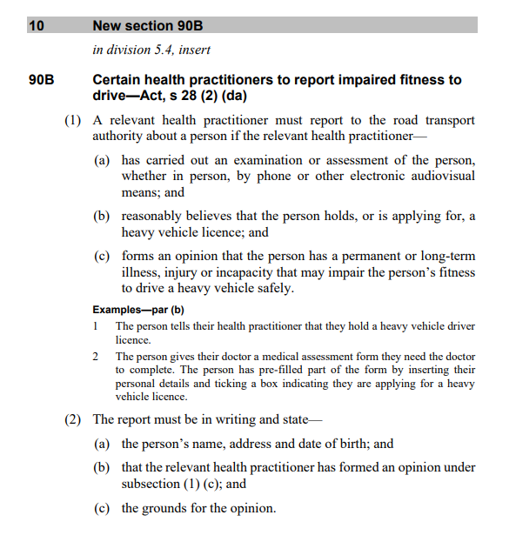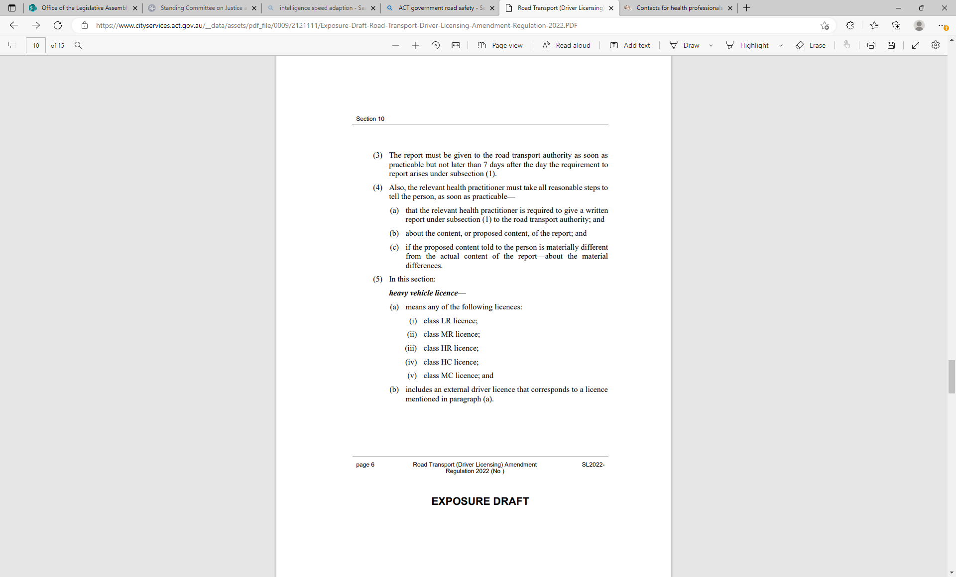

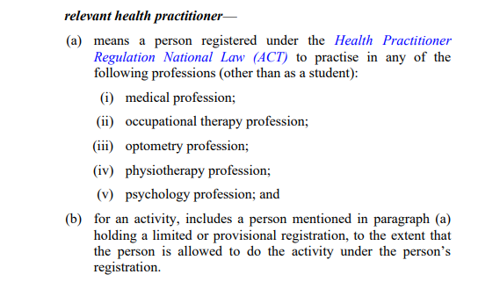

Appendix C: Letter from Committee seeking advice on potential inconsistency relating to the offence for authorised entry to a vehicle

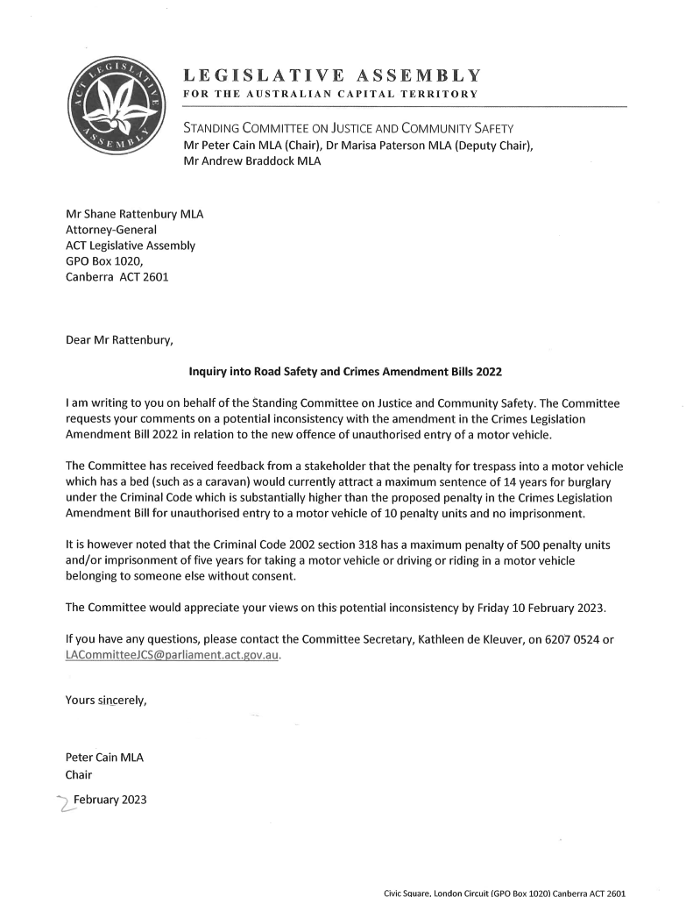

Appendix D: Letter from Attorney-General regarding burglary and the unauthorised entry of a vehicle
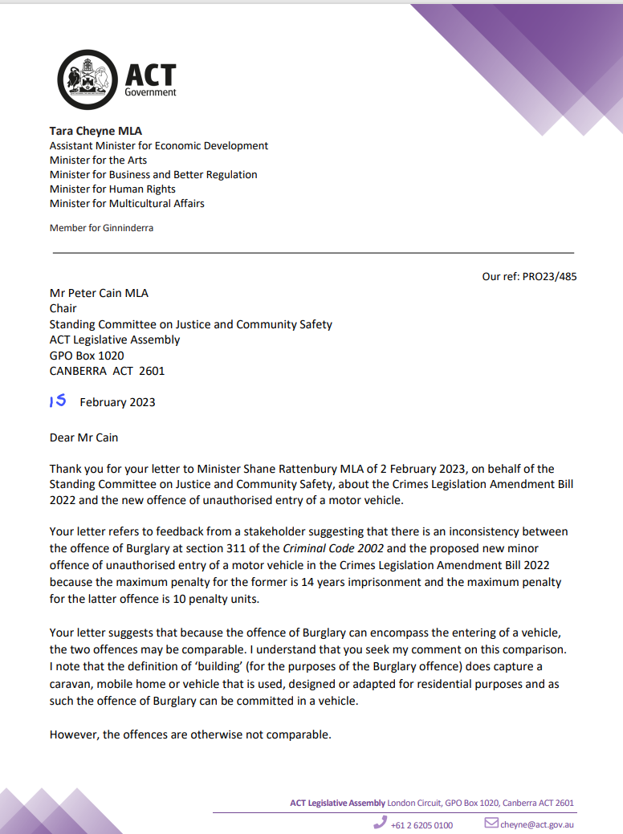

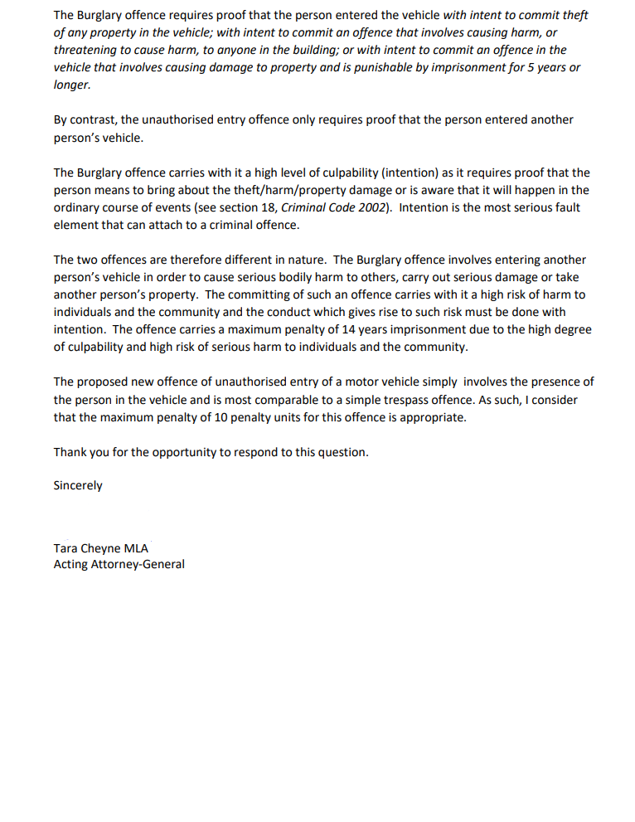

Legislative Assembly for the ACT, Minutes of Proceedings, No 71, 1 December 2022, p 984.
Mr Chris Steel MLA, Proof Legislative Assembly Hansard, 23 November 2022, p 3663.
Mr Chris Steel MLA, Proof Legislative Assembly Hansard, 23 November 2022, p 3663.
Mr Chris Steel MLA, Proof Legislative Assembly Hansard, 23 November 2022, p 3662.
Mr Chris Steel MLA, Proof Legislative Assembly Hansard, 23 November 2022, p 3663.
Road Safety Legislation Amendment Bill 2022, Explanatory Statement and Human Rights Compatibility Statement, p 3.
Road Safety Legislation Amendment Bill 2022, Explanatory Statement and Human Rights Compatibility Statement, pp 22–25.
Austroads, Assessing Fitness to Drive https://austroads.com.au/drivers-and-vehicles/assessing-fitness-to-drive (accessed 6 January 2023).
Austroads, Assessing Fitness to Drive, Frequently asked questions https://austroads.com.au/drivers-and-vehicles/assessing-fitness-to-drive/for-health-professionals/frequently-asked-questions (accessed 6 January 2023).
ACT Government, City Services, Reporting fitness to drive, https://cityservices.act.gov.au/roads-and-paths/road-safety/reporting-fitness-to-drive (accessed 6 January 2023).
Legal Aid ACT, Submission 10, p 2.
Mr Andrew Corney, Proof Committee Hansard, Inquiry into Dangerous Driving, 26 October 2022, p 17.
Andrew Corney, Submission 3, p 2.
Camille Jago, Submission 4, p 2.
Road Safety Legislation Amendment Bill 2022, Explanatory Statement and Human Rights Compatibility Statement, p 11.
Victims of Crime Commissioner, Submission 7, pp 3–4.
Section 90B(5) Road Safety Legislation Amendment Bill 2022.
Road Safety Legislation Amendment Bill 2022, Explanatory Statement and Human Rights Compatibility Statement, p 3 (point f).
Road Safety Legislation Amendment Bill 2022, Explanatory Statement and Human Rights Compatibility Statement, p 3 (point g).
Road Safety Legislation Amendment Bill 2022, Explanatory Statement and Human Rights Compatibility Statement, p 3 (point h).
Legal Aid ACT, Submission 10, p 3.
ACTCOSS, Submission 5, p 1.
Andrew Corney, Submission 3, p 3.
Australian Federal Police Association, Submission 6, p 5.
ACT Policing, Submission 8, pp 5–6.
Road Safety Legislation Amendment Bill 2022, Explanatory Statement and Human Rights Compatibility Statement, p 3 (point c).
Road Safety Legislation Amendment Bill 2022, Explanatory Statement and Human Rights Compatibility Statement, p 3 (point d).
Australian Federal Police Association, Submission 6, p 5.
ACT Policing, Submission 8, p 4.
Legal Aid ACT, Submission 10, p 4.
Name withheld, Submission 2, p 2.
Name withheld, Submission 2, p 4.
ACTCOSS, Submission 5, p 1.
ATODA, Submission 9, pp 1–2.
Road Safety Legislation Amendment Bill 2022, Explanatory Statement and Human Rights Compatibility Statement, p 3 (point e).
Road Safety Legislation Amendment Bill 2022, Explanatory Statement and Human Rights Compatibility Statement, p 3 (point i).
Legal Aid ACT, Submission 6, pp 5–6.
Name withheld, Submission 2, p 4.
ACT Policing, Submission 8, p 5.
ACT Policing, Submission 8, pp 5–6.
Section 20, (new section 754), Crimes Legislation Amendment Bill 2022, p 19.
Crimes Legislation Amendment Bill 2022, Explanatory Statement and Human Rights Compatibility Statement, p 10.
Recommendation 89, Select Committee on Estimates 2022-23, Report on Inquiry into the Appropriation Bill 2022-23 and Appropriation (Office of the Legislative Assembly) Bill 2022-23, p 114.
Deputy Commissioner Neil Gaughan, Select Committee on Estimates 2022-23, Committee Hansard, p 653.
Mr Shane Rattenbury MLA, Proof Legislative Assembly Hansard, 23 November 2022, p 3668.
Mr Shane Rattenbury MLA, Proof Legislative Assembly Hansard, 23 November 2022, p 3668.
Mr Shane Rattenbury MLA, Proof Legislative Assembly Hansard, 23 November 2022, p 3669.
Section 318, Criminal Code 2002.
Standing Committee on Justice and Community Safety (Legislative Scrutiny Role), Report 25, p 6.
ACT Policing, Submission 8, p 7.
ACT Policing, Submission 8, p 8.
AFPA, Submission 6, p 3.
AFPA, Submission 6, p 3.
Legal Aid ACT, Submission 10, p 7.
Deputy Commissioner Neil Gaughan, ACT Police Officer, Proof Committee Hansard, 14 November 2022, p 114.

