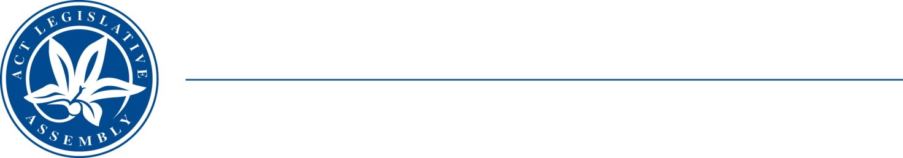
QoN No. 15
Committee Support
LEGISLATIVE ASSEMBLY
FOR THE AUSTRALIAN CAPITAL TERRITORY
Standing Committee on Education and Community Inclusion

Inquiry into Annual and Financial Reports 2021-2022

ANSWER TO QUESTION ON NOTICE

Asked by Elizabeth Kikkert MLA: To ask the Minister for Early Childhood Development
Reference: Early Childhood Development, CSD Annual Report 2022, p. 92

In relation to: Autism Assessments

1. Considering that utilising telehealth autism assessments has increased capacity and that the annual report indicates that this approach has been fully incorporated into an ongoing hybrid assessment model, what is the current impact of this model on service provision?
2. On average, how many people have been on a waiting list for an autism assessment over the reporting year, and what has been the average wait time?
3. What is the average cost of an autism assessment at the CDS under this hybrid model, and how does this compare to previous costs?
4. Has this hybrid model opened up any resources that could be used to provide lowincome families access to autism assessments for children age 12+?
5. During the reporting year, 128 autism assessments were completed. What is the breakdown of these by age

MINISTER Berry : The answer to the Member’s question is as follows:–

- Having a hybrid (telehealth) assessment model has enabled the Child Development Service to continue to provide a range of ASD assessments to families of children up to 12 years of age in the ACT.

- At any one time over the reporting year there were approximately 110-120 people on the waiting list for an ASD assessment. The average wait time for assessment was approximately 12 months.

- The cost of a telehealth assessment and a procured psychologist assessment is considered confidential text under Government Procurement Act 2001 – section 35 (1)(a)(iv) on the grounds that disclosure of the text would be an unreasonable disclosure of information about the business affairs of a person.

- The Child Development Service is funded to provide free Autism Assessments for children up to the age of 12. The current hybrid model has managed to ensure sustainable services and has decreased the significant wait time that these children and their families experience.

- Of the 128 ASD assessments completed in the reporting period:

- 15% of children seen for assessment were aged 11- 12 years olds
- 25% of children seen for assessment were aged 8-10 years
- 31% of children seen for assessment were aged 6-7 years
- 29% of children seen for assessment were aged 5 years or under

Approved for circulation to the Standing Committee on Education and Community Inclusion

Signature: Date:

By the Minister for Early Childhood Development, Yvette Berry MLA

