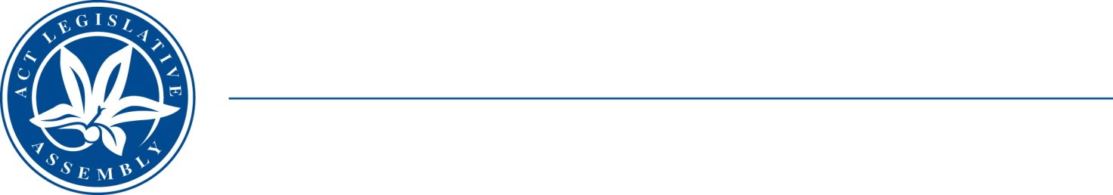
LEGISLATIVE ASSEMBLY
for the Australian Capital Territory

FOR THE AUSTRALIAN CAPITAL TERRITORY

FOR THE AUSTRALIAN CAPITAL TERRITORY

Standing Committee on Planning, Transport and City Services
Jo Clay MLA (Chair), Suzanne Orr MLA (Deputy), Mark Parton MLA

Media Release
On 22 June 2021 the Road Transport (Safety and Traffic Management) Amendment Bill 2021 (No 2) was presented in the Assembly by Jo Clay MLA. The Committee agreed on 1 July 2021 to inquire into the Bill, and called for public submissions.
The bill will improve road safety. Where vulnerable road users (people outside of a car) are harmed, it will bring penalties closer to meeting community expectation. It introduces a new offence for negligent driving that causes harm to a vulnerable road user with a maximum penalty of 50 penalty units and a traffic infringement notice penalty for this offence of $1600 plus the loss of three licence points.
On 5 August 2021 the Minister for Transport and City Services, Mr Chris Steel presented the Road Transport Legislation Amendment Bill 2021. This bill will amend the Territory’s road transport legislation to improve road safety by strengthening the regulatory and enforcement framework for dangerous driving and other unsafe behaviours on the Territory’s road network. The amendments include establishing a new offence for negligent driving that causes actual bodily harm, increasing existing minimum automatic licence disqualification periods for the offences of culpable driving and negligent driving and establishing two new offences to address unsafe behaviours of other transport modes.
The Committee has decided to inquire into both bills together. The Committee has already sought community submissions into Ms Clay’s bill. The Committee is now seeking community submissions into Minister Steel’s bill as well. The Committee will then hold public hearings into both bills.
Submissions into either bill are now open. The Committee is particularly interested in views about the bills themselves and experiences and views about road safety enforcement in Canberra and the experiences of vulnerable road users.
The Committee’s report is due to be tabled by the end of November. The Committee is calling for submission by 16 October 2021.
Public hearings will be announced shortly—the details will be available on the Assembly website.
Further inquiries:
Annemieke Jongsma, Secretary: 6205 1253 or LACommitteePTCS@parliament.act.gov.au
17 September 2021
[End]

