The Conduct of Mr Barr MLA
Standing Committee on Administration and Procedure
August 2016
Report 9

Committee membership

Vicki Dunne MLA (Chair)

Joy Burch MLA

Shane Rattenbury MLA

Brendan Smyth MLA (to July 2016)

Andrew Wall MLA (from July 2016)

Secretariat

Tom Duncan (Secretary)

Janice Rafferty (Assistant Secretary)

Celeste Italiano (Inquiry Secretary)

Contact information

Telephone 02 6205 0173

Facsimile 02 6205 3109

Post GPO Box 1020, CANBERRA ACT 2601

Email admin.proc@parliament.act.gov.au

Website www.parliament.act.gov.au

Resolution of appointment

In 1995 the Legislative Assembly for the Australian Capital Territory (‘the Assembly’) amended Standing Order 16, which established the Standing Committee on Administration and Procedure (‘the Committee’).

Standing Order 16 authorises the Committee to inquire into and report on, among other things, the practices and procedure of the Assembly.

Terms of reference

Continuing resolution 5AA

COMMISSIONER FOR STANDARDS
This resolution provides for the appointment of a Legislative Assembly Commissioner of Standards.
Resolution agreed by the Assembly
31 October 2013 (amended 9 June 2016)
COMMISSIONER FOR STANDARDS
That this Assembly requests the Speaker to appoint a Legislative Assembly Commissioner for Standards on the following terms:
- The Speaker must, after each Assembly is elected or whenever the office becomes vacant, appoint a Commissioner for the life of that Assembly and the period of three months after each election. The initial appointment is for the term of the 8th Assembly and the period of three months after the election at the conclusion of that term.
- Before appointing a Commissioner, the Speaker must consult with the Chief Minister, the Leader of the Opposition and Crossbench Members.
- The Commissioner may be dismissed only following a resolution of the Legislative Assembly resolving to require the Speaker to end the Commissioner’s appointment—
- for misbehaviour; or
- for physical or mental incapacity, if the incapacity substantially affects the exercise of the Commissioner’s functions.
However, a motion for such a resolution may only be debated after the Standing Committee on Administration and Procedure (‘the Committee’) has reported to the Assembly that it is satisfied that the Commissioner is unfit for the office or unable to fulfil the Commissioner’s functions.
- The functions of the Commissioner are to:
- investigate specific matters referred to the Commissioner—
- by the Speaker in relation to complaints against Members; or
- by the Deputy Speaker in relation to complaints against the Speaker; and
- report to the Standing Committee on Administration and Procedure.
(c) if the Assembly is not sitting when the Commissioner provides a report to the Committee, the Committee may send its report to the Speaker or, in the absence of the Speaker, to the Deputy Speaker, who is authorised to give directions for its printing, publication and circulation.
- Members of the public, members of the ACT Public Service and Members of the Assembly may make a complaint to the Speaker about a Member’s compliance with the Members’ Code of Conduct or the rules relating to the registration or declaration of interests.
- If the Speaker receives a complaint about a Member pursuant to paragraph (5) and the Speaker believes on reasonable grounds that—
- there is sufficient evidence as to justify investigating the matter; and
- the complaint is not frivolous, vexatious or only for political advantage;
the Speaker may refer the complaint to the Commissioner for investigation and report.
- Members of the public, members of the ACT public service and Members of the Assembly may make a complaint to the Deputy Speaker about the Speaker’s compliance with the Members’ Code of Conduct or the rules relating to the registration or declaration of interests.
- If the Deputy Speaker receives a complaint about the Speaker pursuant to paragraph (7) and the Deputy Speaker believes on reasonable grounds that—
- there is sufficient evidence to justify investigating the matter; and
- the complaint is not frivolous, vexatious or only for political advantage;
the Deputy Speaker may refer the complaint to the Commissioner for investigation and report.
- In exercising the functions of Commissioner the following must be observed:
- The Commissioner must not make a report to the Committee if the Member or the Speaker about whom the complaint was made has agreed that he or she has failed to register or declare an interest if —
- in the Commissioner’s opinion the interest involved is minor or the failure was inadvertent; and
- the Member concerned has taken such action to rectify the failure as the Commissioner may have required within any procedure approved by the Committee for this purpose.
- The Commissioner must not make a report to the Committee unless the Commissioner has—
- given a copy of the proposed report to the Member or the Speaker who is the subject of the complaint under investigation;
- the Member or the Speaker has had a reasonable time to provide comments on the proposed report; and
- the Commissioner has considered any comments provided by the Member or the Speaker.
- The Commissioner must report by 31 August each year to the Speaker on the exercise of the functions of the Commissioner.
- The Committee must review the operation of the Commissioner after two years following the initial appointment of the Commissioner and report to the Assembly in the last sitting period in 2016.
Continuing resolution 5
CODE OF CONDUCT
FOR ALL MEMBERS OF THE LEGISLATIVE ASSEMBLY
FOR THE AUSTRALIAN CAPITAL TERRITORY
This resolution provides for a code of conduct for Members of the Legislative Assembly.
Resolution agreed by the Assembly
25 August 2005 (amended 16 August 2006, 24 October 2013)
CODE OF CONDUCT FOR ALL MEMBERS OF THE LEGISLATIVE ASSEMBLY FOR THE AUSTRALIAN CAPITAL TERRITORY
The Members of the Legislative Assembly for the Australian Capital Territory acknowledge that, in a parliamentary democracy they cannot command, but must constantly strive to earn and maintain, the respect and support of those who have elected them to their positions of honour and privilege as Members.
In committing to this Code of Conduct, Members undertake, to the community and to one another, that the following principles shall guide their conduct as Members in all matters:
- Members should at all times act with integrity, honesty and diligence.
- Members should act only in the interests of, and with respect for, the people of the Australian Capital Territory and in conformity with all laws applicable in the Territory.
- Members should always act in the public interest, make decisions and choices on merit, and not seek to gain financial or other benefit for themselves, their family or friends.
- Members should be reasonably accessible to the people of the electorate they have been elected to serve, and should represent their interests conscientiously.
- Members should be transparent in, and accountable for, their decisions and actions, should avoid or appropriately resolve any actual or reasonably perceived conflicts of interest and should submit themselves to appropriate scrutiny.
- Members should make only proper use of those public resources to which they have access.
- Members should respect the dignity and privacy of individuals, and not disclose confidential information to which they have official access other than with consent or as permitted by law.
- Members should observe proper standards of parliamentary conduct, and observe respect for differences and fairness in their political dealings.
- Members should promote and support these principles by leadership and example, in order to maintain and support public trust and confidence in the integrity of the Assembly and the conduct by its Members of public business.
Consistent with the above principles, Members further undertake that they should:
- Actively seek to prevent any conflict of interest, or the perception of such a conflict, arising between their duties as a Member and their personal affairs and interests, take all reasonable steps to resolve any such conflict or perception of a conflict that does arise, and:
- comply with section 15 of the Australian Capital Territory (Self-Government) Act 1988 (Cwth);
- declare their pecuniary interests and ensure that their declaration is kept up to date pursuant to the resolution of the Assembly ‘Declaration of Private Interests of Members’ agreed to on 7 April 1992 (as amended or replaced from time to time). Include in the Member’s Statement of Registrable Interests all gifts, payments, fees, rewards or benefits valued at more than $100 received in connection with the Member’s functions as a Member; and
- disclose in a manner appropriate to the circumstances any other financial or non-financial interest that they may hold, or which they may be reasonably perceived to hold (other than as a member of the public or of a broad class of persons) which a reasonable observer, informed of that interest, might perceive as giving rise to a conflict of interest with the performance of the Member’s duty as a Member.
- Not solicit to undertake, or undertake, any activity as a Member in return for the provision, promise or expectation of any improper benefit to the Member or to another person.
- Take care to consider the rights and reputations of others before making use of their unique protection of parliamentary privilege consistent with the resolution of the Assembly ‘Exercise of freedom of speech’ agreed to on 4 May 1995 (as amended or replaced from time to time).
- Not use information received by them as a Member that is not in the public domain in breach of any obligation of confidence applicable to their receipt of that information, or improperly for the private benefit of themselves or another person.
- In their capacity as an employer on behalf of the Territory under the Legislative Assembly (Members’ Staff) Act 1989:
- familiarise themselves and comply with the terms and conditions on which their personal staff are engaged and with all applicable policies and practices (including those related to occupational health and safety, discrimination, harassment and bullying, equal employment opportunity and use of information technology);
- not employ a family member as defined in that Act;
- direct their personal staff to be mindful of the Member’s commitment to this Code of Conduct, and to assist the Member to comply with this Code of Conduct; and
- direct their personal staff to comply with any code of conduct applicable to those staff from time to time.
- In all their dealings with staff of the Assembly and members of the ACT Public Service:
- extend professional courtesy and respect; and
- recognise the unique position of impartiality and the obligations of Public Service officials.
- Only make a complaint about the compliance of another Member with this Code of Conduct where they believe there are reasonable grounds to suspect non-compliance and not make any such complaint that is frivolous or vexatious or only for political advantage.
- Cooperate fully with any official inquiry that may be commenced in connection with their compliance with this Code of Conduct, or that of another Member.

Table of contents
Committee membership i
Secretariat i
Contact information i
Resolution of appointment ii
Terms of reference ii
Recommendations vii
1 Introduction 1
2 Conduct of the Commissioner’s inquiry 1
3 The Commissioner’s Findings 1
4 The Committee’s consideration of the Commissioner’s report 2
Appendix A Letter from Mr Hanson MLA to the Speaker 4
APPENDIX B Letter from the Speaker to the Commissioner for Standards 14
APPENDIX C Report of the Commissioner for Standards 15

Recommendations
Recommendation 1
4.2 The Committee recommends that no further action be taken in relation to this matter.
Recommendation 2
4.7 The Committee recommends that MLAs read the Commissioner’s report and take into account the comments made by the Commissioner about endorsements when they are approached to support a business or organisation.
Recommendation 3
4.9 The Committee recommends that MLAs ensure they are aware of how any endorsement or support for a business or organisation is going to be used and/ or disseminated before it is given.
Recommendation 4
4.12 The Committee recommends that the Code of Conduct for all Members of the Legislative Assembly for the Australian Capital Territory (Continuing Resolution 5) be reviewed by April following an election prior to it being re-endorsed, in accordance with the recommendation of the Ethics and Integrity Adviser.

Introduction
          - On 13 May 2016 Mr Jeremy Hanson MLA wrote to the Speaker to claim that Mr Barr MLA had breached sections 3, 5, 9 and 10 of the Members’ Code of Conduct (see Appendix A). The matter was referred to the Commissioner for Standards, the Honourable Dr Ken Crispin QC, by the Speaker of the Legislative Assembly, Mrs Vicki Dunne MLA on 16 May 2016 (see Appendix B).
          - The Standing Committee on Administration and Procedure has now received a report from the Commissioner for Standards on his investigation into a complaint raised by Mr Hanson.
          - A copy of the Commissioner’s report is published as Appendix C to this report.

Conduct of the Commissioner’s inquiry
          - The Commissioner wrote to Mr Barr MLA. The Commissioner also received an additional email from Mr Hanson, MLA concerning an editorial of The Canberra Times of 14 May 2016, which the Commissioner also sent to Mr Barr. Having considered all of that material he drafted a report which he sent to Mr Barr. The Commissioner considered the response of Mr Barr and then forwarded a copy of his report to this Committee.

The Commissioner’s Findings
          - The Commissioner gave a lengthy and useful outline of the issues associated with conflict of interest.
          - The Commissioner found as follows:
“56. There does seem to have been some real public concern at the Chief Minister’s endorsement of the Dexar Group. This may have been attributable to a number of factors, including an understandable aversion to anything suggestive of political patronage, the fact that the endorsement was videotaped rather than delivered in the well understood context of a trade delegation or trade fair, or the fact that it was available on-line and linked to promotional material of a private company. Perhaps some saw it as a harbinger of things to come and feared having their television screens haunted by Members of the Assembly extolling the virtues of soap flakes or other merchandise. Whatever the precise causes of the controversy, it is essentially one that must be debated in the political arena.

57. My only role has been to consider the particular issues raised by the complaint. Those issues were potentially serious and an independent investigation was clearly warranted. However, after examining the issues raised, I have formed the view that no breach of the Chief Minister’s duty has been substantiated.

58. I recommend that the complaint be dismissed.”.

The Committee’s consideration of the Commissioner’s report
          - The Committee, in accordance with continuing resolution 5AA, has considered the Commissioner’s report and concurs with his conclusion.

          - The Committee recommends that no further action be taken in relation to this matter.
          - The Committee considers that important issues are raised by the matters before it. Many MLAs find themselves in the position of being a patron of an organisation or of hosting a charity event in the ACT community. Typically these are either declared in the Members’ declaration of Members’ Interests or at public events (e.g. trivia nights, morning teas) where it is clear that the MLA is associating themselves with the organisation. In addition, Ministers are now regularly leading trade delegations to overseas destinations accompanied by local ACT business and other groups where the aim is to promote the Territory.
          - The matter that has been referred to the Commissioner does affect every MLA as they are often called upon to associate themselves with various causes and organisations across the Territory.
          - In investigating the matter, the Commissioner noted that he had not been asked to express any opinion about whether the Chief Minister should have provided the endorsement or whether it was warranted.
          - The Committee also makes no comment on this matter, but does believe that MLAs should take into account the matters raised in the Commissioner’s report in deciding whether or not to support a business or organisation.

          - The Committee recommends that MLAs read the Commissioner’s report and take into account the comments made by the Commissioner about endorsements when they are approached to support a business or organisation.
          - The Committee also noted that it would be prudent for MLAs, when giving endorsements or support to a particular business or organisation, to be aware of how that support or endorsement might be used.

          - The Committee recommends that MLAs ensure they are aware of how any endorsement or support for a business or organisation is going to be used and/or disseminated before it is given.
          - The Commissioner’s report to the Committee indicates that the issues raised in the Complaint “were potentially serious and an independent investigation was clearly warranted”. This is the second time in the 8th Assembly where a matter has been referred to the Commissioner for investigation. Both reports contain useful guidance to MLAs about how to address compliance with the Assembly’s code of conduct.
          - The code was reviewed in 2013 by the Assembly’s Ethics and Integrity Adviser who recommended that the code be re-endorsed by members at the beginning of each term.
          - The Committee considers that reviewing the code prior to it being re-endorsed would be useful, so that the code remains a living document.

          - The Committee recommends that the Code of Conduct for all Members of the Legislative Assembly for the Australian Capital Territory (Continuing Resolution 5) be reviewed by April following an election prior to it being re-endorsed, in accordance with the recommendation of the Ethics and Integrity Adviser.

Vicki Dunne MLA
Chair
August 2016

              - Letter from Mr Hanson MLA to the Speaker

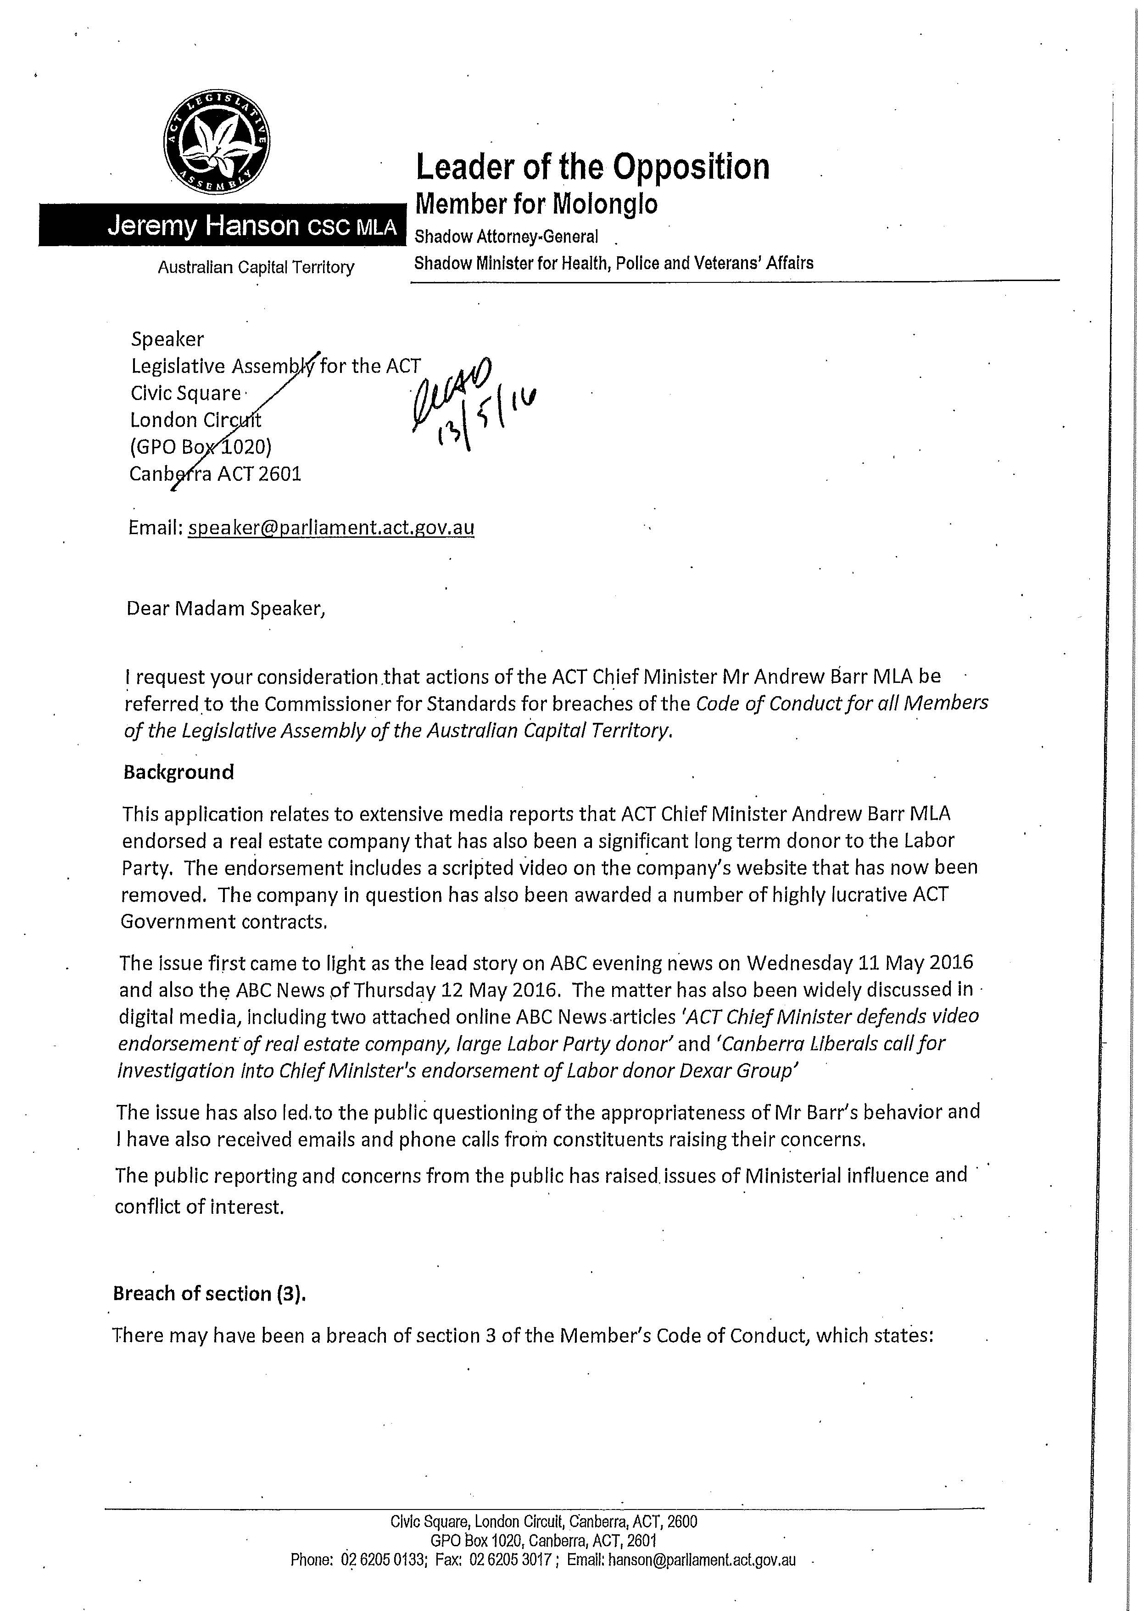

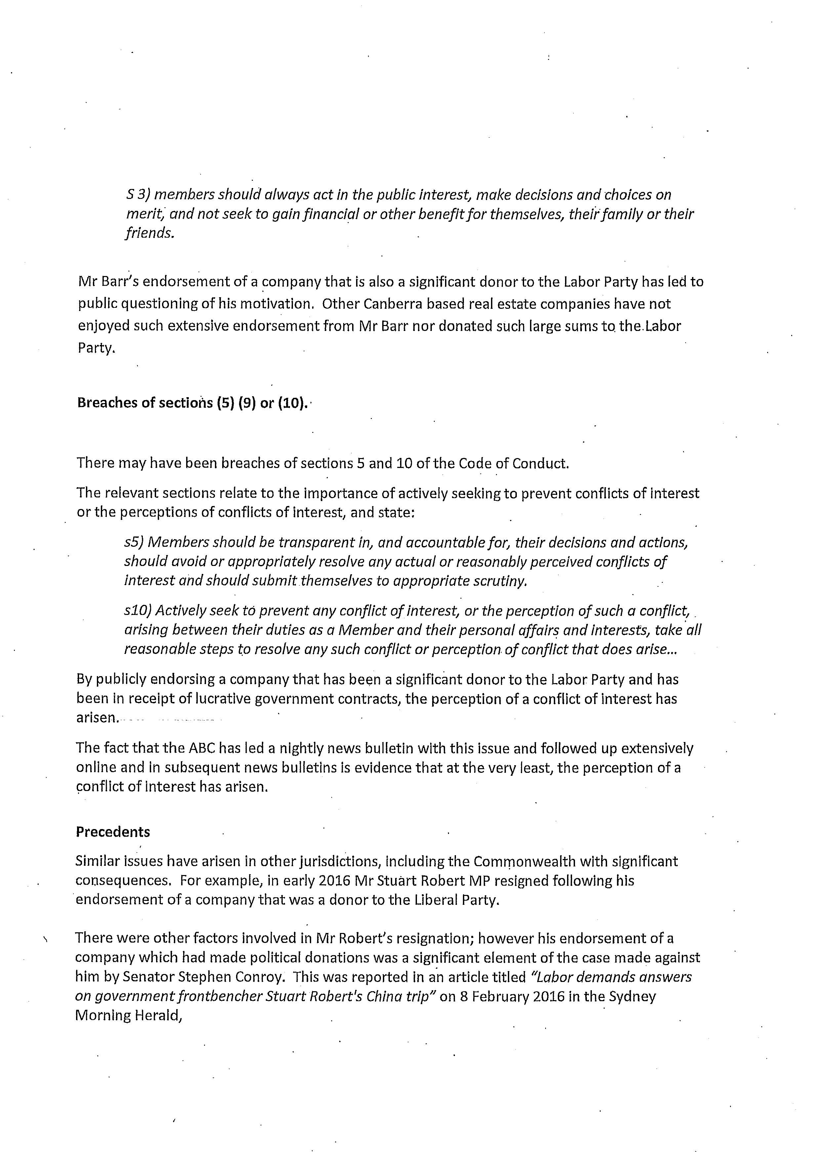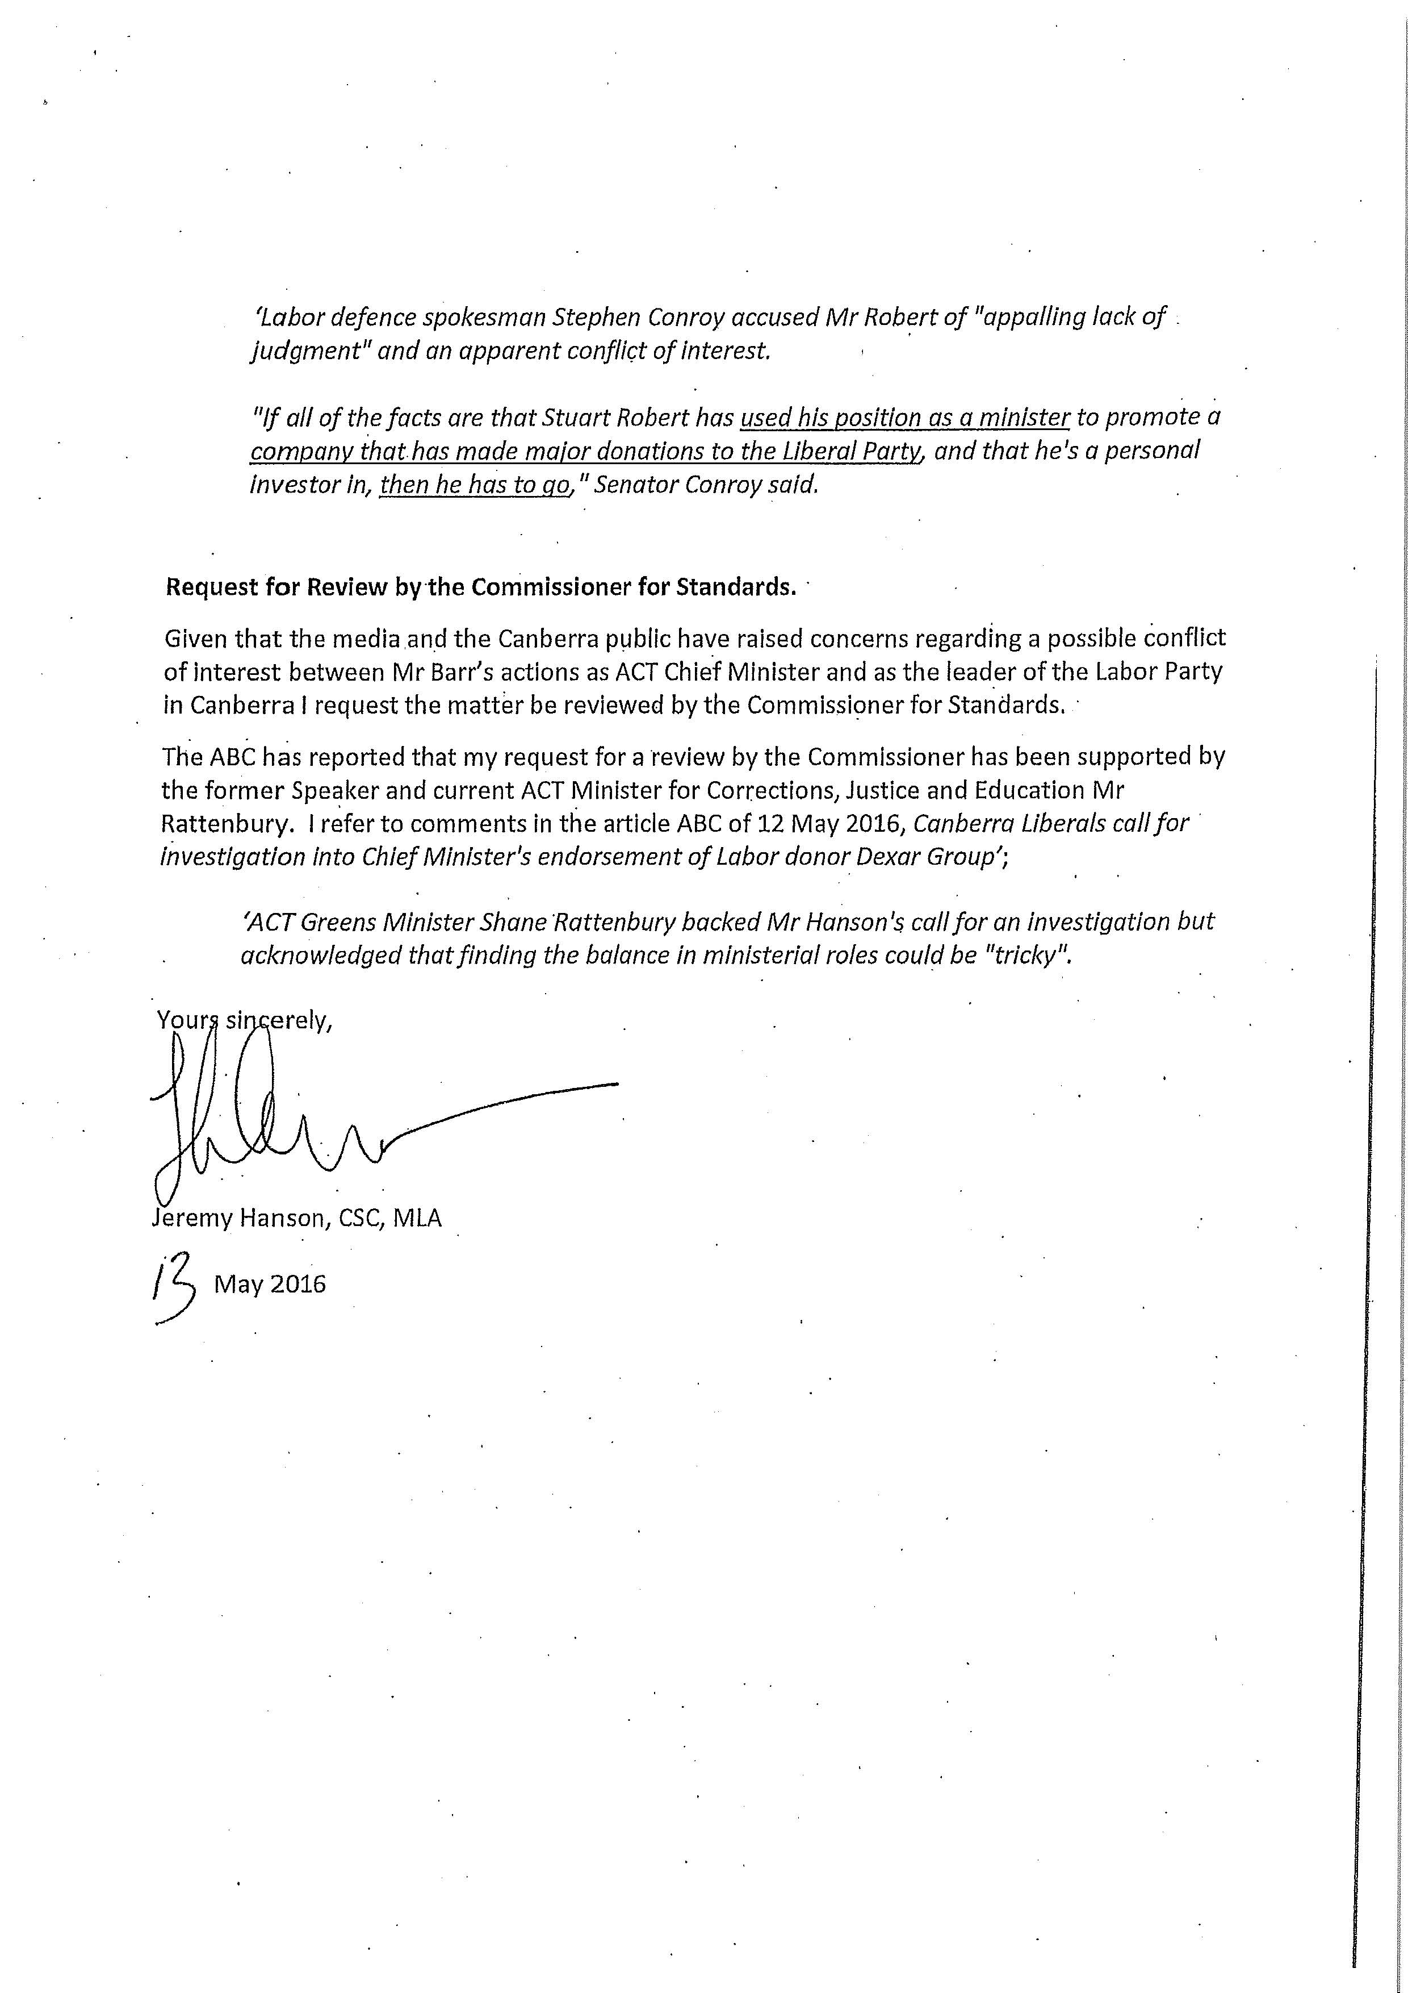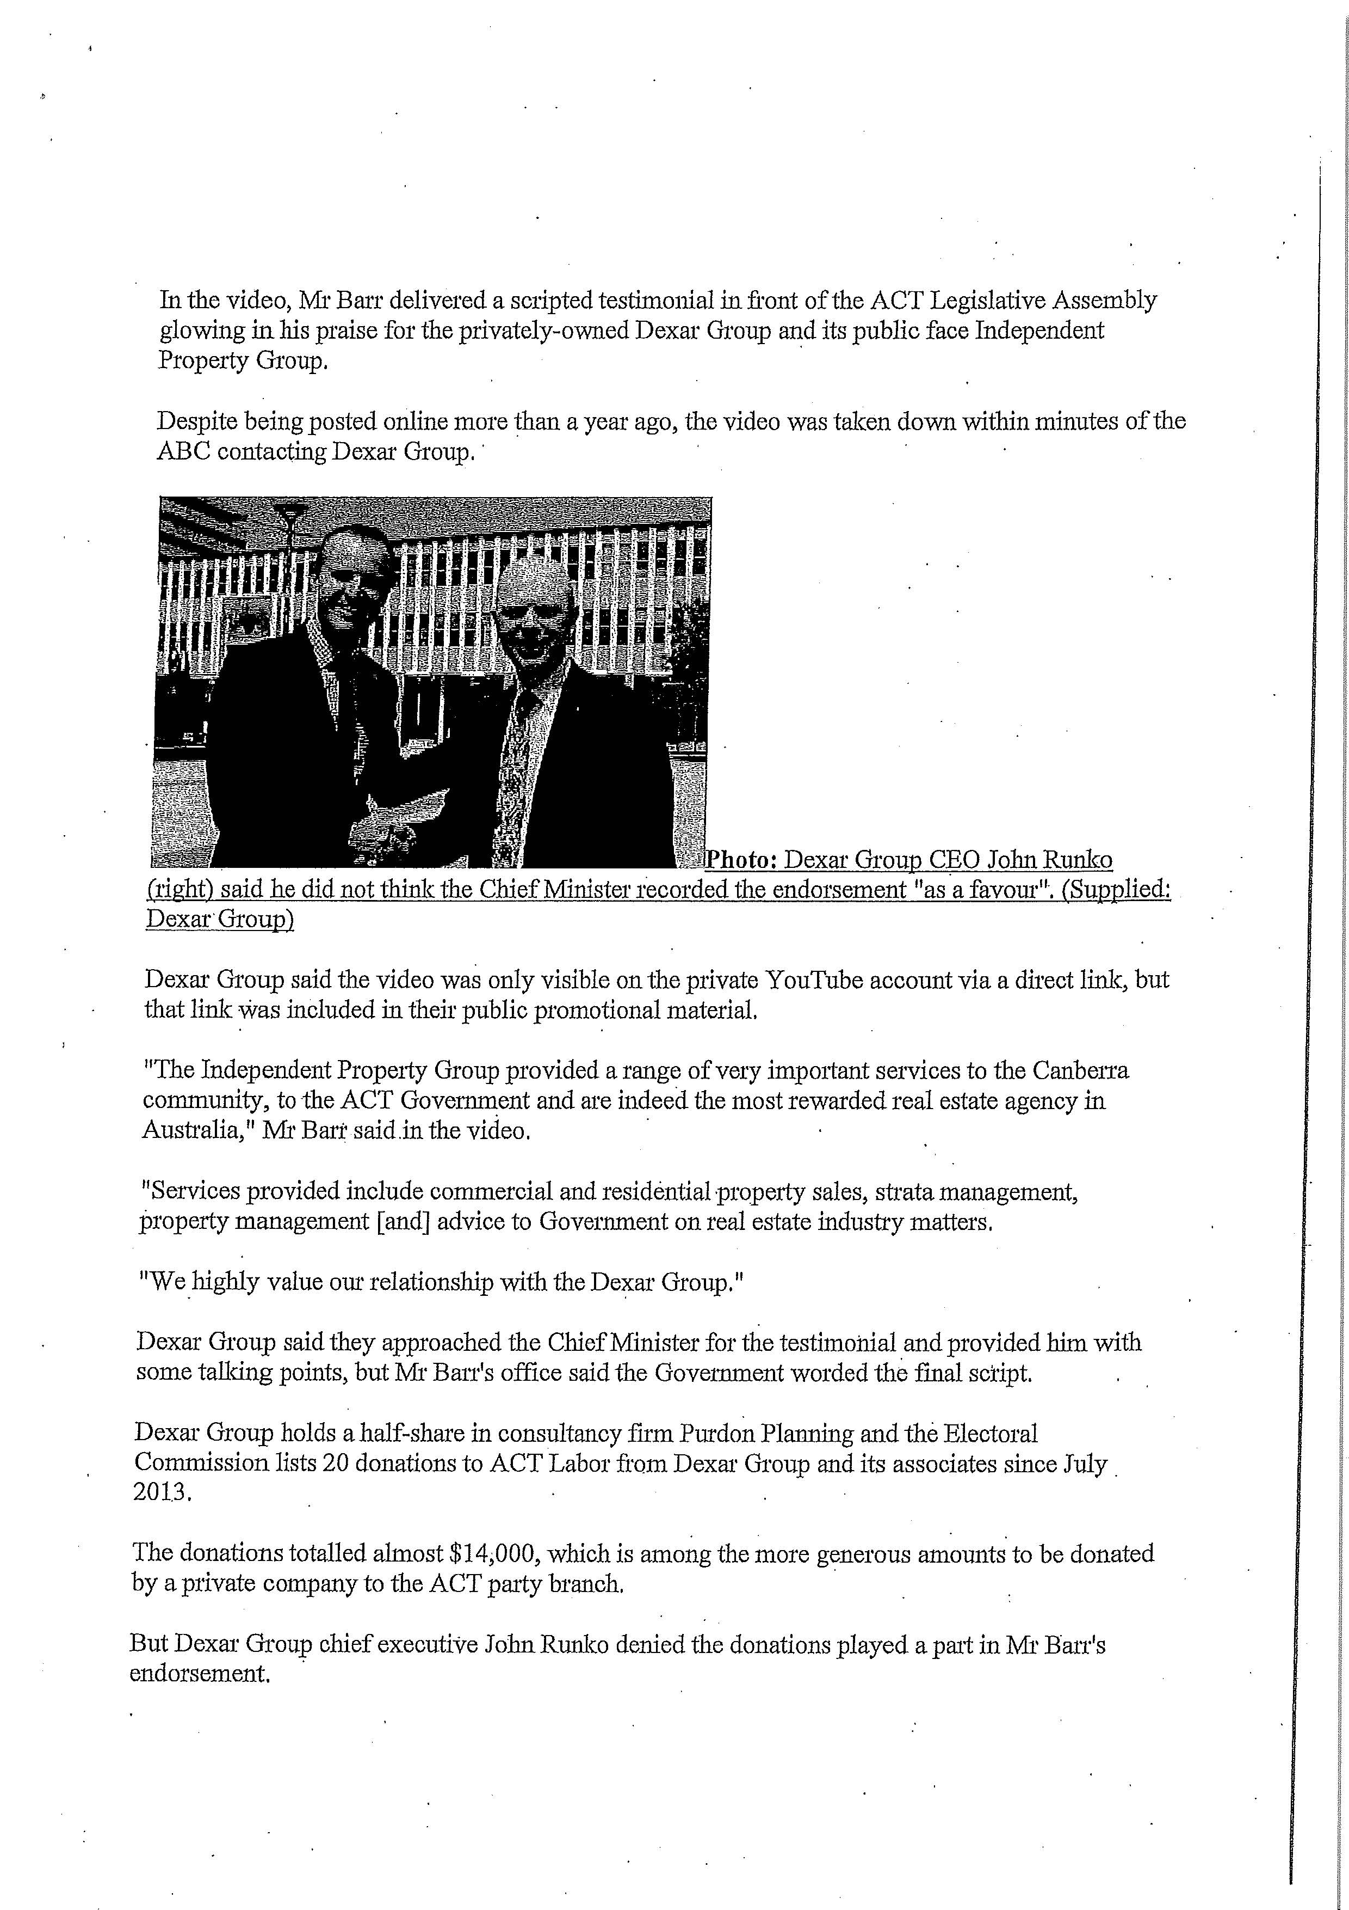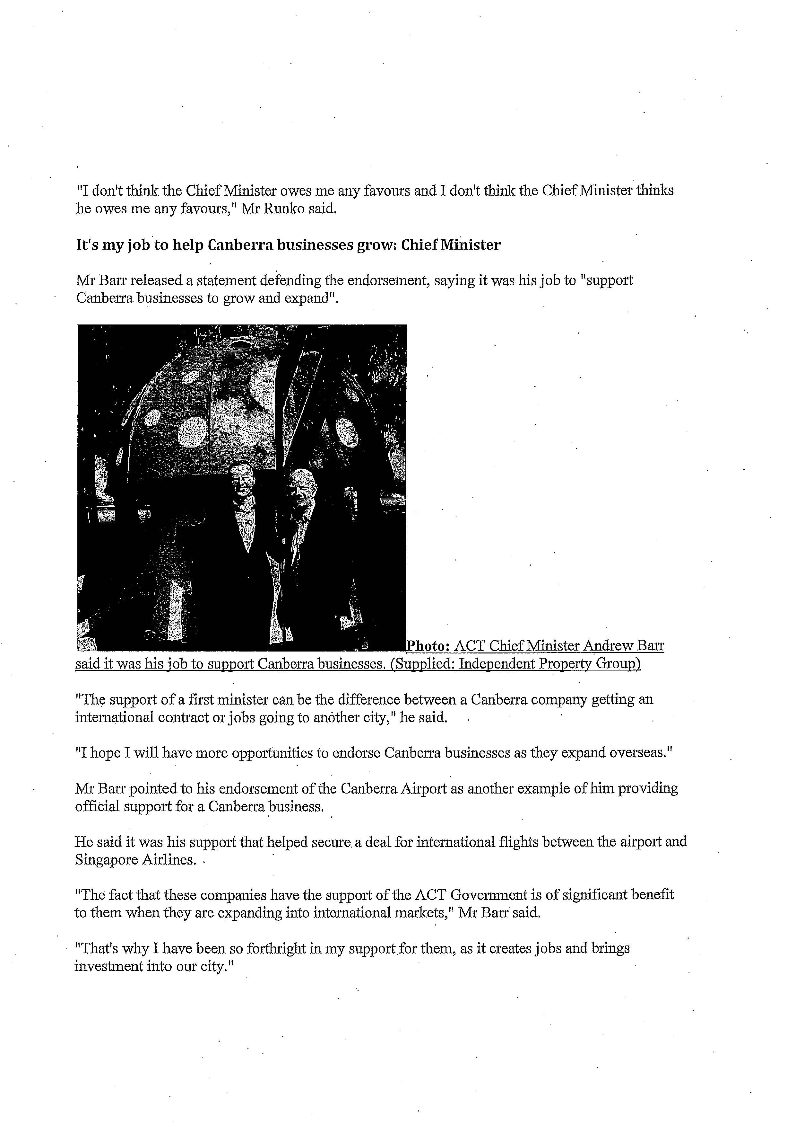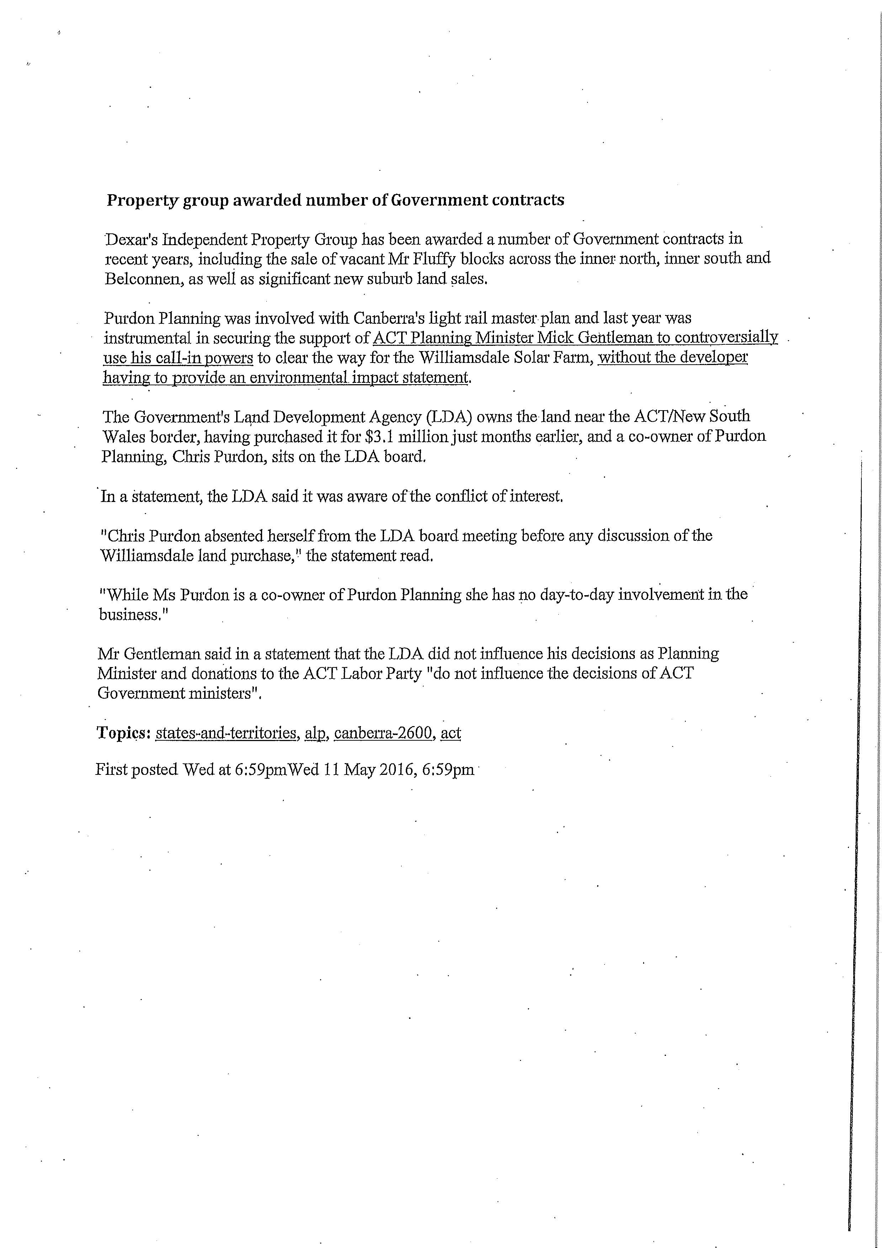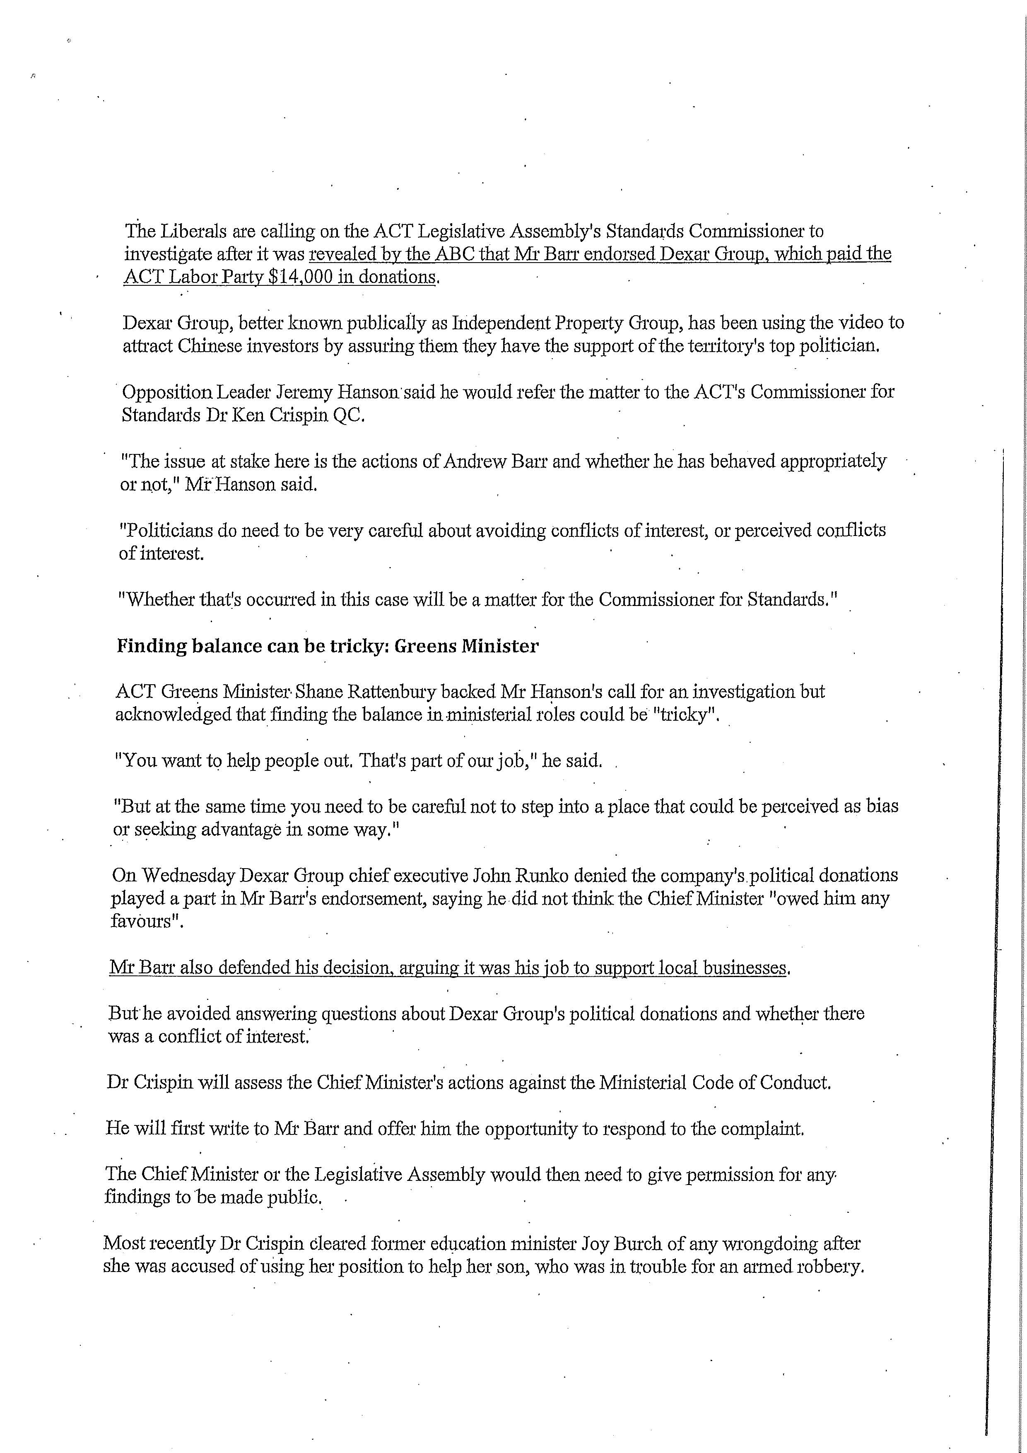

APPENDIX B Letter from the Speaker to the Commissioner for Standards

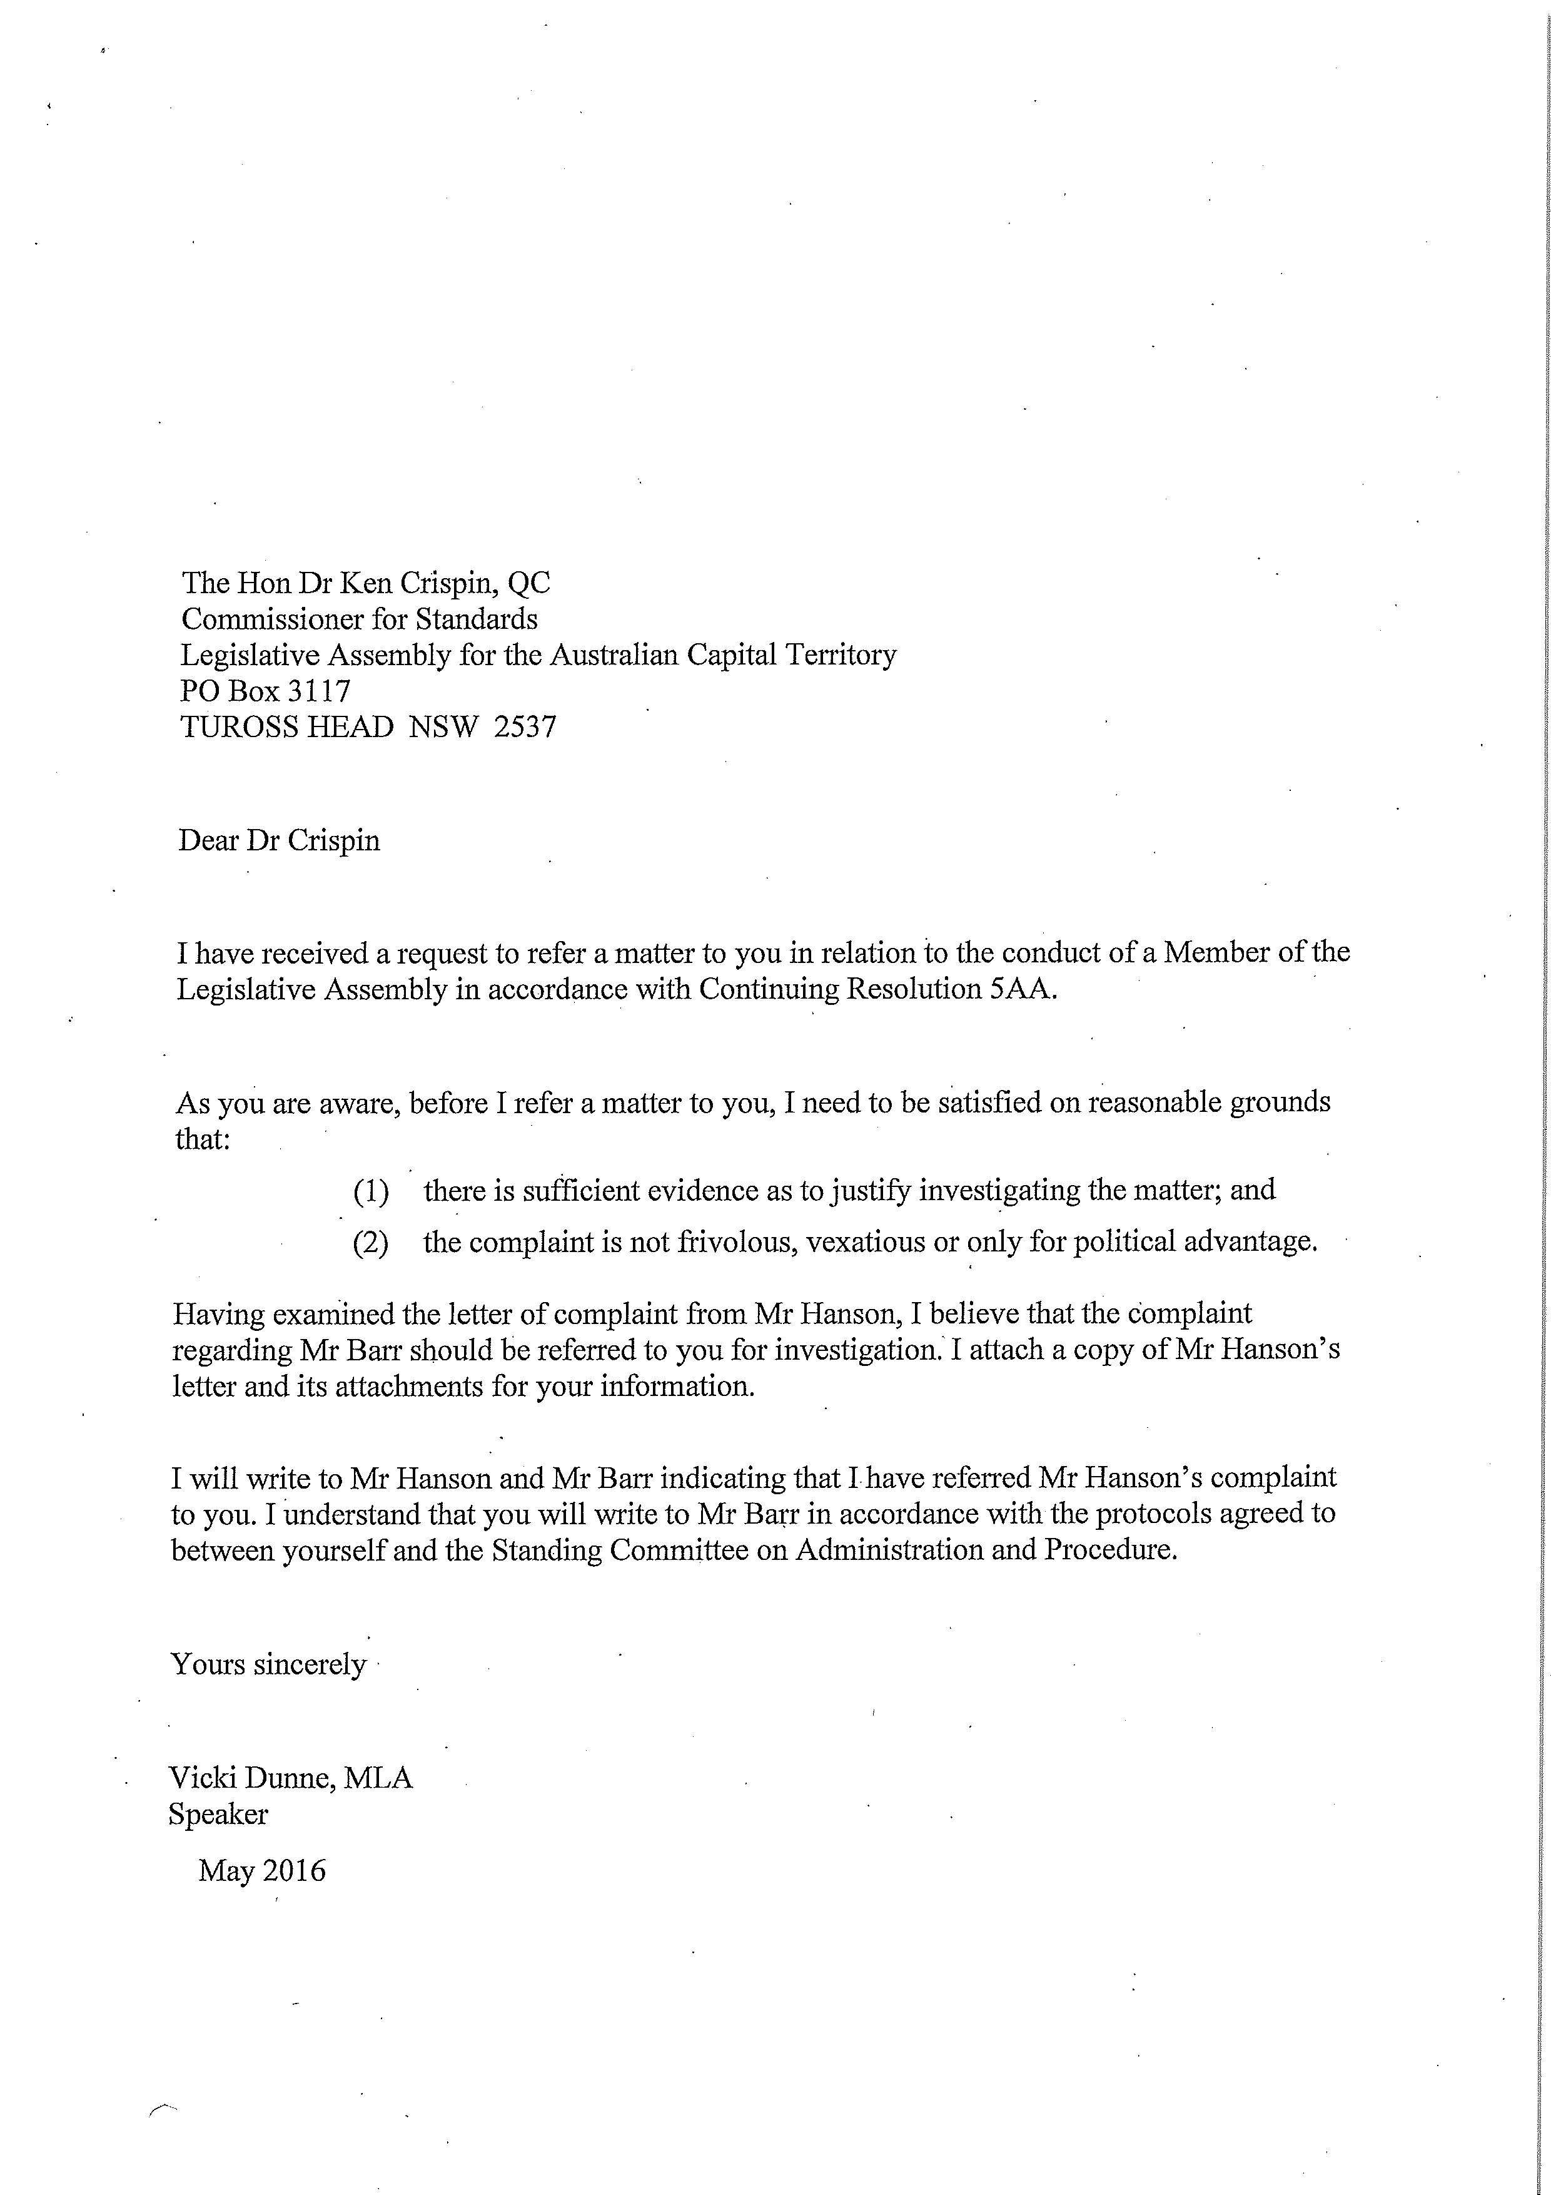
APPENDIX C Report of the Commissioner for Standards
REPORT INTO A COMPLAINT AGAINST MR ANDREW BARR MLA, CHIEF MINISTER OF THE AUSTRALIAN CAPITAL TERRITORY

Background

- On 12 May 2016 successive articles in ABC News reported that the Chief Minister had provided a videotaped endorsement of the Dexar Group. The video is available on-line and I have been able to make the following transcription of the Chief Minister’s remarks:

I am very pleased to provide this testimonial for the Dexar Property Group who have been operating in Canberra as the Independent Property Group since 1958. The Independent Property Group provided a range of very important services to the Canberra community, to the ACT Government and are indeed the most awarded real estate agency in Australia. Services provided include commercial and residential property sales, strata management, property management advice to Government on real estate industry matters. We highly value our relationship with the Dexar Group. They have been used by the ACT Government for government land sales and they have achieved excellent results for the Australian Capital Territory government. They are also extensively involved in the Canberra community and provide tremendous support in so many areas of community life in the city of Canberra. As Chief Minister of the Australian Capital Territory I am delighted to support them and to have a continued strong relationship with the Dexar Group.

- The larger of the two articles also reported that:

- The Dexar Group had approached the Chief Minister for the testimonial and provided him with some talking points, but his office had said that “the Government” had worded the final script.
- the video was used by the company to attract overseas investors by assuring them that the company had the high-level support of the Chief Minister.
- the Dexar Group's website until recently featured a picture of Mr Barr as well as the ACT Coat of Arms and the statement: "Dexar has been endorsed by ACT Chief Minister Andrew Barr”;
- the Dexar Group and its associates had made a series of donations to the ACT Branch of the Australian Labor Party (“ALP”), amounting in total to almost $14,000 since July 2013; and
- the chief executive of the Dexar Group, Mr John Runko, had denied that the donations had played a part in Mr Barr's endorsement.

- The article revealed that the Chief Minister had released a statement defending the endorsement and had said that:

- it was his job to "support Canberra businesses to grow and expand”;
- such support could be “the difference between a Canberra company getting an international contract or jobs going to another city”;
- he hoped to be able to endorse other Canberra businesses “as they expand overseas”;
- he had previously endorsed the Canberra Airport and that this had helped secure a deal for international flights between the airport and Singapore Airlines; and
- he had been forthright in support of ACT companies when expanding into international markets, “as it creates jobs and brings investment into our city.”

- An article published by The Canberra Times on 13 May 2016, reported that Mr Runko had said that he was surprised at calls by the Leader of the Opposition for an investigation as the Dexar Group had also made donations to the Canberra branch of the Liberal Party. He had explained that he had asked Mr Barr to “introduce the company” in a video ahead of meetings with Chinese investors about a year ago.

- However, an editorial in The Canberra Times on 14 May 2016 was strongly critical of the endorsement which it suggested had lent a “brisk new edge” to an “air of patronage and cronyism”. The editorial also suggested that:

- the words used in the endorsement had been “redolent more of puffery than support”;
- the short video had never been meant for local consumption, but intended for use as a marketing tool to help the Dexar Group attract Chinese interest in buying, leasing, developing or managing Canberra property;
- those holding high public office generally do not endorse specific companies or products in public;
- whilst Chief Ministers and Premiers do “spruik” the businesses or products of their home states or territories, they do so in broad-brush terms, since to single out individual brands or products would inevitably give rise to perceptions of conflict of interest; and
- the Chief Minister's gift of his time and the authority of his office to the Dexar Group had elicited surprise, concern and some disapproval in various quarters.

The complaint

- The complaint was made Leader of the Opposition in a letter to the Speaker of the Legislative Assembly, Ms Vicki Dunne MLA, dated 13 may 2016. It suggested possible breaches of sections (3), (5), (9) and (10) The Code of Conduct for all Members of the Legislative Assembly of the Australian Capital Territory (‘the Code’).

- It was referred to me by the Speaker by letter dated 16 May 2016.

The investigation

- I wrote to the Chief Minister on 17 May 2016 inviting him to submit a written response.

- Later that day I received an email from the Leader of the Opposition providing a hyperlink to the editorial in the Canberra Times on 14 May 2016 which was, of course, published after he had formulated his complaint. I immediately sent a copy of the link to the Chief Minister to the ensure that he would have an opportunity to comment on the editorial in his response should he wish to do so.

- The Chief Minister responded on 30 May 2016. His letter included the following explanation:

The video was aimed at assisting the Dexar Group, a leading local company, in their efforts to attract international investment. The ACT has a thriving business community and I have a long and public record of supporting all reputable Canberra-based companies seeking to expand into international markets, because I consider such growth is of benefit to the wider Canberra economy and community. …
As both the Chief Minister and the Minister for Economic Development, I consider it an essential part of my Ministerial responsibilities to support local companies, as appropriate, to compete nationally and internationally for investment and growth opportunities. As part of my role I routinely promote local businesses at events, in the media and social media. Whether these businesses are donors to a political party has no bearing on my decision to support them, I support them to support Canberra.

- The Chief Minister mentioned that he had recently travelled to Singapore and China to lead a delegation of 30 local businesses and organisations seeking closer ties with potential Asian investors, business people and governments. He also referred to the fact that State, Territory and federal Ministers routinely participate in business missions of this nature and and cited, as an example, the Australia - United States Business Week mission in February 2016, which he said had followed on from trade missions and promotional events in China, India and Indonesia.

- Since the factual basis of the complaint was not disputed and the Chief Minister’s response essentially confirmed earlier comments reported by ABC News, it was not necessary to seek further clarification from the Leader of the Opposition or make extensive enquiries.

- The role of the Commissioner is limited to investigating the matters referred to him or her by the Speaker and reporting to the Standing Committee on Administration and Procedure (‘the Committee’). It is for the Committee to determine whether the complaint has been substantiated in any respect and, if so, what consequences should ensue. However, since my report is intended to assist the Committee, I have taken the view that I should record my own impressions of the evidence and express my own opinion as to whether it is capable of substantiating any aspects of the complaint.

- The investigation was conducted in accordance with the protocol adopted by the Committee on 24 March 2015 which includes that statement:

It is the Commissioner’s intention to rely upon written material and not to hold any face to face discussions or otherwise receive oral evidence unless such a course proves necessary for the fair and satisfactory completion of a particular investigation.

- Copies of the letter of complaint and the Chief Minister’s response are enclosed.

- A draft copy of this report was given to the Chief Minister on 3 June 2016 (as required by continuing resolution 5AA made by the Legislative Assembly on 31 October 2013) and he was invited to make further comments for my consideration. He responded on 9 June 2016, indicating that he did not wish to make any comments.

The application of the Code

- I am not, of course, asked to express any opinion about whether the Chief Minister should have provided the endorsement or whether it was warranted by the performance and reputation of the Dexar Group. The only issue I am asked to address is whether, in acting as he did, he committed one or more breaches of the Code.

- Members of the Legislative Assembly undertake that the principles expressed in the Code “shall guide their conduct as Members in all matters.” Their conduct as individuals may be relevant if, as suggested in the present complaint, it gives rise to a conflict of interest or suggests that acts taken in the exercise of their duties may have been influenced by improper motives, but it is their conduct as Ministers that is governed by the principles expressed in the Code.

- The role of the Chief Minister clearly extends to making public statements on behalf of the A.C.T. Government and, since he expressly stated that he was supporting the Dexar Group “as Chief Minister of the Australian Capital Territory”, the endorsement must be regarded as conduct in which he engaged as a Member of the Legislative Assembly.

The suggested breaches

- It is not suggested that the Chief Minister received any personal benefit from the donations made by the Dexar Group or any associated companies to the ALP. Nor is it suggested that he was guilty of any impropriety in relation to their acceptance.

- The complaint essentially raises issues as to his motivation for providing the endorsement and as to whether, in doing so, he failed to avoid or resolve an actual or perceived conflict of interest.

Motivation

- Section (3) states that:

Members should always act in the public interest, make decisions and choices on merit, and not seek to gain financial or other benefit for themselves, their family or friends.

- The principles expressed in this section are concerned with issues of intention and integrity. They are not breached by acts that are conscientiously undertaken but prove unable to serve the public interest as intended. Furthermore, unlike sections (5), (9) and (10), this section is not concerned with issues of perception. It requires Members to act in the public interest and make decisions fairly and honestly, not to ensure that everyone realises that they have done so.

- The suggestion that the Chief Minister may have committed a breach of this section is based upon speculation that, in making the endorsement, he may have been actuated by an improper motive. The fact that he intended to promote the business interests of the Dexar Group is not disputed; the crucial question is whether he did so in order to serve the public interest or whether he departed from this duty for some reason, such as a desire to reward the group for the donations to the ALP or even, perhaps, some hope of prompting further financial support.

- It is understandable that reports of the endorsement generated speculation concerning his motivation. Political leaders rarely endorse particular companies or products and some people may have felt that the Chief Minister’s decision to do so had aligned the status of his high public office with private business interests. It is true that political leaders are known to attend and even lead trade missions which assist companies obtain overseas trade, but this was not a publicly announced venture which other companies might have sought to join, but the endorsement of a single business group. Some people may have felt that the videotaped endorsement seemed more like a commercial television advertisement than a statement of government support for an initiative to foster international trade, and reports of the images and words on the Dexar Group's website may have strengthened any such impression. In this context, it was perhaps inevitable that some would wonder why the Dexar Group had apparently been singled out for such favourable treatment and speculate about the possibility of an ulterior motive, perhaps related to the groups’ support of the ALP. Whilst the group had apparently also made donations to the ACT branch of the Liberal party, this may not have been well-known and may not have wholly assuaged suspicion even if it had been.

- On the other hand, the comments which the Chief Minister reportedly made to ABC News suggest that his endorsement of the Dexar Group reflected a policy of attempting to help ACT businesses grow, especially when attempting to expand into markets overseas. He maintains that this serves the public interest by creating jobs and attracting investment to Canberra. As figures provided to the Legislative Assembly in April 2016 demonstrate, government participation in trade missions can involve considerable expense. The provision of a videotaped endorsement may have seemed a simple but perhaps effective means of extolling the perceived virtues of the Dexar Group to potential investors overseas without any expenditure of public funds. The Chief Minister is also Minister for Economic Development and he has taken steps to help other companies attract international business and investment. The manner in which the endorsement was provided may have been unusual, but he maintains that it was essentially similar to modes of support provided for other local businesses. In short, he insists that his actions in promoting the group’s attempts to attract overseas buyers were intended to serve the public interest by producing flow on effects that would support the local economy.

- The terms of the endorsement do not seem to cast any real light on this issue. There does not appear to have been any material misstatement or any comment that could reasonably be seen as providing an unequivocal indication of improper motive. There is no evidence of any strong friendships that may have provided an alternative explanation for the the Chief Minister’s actions. Political allegiances may be strongly held, but the ALP did not stand to obtain any direct benefit from the endorsement. The party has apparently received donations which, whilst amounting to almost $14,000 in total, have apparently been made over a period of almost three years. The total amount is not inconsiderable, but they would have provided only a small fraction of the overall amount of donations received by the ALP during those years. One may speculate that his decision was influenced by past donations, hopes of future donations or some other factor that may have made him well disposed towards the Dexar Group, but there is no compelling reason to reject his assurance that he was motivated by a sense of duty and an intention to serve the public interest.

- Since I am not not hearing a legal action but merely enquiring into what may have occurred, neither the Leader of the Opposition nor the Chief Minister bears a legal onus of proof. However, the very concept of substantiation involves the proposition that the relevant matter has been established to some level of satisfaction and, in cases involving suggested breaches of non-criminal codes of conduct, the so-called ‘civil’ standard of proof is usually adopted. That requires proof on the balance of probabilities rather than proud beyond reasonable doubt, though the strength of the evidence necessary to establish establish the relevant facts even to that limited standard may vary according to the nature of what is alleged. As Dixon J. commented in Briginshaw v. Briginshaw (7) (1938) 60 CLR, at p 362 “the seriousness of an allegation made, the inherent unlikelihood of an occurrence of a given description, or the gravity of the consequences flowing from a particular finding are considerations which must affect the answer to the question whether the issue has been proved.’ (See also Neat Holdings Pty Ltd v Karajan Holdings Pty Ltd [1992] HCA 66 Mason C.J., Brennan, Deanery and Gaudron JJ at paragraph 2).

- In the absence of any evidence of personal gain or some other compelling factor, I do not believe that any inferences that may reasonably be drawn from the circumstances referred to in the complaint are capable of refuting the Chief Minister’s assurance that, in acting as he did, he had intended to promote the public interest. Whilst some members of the community may remain skeptical of this explanation, in my view the suggested mala fides has not been established.

Conflicts of interest

- Sections, (5), (9) and the relevant portion of section (10) are in the following terms:

(5) Members should be transparent in, and accountable for, their decisions and actions, should avoid or appropriately resolve any actual or reasonably perceived conflicts of interest and should submit themselves to appropriate scrutiny.

(9) Members should promote and support these principles by leadership and example, in order to maintain and support public trust and confidence in the integrity of the Assembly and the conduct by its Members of public business.

Consistent with the above principles, Members further undertake that they should:

(10) Actively seek to prevent any conflict of interest, or the perception of such a conflict, arising between their duties as a Member and their personal affairs and interests, take all reasonable steps to resolve any such conflict or perception of a conflict that does arise …

- It may be noted that section (9) does not express a discrete ethical principle, but rather requires Members to promote and support the principles set out in the other sections of the Code in order to maintain and support public trust and confidence in the integrity of the Assembly and the conduct of public business. Hence, this requirement will be breached only if there is some breach of the principles expressed in other sections. The value of this section lies in the call to leadership and example and in the articulation of the overall objectives which the Code is intended to serve.

- Both section (5) and section (10) deal with conflicts of interests, though the latter section is explicitly confined to conflicts arising by reason of a Member’s personal affairs and interests. In contrast to section (3) which is concerned with actual intentions and motivations, these sections essentially require Members to avoid situations in which there is a conflict between their duties and extraneous interests or which may give rise to perceptions of such a conflict. Whilst these principles are of broad application, neither sections imposes an absolute requirement for Members to prevent any occurrence that might lead others to question their conduct and it may be doubted whether anyone in a senior political role could perpetually maintain such a level of public confidence. The limited scope of the principles expressed in the sections should be kept in mind. Not all suspicions about motives arises from perceptions of a conflict of interest, not all such perceptions are reasonably based and not all are avoidable.

- The purpose of the principles expressed in these sections is well understood. There is an obvious need to maintain public confidence in the integrity of the government by ensuring that decisions involving public funds and/or affecting the rights of others are not tainted or seen to be tainted by self interest or bias. Nonetheless, there may be some questions as to how the relevant principles should be applied. In theory at least, conflicts of interest pervade every aspects of government. Even a routine decision to adjust the level of rates payable on residential properties will to some extent affect the financial position of every Member who owns his or her own home in Canberra. If the ordinary functions of government are not to be unduly hampered, the sections must be construed as applicable only to conflicts of interest that may reasonably lead to some real apprehension that decisions Members are required to make may be inappropriately influenced.

- Similar considerations arise when it is suggested that an apparent conflict of interest may influence a judicial decision. Hence, some guidance as to the application of the principles may be derived from the approach taken by courts in dealing with suggestions of ‘apprehended bias’. As the High Court of Australia has explained in a series of cases, including Johnson v Johnson (2000) 201 CLR 488, Ebner v Official Trustee in Bankruptcy [2000] HCA 63; 205 CLR 337, Forge v Australian Securities and Investments Commission [2006] HCA 44 and Michael Wilson & Partners Ltd v Nicholls (2011) 244 CLR 427, the apprehended bias principle is that, subject to qualifications relating to waiver, a judge is disqualified if a fair-minded lay observer might reasonably apprehend that the judge might not bring an impartial mind to the resolution of the question he or she is required to decide.

- Of course, Members are not judges and the roles they serve are obviously quite different. However, it seems appropriate to adopt the approach of assessing any suggestion of a perceived conflict of interest by reference to the perceptions that a fair-minded lay observer might be expected to form from the relevant circumstances. This hypothetical person is reasonable, does not make snap judgments and is neither complacent nor unduly sensitive or suspicious (Johnson v Johnson (2000) 201 CLR 488). In the context of a complaint of this nature, I think he or she must also be taken to have no political affiliations or loyalties. In addition to these personal qualities, such an observer must also be taken to be aware of the nature of the decision, the context in which it was made and the circumstances leading to the decision (Isbester v Knox City Council [2015] HCA 20).

- This approach may be open to objection on the ground that the principles in the Code are intended to support the trust and confidence of the public as a whole, not merely the odd well-informed exemplar of objectivity. Such a person may not be representative of the vast bulk of people whose opinions may be coloured by their own experiences and presuppositions and who may sometimes accept the first report they read at face value, form beliefs coloured by loyalty or antipathy, and have limited access to reliable information about the relevant facts. However, there is no obvious alternative. Members should not be exposed to adverse findings by ill-informed or unreasonable suspicion.

- The essential issue that must be addressed is the potential influence that an extraneous interest might have had on the decision or conduct in question. However, the present complaint concerns conduct that did not directly the rights of others, did not relate to the expenditure of public funds and did and did not adversely affect the interests of the public, save perhaps by creating some controversy and concern. In these circumstances, one must ask what duty could a fair-minded lay observer fear might have been suborned or inappropriately influenced? In most cases involving a perceived conflict of interest the answer is obvious. For example, a judge should obviously decide cases fairly and impartially. But in this instance the Chief Minister was not required to weigh competing claims; he had no obvious duty to endorse anyone. The only relevant duty seems to have consisted of the general obligation to act in the public interest, guided perhaps by the objectives of maintaining public trust and confidence in the integrity of the Assembly and the conduct of public business.

- Opinions may differ as to whether the provision of the endorsement was consistent with this duty, but concern, even widespread concern, about the wisdom or propriety of a decision should not be conflated with reasonable perceptions of a conflict of interest. The issues raised by the suggestion that the Chief Minister may have breached the principles expressed in section (5) relate specifically to suggested partiality towards the Dexar Group and its potential influence on his decision and subsequent conduct.

- In Forge v Australian Securities and Investments Commission, Gummow, Hayne and Crennan JJ said that:

In applying the apprehension of bias principle to a particular case, the question that must be asked is whether a judicial officer might not bring an impartial mind to the resolution of a question in that case. And that requires no prediction about how the judge will in fact approach the matter. Similarly, if the question is considered in hindsight, the test is one which requires no conclusion about what factors actually influenced the outcome which was reached in the case. No attempt need be made to inquire into the actual thought processes of the judge; the question is whether the judge might not (as a real and not remote possibility rather than as a probability) bring an impartial mind to the resolution of the relevant question. (paragraph 67)

- This formulation may seem to suggest a very low threshold, but in Bienstein v Bienstein [2003] HCA 7, McHugh, Kirby & Callinan JJ said at paragraph [36] that a judge should not disqualify himself or herself on the basis of bias or a reasonable apprehension of bias unless substantial grounds are established. They cited earlier comments by by Mason J in In Re JRL; Ex parte CJL (1986) 161 CLR 342 at 352, who had said that, whilst it was important that justice be seen to be done, it was equally important that judicial officers discharge their duty to hear cases. Similar considerations may apply to Members. It is important to maintain public trust in their fairness and integrity, but the public is also entitled to expect that they will discharge their responsibilities as Members of the Assembly.

- In the more recent case of Isbester v Knox City Council [2015] HCA 20 the High Court recognised that this governing principle is not confined to judges, but that the application of the principle to other decision-makers may depend upon the nature of the decision and its statutory context, upon what is involved in making the decision and upon the identity of the decision-maker. This was said to reflect the wider principles of natural justice, which have a flexible quality, differing according to the circumstances in which a power is exercised. Gageler J explained (at paragraph 59) that the application of the principle involves three steps:

Step one is identification of the factor which it is hypothesised might cause a question to be resolved otherwise than as a result of a neutral evaluation of the merits. Step two is articulation of how the identified factor might cause that deviation from a neutral evaluation of the merits. Step three is consideration of the reasonableness of the apprehension of that deviation being caused by that factor in that way. (See also Ebner v Official Trustee in Bankruptcy per Gleeson CJ, McHugh, Gummow & Hayne JJ at paragraph 8).

- Neither the first nor the second of the suggested steps present any obvious difficulty. The only factor that might be identified as having had a potentially subversive influence on the Chief Minister’s decision seems be a suggested partiality towards the Dexar Group. The only logical connection between this factor and the suggested deviation from his duty to act in the public interest seems to consist of a suspicion that he may have made the endorsement in order to reward the group for past donations or perhaps to encourage continued financial support of the ALP.

- The third step, which requires an assessment of the reasonableness of the suspicion, requires more analysis. Whilst such a suspicion might raise issues about purity of the Chief Minister’s motivation, there may be some scope for debate about whether the suggested partiality towards the group can be said to conflict with the Chief Minister’s duty. He maintains, in effect, that whilst the endorsement was clearly in the group’s interests, it was made with the intention of securing flow on benefits for the ACT. Hence, it may be suggested, the interests were not in conflict but coincided.

- There are two answers to such a contention. First, issues about perceived conflicts of interest are normally resolved without regard to the actual reasoning processes of the decision-maker (Forge v Australian Securities and Investments Commission). The test that must be applied is whether the objective circumstances might lead a fair-minded lay observer to suspect that the decision might have been influenced by the extraneous interest, not whether the decision-maker may be able to provide an alternative explanation or otherwise assuage the suspicion. Second, the public interest requires more than increased sales of property, support for the economy and the prospect of some additional employment prospects. It also requires the maintenance of trust and confidence in the integrity of the Assembly and the conduct of government business. Of course, there may be many circumstances in which action may be taken to assist particular members of the community without raising any perceptions of a conflict of interest but, where there are grounds for such perceptions, it cannot be assumed that they will be dispelled by a mere assertion that the impugned conduct or transaction might produce flow on benefits to the public.

- The potential influence of the interest said to be in conflict with the decision-maker’s duty may be gauged by the extent to which the interest is likely to be affected by the decision. Hence, a judge who holds shares in a company involved in litigation will not be taken to have been disqualified from hearing the case unless the value or income stream of the shares could be affected by the outcome (Dovade Pty Ltd v Westpac Banking Corporation (1999) 46 NSWLR 168). Conflicts of interest may also arise from what have been described as “substantial personal relationships” between decision makers and those affected by their decisions (Bienstein v Bienstein [2003] HCA 7; (2003) 195 ALR 225). However, the logical connection between any such relationships and the feared influence on the decision maker must again be articulated and substantial grounds established. In Smits v Roach [2006] HCA 36 the High Court rejected a challenge to a decision by a judge whose brother was the chairman of the partners in a firm of solicitors which, though not a party to the proceedings, had been accused of negligence and was at risk of adverse consequences as an indirect result of the decision. The case was ultimately decided on another issue, but a majority of the High Court suggested that the judge had not been disqualified by reason of apprehended bias because the outcome of the case had been unlikely to have had more than a negligible effect on his brother’s personal finances. The possibility that the fraternal relationship may have been influenced by non-financial considerations was not raised.

- As previously mentioned, there has been no suggestion that the endorsement provided by the Chief Minister would have had any effect on his personal finances and, whilst political allegiances may be strongly held, the ALP did not stand to obtain any direct benefit from it. Speculation that the Chief Minister may have wished to reward the Dexar Group or encourage further donations seems a flimsy basis for a suggestion that he may, in effect, have been seduced from his duty to pursue the public interest. However, the unusual nature of the endorsement and the fact that it related to a single company or group of companies must also be considered. Whilst, as mentioned earlier, I am not satisfied that the Chief Minister was not motivated by a desire to promote the public interest in the manner claimed, I think that a fair-minded lay observer might reasonably apprehend that there was a real and not remote possibility that the decision was influenced by partiality towards the Dexar Group.

- However, a conclusion that circumstances may have given rise to reasonable perceptions of a conflict of interest does not, of itself, demonstrate that a breach of the Code has occurred. Section (5) does not impose an absolute duty to ensure that such perceptions never arise. It does require Members to “avoid or appropriately resolve” actual or perceived conflicts of interest but, in my view, even this requirement should not be seen as an inflexible rule. The Code does not consist of a series of provisions imposed by some overarching statutory scheme, but a series of ethical principles adopted by an initial resolution made on 25 August 2005 and amended on 16 August 2006 and 24 October 2013. In my view, the principles it embraces must be construed, not only by reference to the general terms in which they are expressed, but also by reference to the purposes they are intended to serve and the practical realities that attend political life in the ACT. Furthermore, it is generally accepted that. unlike legal rules, ethical principles may sometimes have to be balanced against competing considerations. Given the overall nature and purpose of the Code, I think the principle expressed in section (5) should be understood as subject to any overriding demands of the public interest.

- As the courts have recognised, it is not always practicable to expect a government minister to wholly avoid acting in a way that would, in the case of a judge, create an appearance of bias (Minister for Immigration and Multicultural Affairs v Jia Legeng (2001) 205 CLR 507 at 540). The principles expressed in sections (5) and (10) of the Code are intended to serve similar purposes as those applicable to judges, but they must be applied in quite different contexts.

- Government ministers are invariably members of the same or a coalition party and all parties are to some extent dependent upon political donations. Whilst donations of more than $1,000 must be reported to the ACT Electoral Commission, individuals and companies generally remain free to provide financial support for their favourite parties. One perhaps unavoidable consequence is that any subsequent transaction between a donor and a Minister aligned with the party that received the donation may be seen as tainted by a conflict of interest. Many people are deeply cynical about politicians and it may be impossible to wholly dispel such an impression, even if the transaction is otherwise unexceptionable.

- When such perceptions arise as a result of some personal interest involving only one Member, he or she may refer the matter to a colleague so that the decision is made by someone with ‘no axe to grind’. That may not be possible when a government Minister confronts a perceived conflict arising from political donations because all of the ministerial colleagues to whom the matter could otherwise be referred are likely to be members of the same or an aligned party. In theory, of course, governments could simply decline to do business with any companies that have made such donations, but that might not be in the public interest. For example, a Minister responsible for a major building project, such as the construction of a new wing for a hospital, might find that the lowest tender was submitted by a former donor. In such an event, the Minister should not feel obliged to reject the tender and and incur unnecessary public expenditure merely to comply with the terms of section (5), though he or she may be able to ameliorate public concern by subsequently making full disclosure of the relevant circumstances. Whilst I would not suggest that political donations could never give rise to an impermissible conflict of interest, I do not believe that the Code should not be interpreted in a manner that would effectively impose a blanket requirement for donors to be treated as persona non grata.

- Furthermore, whilst a judge must act with complete impartiality and without regard for prior conduct unrelated to the issues in question, Ministers may quite properly prefer to deal with some individuals or companies because of their past performance or reputation. Partiality in this sense should not be confused with favouritism.

- The Chief Minister is also entitled to point out that trade missions led by senior ministers invariably have the effect of promoting the interests of particular companies. Whilst applications from business leaders may be invited, not every application is successful and, whilst participants generally meet their on expenses, those rejected could complain, with some validity, that those accepted would receive benefits they had been denied. The mere inclusion of a company may be seen as an implicit endorsement and it is difficult to imagine that a trade minister asked by an overseas counterpart or business leader about the performance of such a company, would decline to respond. In these circumstances, neither the decision to accept some and reject others nor any more explicit endorsements of particular companies provide adequate grounds for perceptions of an inappropriate conflict of interest. On the contrary, they will usually be seen as reflecting conscientious attempts to secure international trade and hence serve the public interest.

- The conduct challenged by the present complaint has been defended on a similar basis. Whilst the Chief Minister was not speaking at a trade delegation, he maintains that the endorsement was motivated by similar considerations. It is true that the endorsement effectively singled out the Dexar Group for favourable treatment, but the group took the initiative to approach him about the provision of such a testimonial and it apparently did so in the context of previous business dealings with the government. There was no obvious reason for him to have responded to the overture by inviting other companies to seek similar assistance. It is also true that he spoke of the Dexar Group in very favourable terms, but that was perhaps to be expected in an endorsement that was essentially a ‘sales pitch’ to potential international customers. Furthermore, there has been no suggestion that anything he said during the course of the endorsement was misstated or that it was not warranted by the quality of the services the Dexar Group had previously provided to the government and the awards it had received.

- Of course, not every attempt to invoke the public interest may be accepted as a genuine explanation for questioned conduct; much will depend upon the Member’s motivation. There may also be circumstances in which a fair-minded lay observer could acknowledge that the disputed conduct action had the potential to bring real benefits to the ACT community, but still question whether pursuit of the public interest was really the sole or dominant motivation of the decision-maker or merely a rationalisation for what the Canberra Times evocatively described as ‘cronyism’. But where a Member genuinely believes that the public interest would be served by some action and there is no obvious way to avoid perceptions of a conflict of interest, then he or she should not be taken to have breached the Code by giving priority to the public interest rather than by ‘playing it safe’ to avoid criticism.

- In the present case I am not satisfied that the Chief Minister was actuated by an improper motive and, even if his endorsement of the Dexar Group did give rise to some perception of a conflict of interest, I am not satisfied that it involved any breach of section (5) or (10).

CONCLUSION

- There does seem to have been some real public concern at the Chief Minister’s endorsement of the Dexar Group. This may have been attributable to a number of factors, including an understandable aversion to anything suggestive of political patronage, the fact that the endorsement was videotaped rather than delivered in a the well understood context of a trade delegation or trade fair, or the fact that it was available on-line and linked to promotional material of a private company. Perhaps some saw it as a harbinger of things to come and feared having their television screens haunted by Members of the Assembly extolling the virtues of soap flakes or other merchandise. Whatever the precise causes of the controversy, it is essentially one that must be debated in the political arena.

- My only role has been to consider the particular issues raised by the complaint. Those issues were potentially serious and an independent investigation was clearly warranted. However, after examining the issues raised, I have formed the view that no breach of the Chief Minister’s duty has been substantiated.

- I recommend that the complaint be dismissed.

K. J. Crispin QC
Commissioner for Standards
10 June 2016

Stephen Skehill, Ethics and Integrity Adviser for Members of the Legislative Assembly for the Australian Capital Territory, Review of the Code of Conduct for Members of the Legislative Assembly for the Australian Capital Territory, 31 July 2012.
http://www.abc.net.au/news/2016-05-11/act-chief-minister-andrew-barr's-video-endorsement/7405888.
http://www.austrade.gov.au/Events/Ministerial-Led-Business-Missions/Previous/australia-united-states-business-week.
http://www.canberratimes.com.au/act-news/dexar-group-chief-surprised-at-andrew-barr-promotional-video-controversy-20160513-goukm1.html.
http://www.hansard.act.gov.au/hansard/2016/week04/1331.htm; http://www.canberratimes.com.au/act-news/act-government-overseas-trade-missions-cost-750000-20160411-go3jrg.html.
http://www.elections.act.gov.au/funding_and_disclosure/financial_disclosure_returns/20142015_-_returns_of_gifts_received_of_$1,000_or_more.
https://www.austrade.gov.au/Events/Ministerial-Led-Business-Missions/eoi

