

# Legislative Assembly for the Australian Capital Territory

**44th Presiding Officers and Clerks Conference  
Canberra  
30 June - 5 July 2013**

Ten measures of a healthy parliament

Paper to be presented by Tom Duncan  
Clerk of the Legislative Assembly for the Australian Capital Territory

‘Let’s be clear from the beginning: democracy is humanity’s finest achievement. Championed, idealised, misused, distorted, parodied and ridiculed it might be; courted by unfaithful lovers, glad-handed by false friends and skinned by unscrupulous allies it undoubtedly has been; but democracy as a way of living and a system of government is the avenue by which modern humans can fulfil their need to construct lives of real meaning. More than all the paintings and sculptures on earth, more the poems, plays and novels, and more than every scientific and technological invention put together, democracy shows humanity at its most creative and innovative; democracy is a continual, collective enterprise that binds us together while allowing us to live individually. While it endures there is hope, without democracy the world is bereft.’[1][1]

‘...Parliament is in eclipse, a pale, even sickly pale moon reflecting but a little of the shining sunlight of executive power.’**[2][2]**

‘...It is hard to escape the conclusion that in Australia Parliaments are now mainly of ritualistic significance.’**[3][3]**

## Introduction

The opening quotes paint starkly contrasting conceptions about the role and status of parliament (of which democracy is surely its best representative). The first quote was penned in 2012, while the latter two hark back some 30 years. In the era of the pervasive media presence perhaps there is an opportunity to promote the important work of the parliament in a different way. This paper sets out one option to achieve that aim.

## Background

One of our roles as custodians of the parliamentary process is to record and highlight the important work of the institutions we each serve. Almost all of us have websites and annual reports, as well as weekly and daily summaries of what our legislatures have done during the sitting day, week or year. For example, at the end of each calendar year the Office of the Legislative Assembly publishes a document entitled Business of the Assembly which details progress of bills, the work of committees, the progress of motions dealt with, Speakers rulings and statements, ministerial statements made, petitions presented and so on. All of this is very important work by the legislature, and yet I suspect the only readers of such documents are parliamentary tragics, people applying for jobs or those writing papers for parliamentary conferences or for academic research. I don’t mean to suggest that such detail should not be chronicled (and not discounting their importance as reference tools), but perhaps there are other ways to promote to a broader audience the valuable role that parliament plays.

## A new measurement methodology

If you search in your preferred internet search engine for the words ‘10 measures’ you will come across such articles as:

* 10 measures to reduce corruption
* 10 new measures to curb air pollution
* 10 tips to tame your temper

Top ten lists have been around for a millennia going back to the Ten Commandments. Political parties now frequently use a 10 point plan to convey their policy priorities if elected to office. In my internet searching I came across ‘My 10 point plan to reboot Britain’ which would, according to the article, ‘reboot Britain’s crippled downgraded economy.’ Why 10? Apart from the obvious biblical connection, because it is concise, memorable and easily understood.

Advances in technology have meant that parliaments have new avenues to communicate the business of parliament. Parliaments have adapted to the new technology in the way they provide information about their activities and achievements. For example the federal parliament has a magazine and a TV show, many legislatures provide an almost live version of their minutes of proceedings, and most now web cast their proceedings, have twitter accounts and even Facebook pages.

We are now living in what is termed the 24/7 news cycle. The new dictionary and encyclopaedia of our times Wikipedia defines the 24 hour news cycle like this to:

‘24-hour investigation and reporting of news, concomitant with fast-paced lifestyle of modern societies. The vast amount of news resources available in modern society have increased competition for audience and advertiser attention, prompting media providers to deliver the latest news in the most compelling manner in order to remain ahead of competitors. Television, radio, print, online, and now apps for news all have different broadcasters who want to remain relevant to their audiences and deliver news first.’

Should we modify our promotion efforts to take advantage of current media trends and provide a simplified summary of parliament’s key achievements?

## Which measures?

Of course if one does want to choose 10 measures of a healthy parliament the immediate questions arise - which ones? And what is healthy?

In a paper on benchmarking which I presented to this conference in 2004, I turned to the archetypal bureaucrat of our time, Sir Humphrey Appleby (from the BBCTV’s political satire “Yes Minister”), as to how we might measure success. As Sir Humphrey observes:

‘There has been some way to measure success in the Service. British Leyland can measure success by the size of its profits. However, the Civil Service does not make profits or losses. Ergo, we measure success by the size of our staff and our budget. By definition a big department is more successful than a small one. It seems extraordinary that Woolley could have passed through the Civil Service College without having understood that this simple proposition is the basis of our whole system. (Memo from Sir Humphrey Appleby)’

Following Sir Humphrey’s advice, we could simply calculate who has passed the most legislation and who has asked the most questions without notice and that would tell us who was the biggest and thus most successful and healthy. Amongst the Australian and NZ legislatures the most healthy one in terms of the legislative role (i.e. who has passed the most laws), using Sir Humphreys criteria, would be the Commonwealth Parliament, as shown in the following table:

#### Figure 1: Bills passed by legislation, 2012

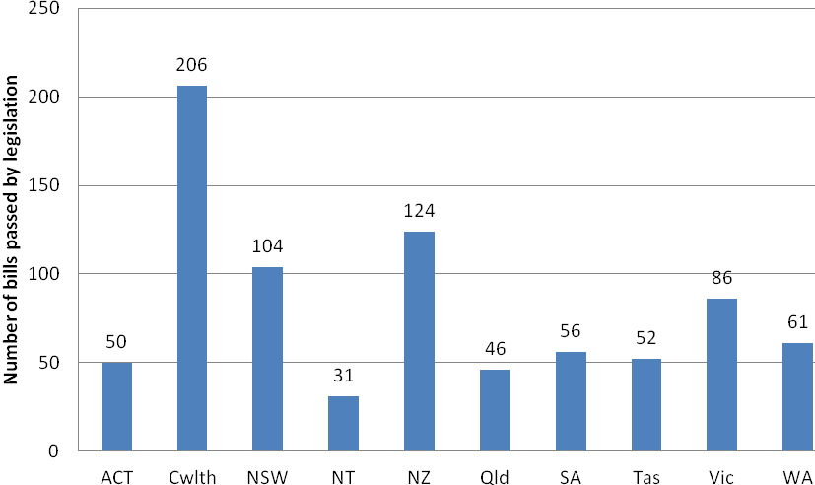

In terms of scrutiny and the most questions asked in a legislature, in Sir Humphrey’s eyes the healthiest legislature would be New Zealand as shown by the following table:

#### Table 2: Questions without notice asked in 2012 (unless otherwise specified)

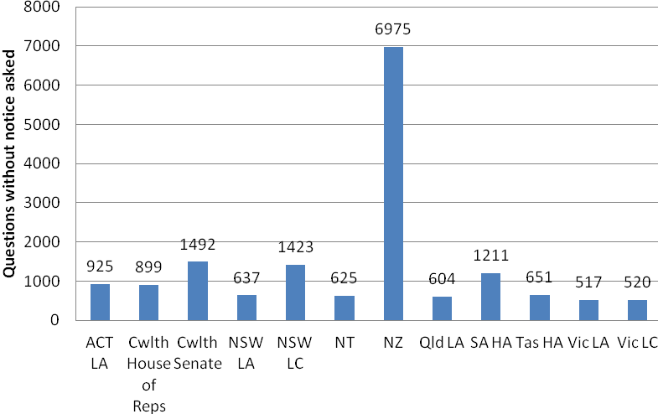

## Proposed 10 measures for parliaments

I believe that there are better measures than just the number of laws passed or questions asked that indicate whether a parliament is healthy or not. The Commonwealth Parliamentary Association /World Bank Institute/United Nations Development Program (CPA/WBI/UNDP) has 87 benchmarks (and you will see I have used some of these), but in the 24/7 news cycle, I doubt whether the achievement against these will rate a mention. Condensing these down to just 10 key measures which best represent to the public the value of parliaments in assisting democratic process is not easy. Such measures would need, in my opinion, to highlight the degree to which the legislature was not being dominated by the executive, there were procedures (through standing orders) to protect minority viewpoints, that the legislative process was being utilised to the fullest extent to provide for the rule of law in the society which is being governed, and effective scrutiny of the executive. So the 10 measures in the categories of legislating, scrutiny and representation that I would choose are as follows:

### Legislation

##### Time taken for Bills to be considered by the Legislature

###### Healthy Parliament

* The legislature provides adequate opportunity for legislators to debate bills prior to a vote[4][4]
* Very few if any closure/guillotine motions that curtail debate on legislation
* Opportunities are given for public input into the legislative process*[5][5]*

###### Unhealthy Parliament

* A high number of bills are introduced and passed on the same day with little or no debate

##### Percentage of Bills considered by committees

Healthy Parliament

* There is a presumption that the legislature will refer legislation to a committee, and any exemption must be transparent, narrowly defined, and extraordinary in nature*[6][6]*
* Committees have adequate time to consider legislation, seek public input and make recommendations which are considered by the legislature

Unhealthy Parliament

* No bills, or very few, are referred to committees.
* Bills are referred to committees, but the time allowed leaves little or no time for a thorough consideration and full inquiry by the committee.

### Scrutiny

##### Percentage of bills passed or introduced by non-executive members

Healthy Parliament

* Although most of the bills agreed to by the legislature are ones that have been introduced by the executive, some bills passed have been introduced by non-executive members.
* If non-government bills are passed it emphasises the independent nature of the legislature and helps to ensure that it is not seen as just rubber-stamping executive bills

Unhealthy Parliament

* The only bills that gain passage are those of the executive and no non-government bills are passed or even considered

##### Number of non-government amendments agreed to

Healthy Parliament

* The legislature considers all amendments on their merit those considered to enhance the legislation are passed regardless of whether they are moved by a government or non-government member
* Legislators in the lower or single House have the right to initiate legislation and to offer amendments to proposed legislation*[7][7]*
* Recommendations made by scrutiny of bills or other committees are considered, debated, and if considered worthy, agreed to

Unhealthy Parliament

* An amendment is agreed to only if moved by a Minister
* Recommendations from scrutiny of bills or other committees are never or rarely agreed to or receive little or no consideration

##### Percentage of questions on notice answered in a timely manner

Healthy Parliament

* Almost all questions on notice are answered within the required time
* Only a very few answers contain the words along the line of ‘there are insufficient resources available to answer the Members question’
* The Legislature has mechanisms to obtain information from the executive branch sufficient to exercise its oversight function in a meaningful way*[8][8]*

Unhealthy Parliament

* No questions on notice are answered within the required timeframe
* Questions are answered, but significantly later than when the question is asked, and don’t really address the question

##### Percentage of government responses to committee reports received in a timely manner

Healthy Parliament

* Government responds to all committee reports within a reasonable time frame (e.g. three months) and the legislature has mechanisms to deal with a lack of a response
* Where governments don’t agree with recommendations, adequate explanations are given

Unhealthy Parliament

* Government doesn’t respond to committee reports, or to only a very few
* Government responds to committee reports, but instead of agreeing or not agreeing to recommendations, the response is that the recommendations are ‘noted’ without a reasonable explanation given

##### Opportunities for the Executive to be asked a number of questions without notice

Healthy Parliament

* There is an opportunity to scrutinise the Executive by asking questions without notice
* There is sufficient time for a large number of questions to be asked of Ministers
* during the questions without notice period by Non-Government Members
* Ministers are asked, on average, at least 1 question per sitting week

Unhealthy Parliament

* The time for questions without notice and the number of questions allowed are small in number, resulting in many Ministers never being asked a question without notice by a non-government Member

#### Table 3: Average number of questions without notice asked of a Minister per year

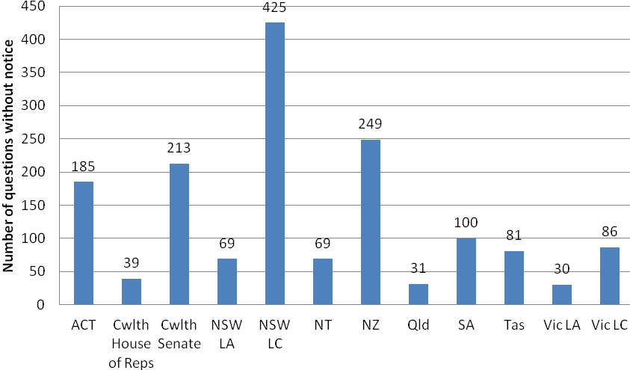

##### Parliamentary sitting time devoted to non-government business

Healthy Parliament

* There is sufficient time and opportunity for Members to raise matters, move motions and introduce and debate legislation

Unhealthy Parliament

* There is little sitting time devoted to non-government business, and there is thus little opportunity for Members to raise matters of concern

##### The number of non-government chairs of parliamentary committees and the level of autonomy of committees

Healthy Parliament

* Oversight committees provide meaningful opportunities for minority or opposition parties to engage in effective oversight of government expenditures. Typically the Public Accounts committee will be chaired by a Member of the opposition party*[9][9]*.
* Committees can self-refer inquiries (within their terms of reference) without approval of the executive or there are adequate opportunities for Chairs/Members to propose motions of referral in the plenum

Unhealthy Parliament

* There are no non-government committee chairs
* The only inquiries committees can undertake must first be approved by the executive

##### Representation/Accessibility

The legislature has a large number of interactions with constituents, including witnesses/submissions to committee inquires and Members following up on constituents representation.

Healthy Parliament

* Parliamentary committees get significant involvement in inquiries from community groups/constituents
* Members follow up constituents concerns and make themselves accessible

Unhealthy Parliament

* Committees do not advertise inquiries and hardly interact with the community
* Members do not make themselves available to see constituents to hear their concerns

**Conclusion**

No doubt there will be discussion on whether there is value in reducing the value of a legislature’s work to 10 measures. In proposing a new methodology for assessing parliamentary performance I again turn to Osbourne’s *Of the People by the People – a new history of democracy* which cautions:

‘...yet when we try to pin down exactly what democracy is, we find ourselves chasing rainbows. The problem is that every time we get near to a definition, or compile a list of conditions that only democracy must fulfil, we find examples of fully functioning democracies that do not comply, or of societies that are not regarded as democratic but never the less fulfil some of the criteria’ [10][10]

Is the ‘10 measures for a healthy parliament’ methodology I propose nothing more than chasing a rainbow? I don’t think so.

To complement the reams of authoritative and factual information we all publish in words, sounds and pictures, let us look in the era of 24/7 to new ways to capture the people’s attention. And, just to show that I’ve got skin in the game (to use well known sporting and political terminology) I’ve put these 10 measures to the test against my own legislature – the ACT Legislative Assembly – and this is what it looks like.

1. [1] R. Osborne, *Of the people by the people – A new history of democracy*, Random House, London, 2012, p 1.
2. [2] L.F Crisp, *Australian National government*, 4th edn, Longman Chesire, Melbourne, 1978, p 250
3. [3] Martin Rawlinson, ‘The House of Representatives’ in R Lucy (ed), *The Pieces of Politics*, Macmillan, Melbourne, 1975, p 379
4. [4] (CPA/WBI/UNDP Recommended Benchmarks for Democratic Legislators, December 2006, para 2.5.2
5. [5] Ibid, paragraph 6.3.1
6. [6] Ibid, paragraph 3.2.1
7. [7] CPA/WBI/UNDP, para 2.4.2
8. [8] CPA/WBI/UNDP, para 7.1.1
9. [9] CPA/WBI/UNDP, op cit, para 7.2.2
10. [10] R.Osbourne, op cit, page 2