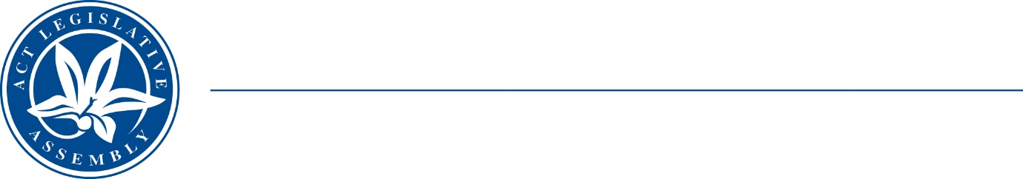
Standing Committee on Public Accounts
Mrs Elizabeth Kikkert MLA (Chair), Mr Michael Pettersson MLA (Deputy Chair),
Mr Andrew Braddock MLA

LEGISLATIVE ASSEMBLY
FOR THE AUSTRALIAN CAPITAL TERRITORY

TERMS OF REFERENCE

Inquiry into responses to Auditor-General Performance Reports January – June 2023
The Standing Committee on Public Accounts will inquire into and report on matters relating to the Government response to performance audit recommendations made in Auditor-General report:
- No 1/2023 – Construction Occupations Licensing;
- No 2/2023 – Management of Operation Reboot (Outpatients);
- No 3/2023 – Financial Management Services for Protected Persons;
- No 4/2023 – Procurement of a Hybrid Electric Fire Truck; and
- any other related matter.

