Standing Committee on Planning, Transport and City Services

Inquiry into Giralang Shops — Final Report

About the committee

Establishing resolution
The Assembly established the Standing Committee on Planning, Transport and City Services on 2 December 2020.

- City Renewal Authority
- Suburban Land Agency
- Planning and land management (excluding parks and conservation)
- Transport
- City services including waste and recycling
- Housing (excluding service provision)
- Building and construction
You can read the full establishing resolution here.

Committee members
Ms Jo Clay MLA, Chair
Ms Suzanne Orr MLA, Deputy Chair
Mr Mark Parton MLA

Secretariat
Ms Miona Ikeda, Acting Committee Secretary
Ms Kate Mickelson, Assistant Secretary (Acting Committee Secretary until 21 November 2022)
Mr Adam Walker, Assistant Secretary
Ms Lydia Chung, Administrative Assistant

Contact us
Mail Standing Committee on Planning, Transport and City Services
Legislative Assembly for the Australian Capital Territory
GPO Box 1020
CANBERRA ACT 2601
Phone (02) 6205 0199
Email LACommitteePTCS@parliament.act.gov.au
Website parliament.act.gov.au/parliamentary-business/in-committees

About this inquiry
Petition 4–21—Giralang Shops was presented to the Assembly on 10 February 2021. It was then referred to the Standing Committee on Planning, Transport and City Services (the Committee) for consideration under Standing Order 99A. This is because the petition had at least 500 signatures.
The Committee agreed on 3 March 2021 to inquire into the petition and seek on behalf of the Giralang community an update from the developer on the progression of the Giralang Shops development.
An interim report was published on 14 December 2021 and tabled in the Assembly on 8 February 2022. The Government response to the interim report was tabled in the Assembly on 7 April 2022. This report will be the final report for the Inquiry into Giralang Shops.

Contents
About the committee i
Establishing resolution i
Committee members i
Secretariat i
Contact us i
About this inquiry ii
Acronyms iv
Findings and Recommendations v
1. Introduction 1
Background 1
Conduct of the inquiry 2
2. Interim Report 3
3. Final Report 4
New developer for Giralang Shops 4
4. Conclusion 7
Appendix A: Submissions 8
Appendix B: Witnesses 11
Thursday, 27 May 2021 11
Thursday, 17 June 2021 11
Thursday, 1 July 2021 11
Appendix C: Questions Taken on Notice 12
Appendix D: Giralang Shops Information Notice 13

Acronyms
Acronym | Long form
ACT | Australian Capital Territory
AO | Officer of the Order of Australia
CMTEDD | Chief Minister, Treasury and Economic Development Directorate
DA | Development Application
EPSDD | Environment, Planning and Sustainable Development Directorate
GFA | Gross Floor Area
IGA | Independent Grocers of Australia
MLA | Member of the Legislative Assembly

Findings and Recommendations
Finding 1
The Committee notes that the barriers to development outlined by the former developer, Giralang Property Group, have not proven significant for the new developer who has been able to resolve these barriers within 6 months of taking ownership of the site.
Recommendation 1
The Committee recommends that the ACT Government work with the new developer, TP Dynamics, to make sure the project and the community commitments are delivered as soon as practicable.
Recommendation 2
The Committee recommends that the new developer, TP Dynamics, continue their proactive and regular updates to the Giralang Community as the construction of the development and associated community works progresses.

Introduction

Background
  - On 10 February 2021, Petition 4–21—Giralang Shops was tabled in the Assembly. The petition was sponsored by Ms Suzanne Orr MLA, signed by 584 residents and sought an update on the progress of the Giralang Shops development.
  - The full terms of Petition 4-21 were:
The residents and supporters of Giralang note that:
- the local shops in Giralang have sat unused and in a state of semi-development for 15 years;
- progress has been made with the developer settling the legal action against them and gaining approval for a Development Application;
- over the last 12 months however progress to build the shops has stalled with no supermarket secured and the development taken off the sales market;
- the developer, who is ultimately responsible under the lease for progressing the shops, has provided only one clear update to the community in this time, which provided no clear indication of what happens next.
As such, the residents of Giralang hereby petition the ACT Legislative Assembly to:
- seek a full update from the developer on any progress and when we can see action on delivering our shops.
  - The petition was referred to the Standing Committee on Planning, Transport and City Services under Standing Order 99A. On 3 March 2021, the Committee resolved to inquire into and report on Petition 4-21. The Committee advised the Assembly of this decision though a statement under Standing Order 246A in the Assembly on 30 March 2021.

Conduct of the inquiry
  - The Committee issued a call for submissions on 12 March 2021, which initially closed on 8 April 2021, and later extended to 14 May 2021. A total of 69 submissions was received by the Committee. A list of all submissions is provided at Appendix A.
  - The Committee held three public hearings, on 27 May 2021, 17 June 2021, and 1 July 2021, and heard from a total of 14 witnesses. A list of witnesses who appeared before the Committee is provided at Appendix B. The transcripts of proceedings are accessible at https://www.hansard.act.gov.au/Hansard/10th-assembly/committee-transcripts.htm.
  - During the public hearings, 13 questions were taken on notice. These questions are listed at Appendix C.
  - An interim report was published on 14 December 2021 and tabled in the Assembly on 8 February 2022. The Government response to the interim report was tabled in the Assembly on 7 April 2022.

Interim Report
  - An interim report was published on 14 December 2021 and tabled in the Assembly on 8 February 2022.
  - The interim report made 13 recommendations in relation to the crown lease of the site, developing a Memorandum of Understanding between the property developer (Giralang Property Group) and ACT Government, and site maintenance and public realm improvements.
  - The Committee also made six findings, including calling for greater transparency and accountability from all parties and for the ACT Government to take a more active role in helping to resolve the issues holding up the development.
  - The Government response to the interim report was tabled in the Assembly on 7 April 2022. In the Government response, the ACT Government stated that:
The ACT Government’s priority for the Giralang Shops is to obtain the best outcome for the community with the greatest amount of certainty over what is to be delivered on the site (Giralang Section 79 Blocks 6 and 3, and Section 80 Block 4).
The ACT Government heard during the inquiry about the difficulties that the limited supermarket size created in the delivery of the Giralang Shops and introduced a draft Territory Plan Variation to address the issue. Territory Plan Variation 381 (V381) was approved and tabled in the Assembly on 22 March 2022. V381 increases the maximum gross floor area (GFA) for shops in local centres from 1000m² to 1500m² by amending the Commercial Zones Development Code.
The ACT Government understands and shares community concern at the lack of development at the site and hopes to see the current development approval acted upon and associated tenancies occupied in the near future.

Final Report

New developer for Giralang Shops
  - In early October 2022, it was publicly announced that TP Dynamics had purchased the development from Giralang Property Group and were planning to open a new shopping centre by mid-2024, with construction set to begin in November 2022.
  - TP Dynamics indicated that they would be commencing construction of the site in accordance with the Development Application that was approved by the Minister for Planning and Land Management in 2017, for a mixed-use development including commercial and residential.
  - On 2 November 2022, the Committee wrote to TP Dynamics to request documents to assist the Committee with the Inquiry into Giralang Shops. On 3 December 2022, the Committee received a response from TP Dynamics which outlined key developments, such as:
- TP Dynamics has secured the project from Giralang Property Group and made a public announcement on 7 October 2022 in relation to the ‘G+’ project.
- TP Dynamics has confirmed that the building approval has been received and is in line with the current approved development application (DA) and that construction has commenced on site.
  - The development consists of a 1,000m² supermarket and supporting retail spaces, as well as 50 apartments (1, 2, 3-bedroom types) with underground parking for commercial tenancies, residents, and visitors. TP Dynamics are currently talking to some potential supermarket operators.
- TP Dynamics has commenced and is providing regular project updates to the public and relevant neighbourhood groups through initial meetings held with the Giralang Primary School, Giralang Residents Action Group, and Ms Suzanne Orr MLA.
  - TP Dynamics has distributed a project update and information sheet by way of a letter drop to all neighbouring residents within 500 metres of the site (see Appendix D). TP Dynamics has also set up a website (see https://gplus.tpdynamics.com.au/) to provide updates on the project.
- TP Dynamics has set the expected construction completion date for mid-2024; however, TP Dynamics are trying to deliver the project sooner, if possible.
  - On 6 March 2023, it was publicly announced that TP Dynamics has secured a supermarket tenant (IGA) for the Giralang Shops.
  - The supermarket will be one of seven commercial tenants to occupy the ground-floor retail area, due to be open in early 2024.

Committee comment
  - The Committee initiated this inquiry in order to ‘seek on behalf of the Giralang Community an update from the developer on the progression of the Giralang Shops Development.’ The Committee held public hearings and engaged in correspondence with the previous developer which resulted in the update for the community given in the interim report.
  - The interim report was issued in the context of the developer, Giralang Property Group, continuing with the development and based on the evidence that they could not provide a firm timeline for how the development would progress or a supermarket would be secured.
  - The intention of the recommendations was to create greater accountability of the developer, Giralang Property Group, as well as creating a process by which the community could be kept well informed, so they did not have to resort to petitioning for an update in the future.
  - The Committee notes that following the sale of the site from Giralang Property Group to TP Dynamics and the subsequent commencement of construction and securing of a supermarket, the broader issue now appears to be resolved with the result that the shopping centre will be developed, and the community will get a supermarket and other community facilities.
  - The Committee notes that neither the Committee nor the ACT Government had a part in the choice to sell the site. That decision was purely at the discretion of the former owner of the site, Giralang Property Group.
  - The Committee further notes that the challenges and impediments put forward by the previous developer, Giralang Property Group, have not been a barrier for the new developer of the site, who within 6 months of taking ownership of the site has commenced construction and secured a supermarket tenant.
  - The Committee further notes the supermarket will be 1,000 square metres, a capped floor space limit that the former developer claimed was a major barrier to overcome.
Finding
The Committee notes that the barriers to development outlined by the former developer, Giralang Property Group, have not proven significant for the new developer who has been able to resolve these barriers within 6 months of taking ownership of the site.
  - The Committee is glad that the development is now underway and welcomes this new chapter for the residents of Giralang which will see a shopping centre returned to the suburb without any further delays.
  - The Committee acknowledges the residents of Giralang have, over many years, actively campaigned to keep a focus on this matter and to ensure a supermarket be returned to their suburb. Such campaigning has taken the form of residents groups, community meetings, and petitions, including the one that lead to this inquiry.
  - The Committee notes that through this inquiry the voices of the community were able to be heard by the Legislative Assembly and its Members and the former developer, Giralang Property Group, and it would appear their call for action has in one way or another been heard.
  - The Committee considers that the ongoing progress at the Giralang Shops has resolved the issues raised in Petition 4-21—Giralang Shops, and that the concerns raised in the Committee’s interim report have been addressed through the outcomes achieved thus far.
  - Therefore, in order to achieve the best outcome for all parties and stakeholders involved, the Committee is of the view that the ACT Government should continue to liaise with TP Dynamics to ensure the Giralang Shops ‘G+’ project and the associated community commitments such as the reconfiguration and improvement of the school drop-off zone on Atalumba Close, bicycle storage shelter, new parking and increased access to the Giralang Nature Playground on Menkar Close, and increased pedestrian accessibility to the shopping centre from Canopus Crescent, are delivered as soon as practicable.
Recommendation 1
The Committee recommends that the ACT Government work with the new developer, TP Dynamics, to make sure the project and the community commitments are delivered as soon as practicable.
  - The Committee is pleased to see TP Dynamics actively engaging with the Giralang Community through their provision of information to the community. The Committee is of the view that TP Dynamics should continue their proactive and regular updates to the Giralang Community, to ensure that the community is kept up to date as the construction of the development and associated community works progresses over 2023 and into early 2024.
Recommendation 2
The Committee recommends that the new developer, TP Dynamics, continue their proactive and regular updates to the Giralang Community as the construction of the development and associated community works progresses.

Conclusion
  - The Committee wishes to extend its appreciation to all those who have participated in this inquiry into Giralang Shops. The Committee appreciates the patience of the petitioners and the Giralang community throughout this lengthy inquiry, and is pleased that the desired outcome has come to fruition.
  - The Committee makes 1 finding and 2 recommendations in this final report.
Ms Jo Clay MLA
Chair
16 March 2023

Appendix A: Submissions
No. | Submission by | Received | Published
1 | Dr Jenny Thomson | 15/03/21 | 18/03/21
2 | Dr Nick Thomson | 15/03/21 | 18/03/21
3 | Ms Simone Hijazi | 18/03/21 | 25/03/21
4 | Ms Carly Fiumara | 19/03/21 | 25/03/21
5 | Ms Giselle Cruzado | 19/03/21 | 25/03/21
6 | Mr Ken Matthews AO | 19/03/21 | 25/03/21
7 | Ms Sarah Crooks | 20/03/21 | 25/03/21
8 | Mr David Ball | 20/03/21 | 25/03/21
9 | Ms Catherine Vaughn Turnbull | 22/03/21 | 25/03/21
10 | Mr Shane Turnbull | 23/03/21 | 25/03/21
11 | Ms Briana Lloyd | 23/03/21 | 01/04/21
12 | Mr Robert Kyle | 24/03/21 | 01/04/21
13 | Mr James Forwood | 24/03/21 | 01/04/21
14 | Ms Anne Gibson | 24/03/21 | 01/04/21
15 | Mr Michael Stachow | 24/03/21 | 01/04/21
16 | Mr Shaun Masters | 24/03/21 | 01/04/21
17 | Ms Phaedra Eayrs | 24/03/21 | 01/04/21
18 | Ms Margaret Matthews | 24/03/21 | 01/04/21
19 | Mr Brett Goyne | 31/03/21 | 01/04/21
20 | Mr Austin Kenney | 31/03/21 | 01/04/21
21 | Mr Phil Rabl | 01/04/21 | 01/04/21
22 | Mr Joe Hedger and Ms Louise Taylor | 01/04/21 | 08/04/21
23 | Mr Sean Minney | 01/04/21 | 08/04/21
24 | Ms Veneta Amies | 02/04/21 | 08/04/21
25 | Ms Penny Costello | 02/04/21 | 08/04/21
26 | Mr Greg Curr | 03/04/21 | 08/04/21
27 | Ms Jane Harms | 04/04/21 | 08/04/21
28 | Confidential | 04/04/21
29 | Ms Jenny Millea | 04/04/21 | 08/04/21
30 | Mr Aidan Heerdegen and Ms Janelle Kennard | 05/04/21 | 08/04/21
31 | Ms Lesley Irvine | 06/04/21 | 08/04/21
32 | Mr Owen Ferris | 06/04/21 | 08/04/21
33 | Mr Richard Mathe | 06/04/21 | 08/04/21
34 | Ms Courtney Hayden | 06/04/21 | 08/04/21
35 | Mrs Patrice and Mr John Simmons | 06/04/21 | 08/04/21
36 | Ms Roz Chivers | 06/04/21 | 08/04/21
37 | Ms Maxine Berryman | 06/04/21 | 08/04/21
38 | Mr Sean Macintyre | 06/04/21 | 08/04/21
39 | Ms Denise Kay | 07/04/21 | 08/04/21
40 | Ms Eve Wisowaty | 07/04/21 | 08/04/21
41 | Ms Kathy Dunn | 07/04/21 | 08/04/21
42 | Ms Nichola Aitken | 07/04/21 | 08/04/21
43 | Ms Amy Pepper | 07/04/21 | 08/04/21
44 | Mr Murray Brown | 07/04/21 | 08/04/21
45 | Ms Helen Gladman | 07/04/21 | 08/04/21
46 | Mr William Burmester | 07/04/21 | 08/04/21
47 | Mr Christopher Dennis | 07/04/21 | 08/04/21
48 | Mr Craig Windross | 07/04/21 | 06/05/21
49 | Mr Greg & Mrs Lee Hollands | 07/04/21 | 06/05/21
50 | Ms Claire Reynolds | 07/04/21 | 06/05/21
51 | Dr Katie Ryan Calvert | 07/04/21 | 06/05/21
52 | Ms Briony MacGregor | 07/04/21 | 06/05/21
53 | Ms Megan Mackenzie-Davies | 07/04/21 | 06/05/21
54 | Ms Julie Brandon | 08/04/21 | 06/05/21
55 | Ms Anne Grant | 08/04/21 | 06/05/21
56 | Ms Felicity Goyne | 08/04/21 | 06/05/21
57 | Mr Paul Calvert | 08/04/21 | 06/05/21
58 | Ms Elly Mackay | 08/04/21 | 06/05/21
59 | Ms Kelly Baseler | 08/04/21 | 06/05/21
60 | Dr Chris Aulich | 08/04/21 | 06/05/21
61 | Mr Chad Swanson | 08/04/21 | 06/05/21
62 | Ms Kathryn Dan | 08/04/21 | 06/05/21
63 | Mr Ross Calvert | 12/04/21 | 06/05/21
64 | Mr David Pollard | 08/04/21 | 06/05/21
65 | Ms Lee-Ann Swift | 08/04/21 | 06/05/21
66 | Mr Scott Bamford | 12/04/21 | 06/05/21
67 | Ms Domenica O'Dea | 12/04/21 | 06/05/21
68 | Associate Professor Tanya Jakimow | 10/05/21 | 17/06/21
69 | Ms Amber Noble | 11/05/21 | 17/06/21

Appendix B: Witnesses

Thursday, 27 May 2021
Mr Dimitri Nikias, Director, Nikias Diamond
Mr Pieter Van Der Walt, Director, Canberra Town Planning

Thursday, 17 June 2021
Mr Mick Gentleman MLA, Minister for Planning and Land Management
Mr Ben Ponton, Director-General, EPSDD
Mr George Cilliers, Executive Branch Manager, Statutory Planning, EPSDD
Mr Nick Lhuede, Acting Executive Branch Manager, Building and Construction, Access Canberra, CMTEDD

Thursday, 1 July 2021
Dr Chris Aulich
Mr Bill Burmester
Mr Paul Calvert
Ms Anne Gibson
Ms Anne Grant
Mr Chad Swanson
Dr Nick Thomson
Mr Shane Turnbull

Appendix C: Questions Taken on Notice
No. | Date | Asked of | Subject | Response received
1 | 27/05/2021 | Mr Dimitri Nikias, Director, Nikias Diamond | Deed of settlement | 04/06/2021
2 | 27/05/2021 | Mr Dimitri Nikias, Director, Nikias Diamond | EPSDD approval for extension to DA date of commencement | 04/06/2021
3 | 27/05/2021 | Mr Dimitri Nikias, Director, Nikias Diamond | Rates | 04/06/2021
4 | 27/05/2021 | Mr Dimitri Nikias, Director, Nikias Diamond | Completion date for development | 04/06/2021
5 | 27/05/2021 | Mr Dimitri Nikias, Director, Nikias Diamond | Site ownership | 04/06/2021
6 | 17/06/2021 | Minister for Planning and Land Management | Lease terminations | 30/06/2021
7 | 17/06/2021 | Minister for Planning and Land Management | DA Extensions | 30/06/2021
8 | 17/06/2021 | Minister for Planning and Land Management | Extension criteria | 30/06/2021
9 | 17/06/2021 | Minister for Planning and Land Management | Controlled activity complaints | 30/06/2021
10 | 17/06/2021 | Minister for Planning and Land Management | Site history—Controlled activity complaints | 30/06/2021
11 | 17/06/2021 | Minister for Planning and Land Management | Notice of decision and conditions | 30/06/2021
12 | 17/06/2021 | Minister for Planning and Land Management | Work Health and Safety inspections on site | 30/06/2021
13 | 17/06/2021 | Minister for Planning and Land Management | Shopping centre refurbishment program | 30/06/2021

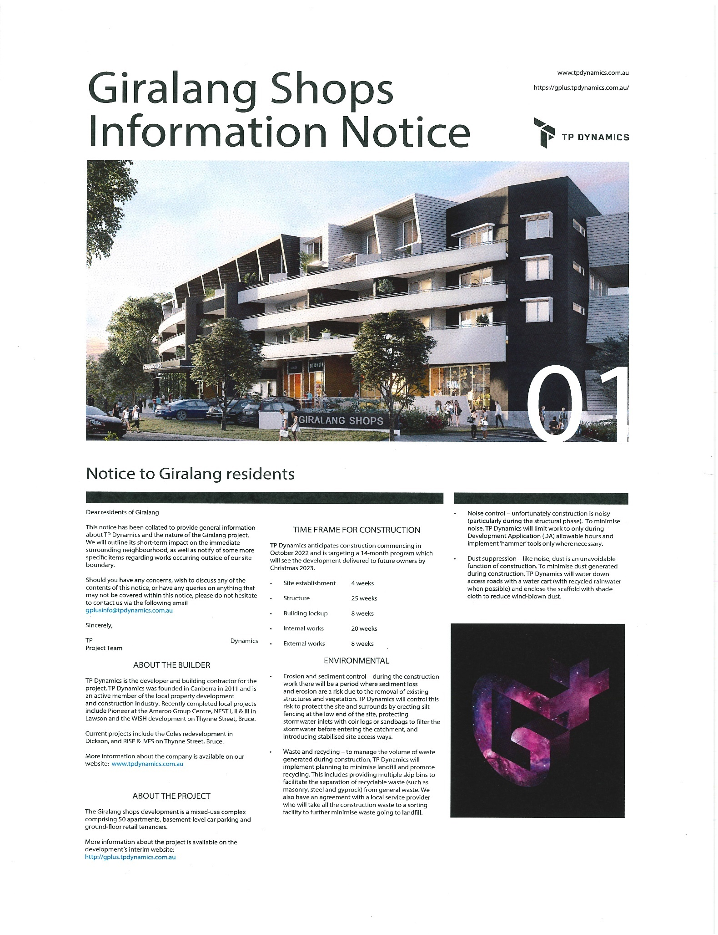
Appendix D: Giralang Shops Information Notice
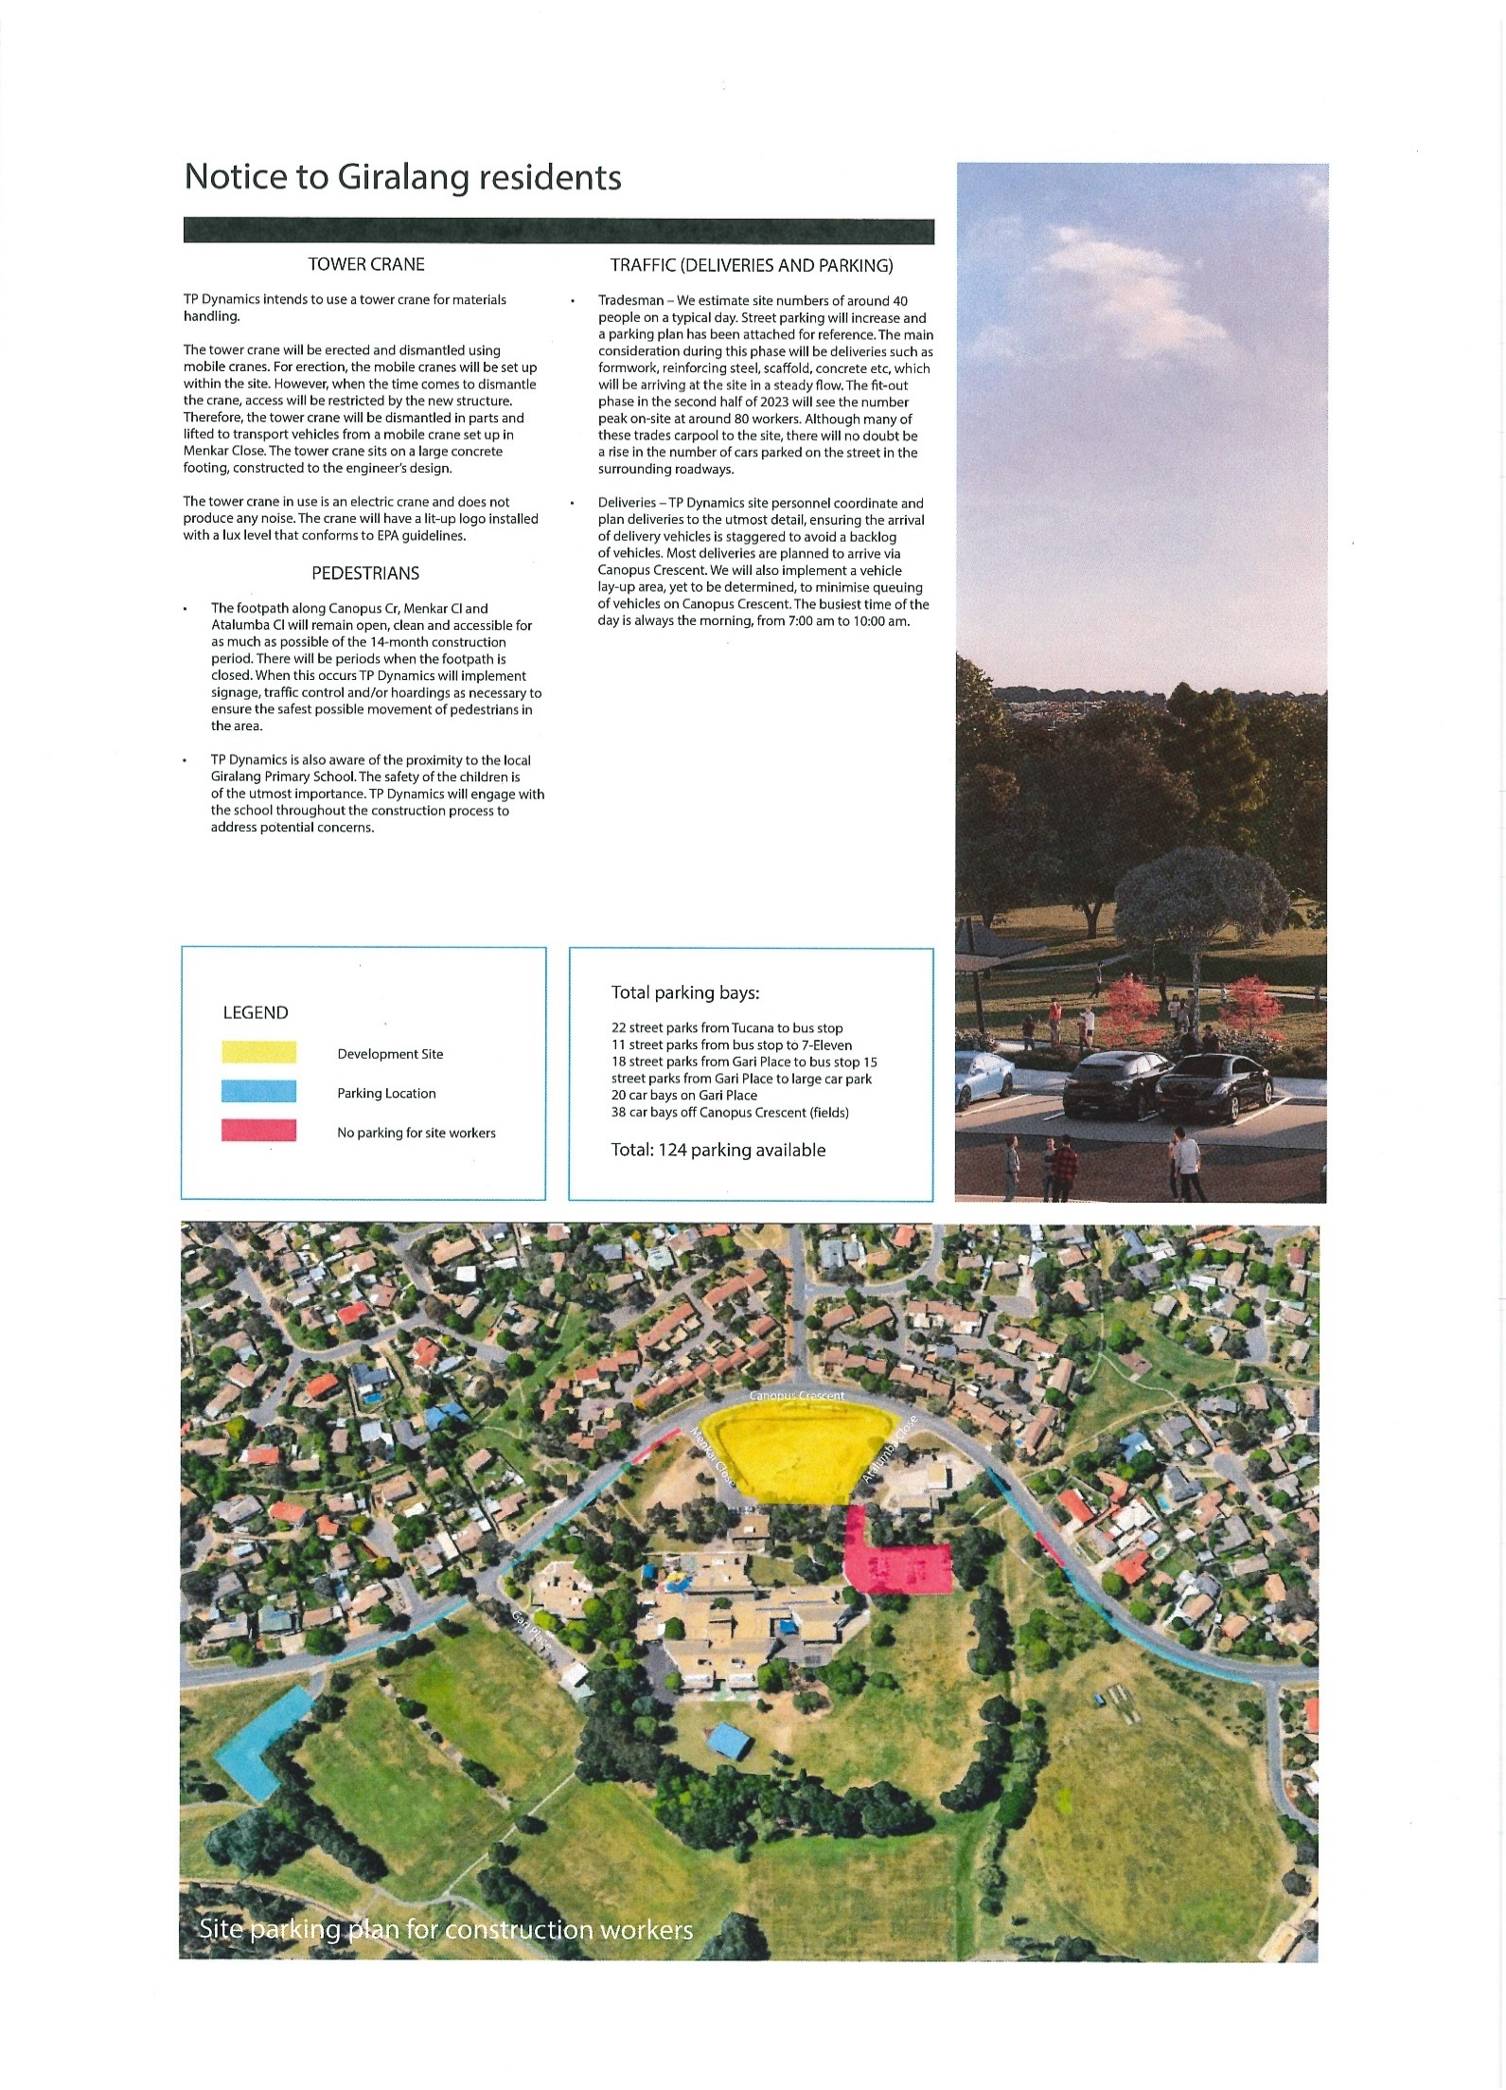

Petition 4-21, Petition 4-21—Giralang Shops, https://epetitions.parliament.act.gov.au/details/004-21 (accessed 9 March 2023).
ACT Legislative Assembly, Minutes of Proceedings, No 5, 10 February 2021, p 57.
ACT Legislative Assembly, Minutes of Proceedings, No 37, 8 February 2022, p 468.
ACT Legislative Assembly, Minutes of Proceedings, No 45, 7 April 2022, p 591.
ACT Legislative Assembly, Minutes of Proceedings, No 5, 10 February 2021, p 57.
Petition 4-21, Petition 4-21—Giralang Shops, https://epetitions.parliament.act.gov.au/details/004-21 (accessed 9 March 2023).
ACT Legislative Assembly, Minutes of Proceedings, No 7, 30 March 2021, p 88.
ACT Legislative Assembly, Minutes of Proceedings, No 37, 8 February 2022, p 468.
ACT Legislative Assembly, Minutes of Proceedings, No 45, 7 April 2022, p 591.
ACT Legislative Assembly, Minutes of Proceedings, No 37, 8 February 2022, p 468.
ACT Legislative Assembly, Minutes of Proceedings, No 45, 7 April 2022, p 591.
ACT Government, ACT Government Response to the Standing Committee on Planning, Transport and City Services Interim Report 08 – Inquiry into Giralang Shops, April 2022, p 3.
Hannah Neale, ‘TP Dynamics buys Giralang shops site on Canopus Crescent from Giralang Property Group, plan to begin construction in November’, The Canberra Times, 7 October 2022, https://www.canberratimes.com.au/story/7933539/new-owners-to-begin-construction-at-embattled-giralang-shops-site/?cs=14227 (accessed 11 October 2022).
Brittney Levison, ‘IGA confirmed to open at Giralang shops as construction gets underway’, The Canberra Times, 6 March 2023, https://www.canberratimes.com.au/story/8109592/supermarket-operator-confirmed-for-giralang-shops/ (accessed 7 March 2023).
Genevieve Jacobs, ‘IGA will be supermarket tenant at Giralang Shops after 17 year wait for action’, The RiotACT, 6 March 2023, https://the-riotact.com/iga-will-be-supermarket-tenant-at-giralang-shops-after-17-year-wait-for-action/641367 (accessed 7 March 2023).
See, for example, Petition 003-15; Petition 007-15; Petition 012-17; Petition 001-21; Petition 004-21.

