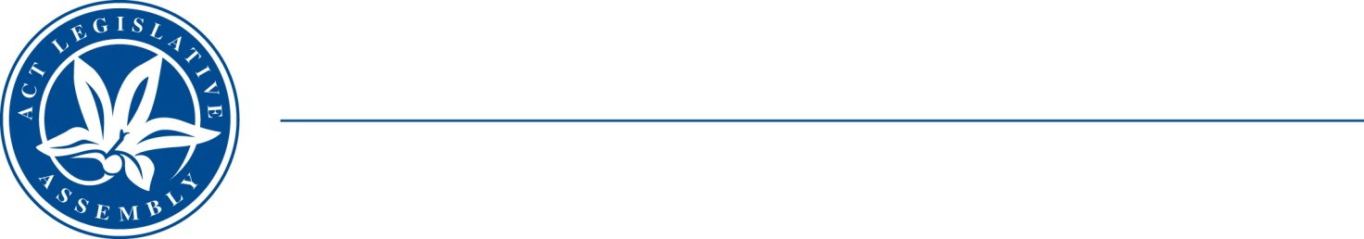
QoN No. 10
Committee Support
LEGISLATIVE ASSEMBLY
FOR THE AUSTRALIAN CAPITAL TERRITORY
Standing Committee on Education and Community Inclusion

Inquiry into Annual and Financial Reports 2021-2022

ANSWER TO QUESTION ON NOTICE

Asked by Elizabeth Kikkert MLA: To ask the Minister for Education and Youth Affairs:

Reference: Youth Affairs, CSD Annual Report 2022, p. 53

In relation to: ACT Youth Week

- How many of the 175 young people who visited the National Zoo and Aquarium were engaged with the CREATE program?
- How many of them were engaged with the Multicultural HUB (or another program targeting CALD young people)?
- What other members of ACT Youth Services had young people who participated in this event?
- How much did this visit to the zoo cost the government?
- Are there plans to repeat this event (or a similar one) for next year’s Youth Week?

Minister Berry: The answer to the Member’s question is as follows:–

- A total of 25 young people from the CREATE Program attend the National Zoo and Aquarium during Youth Week 2022.

- A total of 25 young people from the Multicultural HUB attend the National Zoo and Aquarium during Youth Week 2022.

- Tickets to ticketed events were distributed through the ACT Youth Services Program within the Community Services Directorate (CSD), with the remaining tickets offered to young people aged 12 to 25 who access ACT community services. The following services were offered tickets the event and accepted:
- CREATE
- Carers ACT-Young carers
- Multicultural Youth Service
- Gugan Gulwan Aboriginal Youth Centre
- Diversity ACT
- St Vincent De Paul- Youth Program VINES
- YWCA
- Menslink

The following services were offered tickets to the event and declined due to holiday program commitments:

- Anglicare ACT
- PCYC
- Woden Community Service
- Capital Regional services
- Northside Community Services

- National Zoo and Aquarium offered a discount student rate $15.00 per person. The total cost of the National Zoo and Aquarium Youth Week Event was $2,625.00.

- To celebrate young Canberrans during Youth Week the ACT Government partners with various entertainment and recreational businesses across the ACT to deliver large scale free events for young people. Funding of $10,000 is available to facilitate events, and the National Zoo and Aquarium will be considered as one of the event locations for 2023.

ACT Youth Week is a ten-day celebration of young people in our community aged 12-25 years old. 2022 ACT Youth Week will be held from 14 April 2023 to 24 April 2023.

Approved for circulation to the Standing Committee on Education and Community Inclusion

Signature: Date:

By the Minister for Education and Youth Affairs, Yvette Berry MLA

