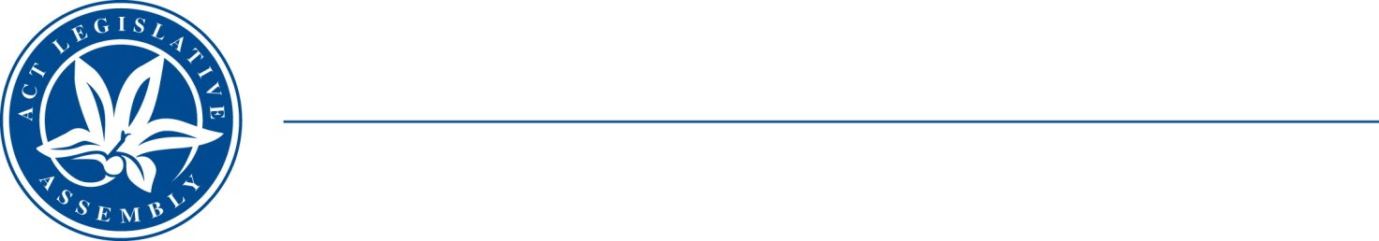
QoN No. 29
Committee Support
LEGISLATIVE ASSEMBLY
FOR THE AUSTRALIAN CAPITAL TERRITORY
Standing Committee on Health and Community Wellbeing

Inquiry into Annual and Financial Reports 2021-2022

ANSWER TO QUESTION ON NOTICE

Asked by MS LEANNE CASTLEY MLA:

Reference: Hearing on 1 November 2022, Annual Report of CHS

In relation to: CHS Annual report 2021-22, Page 151

Page 151 of the CHS annual report displays targets for Walk-In-Centres.

The ACT Health Quarterly Performance report for Quarter 4 2021-22 says that 80.5% of presentations received treatment at the walk-in centres and 7.1% were redirected to ED.

- What group did the remaining 12.4% belong to? Did these patients leave or get discharged without receiving treatment?
- If yes, why?
- If not, what care did the remaining 12.4% receive?
- For each walk-in centre, how many patients left without being treated or referred to ED?
- Is there any work or investigation into why 12.4% are not receiving treatment or being referred to ED?
- If so, what work and what have you discovered?

MINISTER STEPHEN-SMITH MLA: The answer to the Member’s question is as follows: –
- Of the 12.4 per cent, 6.3 per cent were redirected to a General Practitioner, 1.7 per cent to an imaging service and 3.3 per cent did not wait for treatment. The clinical records for the remaining presentations do not provide information to allow for redirection data to be captured.
- During this reporting period, 3.3 per cent of presentations to Walk-in Centres left after registration and before being assessed by a nurse.
- There is a percentage of presentations to Walk-in Centres that are out of the service’s scope of treatment. Where a presentation is out of scope, this can be recorded as not treated, or referred to another service. Where clinical care or a level of intervention has been provided prior to referral to another clinical service, this will be entered into the clinical record including which service the patient has been referred to.

- For the Quarter 4 2021-22 reporting period, the number of presentations that left a Walk-in Centre without treatment or review is 727 or 3.3 per cent. This is broken down as:
Walk-in Centre | Number of Presentations that left without treatment
Gungahlin | 160
Belconnen | 247
Weston Creek | 124
Tuggeranong | 181
COVID-19 | 15

- In 2021, the Walk-in Centres conducted a review of presentations that were subsequently redirected to an Emergency Department. This review was undertaken in consideration of the appropriateness of referral. The review found referrals were appropriate.
The Walk-in Centre team regularly review treatment protocols for consideration of opportunity to expand the scope of service. An example of this is the recent expansion to provide treatment to children from one year of age.

Approved for circulation to the Standing Committee on Health and Community Wellbeing

Signature: Date:

By the Minister for Health, Rachel Stephen-Smith MLA

