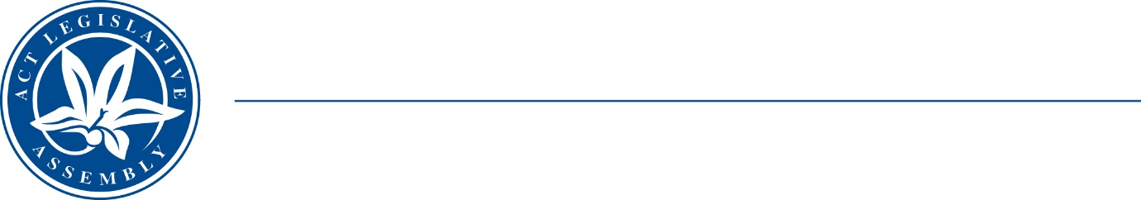
Standing Committee on Economy and Gender and Economic Equality
Ms Leanne Castley MLA (Chair), Ms Suzanne Orr MLA (Deputy Chair),
Mr Johnathan Davis MLA
Ms Caroline Le Couteur MLA

LEGISLATIVE ASSEMBLY
FOR THE AUSTRALIAN CAPITAL TERRITORY

Media Release

Extension of submission deadline

Inquiry into Memorialisation through Public Commemoration
The ACT Legislative Assembly’s Standing Committee on Economy and Gender and Economic Equality (the Committee) has extended its deadline for submissions to its inquiry into memorialisation through public commemoration—to close of business 8 April 2022.
The Committee’s terms of reference are available on the Legislative Assembly website.
Information about how to make a submission is available at on the Assembly website.

STATEMENT ENDS—16 December 2021
–––––––––––––––––––––––––––––––––––––––––––––––––––––––––––––––––––––––––––––––––––––––––
contacts: | Ms Leanne Castley MLA  (for comment on the inquiry) | Committee Chair | (02) 620 50283
contacts: | Dr David Monk  (for further information) | Committee Secretary | (02) 620 50129

