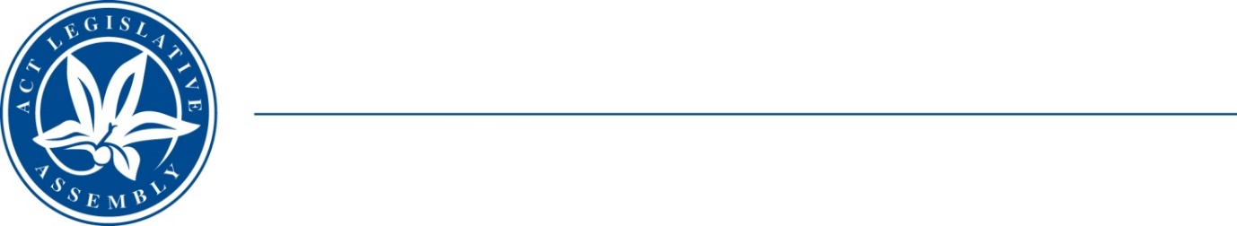
LEGISLATIVE ASSEMBLY
for the Australian Capital Territory

FOR THE AUSTRALIAN CAPITAL TERRITORY

FOR THE AUSTRALIAN CAPITAL TERRITORY

Standing Committee on Planning, Transport and City Services
Jo Clay MLA (Chair), Suzanne Orr MLA (Deputy), Mark Parton MLA

INQUIRY INTO IMPACT OF REVISED SPEED LIMITS IN CIVIC – PETITIONS 31-21 AND 38-21
Background
On 5 July a number of 40kph speed limits became effective in Civic on sections of Northbourne Avenue, Barry Drive, Cooyong Street and the commercial areas of Braddon. The Minister for Transport and City Services announced these on 24 March, and new or existing speed cameras were adjusted to the lower limit on 21 June. In the following 48 hours, the adjusted cameras identified some 5,000 exceeding the new limit with some 20,000 detected during the ‘amnesty period’.
Since infringements became applicable on 5 July, some 18,400 penalty notices were issued in a three week period with fines amounting to $1.6m a week in a three week period.
A petition calling for the waiver of fines for the month of July and to make it clearer as to where the new limits apply attracted 1,303 signatures (1,286 electronic). On 16 September 2021, in accordance with Standing Order 99A, the Clerk referred petition 31-21 to PTCS for consideration.
Offices continue to receive pleas for relief from people who have received multiple fines arguing that signage is ambiguous or confusing. Some businesses advise these fines and impact on their drivers’ licence points will push them to the point of collapse.
Terms of Reference
On 30 September 2021 the Standing Committee on Planning, Transport and City Services resolved to inquire and report on the implementation of the revised speed limits in parts of civic that became effective on 5 July 2021 with particular reference to:
- road user advice and education effectiveness prior to the 5 July implementation;
- effectiveness of warning signage;
- reasons for the continued and abnormally large number of breaches;
- strategies for rectifying causes of the infringement rate;
- impact on the community of the new fines and whether the level of this impact justifies a fines waiver for the month of July; and
- any other matter relevant to this issue.

