Inquiry into Planning for the Surgical Procedures, Interventional Radiology and Emergency Centre (SPIRE) and the Canberra Hospital campus and immediate surrounds
Standing Committee on Planning and Urban Renewal
August 2020
Report 14

The Committee

Committee Membership
- Ms Caroline Le Couteur MLA Chair
- Ms Suzanne Orr MLA Deputy Chair (until 23 August 2019)
- Mr Mark Parton MLA Deputy Chair (from 28 August 2019)
- Mr Michael Pettersson MLA (from 24 August 2019)

Secretariat
- Ms Annemieke Jongsma Secretary
- Alice Houghton Senior Research Officer
- Dr Frieda Scott Senior Research Officer
- Ms Lydia Chung Administrative Officer

Contact Information
Telephone 02 6205 1253
Post GPO Box 1020, CANBERRA ACT 2601
Email committees@parliament.act.gov.au
Website www.parliament.act.gov.au

Resolution of appointment

On 13 December 2016 the Legislative Assembly for the ACT, when it created Standing Committees for the Ninth Assembly, resolved at Part 1(f) of the Resolution that there would be a:
Standing Committee on Planning and Urban Renewal to examine matters relating to planning, land management, the planning process, amendments to the Territory Plan, consultation requirements, design and sustainability outcomes including energy performance and policy matters to support a range of housing options.

On the same day, the Legislative Assembly also resolved at Part 3 of the Resolution that:
If the Assembly is not sitting when the Standing Committee on Planning and Urban Renewal has completed consideration of a report on draft plan variations referred pursuant to section 73 of the Planning and Development Act 2007 or draft plans of management referred pursuant to section 326 of the Planning and Development Act 2007 the Committee may send its report to the Speaker, or, in the absence of the Speaker, to the Deputy Speaker, who is authorised to give directions for its printing, publication and circulation.

Terms of reference

On 11 February 2020 the Assembly was informed that the Standing Committee on Planning and Urban Renewal had resolved to inquire into and report on: Planning for the Surgical Procedures, Interventional Radiology and Emergency Centre (SPIRE) and the Canberra Hospital campus and immediate surrounds, with reference to:
- Planning for the SPIRE project, including:
- site selection
- consultation process(es)
- project timeline
- vehicle (including public and ambulance) access via Palmer Street and Gilmore Crescent to the Canberra Hospital
- other traffic and parking issues
- community safety and environmental considerations
- impact on surrounding residences, school and community facilities
- impact on existing hospital and emergency infrastructure and services.

- Longer term planning for the Canberra Hospital campus and immediate surrounds, including:
- development of Master Plan and possible Canberra Hospital Precinct Plan
- mechanisms for ongoing consultation with the local community
- safe traffic flow within the Canberra Hospital campus
- traffic and parking within the Canberra Hospital campus
- management of impacts on local community and school
- management of impacts on the safety of the community
- emergency vehicle and helicopter access
- impact of helicopter noise on surrounding residences and school.

- Any other relevant matter.

Acronyms
ACT | Australian Capital Territory
ACTHD | ACT Health Directorate (used interchangeably with ACT Health)
AMHRU | Adult Mental Health Rehabilitation Unit
BHSP | Building Health Services Program
CADP | Capital Asset Development Plan
CAG | Clinical Advisory Group
CCCACT | Combined Community Councils of the ACT
CHS | Canberra Health Services
CIT | Canberra Institute of Technology
CMTEDD | Chief Minister Treasury and Economic Development Directorate
CRG | Consumer Reference Group
DA | Development Application
ECI | Early Contractor Involvement
ED | Emergency Department
EOI | Expression of Interest
EPSDD | Environment, Planning and Sustainable Development Directorate
ESC | Executive Steering Committee
FoHV | Friends of Hawker Village
FOI | Freedom of Information
GRA | Garran Residents Association
HCCA | Health Care Consumer’s Association
HDU | High Dependency Unit
HFE | Health Funding Envelope
HMA | Healthcare Management Advisors
HIP | Health Infrastructure Program
HPU | Health Planning Unit
ICFW | Infrastructure Finance and Capital Works
ICU | Intensive Care Unit
IEOI | Invitation for Expression of Interest
LCRG | Local Community Reference Group
MoC | Models of Care
MPC | Major Projects Canberra
NCDRP | National Capital Design Review Panel
NCAP | National Capital Private Hospital
NICU | Neonatal Intensive Care Unit
NSW | New South Wales
PCG | Project Control Group
PoC | Proof of Concept
PSP | Preliminary Sketch Phase
RACS | Royal Australasian College of Surgeons
RAS | Residential Accommodation Services
RFD | Request for Documentation
SoA | Schedule of Accommodation
SPIRE | Surgical Procedures, Interventional Radiology and Emergency Centre
SSC | Strategy Steering Committee
STH | Silver Thomas Hanley
TCCS | Transport Canberra and City Services
TCH | The Canberra Hospital
UCH | University of Canberra Hospital
UMAHA | Upgrading and Maintaining ACT Health Assets
WCCC | Weston Creek Community Council
WVCC | Woden Valley Community Council
WWDACT | Women With Disabilities ACT

Table of Contents
The Committee i
Committee Membership i
Secretariat i
Contact Information i
Resolution of appointment ii
Terms of reference ii
Acronyms iv
Recommendations ix
1. Introduction 1
Conduct of the Inquiry 1
Acknowledgements 1
2. Hospital History 2
3. Health/Hospital Funding and Programs 8
ACT Health/Hospital Funding 8
4. The SPIRE Project 14
Scope of Project 14
Site Selection 17
Governance Structure 31
Project Documentation 38
Design and Construction Tender 40
Site Activities 45
Committee Comment 52
5. Development Concerns 53
Helipad and Helicopters 53
Transport and Site Access 54
Pedestrian and Student Safety 65
Wayfinding 66
Construction Impacts 70
Noise Issues 72
Capacity of SPIRE 73
6. Consultation 75
Previous Consultation 82
Consumers and Carers 83
Local Community 85
Clinical 90
Other Consultation 91
Committee Comment 91
7. Future Planning 93
Demographics of Canberra 93
Demand for Health Services 93
Master Planning 95
8. Conclusion 105
Appendix A – Submissions 107
Appendix B – Major Projects Canberra; SPIRE: Stakeholders Communications and Engagement Strategy 109
Appendix C – Traffic Analysis 148
Appendix D – Work Order Building 5 158

Recommendations
Recommendation 1
4.51 The Committee recommends that the ACT Government provide the community with all the changes and the reasons for the changes to the SPIRE Project since 2014.
Recommendation 2
4.52 The Committee recommends that where there are significant changes to this or other government projects, the ACT Government proactively brings these to the attention of interested members of the community rather than expecting the community to discover the changes.
Recommendation 3
4.91 The Committee recommends that the Auditor General undertake a performance review of the ACT Government’s planning for health infrastructure, including the SPIRE Project, as soon as practicable. In particular the Committee recommends that this is undertaken before the SPIRE Project is finished.
Recommendation 4
4.92 The Committee recommends that the ACT Government ensure that governance structures for all major projects require and include meaningful consultation with local affected communities.
Recommendation 5
4.123 The Committee recommends that the ACT Government ensure that the SPIRE building is built to high environmental standards. In particular the design and construction should be consistent with the ACT Government Climate Change Strategy 2019-2025.
Recommendation 6
4.124 The Committee recommends that the ACT Government ensure that the SPIRE building has access to natural daylight and views of the outdoors.
Recommendation 7
5.28 The Committee recommends that the ACT Government ensure the Canberra Hospital provides clear and explicit direction at all entry points for people attempting to access the emergency department who are not in an ambulance.
Recommendation 8
5.29 The Committee recommends that the ACT Government ensure the Canberra Hospital provides sufficient short term parking for people attempting to access the emergency department in a private vehicle to ensure that the patients can be safely delivered to the emergency department.
Recommendation 9
5.41 The Committee recommends that the ACT Government ensure that the master plan process investigates options for relocating ambulance access from residential streets which can be delivered through future expansion projects.
Recommendation 10
5.59 The Committee recommends that the ACT Government ensure that the master plan process includes a comprehensive review of traffic and transport for the wider precinct, including options for improving school pick-up and drop-off arrangements.
Recommendation 11
5.60 The Committee recommends that the ACT Government consult with Garran residents on the development of safe traffic and parking solutions for the hospital precinct (specifically those in Palmer Street and Gilmore Crescent).
Recommendation 12
5.61 The Committee recommends that the ACT Government establish proper bike paths in the residential areas around the hospital. These bike paths should connect with the main bike-path network in Woden.
Recommendation 13
5.62 The Committee recommends that planning for the hospital precinct include better transport facilities including:
▪ adequate and accessible disabled parking;
▪ better wayfinding both within the precinct and from the major public transport hub in Woden;
▪ better public transport options, especially for disabled patrons;
▪ better shuttle buses within the hospital precinct and to the external carparks in Phillip; and
▪ sufficient parking for visitor, staff and patient residual needs – i.e. after improved public transport and active transport.
Recommendation 14
5.68 The Committee recommends that the ACT Government ensure that the SPIRE Project design considers the safety of the Garran primary school students and residents in surrounding streets.
Recommendation 15
5.80 The Committee recommends that in partnership with the Garran Primary School Board and the Education Directorate, the ACT Government should ensure that the SPIRE Project incorporates and implements any necessary noise pollution mitigation measures, such as double glazing.
Recommendation 16
6.72 The Committee recommends that the ACT Government revise its engagement and consultation policy to ensure it is timely, transparent and meets the needs of stakeholders.
Recommendation 17
6.73 The Committee recommends that the Auditor-General conduct a performance audit of community consultation conducted by the ACT Government.
Recommendation 18
6.74 The Committee recommends that the ACT Government ensures extensive consultation is undertaken with health and local community stakeholders during development of the master plan.
Recommendation 19
6.75 The Committee recommends that the ACT Government ensures ensure that the Local Community Reference Group continues after the completion of SPIRE; as an ongoing forum for consultation on smaller operational changes that will occur following development of the master plan.
Recommendation 20
7.46 The Committee recommends that the ACT Government complete its current master planning process for the Canberra Hospital precinct as a matter of urgency.
Recommendation 21
7.47 The Committee recommends that the ACT Government maintain an up-to-date master plan for each of its key health services sites.
Recommendation 22
7.48 The Committee recommends that a legislative requirement is placed on Canberra Health Services to undertake and maintain a master plan for each major hospital and to review the master plan every five (5) years
Recommendation 23
7.49 The Committee recommends that a legislative requirement is placed on the ACT Health Directorate to maintain a model of future demand for health services and a service delivery plan and to review these every five (5) years. This model should:
▪ Cover at least ten (10) years;
▪ Cover the ACT plus the areas of NSW that the ACT supports in conjunction with the NSW Government;
▪ Be prepared with extensive public and expert consultation; and
▪ Be made publicly available.
Recommendation 24
7.50 The Committee recommends that the ACT Government ensure that the master plan process is not limited by the current boundaries of the precinct and includes consideration of the future role of other nearby Government sites such as the former Woden CIT and the Garran Primary School oval.
Recommendation 25
7.51 The Committee recommends that the ACT Government ensure that the master plan process identifies ACT Government facilities and functions that can no longer be catered for within the precinct and need to be relocated or devolved to other parts of Canberra.
Recommendation 26
7.52 The Committee recommends that the Environment, Planning and Sustainable Development Directorate conducts a planning investigation into the need for land for private health facilities and supporting services in the vicinity of the hospital precinct, including the role of Garran Shops and the Deakin Business Precinct.

Introduction

Conduct of the Inquiry
  - At a private meeting on 11 December 2019, the Committee resolved to undertake an inquiry into Planning for the Surgical Procedures, Interventional Radiology and Emergency Centre (SPIRE) and the Canberra Hospital campus and immediate surrounds.
  - The Committee announced its inquiry in the Assembly on 11 February 2020 and distributed a media release on the same day. The Committee received twenty-five (25) submissions and a list of these is provided at Appendix A.
  - The Committee had planned to hold public hearings in late March 2020, however due to the onset of the COVID-19 pandemic; social isolation requirements and the inability to host hearings remotely at that juncture, the decision was made that in the interests of everyone’s health and safety that the hearings would not go ahead.
  - As part of the inquiry, the Committee were able to access a significant number of documents from the ACT Health Directorate (ACTHD) and Major Projects Canberra (MPC) which had been subject to and published via an earlier Freedom of Information (FOI) request by an MLA who was and is not on the Committee.
  - Whilst it is noted that it was announced on 12 August 2020 that the SPIRE Project would now be called the Canberra Hospital expansion, this report will use SPIRE or SPIRE Project when referencing the project.

Acknowledgements
  - The Committee would like to extend its thanks to those who took the time to make written submissions to the inquiry.

Hospital History

From Canberra Hospital to the Royal Canberra Hospital
  - The first hospital in Canberra opened as Canberra Hospital in Balmain Crescent, Acton, in May 1914. The hospital had eight beds and tents were used to supplement the isolation ward. Despite an increasing number of women living in Canberra, there was no obstetrics facility, and patients had to travel to Queanbeyan Hospital. In 1930, the name changed to Canberra Government Hospital, and then in 1935 to Canberra Community Hospital.
  - In 1942, a modern brick hospital was completed at Acton Peninsula. Initially, the new building was occupied by the United States Army Medical Corps, but the Canberra Hospital Board was able to take over the premises in February 1943.
  - New wings were added in 1948 and 1956, while the 1960s saw the main building extended and the completion of more staff facilities. These included a new nurses’ residence and training facilities.
  - Between 1968 and 1979, it was again called Canberra Hospital. In 1979, it became the Royal Canberra Hospital. From November 1990 to August 1991, it was called Royal Canberra Hospital (North) before reverting to Royal Canberra Hospital.
  - The Royal Canberra Hospital amalgamated with the Woden Valley Hospital in 1991. It was closed amid protests in 1991 and was demolished in 1997.

Woden Valley Hospital / Canberra Hospital
  - Opened in 1973 after four years of construction, the Woden Valley Hospital was the second hospital in Canberra. It was established as a response to concerns about the Canberra Community Hospital’s capacity and suitability in providing adequate health care services to the rapidly growing Canberra population.
  - According to a House of Representatives Public Account Committee report in 1966, one of the main concerns was the location of the Canberra Community Hospital. Its proximity to the Australian National University and Canberra city centre was thought by decision makers as a barrier for the expansion of the Canberra Community Hospital. It was noted that the hospital could not increase its bed capacity beyond 600 beds as ‘the price that could be paid in congestion, loss of amenities and hospital grounds and surrounds would be undesirable.’
  - After a three-year negotiation and discussion, in 1965 the Director-General of Health reached an agreement with the National Capital Development Commission and the Department of Interior for the allocation of a 40-acre site in Woden, as selected by the Director-General of Health, for the proposed Woden Valley Hospital.
  - The Royal Canberra Hospital was amalgamated with Woden Valley Hospital in 1991 and the Acton campus closed later that year. Woden Valley Hospital was renamed Canberra Hospital in 1996.
  - According to the ACTHD, Canberra Hospital today is the largest public hospital in the region. The hospital campus has 28 buildings and provides health care to over 500,000 people. It is also a principal teaching hospital and tertiary referral centre in the region.
  - The Canberra Hospital’s current 28 buildings cover a gross floor area of nearly 207,000sqm. The campus is connected by a network of roads, bridges and tunnels, and is serviced by a multi-storey carpark and helipad.
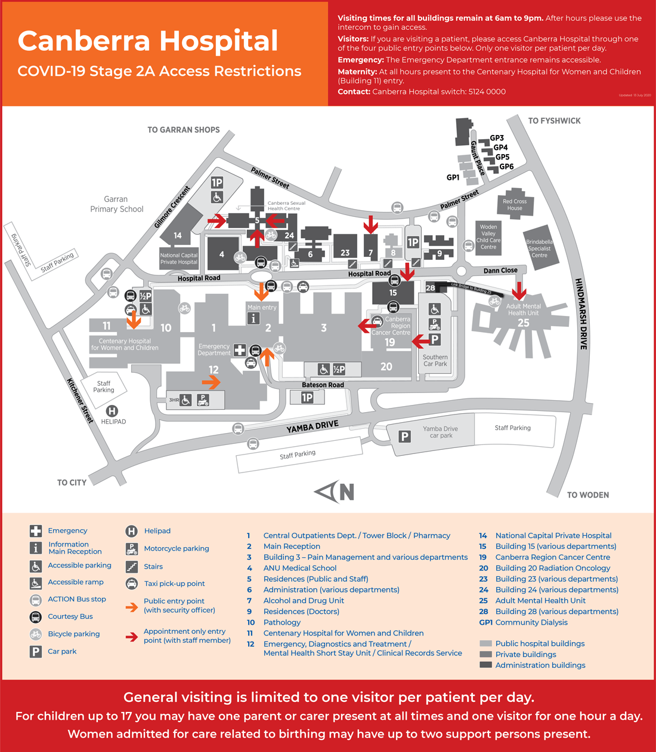
FIGURE 1: Canberra Hospital Campus Map

Calvary Public Hospital
  - As a teaching hospital, Calvary Public Hospital Bruce is affiliated with the Australian Catholic University, the Australian National University and the University of Canberra as well as providing clinical placements for a number of other tertiary providers.
  - Calvary Public Hospital is co-located with the Calvary Private Hospital and Hyson Green Mental Health Clinic in Bruce. Its catchment area is North Canberra, Belconnen and the Gungahlin precinct and surrounding areas of the ACT and NSW. Calvary also has Calvary John James in Deakin.
  - In addition to Calvary Public Hospital, the Little Company of Mary also operate Clare Holland House, a palliative care facility.
  - In 2009, The ACT Government stated that it wanted to buy Calvary Public Hospital and said it was in discussions with the Little Company of Mary about a possible deal. Then, Health Minister Katy Gallagher said, "If we're to spend 2 to 3 hundred million dollars on Calvary and we don't own those assets, these assets are then transferred to Little Company of Mary, that is something the Government has to consider.” The sale did not proceed.
  - In 2019, Calvary Public Hospital told the ACT Government that many of Calvary Public Hospital's buildings and infrastructure are rapidly reaching the end of their useful life and that a capital injection of $109 million was required.

University of Canberra Hospital
  - The University of Canberra Hospital (UCH) is the newest public hospital in Canberra. It opened in 2018 as a specialist centre for rehabilitation, recovery and research. Providing all general rehabilitation services for people from the age of 18, the hospital also houses the Adult Mental Health Rehabilitation Unit (AMHRU), a specialist mental health inpatient rehabilitation unit.
  - As the third public hospital in the ACT, UCH was created to ease the pressure on the other two public hospitals so as to enable them to focus on acute services such as emergency, intensive care and surgery. As a rehabilitation hospital, the UCH does not have an emergency department or intensive care unit. It also does not provide surgery, maternity services, palliative care or psycho-geriatrics.
  - At capacity, UCH provides 140 overnight rehabilitation beds, including 20 adult mental health beds. In addition to overnight beds, the hospital offers 75 day places for mental health and rehabilitation services.

Private Hospitals
  - There are three main private hospitals in the ACT: Calvary John James Hospital, Calvary Bruce Private Hospital and the National Capital Private Hospital.
  - Calvary John James Hospital in Deakin first opened its doors in 1970 as the John James Hospital, named after the late Dr John James, a medical practitioner and surgeon in Canberra. In 2006, it joined the Calvary group and became Calvary John James Hospital. In addition to providing surgical and medical services, Calvary John James Hospital is the only private maternity unit on the south side of Canberra with a special care nursery. The Catholic not-for-profit hospital also has the only purpose built private rehabilitation unit in the ACT.
  - Calvary Bruce Private Hospital was established in 1987 by the Sisters of the Little Company of Mary as a Catholic not-for-profit organisation. Co-located with Calvary Public Hospital Bruce, the hospital is a teaching hospital and affiliated with the three universities in Canberra: the Australian National University, the Australian Catholic University, and the University of Canberra. The hospital also offers a dedicated private mental health facility through its Hyson Green unit. Up until September 2017, Calvary Bruce Private Hospital was located within the Calvary Public Hospital Bruce building. Since then it has been operating out of a new stand-alone facility on the south east corner of the Calvary Bruce campus.
  - The National Capital Private Hospital is located within the Canberra Hospital campus in Garran. It is run by Healthscope, a for-profit private health company and provides 148-bed acute care medical and surgical services to private patients. It recently underwent extensive redevelopment which resulted in three new operating theatres, including a hybrid theatre for complex cardiac, vascular and neurosurgery, a 22-bed intensive care unit, an 18-bed coronary care unit and 10 medical consulting suites.

Health/Hospital Funding and Programs

ACT Health/Hospital Funding
  - ACT Health receives funding from several sources including funding from the Commonwealth under the National Health Reform Agreement 2011 (National Health Reform Agreement), various partnership agreements and appropriation funding through the ACT Government Budget.
  - Other funding sources include user charges and cross border revenue in relation to interstate (NSW mainly) patients and other minor, miscellaneous streams of income such as donations and patient revenue. The ACT Government funds about 70 per cent of the ACT health system whilst the Commonwealth government provides about 30 per cent funding.
  - ACT Health have indicated that between 2013 and 2018, ACT Health’s total health expenses (not including capital) increased at a rate 5.6 per cent, per year. These expenses are known as the ACT Health Funding Envelope (HFE). The HFE is designed to provide budget certainty for overall net Controlled Recurrent Payments which are expenses (less depreciation) rather than for capital funding. HFE growth rate has been budgeted at between four and six percent per annum.
  - ACT Government expenditure on health was $1.63 billion in 2017-18, which equates to 31 per cent of the ACT Budget. Health is the largest single area of ACT Government expenditure.
  - Capital funding decisions by Cabinet, such as those in relation to the current Infrastructure program, are outside the HFE arrangements. The 2019-20 budget for Health as part of the Government’s Capital Works Program for the four years to 2022-23 is $367,472,000 or 20 per cent of the capital works budget.
  - Despite the increasing figures in health expenditure it is claimed that the ACT health system has endured funding cuts of approximately 1 per cent in real terms since 2012-13. This considers population growth, ageing, change in technology; inflation in prices of medicines and wages.

Capital Asset Development Plan (CADP)
  - The Capital Asset Development Plan (CADP) was established in 2008 as a 10-year plan, funding $1b to expand and modernise the ACT’s health system.
  - In the 2008-09 Budget $300m was allocated over four years with $63m over the same period allocated for planning and design work to enhance the Canberra Hospital campus including the redevelopment and replacement of infrastructure needed to support a sustainable health system, to ensure the safety, availability and viability of quality health care in the ACT.
  - The $300m for CADP was the health allocation from the Building the Future Program.
  - The aims of the CADP included:
- Double the treatment spaces available to patients in the ACT
- Almost double the beds in ACT public hospitals
- Significantly upgrade mental health care
- Provide improved and extended day surgery services
- Transition as many non-acute services as possible out of the hospital setting and relocate these to convenient local health centres
- Deliver improved and increased services through local health centres
- Ensure timely access to health services.
  - Since 2008, the ACT Government has delivered a significant number of CADP and other projects, including:
• The Centenary Hospital for Women and Children;
• The Canberra Regional Cancer Centre;
• Inpatient ward refurbishments at the Canberra Hospital;
• Canberra Hospital’s Southern Car Park;
• Adult Acute Mental Health Inpatient at Canberra Hospital;
• Dhulwa Secure Mental Health Facility;
• New Gungahlin and Belconnen Community Health Centres and a refurbished Tuggeranong Community Health Centre;
• The Intensive Care Unit/Coronary Care Unit at Calvary Public Hospital Bruce; and
• CPHB’s multi-storey car park.
  - The Capital Asset Development Plan Project Definition Plan was finalised in 2010 and incorporated a conceptual site plan for the Canberra Hospital, which included a major clinical services block (labelled new Building 2/3). This work was furthered through a Design Options Study undertaken in 2010 and a Future Facility Profile completed in 2013.
  - By 2011, the ACT Government considered that 400 additional beds and a full redevelopment of the Canberra Hospital site were needed. An assessment of expected future growth at that time foresaw a continuing expansion of this need for bed capacity. In February 2011, a discussion paper was released that sought feedback on five options to counter the estimated need for 400 beds by 2022.
  - In 2015, ACT Health progressed work on master plans for both Calvary and Canberra Hospitals. It was intended to table overarching details of these master plans when finalised, but it was also forecasted that the tabling of detailed plans may not be appropriate in view of security implications.

Your Health - Our Priority Program
  - In 2008, the Your Health Our Priority Program was developed as the first stage in the CADP project to upgrade health infrastructure. It involved an overall health service redesign and infrastructure program for services to be implemented over ten years.
  - This included the overall plan to provide future health services to the:
    - Canberra Hospital campus
    - Calvary Hospital campus
    - Mental Health services
    - Community Based Services.
  - Feedback, ideas and input on these priorities were welcomed from the public through the Your Health – Our Priority website and via post.

Health Infrastructure Program
  - In 2012, the CADP was changed to the Health Infrastructure Program (HIP). At this time ACT Health took over the project management role from the private company, THINC Health.
  - As a consequence, the outcomes from the Discussion Paper consultation process and the master plans were abandoned. Although $404m was budgeted to continue HIP in the 2016-17 Budget, with the program being extended until 2022, the HIP concluded in July 2016.
  - The 2016-17 Budget also provided a significant investment in existing infrastructure through the nearly $100m Upgrading and Maintaining ACT Health Assets (UMAHA) program.

2016 Election – ACT Labor’s 10 year health plan
  - ACT Labor in a parliamentary agreement with the Greens was able to form a minority government following the 2016 election. This enabled them to begin implementing their 10 Year Health Plan.
  - The plan was formed with the aim of keeping Canberrans healthy and building the infrastructure needed for the future. SPIRE became part of the Building Health Service Program of related infrastructure building projects which also included:
    - Expansion of the Centenary Hospital for Women and Children (to include a new child and adolescent mental health unit, an adolescent gynaecology service, a new paediatric high dependency unit, and paediatric intensive care beds).
    - Expansion of Clare Holland House
    - Walk-In Centres for Weston and Inner North
    - Northside Hospital Scoping Study.
  - Successive budgets have provided for the $500 million SPIRE Project.
    - In 17/18: $236m investment over four years ($6m over two years for planning; $230m for capital for design and construction of SPIRE to begin in 2020).
    - In 18/19: $13m in capital.

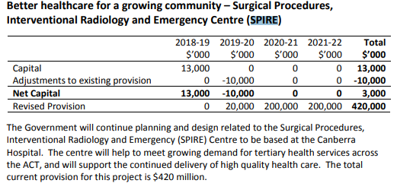
TABLE 1: Extract from 2018/19 Budget paper
  - The ACT Government through its 2019-20 Budget, allocated $54.8m over the forward estimates for SPIRE but estimated construction costs were left unpublished so as to not send signals to the market prior to project design and construction procurement processes concluding.
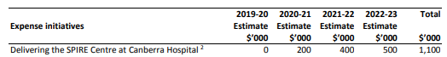
TABLE 2: Extract from 2019/20 Budget paper
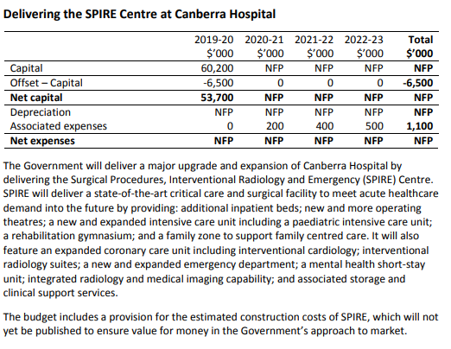
TABLE 3: Extract from 2019/20 Budget paper

The SPIRE Project
  - The SPIRE Project was developed as a concept by the ACTHD to address future pressures in the Canberra Hospital and Health Services (now Canberra Health Services). Further development of the concept began in late 2016, with an initial budget of $500 million.
  - Since 2016, feasibility studies, clinical service planning, site due diligence, infrastructure planning and early stakeholder consultation have been developing the concept.
  - It is claimed that the SPIRE Project will address:
- The need to respond to increased demand for acute and critical care services – the Territory must invest in new infrastructure to address population growth, the ageing population and growing levels of chronic illness;
- Innovative models of care and new technologies – new infrastructure provides the opportunity to fully implement contemporary clinical practice and technology to provide better outcomes for Canberran’s and a more efficient health system;
- Ageing infrastructure – the SPIRE Project will not only replace existing aged buildings, but will provide the cornerstone for Canberra Hospital master planning to manage future infrastructure challenges.
  - It was announced on 12 August 2020 that the SPIRE Project would now be known as the Canberra Hospital expansion.

Scope of Project

Initial Scope
  - When first proposed the functional scope of the SPIRE project was promoted as follows:
    - Intensive Care Unit (ICU) with 48 beds (including High Dependency Unit (HDU) and paediatric)
    - 20 operating theatres
    - 24 bed coronary care unit
    - 64 in-patient beds for overnight care
    - More elective and day surgical spaces
    - Surgical, procedural and imaging facilities
    - 12 Ambulance bays
  - It was also stated that a new expanded general Emergency Department (ED) would allow the current ED to be dedicated to women and children. The two EDs were to operate as one, but with separate entrances to provide the best patient and family experience.
  - It was estimated that SPIRE would be operational by 2022.

Current Scope
  - By the time the business case had been developed the functional scope for SPIRE was promoted as follows:
    - 114 Emergency Department treatment spaces – 39 more than are currently available at the Canberra Hospital
    - 60 ICU beds – (including HDU and paediatric) double the current number
    - Four new paediatric ICU beds (included as part of the above 60 ICU beds) and a family zone to provide support services for families who have children in the ICU.
    - 22 new state-of-the-art operating theatres – nine more than are currently available, including hybrid theatres and interventional radiology theatres.
    - 12 Ambulance bays
    - Ten bed short-stay mental health unit in ED
    - Resourcing four additional intensive care unit beds and 12 beds for inpatient services in medicine, surgery and aged care.
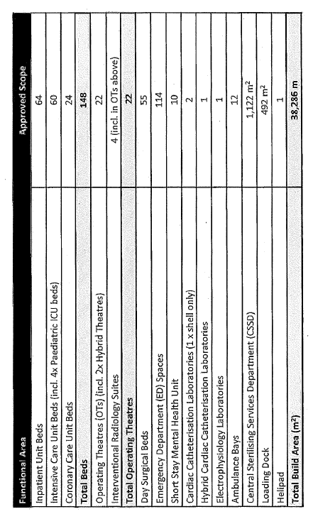
TABLE 4: Functional Scope
  - It was estimated that this iteration of SPIRE would be operational by 2024.
  - Contrary to the initial scope it is believed the current ED will be closed once SPIRE is commissioned. It is unclear how this will affect the above numbers.
  - Whilst the above numbers have been gleaned from a variety of documents and online a detailed Question on Notice (3204) was lodged by Mr Alistair Coe MLA on July that seeks information in relation to the SPIRE Project scope when compared to existing resources. These questions relate to:
    - Bed numbers (inpatient, ICU, coronary care, ED, day surgery);
    - Electrophysiology laboratories;
    - Cardiac Catherisation laboratories;
    - Interventional Radiology;
    - Procedure room numbers;
    - Operating Theatre Numbers; and
    - Ambulance Bays.
  - The answer to this Question on Notice is expected by 23 August 2020 however, if received before this report is finalised, it will be included in the report.

Site Selection
  - As noted in 2008, the ACT Government established the Capital Asset Development Plan (CAPD) and in 2010 the CAPD Project Definition Plan was developed. It included a major expansion at the Canberra Hospital. This has not been controversial, what has been controversial and has changed over the years is the siting of the new building within the Canberra Hospital campus.

Site Selection – First Alternative
  - In the early stages the Canberra Hospital redevelopment was not known as SPIRE and the site selection was based on the plans developed following the implementation of the CADP (Figure 2):
In 2014, the ACT Health Directorate (ACTHD) sought Government’s approval to bring forward a business case for the most ambitious element of the CADP, the demolition and redevelopment of Buildings 2 and 3 at the Canberra Hospital.
  - However, the business case did not proceed, as:
Given the significance of the project, in terms of impacts on ongoing services, operational efficiency and with a capital cost of over $1 billion, the ACT Government sought additional due diligence and review to inform decision making.
  - The ensuing 2015 ‘review included consideration of clinical performance, existing infrastructure condition and capacity and future capital works.’ Based on this review it was announced in 2016 that ‘a redevelopment such as that proposal for Building 2 and Building 3 would not be necessary for up to 10 years.’ With Mr Corbell MLA advocating that
…better utilisation of beds, improved processes and practices and a $100 million infrastructure investment over the next four years would result in improved capacity and efficiency throughout the health system.
  - A number of other risks were also factored into the decision not to proceed, including:
    - Unavoidable interruptions to clinical services during construction;
    - A prolonged construction delivery phase increasing overall project costs;
    - Staging such that construction was being undertaken on top of live clinical areas, increasing the risk of operational interruptions, which may also impact clinical and workplace safety; and
    - A physical reduction in available inpatient beds during the mid-point of construction, increasing rather than decreasing demand issues at the Canberra Hospital.
  - Even though this option did not proceed some submitters preferred this proposal. It was considered that compared to the current proposal site:
…the long-term benefits of ambulance access and patient flows from delivering SPIRE on the centrally-located Building 3 would be significantly more effective, despite potential greater disruption during the renewal phase.
  - It would also ‘preserve the opportunities for growth of the emergency, ambulance bays and wards on all areas of the campus.’
  - The Weston Creek Community Council recalled a presentation ‘on 27 May 2015 by Paul Carmody from ACT Health where the proposal was for a central location of the surgical centre.’
  - They indicated to the Committee that they are of the view that this is still the best option in terms of internal and external accessibility as:
…the external access should be via ambulance access from the main arterial road, Yamba Drive while the internal access should be from the various wards and associated facilities to a centrally located anchor building to ensure effective patient flows and interfaces with existing services.
  - They further stated that:
The SPIRE building provides an opportunity to plan the campus and the interfaces with existing campus services (and the broader precinct) to achieve better health outcomes. It is the anchor of the campus and includes medical imaging, a surgical inpatient unit, an intensive care unit, an acute cardiac care unit and a mental health short stay unit. A variety of patients which would be better suited with a Central location.

FIGURE 2: SPIRE Site Selection – First Alternative

Site Selection – Second Alternative
  - Figures 3 and 4 illustrate the second site and the original proposed location for SPIRE. This location stemmed from design and planning conducted as part of the Building Health Services Program (BHSP) following the 2016 election.
  - This site was selected because of its:
• Integration with the existing critical care building (Building 12), allowing for refurbishment of some elements rather than all new construction;
• Yamba Drive frontage;
• Relatively clear site, were the helicopter landing site readily relocated; and
• Direct connection with the Centenary Hospital for Women and Children.
FIGURE 3: SPIRE Site Selection – Second Alternative
  - However, a number of challenges with the site were identified:
• Undertaking prolonged major construction works adjacent to critical services, including operating theatres and neonatal intensive care would create a service interruption risk;
• A site selection report showed that the relocation of the helicopter landing site had the potential to delay the project substantially and increase costs;
• The distance from inpatient facilities would decrease the efficiency of patient movements on the campus; and
• The distance from the main entry and existing car parking structures would have necessitated two distinct entry points to the hospital and increased parking, mobility and wayfinding issues on the campus.
  - Although the site could be justified on a practical level it was determined that better clinical outcomes may be achieved through other options.
  - In 2018, ACTHD convened the cross-directorate Building Health Services Program Strategy Steering Committee (SSC), which considered, among other things, the planning and site for the SPIRE Project.
  - The SSC membership consisted of senior executives and advisors from ACTHD (including senior representation from the Canberra Hospital), Treasury, Environment, Planning and Sustainable Development Directorate and Calvary Healthcare.
  - Following its considerations, the SSC recommended that the SPIRE be located in an alternative location.
  - Despite this view, one submitter believed that this second site would be the best option and that the issues relating to the helipad could be resolved:
If land in the area of the current helipad site was to be considered for use as part of the hospital expansion, thought could be given to relocating the helipad to a nearby off-site location (perhaps one of the very close by sports ovals) during the construction stage of SPIRE, and returning it on-site once building work is completed.
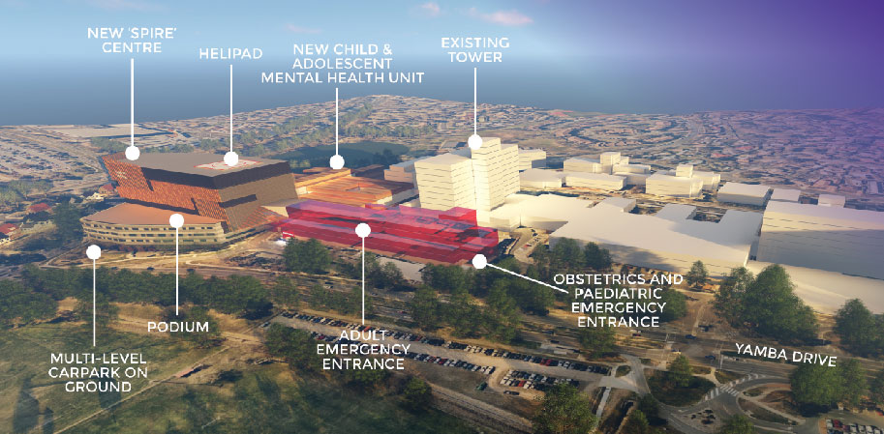
FIGURE 4: SPIRE Site Selection – Second Alternative - Labor Election Proposal

Site Selection – Third Alternative - Final
  - As the SPIRE Project evolved it was described as ‘the anchor of the campus’ and it was essential that wherever it was located it was able to be integrated with its surrounds and accessible to all. As it will be frequented by patients for multiple reasons its location on the Canberra Hospital campus is ‘critical for efficient and effective patient flows.’
  - Following the SSC recommendation to change the SPIRE location, a site of approximately 11,000sqm site at the north eastern quadrant of the Canberra Hospital campus between Hospital Road and Palmer Street was chosen (see Figures 5 and 6). This site currently houses Building 5 and Building 24 and is directly opposite the main hospital entry to Building 2.
  - Using the Canberra Hospital Strategic Asset Management Plan, due diligence reports and stakeholder feedback to support their decision the SSC considered the space available on campus, linkages to existing services and the ability to keep all clinical services during construction and determined that:
- The existing buildings (5 and 24) are at the end of their useful life and not readily able to be refurbished and/or repurposed;
- The site would allow for construction of a wholly new facility, where the original site would require integration with already aged infrastructure, increasing the capacity for contemporary design and technology integration;
- The site would mean there is minimal impact on any critical care services during construction;
- The location provides for direct connection to the existing inpatient tower (Building 1); and
- The project will unlock the Eastern side of the campus for future redevelopment to address expansion pressures.
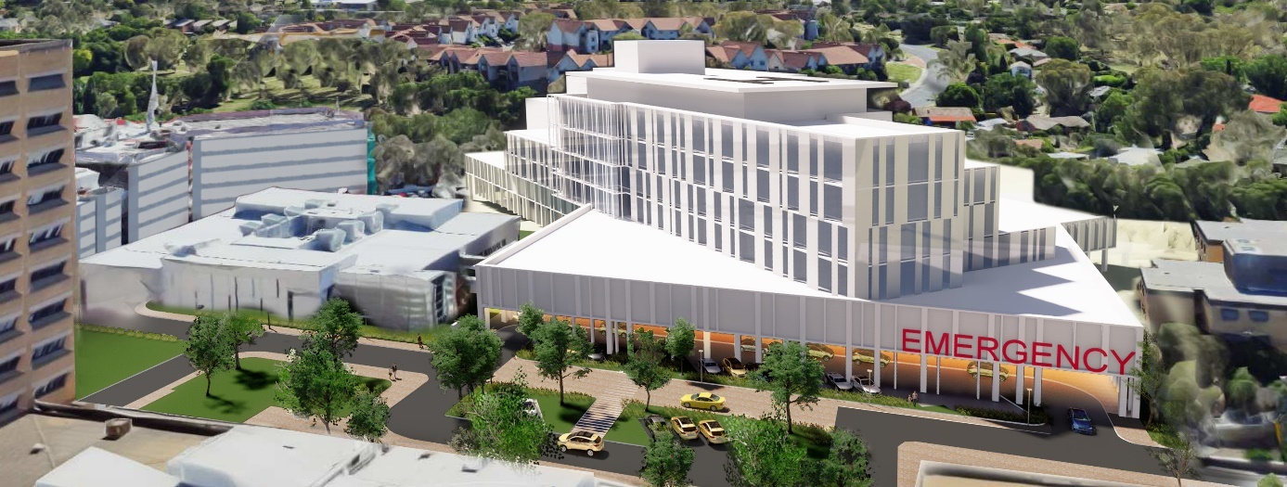
FIGURE 5: SPIRE Site Selection – Third Alternative – Final - Artist images – June 2020

FIGURE 6: SPIRE Site Selection – Third Alternative – Final - Artist images – August 2020
  - The new location was publicly announced by Minister for Health and Wellbeing, Meegan Fitzharris MLA, on 12 December 2018, who stated in a media release:
SPIRE is an important health investment for the ACT – one that will future proof our city and help our public health system respond to increasing demand as our city grows…
SPIRE will transform the Canberra Hospital, increasing the territory’s capacity to deliver acute, hospital-based healthcare in a modern, purpose-built facility…
The advice of the Steering Committee has been critical in determining the optimal location for SPIRE, acknowledging the hospital is an operational site where existing health services are delivered and will need to continue to be delivered while construction is underway….
The advantage of this location is the minimal disruption to critical care services during the building phase. It will replace administrative buildings that are aged, while allowing integration with other acute services buildings on the campus.
  - The Canberra Times reported the site for SPIRE had changed as a result of a cost and time blowout.
  - Whilst there was some public support for this location, the majority of evidence provided to the Committee was not in favour of the chosen site. Despite this opposition the ACT Government was steadfast in their decision that the chosen site would not be reviewed or reconsidered, with the Health Minister stating it was “not for negotiation”.
  - The Garran Residents’ Association (GRA) indicated to the Committee that it appears as if the SPIRE site selection had ‘been primarily influenced by the Building Health Services Steering Committee convened by the Minister.’ Specifically, the GRA noted that:
The advice from the SPIRE Steering Committee has been critical in determining the optimal location for SPIRE, acknowledging the hospital is an operational site where existing health services are delivered and will need to continue to be delivered while construction is underway.
  - Several submitters felt that the ‘decision-making process undertaken prior to the 12 December 2018’ announcement was not transparent and has not yet been explained.
  - It was noted in a number of submissions that the Government maintained that the ‘site decision was made after extensive consultation with clinicians.’ However many felt that the interaction between the proposed ED and areas outside of the Canberra Hospital campus seems to have been ignored. Combined Community Councils of the ACT (CCCACT) stated that:
The Palmer Street site for SPIRE was chosen, prior to either a Precinct or Master Plan being developed, on the basis that it would minimise disruption during construction, rather than for producing optimal health outcomes. This is no way to make the best decision for the location of the SPIRE building.
  - Despite assertions to the contrary, there was doubt as to whether a sufficient level of clinical consultation had in fact been done with a Royal Australasian College of Surgeons (RACS) letter, dated 21 December 2018 querying why SPIRE was now going to be built on the location that was earmarked for a skills training centre. The letter indicated that RACS had discussed this project proposal with the Government as recently as September 2018 and that discussion had been progressing since 2015 with design and fit-out requirements submitted.
  - The GRA, in line with many other submitters queried the level of due diligence and risk assessment for such a large project and felt that it was not adequate:
This large investment in the critical foundation of our health system demands rigorous analysis to ensure that the money is well spent and will support the needs of, and services provided by, a tertiary referral hospital. It is therefore deeply disappointing that we feel that the process of site selection for the SPIRE building and planning to date has not been adequate, transparent or consultative. This indicates a lack of consideration of accessibility, connectivity and safety at the interface of the region’s major hospital with the residential suburb of Garran in the “extensive planning and feasibility work” and “due diligence” for SPIRE.
  - In this context it was also queried why expenditure above a certain figure was not subject to a process of scrutiny, such as a parliamentary committee:
In this regard, the GRA notes that the Commonwealth Parliament justifiably determines that all Commonwealth public works estimated to cost in excess of $15 million must not commence until the work has been considered and reported on by the Parliamentary Standing Committee on Public Works. Therefore, why hasn’t the ACT Government, as a matter of due diligence, referred the SPIRE proposal to an Assembly Committee for scrutiny prior to the present inquiry which has been generated by a petition to the Assembly and prior to the site being declared “not negotiable”?
  - Woden Valley Community Council (WVCC) and others expressed concern about the lack of awareness about the Palmer Street ambulance access, particularly in light of the fact that there had been community meetings since the announcement where this could be explained but was not:
In June 2018 the former Minister for Health attended our public meeting to discuss matters in her portfolio, this primarily included discussion around the ANU Medical School. We were not aware of the ambulance access from Palmer St and the concerns of the Garran residents until the September 2019 meeting at the Garran Primary School.
After the December 2018 announcement regarding the site on Palmer St, the ACT Government discussed the project at the WVCC March public meeting. The presentation was very brief and did not mention that the ambulance access to SPIRE was from Palmer St.
  - Garran residents also expressed frustration indicating that they too were not aware of any changes and the GRA told the Committee that at the September 2019 meeting residents:
….were taken by surprise at the latest proposed location of SPIRE, as it had been previously publicised as being in the area of either building 3 or, the current helipad site up until December 2018. This experience has caused considerable and unnecessary distress to some within the community given the significant impacts of the proposed location.
  - By May 2019, the functional scope of the project had changed from that proposed in December 2018. A ‘series of meetings with nominated senior clinical representatives from each impacted service area between December 2018 and May 2019 informed the current scope and clinical planning outcomes.’
  - Following the clinical endorsement of the SPIRE Project configuration, the business case was submitted to Cabinet. Following its approval SPIRE was officially launched on 28 May 2019.
  - It was noted in correspondence between Michael D’Ath and Bernadette McDonald in May 2019 that the option the Government had chosen was ‘the CHS and ACT Health preferred option.’
  - Correspondence dated 28 May 2019, just prior to the launch, suggested that the plan was to ‘avoid talking too much about how it had all changed between the original commitment and what we are now going to deliver.’
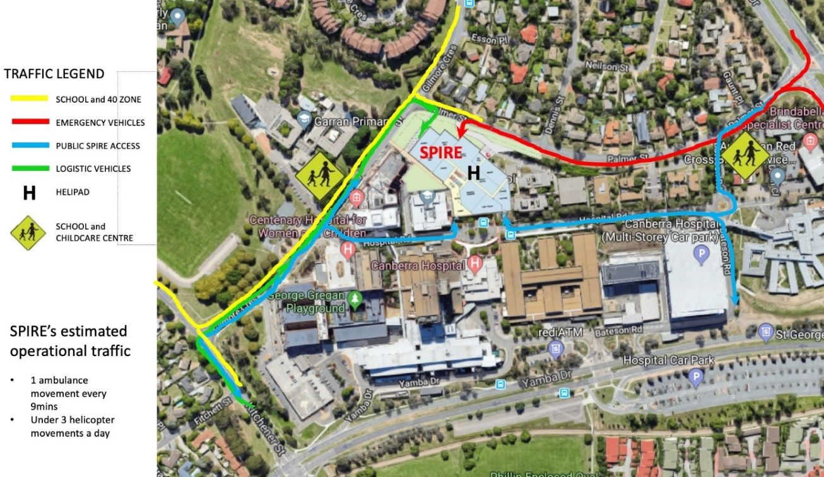
FIGURE 7: SPIRE Site Selection – traffic movements likely around the proposed SPIRE redevelopment of Canberra Hospital.

Committee Comment
  - It is clear from the many submissions received by the Committee, as well as public commentary, that the location of the SPIRE building within the Canberra hospital precinct, and in particular its impact on traffic (as indicated in Figure 7), is the major point of contention about the SPIRE Project. Given that, the majority of the Committee felt it is was very regrettable that the Government adopted a plan to ‘avoid talking too much about how it had all changed between the original commitment and what we are now going to deliver.’
  - The following recommendations seek to obtain clarification in relation to the planning and decision-making processes involved in the evolution of the SPIRE Project.
Recommendation 1
The Committee recommends that the ACT Government provide the community with all the changes and the reasons for the changes to the SPIRE Project since 2014.
Recommendation 2
The Committee recommends that where there are significant changes to this or other government projects, the ACT Government proactively brings these to the attention of interested members of the community rather than expecting the community to discover the changes.

SPIRE Access and Entry Review Study - Options Paper
  - The SPIRE Access and Entry Review Study, created by Silver Thomas Hanley (STH) Health Architecture and dated 19 November 2019, is a paper developed to inform Cabinet consideration of options regarding three potential footprint options for the SPIRE Project.
  - The study was referred to in the ACT Legislative Assembly as the ‘Options Paper’ and was the subject of much debate and a barrage of questions for the Minister for Health via Questions Without Notice (during Question Time) and Questions With Notice.
  - A resolution was passed in the Assembly on 12 February 2020, which called on the Minister for Health to table the ‘Options Paper’, however in correspondence to the Clerk, dated 25 February 2020 the Government claimed privilege:
I consider the SPIRE Options Paper to be privileged and I claim executive privilege over the SPIRE Options Paper pursuant to Standing Order 213A of the Standing Orders and Continuing Resolutions of the Legislative Assembly. The SPIRE Options Paper is currently informing Cabinet consideration of this topic. It will be presented to Cabinet in circumstances of confidentiality and its contents underpin the choices to be presented to Cabinet in the next couple of weeks and the substantive reasoning upon which the decisions of Cabinet will be based.
  - It was noted that the Minister for Health informed the Assembly that she would release the document once Cabinet has finalised its decision on this matter and she did so on 15 March 2020.
  - Correspondence, including that between the CEO of Canberra Hospital Services (CHS) and the Executive Director of Major Projects Canberra (MPC) was obtained under FOI and indicated quite strongly that Option 1 was to be recommended to be referred to Cabinet.
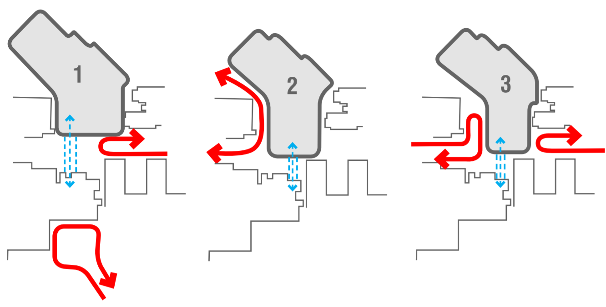
FIGURE 8: SPIRE Access and Entry - Footprint Options

Current Site Footprint
  - The selected option represented a change from the existing proposal. The selected ‘footprint’ (as indicated by Option 1 in Figure 8 and in Figure 9) revealed the following:
    - New physical connection between Building 2 and SPIRE across Hospital Road;
    - Clear main entry to hospital in Building 2, facing Yamba Drive;
    - Public vehicle access to ED via Gilmore Crescent not possible;
    - Self-presentations to new ED from southern part of Hospital Road;
    - Access to National Capital Private Hospital still possible from Gilmore Crescent but not ED; and
    - Ambulance access from Palmer Street.
  - The current proposal was announced on 28 March 2020.
  - It was noted by the Minister for Health that ‘the amendments to the project’s design were informed by discussions with the community, clinicians and consumer groups’:
We know that traffic flow and road safety are of particular interest to the Garran community. Following feedback from the community, the revised design we are releasing today…will reduce hospital-related traffic near Garran Primary School along Kitchener Street and Gilmore Crescent.
  - With connectivity and optimal patient flow a priority, ‘the need for integration of SPIRE into the broader hospital campus, including the clinical and public linkages between SPIRE and other areas of the Canberra Hospital’ was essential and this is apparent in the chosen footprint.
  - It was indicated that ‘connectivity of the new facility to those functions that will remain in other parts of the hospital has been examined during the planning stage and will continue to form part of the design focus’and the selected approach would also mean that:
Once complete, clinical operations will be able to be migrated to the new facility efficiently without the need for protracted and complex staging and sequencing of moves, or dislocation of functions for which close proximity is critical.

Committee Comment
  - It is clear from the site selection process for SPIRE that there was no effective master plan in place for the Canberra Hospital precinct in 2014 and there is not one now. An effective master plan would have considered issues such as the impact of construction on ‘live’ clinical care activities, where space was available to decant services from one site to another prior to construction, relocation of the helicopter landing facility and efficiency of moving patients from one function to another within the hospital. Having an effective master plan in place in 2014 would have avoided a substantial amount of abortive work on expansion options that ultimately did not proceed, as well as avoided years of delay to the expansion. Given the rapid growth in health demand, the complexity of hospital planning and the time it takes to deliver new hospital infrastructure, this is not a failure that should be allowed to happen again.
  - The Committee has made a number of recommendations about master planning in the health context and the current master planning process for the Canberra Hospital precinct. They can be found in Chapter 7, Future Planning.

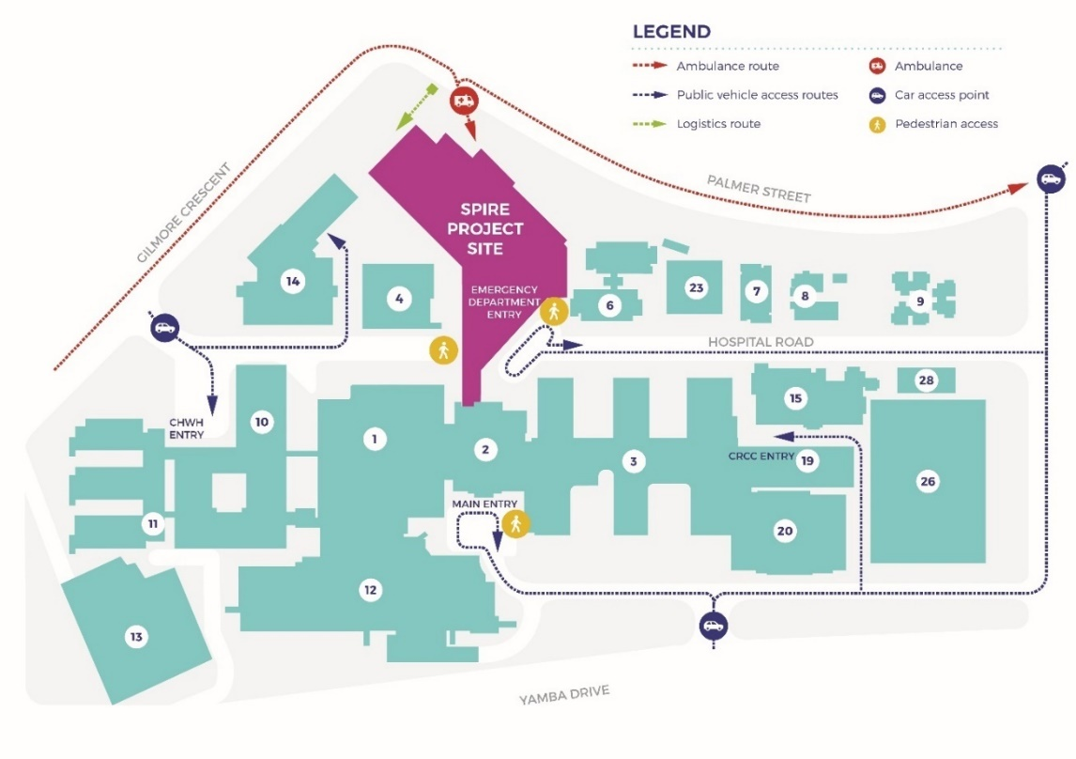
FIGURE 9 : SPIRE Project Site – Footprint

Governance Structure
  - The Governance structure of the project has undergone various iterations with documentation showing that whilst the projects still moved forward there were delays encountered whilst responsibilities were sorted out when the project transitioned from ACTHD to Major Projects Canberra (MPC).
  - The most recent, accessible, iteration of the SPIRE Governance Framework was created in August 2019. It confirms the SPIRE Project's current:
- governance structure, including key groups and individuals;
- governance principles;
- decision types required, the decision-making hierarchy and the associated accountabilities; and
- governance arrangements for project planning, reporting and risk management; and

Under Health
  - The following flow chart (Figure 10) illustrates the governance structure whilst ACTHD had project ownership. ACTHD devised this model for the business case phase. The Infrastructure Finance and Capital Works (ICFW) Division was responsible for project management.
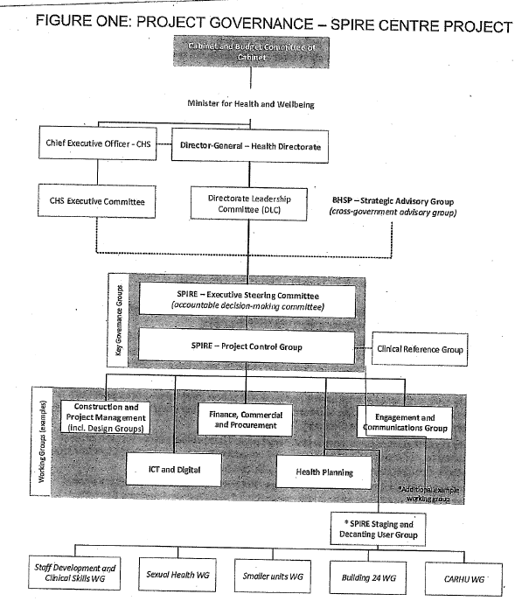
FIGURE 10: SPIRE Project Governance – ACT Health

Executive Steering Committee (ESC)
  - The Executive Steering Committee (ESC) was established to provide the strategic management and guidance for the project. The ESC was the key decision-making body for the SPIRE Project and provides higher level guidance and advice to the Project Control Group (PCG) and Working groups established for the project.

Project Control Groups, Advisory and Reference Groups
  - In addition to the ESC, the following groups were also established:
    - Enabling Works Project Control Group
    - Main Works Project Control Group
    - Clinical Advisory Group (CAG)
    - Consumer Reference Group (CRG)
  - The Project Control Groups had the role of communicating with and providing direction, guidance and oversight to the Working Groups and User Groups for the delivery of the SPIRE Project. They also monitored project performance and reported to the ESC. The current iterations of the PCGs are discussed below.
  - The CAG and CRG and their current iterations are discussed below and in Chapter 6.

Transition to Major Projects Canberra (MPC)
  - Major Projects Canberra (MPC) was established on 1 July 2019 to lead the procurement and delivery of the Territory’s infrastructure program, including SPIRE.
  - The project management of SPIRE, as a Tier 1 capital project, was previously managed by ACTHD, with consultation between Canberra Hospital Services (CHS) management and clinical advisory groups.
  - A Section 16 (s16) Instrument was required to reallocate the 2019-2020 capital budget of $60.2m. This was authorised in July 2019.
  - As of 2 October 2019, MPC had not acquired an ABN and could not bank or pay invoices. As such, ACTHD was still paying invoices for some time after the transition. Issues were still being encountered in 19 November 2019 in transferring some of the monies.
  - A team of five health planners and clinical liaison officers were transferred from ACHD to MPC. This did not include any executive positions.
  - Following the announcement on 16 June 2019 a transition team was put in place from 1 July 2019 with the aim of providing:
…guidance and decisions in relation to the transition of staff from Transport Canberra and City Services, Infrastructure Finance and Capital Works, Health Services ACT in the new agency, Major Projects Canberra (MPC).

Under Major Projects
  - The current governance structure for the SPIRE Project has been refined post transition from ACTHD and post the completion of the business case. The following flowchart (Figure 11) illustrates the governance structure with MPC having project ownership.
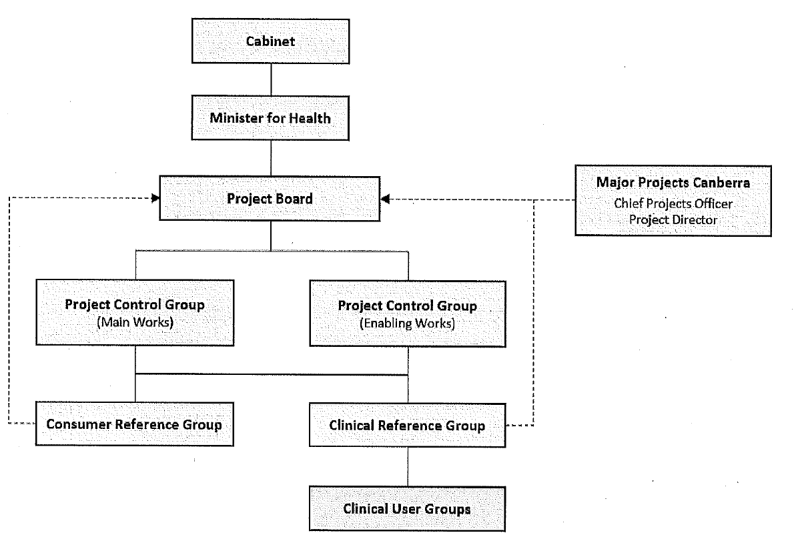
FIGURE 11: SPIRE Project Governance – Major Projects Canberra

Project Board (former ESC)
  - The SPIRE Project Board was established in October 2019 and functions as the key advisory body providing strategic decision-making advice and guidance in relation to the procurement and delivery of the SPIRE Project.
  - The membership is made up of an independent chair, an independent member, and four senior executive level staff from ACT Directorates whose operations intersect in some way with the delivery of the SPIRE Project. It meets monthly.

Project Control Groups and Reference Groups
  - On 27 August 2019, the ESC approved the Project Board Charter and Governance Framework for the Project. These governance documents established the need to create the following subordinate groups:
    - Enabling Works Project Control Group
    - Main Works Project Control Group
    - Clinical Reference Group
    - Consumer Reference Group

Project Control Groups (PCG)
  - The ESC recognised that such a substantial project requires significant project control. Consequently, two Project Control Groups (PCGs) were established:
    - Enabling PCG; and
    - Main PCG.
  - Both PCGs will support the Project Director to manage project planning, delivery and risk. They will monitor project performance and risk and report to the Board, escalating endorsed matters to the Board for approval where necessary.
  - Each PCG may recommend the formation of Working Groups to inform the delivery of projects for endorsement and provide the Project Board with advice regarding various issues. The relative PCG will nominate Working Group Chairs and recommend the membership of each group.
Clinical Reference Group (formally the Clinical Advisory Group) – see also Chapter 6
  - The Clinical Reference Group provides guidance and direction to the PCG and oversight of the User Groups. It will focus on CHS operational considerations and endorse all design and design-related matters at key development points. It will also be the first point of escalation if matters cannot be resolved by the Project Team at the User Group level.
The Consumer Reference Group (CRG) – see also Chapter 6
  - The Consumer Reference Group will provide guidance and direction to the PCG and ensure that consumer views are reflected in the design for the project through engagement with User Groups and other mechanisms. The CRG is advisory and has no formal decision-making powers.
Clinical User Groups – see also Chapter 6
  - In addition to the Clinical Reference (advisory) Group, there are 10 Clinical User Groups focusing on the:
- Emergency Department
- Intensive Care Unit
- Acute Cardiac Care Unit and Interventional Cardiac Laboratories
- Mental Health Short Stay Unit
- Perioperative and Interventional Suite
- Surgical Inpatient Unit
- Helipad
- Medical imaging
- Loading dock
- Central sterilisation.

Committee Comment
  - The Committee notes the changes in the governance and delivery structures within the ACT Government responsible for the delivery of the SPIRE Project and its previous and future iterations. As well as delaying the project, the majority of the committee is concerned that it may have led to some of the confusion about it.
  - The majority of the Committee is concerned that the governance structure is internally focused and incorporates representatives of the government, clinicians and the Health Care Consumers’ Association (HCCA). It does not appear to consider the views of the local community where the project is located.
  - The majority of the Committee were of the opinion that a review of health infrastructure which incorporated the SPIRE Project would be advisable.
Recommendation 3
The Committee recommends that the Auditor General undertake a performance review of the ACT Government’s planning for health infrastructure, including the SPIRE Project, as soon as practicable. In particular the Committee recommends that this is undertaken before the SPIRE Project is finished.
Recommendation 4
The Committee recommends that the ACT Government ensure that governance structures for all major projects require and include meaningful consultation with local affected communities.

Project Documentation

Proof of Concept (PoC) and Business Case
  - Following the government’s agreement on the SPIRE Project’s location, ACTHD engaged health architects (STH) and sub-consultants in December 2018 to undertake a Proof of Concept Report. This included, among other things:
• Planning and site analysis;
• Access and linkages, including ambulance, logistical and public access;
• Operational and clinical linkages;
• Functional relationships (facility planning);
• Urban design and place making (neighbourhood character);
• Aviation review (including noise impacts and flight paths); and
• Building, structural, acoustic and fire engineering analysis.
  - Ernst and Young were engaged in December 2018 to draft the Business Case which was presented to the ACT Government for Cabinet approval in April/May 2019.
  - The Proof of Concept report was completed on 26 July 2019.

Preliminary Sketch Phase (PSP)
  - The Preliminary Sketch Phase (PSP) is being undertaken by STH.
  - Comments and feedback from the PoC design phase will be addressed as part of the PSP stage.

Models of Care (MoC) and Health Planning Unit (HPU) Briefs and Schedule of Accommodation (SoA)
  - In February 2018, ACT Health engaged Healthcare Management Advisors (HMA) to develop Models of Care (MoC); Health Planning Unit (HPU) Briefs and a draft Schedule of Accommodation (SoA). This request applied to the proposed location at the existing helipad site.
  - Extensive engagement with clinical stakeholders was conducted between February and April 2018 with the project concluding in April 2018.
  - The MoC’s did not go to final endorsement due to the planning activities in 2018 ‘to refine the infrastructure solution for SPIRE’. Soon after ACT Health split into CHS and ACTHD, with CHS holding onto the MoC’s and ACTHD holding onto the HPU’s.
  - The intention was then to get the documents reviewed and validated, by June 2019, so as to inform the Integrated Service Delivery Plan and functional brief. However, by October 2019 the documents still had not been signed off.
  - Subsequently a Request for tender to review MoC, HPU and other related documentation was sent out between 18 July 2019 and 6 August 2019 and requested that the review was completed by the end of 2019.
  - At various stages in the project to date there have been a number of consultation plans, programs and strategies. Some have been specific to the phase of the project whilst others have been reviewed and update as a result of the transition from ACTHD to MPC. Chapter 6 is devoted to discussions on these consultation plans and processes.

Design and Construction Tender
  - The procurement of a contractor to design and construct SPIRE Project is being conducted under a Two Stage Procurement process (Expression of Interest (EOI) and Request for Documentation (RFD)) with Early Contractor Involvement (ECI) form of delivery.
  - As per Figure 12, the contractor under an ECI will develop the design ahead of submitting a fixed prices offer to deliver the project. As part of that process the head contractor will refine the operational requirements of the key medical and user stakeholders, then translate them into the overall design. The head contractor will then be responsible for the procurement, delivery and commissioning of the associated capital works.
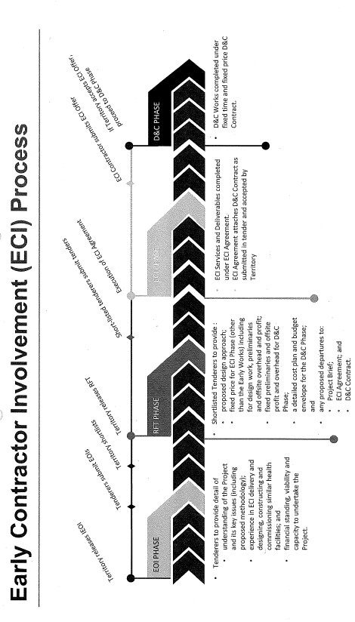
FIGURE 12: SPIRE Early Contractor Involvement (ECI) Process
  - Following an industry briefing on 24 October 2019, the SPIRE Project released an Invitation for Expression of Interest (IEOI) to the market in mid-November 2019 (endorsed by the Government Procurement Board in September 2019) which closed in December 2019.
  - The five applicants were reduced to a shortlist of two parties. These were announced in December 2019 as:
    - Lendlease Building; and
    - Multiplex
  - Both were issued with a Select Request or Proposal (RFP) in May 2020. This closed in June 2020 with the successful appointment announced in late 2020. A contract is expected to be entered into in early 2021.
  - On 11 August 2020, the successful tender was announced as Multiplex.

Project Timeline
  - As per Table 5 and Figure 13, the ACT Government has given a commitment to complete construction of the SPIRE Project by mid-2024, with main works construction commencing in early-2021. The current indicative program shows:
Project Phase | Project Stage | Estimated Period
Definition | Needs analysis | 2016 - Q3 2019  (completed)
Definition | Proof of Concept Design | 2016 - Q3 2019  (completed)
Definition | Business Case | 2016 - Q3 2019  (completed)
Enabling Works | Staging and Decanting and site preparation | Q3 2019 - Q4 2020
Project Design | Pre-tender design | Q4 2019 – Q2 2020
Project Design | Post-tender design by contractor | Q3 2020 – Q2 2021
Main Works Procurement | Main ECI tender process | Q4 2019 - Q4 2020
Main Works Procurement | Detailed design and fixed price offer | Q4 2019 - Q4 2020
Main Works Delivery | Main construction stage | Q1 2021 - 2023/24
Main Works Delivery | Building commissioning and acceptance | Q1 2021 - 2023/24
Clinical Commissioning | Preparations for operational commencement | 2023/24
TABLE 5: Project Timeline
  - Schematic designs for the SPIRE Project will be developed by the Territory during the period prior to the engagement of the ECI Contractor and thereafter will be further developed and finalised (including obtaining Development Approvals) by the ECI Contractor.
FIGURE 13: SPIRE Project Timeline
  - The HCCA indicated that they had concerns about the timeframes that have been forecasted:
HCCA is concerned that an unrealistically tight timeline means that there are a number of important processes to develop or update key planning documents running concurrently with SPIRE design development work and the procurement process. Best practice is that these processes should proceed sequentially, not concurrently. For example, work on updating Models of Care and Functional Briefs, which are key planning documents to inform work on Preliminary Sketch Plans, are still to be finalised despite design development work being underway for some time. Ideally, a Master Plan for the Canberra Hospital would also have been finalised prior to decisions about site and design of SPIRE being made.
  - Women With Disabilities ACT (WWDACT), concurred stating:
Project timelines for planning documents such as the updated Models of Care have overlapped with work already being completed on the designs which they are to inform…
  - Both the WWDACT and the HCCA expressed concerns that the compressed timeframes will impact on the capacity for the SPIRE Project to deliver high quality and safe health care for consumers:
    - as it does not allow sufficient time for Major Projects Canberra to undertake effective consumer engagement.
    - does not accommodate the time organisations such as HCCA and the Mental Health Consumer Network require to identify and train consumer representatives for clinical user groups.
    - does not allow health consumer organisations to seek input from their broader membership base.
    - has the potential to put undue pressure on already busy CHS staff and could lead to decisions being made without sufficient time to properly consider important clinical issues.

Committee Comment
  - The Committee agrees with numerous submitters that it would have been preferable for the project to proceed in an orderly fashion with the master plan being completed before the specific and detailed project documentation and allowing ample time for clinical, consumer and community consultation.

Development Applications for SPIRE Development
  - There has been no Development Applications (DA) submitted for the main development site for SPIRE as yet. However, a DA for demolition of some existing buildings in preparation for the SPIRE building has been approved and demolition commenced. The DA for the design and construction of Building 8 was submitted in April 2020.
  - ACTHD recognised the importance of development approvals and thus early engagement with the Environment, Planning and Sustainable Development Directorate (EPSDD) was sought in January 2019, albeit also in an effort to have the DAs for the SPIRE Project prioritised.
  - As part of the DA process it will need to be considered by the National Capital Design Review Panel (NCDRP).
  - The business case anticipated consultation with stakeholders prior to the submission of the DA. It also anticipated concerns and objections relating to:
- Palmer Street
- Garran Primary School on Gilmore Crescent
- The relocation of the helipad from the north-west corner of the campus to the roof of the new SPIRE
- Height and set-back restrictions.
  - In line with the ‘principles underpinning the ACT Aboriginal and Torres Strait Islander Agreement and the approach taken in the development of the University of Canberra Hospital MPC will also engage with the United Ngunnawal Elders Council to ensure the development respects and celebrates Ngunnawal culture.
  - A submitter to the inquiry also suggested that in line with the ACT Government Climate Change Strategy 2019-2025 that ‘SPIRE and the broader hospital campus are designed and built to respond to the changing climate by reducing carbon emissions, improving energy efficiency and creating liveable and climate change resilient buildings’ and ‘that SPIRE be an environmentally sustainable and healthy building which adopts a wide variety of “green building” tools and resources related to healthcare.’
  - HCCA noted that, ‘access to natural daylight and views of the outdoors have been found to improve patient outcomes by improving sleep, reducing stress and anxiety, and alleviating pain and reducing the use of pain medications.’ They told the Committee that initial designs for the SPIRE Project included natural elements but were concerned that cost pressures may lead to in access to light and outdoor spaces not being part of the final design.
Recommendation 5
The Committee recommends that the ACT Government ensure that the SPIRE building is built to high environmental standards. In particular the design and construction should be consistent with the ACT Government Climate Change Strategy 2019-2025.
Recommendation 6
The Committee recommends that the ACT Government ensure that the SPIRE building has access to natural daylight and views of the outdoors.

Site Activities

Workstreams
  - The SPIRE Project includes two significant workstreams:
1.the SPIRE Main Works -the planning, design, procurement and delivery of the new emergency, surgical and critical healthcare facility and the process of clinical commissioning that will follow completion of construction; and
2.the SPIRE Enabling Works (Figure 14) -the planning, design, procurement and delivery of multiple projects necessary to facilitate the decant from and demolition of Buildings 5 and 24.
  - These two workstreams confused many as it appeared construction had started when in fact it was only enabling works such as demolition, staging and decanting.

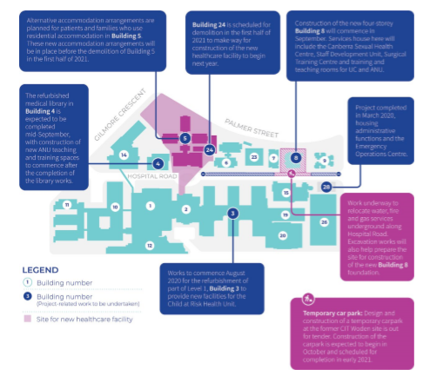
FIGURE 14: SPIRE Project - Enabling Works

Building Demolition and Construction
  - The DA (201936089) for the demolition of Building 5 on Hospital Road, and Buildings 8 and 24 on Palmer Street (see Figure 15) was submitted in September 2019.
  - STH was contracted in February/March 2019 to undertake the preparation of both the DA and future tender documents for the demolition.
  - The demolition includes more than 9,000 squares of floor space, surrounding paved areas, approved tree as well as the disconnection of services disconnected and landscaping of affected areas.
  - An article in RiotACT on 29 October 2019 claimed the demolition is expected to cost $2,773,800.
  - The DA for the demolition of Building 28 was submitted in August 2019.
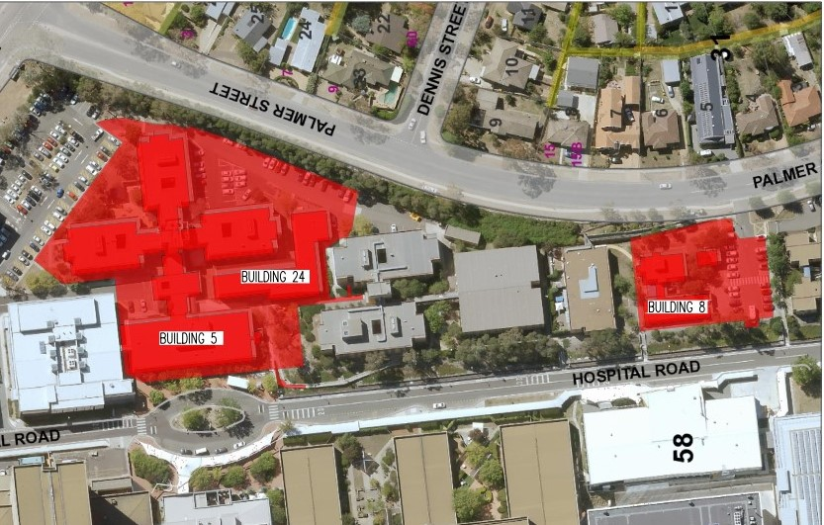
FIGURE 15 : SPIRE Project - The buildings to be demolished to make way for SPIRE

Canberra Institute of Technology Carpark Construction
  - The DA for the design and construction of the carpark at the former Canberra Institute of Technology (CIT) campus (see Figure 16) was submitted in May 2020.
  - A request for tender for the design and development was released on 21 July 2020 with documents due by 28 July 2020. The completion date has moved from late 2020 to early 2021.
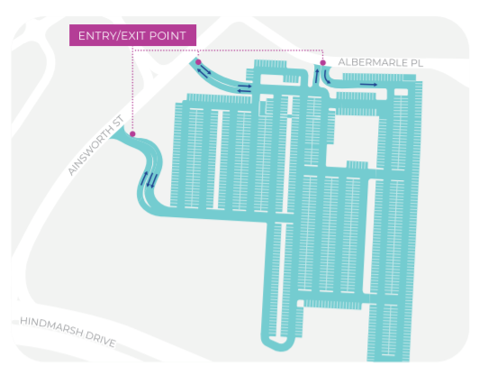
FIGURE 16: SPIRE Project – Car-Park Development – Former Woden CIT

Refurbishment
  - At the time of writing of this report, Building 4 and Building 3 were being refurbished to facilitate the new accommodation arrangements.

Staging and Decanting (Bldg. 5,24 & 8)
  - The staging and decanting program was drafted by STH to provide information on:
    - Demolition of buildings and relocation of services; and
    - Staff movements to new locations.
  - The timeline for the process was stipulated as per Table 6:
February-October 2020  - move out  - refurbish/construct new location | March-August 2020  - relocate | August-December 2020  - demolition
TABLE 6: Staging and Decanting Timeline

Building 5
  - Building 5 was occupied by the following organisations who would be relocated in a variety of locations as per Table 7:
Organisation | New Location
ANU Medical School – training and admin | B8 Modular and B4
Accommodation and Volunteers | B3
Sexual Health Unit | B8 Modular
Child at Risk of Harm Unit | B3
Staff Development | B8 Modular
Clinical Skills Unit | B8 Modular
Clinical Placement Unit | B8 Modular
Tissue Viability | B3
Meeting and Training Rooms | B8 Modular
TABLE 7: Building 5 Relocations

Residential Accommodation Services
  - One of the tenants, Residential Accommodation Services (RAS) currently houses interstate consumers travelling to the ACT to receive care and to care for unwell family membersand there was an imperative that any ‘future accommodation options are provided at low cost on campus or as close to the campus as possible, and that, if required, transport needs are met.’
  - A consultation process in relation to the process to decant and relocate Residential Accommodation Services and provide suitable accommodation was undertaken by Communication Link (see Appendix D for work order). This involved:
    - The engagement and consultation across the region, including Goulburn, Bega and Batemans Bay;
    - Workshops, media, online survey’s and final report.
  - The consultation resulted in the following options being proposed:
I. repurposing some of the existing doctor’s accommodation located in Building 9 to be used as a place for patients and carers to stay while attending treatment at the Canberra Hospital. This would also accommodate emergency residential requirements following trauma incidents involving interstate consumers
II. increasing the occupancy level of Duffy House to maximise the available space
III. negotiate with local hotels close to the Canberra Hospital.
  - Whatever solution is adopted, the HCCA noted that there was a need for residential accommodation for patients and families to be available on the Canberra Hospital campus and that it was ‘important to ensure that proposed changes to accommodation do not result in a move away from providing the level of accommodation support currently available.’

Australian National University
  - One of the other tenants of Building 5, the Australian National University will be constructing a training facility on the Canberra Hospital campus that looks to complement the SPIRE building.
  - Even though a site is yet to be confirmed the facility is planned to boost the teaching, training and research presence on the Canberra Hospital campus:
This investment by the ANU means Canberra and the SPIRE Centre will be very attractive to the best and brightest students and clinicians nationally and internationally who want to do their medical training and research in a modern, state-of-the-art facility.

Building 24
  - Building 24 was occupied by CHS. The affected personnel are to be relocated to B28 - a purpose built demountable.

Building 8
  - Following the demolition of Building 8 construction work will commence in September 2020 for a new four storey building on the site (Figure 17) with:
…local company SHAPE Australia (Pty Ltd.) selected to deliver the work. This project is expected to support more than 100 jobs during construction and the project is anticipated to be completed in the first half of 2021.
  - This building will house the Canberra Sexual Health Centre, Staff Development Unit, Surgical Training Centre and training and teaching rooms for the University of Canberra and Australian National University.
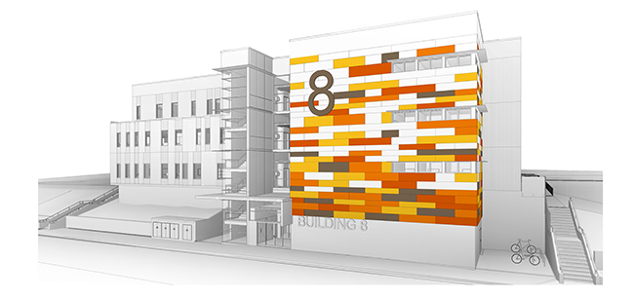
FIGURE 17: SPIRE Project – Building 8

Committee Comment
  - The Committee believes that given the urgent need for additional space at the hospital for critical clinical care and the extensive work already underway for the SPIRE facility, it is likely to be too late to make significant changes to address the concerns of stakeholders. This is a deeply unfortunate situation that needs to be avoided in future.

Development Concerns

Helipad and Helicopters
  - Between July 2013 and August 2017 there has been 1788 helo missions involving Canberra Hospital. This included 161 referring and 1627 receiving. A Helipad MoC workshop on 3 September 2019 noted that two helipads were considered as essential, however, the current functional scope for the SPIRE Project has only one helipad planned.
  - Whilst it was appreciated that the helicopter is a vital part of hospital services, particularly critical care, there was concern about the noise generated by the helicopters flying 24 hours each day seven days a week ‘during take-off and landing and during hovering and waiting periods.’
  - It was noted in a letter to City News in October 2019 that:
When the helicopter service was proposed the approach and take off were to follow Hindmarsh Drive or Yarra Glen. This does not happen and at night Kitchener Street lights are used as a landing strip. Although the service saves many lives it covers an enormous area of more than a 200-kilometre radius. Needless to say, it has outgrown the original intention of sporadic use.
  - It was felt by many submitters that with over 600 flights per year the proposed ‘new location of the helicopter pad on the top of the SPIRE building’ would have an impact on ‘neighbouring homes, and the neighbouring primary school’s learning atmosphere and playground‘
  - Local residents, through the GRA, noted that it was ‘important for relevant risk assessments to be completed and mitigation measures identified and communicated to the local community’ but told the Committee that their concerns about the helipad’s relocation had not been addressed and they were seeking answers to the following questions:
    - What will the helicopter flight path be for the SPIRE helipad?
    - In the case of an emergency with the helicopter itself, where will the emergency landing area be?
    - Where will the “overflow” for the helipad be?
    - What impact will the downdrafts from the helicopter have on homes and the school and its’ playground?
    - Will residents within a pre-determined radius offered appropriate noise insulation?

Transport and Site Access
  - Local residents, through the GRA, informed the Committee that:
Ever since the then Woden Valley Hospital was opened in 1973, there has been significant and broad community concern about the traffic and safety at the interface between the residential part of the suburb and the hospital. This has become significantly worse in the last five years. It been well documented and regularly brought to the attention of the hospital and relevant government departments/directorates. We feel that the community’s concerns have not been adequately addressed over the decades as the hospital has always had priority. The community has understood and has adapted to this situation. However, as the hospital has grown and changed from being a secondary hospital to a tertiary referral hospital, the level of traffic and corresponding concern, have grown. In this regard, the concerns have reached a point that we feel it warrants community action to ensure the safety of vulnerable people and the general community are no longer ignored or taken for granted.
  - Whilst some concerns raised by submitters in a variety of forums have been alleviated by the revised access and entry routes as incorporated into the site footprint announced in March 2020, there are ongoing concerns about issues relating to increased traffic in residential streets and around schools. It was highlighted by one submitter that the ‘inherent nature of hospital, and suburban residential, and school traffic are very different.’
  - Of primary concern in this context was that the ‘proposed SPIRE Centre with its range of services will vastly increase the amount of traffic on Kitchener Street, Gilmour Crescent and Palmer Street.’
  - In February/March 2019, a consultant assessment paper relating to vehicular access and entry considerations for SPIRE was drafted (see Appendix C).
  - This report identified that:
    - Gilmore Road is unfavourable for any form of access due to the limited frontage between the Hospital Road and Palmer Street;
    - Palmer Street provides a suitable access location for ambulances, as it is separated from the existing activity on Hospital Road and paramedics would be informed of the location prior to use, reducing the need for it to be in an obvious location;
    - Hospital Road provides the most logical access for the public vehicles as the. road infrastructure is already ·in place and well established. Directing traffic to an independent access for a specific purpose can be difficult with regard to wayfinding and orientation;
    - The vast majority of vehicles on Hospital Road are traveling at 30kph or below, with most of the remainder between 30-40kph. This reasonably dense, slow moving traffic in a constrained road corridor (i.e., not much room to overtake etc.) is a problem for ambulances. However Palmer Street, albeit with approximately double the volume of traffic is wider and is likely to be more free flowing conditions allowing cars to pull over to allow an ambulance to pass.
  - Another traffic study was referenced by the Minister for Health on 24 October 2019, when she stated in the Assembly that ‘traffic analysis work is currently underway [and] will be shared with the community at the earliest opportunity upon its completion.’
  - This was reiterated in the Government submission which indicated that:
MPC is undertaking an extensive survey of traffic in and around the Canberra Hospital site to build on the work done during the concept design stage. The data from this survey will be analysed and used to generate pre and post-SPIRE traffic models. This analysis will be used in ongoing community consultation and design activities.
  - Whilst it is not clear how and when the relevant studies were conducted but, as Figure 18 suggests, and as has been reported online, the ACT Government has indicated these studies show that:
    - Volume of traffic on Gilmore Crescent will decrease;
    - Volume of traffic on Palmer Street expected to have no substantive change; and
    - There will be a small addition to normal volume of Ambulance’s on Palmer Street.
  - The ACT Government asserted that these findings would be complemented by a ‘reduction of hospital-related passenger motor vehicle movements along Kitchener Street and Gilmore Crescent’ when the ‘54 staff and fleet carparking spaces and 86 short-stay public parking spaces at the northern end of the campus’ were closed and replacement parking would be ‘accessed predominantly from Yamba Drive and Hindmarsh Drive.’
  - However, a presentation to the ACT Ambulance Service on 15 March 2019 identified that the proposed site:
• Adds traffic activity to Palmer Street (and associated siren noise)
• Potentially adds activity along the school frontage if the secondary route shown is used.
  - The ACT Government’s submission noted that ‘traffic impacts as well as parking demand and provision will be formally considered by the planning and land authority and Transport Canberra and City Services (TCCS) as part of the development assessment process’ and it is likely that any mitigation measures to ensure safety of students and residents would be considered as part of this process.
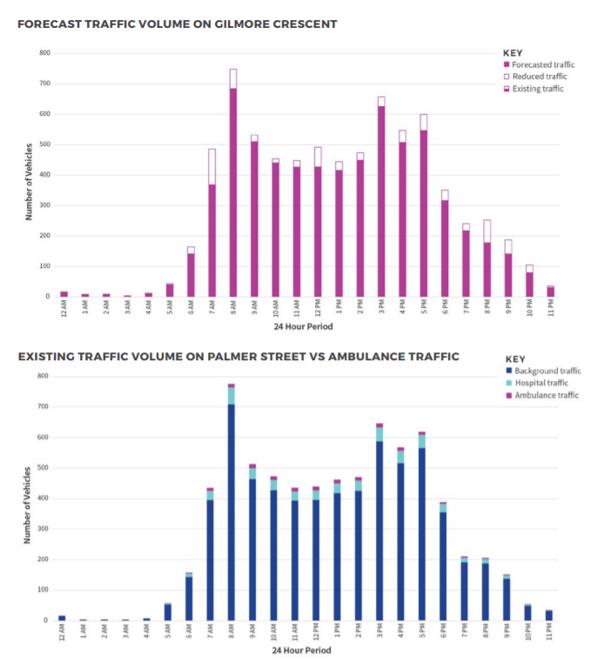 FIGURE 18: SPIRE Project – Traffic Analysis

Public Transport
  - WWDACT informed the Committee that whilst:
…community transport or the taxi voucher scheme are available to assist some women* with disabilities, there are barriers to accessing these, including where you live, diagnostic barriers, lack of information and the restrictive timings of the services. These services should not be relied on to fill the gap where well planned public transport infrastructure could otherwise do so.
  - However, it was noted in submissions that there are elements in the design that do ‘not appear to have regard to the mobility needs of people unable to access the site using a private motor vehicle’ particularly as the layout of the Canberra Hospital campus means that Hospital Road is the only suitable location which allows exit from public transport, taxis and drop offs onto a level surface.
  - This was of particular concern, as WWDACT noted, with ‘previous disruptions in access via Gilmore Crescent have caused major access issues for people with mobility and vision impairments.’
If access is cut off via Gilmore Crescent, it will impact the accessibility of public transport for people with disabilities. Previously, buses have dropped people off on Yamba Drive or on Gilmore Crescent, both of which have steep inclines or long distances to get to the main buildings, creating a significant barrier for people with mobility issues.
  - Whilst the Canberra Hospital is serviced by the R6 Rapid route, the Canberra Hospital is 2km from the Woden bus interchange which is a longer walk than most patients and visitors are able to or are prepared to undertake if they cannot get a direct service.
  - During consultation in 2017 about the preferred route for Light Rail Stage 2, about half the respondents preferred a route via the hospital. This option did not proceed due to constraints with the terrain.
  - The HCCA highlighted the need for:
    - the hospital to be accessible by public transport as a viable alternative to the car;
    - public transport options to be available after business hours and on the weekends as well as the usual business hours; and
    - seating to be provided along the way between the car park, bus stop and hospital entries.

Private Transport
  - It was noted by Dr Soh that it is ‘important to acknowledge that not all traffic is equal’ and that traffic studies and ‘mere counting of vehicles’ would not be able to capture the driver distraction that accompanies ‘people driving to and from the ED [who] are often unwell themselves or concerned for a family member or loved one who is acutely unwell and therefore unlikely to be driving at their optimum ability.’
  - With increased volumes of traffic likely on Gilmore Crescent and Palmer Street with the proposed SPIRE footprint, The Garran School Board also raised the likelihood that ‘this traffic will be even less predictable and safe than that already being encountered.’ They also expressed concerns that there could be adverse consequences involving a distracted driver ‘under stress driving during an emergency situation’, particularly in a school zone.
  - Mari Kondo concurred, telling the Committee:
These drivers are highly likely to be distracted by either their own pain or the distress of a loved one that they are transporting to the hospital. We all know the danger posed by distracted drivers.
  - It was a common view that ‘building SPIRE in the proposed site near Palmer Street will make access to hospital services much harder’ for many using private vehicles and not just for those accessing the Emergency Department.
  - A submitter observed that when she travels to the ED she is ‘grateful’ that she has ‘such a wide knowledge of the hospital, its layout and services’ as ‘negotiating tricky suburban streets to find the SPIRE building at the proposed site’ would add another level of anxiety. When trips to an ED are needed many people self-presenting are in a heightened state so easy access is important and access from Yamba Road is much more straightforward.

Recommendation 7
The Committee recommends that the ACT Government ensure the Canberra Hospital provides clear and explicit direction at all entry points for people attempting to access the emergency department who are not in an ambulance.
Recommendation 8
The Committee recommends that the ACT Government ensure the Canberra Hospital provides sufficient short term parking for people attempting to access the emergency department in a private vehicle to ensure that the patients can be safely delivered to the emergency department.

Emergency Vehicles
  - It was documented in the SPIRE Project documents that Ambulances require minimal friction on the approach to the Hospital, which is possible when there is sufficient space available for vehicles to move out of the way of an approaching Ambulance. Consequently, it was noted that road width/size is an important factor in the selection of an access location for emergency vehicles.
  - It was noted in traffic studies that:
The access within the Hospital should be separated from all other vehicle user groups which ensures that the access is always available for rapid access. This also assists with wayfinding, in that the public can be clearly directed away from the emergency access (passive separation), while the emergency access itself can be signposted as No Entry for general traffic (active separation)…The access should ideally be located with a short internal connection to the ED.
  - In this context a number of submitters observed that:
…the emergency vehicle access to the new building will be off Palmer Street. This is better than being directly opposite the primary school and it gives access from Yamba Drive but neither Palmer nor Gilmour Streets are designed for such a function and are not suitable for such a function.
  - It was further noted that the proposed emergency vehicle entrance on Palmer Street ‘effectively diverts all the ED traffic away from a major road (Yamba Drive) and on to suburban residential roads’ and potentially puts heavy vehicles servicing the hospital outside the primary school.
  - Mari Kondo told the Committee that:
Both Gilmore Cres and Palmer St are residential streets with lots of foot traffic as well as cars parking to pick up/drop off children at Garran primary school. It makes no sense to turn residential streets into access routes for Australia’s 3rd busiest emergency department.
  - She also noted the anomaly in that:
Access to the emergency department from Yamba Dr ensures a shorter travel time for ambulances compare to driving around Hindmarsh Dr then onto Palmer St, a small residential street…
  - Canberra Hospital can currently be accessed ‘from the duplicated north south and east west road corridors’ and ‘Yamba Drive [is a] main arterial road that is easily accessible from all directions’ however, with the proposed new access and entry points it was felt that it was likely that people from most areas across Canberra ‘will be required to travel further to reach Emergency.’ There was concern this could have negative impacts on the outcomes of many ‘time-sensitive health conditions, such as heart attacks, trauma, and stroke.’
  - It was noted that Palmer Street was not designed to take this type of traffic. Many submitters highlighted its topography and noted the intersection with Dennis Street at the crest of a rise only adds to its unsuitability. The Committee was informed that:
Palmer Street in Garran presents a number of significant traffic hazards and there is no wisdom at all in the proposal to add new entry points for ambulances and services off this street. Palmer Street is a narrow suburban street, with difficult topography because of the rise in land level and it already has visibility problems for vehicular and pedestrian traffic. The close proximity of the proposed ambulance and service entry points to Garran Primary School and the busy intersection of Palmer Street and Gilmore Crescent poses serious safety issues which definitely need a re-think.
  - The GRA further stated that:
It is therefore not a logical proposal for a tertiary referral hospital (which is specifically being redeveloped to increase its capability), to have its entry for emergency vehicles off a minor residential road…Palmer Street is narrow and the topography inhibits visibility, especially at the intersection with residential Dennis Street. Retaining access to the campus from the main arterial roads by all hospital traffic will ensure the safety of local residential and school traffic, and reduce associated noise from sirens and delivery vehicles.
  - One submitter outlined to the Committee the difficulties Ambulances could face accessing the ED irrespective of the access and entry configuration with all scenarios showing ‘an interrupted flow of movement for the ambulance in its closing approach to the emergency destination’:
Difficult turning Right onto Palmer from Hindmarsh - This is a difficult turn with only a single lane. Emergency vehicles will be hampered in making this turn if other vehicles occupy the lane ahead of the Ambulance.
Difficult turning Left onto Palmer from Hindmarsh - Again this is a single lane for the left turn, needing to give way to traffic from the right. Emergency vehicles will be hampered in making this turn if other vehicles occupy the lane ahead of the Ambulance, and I other vehicles are stopped at the lights travelling to continue straight ahead on Hindmarsh.
After entering Palmer from Hindmarsh - Ambulances will be challenged by movements at the T-junctions, for the Gaunt Pl entry and the Bateson Rd hospital entry. Mixed in with other slow moving vehicles negotiating their turn and waiting for others to turn, the ambulance will be forced to be slow moving.
While being slow moving there will be a tendency to overuse siren(s). In this area the slow moving ambulance with siren sounding will be a noise disturbance. The childcare centre adjacent to Bateson Rd will be particularly affected, possibly causing unnecessary anxiety within the children and nearby residents.
On the final approach to the SPIRE entry the ambulance needs to pass by the heavily used right hand turn Palmer Dennis T-junction. This T-junction on a crest with impaired sight to cars waiting to turn right Palmer into Dennis, the ambulance will have two choices.
First if possible stay left and squeeze past the right hand turn waiting car facing opposing traffic up the hill on Palmer, or second and most commonly the waiting car will be uncomfortably positioned in the centre of the lane, forcing a frustrated ambulance driver to stop behind. This bottleneck notwithstanding the use of siren(s) will frequently cause inconvenient frustrating ambulance movement interruption.
Approach to Palmer from Yamba - Turning left from Yamba onto Kitchener again is another difficult turn similar to the left turn onto Palmer. This is a single lane for the left turn, needing to give way to traffic from the right. Emergency vehicles will be hampered in making this turn if other vehicles occupy the lane ahead of the Ambulance, and if other vehicles are stopped at the lights travelling to continue straight ahead on Yamba.
Now on Kitchener the ambulance needs to turn right onto Gilmore. Again the ambulance will at times be forced to give way, unless sirens are sounded, which if so will be unnecessary noise disturbance.
Now on Gilmore the ambulance is travelling through a 40kph zone, needing to negotiate the primary school pedestrian crossing. Maintaining heightened alertness in this area for any unexpected movements, the ambulance will at times be interrupted in its progress unless sirens are sounded, which if so will be unnecessary noise disturbance.
Finally the turn right from Gilmore onto Palmer, is awkwardly sloped and again require another give way, unless sirens are sounded, which if so will be unnecessary noise disturbance.
On Palmer, nearly there now but needing to turn right into the SPIRE entry, the ambulance may again be interrupted if needing to give way, unless sirens are sounded, which if so will be unnecessary noise disturbance.

Committee Comment
  - The Committee agrees with submitters that emergency access via residential streets is not ideal. However, given the chosen SPIRE site, it is likely to be unavoidable in the current phase of hospital expansion. The hospital precinct will, however, continue to expand and change over time and consequently the ambulance access situation should be addressed in the master plan for the site with an eye to using future expansions to relocate it.
Recommendation 9
The Committee recommends that the ACT Government ensure that the master plan process investigates options for relocating ambulance access from residential streets which can be delivered through future expansion projects.

Parking
  - Parking at Canberra Hospital has been an issue for many years and it was observed by submitters that ‘the problem of hospital staff and visitor parking reaches further than the local area, having impacts on local streets and the free parking at the Garran Shops.’
  - In particular it was noted that ‘parking is currently a significant issue for women* with disabilities at the Canberra Hospital campus.’ Issues that have been encountered include:
    - all the accessible parking spots to be taken in the multi-storey carpark, particularly from 10am to 2pm on weekdays;
    - lack of parking near the entrance to the ED, particularly for people with disabilities;
    - issues accessing the courtesy bus;
    - lack of knowledge of the courtesy bus;
    - poor signage, and a lack of accessible wayfinding tools; and
    - lack of seating along pedestrian routes between entrances, car parks and transport.
  - Additionally, it was noted that:
WWDACT members have expressed frustration with the confusing design of the existing multistorey carpark including poor wayfinding signage, bollards that physical accessibility, lifts that are too small, not enough dedicated disabled spaces, narrow access ramps, confusing layout and long walking distance from the entrance. We recommend that this design is not replicated elsewhere on campus.
  - Local residents noted previous reviews of traffic issues around Garran Primary School have identified:
1. lack of safely accessible parking, and
2. congestion caused by parents attempting to access the limited kerb drop-off and pick-up spaces.
  - Whilst the school ‘provides off-street parking for staff and a very limited number of visitors’ it was observed by the Garran Primary School Board that once these are full, ‘school visitors have always had to compete for the on-street parking spaces with hospital visitors.’ Currently parking spaces on both Gilmore Crescent and Palmer street narrows both these roads, which makes the bus transport difficult.
  - The Government noted that since the SPIRE Project had been announced:
To alleviate parking and traffic pressures within the Canberra Hospital precinct during the SPIRE Project’s construction phase, MPC is constructing a temporary carpark near Canberra Hospital at the former CIT Woden campus. The new carpark will primarily be for the use of hospital staff and will provide approximately 1100 additional spaces. It is intended that this will free up additional parking on the hospital campus for patients and visitors, which would be accessed primarily from Yamba Drive.
  - This was welcomed by WWDACT. However, they also noted that ‘a long-term solution for parking on or near the campus needs to be found.’
  - It was indicated by MPC that a master plan would address a permanent parking solution for the precinct.

Pedestrian and Student Safety
  - Garran Primary School Board noted that:
The limited capacity of Gilmore Crescent, particularly at peak times of school drop-off and pick-up, is already a cause for concern by the school. There is insufficient space within the school grounds, in the current configuration, to significantly mitigate this congestion. The school board already holds very serious concerns for the safety of students, families and staff travelling to and from the school, particularly during these times.
  - The Committee were informed that ‘the risk to public safety from locating a hospital emergency department on residential streets and opposite a primary school is unacceptably high.’
The risk is not from ambulances: their drivers are well trained and highly skilled. The risk is from all the other vehicles rushing to take some-one to emergency. The drivers of these vehicles will be worried and distracted.
They are likely to be going fast. They are very likely to ignore the 40kph speed limit in the school zone. Consequently, they will pose an unacceptably high level of risk of injury and death, particularly to school children.
  - The amount of traffic was also a concern:
The significant increase in vehicular traffic along Gilmore Crescent brought about by the proposed Palmer Street access points, creates a significant safety issue for students of Garran Primary School which fronts onto Gilmore Crescent.
  - The access for foot traffic to and from the ED also raised some health and safety concerns with one submitter suggesting that foot traffic would need to be discouraged from leaving the SPIRE Centre towards the Gilmore Crescent and Palmer Street boundaries.
  - The Committee were also told that a reconsideration of the introduction of mechanisms to support ‘Active Travel’ would be needed, and that this would have an impact on students and residents alike. The GRA noted that:
ACT Health’s “Ride or Walk to School” Program also actively encourages and supports school children walking or riding to and from school. As outlined previously, the streets around SPIRE will become significantly more dangerous for children given the increase in traffic and the nature of the vehicles. This is likely to inhibit the use of active transport at a time when children could be developing positive habits around active travel that could last a lifetime, providing various other co-benefits in terms of health and wellbeing.

Wayfinding
  - The WWDACT highlighted the sentiments of many submitters, noting that:
The current Canberra Hospital Campus is often reported to be confusing, inaccessible and hostile to patients and visitors. This is partially because there has been no coherent plan behind the development of the campus and patient journeys have not been considered in the set-up of the campus.
  - The Committee were told that this results in difficulties for those with disabilities and mobility issues. In this context submitters expressed concerns about:
I. accessibility to SPIRE, especially the ED, for consumers of all abilities.
II. the distance consumers are required to walk from carparks or bus stops, which can be a burden for ill, elderly or disabled patients, carers and visitors. Consumers are concerned that SPIRE will exacerbate the current situation.
III. the need for the hospital to be accessible by public transport as a viable alternative to the car. Public transport options need to be available after business hours and on the weekends as well as the usual business hours.
IV. the need for seating to be provided along the way between the car park, bus stop and hospital entries.
V. lack of parking options near the ED requiring people to drop off very sick family members who may then have to wait unattended until the person has parked their car and returned to ED.
VI. insufficient parking, including disabled parking, particularly during the period of 10.00am to 2.00pm on weekdays.
VII. the need to provide additional parking for people with disabilities or who have mobility issues as close to hospital entry points as possible including the ED, the Hospital Main Entry and the Centenary Hospital for Women and Children.
VIII. whether the hospital courtesy bus is accessible to consumers of all abilities. Some consumers have indicated that they are currently unable to use the courtesy bus because of their disability
IX. issues with signage and way finding, including the need to provide signage and directions in an accessible format.
X. The impact of increased traffic flows and demand for parking in Palmer St and Gilmore Crescent; and impacts on traffic flow on Hospital Road during and after the construction of SPIRE.
XI. Two new entrances to Canberra Hospital (the public entrance and entrance to the ED) will add further confusion about the “front door” of the hospital for consumers navigating the campus.

Committee Comment
  - The ACT Government appears to be taking a narrow approach to traffic and transport issues, focussing solely on direct hospital impacts on surrounding streets. However, this does not recognise the reality of a major health precinct. The location of Canberra Hospital has attracted health services such as medical specialists to the local area, including Garran Shops and the Deakin Business Precinct. This brings traffic to the local area. Parking spill over is also substantial and inevitable. This brings traffic to local streets. These wider impacts need to be considered as they will grow over time.
  - Further, Garran Primary School is an ACT Government facility which generates a substantial amount of traffic and needs to be considered in an integrated way with the hospital. It presents important challenges for managing traffic in the area, such as changing drop-off and pick-up arrangements and encouraging local students to walk and cycle to school.
Recommendation 10
The Committee recommends that the ACT Government ensure that the master plan process includes a comprehensive review of traffic and transport for the wider precinct, including options for improving school pick-up and drop-off arrangements.
Recommendation 11
The Committee recommends that the ACT Government consult with Garran residents on the development of safe traffic and parking solutions for the hospital precinct (specifically those in Palmer Street and Gilmore Crescent).
Recommendation 12
The Committee recommends that the ACT Government establish proper bike paths in the residential areas around the hospital. These bike paths should connect with the main bike-path network in Woden.
Recommendation 13
The Committee recommends that planning for the hospital precinct include better transport facilities including:
adequate and accessible disabled parking;
better wayfinding both within the precinct and from the major public transport hub in Woden;
better public transport options, especially for disabled patrons;
better shuttle buses within the hospital precinct and to the external carparks in Phillip; and
sufficient parking for visitor, staff and patient residual needs – i.e. after improved public transport and active transport.

Violent and Mass Casualty Situations
  - Concerns were raised with the Committee about violent patients. Garran residents queried what measures would be taken to protect nearby residents and school children should a patient act in a way similar to patients involved in incidents, in July 2018 and September 2019, at Canberra Hospital ‘whereby people were threatened or hurt by patients, one of which had stolen a policeman’s fire-arm.’
  - Local residents queried how these occasional instances would be managed, especially if the patient escapes custody from the ED onto Palmer Street. The Committee were informed that the current situation is that ‘if a patient with behavioural issues leaves the ED, they would find themselves on Yamba Drive facing the Phillip District Playing Fields.’ However:
…in the proposed location of the SPIRE Centre a patient with behavioural issues absconding from the ED would come out of the hospital near the Garran Primary School and the residential properties on Palmer Street and Gilmore Crescent. Although these incidents are not frequent, the location near a primary school and near residences makes this a serious concern.
  - Other concerns included the ability for the hospital to manage mass casualty situations and incidents involving the need for decontamination:
As the nation’s capital with Government bodies and foreign embassies, it is also pragmatic to consider how SPIRE will manage mass casualty situations. Furthermore, which area will be used for human decontamination situations and how will this impact neighbouring residents and school children?
  - Concerns were expressed that the Palmer Street ambulance access point would not be able to cope with a mass casualty situation:
We note that when it comes to responding to catastrophic natural disasters, accidents with multiple casualties, acts of terrorism, and infectious disease outbreaks, emergency departments are on the front line and often require great access and additional capacity to accommodate a sudden massive influx of patients.
  - In this context the Minister for Health was asked about risk mitigation for Garran Primary School in the event of the need to manage the aftermath of a mass casualty incident such as a bushfire or a terrorist incident. The Minister stated in her answer that:
…emergency planning is, again, an ongoing and continuous process. Until we have made final decisions in relation to the detailed design and context of the SPIRE facility—and I mentioned earlier that we recognise that access to the emergency department both for emergency vehicles but particularly for people arriving under their own steam will be a matter for further consideration; under even the current proposed design and access routes there are multiple access routes to the site of the new SPIRE project—that emergency planning will take place, as is always the case, on an ongoing basis and obviously it will depend—(Time expired.)
Recommendation 14
The Committee recommends that the ACT Government ensure that the SPIRE Project design considers the safety of the Garran primary school students and residents in surrounding streets.

Construction Impacts
  - Most concerns in this sphere related to access and parking arrangements during construction. Submitters told the Committee that ‘during previous construction projects undertaken at the hospital campus and during non-construction daytime periods, parking varies between problematic to at times chaotic.’
  - A notable example given to the Committee was during the recent extensions to the National Capital Hospital during 2018-2019 when:
…large areas of short-term parking on Gilmore Crescent (which would otherwise be used during school pick-up and drop-off, and those briefly accessing the hospital) was dedicated to exclusive use by construction workers and associated vehicles. Their vehicles overflowed into the other short-term parking areas with employers often covering the costs of any traffic infringement that was received by employees. The shortage of safe parking areas in this relatively small area immediately became a larger problem, with parents, construction workers and hospital workers parking where possible in residential streets (such as Eldridge Crescent and Hopegood Place) and at the local Garran shops. Garran has successful local shops and we would like to ensure that adequate parking is available for customers of these businesses. It is important for customers who have limited mobility to be able to park close by, especially those visiting medical practices and businesses.
  - The Government acknowledged in their submission that ‘there will inevitably be some short-term impacts during construction of the new facility’ and sought to alleviate concerns stating that once the contractor is engaged the Government ‘will be working with the contractor to ensure that these impacts are effectively managed and minimised.’
  - They also noted that ‘the Territory is also able to require that the contractor implements parking solutions for contractors which minimise the impact on the campus parking during the construction phase.’
  - WWDACT were particularly emphatic about ensuring ‘minimal impact on consumers accessing hospital services during construction’ and that information about ‘location and access changes for services are well communicated to patients via telephone, website and appointment letters. Similarly information about access for visitors must be widely available and readily accessible.’
  - They suggested that:
Where access to buildings on Hospital Road is interrupted, there should be maps available onsite and online indicating accessible routes to the main services on campus, such as Outpatient Clinics, Reception and Centenary Women’s and Children’s Hospital. To ensure easy wayfinding, there also needs to be clear temporary signage wherever obstructions may occur [and] an Auslan inset should be included with all website information.
  - In terms of effects on hospital functions the Government indicated in their submission that:
The SPIRE Project will be constructed on a part of the Canberra Hospital Campus that is not currently used for emergency or critical healthcare functions. One of the primary benefits of this location is that the project can be delivered with minimal impact on existing campus operations, including access to these services by the public. The construction site will be largely self-contained at the edge of the campus and it is expected that the delivery of the SPIRE Project will have minimal impacts on the functioning of the hospital.

Noise Issues
  - The main concerns about noise levels centred around the impact on the school and the effect it would have on their learning environment. The potential increase in the use of sirens due to the ‘narrower residential streets, congestion, roadside parking and restricted viewing distances’ was seen as the antithesis to quality learning:
The provision of a quiet, quality learning atmosphere is essential for the education of students at the school. Consequently, we also have concerns relating to potential noise impacts from the hospital development – including, but not limited to, construction activities, traffic flows and helicopter movements.
  - The Friends of Hawker Village (FoHV) concurred with this view stating that:
There is no doubt that the increased traffic, especially the emergency vehicles and the helicopters, will disrupt the peaceful neighbourhood. The negative effects would be greater on the school.
  - Construction noise was also a concern with one submitter emphasising that:
…the contracts for all work should be rigorous in their provisions relating to the levels of noise between before 7 a.m. and after 6 p.m. and on the minimization of dust during the construction phase. Teachers at the Primary School should not have to stop lessons while heavy construction traffic, ambulances and police vehicles pass by.
  - It was also noted that the adverse impact on neighbouring residences, including the school, from the noise and associated activity would affect ‘property values, liveability and amenity.’ The GRA told the Committee that ‘the Government must be a “good neighbour” and provide due compensation to those who will be significantly adversely affected’ at the very least in the form of some kind of noise mitigation strategy.
Recommendation 15
The Committee recommends that in partnership with the Garran Primary School Board and the Education Directorate, the ACT Government should ensure that the SPIRE Project incorporates and implements any necessary noise pollution mitigation measures, such as double glazing.

Capacity of SPIRE

Theatres
  - Canberra Hospital currently has 13 operating theatres in Building 12. The SPIRE proposal increases the number of operating theatres to 22.
  - In correspondence to the Directorate in late 2019 a number of doctors expressed concerns about the insufficient number of theatres planned for SPIRE. This correspondence echoed the outcomes of a perioperative MoC workshop on 5 September 2019 where it was noted that 22 operating theatres was not sufficient to meet population projections.
  - This concern was exacerbated by fears that the 13 operating theatres in Building 12 would be closed as part of the master plan and that moving the obstetric theatre from Building 12 would be taking it further away from the birthing suites and NICU, potentially putting mothers and infants at risk due to transfer times between the two buildings.
  - Some doctors in this workshop also indicated that, at the time SPIRE becomes operational, all of the theatres would be at capacity.

Beds
  - Chapter 3 and Chapter 7 make reference to how ‘population numbers and demand for beds have grown significantly over the last decade.’ However, evidence suggested that some felt the Government commitment to meeting the demand has waxed and waned, resulting in the present critical under-provision of beds.
  - The Committee noted that it appears to be widely accepted that:
…there is a present urgent and critical need for more beds – both in the hospital generally and in the Accident and Emergency Department. This shortage of beds is adversely affecting the ability of Canberra Hospital to do its job. It must surely be having an adverse effect on all those working in the hospital. This need should be tackled as a matter of urgency – while the planning for the longer term is undertaken.
  - The GRA cited Ian Bushnell in their submission, informing the Committee that SPIRE will not deliver the required number of beds. They indicated by 2024 it will only deliver 148 beds:
“by which time it is estimated an additional 400 beds will be required over 2017-18 bed numbers based on current growth estimates.”
“In short, if SPIRE was operational today it would be fully utilised and a further two similarly sized hospital bed supply projects would still need to be delivered by 2024 in order to meet currently estimated growth in demand for hospital beds.”

Consultation
  - At various stages in the project to date there have been a number of consultation plans, programs and strategies. Some have been specific to the phase of the project whilst others have been reviewed and update as a result of the transition from ACTHD to MPC.
  - In January/February 2019, STH drafted a document entitled Stakeholder Consultation Matrix and Program. This document indicated that community groups, residents, and the school were not to be consulted as part of the PoC; only in the phase prior to the submission of the DA.
  - In January 2019, ACT Health drafted an ACT Health Stakeholder Lists and Analysis document supported by its policy on consumer and carer engagement. This document included a Stakeholder Table which identified internal and external stakeholders and recommended modes of communication.
  - During January 2019 and September 2019 ACT Health and MPC updated their communication strategies and the list of stakeholders. The current MPC SPIRE Stakeholders Communications and Engagement Strategy is located at Appendix B.
  - This strategy document identified the following stakeholders (see Table 8) as key to the SPIRE Project:
ANU Medical School staff and students
Directly Affected | Indirectly Affected
Teaching staff  Research staff  Administrative staff  Students | Executive staff  ANU medical facility  ANU Medical School communications unit  Policy and administration staff
ACT Health staff
Directly Affected | Indirectly Affected
Planning  Corporate Unit | Executive staff  ACT Health staff  Policy and administration staff

Canberra Health Services staff
Directly Affected |  | Indirectly Affected
Clinical staff working in building 5 and 24; doctors, nurses, allied health professionals  Non-clinical staff working in buildings 5 and 24; administrative staff, building management staff , security  CHS Executive  Clinical Directors of acute services to be delivered in SPIRE  Staff delivering services in SPIRE |  | CHS staff  CHS switchboard staff  Policy and administration staff
Other Internal stakeholders
ACT Minister for Health and Wellbeing  ACT Minister for Mental Health  Members of the Legislative Assembly  The Chief Minister Treasury and Economic Development Directorate (CMTEDD)  Environment, Planning and Sustainable development Directorate (EPSDD) |  | ACT Government staff answering public enquiries (e.g. Access Canberra)  Statutory government offices/officers  Potential CHS employees
External stakeholders
Health Professionals | Facility |  | Higher education
National Capital Private Hospital  Australian Medical Association (ACT Branch)  Australian College of Midwives (ACT Branch)  General practitioners (GPs) and referring doctors  Potential ACT Heath employees  Capital Health Network | Other facility management services e.g. IT  Health Services Union NSW/ACT/QLD branch  CHS staff delivering support services – e.g. linen, meals cleaning |  | Providers who have students on placement with Canberra Health Services – CIT, ANU, UC
 | Government |  | ACT Community
 | ACT Legislative Assembly representatives and decision makers  Ministerial advisory committees and councils  Transport Canberra |  | Patient and carers (existing and future)  Garran Community  Woden Valley Community Council  Health Care Consumers’ Association  Media
TABLE 8 : SPIRE Stakeholders

  - The strategy document also listed the role of key Directorates in the SPIRE project (see Table 9):
Organisation | Representative
Directly Involved
Canberra Health Services | The Chief Executive Officer, Canberra Health Service (CHS) is the Deputy Chair of the SPIRE Project Board. Whilst CHS does not have budget or administrative accountability for delivery of the SPIRE centre asset, it is recognised that the completed facility will be operated by CHS and that CHS (and the Chief Executive Officer) will have accountability for the asset once delivered.
ACT Health Directorate | The Director-General (or delegate), ACT Health Directorate is a member of the SPIRE Project Board
Chief Minister Treasury Economic Development Directorate | The Under Treasurer (or delegate), Treasury is a member of the SPIRE Project Board
Environment, Planning and Sustainable Development Directorate | The Director-General (or delegate), Environment, Planning and Sustainable Development Directorate is a member of the SPIRE Project Board
Justice and Community Safety Directorate | The Director-General (or delegate), Justice and Community Safety Directorate is a member of the SPIRE Project Board
Other Directorates (Indirectly Involved)
Community Services Directorate | The Directorate will be consulted on cross-portfolio activities as they arise
Education and Training Directorate | The Directorate will be consulted on cross-portfolio activities as they arise
TABLE 9 : SPIRE Stakeholders - Directorates
  - The current Stakeholder Communications and Engagement Plan outlines the staff and stakeholder expectations for the SPIRE Project. It notes that:
Expectations for consultation amongst staff and key stakeholders are high. Clinical staff working in the Canberra Hospital, and health system more broadly, will expect to be consulted during the planning and design phases of the project. They will expect to see the work they have contributed to the Health Planning Unit (HPU) Briefs and Models of Care reflected in the designs.
  - In terms of the expectations of patients and users of Canberra Hospital the plan states that they:
…will expect to be informed of changes to the extent that these changes impact on their experience of the service. Key user/stakeholder groups will expect be consulted and to influence design to best meet their needs. This is a higher level of information than what is required by the general community.
  - The expectations of the community were also noted with the plan stating that:
The community will expect that information on this major health infrastructure project will be readily available and up-to-date. Transparency in relation to project development will be required.
  - It has been documented that the levels of engagement will vary across audiences and stages of project development. Current plans indicate that:
The early design phase will include consultation with key staff and stakeholders to inform the development of detailed design options. At later stages of the project, staff will be kept informed.
Engagement with the public will be also be consultative in the early phase. Once the project design is confirmed, the community will be kept informed of developments.
  - As there is a risk that engagement plans are disconnected, it is noted that MPC is working closely with CHS to ensure such plans are not in conflict. The CHS and SPIRE Project Communications and Engagement managers are reported to be meeting fortnightly to ensure communications messages are consistent and opportunities are maximised.
  - The SPIRE Project has, and will continue to make use of multiple modes of communication and existing CHS channels to inform and engage target audiences (Figure 10):
Channel | Internal | External
ACT Health Intranet
CHS Internal Staff newsletter – Pulse
CHS CEO all staff emails
ACT Health Director-General all-staff emails
Division-wide newsletters
Canberra Health Services all staff email
Managers information kit
Director-General and Chief Executive Forums
Direct Email
Media Relations (releases, alerts, press conferences, op-eds, backgrounders with journalists)
Collateral (Posters/flyers in workplaces, hospital tea rooms, digital screens across TCH etc)
Face-to-face meetings
Presentations at existing scheduled staff meetings
Your-say website
Our Canberra Newsletter
Public Meetings
Letterbox Drops (Garran residences)
External signage and worksite hoardings
TABLE 10 : SPIRE Engagement Channels
  - The Government claims in their submission that:
The SPIRE Project has been subject to significant due diligence, consultation and review since 2015-16, and the Government has listened carefully to clinicians and staff from Canberra Health Services, as well as other key stakeholders to ensure that the Territory achieves the best value for money and greatest clinical outcomes from this significant investment.
  - The Government has maintained the position that whilst consultation with the community and consumer groups is not as significant as that with clinical groups in the early phases of the project, they will be involved in the consultation processes that will occur during the design phase and as part of the DA process. The Government submission indicated that the following Issues are currently being considered:
• helicopter movements, flight paths and acoustic profile in comparison to the existing profile;
• emergency vehicle movements and operational protocols to minimise impact on the local community;
• arrival route to the new emergency department by private vehicles;
• boundary landscaping and streetscaping along Palmer Street;
• presentation of the new facility to Palmer Street; and
• effects of the new facility on traffic flows in the local area.
  - They also indicated that:
…environmental and wider impacts on the community will be assessed as part of the development assessment process, including issues raised through the statutory notification process.
  - Through its experience in consumer advocacy and involvement in the planning and design of health infrastructure, the HCCA identified several factors that they believe enable the delivery of quality health services that meet consumer needs. These included:
- Early consumer involvement in site selection;
- Early, ongoing, clear communication with consumers/community about infrastructure projects to build public awareness;
- Transport to and from services is an important aspect of consumer access to services;
- When consumers are involved in planning for POE (post occupancy evaluation), the things that matter to consumers will be measured;
- earlier and ongoing consumer involvement in developing models of care can assist to ensure that design/construction considerations do not overshadow consideration of the model of care to operate from new or redesigned health services; and
- Consistent attention to signage and wayfinding is an essential enabler of positive consumer experiences of health services.

Previous Consultation
  - It was noted by community organisations, that when compared with the current process the consultation in relation to the first two site options was more complete and favourable, as there was:
…adequate opportunity for the concept and proposal to be discussed in the public arena, which is to be expected considering the level of financial investment and critical services to be provided by SPIRE within TCH.
  - Mr Manthena concurred, also noting that ‘multiple sites have been announced previously which were an outcome of rigorous analysis and with a decent and transparent consultation with the local community.’
  - It was noted by the HCCA, that during these earlier projects the then ACT Health Minister, Katy Gallagher MLA, demonstrated her:
Willingness to have dialogue with health consumers over a range of health priorities, and priority-setting and operations with health services was quite genuine.
  - HCCA also told the Committee that whilst there were challenges for consumer participation (e.g. significant time pressures; the ability to understand complex materials quickly to make a decision and participate in meetings effectively), consumer representatives were recorded as being involved in important briefings from the implementation of CADP until mid-2016.

Consumers and Carers
  - It was alleged by the HCCA that upon the cessation of HIP (July 2016), there was no significant consumer input into the SPIRE Project until September 2019 when HCCA was contracted by MPC to provide consultancy services.
  - The HCCA is now documented as providing support to the SPIRE Project in the development of the Consumer Reference Group and in the development of the Models of Care. However, they informed the Committee that:
…there have been limited opportunities to provide well-considered and comprehensive consumer input on key planning and design issues within these committees due to the simultaneous and conflicting process and the timeframe.
  - They also noted that whilst Dr Alan Thomas (HCCA President) chairs the CRG and attends the SPIRE Project Control Groups for Main Works and Enabling Works he is not an official member of these groups and as such there is no current consumer representation in decision making and governance processes for the SPIRE Project.
  - The WWDACT also noted that ‘consumers including women* with disabilities have not been engaged during the early planning, design and site selection for the SPIRE Project.’ they told the Committee that although ‘the planning for this project has been underway since 2016, consumer reference groups have only begun meeting since late 2019.’
  - In order to rectify this situation the WWDACT stated that they would like to see MPC and CHS:
…commit to stronger community engagement, proportional to the long-term impact that this project will have on health services for all of Canberra. We recommend that more consumers are engaged to test designs and features during the planning process to ensure that the patient is at the centre of the project and reduce the need for upgrades further down the line.

Consumer Reference Group (CRG)
  - The SPIRE Project Consumer Reference Group (CRG) is ‘an advisory body providing guidance, advice and consumer (patients and carers) insights on matters of design, accessibility, safety (including cultural safety) and amenity in relation to the SPIRE Project.’
  - The CRG focuses on providing advice and consumer insights related to:
    - Building design
    - Service accessibility – from a range of consumer perspectives
    - Consumer safety, including cultural safety
    - Consumer communications and engagement during the design and construction phases
    - Way-finding and user journeys
    - Any mater referred to it by the PCG.
  - The CRG is comprised of a cross-section of groups representing diversity of community and includes members from:
    - Health Care Consumers Association (HCCA)
    - Mental Health Consumers Network
    - CHS Patient Experience Team
    - Carers ACT
    - Council of the Ageing
    - Aboriginal and Torres Strait Islander Elected Body
    - Multicultural Advisory Council ACT
    - People with Disabilities ACT.
  - Following the transition of the SPIRE Project from ACTHD, MPC established its iteration of a Consumer Reference Group (CRG). This group did not meet until 2 October 2019, sometime after the announcement of the SPIRE Project, and after the proposed site and scope of services for the SPIRE Project had already been determined.
  - The chair of the CRG, the HCCA, informed the Committee that:
To date, the CRG has met monthly but has not been actively engaged in providing any significant input into the planning and design of the SPIRE project. Meetings have primarily focused on Major Projects Canberra sharing information with the CRG rather than seeking input to the process. Consumer representatives on the CRG have expressed their concern that the Reference Group is at risk of becoming a tokenistic consultation process. Falling attendance at CRG meetings by various consumer groups reflect these concerns.
  - The HCCA continued, again indicating that there is only limited ability to provide input and there is no consumer representative in SPIRE decision making and governance processes.
  - The ACT Government, however, indicated that:
…consumer representatives are placed with each of the clinical user groups to ensure that input is received at the all stages of design development.
  - Local residents have expressed hope that ‘the Community Reference Group proves to be an effective way of keeping not only the residents living close to the hospital but also the wider community fully informed on the plans as they evolve.’

Local Community
  - Garran has a population of 3,497 people as per the 2016 Census, with an average population age of 43 years. The predominant age cohorts are 35 – 49 years (22.4 per cent of the population), followed closely by those aged 65 years old and over (22 per cent) and children aged 0 – 14 years (20.1 per cent).
  - According to the 2016 Census 14.7 per cent of Garran residents in the workforce worked in Hospitals.
  - The Canberra Hospital is co-located with an extensive network of medical specialist services; pathology; residences; medical training facilities. Childcare facilities and the Red Cross is also on the Canberra Hospital campus.
  - There are three primary schools (Garran Public School, Malkara specialist school and Saints Peter and Paul Catholic School) in Garran. Garran Public School is adjacent to the Canberra Hospital.
  - Garran Primary School is a public school that was opened in 1967. The school offers education for children from preschool to year 6. There was a total of 647 students enrolled in the school in 2019.
  - Garran Primary’s enrolments have reportedly been at capacity for many years, with a 2016 news article reporting that at least one class had 37 students and that teachers converted staff rooms and library into classrooms.
  - Despite the current Stakeholder Communications and Engagement Plan noting that ‘Garran residents and the Garran Primary School community are key stakeholders and will require additional engagement activities’ the consultation process with Garran Residents was seen in the following light by a number of residents:
There is no point dwelling on the consultation process with the residents of the surrounding suburbs prior to the presentation on the SPIRE project at a community meeting in September 2019. There was none and, considering the potential impact of the project on the surrounding suburbs, that oversight speaks volumes.
  - A Palmer Street resident made this observation in his submission to the Committee:
I became aware of SPIRE in September 2019. For such a major project the consultation period with the community was non-existent.
  - These views were echoed by others in the Woden Valley community who expressed frustration and outrage at the lack of consultation surrounding the SPIRE development with the WVCC telling the Committee that ‘the ACT Government has not brought the community ‘along for the ride’ and we now, quite rightly, have very upset residents, both in Garran and in the broader community.’
  - The GRA noted that the lack of consultation for such a major project was incredulous as:
Many Garran residents are hospital staff, patients, and professionals as well as neighbours of the hospital. Members of our community have watched the hospital being built, and have lived with the continuous construction that has occurred over the decades to transform the Woden Valley Hospital as it first was, into the Territory and region’s major hospital. We know the “ins and outs” of accessibility and safety (especially around the borders of the campus) better than most.
  - The Government submission noted that in addition to the detailed clinical consultation during 2018-19, ACTHD hosted or attended a number of consultation events, including:
• a presentation and Q&A at the Woden Valley Community Council meeting of 6 March 2019; and
• presentations and discussions with Garran Primary School representatives on 11 April 2019.
  - The Government submission also noted that since taking responsibility for the project on 1 July 2019, MPC had undertaken further consultation and engagement to inform planning, preliminary sketch plan design and procurement, including:
• meetings with the Garran Primary School on 26 August and 6 November 2019;
• a community consultation session hosted at Garran Primary School on 26 September 2019;
• a meeting with the Garran Residents’ Association on 30 October 2019;
• a presentation at the Woden Valley Community Council on 6 November 2019.
  - Correspondence between the Garran Primary School Board and the Minister for Health and Wellbeing on 24 March 2019 resulted in a meeting to discuss concerns about the impacts of an increase in traffic on Gilmore Crescent. The meeting between representatives from Garran Primary School and the Garran Primary School Board, with officials from ACTHD; TCCS and the Education Directorate was held, as indicated above, on 11 April 2019.
  - During this April meeting Garran Primary School requested that, due to its proximity to the hospital, it be considered as part of the hospital ‘precinct’ and that it be included in the hospital master plan. This was agreed to by ACTHD alongside a commitment to ongoing dialogue between ACTHD and the Education Directorate to improve traffic safety.
  - The Garran School Board also asked in their submission to:
…be in a position to continue a direct dialogue between the school board (with the support of the Education Directorate), the Department of Health and the project team within Infrastructure ACT to look for innovative solutions to the problems discussed here and to make sure that the best interests of the school are considered at all stages of the project.
  - On 24 October 2019 correspondence from the Minister for Health was received by the Garran Residents Association.
  - The letter acknowledged concerns raised by Garran residents at the community consultation held on 26 September 2019 at Garran Primary School and the Chief Minister's talkback on ABC radio, which related to public safety, parking and traffic impacts on Gilmore Crescent and Palmer Street. It noted that ‘traffic analysis is currently underway and will be shared with the community upon completion.’
  - Following this correspondence, a petition with 534 signatures was lodged by Garran residents in relation to the Canberra Hospital Precinct – Safety, traffic, parking and noise.Vicki Dunne MLA tabled the petition and it was referred to the Minister for Health and the Standing Committee on Planning and Urban Renewal (PUR Committee) on 29 November 2019.
  - Following receipt of the petitions the PUR Committee decided to undertake an inquiry into the issues raised in the petition. This report is the outcome of that inquiry.

Local Community Reference Group (LCRG)
  - The Local Community Reference Group (LCRG) was announced on 9 November 2019 with expressions of interest for membership open between 22 November 2019 and 12 December 2019.
  - The objectives of the LCRG were listed as providing a forum through which:
- The needs of local residents, businesses and Garran Primary School are represented in the development of the project.
- The interest of the general community is represented in the development of the project.
- Dialogue between Major Projects Canberra, its contractors and the community is encouraged and supported.
  - The Government submission referred to the LCRG as being ‘a formal mechanism for the community to have their voice heard throughout the planning and development of the project.’ The Your Say website and the Government submission both indicated that the LCRG would be:
- Providing input to streetscaping - so all elements fit cohesively together in the visual landscape;
- Contributing to the urban design of the SPIRE Project; and
- Collaborating with other Government organisations to address concerns around key traffic interfaces, to arrive at innovative solutions that meet the needs of the local community.
  - The LCRG first met in early 2020 and is scheduled to meet monthly. Key discussion points are to be shared at Forums and on the Your Say page, with outcomes from the Forums to inform the LCRG.
  - The first LCRG Forum was held on 4 February 2020 and explored themes such as:
- Urban design
- Delivery arrangements.
- Parking and local traffic
- School access.
  - Whilst the HCCA felt that the LCRG should be expanded to include community consultation beyond the immediate neighbourhood,many in the community felt that the creation of the LCRG was a reactive step in response to ‘unexpected’ community anger reported at the SPIRE Project Public Forum held at the Garran Primary School in September 2019. Despite the Minister for Health not attending this meeting it is believed that the community reaction to not having had their concerns acknowledged or addressed:
…resulted in the ACT Government establishing the Local Community Reference Group….[although] It is not clear how the ACT Government will ensure the Group represents the community’s views, given the SPIRE site is not included for discussion.
  - The Minister referenced this meeting in the Legislative Assembly, on 24 October 2019, stating that ‘Obviously, that meeting did not go as well as we would have hoped, and raised some community concerns.’ She went on to tell the Assembly that:
This meeting was an introductory meeting that I understand had been organised by Major Projects Canberra, following a meeting with the Garran Primary School. This was a meeting to introduce the project to the community. As I have said a number of times today, the project is in the early detailed design stage.

Clinical
  - The Clinical Advisory Group (CAG) is an advisory, investigative and decision-making body that will focus on clinical planning, policy and strategy for the SPIRE Project in the context of the whole hospital. It role is to ensure that the operational requirements of clinical staff are reflected in the designs for the new facility.
  - In addition to the CAG, there are 10 Clinical User Groups.
  - In addition to the detailed clinical consultation during 2018-19, ACTHD hosted or attended a number of consultation events for clinical staff, including a joint Canberra Hospital and Calvary Public Hospital Bruce briefing in November 2018 and a briefing of the ACT Ambulance Service on 15 March 2019.
  - MPC also undertook further consultation and engagement to inform planning, preliminary sketch plan design and procurement, including ‘approximately 50 meetings with clinicians as part of preparing the Models of Care and functional briefs which will inform the project’s design process.’
  - The WVCC felt that there should have been more consultation with a wider range of hospital staff:
The SPIRE building provides an opportunity to plan the campus and the interfaces with existing campus services (and the broader precinct) to achieve better health outcomes and staff morale. This process would ‘bring the staff along for the ride’ and build a sense of hope in the future of the hospital. It is a concern that this opportunity is being missed.

Other Consultation
  - Extensive community consultation was undertaken in October 2019 about the planned phase out of the RSA at the Canberra Hospital due to the demolition of Building 5.
  - Additionally there were briefings with the union, staff and consumer stakeholders in September 2019.

Committee Comment
  - The Committee notes there is a clear and acknowledged need for more health facilities and also acknowledges that the local community, health consumers and clinicians feel that consultation has been less than satisfactory.
  - Given the number of changes to the SPIRE Project from 2014 onwards, it is understandable that the local community feels that it was not adequately consulted. It is surprising that a meeting at Garran Primary School in September 2019, which was instigated by the local community, was described by the minister as “This was a meeting to introduce the project to the community,”given that the project had been planned for the Canberra Hospital campus in one form or another since 2008. It is clear from community comment and evidence from the FOI documents that the community was told different things at different times.
  - To stop problems like this occurring in the future, it is important that government agencies change their attitude to community consultation. It needs to be transparent and timely, and deal respectfully with feedback and issues that arise.
  - Developing a master plan is also key to making sure that this failure of consultation does not happen again. However, there is also the need for an ongoing consultation mechanism to deal with smaller operational changes that will happen between master planning exercises.
  - The Committee feels that it would be within the ambit of the Auditor-General to conduct an audit into the consultation processes undertaken by the ACT Government.
Recommendation 16
The Committee recommends that the ACT Government revise its engagement and consultation policy to ensure it is timely, transparent and meets the needs of stakeholders.
Recommendation 17
The Committee recommends that the Auditor-General conduct a performance audit of community consultation conducted by the ACT Government.
Recommendation 18
The Committee recommends that the ACT Government ensures extensive consultation is undertaken with health and local community stakeholders during development of the master plan.
Recommendation 19
The Committee recommends that the ACT Government ensures ensure that the Local Community Reference Group continues after the completion of SPIRE; as an ongoing forum for consultation on smaller operational changes that will occur following development of the master plan.

Future Planning

Demographics of Canberra
  - As at 31 December 2019, the Australian Capital Territory (ACT) has a population of 427,400 - which represents a 1 per cent population growth from the previous year. People in the age group of 20 to 39 years make up the largest proportion of the ACT population at around 32 per cent. The median age is 35 years..
  - The territory’s population continues to demonstrate strong population growth. The ACT Government has projected (prior to the COVID-19 pandemic) that the ACT population will reach 452,590 people by 2022 and 703,422 people by 2058.

Demand for Health Services
  - Government reports show that:
…according to the 2019-20 community budget online survey, health services are regarded by the public as the most important area of government service delivery. The ACT Government received many suggestions for the improvement of health services and heard that mental health support, alcohol and drug treatment services, and aged care services are key areas of importance to the community.
  - The ACT has cross border arrangements with NSW for health costs and also undertakes population health planning with the surrounding NSW health service providers. Consequently, in addition to meeting the future needs of the ACT populations future, the tertiary referral needs of surrounding NSW also need to be accommodated. Interstate numbers are also a factor that needs to be considered when making service planning and activity projections.
  - Hospital activity demand projections in the ACT are developed using five year trends of actual activity as well as population growth and ageing. With the ACT’s location in the region encompassing the neighbouring south-east region of NSW, Canberra’s potential service population is close to 500,000 people. The impact of this is that approximately 25 per cent of ACT hospital services are provided to NSW residents, and 30 per cent of the elective surgery list are NSW residents.
  - It is expected that demand for health services will increase with the increasing ageing population. Between 2019 and 2029 the proportion of those aged >65 is expected to increase by 13-15%.
  - With cardiovascular disease the leading cause of mortality and a steady increase in the need for cancer treatment there has been an increase in admissions for these illnesses as well as illnesses such as chronic respiratory disease, diabetes and renal disease which are often associated with an ageing population.
  - It has been documented that between 2017-18 and 2031-32 it was expected that hospital admissions will increase by 53% with overnight stays to increase by 52%. Between 2008-09 and 2021-22 the increase in admissions was predicted to be 77%. In a discussion paper commissioned in 2011 it was expected that more than 272 extra hospital beds were needed to meet demand.
  - The Committee noted that submitters felt that there was no doubt that:
…there is unreserved support for Canberra and the surrounding region having access to high quality hospital facilities.
  - Many also concurred with Julie Cochran’s assessment that:
…there is currently an undisputed and critical need to expand many areas of the hospital’s functions and the SPIRE centre is expected to meet some, at least, of this need.
  - However, there was also angst that the current plans for SPIRE have been made in the absence of:
…a comprehensive and informed plan for how the hospital requirements of the growing population of the ACT and the Territory’s obligations in this regard to the surrounding areas of NSW are to be met.

Master Planning
  - Submitters told the Committee that ‘the ad hoc development of the site is confusing.’ It was felt that despite the Woden hospital being designated as the major hospital for Canberra and the surrounding region:
…there seems, to date, to have been little thoughtful, forward planning for the future and the suitability of the current site for long-term needs.
  - It was also seen by some that ‘in recent years short term and financially expedient solutions have been imposed on the hospital in lieu of longer-term answers’and that the plans have also failed to recognise that 55% of Canberrans live north of the Lake and this percentage is not likely to change significantly in the foreseeable future.
  - Ian Cochran suggested that with key infrastructure and landmarks located on the northside:
…the concept that the Canberra Hospital, located in the Woden Valley, should be the major tertiary hospital in the Territory has passed its use-by date and that the Territory should be assessing the need for the construction of a major, possible the major, tertiary hospital for the Territory north of the Lake now - and not at some time in the future.
  - It is noted that the Canberra Hospital’s previous master plan, drafted around 2010-11 and accessible only via archival hardcopy has ‘been retired.’ However, the ACT Government has indicated that it will be ‘building on previous work to develop a new Canberra Hospital Master Plan.’
  - The Government has indicated that this master plan will set out the development stages and design parameters for future development of the campus and will have a 20-year focus.
This project will see the Canberra Hospital campus evolve into a series of interconnected precincts and will help to break down the boundaries between clinicians, industry and community. It presents the opportunity to consolidate ACTHD’s past planning documents, investigative studies and reports into a single comprehensive planning document.
  - Despite organisations like WWDACT and the HCCA advocating for a master plan that considers the ACT-wide planning of Health Services, so as to ensure a cohesive service offering across the Territory,the ACT Government has indicated that the master plan it will develop will specifically focus on the Canberra Hospital Campus itself, with consideration given to traffic and parking within the Canberra Hospital campus and surrounds to ensure the safety and accessibly for staff, patients and visitors alike.
  - This approach has appeared to many as if the planning and building of the SPIRE Project is taking precedence over planning for the Canberra hospital precinct where SPIRE is being built. Normally master planning is done before building.
  - Consequently there were significant concerns that the Master Plan for the Canberra Hospital Precinct is not being finalised until after the SPIRE Project has begun. The GRA, in particular observed that:
The urgent need to expand TCH’s capacity and to update its facilities has been widely recognised since 2008. It is disturbing that, after many years of planning, discussion papers, reports and considerable expenditure, it has reached a political, and/or critical point requiring rushed action to be taken now on a new site, without the solid foundation of a hospital and precinct masterplan.
  - The importance of the master plan was conveyed to the Committee with submitters indicating that it was critical to ensuring:
…the Canberra Hospital can meet the future health needs and demands of a growing and ageing population and is an essential first step in ensuring rate- and tax-payers’ money is spent to good effect.
A Precinct Plan for the hospital site is required to determine the best layout of the hospital for ambulance access, patient flows between wards etc., interfaces with existing services, parking, traffic movements, and to minimise impacts on the surrounding residents.
  - Julie Cochran noted in her submission that:
Without a master plan, site selection, vehicular site access and on-site movement, parking considerations and interaction between the hospital and the immediate surrounds become fragmented, ad hoc and totally unsatisfactory. The development of a master plan, or refinement of any earlier master plan, should be an urgent, essential, and immediate first step in the planning process and in site selection.

Master Plan Inclusions
  - The Garran Primary School Board noted that the development of a master plan provides the opportunity ‘to create a cohesive government precinct, with state-of-the-art health and education facilities co-existing for the benefit of all stakeholders.’
  - WWDACT supported this view indicating that it is also ‘a time-limited opportunity to address the existing accessibility issues and consumer concerns’ and ensure that the facilities and services delivered are inclusive, person-centred, accessible and use the principles of universal design.
  - Across various sectors it was felt that some of the considerations for the master plan should be:
    - Logical co-location of all outpatient services such as clinics, pharmacy, pathology and pain management;
    - Easy access to main buildings, including Centenary Women’s and Children’s Hospital, from drop-off points and public transport;
    - More accessible parking options around the campus;
    - Universal design throughout all facilities, e.g. corridors with room for wheelchairs to turn, short desk heights at nurses stations;
    - Dementia enabling design features3, e.g. acoustic and lighting features to minimize patient disturbance, colour contrasting furniture;
    - Accessible wayfinding, including user-testing of signage, and use of up-to-date wayfinding technology, e.g. infrared beacons for navigation by blind people;
    - Safety on the campus at night;
    - Distance from parking and public transport to the ED, especially for people with mobility issues;
    - Accessibility and location of drop-off zones near the ED;
    - Impact on Hospital Road, including its impact on public transport;
    - Integration with the rest of the Canberra Hospital Campus, including movement and patient transfer from wards in other buildings;
    - Provision of residential services on campus;
    - Safe, comfortable, private and discreet patient transport thoroughfare links through the campus;
    - Protected external pedestrian walkways;
    - Sufficient outdoor green spaces;
    - An easily identifiable main entry point to the campus and central meeting place;
    - Consistency in the age, fit out and condition of wards across the campus; and
    - Appropriate end-of-trip facilities.
  - Other considerations for inclusion in the master plan, included facilities such as an Inpatient Palliative Care ward and procedures such as geriatric streaming, both of which would go some way to address the challenge of meeting increasing demand for medical care, especially for older people and people with dementia; those requiring oncology services; and palliative care.
  - In acknowledging these challenges the Government noted in their submission that in order to address them, the master plan will focus on:
    - The patient experience;
    - Access; and
    - Amenity.

Master Plan Formation
  - The Government has indicated to the Committee that the Canberra Hospital Master Plan will be a ‘core planning document which identifies any interface issues with existing operations and will synthesise these functional requirements into a consolidated plan.’
  - As a strategic planning document it will set out how the campus could change over the next 20 years and align planning and development scenarios against the Canberra Hospital campus vision. It will centre around four themes:
- Health and Wellbeing
- Social Value
- Future Readiness
- Environmental Gain
  - The Government noted that the formation of the master plan will involve design considerations which activate physical improvements in the amenity, movability and the experience of visiting the site. These include:
    - functional service precincts;
    - Transport and connectivity;
    - Urban design and green space;
    - Built form;
    - Infrastructure;
    - Collaboration; and
    - Sustainability.
  - Further to this, it will also provide a comprehensive guide about:
    - building massing and capacity;
    - demolition and re-purposing of existing low priority infrastructure;
    - services infrastructure;
    - engineering plant;
    - how the campus will function with respect to:
    - logistics and material distribution;
    - parking;
    - support services for staff and patients, community;
    - recreational space and retail; and
    - a costed prioritised sequencing strategy for campus development and expansion.
  - The Government indicated that the expected outcomes of the master plan will be:
    - clear definition of land uses and the arrangement of the site into ‘functional precincts’ including their relationships;
    - conceptualisation of the three-dimensional urban environment;
    - a phasing and implementation schedule and the identification of priorities for action;
    - a framework for regeneration and attraction of private sector investment; and
    - an engagement process with the local community to solidify consensus on the change horizon for the campus.
  - The Canberra Hospital Precinct Master Plan tender was open from October 2019- 28 November 2019 with the document to be drafted by mid-2020. As of the date of this report no Canberra Hospital Precinct Master Plan has been publicly released.
  - The Government has indicated that the ACTHD is working closely with MPC and CHS as the design process for SPIRE runs in parallel with the development of the master plan.

Master Plan Consultation
  - Julie Cochran informed the Committee that meaningful inputs from professional and lay hospital staff, patients and the hospital neighbours would lead to the establishment of a first-class hospital facility that will meet the needs of its users. She indicated that this process should be treated as a positive input to the planning process, rather than as a token public relations exercise with appropriate consideration of the representatives selected.
  - In their submission, the Government indicated that throughout the master plan process ‘the Government will engage with users of the campus, the surrounding residents and the wider ACT community.’
  - In this context, the Garran Primary School Board indicated that they would ‘welcome the opportunity to take a part in attaining this visionary goal’ whilst the GRA was ‘confident we can positively contribute through consultation processes to the development of the hospital precinct master plan and in the planning of SPIRE.’ WWDACT, as an advocate of a ‘co-design approach,’ supported the involvement of a diverse range of consumers in the development of the master plan.
  - In addition to utilising existing community engagement avenues the Government told the Committee that the CRG and LCRG would also be used as a mechanism to receive input to and feedback on the master plan as it develops.
  - The WWDACT suggested that:
…the Major Projects Directorate to look to the successes of the University of Canberra Hospital and the Walk-In Centres at Tuggeranong and Weston, where consumers were strongly involved in the projects and continue to help to improve services through their engagement in giving feedback. We particularly draw attention to the work of the Health Care Consumers’ Association of the ACT, an organisation with which we work on a regular basis, who engaged consumers in these processes.

Use of CIT land
  - If the population is to continue to grow and meet the needs of patients from the wider region, it was recommended to the Committee that consideration of available land in the environs for future needs is required.
  - It was observed that the buildings on the CIT site are to be demolished an enlarged precinct plan for the hospital and surrounds could include these blocks. Jenny Tyrell suggested that another option would be if the playing fields and enclosed oval could be relocated to the CIT site and the current playing fields site included in the hospital precinct. She indicated that this would allow for a bridge across Yamba Drive for undercover and easy access to the rest of the hospital campus.
  - It was also noted in a number of submissions that the former CIT site, in whatever configuration, would allow for growth in the capacity of acute care services on the main hospital campus into the future. However, if the site was used for other purposes, and the revenue that would bring, it will reduce future options for expansion, thus inevitably increasing costs of development in the future.

Committee Comment
  - Canberra Hospital is clearly spilling well beyond the traditional precinct, as can be seen by the car parking on the western side of Yamba Drive, and the former CIT site. This is likely to continue, and more land may be needed in future. The hospital master plan needs to examine this issue without being blinkered by the current boundaries of the immediate precinct.
  - The master plan should also identify ACT Government facilities and functions that can no longer be catered for within the precinct, and commit to further work identifying solutions for these. This may require some facilities to be relocated or devolved to other parts of Canberra.
  - Beyond direct ACT Government facilities and functions, there are private facilities associated with the health precinct that need to be considered. Health precincts of a similar size around Australia, such as St George Hospital in Sydney, University Hospital Geelong in Victoria and Ballarat Hospital in Victoria, are typically accompanied by a cluster of related private facilities such as:
    - suites for medical specialists;
    - medical centres and allied health practices;
    - medical imaging and pathology services;
    - pharmacies;
    - campuses for medical students;
    - child care facilities catering for staff; and
    - eateries catering for staff and visitors.
  - Canberra Hospital has traditionally catered for some of these activities on-site. However, as the hospital functions and facilities grow, less room is available for private facilities but demand for space is higher. Further, these activities are largely excluded from surrounding land by land use zoning. In recent years, there has been clear spill-over of these activities to Garran Shops and the Deakin Business Park. However these are some distance from the hospital, potentially exacerbating traffic issues and inconveniencing patients, medical practitioners and other staff. This issue goes beyond the hospital master plan itself, and needs to be considered through a wider planning investigation to be conducted by the Planning Directorate.
Recommendation 20
The Committee recommends that the ACT Government complete its current master planning process for the Canberra Hospital precinct as a matter of urgency.
Recommendation 21
The Committee recommends that the ACT Government maintain an up-to-date master plan for each of its key health services sites.
Recommendation 22
The Committee recommends that a legislative requirement is placed on Canberra Health Services to undertake and maintain a master plan for each major hospital and to review the master plan every five (5) years
Recommendation 23
The Committee recommends that a legislative requirement is placed on the ACT Health Directorate to maintain a model of future demand for health services and a service delivery plan and to review these every five (5) years. This model should:
Cover at least ten (10) years;
Cover the ACT plus the areas of NSW that the ACT supports in conjunction with the NSW Government;
Be prepared with extensive public and expert consultation; and
Be made publicly available.
Recommendation 24
The Committee recommends that the ACT Government ensure that the master plan process is not limited by the current boundaries of the precinct and includes consideration of the future role of other nearby Government sites such as the former Woden CIT and the Garran Primary School oval.
Recommendation 25
The Committee recommends that the ACT Government ensure that the master plan process identifies ACT Government facilities and functions that can no longer be catered for within the precinct and need to be relocated or devolved to other parts of Canberra.
Recommendation 26
The Committee recommends that the Environment, Planning and Sustainable Development Directorate conducts a planning investigation into the need for land for private health facilities and supporting services in the vicinity of the hospital precinct, including the role of Garran Shops and the Deakin Business Precinct.

Conclusion
  - The Committee recognises the two competing realities within the SPIRE Project. Firstly, there is an urgent need for additional medical facilities in Canberra, and in particular at the only tertiary hospital in the area. Secondly the local community, clinicians and health care consumers have very reasonable concerns about the project. They very reasonably point out that the SPIRE project has been started before a master plan for the precinct and it seems quite likely that it will have negative impacts on the surrounding community. This community angst lead to the petition that lead to this inquiry. The Committee understands that the ACT Government has made other responses in terms of improved planning and consultation.
  - The unfortunate timing of this inquiry at the beginning of the COVID-19 pandemic, but before the ACT Legislative Assembly had fully transitioned to new arrangements, meant that the Committee had limited opportunities for questioning witnesses, including the Government, as part of the inquiry.
  - Given the need for more hospital facilities, the Committee has not made any recommendations that would have the effect of stopping the SPIRE Project. Instead we have aimed to improve the SPIRE Project and future health projects in the ACT.
  - The Committee makes 26 recommendations.
  - The Committee thanks the organisations and individuals who made submissions to this inquiry.
Ms Caroline Le Couteur MLA
Chair
August 2020

Appendix A – Submissions
Submission Number | Submitter | Received
01 | Dr T. Soh | 26 January 2020
02 | Garran Primary School Board | 26 February2020
03 | I. Cochran | 26 February 2020
04 | J. Cochran | 26 February 2020
05 | R. St George | 26 February 2020
06 | J. Tyrell | 26 February 2020
07 | Garran Residents’ Association | 26 February 2020
08 | Health Care Consumers Association | 26 February 2020
09 | Women with Disabilities ACT | 26 February 2020
10 | T. Tyrell | 26 February 2020
11 | ACT Government | 26 February 2020
12 | J. De Sousa | 26 February 2020
13 | Friends of Hawker Village | 26 February 2020
14 | G. Nielsen | 26 February 2020
15 | I. Elsum | 26 February 2020
16 | Combined Community Councils ACT | 26 February 2020
17 | J. Ware | 26 February 2020
18 | Woden Valley Community Council | 26 February 2020
19 | R. Bischoff | 26 February 2020
20 | Weston Creek Community Council | 26 February 2020
21 | N. R. Manthena | 26 February 2020
22 | G. Pidgeon | 26 February 2020
23 | M. Carrick | 26 February 2020
24 | D. Smith | 26 February 2020
25 | M. Kondo | 26 February 2020

Appendix B – Major Projects Canberra; SPIRE: Stakeholders Communications and Engagement Strategy

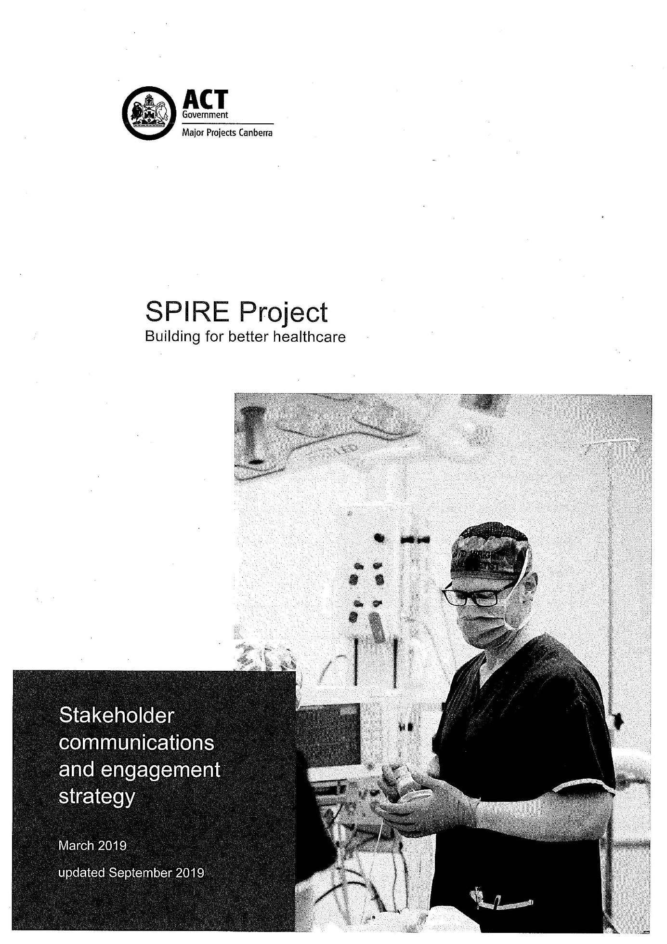

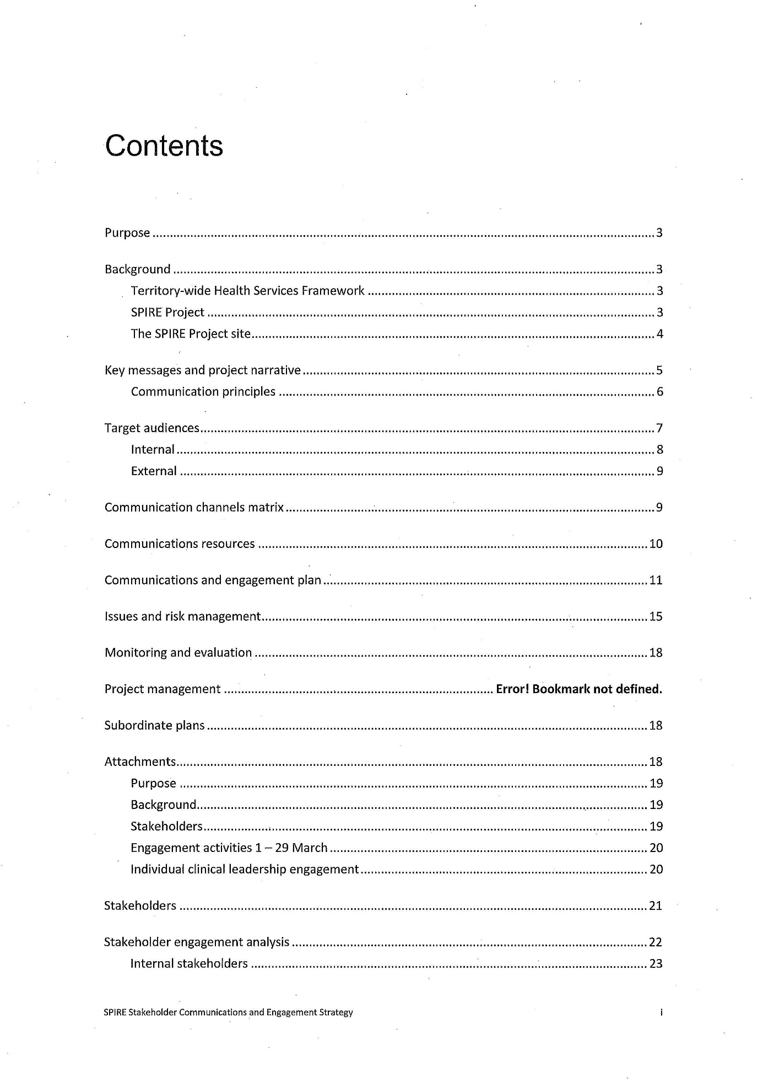



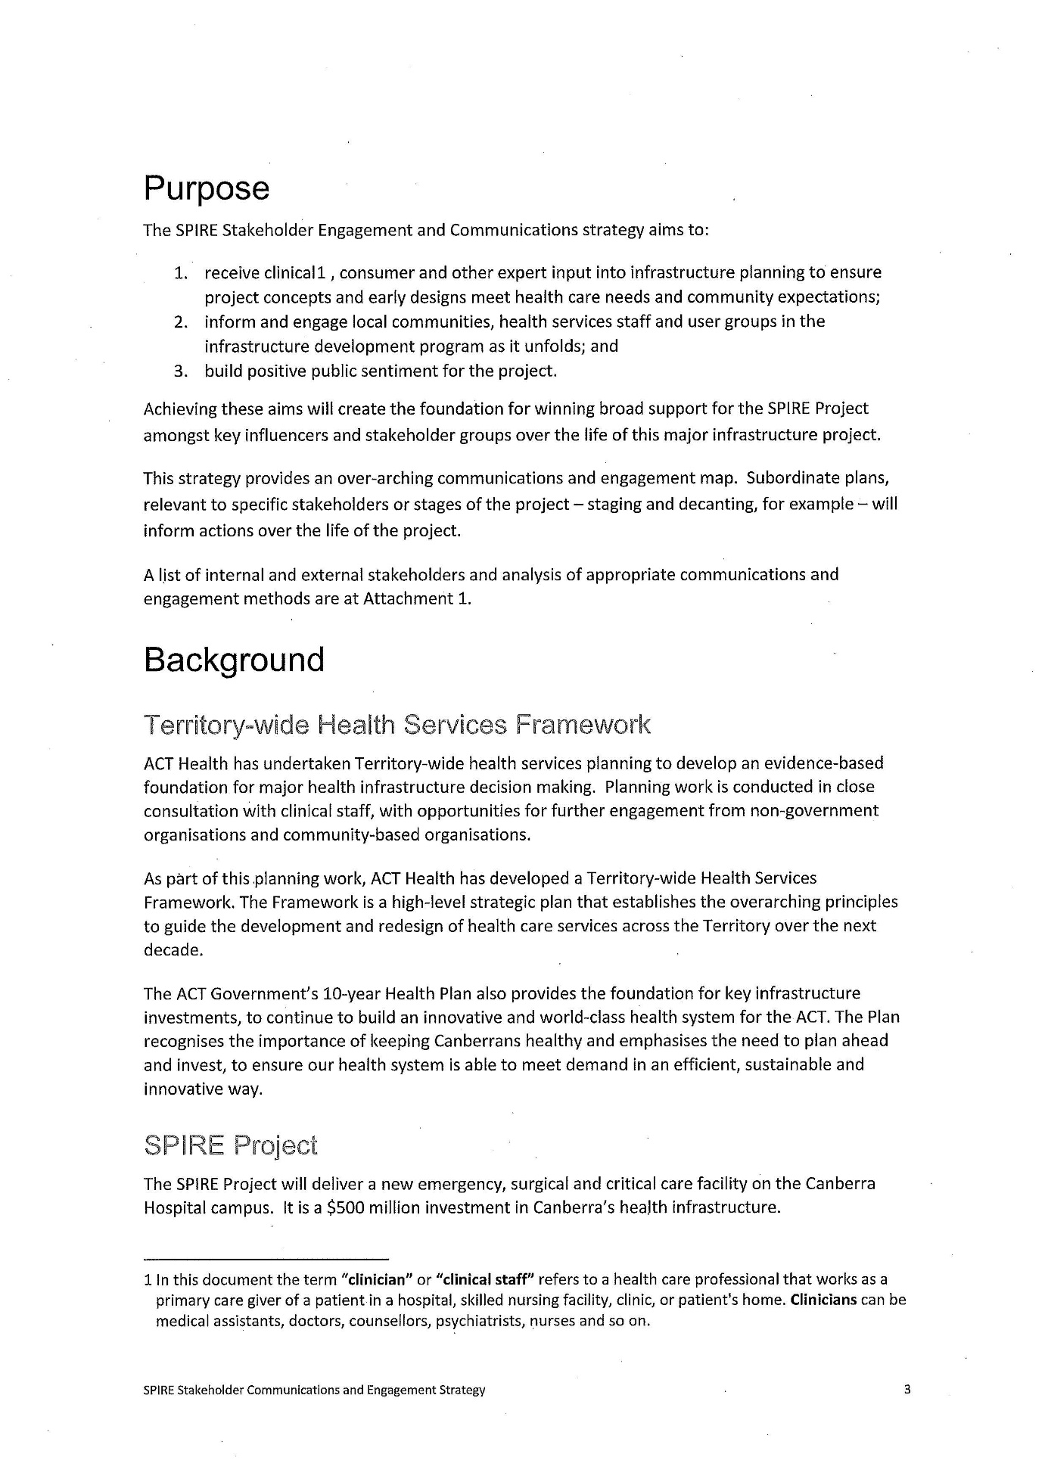
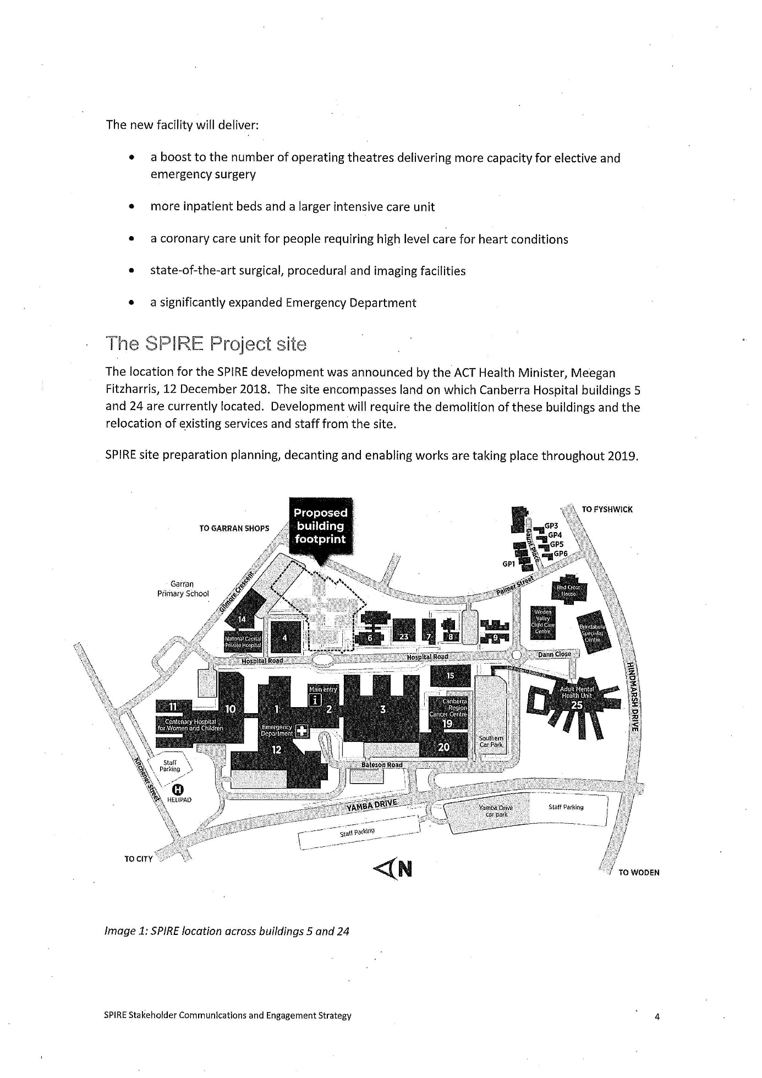

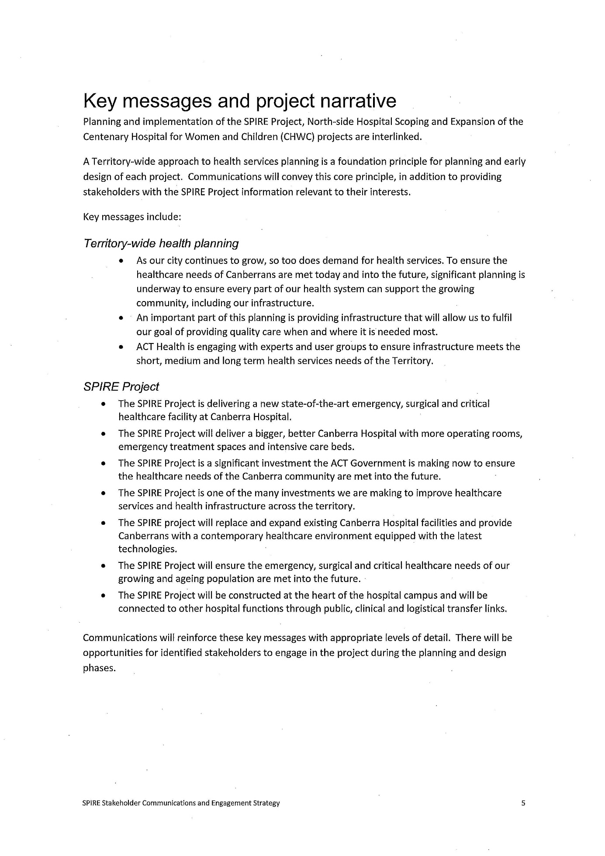
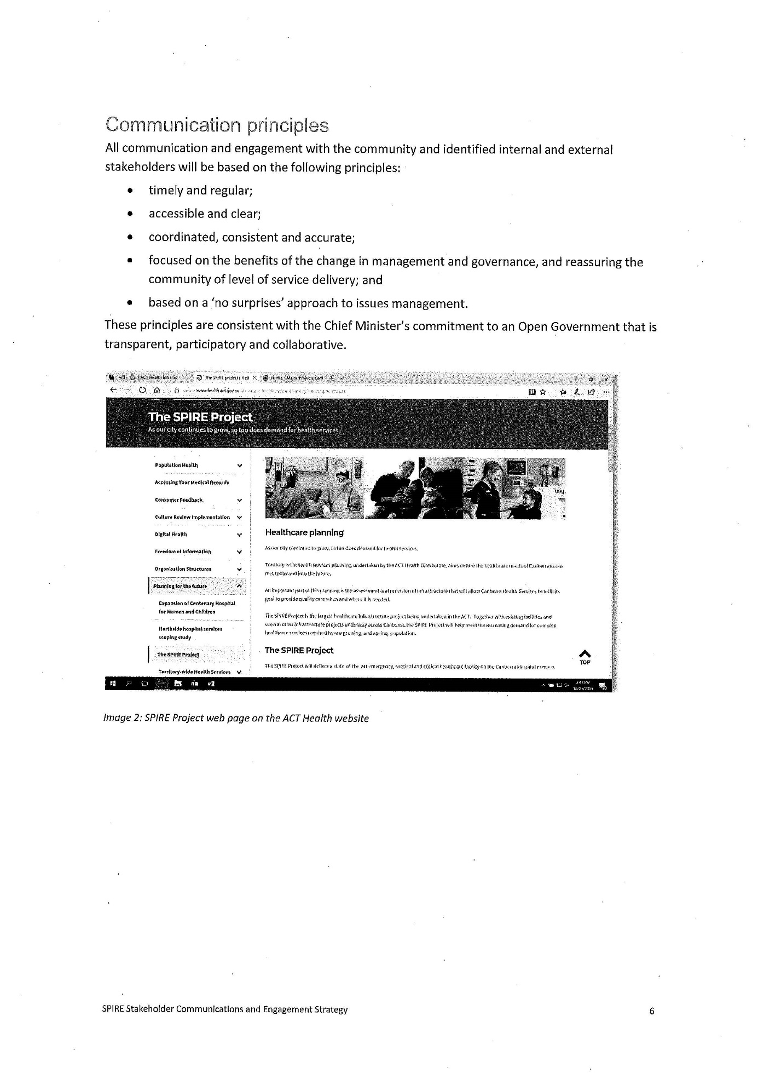

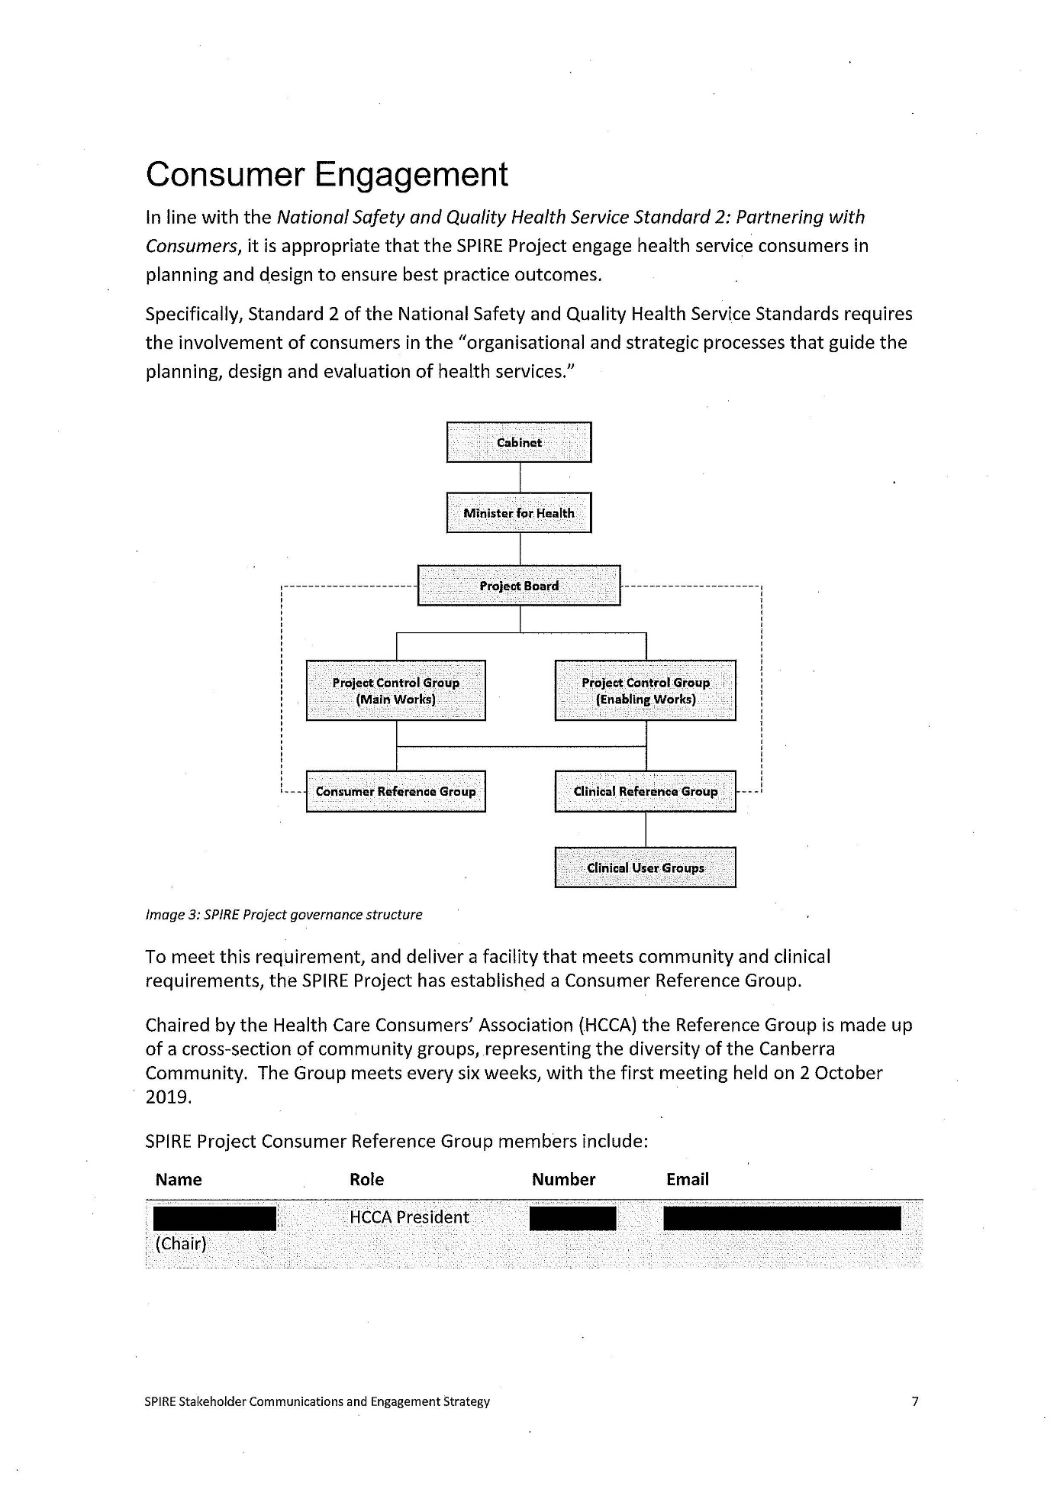
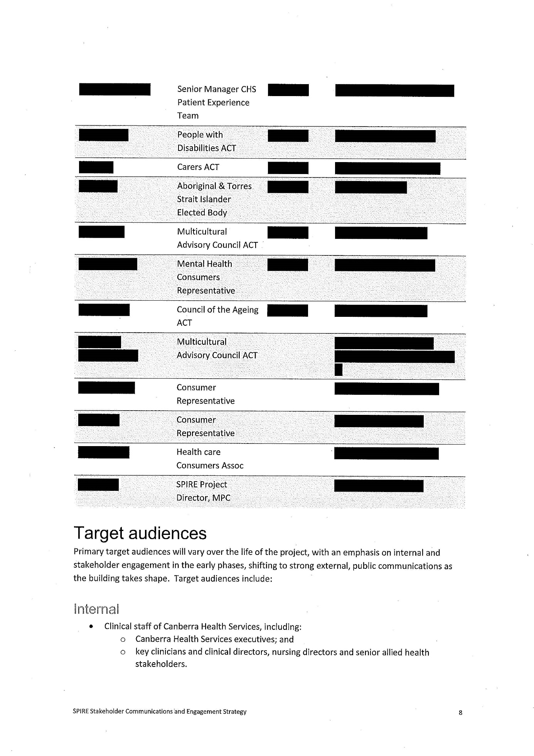
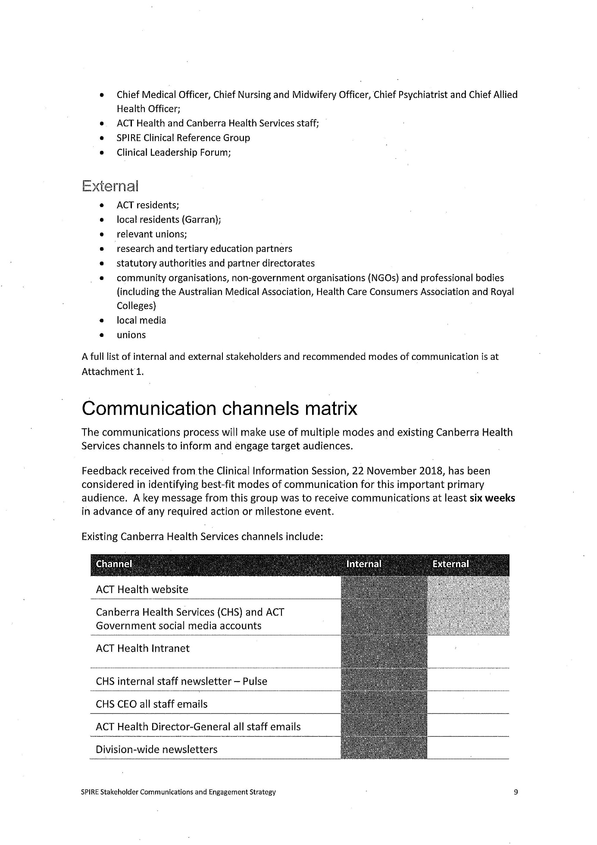
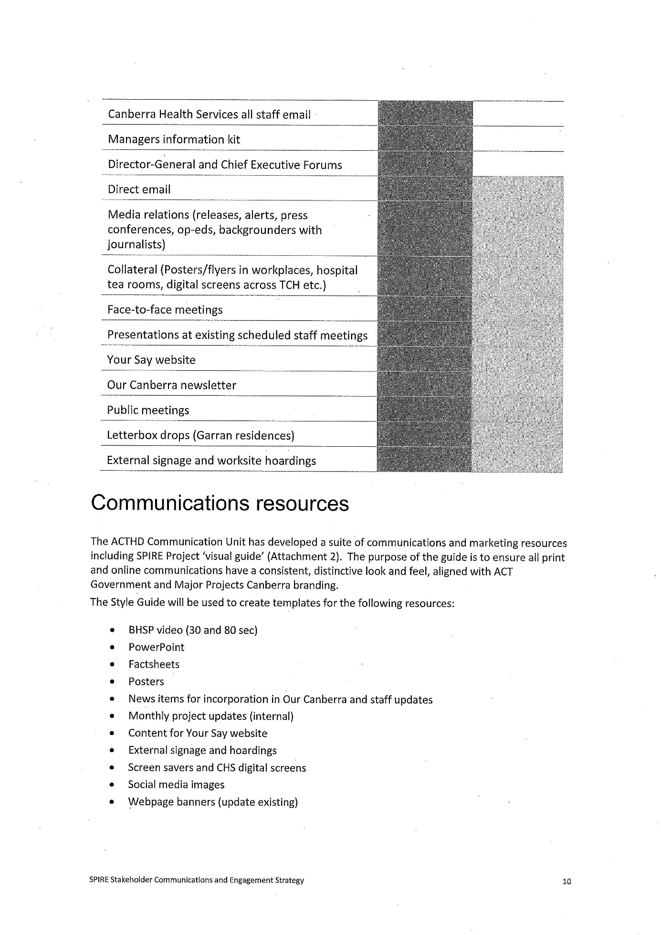
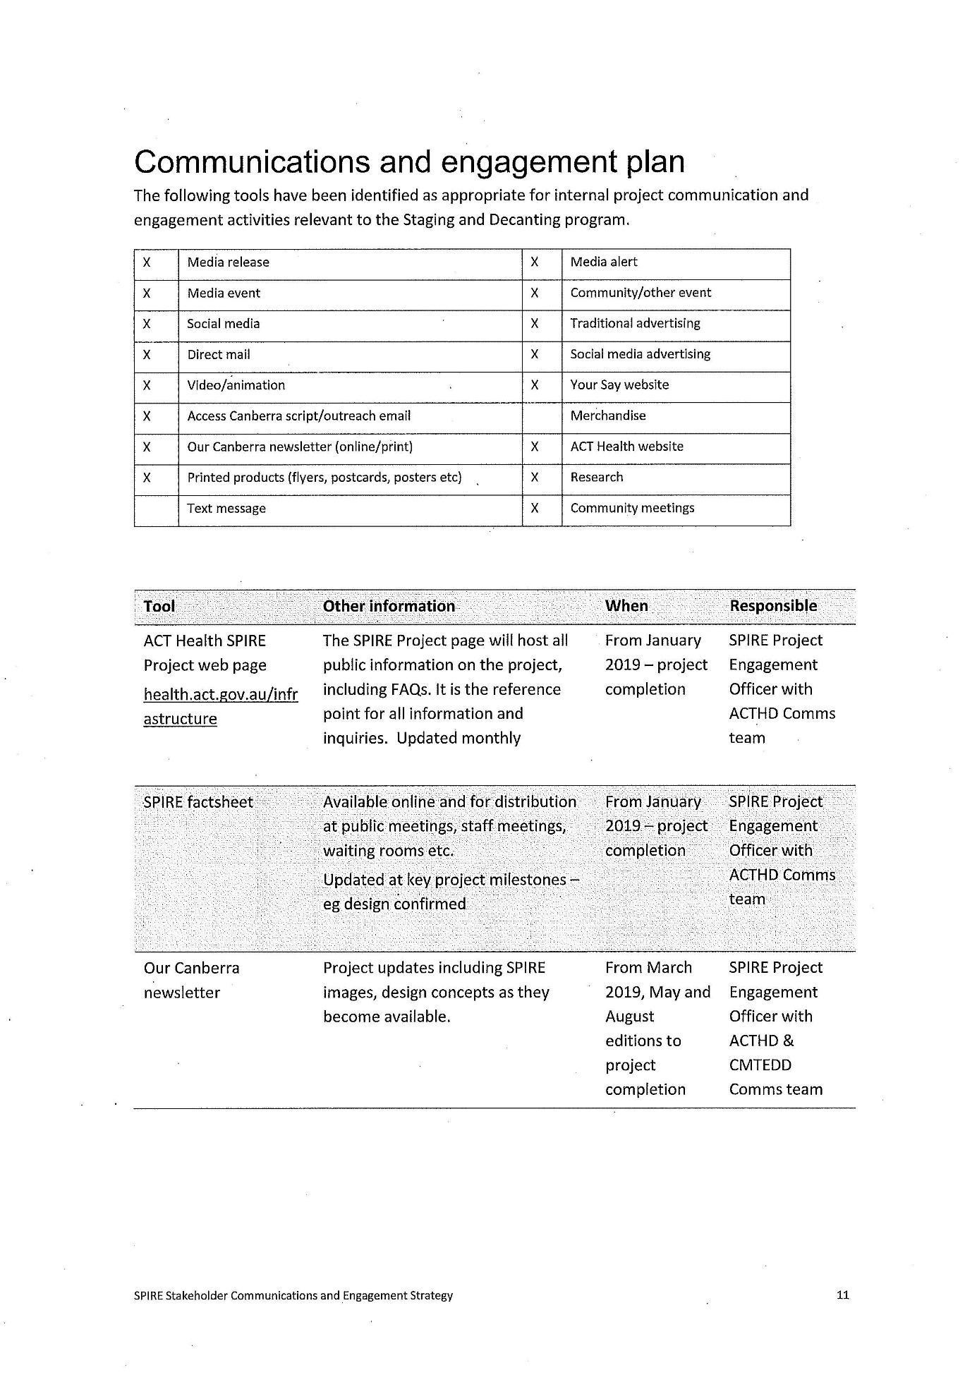
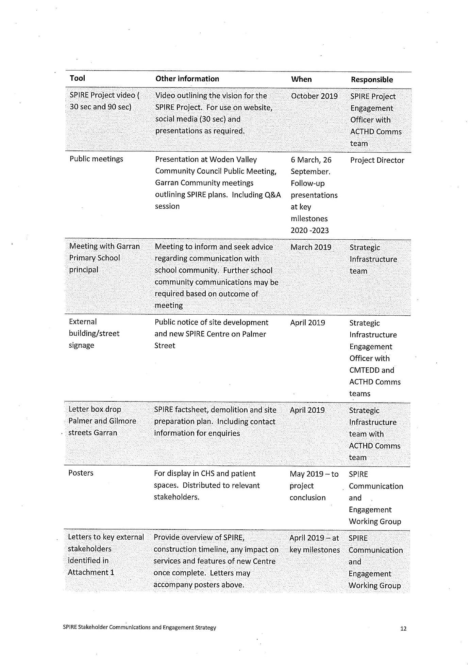
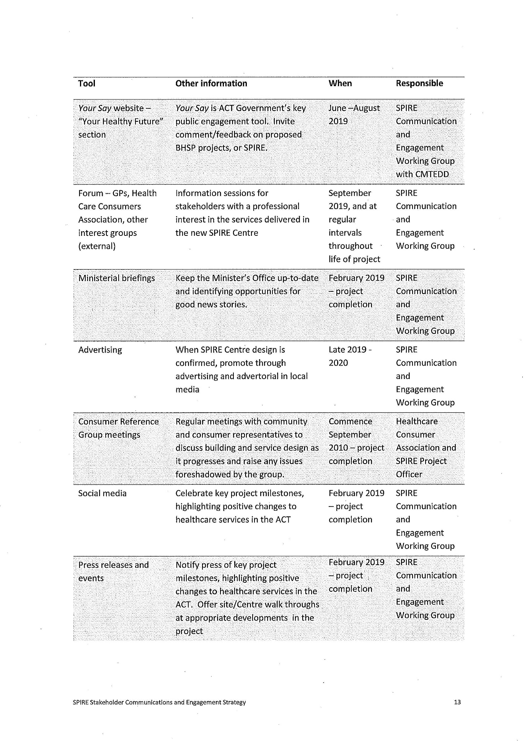

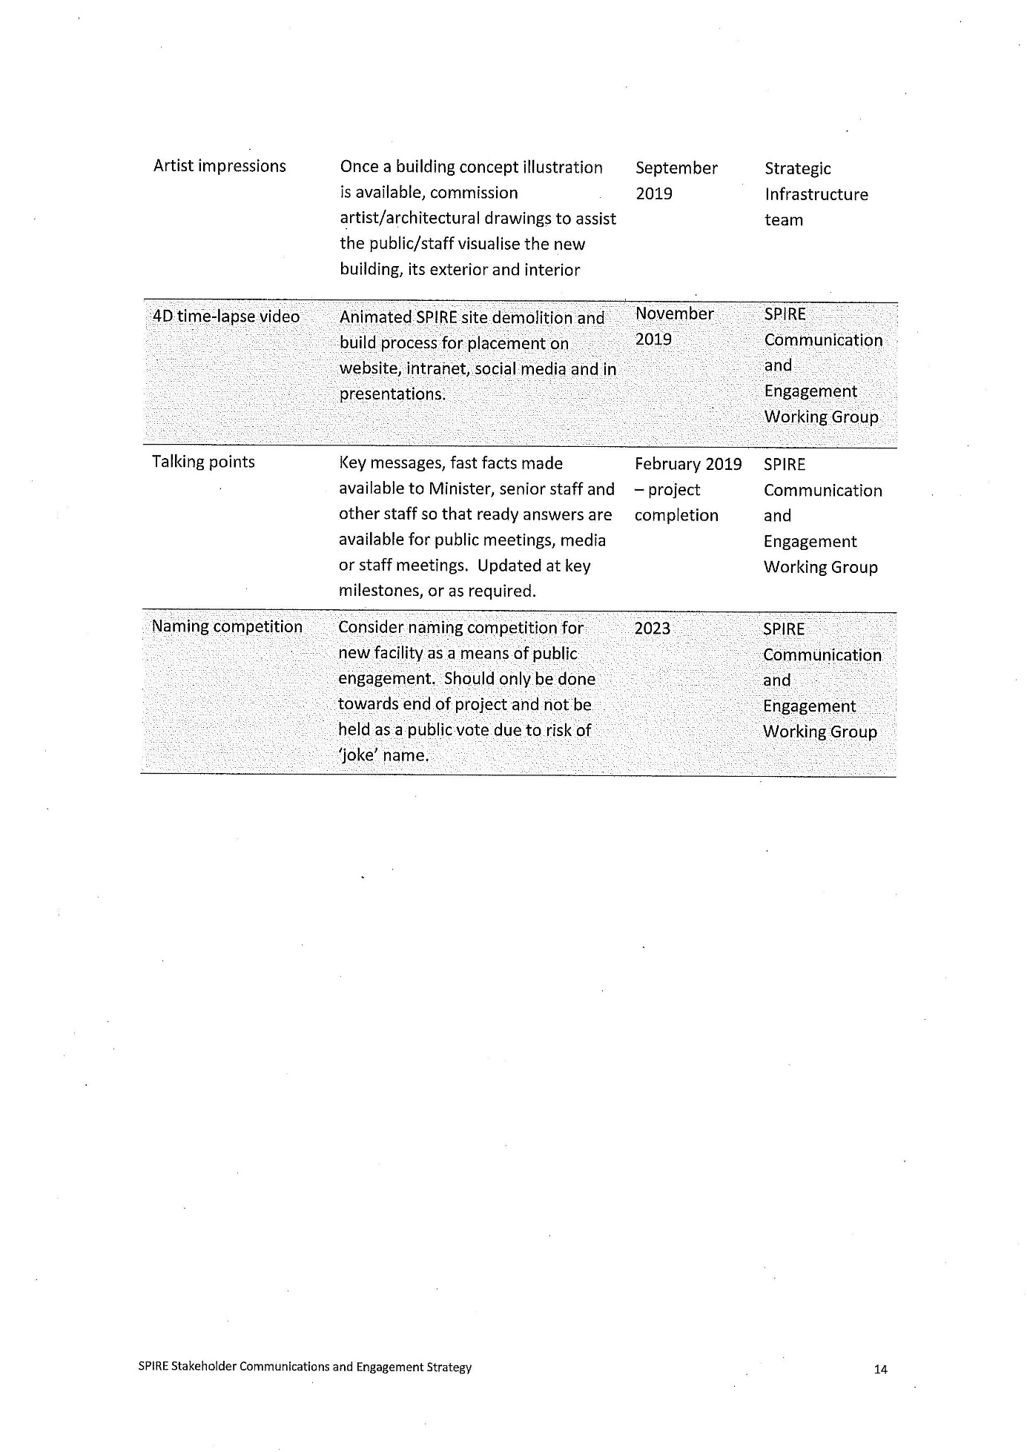
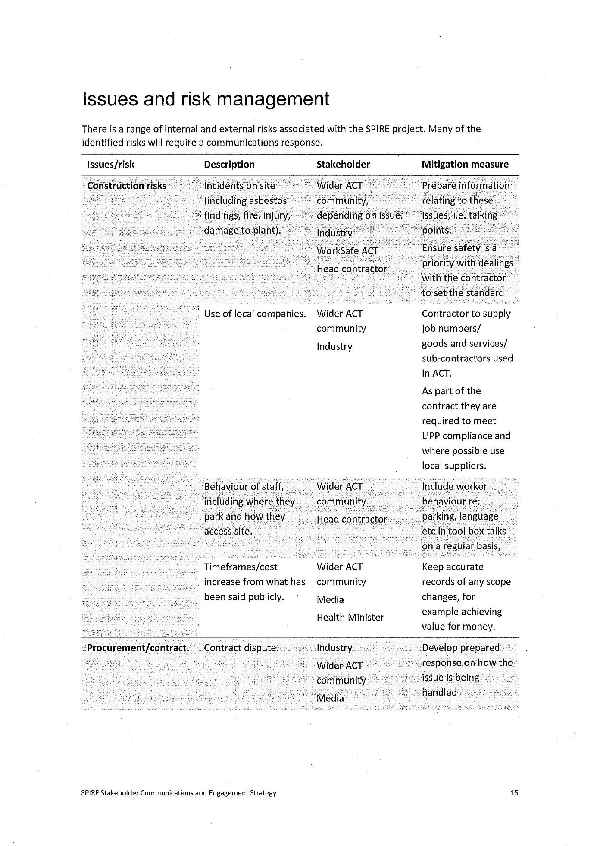
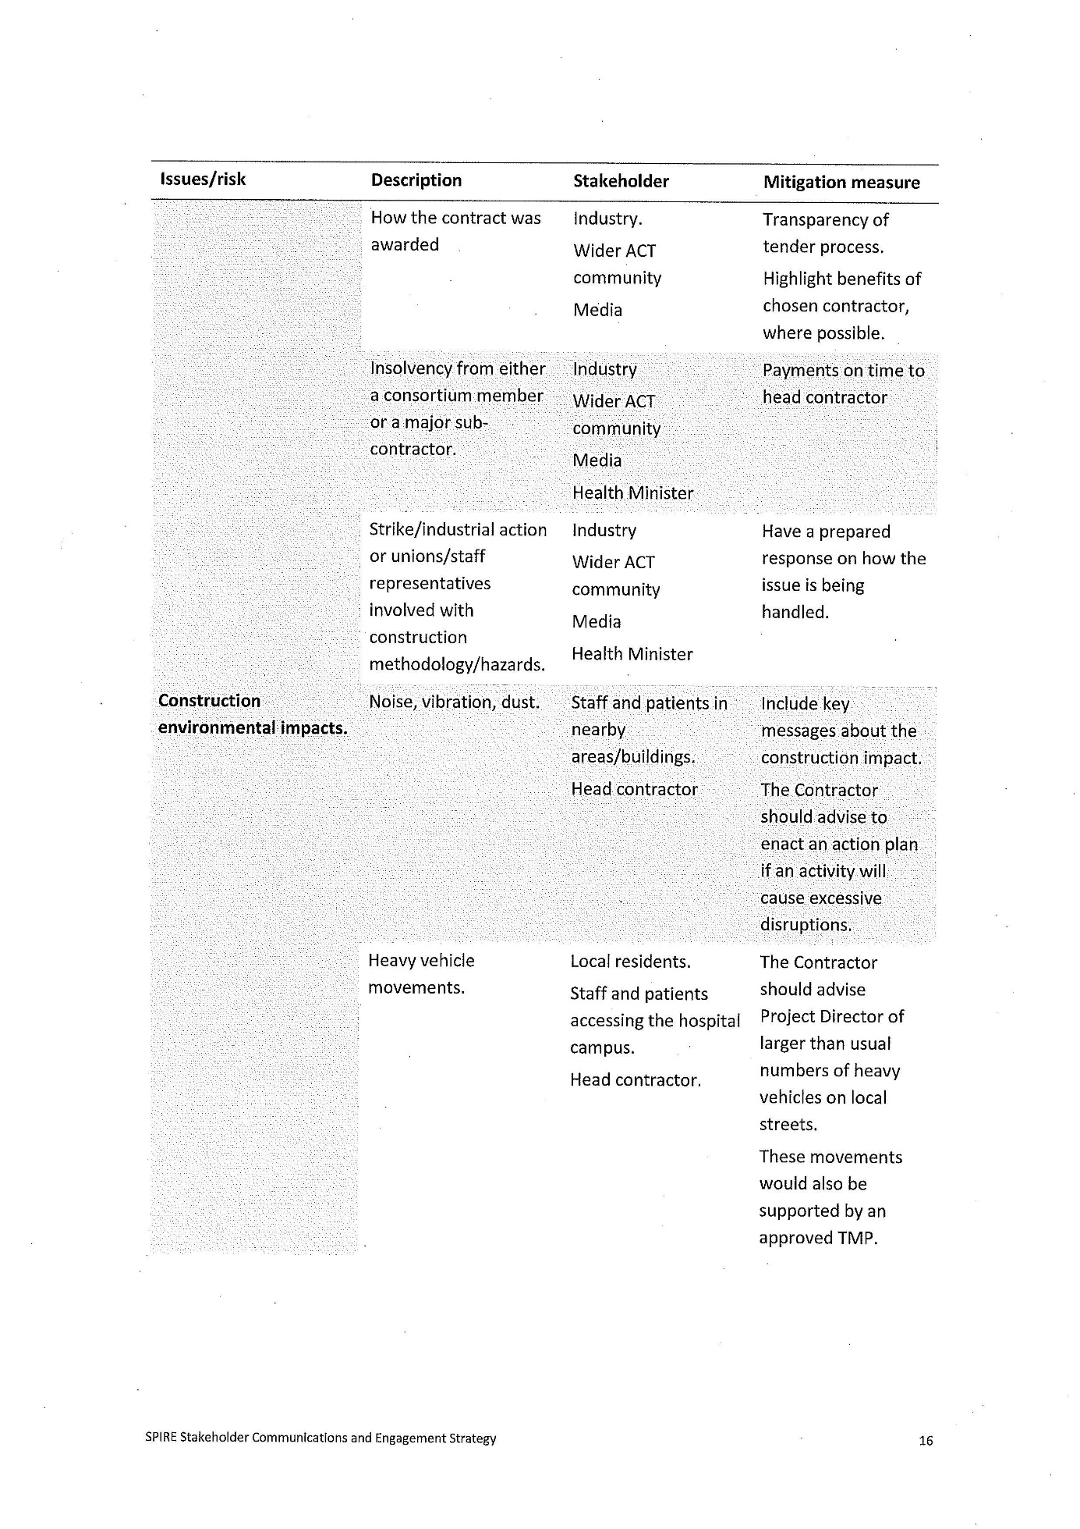
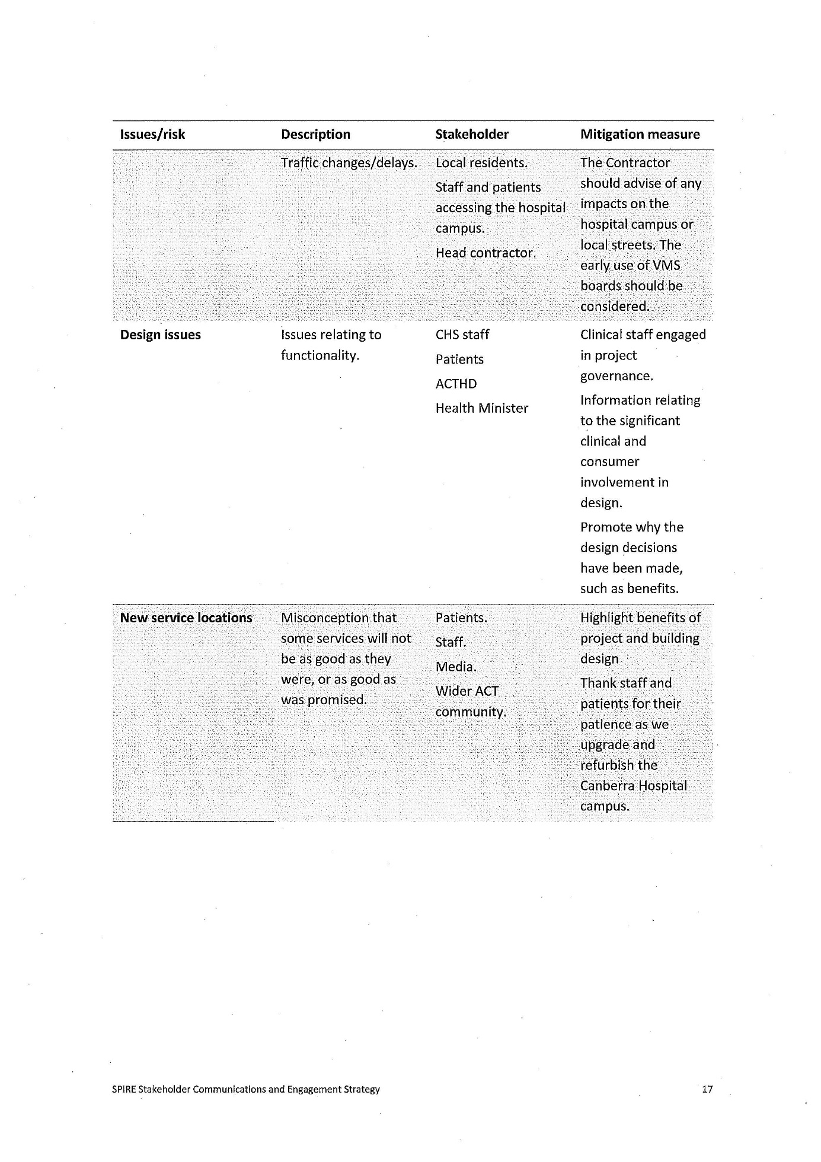
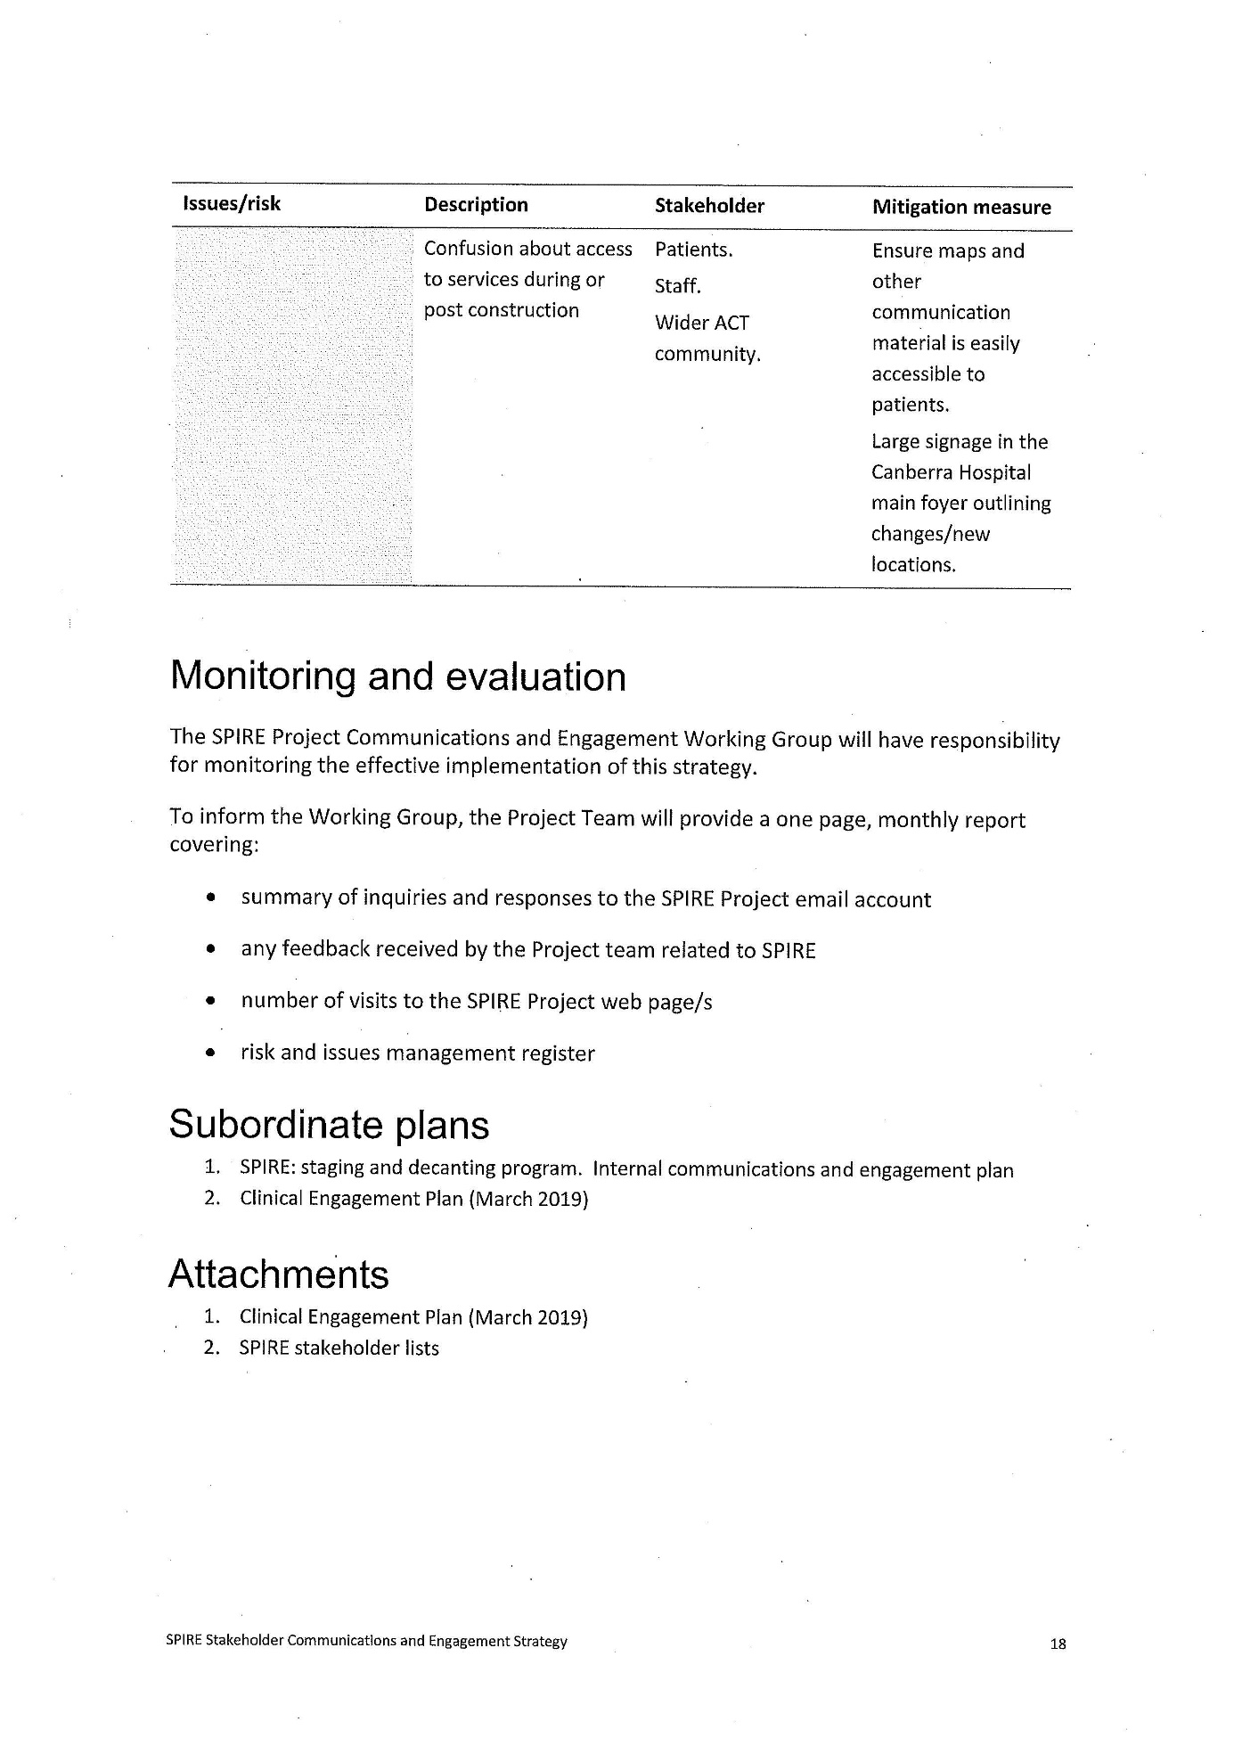
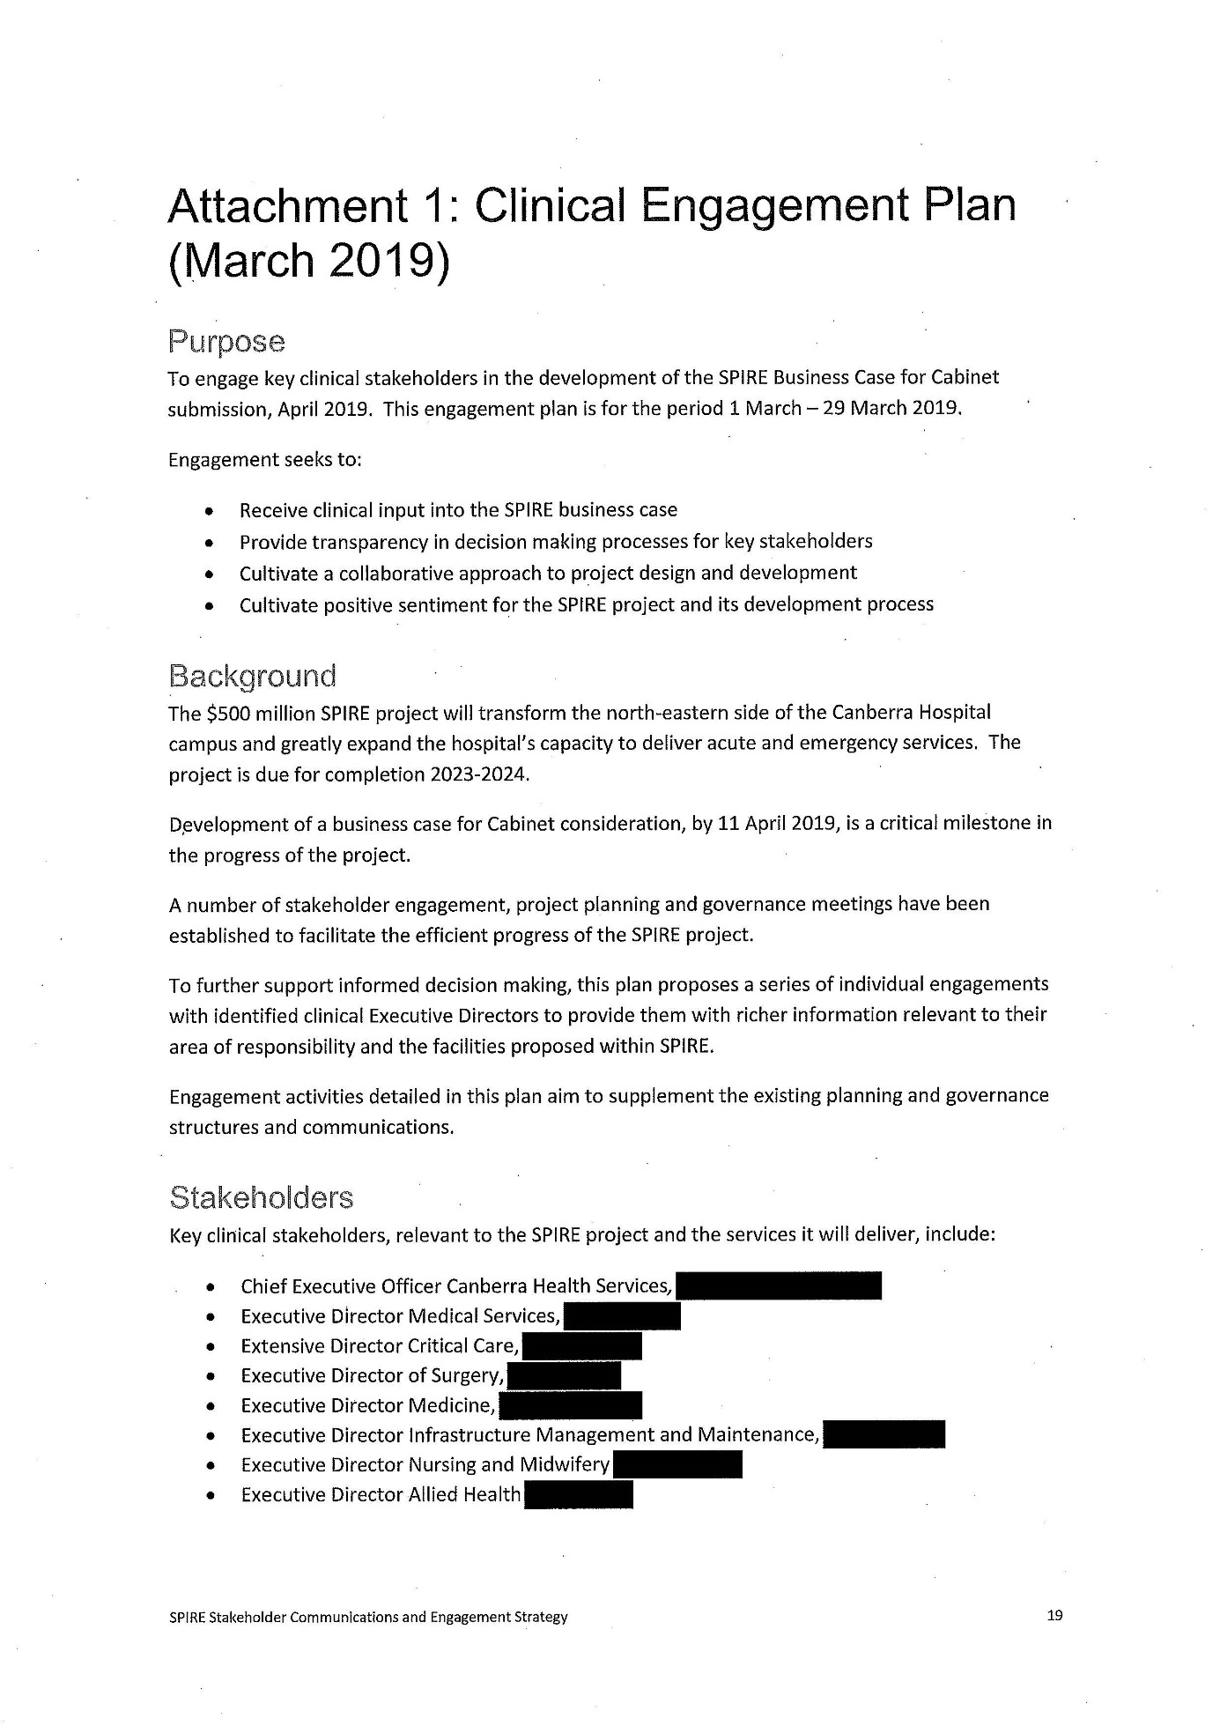
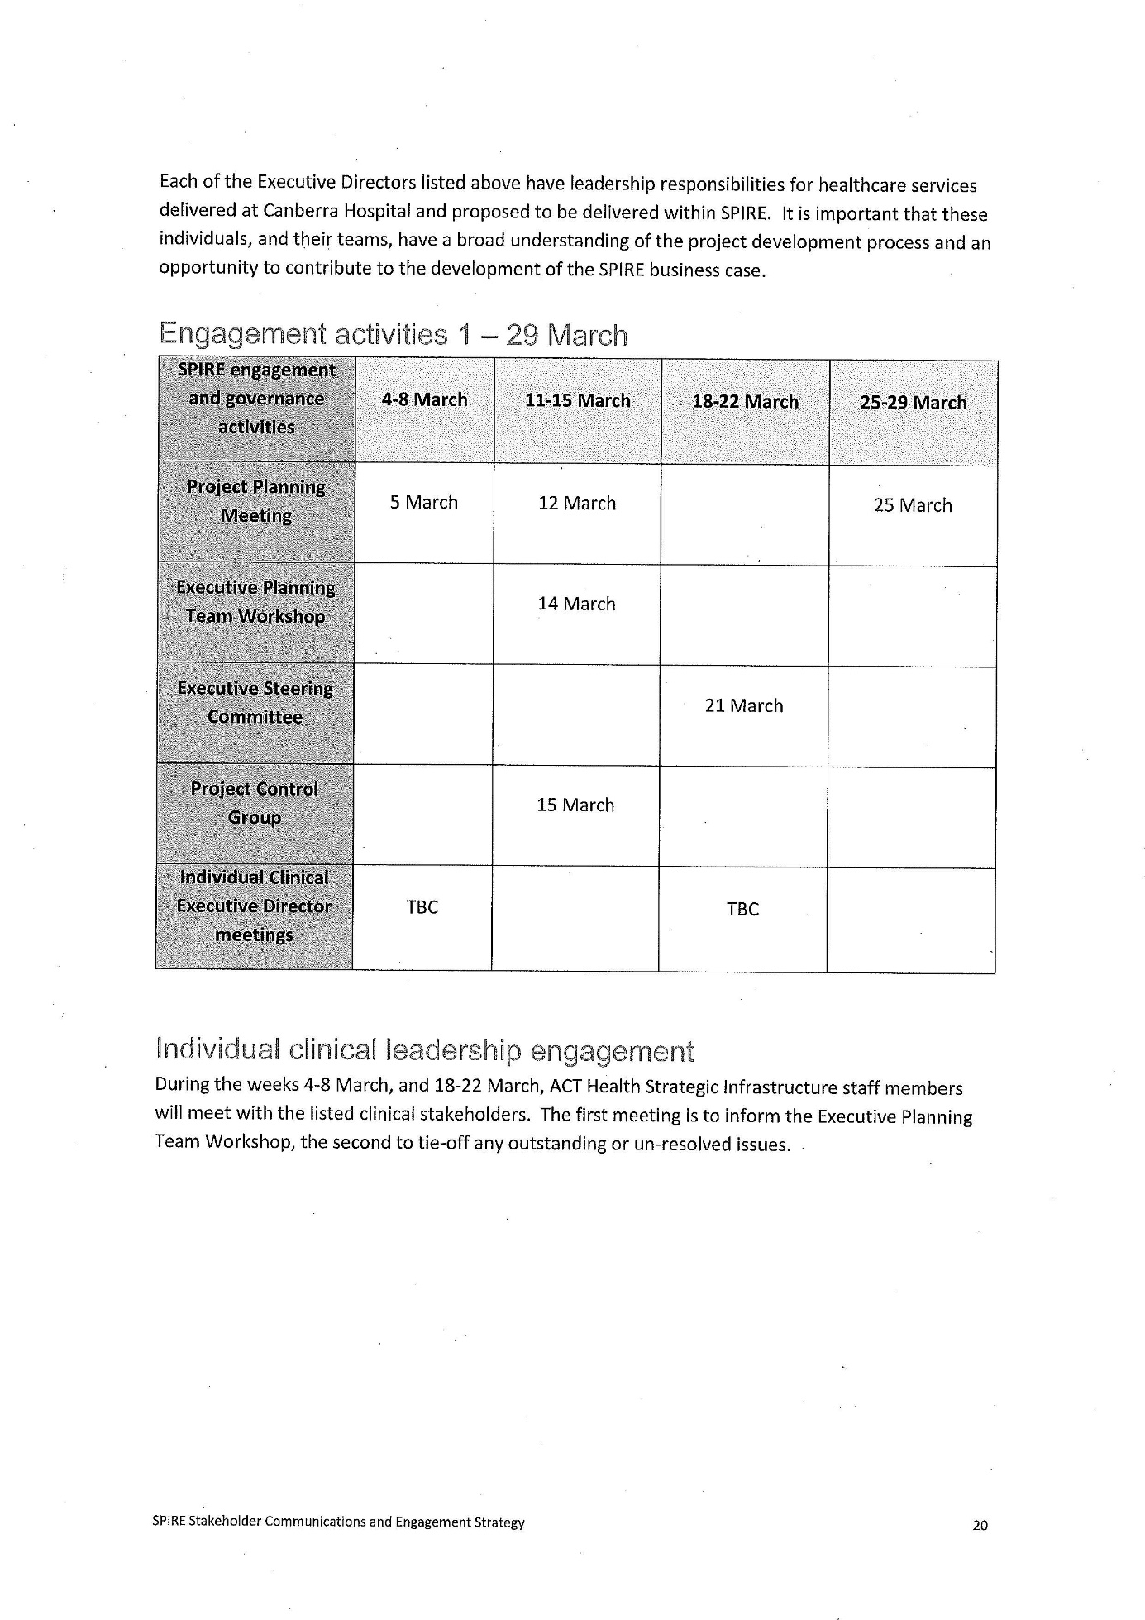
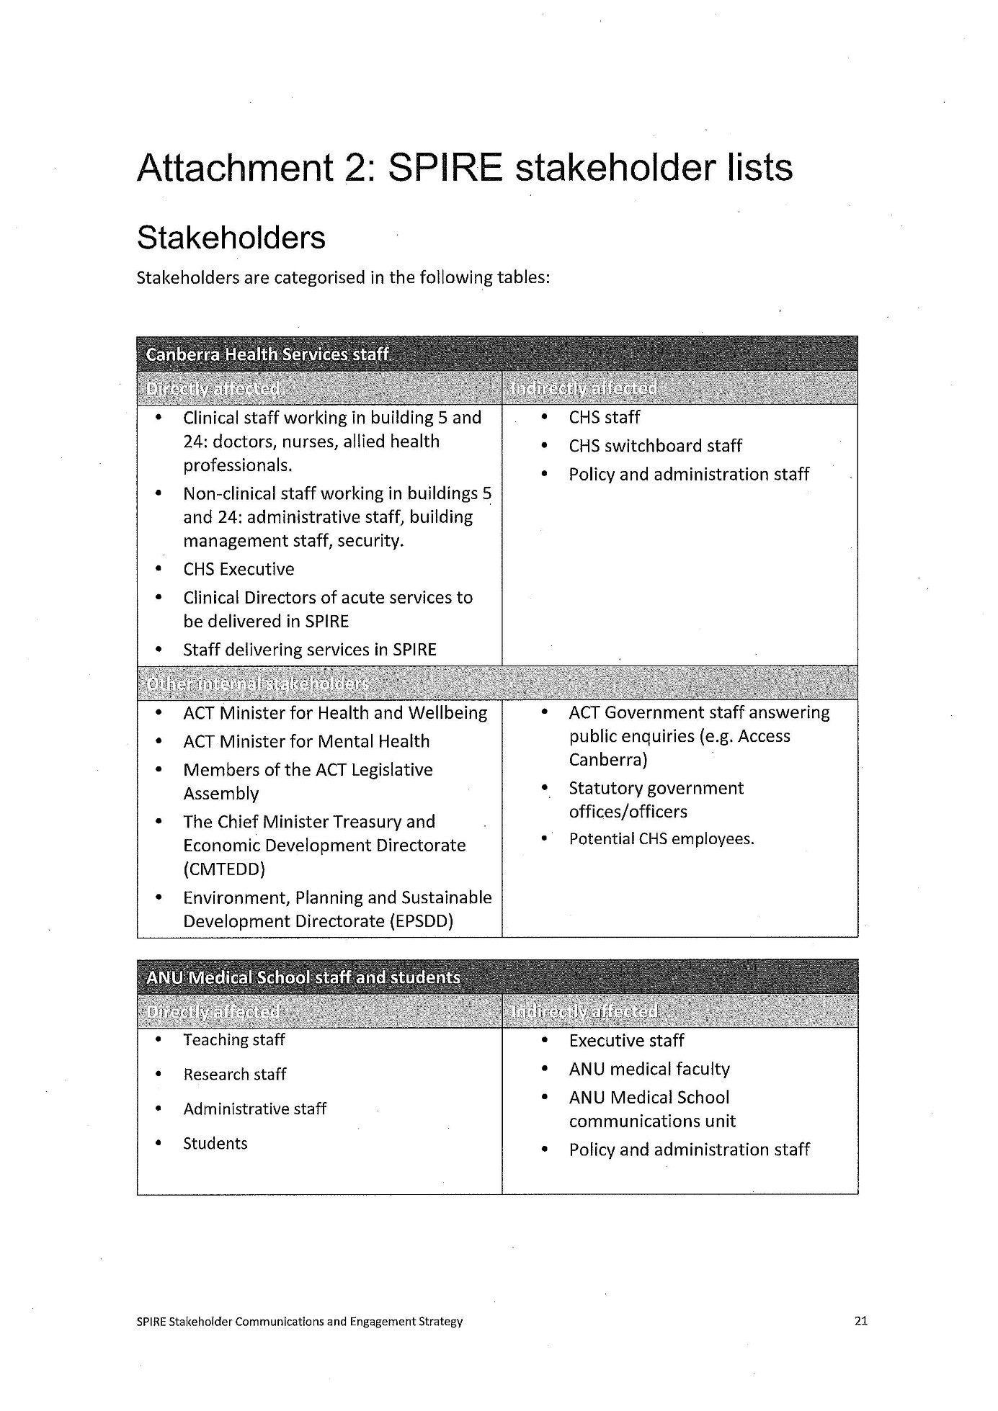
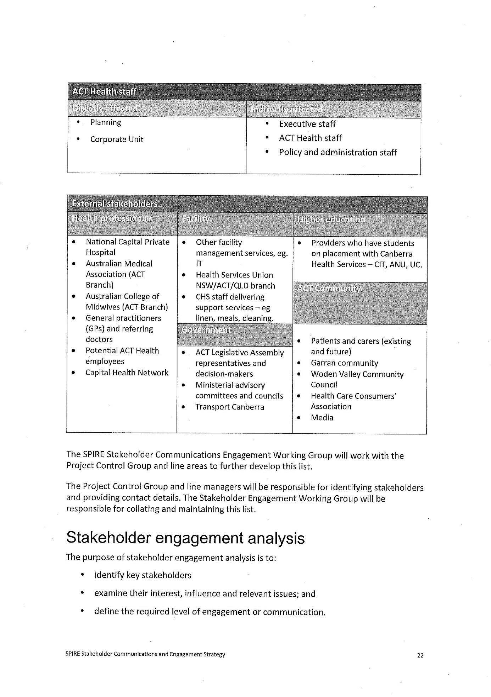
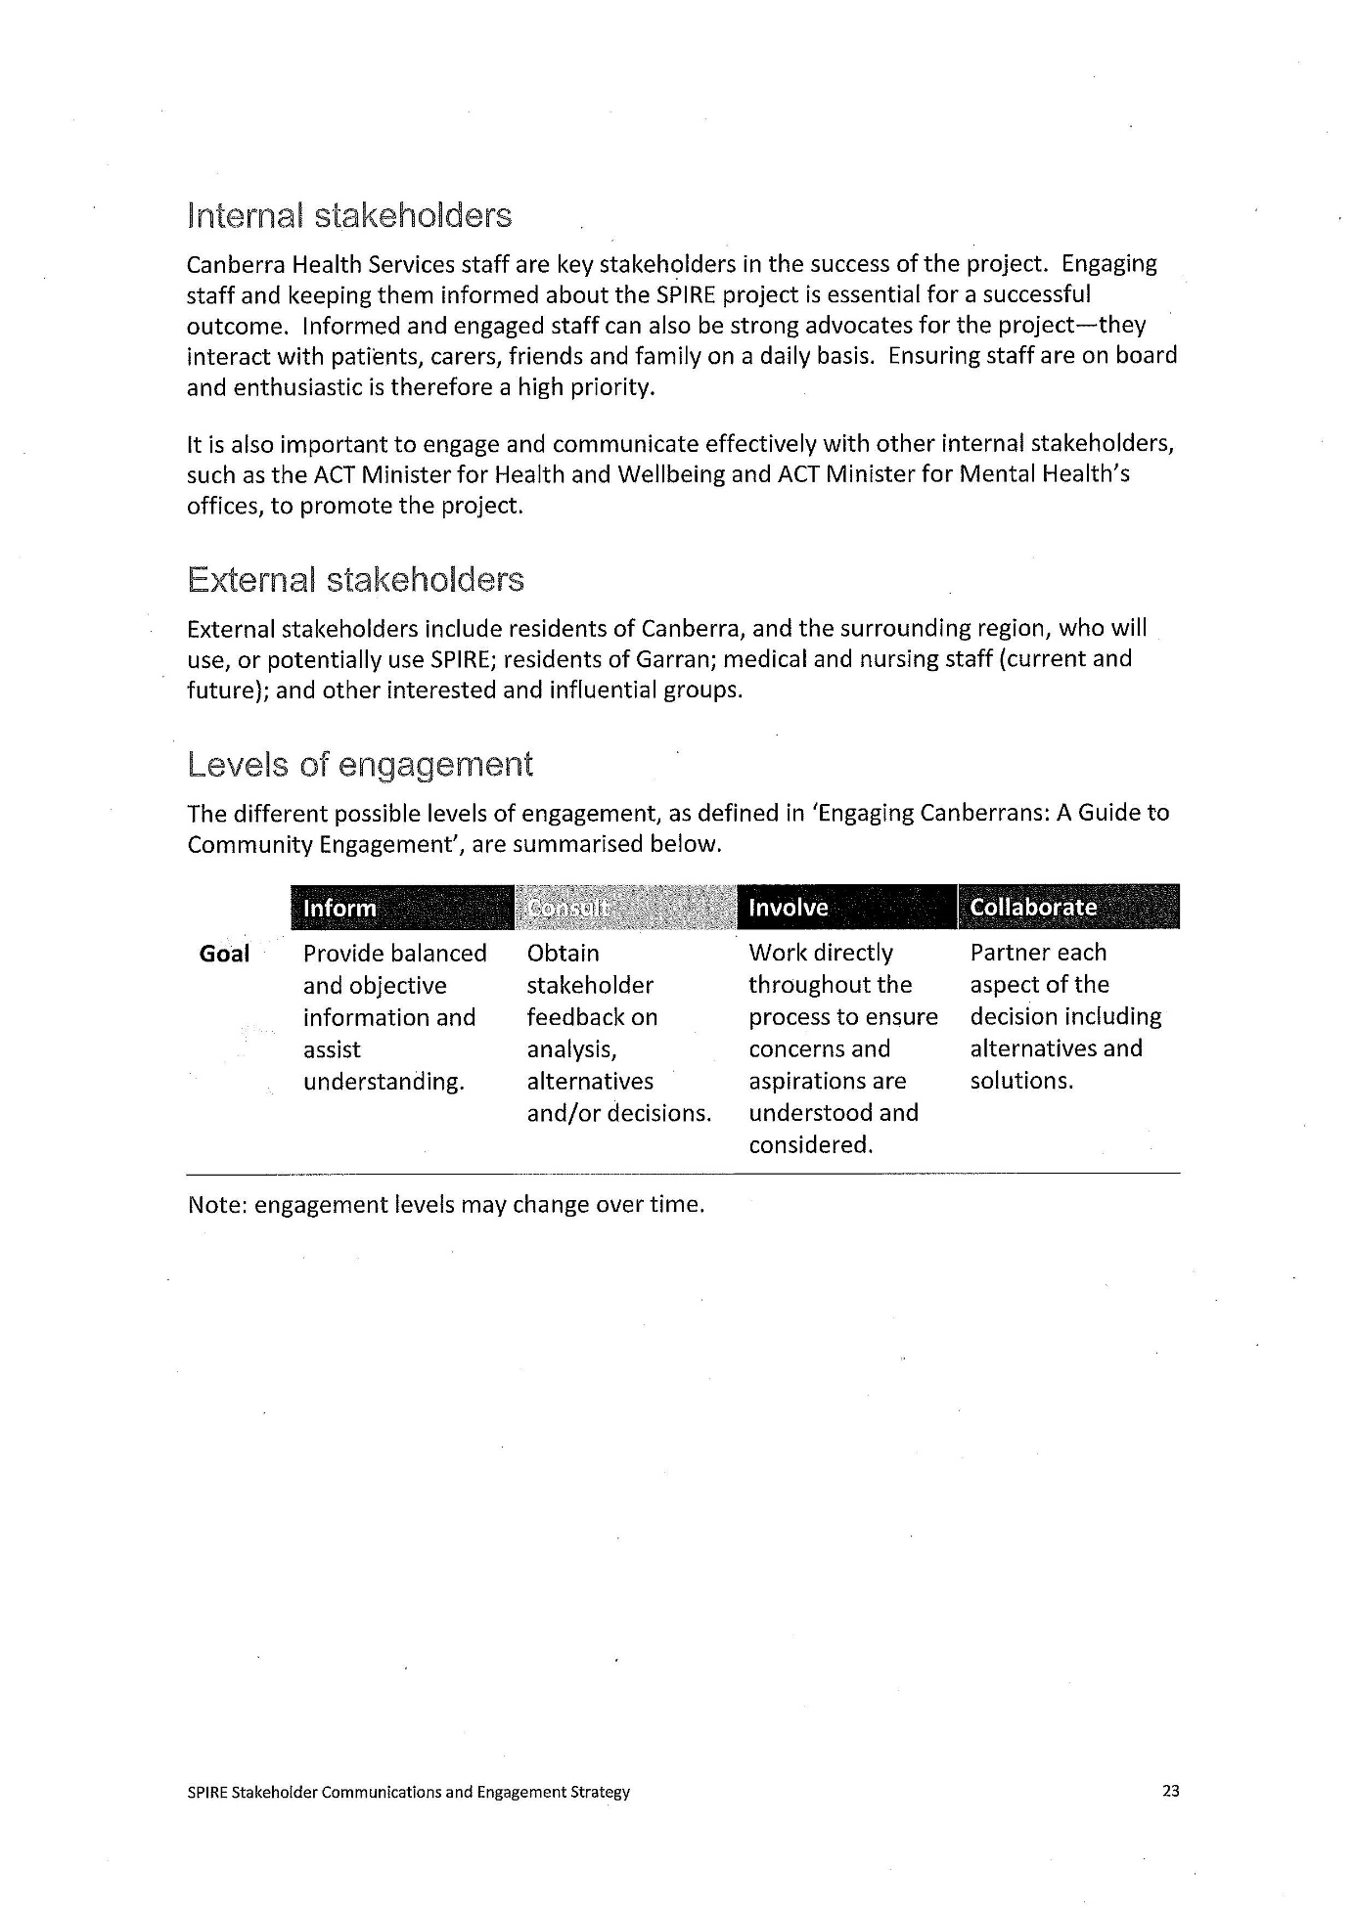

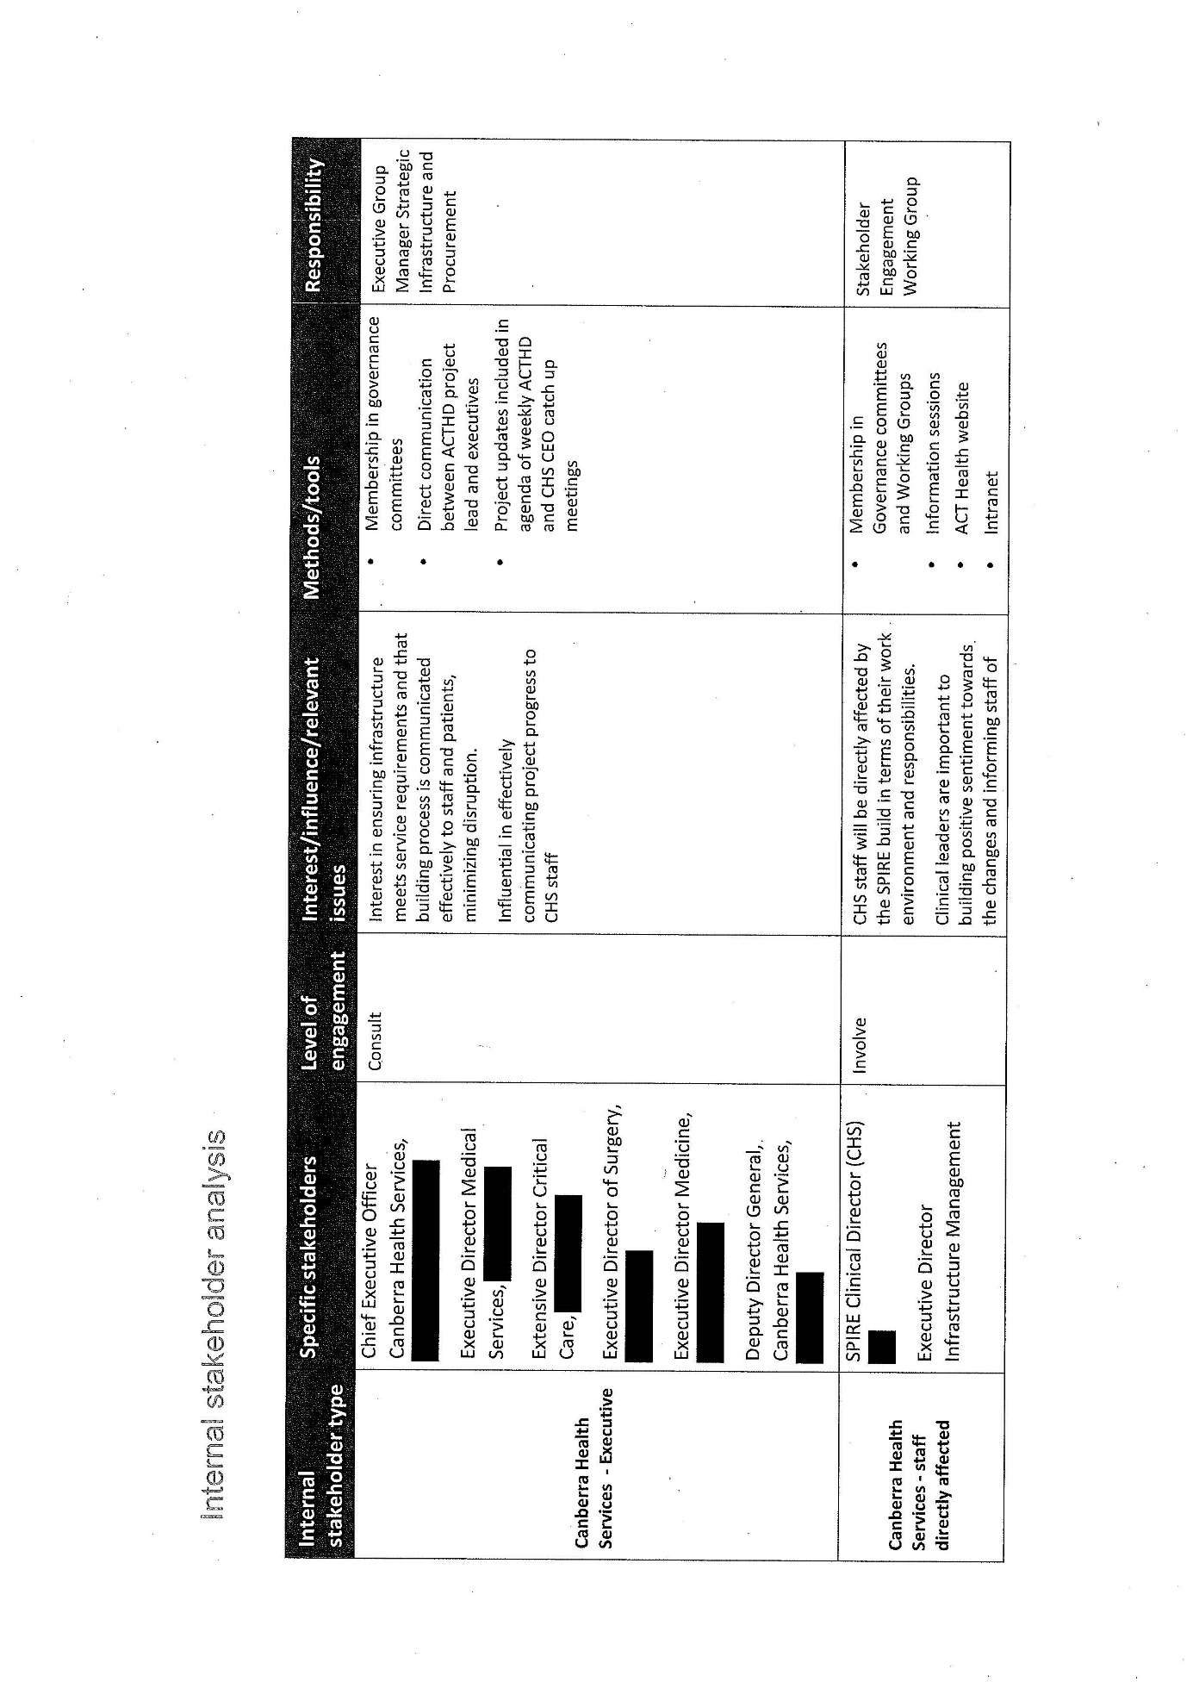
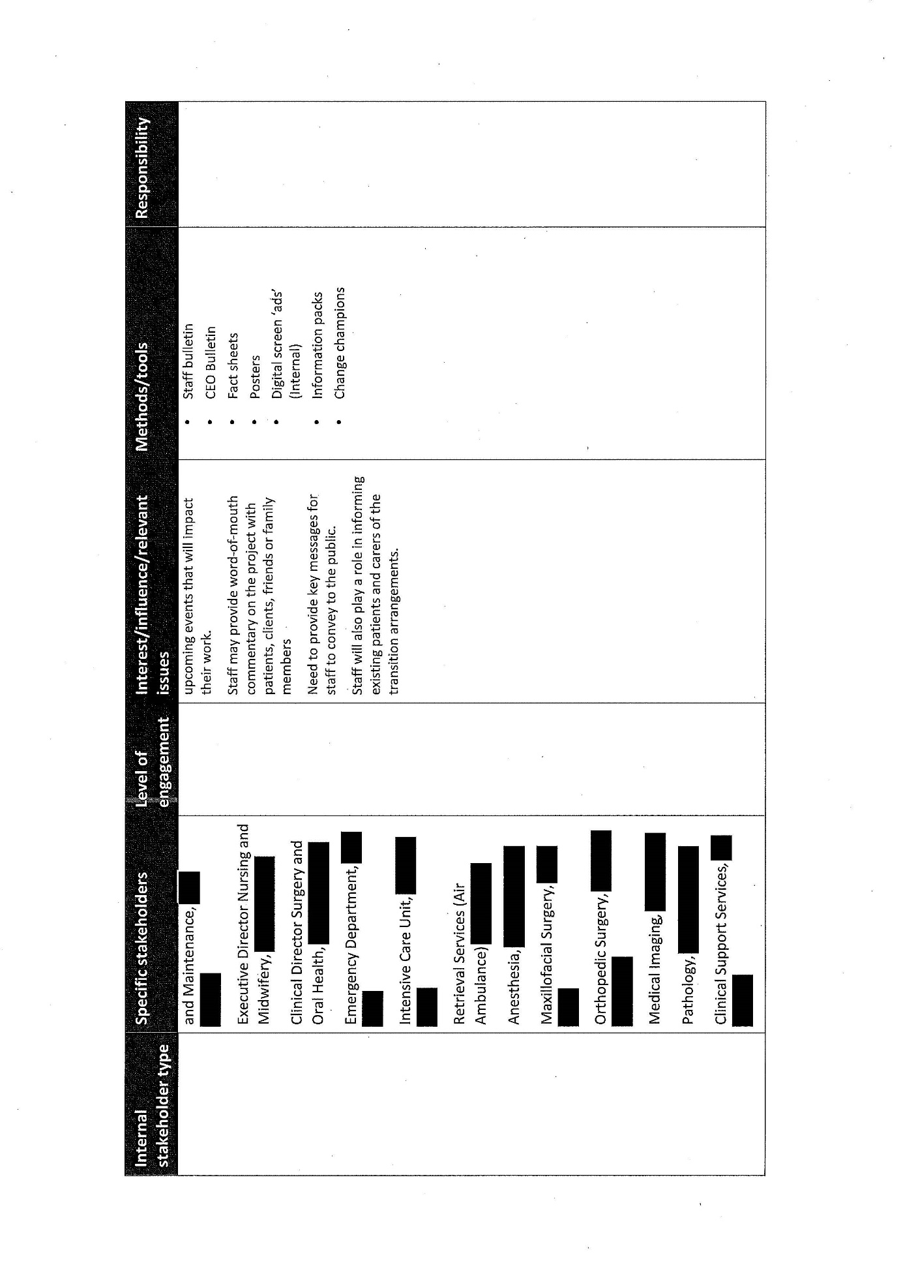
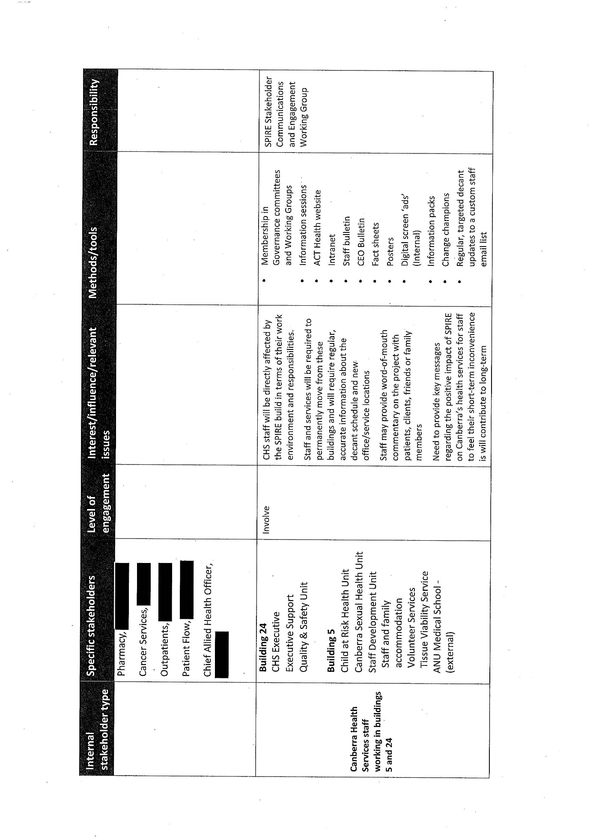
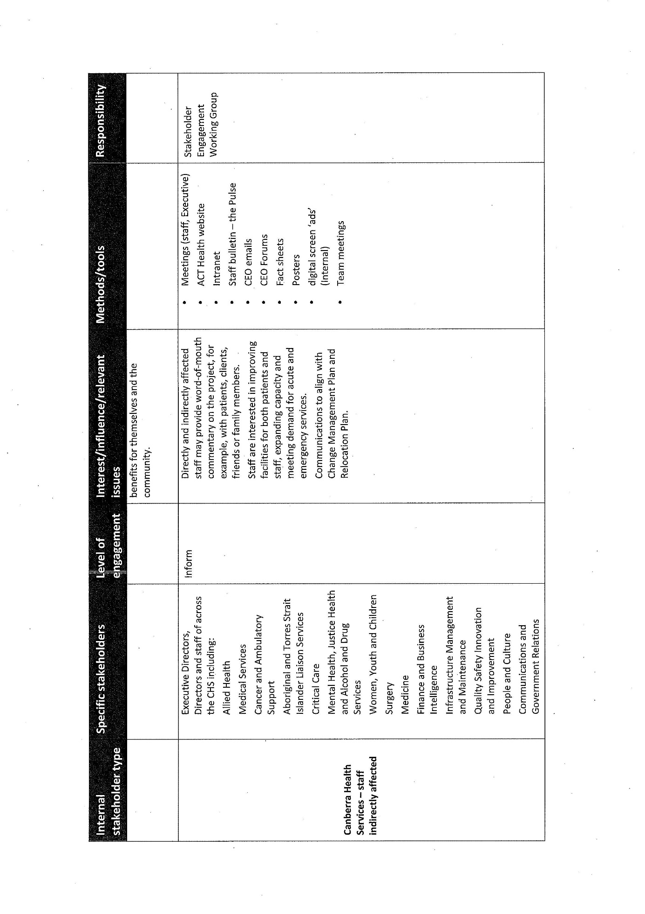
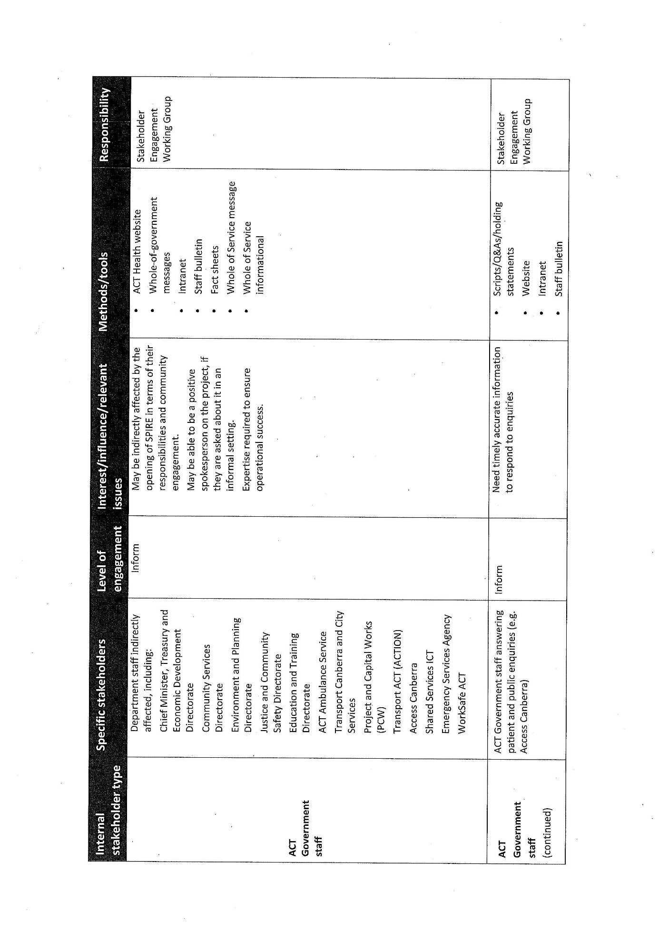
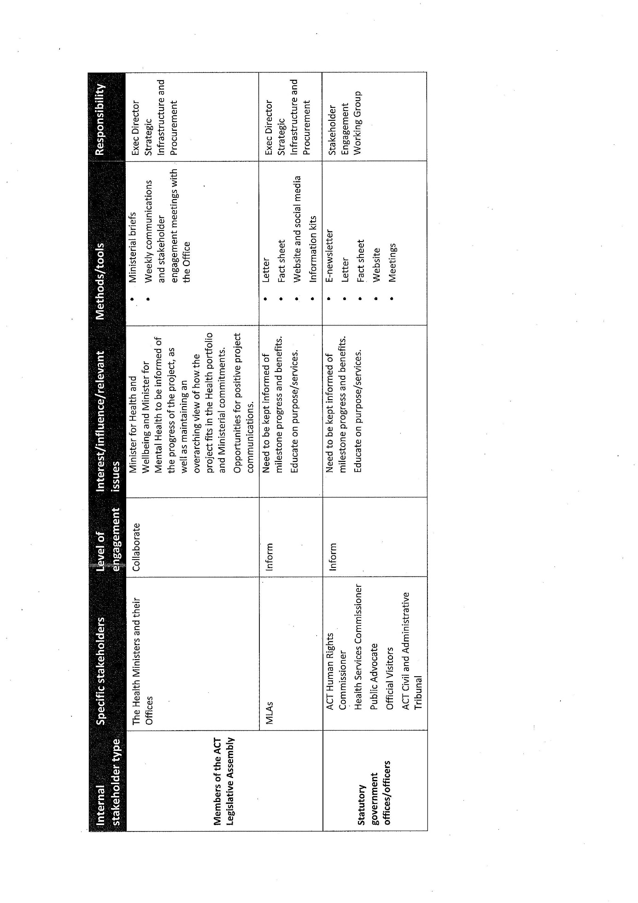
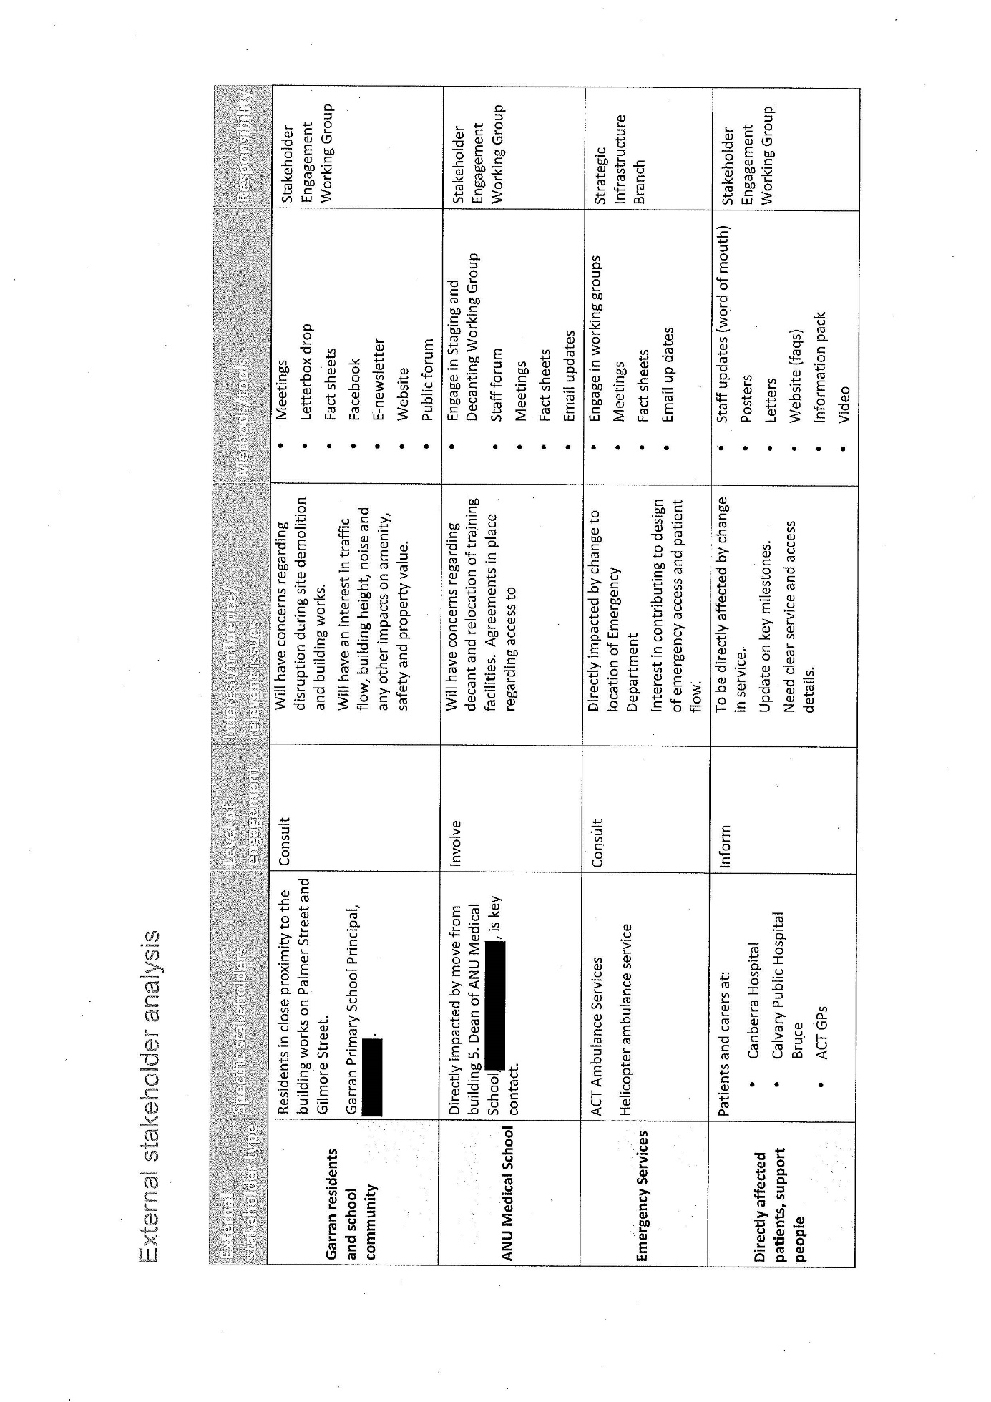
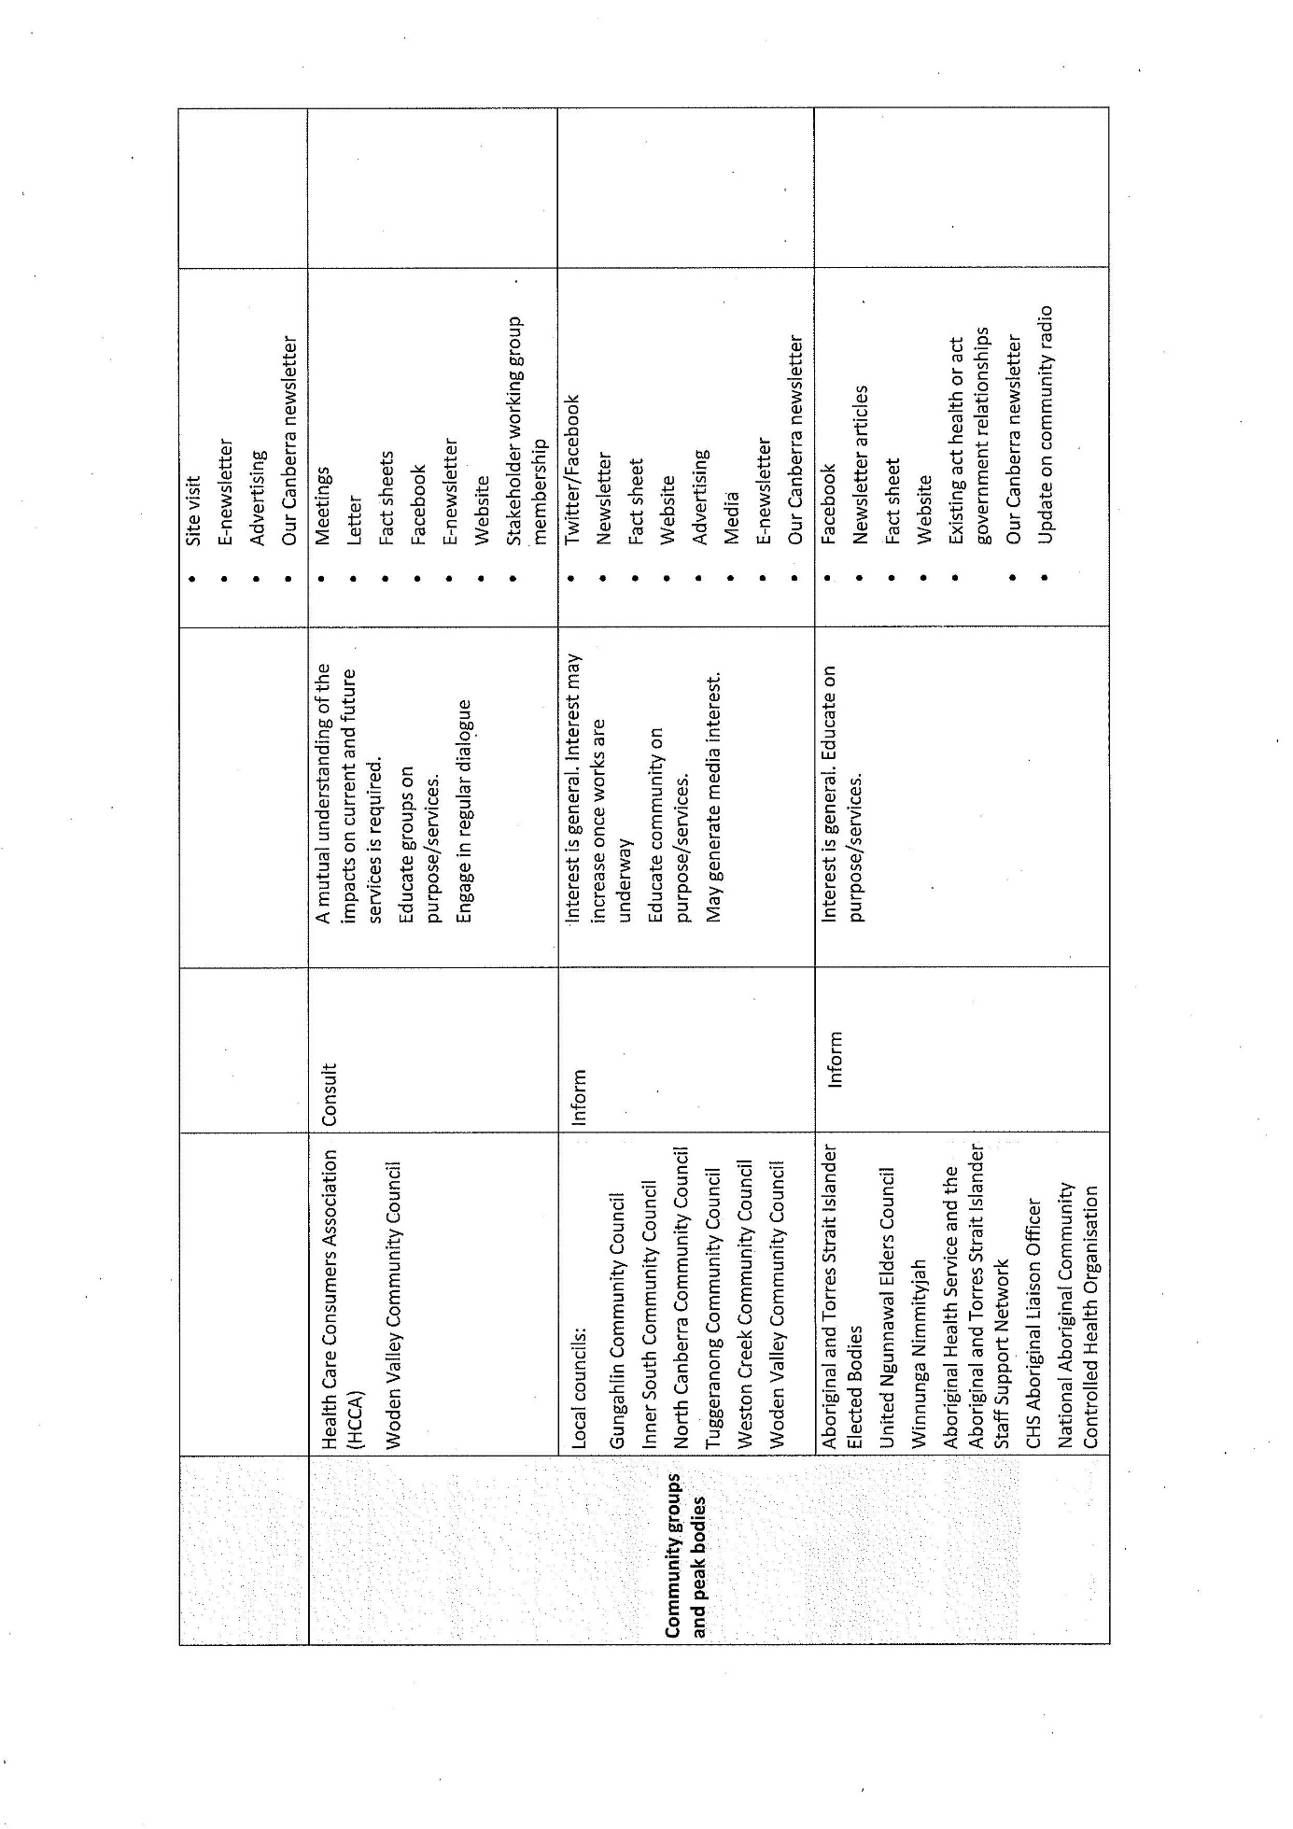
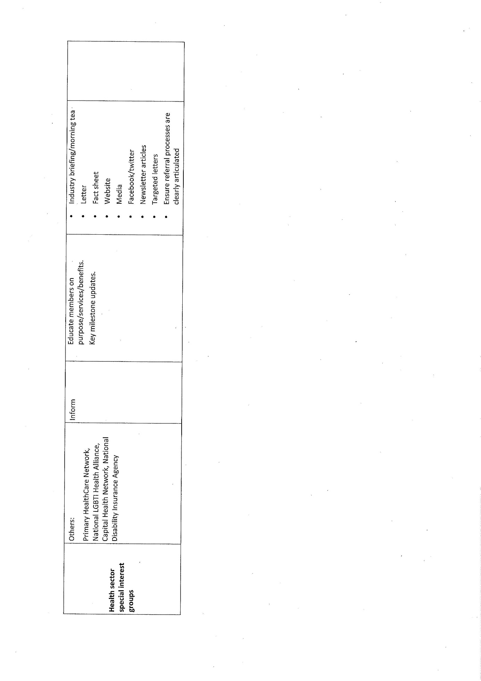
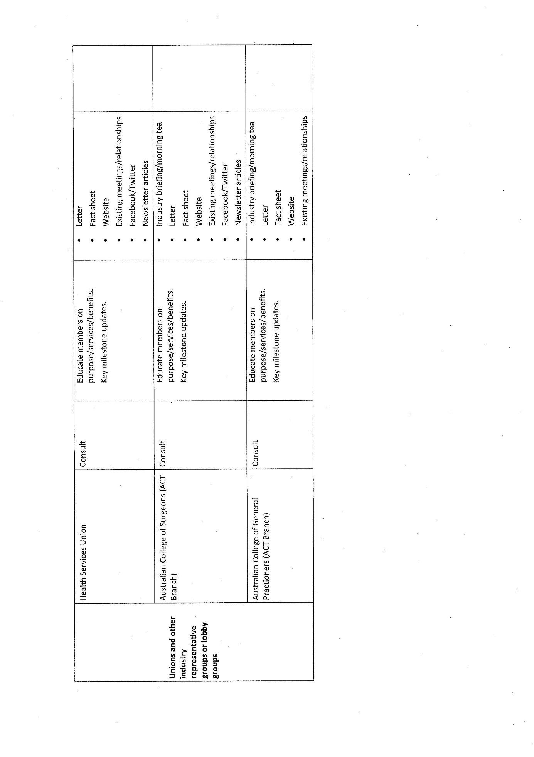
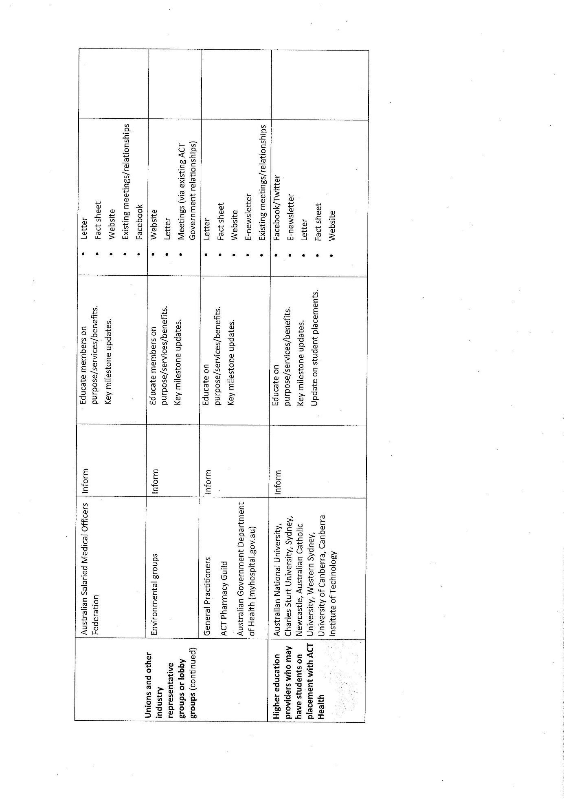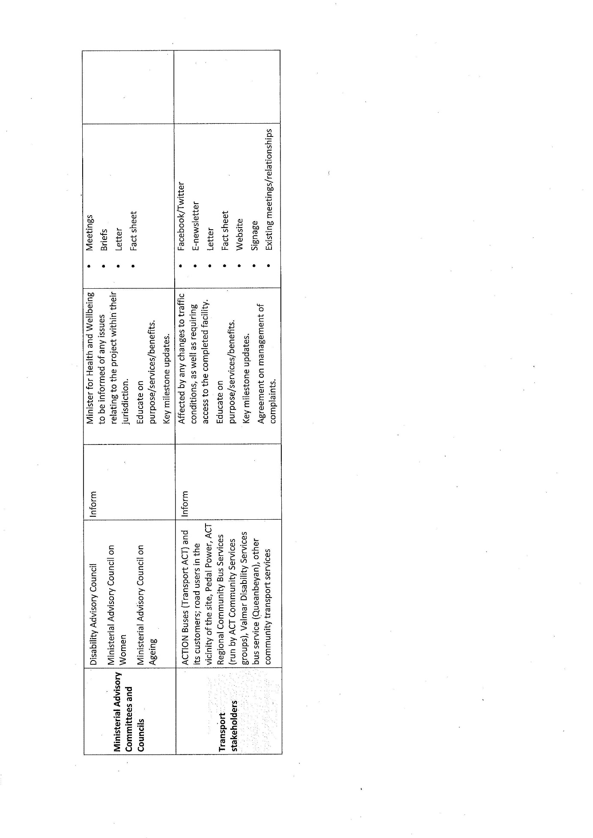
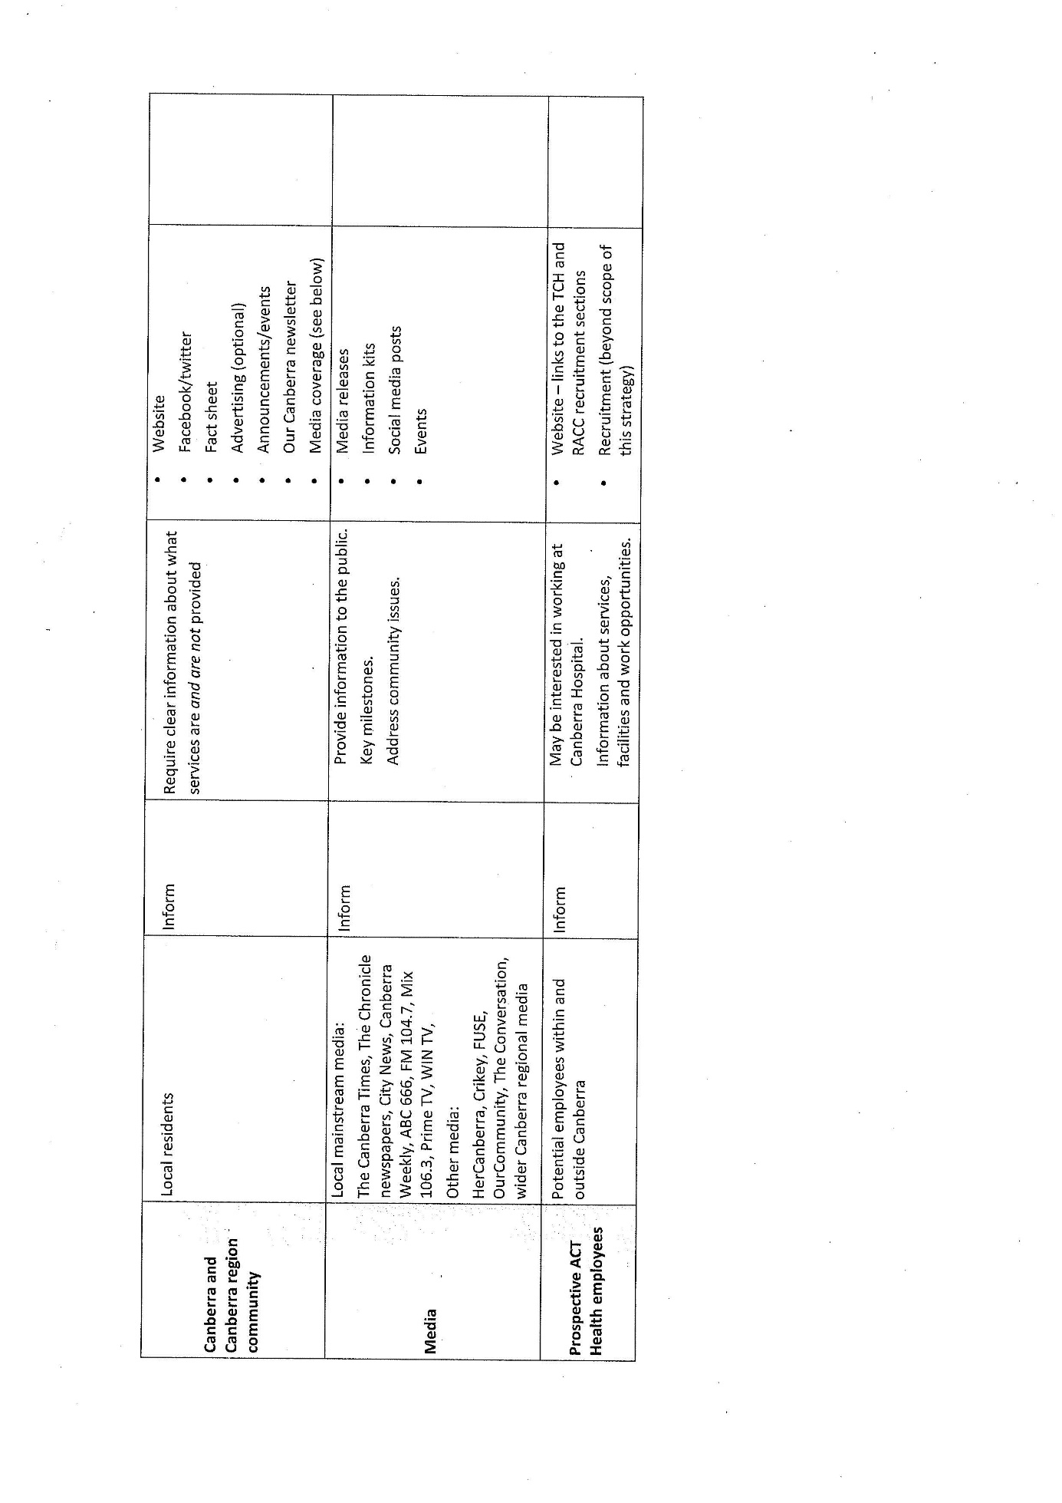

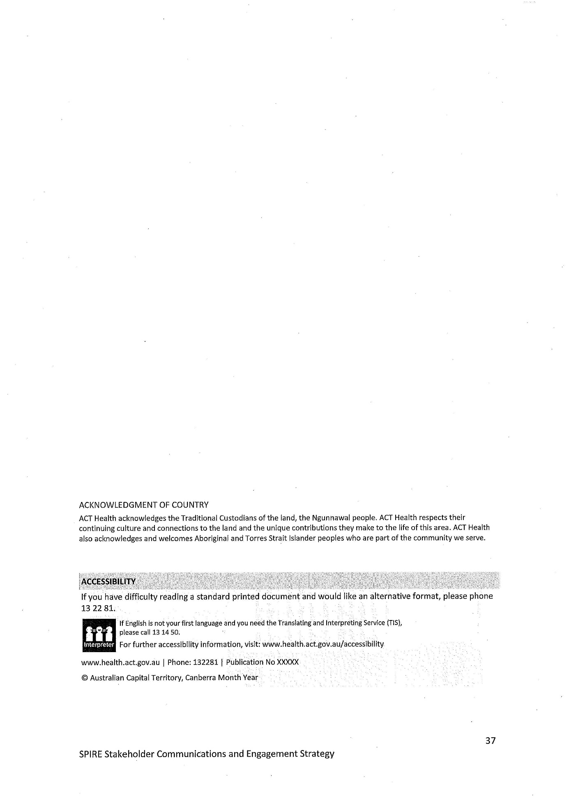

Appendix C – Traffic Analysis
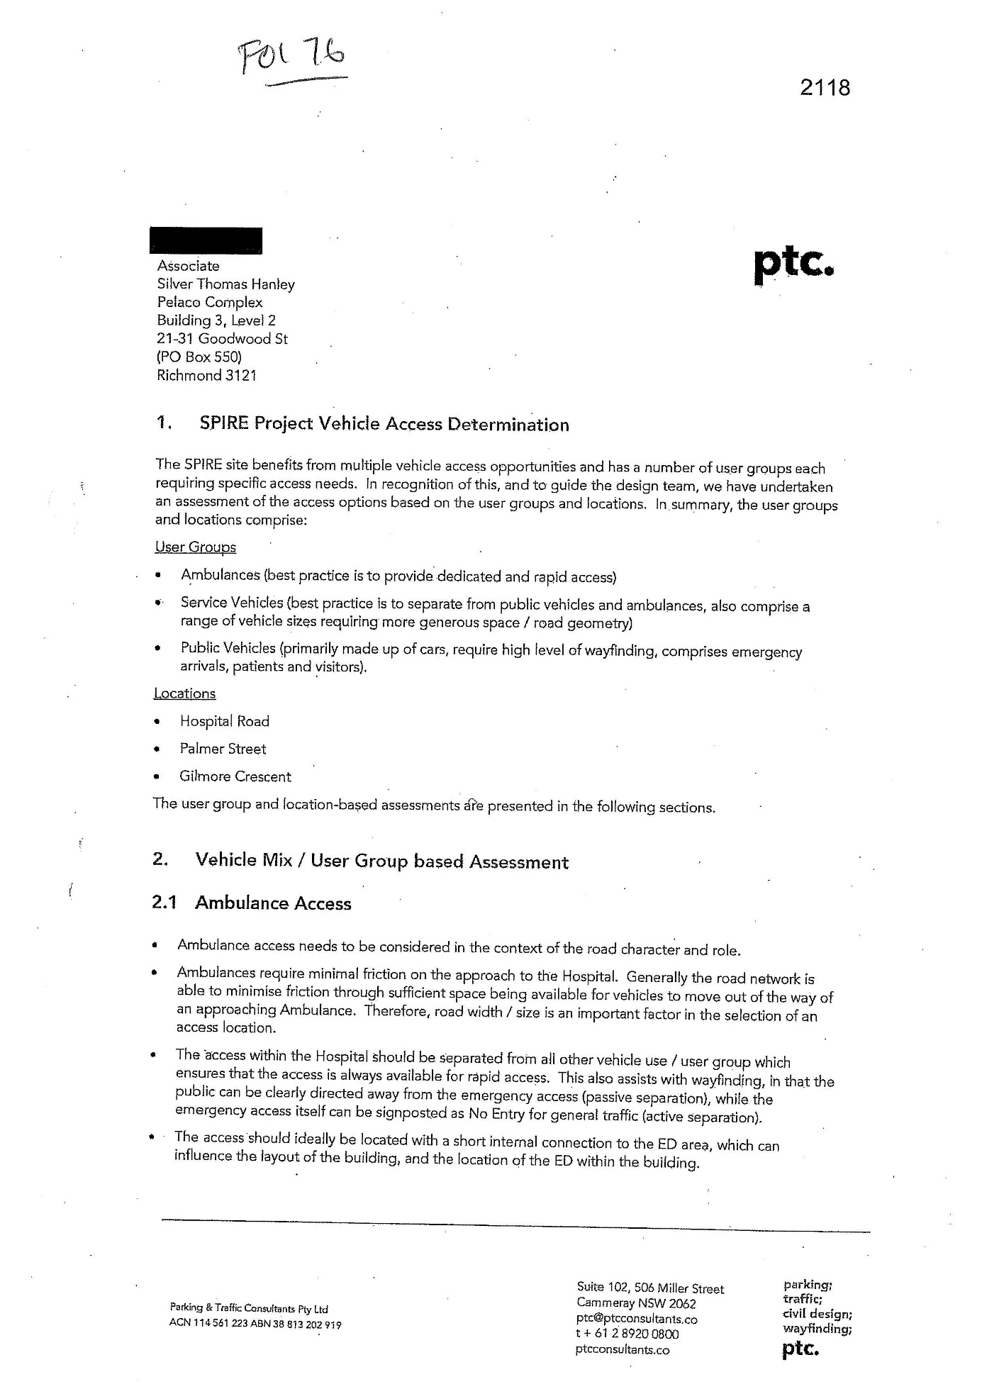
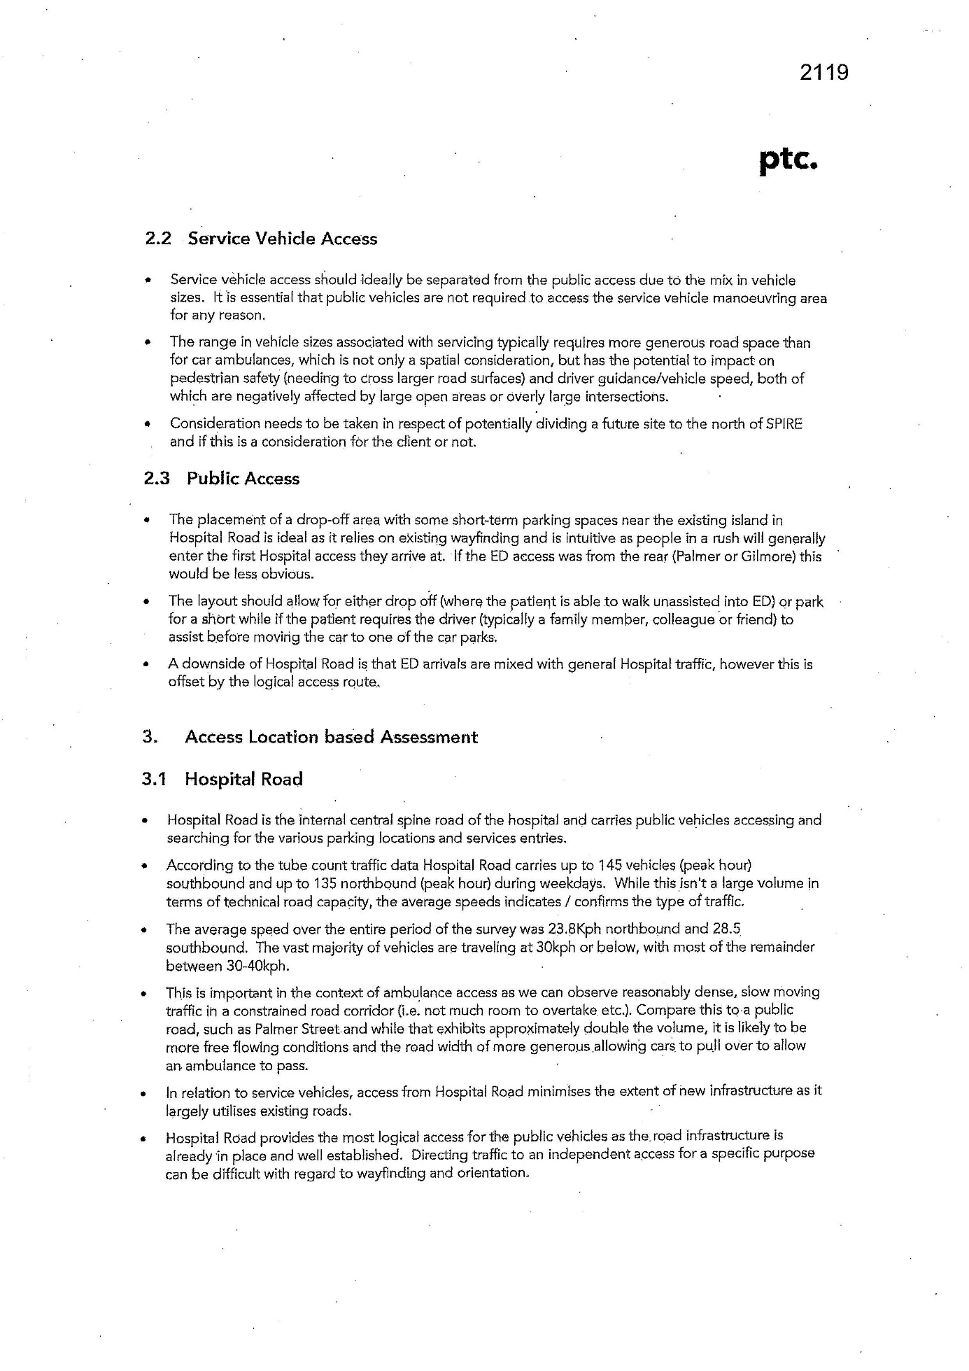
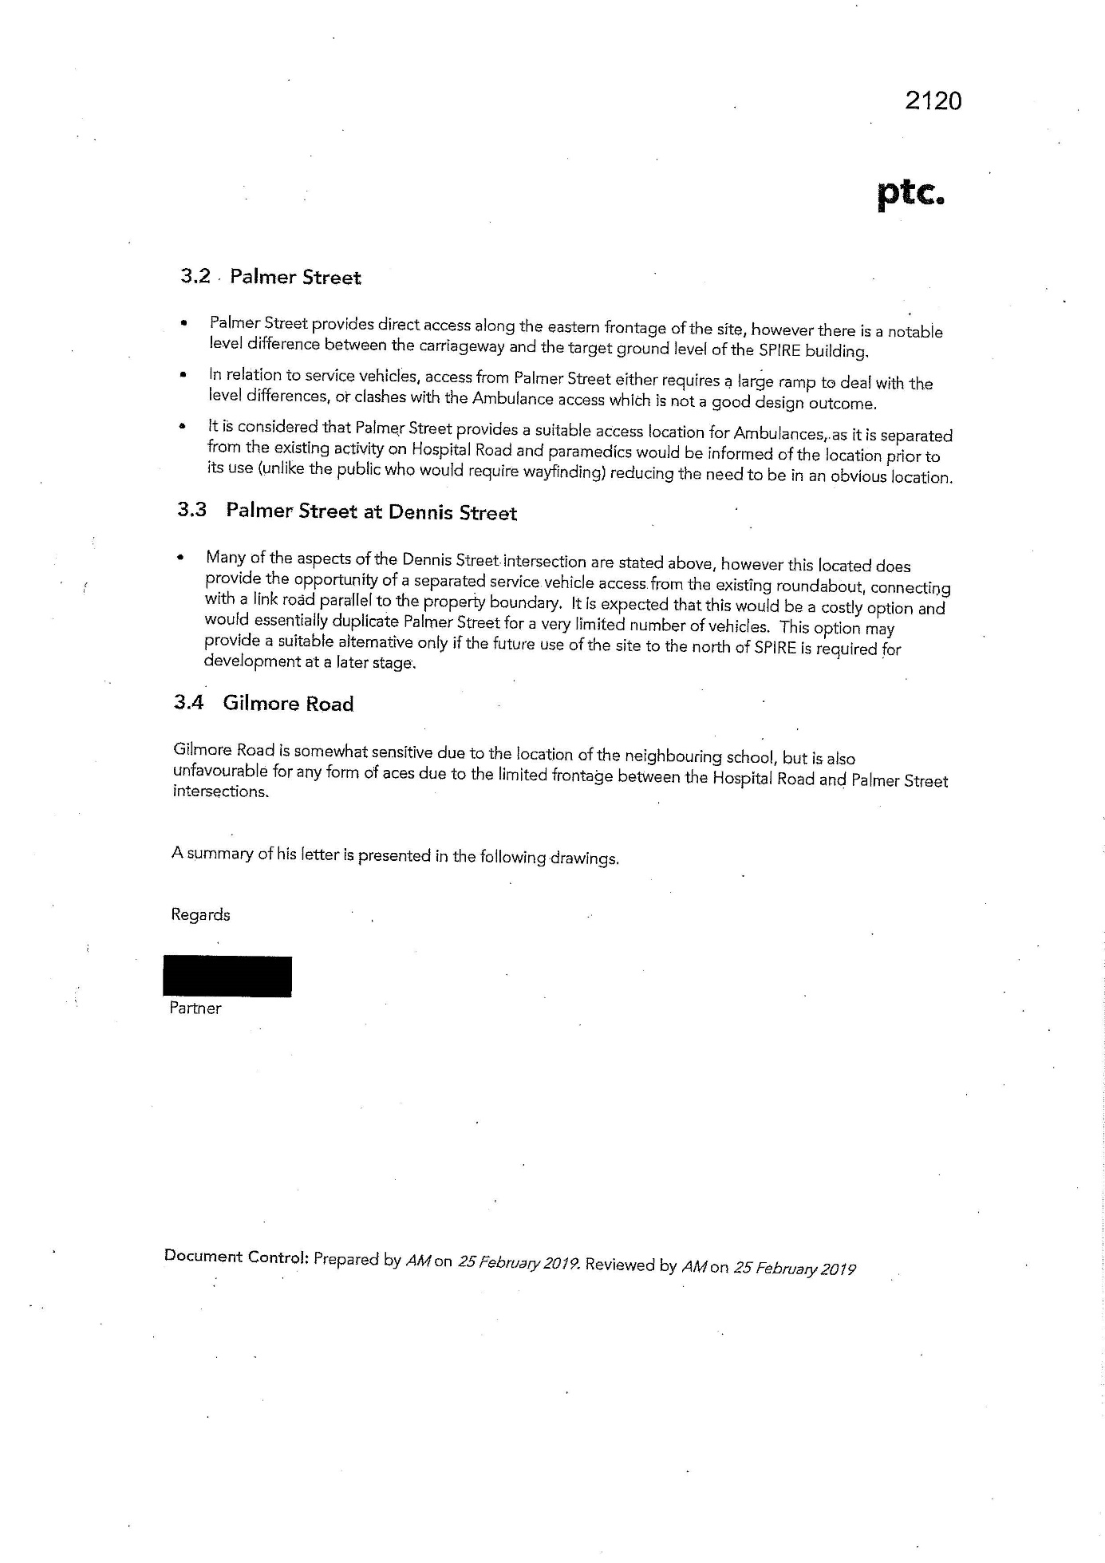

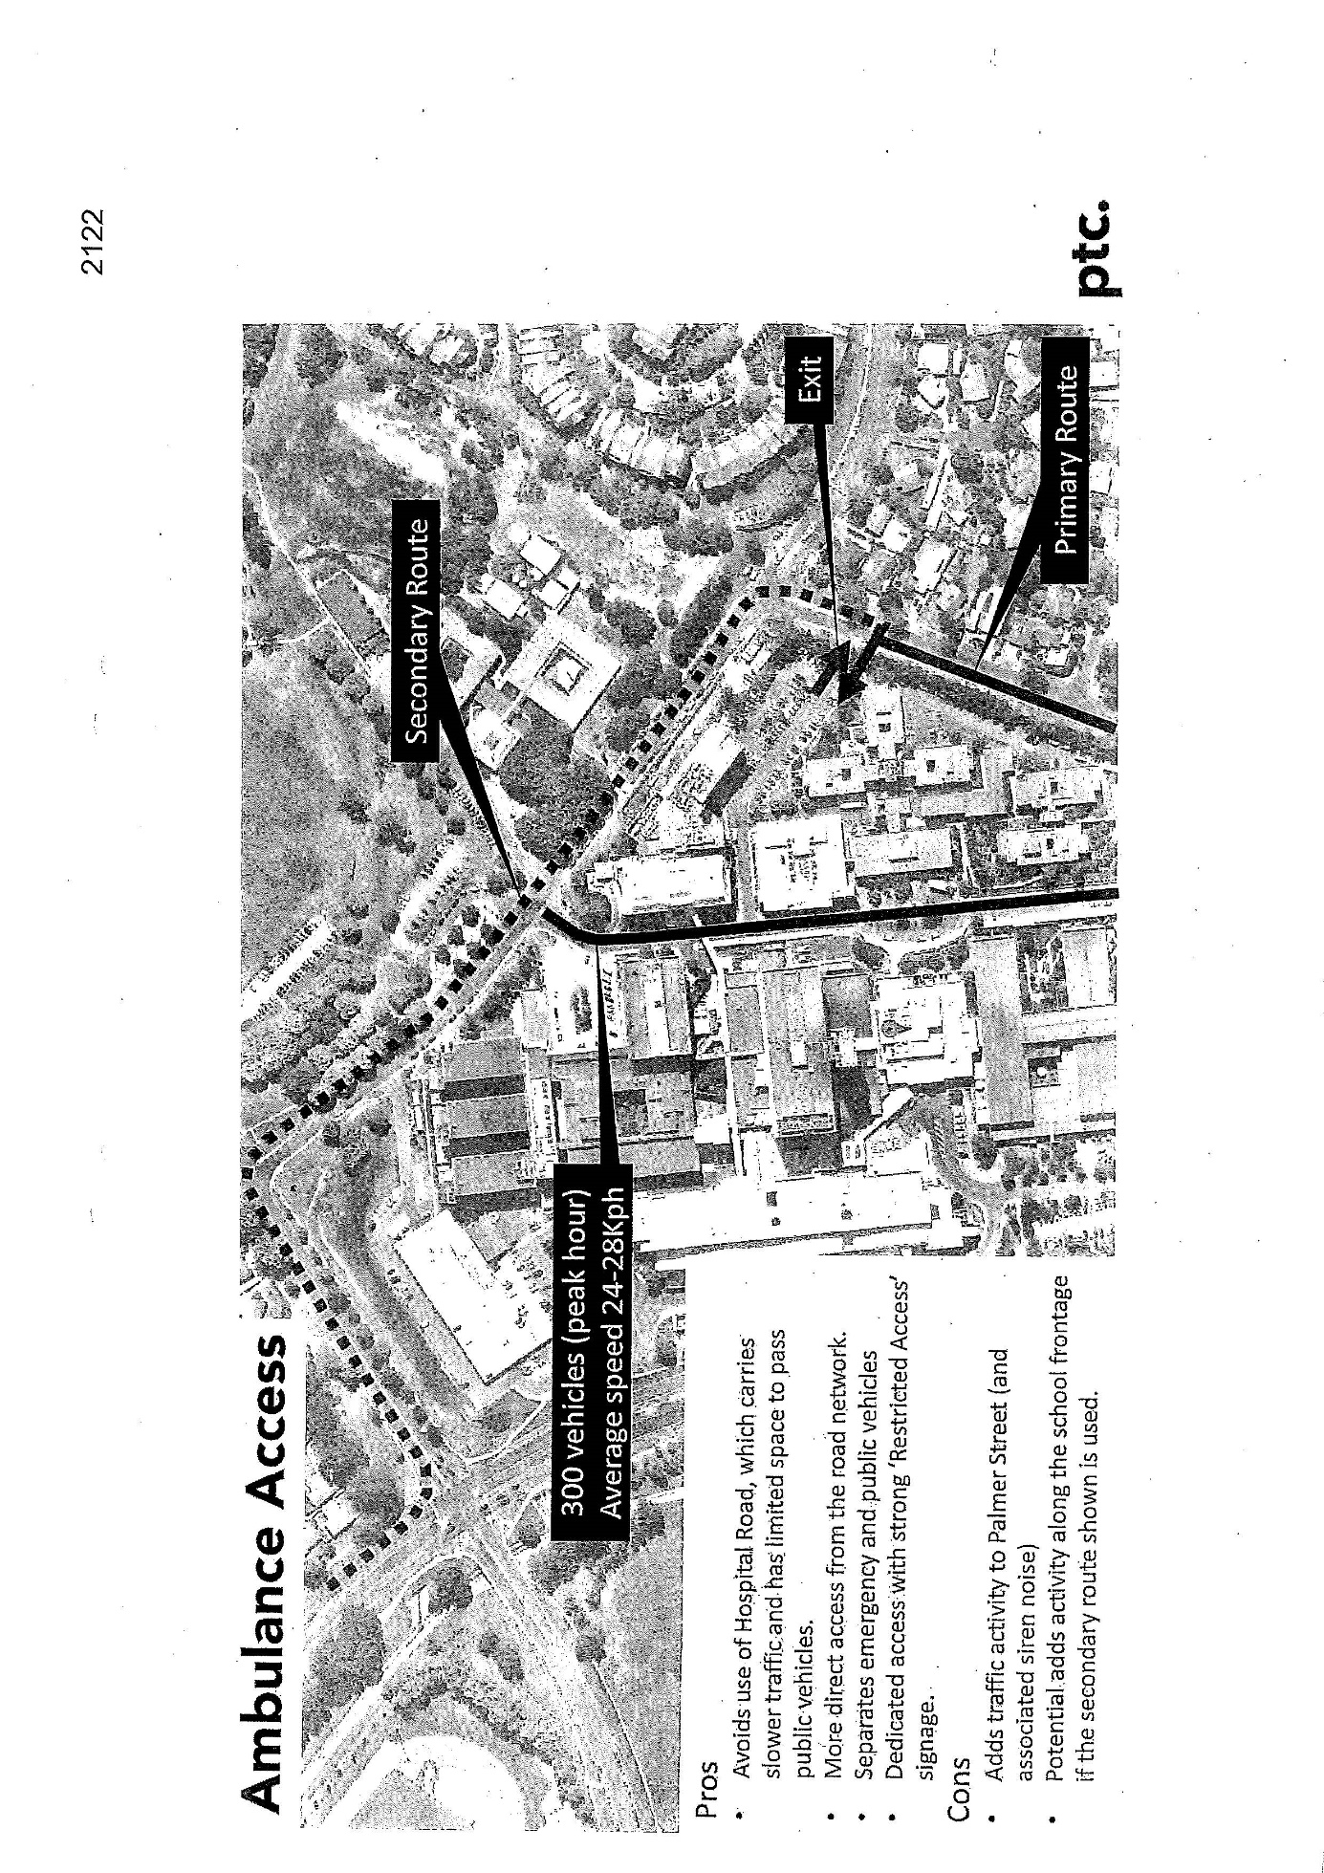
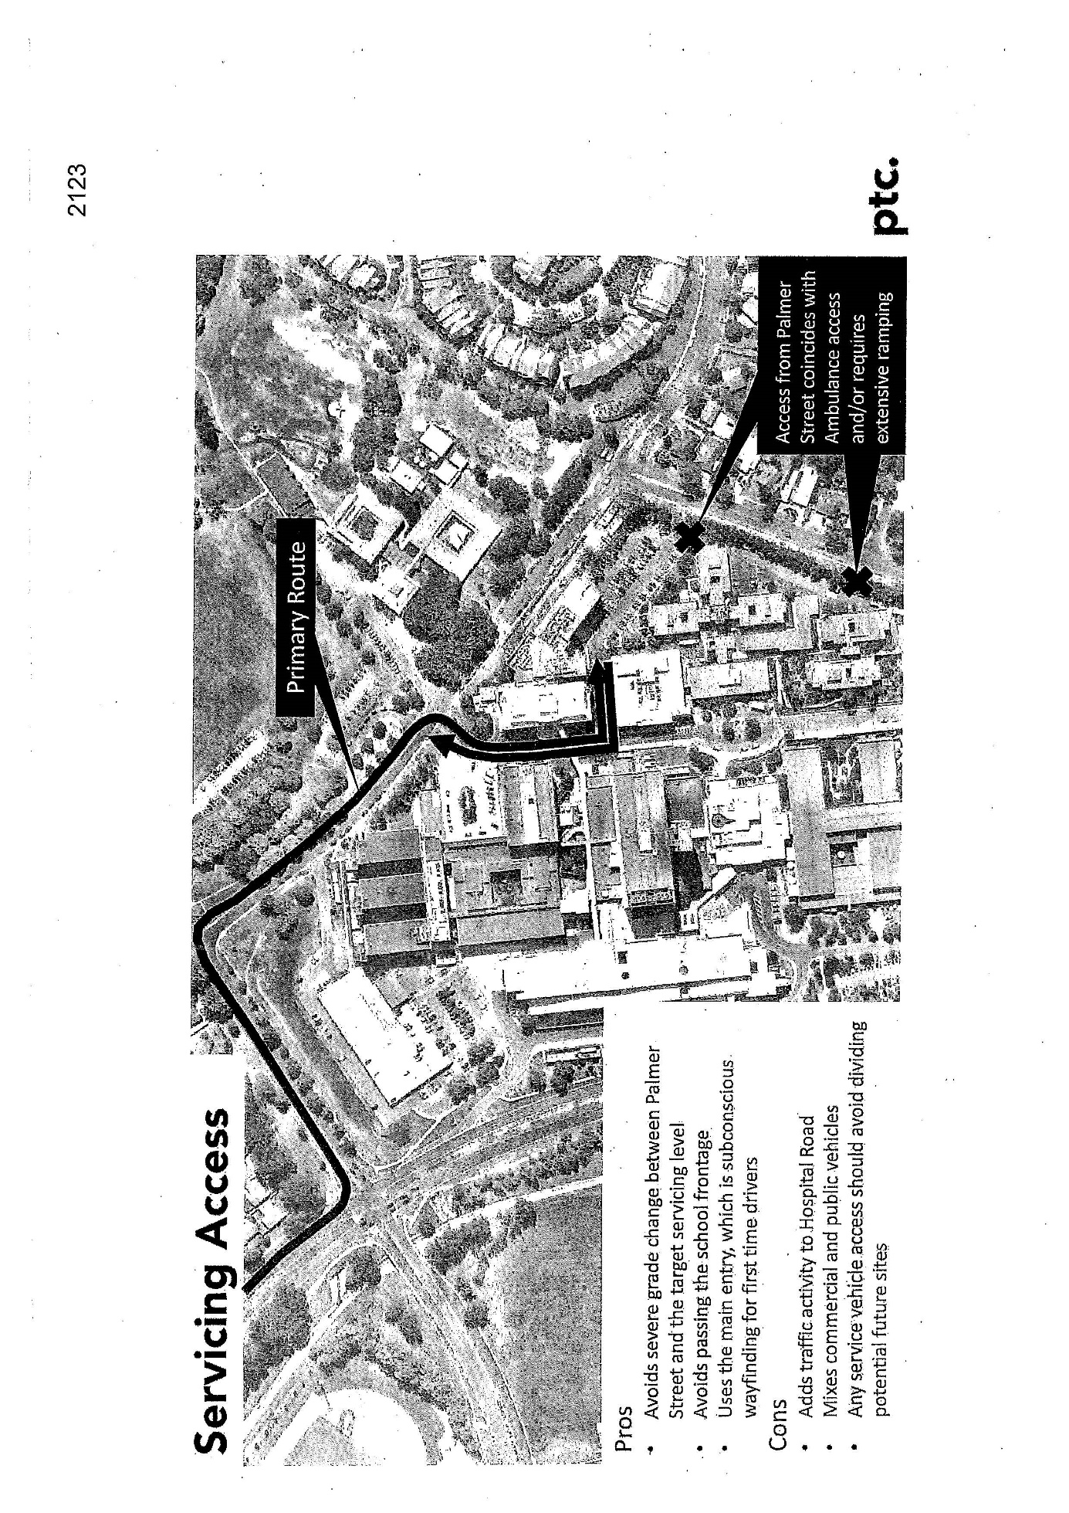
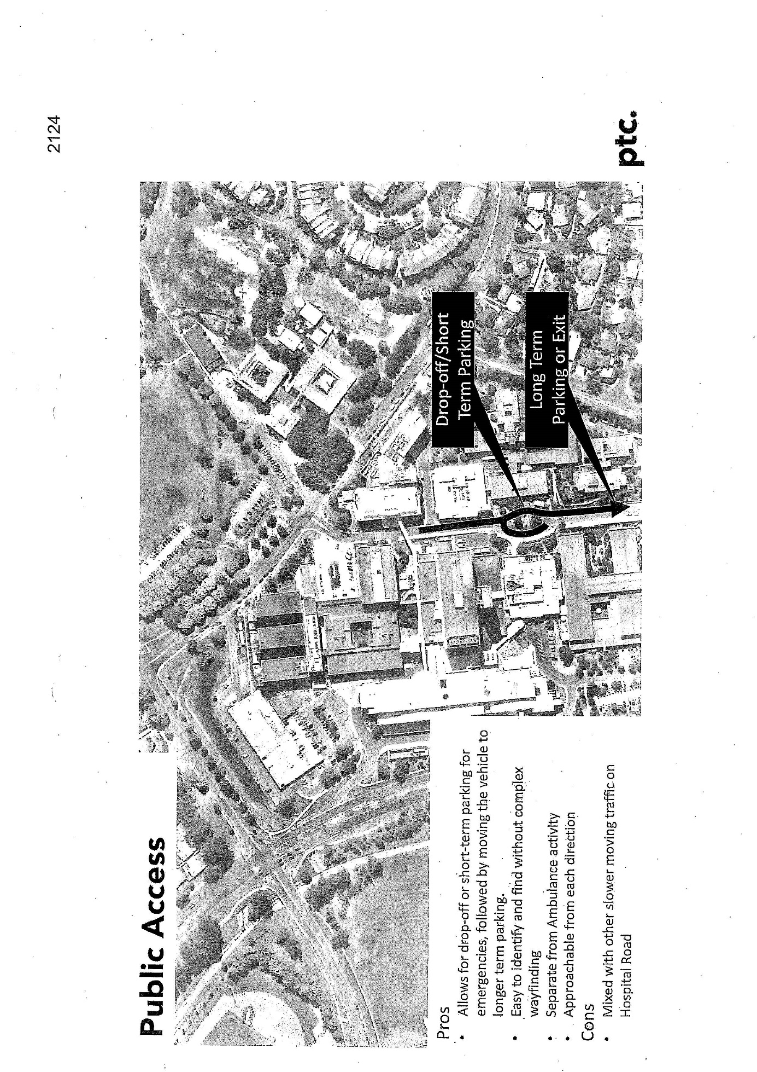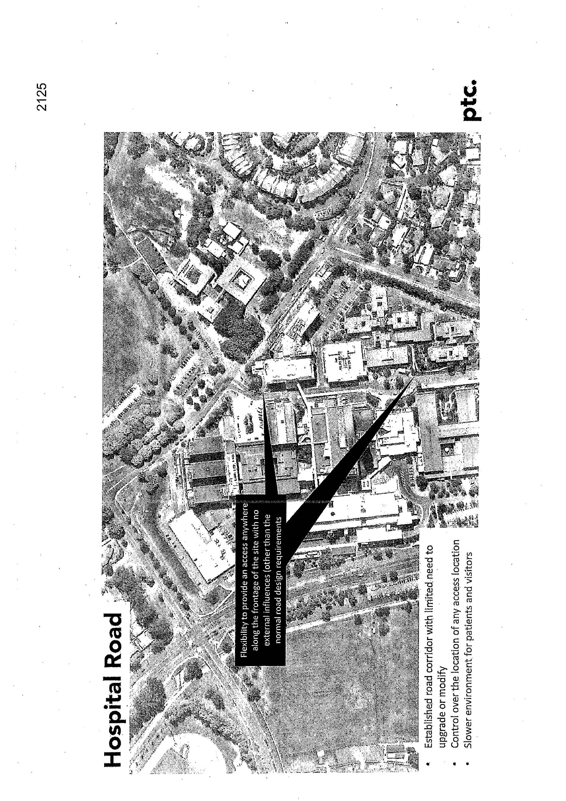
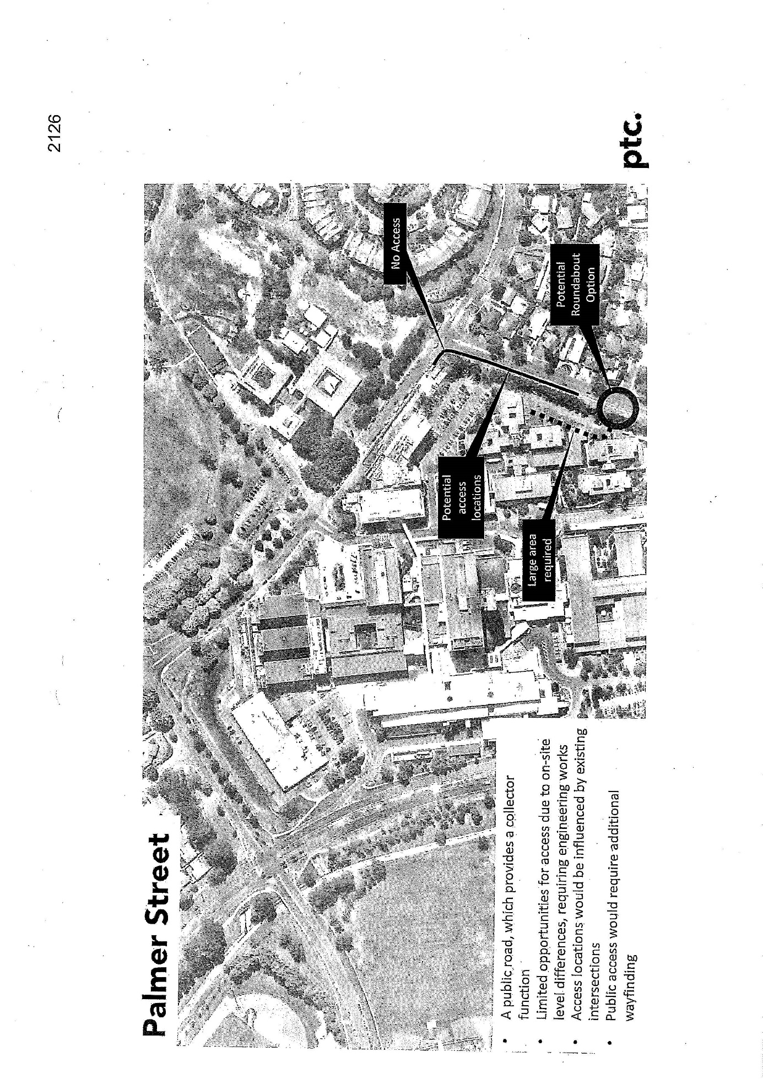
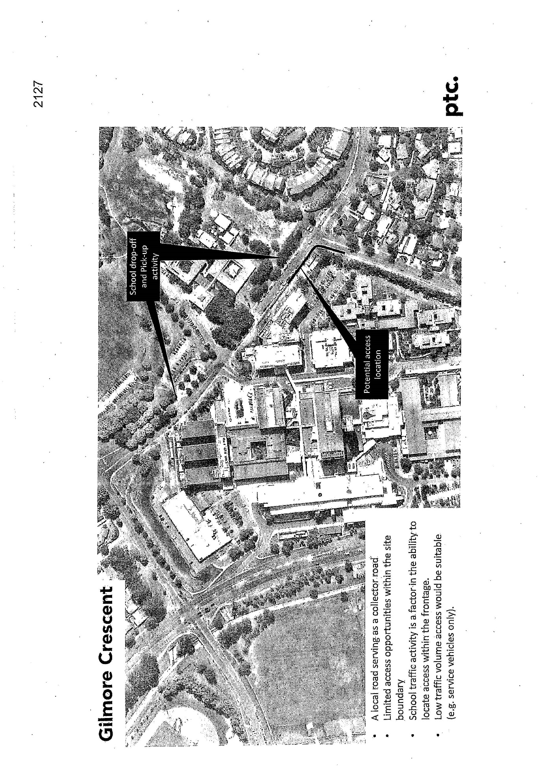

Appendix D – Work Order Building 5

Legislative Assembly for the ACT, Debates, 13 December 2016.
Legislative Assembly for the ACT, Debates, 13 December 2016,
Australian Bureau of Statistics, 1307.8 - Australian Capital Territory in Focus, 2006, https://www.abs.gov.au/AUSSTATS/abs@.nsf/Previousproducts/B43FFBFD93BFC572CA2571E600180BCF?opendocument, accessed 7 August 2020.
Trove, Royal Canberra Hospital, https://trove.nla.gov.au/people/622808?c=people, accessed 7 August 2020.
ANU Open Research Library, Canberra Community Hospital, https://openresearch-repository.anu.edu.au/handle/1885/336, accessed 7 August 2020.
The Australian Senate’s Public Works Committee, Nurses’ Home and Training School at Canberra Community Hospital, https://parlinfo.aph.gov.au/parlInfo/search/display/display.w3p;query=Id%3A%22hansard80%2Fhansards80%2F1960-06-02%2F0190%22;src1=sm1, accessed 7 August 2020.
Trove, Royal Canberra Hospital, https://trove.nla.gov.au/people/622808?c=people, accessed 7 August 2020.
National Film and Sound Archive of Australia, The Royal Canberra Hospital Implosion, https://www.nfsa.gov.au/collection/curated/royal-canberra-hospital-implosion, accessed 7 August 2020. The ACT Government-encouraged public to watch the controlled demolition. Unfortunately this resulted in the death of 12 year old Katie Bender by flying debris.
For a detailed discussion about Canberra Community Hospital’s issues and solutions, see Parliament of Australia’s Joint Committee of Public Accounts, The Supplementary Report of the Auditor-General Financial Year 1964-65 (the Canberra Community Hospital), https://www.aph.gov.au/Parliamentary_Business/Committees/House_of_Representatives_Committees?url=reports/1966/1966_pp319.pdf, accessed 5 August 2020.
Parliament of Australia’s Joint Committee of Public Accounts, The Supplementary Report of the Auditor-General Financial Year 1964-65 (the Canberra Community Hospital), https://www.aph.gov.au/Parliamentary_Business/Committees/House_of_Representatives_Committees?url=reports/1966/1966_pp319.pdf, pp. 15-16, accessed 5 August 2020.
Parliament of Australia’s Joint Committee of Public Accounts, The Supplementary Report of the Auditor-General Financial Year 1964-65 (the Canberra Community Hospital), https://www.aph.gov.au/Parliamentary_Business/Committees/House_of_Representatives_Committees?url=reports/1966/1966_pp319.pdf, p. 16, accessed 5 August 2020.
Parliament of Australia’s Joint Committee of Public Accounts, The Supplementary Report of the Auditor-General Financial Year 1964-65 (the Canberra Community Hospital), https://www.aph.gov.au/Parliamentary_Business/Committees/House_of_Representatives_Committees?url=reports/1966/1966_pp319.pdf, p. 17, accessed 5 August 2020.
Trove, Royal Canberra Hospital, https://trove.nla.gov.au/people/622808?c=people, accessed 7 August 2020.
ACT Health, Canberra Hospital, https://health.act.gov.au/hospitals-and-health-centres/canberra-hospital, accessed 7 August 2020.
Major Projects Canberra, Canberra Hospital Expansion: a SPIRE Project Update – March 2020, p. 7, https://www.health.act.gov.au/sites/default/files/2020-04/Canberra%20Hosptial%20Expansion%20SPIRE%20Project%20update%20March%2020_web.2.pdf, accessed 7 August 2020.
Major Projects Canberra, Canberra Hospital Expansion: a SPIRE Project Update – March 2020, p. 10, https://www.health.act.gov.au/sites/default/files/2020-04/Canberra%20Hosptial%20Expansion%20SPIRE%20Project%20update%20March%2020_web.2.pdf, accessed 7 August 2020.
ACT Health, Canberra Hospital, https://health.act.gov.au/hospitals-and-health-centres/canberra-hospital, accessed 7 August 2020.
Calvary, About Calvary Public Hospital Bruce, https://www.calvarycare.org.au/public-hospital-bruce/about/, accessed 6 August 2020.
Calvary, About Calvary Public Hospital Bruce, https://www.calvarycare.org.au/public-hospital-bruce/about/, accessed 6 August 2020.
Calvary, Calvary John James Hospital, https://www.calvarycare.org.au/john-james-private-hospital-canberra/, accessed 6 August 2020.
ABC News, ACT Govt plans to take over Calvary Hospital, https://www.abc.net.au/news/2009-04-Engagement Paln/act-govt-plans-to-take-over-calvary-hospital/1657880, accessed 6 August 2020.
Daniella White, Calvary Public Hospital Buildings Reaching 'End of life', The Canberra Times, 30 May 2019, https://www.canberratimes.com.au/story/6189568/hospital-buildings-reaching-end-of-life/digital-subscription/, accessed 6 August 2020.
ACT Health, Adult Mental Health Rehabilitation Unit, https://www.health.act.gov.au/hospitals-and-health-centres/university-canberra-hospital/wards-and-departments/adult-mental-health, accessed 6 August 2020.
The University of Canberra and ACT Health, The University of Canberra Public Hospital Fact Sheet, p. 2, https://www.canberra.edu.au/on-campus/campus-development/precincts-and-projects/health-precinct/university-of-canberra-hospital/documents/UCPH-fact-sheet-Mar-16.pdf, accessed 6 August 2020.
The University of Canberra and ACT Health, The University of Canberra Public Hospital Fact Sheet, p. 2, https://www.canberra.edu.au/on-campus/campus-development/precincts-and-projects/health-precinct/university-of-canberra-hospital/documents/UCPH-fact-sheet-Mar-16.pdf, accessed 6 August 2020.
Mirage News, University of Canberra Celebrates First Birthday, https://www.miragenews.com/university-of-canberra-hospital-celebrates-first-birthday/, accessed 6 August 2020.
Mirage News, University of Canberra Celebrates First Birthday, https://www.miragenews.com/university-of-canberra-hospital-celebrates-first-birthday/, accessed 6 August 2020.
Calvary, About Calvary John James Hospital, https://www.calvarycare.org.au/john-james-private-hospital-canberra/about/, accessed 6 August 2020.
Calvary, About Calvary John James Hospital, https://www.calvarycare.org.au/john-james-private-hospital-canberra/about/, accessed 6 August 2020.
Calvary, About Calvary John James Hospital, https://www.calvarycare.org.au/john-james-private-hospital-canberra/about/, accessed 6 August 2020.
Calvary, About Calvary Private Hospital Bruce, https://www.calvarycare.org.au/bruce-private-hospital/about/, accessed 6 August 2020.
Calvary, About Calvary Private Hospital Bruce, https://www.calvarycare.org.au/bruce-private-hospital/about/, accessed 6 August 2020.
National Capital Private Hospital, National Capital Private Hospital, https://nationalcapitalprivatehospital.com.au/, accessed 6 August 2020.
National Capital Private Hospital, National Capital Private Hospital, https://nationalcapitalprivatehospital.com.au/, accessed 6 August 2020.
ACT Legislative Assembly Standing Committee on Health, Ageing and Community Services, Inquiry into the future sustainability of health funding in the ACT – Report 5, December 2018, p. 3, https://www.parliament.act.gov.au/__data/assets/pdf_file/0005/1294844/9th-HACS-05-Inquiry-into-the-Future-Sustainability-of-Health-Funding-in-the-ACT.pdf, accessed 7 August 2020.
ACT Legislative Assembly Standing Committee on Health, Ageing and Community Services, Inquiry into the future sustainability of health funding in the ACT – Report 5, December 2018, p. 3, https://www.parliament.act.gov.au/__data/assets/pdf_file/0005/1294844/9th-HACS-05-Inquiry-into-the-Future-Sustainability-of-Health-Funding-in-the-ACT.pdf, accessed 7 August 2020.
Legislative Assembly for the ACT, Debates, 6 May 2009, http://www.hansard.act.gov.au/hansard/2009/pdfs/20090506.pdf, accessed 7 August 2020.
ACT Legislative Assembly Standing Committee on Health, Ageing and Community Services, Inquiry into the future sustainability of health funding in the ACT – Report 5, December 2018, p. 9, https://www.parliament.act.gov.au/__data/assets/pdf_file/0005/1294844/9th-HACS-05-Inquiry-into-the-Future-Sustainability-of-Health-Funding-in-the-ACT.pdf, accessed 7 August 2020.
ACT Legislative Assembly Standing Committee on Health, Ageing and Community Services, Inquiry into the future sustainability of health funding in the ACT – Report 5, December 2018, p. 9, https://www.parliament.act.gov.au/__data/assets/pdf_file/0005/1294844/9th-HACS-05-Inquiry-into-the-Future-Sustainability-of-Health-Funding-in-the-ACT.pdf, accessed 7 August 2020.
ACT Legislative Assembly Standing Committee on Health, Ageing and Community Services, Inquiry into the future sustainability of health funding in the ACT – Report 5, December 2018, p. 9, https://www.parliament.act.gov.au/__data/assets/pdf_file/0005/1294844/9th-HACS-05-Inquiry-into-the-Future-Sustainability-of-Health-Funding-in-the-ACT.pdf, accessed 7 August 2020.
ACT Government, Budget by Government Priority, https://apps.treasury.act.gov.au/budget/budget-2019-20/capital-works/budget-by-government-priority, accessed 4 august 2020. In terms of federal funding, the ACT Government stated in its 2019-20 budget review that it anticipates receiving approximately 41 per cent of total revenue via the Commonwealth in 2019-20 – including both GST distributions and direct government payments. This will also include funding to the ACT under health agreements. See ACT Government, Australian Capital Territory Budget 2019-20 Building for the future – Budget Review, p. 95, p. 96, https://apps.treasury.act.gov.au/__data/assets/pdf_file/0006/1479975/2019-20-budget-review.pdf, accessed 7 August 2020.
Jon Stanhope & Khalid Ahmed, ACT Public Hospitals Hit by Predicted Health Tsunami, The Policy Space, 22 January 2020, https://www.thepolicyspace.com.au/2020/22/294-act-public-hospitals-hit-by-predicted-health-tsunami, accessed 5 August 2020.
Health Care Consumer’s Association (HCCA), “Of course it’s better if we’re there”: Consumer involvement in health infrastructure in the ACT, 2009-2016, p. 22, https://www.hcca.org.au/wp-content/uploads/2018/04/Consumer-involvement-in-health-infrastructure-projects-in-the-ACT-2009-2016-FINAL-DECEMBER-2016.compressed.pdf, accessed 6 August 2020.
ACT Government, 2008-2009 Budget paper No. 5, http://www.treasury.act.gov.au/budget/budget_2008/files/paper5/08explai.pdf, accessed 7 August 2020.
Health Care Consumer’s Association (HCCA), “Of course it’s better if we’re there”: Consumer involvement in health infrastructure in the ACT, 2009-2016, p. 22, https://www.hcca.org.au/wp-content/uploads/2018/04/Consumer-involvement-in-health-infrastructure-projects-in-the-ACT-2009-2016-FINAL-DECEMBER-2016.compressed.pdf, accessed 6 August 2020.
ACT Government, Submission 11, p. 4.
Minister Corbell, (in reply to supplementary questions by Mr Coe and Mr Hanson on Tuesday, 24 March 2015), Legislative Assembly for the ACT, Debates, 7 May 2015, http://www.hansard.act.gov.au/hansard/2015/pdfs/20150507a.pdf p. 1570.
Minister Corbell, (in reply to supplementary questions by Mr Coe and Mr Hanson on Tuesday, 24 March 2015), Legislative Assembly for the ACT, Debates, 7 May 2015, http://www.hansard.act.gov.au/hansard/2015/pdfs/20150507a.pdf p. 1570.
Julie Cochran, Submission 4, p. 1.
ACT Health, Expanding hospital services in the ACT: an additional 400 Hospital Beds – Health Service Delivery Public Consultation & Discussion Paper, https://www.parliament.act.gov.au/__data/assets/pdf_file/0016/373012/05._ACT_Govt-Expanding_Hospital_Services.pdf, accessed 5 August 2020.
Jon Stanhope & Khalid Ahmed, ACT Public Hospitals Hit by Predicted Health Tsunami, The Policy Space, 22 January 2020, https://www.thepolicyspace.com.au/2020/22/294-act-public-hospitals-hit-by-predicted-health-tsunami, accessed 5 August 2020; The Master Plan is only accessible in archival hard copy at ACT Heritage Library.
https://www.cmtedd.act.gov.au/__data/assets/pdf_file/0013/220306/infrastructureplan2011.pdf.
http://www.hansard.act.gov.au/hansard/2015/pdfs/20150507a.pdf, p. 1570.
http://www.hansard.act.gov.au/hansard/2015/pdfs/20150507a.pdf p. 1570.
Health Care Consumer’s Association (HCCA), “Of course it’s better if we’re there”: Consumer involvement in health infrastructure in the ACT, 2009-2016, p. 15, https://www.hcca.org.au/wp-content/uploads/2018/10/Consumer-Involvement-in-Health-Infrastructure-Projects-in-the-ACT-2009-2016.docx, accessed 5 August 2020.
Jon Stanhope & Khalid Ahmed, ACT Public Hospitals Hit by Predicted Health Tsunami, The Policy Space, 22 January 2020, https://www.thepolicyspace.com.au/2020/22/294-act-public-hospitals-hit-by-predicted-health-tsunami, accessed 5 August 2020.
ACT Government, Submission 11, p. 6.
ACT Government, 10-Year Health Plan will deliver better care when you need it, https://apps.treasury.act.gov.au/__data/assets/pdf_file/0008/1069973/10-Year-Health-Plan-Factsheet.pdf, accessed 30 July 2020; ACT Labor, ACT Labor’s Ten Year Health Plan, https://www.actlabor.org.au/media/42971/10_year_health_plan_final.pdf, accessed 30 July 2020.
ACT Government, 10-Year Health Plan will deliver better care when you need it, p. 2, https://apps.treasury.act.gov.au/__data/assets/pdf_file/0008/1069973/10-Year-Health-Plan-Factsheet.pdf, accessed 30 July 2020.
ACT Government, Australian Capital Territory Budget 2019-20 Building for the future – Budget Paper 3: Budget Outlook, p. 154, https://apps.treasury.act.gov.au/__data/assets/pdf_file/0004/1369831/Budget-Paper-3-Budget-Outlook-2019-20.pdf, accessed 30 July 2020.
ACT Government, Australian Capital Territory Budget 2019-20 Building for the future – Budget Paper 3: Budget Outlook, p. 156, https://apps.treasury.act.gov.au/__data/assets/pdf_file/0004/1369831/Budget-Paper-3-Budget-Outlook-2019-20.pdf, accessed 30 July 2020.
ACT Government, Australian Capital Territory Budget 2019-20 Building for the future – Budget Paper 3: Budget Outlook, p. 51, https://apps.treasury.act.gov.au/__data/assets/pdf_file/0004/1369831/Budget-Paper-3-Budget-Outlook-2019-20.pdf, accessed 30 July 2020.
ACT Government, Australian Capital Territory Budget 2019-20 Building for the future – Budget Paper 3: Budget Outlook, p. 154, https://apps.treasury.act.gov.au/__data/assets/pdf_file/0004/1369831/Budget-Paper-3-Budget-Outlook-2019-20.pdf, accessed 30 July 2020.
ACT Government, Submission 11, p. 6.
ACT Government, Submission 11, p. 3.
ACT Government, Submission 11, p. 3.
ACT Labor, ACT Labor’s Ten Year Health Plan, https://www.actlabor.org.au/media/42971/10_year_health_plan_final.pdf, accessed 30 July 2020.
ACT Labor, ACT Labor’s Ten Year Health Plan, https://www.actlabor.org.au/media/42971/10_year_health_plan_final.pdf, accessed 30 July 2020.
Functional Areas Scope, MPC FOI MPCFOI2019-08, Part 1 p. 64, https://www.act.gov.au/majorprojectscanberra/about-us/access-to-information/foi-disclosure-log, accessed 1 July 2020.
Major Projects Canberra, Canberra Hospital Expansion: a SPIRE Project Update – August 2020, https://www.act.gov.au/__data/assets/pdf_file/0008/1612673/20351-MP-Canberra-Hospital-Expansion-August-Newsletter-PAGES-WEB-1.pdf accessed 14 August 2020.
ACT Legislative Assembly, Notice Paper No. 49, Friday 24 July 2020.
ACT Government, Submission 11, p. 4.
ACT Government, Submission 11, p. 4.
ACT Government, Submission 11, p. 5.
ACT Government, Submission 11, p. 5.
ACT Government, Submission 11, pp. 5-6.
Mari Kondo, Submission 25, p. 1.
Combined Community Councils ACT, Submission 16, p. 3.
Woden Valley Community Council, Submission 18, p. 4.
Weston Creek Community Council, Submission 20, p. 1.
Weston Creek Community Council, Submission 20, p. 2.
Weston Creek Community Council, Submission 20, p. 2.
ACT Government, Submission 11, p. 5.
ACT Government, Submission 11, p. 7.
ACT Government, Submission 11, p. 6.
ACT Government, Submission 11, p. 7.
ACT Government, Submission 11, p. 7.
ACT Government, Submission 11, p. 7.
ACT Government, Submission 11, p. 8.
Julie Cochran, Submission 3, p. 3.
ACT Government, 10-Year Health Plan, https://apps.treasury.act.gov.au/budget/budget-2017-2018/better-care-when-you-need-it/10-year-health-plan, accessed 30 July 2020.
Woden Valley Community Council, Submission 18, p. 3.
Woden Valley Community Council, Submission 18, p. 3.
ACT Government, Submission 11, p. 8; Major Projects Canberra, Canberra Hospital Expansion: a SPIRE Project Update – March 2020, p. 10, https://www.health.act.gov.au/sites/default/files/2020-04/Canberra%20Hosptial%20Expansion%20SPIRE%20Project%20update%20March%2020_web.2.pdf, accessed 7 August 2020.
ACT Government, Submission 11, p. 8; Major Projects Canberra, Canberra Hospital Expansion: a SPIRE Project Update – March 2020, p. 10, https://www.health.act.gov.au/sites/default/files/2020-04/Canberra%20Hosptial%20Expansion%20SPIRE%20Project%20update%20March%2020_web.2.pdf, accessed 7 August 2020.
ACT Government, Submission 11, p. 8.
ACT Government, Your Say: Canberra Hospital Expansion, https://www.yoursay.act.gov.au/spire, accessed 30 July 2020.
ACT Government, Your Say: Canberra Hospital Expansion, https://www.yoursay.act.gov.au/spire, accessed 14 August 2020.
See Media Release, Minister Meegan Fitzharris MLA, 12 December 2018, Future proofing our health system: major infrastructure investment continues at Canberra Hospital https://www.cmtedd.act.gov.au/open_government/inform/act_government_media_releases/meegan-fitzharris-mla-media-releases/2018/future-proofing-our-health-system-major-infrastructure-investment-continues-at-canberra-hospital, accessed 30 July 2020.
See Media Release, Minister Meegan Fitzharris MLA, 12 December 2018, Future proofing our health system: major infrastructure investment continues at Canberra Hospital https://www.cmtedd.act.gov.au/open_government/inform/act_government_media_releases/meegan-fitzharris-mla-media-releases/2018/future-proofing-our-health-system-major-infrastructure-investment-continues-at-canberra-hospital, accessed 30 July 2020.
Daniella White, New Site for Hospital Expansion Named after Cost Blowout Fears, The Canberra Times, 12 December 2018.
Health Care Consumers Association, Submission 8, pp. 5-6.
Garran Residents’ Association, Submission 7, p. 2; Health Care Consumers Association, Submission 8, p. 5; Women with Disabilities ACT, Submission 9, p. 2.
Garran Residents’ Association, Submission 7, p. 3.
Roy St George, Submission 5, p. 1.
Daniella White, Student Safety Fears from Hospital Expansion, The Canberra Times, 25 October 2019.
Ian Elsum, Submission 15, p. 1; Judy Ware, Submission 17, p. 1; Garran Residents’ Association, Submission 7, p. 1.
Combined Community Councils of the ACT, Submission 16, p. 2.
RACS letter to ACT Health Director-General, 21 December 2018, Health FOI HDFOI19/76 p. 6641, https://health.act.gov.au/about-our-health-system/freedom-information/disclosure-log, accessed 30 July 2020.
Garran Residents’ Association, Submission 7, p. 1.
Garran Residents’ Association, Submission 7, p. 1.
Garran Residents’ Association, Submission 7, p. 2.
Woden Valley Community Council, Submission 18, p. 5.
Woden Valley Community Council, Submission 18, p. 5.
Garran Residents’ Association, Submission 7, p. 4.
Joint Media Release, Chief Minister Andrew Barr MLA and Minister Meegan Fitzharris MLA, 28 May 2019, SPIRE Centre set to transform The Canberra Hospital, https://www.cmtedd.act.gov.au/open_government/inform/act_government_media_releases/meegan-fitzharris-mla-media-releases/2019/spire-centre-set-to-transform-the-canberra-hospital, accessed 1 July 2020.
A letter from the Office of the ACT Director-General of Health to the Chief Executive Officer to Canberra Health Services, May 2019, Health FOI HDFOI19/76, p. 734, https://health.act.gov.au/about-our-health-system/freedom-information/disclosure-log, accessed 30 July 2020.
ACT Health staff email communication, 28 May 2019, Health FOI HDFOI19/76, p. 738, https://health.act.gov.au/about-our-health-system/freedom-information/disclosure-log, accessed 30 July 2020.
Paul Costigan, The Changing Hospital Promise Hurts the Locals, CityNews, 20 November 2019, https://citynews.com.au/2019/the-changing-hospital-promise-hurts-the-locals/, accessed 29 July 2020.
Mr Pettersson MLA did not support this view.
See Email and attachment – Event brief for SPIRE pre-budget announcement, Health FOI HDFOI19/76 p. 738 https://health.act.gov.au/about-our-health-system/freedom-information/disclosure-log, accessed 30 July 2020; ACT Health, Canberra Hospital Spire Project: Access & Entry Review Study - 19 November 2019, https://www.health.act.gov.au/sites/default/files/2020-03/SPIRE%20Access%20and%20Entry%20Review%20Study.pdf, accessed 30 July 2020.
Despite the majority view on both recommendations, not all members were in agreement, with Mr Pettersson MLA not supporting Recommendation 2.
ACT Health, Canberra Hospital Spire Project: Access & Entry Review Study - 19 November 2019, https://www.health.act.gov.au/sites/default/files/2020-03/SPIRE%20Access%20and%20Entry%20Review%20Study.pdf, accessed 30 July 2020.
See for example Legislative Assembly for the ACT, Debates, 12 February 2020.
Chief Minister Andrew Barr MLA, Correspondence to Clerk of the Legislative Assembly, dated 25 February 2020.
See Health FOI HDFOI19/76 pp. 1233-1235 and pp. 1317-1322 https://health.act.gov.au/about-our-health-system/freedom-information/disclosure-log; ACT Health, Canberra Hospital Spire Project: Access & Entry Review Study - 19 November 2019, https://www.health.act.gov.au/sites/default/files/2020-03/SPIRE%20Access%20and%20Entry%20Review%20Study.pdf, accessed 30 July 2020.
ACT Health, Canberra Hospital Spire Project: Access & Entry Review Study - 19 November 2019, https://www.health.act.gov.au/sites/default/files/2020-03/SPIRE%20Access%20and%20Entry%20Review%20Study.pdf, accessed 30 July 2020.
Major Projects Canberra, Canberra Hospital Expansion: a SPIRE Project Update – March 2020, p. 11, https://www.health.act.gov.au/sites/default/files/2020-04/Canberra%20Hosptial%20Expansion%20SPIRE%20Project%20update%20March%2020_web.2.pdf, accessed 7 August 2020.
Newstate Media, SPIRE Project flags Hospital Road changes, Canberra Weekly, 26 March 2020.
Health Care Consumers’ Association, Submission 8, p. 5.
ACT Government, Submission 11, p. 15.
ACT Government, Submission 11, p. 15.
Major Projects Canberra, Canberra Hospital Expansion: a SPIRE Project Update – March 2020, p. 11, https://www.health.act.gov.au/sites/default/files/2020-04/Canberra%20Hosptial%20Expansion%20SPIRE%20Project%20update%20March%2020_web.2.pdf, accessed 7 August 2020.
Major Projects Canberra, SPIRE Governance Framework, August 2019. See Major Projects Canberra FOI MPCFOI 2019-08 Part 3, , https://www.act.gov.au/majorprojectscanberra/about-us/access-to-information/foi-disclosure-log, accessed 1 July 2020.
Health FOI HDFOI19/76 pp. 5945, https://health.act.gov.au/about-our-health-system/freedom-information/disclosure-log, accessed 1 July 2020.
ESC Terms of Reference, see Health FOI HDFOI19/76 p.623, https://health.act.gov.au/about-our-health-system/freedom-information/disclosure-log, accessed 1 July 2020.
PCG Terms of Reference, see Health FOI HDFOI19/76 pp. 9857-9858, https://health.act.gov.au/about-our-health-system/freedom-information/disclosure-log, accessed 1 June 2020.
Ministerial Brief – Surgical Procedures Interventional Radiology and Emergency Centre – transfer of capital funding from ACT Health Directorate to Major Projects Canberra, Health FOI HDFOI19/76, p. 555, https://health.act.gov.au/about-our-health-system/freedom-information/disclosure-log, accessed 1 June 2020.
Ministerial Brief – Surgical Procedures Interventional Radiology and Emergency Centre – transfer of capital funding from ACT Health Directorate to Major Projects Canberra, Health FOI HDFOI19/76, p. 555, https://health.act.gov.au/about-our-health-system/freedom-information/disclosure-log, accessed 1 June 2020.
Ministerial Brief – Surgical Procedures Interventional Radiology and Emergency Centre – transfer of capital funding from ACT Health Directorate to Major Projects Canberra, Health FOI HDFOI19/76, p. 555, https://health.act.gov.au/about-our-health-system/freedom-information/disclosure-log, accessed 1 June 2020.
Email – Invoicing of SPIRE – Interim arrangements, Email – Reprofiling for SPIRE, Health FOI HDFOI19/76 p. 574 and p. 581, https://health.act.gov.au/about-our-health-system/freedom-information/disclosure-log, accessed 1 June 2020.
Question Time Brief (Health) – Establishment of Major Projects Canberra and Transfer of SPIRE See Health FOI HDFOI19/76 pp. 561 – 564, https://health.act.gov.au/about-our-health-system/freedom-information/disclosure-log, accessed 1 June 2020.
Major Projects Canberra, Transition Team Terms of Reference, June 2019. See Major Projects Canberra FOI MPCFOI 2019-08 Part 3, https://www.act.gov.au/majorprojectscanberra/about-us/access-to-information/foi-disclosure-log, accessed 1 July 2020.
Major Projects Canberra, Main Works Project Control Group TOR. See Major Projects Canberra FOI MPCFOI 2019-08 Part 3, https://www.act.gov.au/majorprojectscanberra/about-us/access-to-information/foi-disclosure-log, accessed 1 July 2020.
ACT Government, Major Project Canberra – Our Project Boards, https://www.act.gov.au/majorprojectscanberra/about-us/who-we-are/our-project-boards, accessed 1 June 2020.
Major Projects Canberra, SPIRE Governance Framework, August 2019. See Major Projects Canberra FOI MPCFOI 2019-08 Part 3, pp. 152-153, https://www.act.gov.au/majorprojectscanberra/about-us/access-to-information/foi-disclosure-log, accessed 1 July 2020.
Major Projects Canberra, SPIRE Governance Framework, August 2019. See Major Projects Canberra FOI MPCFOI 2019-08 Part 3, pp. 152-153, https://www.act.gov.au/majorprojectscanberra/about-us/access-to-information/foi-disclosure-log, accessed 1 July 2020.
PCG Terms of Reference, Health FOI HDFOI19/76 pp. 9857-9858, https://health.act.gov.au/about-our-health-system/freedom-information/disclosure-log, accessed 1 July 2020.
Major Projects Canberra, SPIRE Governance Framework, August 2019. See Major Projects Canberra FOI MPCFOI 2019-08 Part 3, p. 153 https://www.act.gov.au/majorprojectscanberra/about-us/access-to-information/foi-disclosure-log, accessed 1 July 2020.
Major Projects Canberra, SPIRE Governance Framework, August 2019. See Major Projects Canberra FOI MPCFOI 2019-08 Part 3, p. 153 https://www.act.gov.au/majorprojectscanberra/about-us/access-to-information/foi-disclosure-log, accessed 1 July 2020.
ACT Government, Canberra Hospital Expansion, https://www.health.act.gov.au/about-our-health-system/planning-future/spire-project, accessed 1 August 2020.
This Committee comment was not supported by Mr Pettersson MLA.
This Committee comment was not supported by Mr Pettersson MLA.
This view and Recommendation 3 were not supported by Mr Pettersson MLA.
ACT Government, Submission 11, p. 9.
Director-General Minute – Project Update (SPIRE) Centre project, Health FOI HDFOI19/76 pp. 6872-6873, https://health.act.gov.au/about-our-health-system/freedom-information/disclosure-log, accessed 1 July 2020.
Email and attachment – SPIRE Enabling Works PCG Papers; Email and attachment, Health Planning Consultancy – Functional Brief, MoC and HPU; Director-General Minute – Models of Care Review for the Surgical Procedures, Interventional Radiology and Emergency (SPIRE) Centre project, Health FOI HDFOI19/76 pp. 9973-9974; 6361; 734-736, https://health.act.gov.au/about-our-health-system/freedom-information/disclosure-log, accessed 1 July 2020.
Email and attachment – SPIRE Enabling Works PCG Papers; Email and attachment, Health Planning Consultancy – Functional Brief, MoC and HPU; Director-General Minute – Models of Care Review for the Surgical Procedures, Interventional Radiology and Emergency (SPIRE) Centre project, Health FOI HDFOI19/76 pp. 9973-9974; 6361; 734-736, https://health.act.gov.au/about-our-health-system/freedom-information/disclosure-log, accessed 1 July 2020.
Director-General Minute – Models of Care Review for the Surgical Procedures, Interventional Radiology and Emergency (SPIRE) Centre project, Health FOI HDFOI19/76 pp. 734-736, https://health.act.gov.au/about-our-health-system/freedom-information/disclosure-log, accessed 1 July 2020.
Email and attachment – SPIRE Enabling Works PCG Papers; Email and attachment, Health Planning Consultancy – Functional Brief, MoC and HPU; Director-General Minute – Models of Care Review for the Surgical Procedures, Interventional Radiology and Emergency (SPIRE) Centre project, Health FOI HDFOI19/76 pp. 9973-9974; 6361; 734-736, https://health.act.gov.au/about-our-health-system/freedom-information/disclosure-log, accessed 1 July 2020.
Email and attachment – SPIRE Enabling Works PCG Papers; Email and attachment, Health Planning Consultancy – Functional Brief, MoC and HPU; Director-General Minute – Models of Care Review for the Surgical Procedures, Interventional Radiology and Emergency (SPIRE) Centre project, Health FOI HDFOI19/76 pp. 9973-9974; 6361; 734-736, https://health.act.gov.au/about-our-health-system/freedom-information/disclosure-log, accessed 1 July 2020.
MPC FOI MPCFOI2019-01 https://www.act.gov.au/majorprojectscanberra/about-us/access-to-information/foi-disclosure-log, accessed 1 July 2020.
Strategic Review Submission, MPC FOI MPCFOI2019-08, Part 1 pp. 14-15, https://www.act.gov.au/majorprojectscanberra/about-us/access-to-information/foi-disclosure-log, accessed 1 July 2020.
Early Contractor Involvement (ECI) Process, MPC FOI MPCFOI2019-08, Part 1 p. 64, https://www.act.gov.au/majorprojectscanberra/about-us/access-to-information/foi-disclosure-log, accessed 1 July 2020.
Major Projects Canberra, Canberra Hospital Expansion: a SPIRE Project Update – March 2020, p. 14, https://www.health.act.gov.au/sites/default/files/2020-04/Canberra%20Hosptial%20Expansion%20SPIRE%20Project%20update%20March%2020_web.2.pdf, accessed 7 August 2020.
Chief Minister Andrew Barr MLA; Minister Rachel Stephen-Smith MLA; Media Release, Canberra Hospital expansion to create 500 local jobs, 11 August 2020, https://www.cmtedd.act.gov.au/open_government/inform/act_government_media_releases/barr/2020/canberra-hospital-expansion-to-create-500-local-jobs, accessed 12 August 2020.
Project Timeline, MPC FOI MPCFOI2019-08, Part 1 https://www.act.gov.au/majorprojectscanberra/about-us/access-to-information/foi-disclosure-log, accessed 1 July 2020.
ACT Government, Submission 11, p. 12.
Indicative Timeline, MPC FOI MPCFOI2019-08, Part 1 https://www.act.gov.au/majorprojectscanberra/about-us/access-to-information/foi-disclosure-log, accessed 1 July 2020.
Health Care Consumer’s Association, Submission 8, p. 7.
Women with Disabilities ACT, Submission 9, p. 2.
Health Care Consumers’ Association, Submission 8, p. 7; Women with Disabilities ACT, Submission 9, p. 2.
Health Care Consumers’ Association, Submission 8, p. 7.
Health Care Consumers’ Association, Submission 8, p. 7.
ACT Health, Canberra Hospital Expansion, https://s3.ap-southeast-2.amazonaws.com/hdp.au.prod.app.act-yoursay.files/2715/8944/0728/Project_update_May_WEB.pdf, accessed 14 August 2020.
Email – Meeting with EPSDD to discuss preliminary DA strategy for Spire, Health FOI HDFOI19/76 pp. 6759-60, https://health.act.gov.au/about-our-health-system/freedom-information/disclosure-log, accessed 1 July 2020.
ACT Government, Submission 11, p. 12.
Business Case Draft, Health FOI HDFOI19/76 p. 2719, https://health.act.gov.au/about-our-health-system/freedom-information/disclosure-log, accessed 1 July 2020.
ACT Government, Submission 11, p. 12
Health Care Consumers’ Association, Submission 8, p. 11.
Garran Residents’ Association, Submission 7, p. 7.
Health Care Consumers’ Association, Submission 8, p. 11.
PCG Terms of Reference, Health FOI HDFOI19/76 pp. 9857-9858, https://health.act.gov.au/about-our-health-system/freedom-information/disclosure-log, accessed 1 June 2020.
Major Projects Canberra, Canberra Hospital Expansion: a SPIRE Project Update – August 2020, p. 8, 1https://www.act.gov.au/__data/assets/pdf_file/0008/1612673/20351-MP-Canberra-Hospital-Expansion-August-Newsletter-PAGES-WEB-1.pdf, accessed 14 August 2020.
Email and attachment SPIRE VPR – No. 1, Health FOI HDFOI19/76 p. 2269, https://health.act.gov.au/about-our-health-system/freedom-information/disclosure-log, accessed 1 July 2020.
Ian Bushnell, Plans lodged for demolition of hospital buildings for SPIRE project, Riot ACT, 29 October 2019, https://the-riotact.com/plans-lodged-for-demolition-of-hospital-buildings-for-spire-project/333794, accessed 1 July 2020.
Ian Bushnell, Plans lodged for demolition of hospital buildings for SPIRE project, Riot ACT, 29 October 2019, https://the-riotact.com/plans-lodged-for-demolition-of-hospital-buildings-for-spire-project/333794, accessed 1 July 2020.
ACT Government, Canberra Hospital Expansion, https://s3.ap-southeast-2.amazonaws.com/hdp.au.prod.app.act-yoursay.files/2715/8944/0728/Project_update_May_WEB.pdf, accessed 14 August 2020.
Major Projects Canberra, Canberra Hospital Expansion: a SPIRE Project Update – March 2020, p. 14, p. 18, https://www.health.act.gov.au/sites/default/files/2020-04/Canberra%20Hosptial%20Expansion%20SPIRE%20Project%20update%20March%2020_web.2.pdf, accessed 7 August 2020; ACT Government, Canberra Hospital Expansion, https://s3.ap-southeast-2.amazonaws.com/hdp.au.prod.app.act-yoursay.files/2715/8944/0728/Project_update_May_WEB.pdf, accessed 14 August 2020.
ACT Government, Canberra Hospital Expansion, https://s3.ap-southeast-2.amazonaws.com/hdp.au.prod.app.act-yoursay.files/2715/8944/0728/Project_update_May_WEB.pdf, accessed 14 August 2020.
ACT Health, SPIRE: staging and decanting program, March 2019, Health FOI HDFOI19/76 pp. 655-679, https://health.act.gov.au/about-our-health-system/freedom-information/disclosure-log, accessed 1 July 2020.
Enabling Works, Health FOI HDFOI19/77, p. 1225, https://health.act.gov.au/about-our-health-system/freedom-information/disclosure-log, accessed 1 July 2020; Email and attachment, SOAC meeting this Friday – agenda papers, Health FOI HDFOI19/76 pp. 9857-9858, https://health.act.gov.au/about-our-health-system/freedom-information/disclosure-log, accessed 1 July 2020.
Health Care Consumers’ Association, Submission 8, p. 10.
Health Care Consumers’ Association, Submission 8, p. 10.
Health Care Consumers’ Association, Submission 8, p. 10.
Work Order, Health FOI HDFOI19/77, pp. 1344-1346, https://health.act.gov.au/about-our-health-system/freedom-information/disclosure-log, accessed 1 July 2020.
Health Care Consumers’ Association, Submission 8, p. 10.
Health Care Consumers’ Association, Submission 8, p. 10.
Joint Media Release, Chief Minister Andrew Barr MLA and Minister Meegan Fitzharris MLA, 28 May 2019, SPIRE Centre set to transform The Canberra Hospital, https://www.cmtedd.act.gov.au/open_government/inform/act_government_media_releases/meegan-fitzharris-mla-media-releases/2019/spire-centre-set-to-transform-the-canberra-hospital, accessed 1 July 2020.
Email and attachment, SOAC meeting this Friday – agenda papers, Health FOI HDFOI19/76 pp. 9857-9858, https://health.act.gov.au/about-our-health-system/freedom-information/disclosure-log, accessed 1 July 2020.
ACT Government, Project Updates https://www.act.gov.au/canberrahospitalexpansion/project-delivery/project-updates accessed 14 August 2020.
ACT Government, Project Updates https://www.act.gov.au/canberrahospitalexpansion/project-delivery/project-updates accessed 14 August 2020.
Email and attachment - Request for Information: Helipad activity; Email and attachment – SPIRE Business Case – market sounding materials, Health FOI HDFOI19/76 p. 1226; p. 1857, https://health.act.gov.au/about-our-health-system/freedom-information/disclosure-log, accessed 1 July 2020.
Email and attachment – Draft Monthly Reports – SPIRE and CHWC Expansion Projects, Health FOI HDFOI19/76 p. 825, https://health.act.gov.au/about-our-health-system/freedom-information/disclosure-log, accessed 1 July 2020.
Garran Residents Association, Submission 7, p. 8; Ian Cochran, Submission 3, p. 3; Julie Cochran, Submission 4, p. 3.
Robert Courtney, Letters/Meeting turns 'feral' as residents react to hospital plans, City News, 8 October 2019.
Garran Residents Association, Submission 7, p. 8; Ian Elsum, Submission 15, pp. 3-4; Judy Ware, Submission 17, p. 3; Julie Cochran, Submission 4, p. 3; Dione Smith, Submission 24, p. 1.
Garran Residents Association, Submission 7, p. 8; Dione Smith, Submission 24, p. 1.
Garran Residents Association, Submission 7, p. 5.
Garran Residents Association, Submission 7, p. 6.
Friends of Hawker Village, Submission 13, p. 3; Greta Nielsen, Submission 14.
Email and attachment – SPIRE – Facility Access Traffic Analysis, Health FOI HDFOI19/76, pp. 2118-2127, https://health.act.gov.au/about-our-health-system/freedom-information/disclosure-log, accessed 1 July 2020.
Email and attachment – SPIRE – Facility Access Traffic Analysis, Health FOI HDFOI19/76, pp. 2118-2127, https://health.act.gov.au/about-our-health-system/freedom-information/disclosure-log, accessed 1 July 2020.
Legislative Assembly for the ACT, Debates, 24 October 2019, http://www.hansard.act.gov.au/hansard/2019/pdfs/20191024.pdf, p.4344; Garran Residents Association, Submission 7, p. 5.
ACT Government, Submission 11, p. 13.
Major Projects Canberra, Canberra Hospital Expansion: a SPIRE Project Update – March 2020, p. 12, https://www.health.act.gov.au/sites/default/files/2020-04/Canberra%20Hosptial%20Expansion%20SPIRE%20Project%20update%20March%2020_web.2.pdf, accessed 1 July 2020.
ACT Government, Submission 11, p. 13.
Garran Residents’ Association, Submission 7, p. 4; Health FOI HDFOI19/76 pp. 6-22, https://health.act.gov.au/about-our-health-system/freedom-information/disclosure-log, accessed 1 July 2020.
ACT Government, Submission 11, p. 13.
Major Projects Canberra, Canberra Hospital Expansion: a SPIRE Project Update – March 2020, p. 12, https://www.health.act.gov.au/sites/default/files/2020-04/Canberra%20Hosptial%20Expansion%20SPIRE%20Project%20update%20March%2020_web.2.pdf, accessed 1 July 2020.
Women with Disabilities ACT, Submission 9, p. 4.
Weston Creek Community Council, Submission 20, p. 2.
Women with Disabilities ACT, Submission 9; Weston Creek Community Council, Submission 20; Health Care Consumers’ Association, Submission 8.
Women with Disabilities ACT, Submission 9, p. 3.
Women with Disabilities ACT, Submission 9, p. 3.
Katie Burgess, Canberra Hospital extension officially dropped for stage two of light rail, The Canberra Times, 18 December 2017, https://www.canberratimes.com.au/story/6024730/canberra-hospital-extension-officially-dropped-for-stage-two-of-light-rail/, accessed 1 July 2020.
Health Care Consumers’ Association, Submission 8, p. 9.
Dr Tracy Soh, Submission 1, p. 1.
Garran Primary School Board, Submission 2, p. 2.
Mari Kondo, Submission 25, p. 1.
Jenny Tyrell, Submission 6, p. 2; Tom Tyrell, Submission 10, p. 1.
Jenny Tyrell, Submission 6, p. 1; Tom Tyrell, Submission 10, p. 1.
Email and attachment – SPIRE – Facility Access Traffic Analysis, Health FOI HDFOI19/76, pp. 2118-2127, https://health.act.gov.au/about-our-health-system/freedom-information/disclosure-log, accessed 1 July 2020.
Email and attachment – SPIRE – Facility Access Traffic Analysis, Health FOI HDFOI19/76, pp. 2118-2127, https://health.act.gov.au/about-our-health-system/freedom-information/disclosure-log, accessed 1 July 2020.
Friends of Hawker Village, Submission 13, p. 3; Greta Nielsen, Submission 14.
Friends of Hawker Village, Submission 13, p. 3.
Dr Tracy Soh, Submission 1, p. 2.
Mari Kondo, Submission 25, p. 1.
Mari Kondo, Submission 25, p. 1.
Combined Community Councils ACT, Submission 16, p. 2.
Woden Valley Community Council, Submission 18, p. 3; Garran Residents’ Association, Submission 7.
Ian Cochran, Submission 3, p. 3. See also Garran Residents’ Association, Submission 7, p. 5; Weston Creek Community Council, Submission 20, p. 2; Combined Community Councils ACT, Submission 16, p. 2.
Julie Cochran, Submission 4, p. 2.
Garran Residents’ Association, Submission 7, p. 5.
John Paul De Sousa, Submission 12, p. 1.
John Paul De Sousa, Submission 12, pp. 1-2.
Garran Primary School Board, Submission 2, p. 2. See also Ian Cochran, Submission 3, p. 3; Women with Disabilities ACT, Submission 9, p. 5; Garran Residents’ Association, Submission 7, p. 6.
Women with Disabilities ACT, Submission 9, p. 4.
Women with Disabilities ACT, Submission 9, p. 4.
Garran Residents’ Association, Submission 7, p. 6.
Garran Primary School Board, Submission 2, p. 2.
Greta Nielsen, Submission 14.
ACT Government, Submission 11, p. 13.
Women with Disabilities ACT, Submission 9, p. 4.
Major Projects Canberra, Canberra Hospital Expansion: a SPIRE Project Update – March 2020, p. 13, https://www.health.act.gov.au/sites/default/files/2020-04/Canberra%20Hosptial%20Expansion%20SPIRE%20Project%20update%20March%2020_web.2.pdf, accessed 1 July 2020.
Garran Primary School Board, Submission 2, p. 2.
Ian Elsum, Submission 15, p. 2; Judy Ware, Submission 17, p. 1.
Ian Elsum, Submission 15, p. 2; Judy Ware, Submission 17, p. 1.
Ian Elsum, Submission 15, p. 3; Judy Ware, Submission 17, p. 1.
Julie Cochran, Submission 4, p. 2.
Dr Tracy Soh, Submission 1, p. 2.
Garran Residents’ Association, Submission 7, pp. 6-7.
Women with Disabilities ACT, Submission 9, p. 3.
Health Care Consumers’ Association, Submission 8, pp. 8-9.
Health Care Consumers’ Association, Submission 8, p. 6.
Health Care Consumers’ Association, Submission 8, p. 6.
Garran Residents’ Association, Submission 7, p. 2.
Dr Tracy Soh, Submission 1, p. 2.
Dr Tracy Soh, Submission 1, p. 2.
Garran Residents’ Association, Submission 7, p. 2.
Woden Valley Community Council, Submission 18, p. 6.
Legislative Assembly for the ACT: 2019 Week 12 Hansard (24 October), p. 4359, http://www.hansard.act.gov.au/hansard/2019/week12/4359.htm, accessed 1 July 2020.
Legislative Assembly for the ACT: 2019 Week 12 Hansard (24 October), p. 4360, http://www.hansard.act.gov.au/hansard/2019/week12/4360.htm, accessed 1 July 2020.
Garran Residents’ Association, Submission 7, p. 6.
Garran Residents’ Association, Submission 7, p. 6. See also Julie Cochran, Submission 4. p. 2; Ian Cochran, Submission 3, p. 3.
ACT Government, Submission 11, p. 14.
ACT Government, Submission 11, p. 14.
Women with Disabilities ACT, Submission 9, p. 3.
Women with Disabilities ACT, Submission 9, p. 3.
Women with Disabilities ACT, Submission 9, p. 3.
ACT Government, Submission 11, p. 15.
Roy St George, Submission 5, p. 1.
Garran Primary School Board, Submission 2, p. 2; Macia Carrick, Submission 24.
Friends of Hawker Village, Submission 13, p. 3.
Ian Cochran, Submission 3, p. 3.
Garran Residents’ Association, Submission 7, p. 3.
Email – Perioperative MOC Workshop, Health FOI HDFOI19/76, pp. 824-825, https://health.act.gov.au/about-our-health-system/freedom-information/disclosure-log, accessed 1 July 2020.
Email – Perioperative MOC Workshop, Health FOI HDFOI19/76, pp. 824-825, https://health.act.gov.au/about-our-health-system/freedom-information/disclosure-log, accessed 1 July 2020.
Email – Perioperative MOC Workshop, Health FOI HDFOI19/76, pp. 824-825, https://health.act.gov.au/about-our-health-system/freedom-information/disclosure-log, accessed 1 July 2020.
Email – Perioperative MOC Workshop, Health FOI HDFOI19/76, pp. 824-825, https://health.act.gov.au/about-our-health-system/freedom-information/disclosure-log, accessed 1 July 2020.
Email – Perioperative MOC Workshop, Health FOI HDFOI19/76, pp. 824-825, https://health.act.gov.au/about-our-health-system/freedom-information/disclosure-log, accessed 1 July 2020.
Julie Cochran, Submission 4, p. 1; Jon Stanhope & Khalid Ahmed, ACT Public Hospitals Hit by Predicted Health Tsunami, The Policy Space, 22 January 2020, https://www.thepolicyspace.com.au/2020/22/294-act-public-hospitals-hit-by-predicted-health-tsunami, accessed 5 August 2020.
Ian Cochran, Submission 3, p. 2.
Garran Residents’ Association, Submission 7, p. 7.
Email – SPIRE Status Update, Email and attachment – SPIRE Consultation Plan, Health FOI HDFOI19/76 p. 6808; p. 10217, https://health.act.gov.au/about-our-health-system/freedom-information/disclosure-log, accessed 1 July 2020.
Email – SPIRE Status Update, Email and attachment – SPIRE: Consultation Plan, Health FOI HDFOI19/76 p. 6808; pp. 6886-6890, https://health.act.gov.au/about-our-health-system/freedom-information/disclosure-log, accessed 1 July 2020.
SPIRE Centre – Stakeholder lists and analysis, Health FOI HDFOI19/76 pp. 589-607, https://health.act.gov.au/about-our-health-system/freedom-information/disclosure-log, accessed 1 July 2020.
Stakeholders Communications and Engagement Strategy, MPC FOI MPCFOI2019-08, Part 2 pp. 88-89, https://www.act.gov.au/majorprojectscanberra/about-us/access-to-information/foi-disclosure-log, accessed 1 July 2020.
Stakeholders Communications and Engagement Strategy, MPC FOI MPCFOI2019-08, Part 2 pp. 88-89, https://www.act.gov.au/majorprojectscanberra/about-us/access-to-information/foi-disclosure-log, accessed 1 July 2020.
Stakeholders Communications and Engagement Strategy, MPC FOI MPCFOI2019-08, Part 2 pp. 88-89, https://www.act.gov.au/majorprojectscanberra/about-us/access-to-information/foi-disclosure-log, accessed 1 July 2020.
Communications and Engagement Plan for SPIRE Project, MPC FOI MPCFOI2019-08, Part 3 p. 211, https://www.act.gov.au/majorprojectscanberra/about-us/access-to-information/foi-disclosure-log, accessed 1 July 2020.
Communications and Engagement Plan for SPIRE Project, MPC FOI MPCFOI2019-08, Part 3, p. 211, https://www.act.gov.au/majorprojectscanberra/about-us/access-to-information/foi-disclosure-log, accessed 1 July 2020.
Communications and Engagement Plan for SPIRE Project, MPC FOI MPCFOI2019-08, Part 3 p. 212, https://www.act.gov.au/majorprojectscanberra/about-us/access-to-information/foi-disclosure-log, accessed 1 July 2020.
Communications and Engagement Plan for SPIRE Project, MPC FOI MPCFOI2019-08, Part 3 p.212, https://www.act.gov.au/majorprojectscanberra/about-us/access-to-information/foi-disclosure-log, accessed 1 July 2020.
Communications and Engagement Plan for SPIRE Project, MPC FOI MPCFOI2019-08, Part 3 p. 212, https://www.act.gov.au/majorprojectscanberra/about-us/access-to-information/foi-disclosure-log, accessed 1 July 2020.
Communications and Engagement Plan for SPIRE Project, MPC FOI MPCFOI2019-08, Part 3 p. 212, https://www.act.gov.au/majorprojectscanberra/about-us/access-to-information/foi-disclosure-log, accessed 1 July 2020.
Stakeholders Communications and Engagement Strategy, MPC FOI MPCFOI2019-08, Part 2 pp. 77-78, https://www.act.gov.au/majorprojectscanberra/about-us/access-to-information/foi-disclosure-log, accessed 1 July 2020.
ACT Government, Submission 11, p. 3.
ACT Government, Submission 11, p. 14.
ACT Government, Submission 11, p. 14.
Health Care Consumer’s Association (HCCA) Report, p. 13, https://www.hcca.org.au/wp-content/uploads/2018/04/Consumer-involvement-in-health-infrastructure-projects-in-the-ACT-2009-2016-FINAL-DECEMBER-2016.compressed.pdf, accessed 1 July 2020.
Garran Residents’ Association, Submission 7, p. 2.
Narasimha Raju Manthena, Submission 21, p. 1.
Health Care Consumer’s Association (HCCA) Report, p. 30, https://www.hcca.org.au/wp-content/uploads/2018/04/Consumer-involvement-in-health-infrastructure-projects-in-the-ACT-2009-2016-FINAL-DECEMBER-2016.compressed.pdf, accessed 1 July 2020.
Health Care Consumer’s Association (HCCA) Report, p. 30, https://www.hcca.org.au/wp-content/uploads/2018/04/Consumer-involvement-in-health-infrastructure-projects-in-the-ACT-2009-2016-FINAL-DECEMBER-2016.compressed.pdf, accessed 1 July 2020.
Health Care Consumers’ Association, Submission 8, p. 4; The Health Care Consumers’ Association is a health promotion agency and the peak consumer advocacy organisation in the Canberra region. HCCA provides a voice for consumers on local health issues and provides opportunities for health care consumers to participate in all levels of health service planning, policy development and decision making. The contract is for the period 1 September 2019 - 31 December 2020.
Health Care Consumers’ Association, Submission 8, p. 5.
Health Care Consumers’ Association, Submission 8, p. 5.
Women with Disabilities ACT, Submission 9, p. 2.
Women with Disabilities ACT, Submission 9. p. 2.
ACT Government, Canberra Hospital Expansion, https://www.health.act.gov.au/about-our-health-system/planning-future/spire-project, accessed 1 July 2020; Email and attachment – SPIRE ESC – Papers, Health FOI HDFOI19/76, p. 9280, https://health.act.gov.au/about-our-health-system/freedom-information/disclosure-log, accessed 1 July 2020.
Email and attachment – SPIRE ESC – Papers, Health FOI HDFOI19/76, p. 9280, https://health.act.gov.au/about-our-health-system/freedom-information/disclosure-log, accessed 1 July 2020.
ACT Government, Your Say: Canberra Hospital Expansion, https://www.yoursay.act.gov.au/spire, accessed 1 July 2020.
Health Care Consumers’ Association, Submission 8, p. 6.
Health Care Consumers’ Association, Submission 8, p. 6.
ACT Government, Submission 11, p. 11.
Ian Cochran, Submission 3, p. 4.
Australian Bureau of Statistics, 2016 Census QuickStats: Garran, accessed 3 August 2020.
Australian Bureau of Statistics, 2016 Census QuickStats: Garran, accessed 3 August 2020.
Australian Bureau of Statistics, 2016 Census QuickStats: Garran, accessed 3 August 2020.
Archives ACT Finding Aid School, https://www.archives.act.gov.au/__data/assets/pdf_file/0011/562637/Schools.pdf
ACT Education, Census of ACT public schools August 2019, p. 8, p. 11, https://www.education.act.gov.au/__data/assets/word_doc/0009/1407339/Min19_1017-Attachment-A-August-2019-Census-Publication_Final.docx, accessed 7 August 2020.
Emma Macdonald, Demountable classroom eases strain on jam-packed Garran Primary School, The Sydney Morning Herald, 16 June 2016, https://www.smh.com.au/national/act/demountable-classroom-eases-strain-on-jampacked-garran-primary-school-20160616-gpkfk9.html, accessed 3 August 2020; See also Louise Willis, Garran Primary School 'bursting at seams', figures show school likely to exceed capacity in 2016, ABC News, 22 January 2016, https://www.abc.net.au/news/2016-01-22/garran-primary-school-to-operate-over-capacity-in-2016/7106154, accessed 3 August 2020.
Communications and Engagement Plan for SPIRE Project, MPC FOI MPCFOI2019-08, Part 3 p. 212, https://www.act.gov.au/majorprojectscanberra/about-us/access-to-information/foi-disclosure-log, accessed 1 July 2020.
Ian Cochran, Submission 3, p. 4.
G. Pidgeon, Submission 22, p. 1.
Mari Kondo, Submission 25; Dione Smith, Submission 24.
Woden Valley Community Council, Submission 18, p. 5.
Garran Residents’ Association, Submission 7, p. 3.
ACT Government, Submission 11, p. 10.
ACT Government, Submission 11, p. 10.
MIN19/480 - Ministerial Brief – Meeting outcomes – Garran Primary School re Surgical Procedures Interventional Radiology and Emergency (SPIRE) Centre, Health FOI HDFOI19/76, pp. 489-491, https://health.act.gov.au/about-our-health-system/freedom-information/disclosure-log, accessed 1 July 2020.
MIN19/480 - Ministerial Brief – Meeting outcomes – Garran Primary School re Surgical Procedures Interventional Radiology and Emergency (SPIRE) Centre, Health FOI HDFOI19/76, pp. 489-491, https://health.act.gov.au/about-our-health-system/freedom-information/disclosure-log, accessed 1 July 2020.
Garran Primary School Board, Submission 2, p. 3.
A letter from the Minister for Health to Garran Residents, https://www.parliament.act.gov.au/__data/assets/pdf_file/0003/1438914/The-Canberra-Hospital-SPIRE-Project-Traffic-impacts-on-Gilmore-Crescent-and-Palmer-Street,-Garran-Copy-of-correspondence-from-the-Minister-for-Health-to-the-Garran-Residents-Association.pdf, accessed 1 July 2020.
A letter from the Minister for Health to Garran Residents, https://www.parliament.act.gov.au/__data/assets/pdf_file/0003/1438914/The-Canberra-Hospital-SPIRE-Project-Traffic-impacts-on-Gilmore-Crescent-and-Palmer-Street,-Garran-Copy-of-correspondence-from-the-Minister-for-Health-to-the-Garran-Residents-Association.pdf, accessed 1 July 2020.
Petition 32-19, https://epetitions.act.gov.au/PaperPetition.aspx?PetId=131&lIndex=-1
ACT Government, Your Say: Canberra Hospital Expansion, https://www.yoursay.act.gov.au/spire, accessed 1 July 2020.
ACT Government, Submission 11, p. 11.
ACT Government, Your Say: Canberra Hospital Expansion, https://www.yoursay.act.gov.au/spire, accessed 1 July 2020; ACT Government, Submission 11, p. 11.
It is of note that at the time of writing the report all in-person community engagement activities have been postponed due to the COVID-19 pandemic.
ACT Government, Your Say: Canberra Hospital Expansion, https://www.yoursay.act.gov.au/spire, accessed 1 July 2020.
ACT Government, Your Say: Canberra Hospital Expansion, https://www.yoursay.act.gov.au/spire, accessed 1 July 2020.
Health Care Consumers’ Association, Submission 8, p. 7.
Combined Community Councils ACT, Submission 16, p. 3; Woden Valley Community Council, Submission 18, p. 5. It is of note that at the time of writing the report all in-person community engagement activities have been postponed due to the COVID-19 pandemic.
Legislative Assembly for the ACT: 2019 Week 12 Hansard (24 October), p. 4353, http://www.hansard.act.gov.au/hansard/2019/week12/4353.htm, accessed 1 July 2020.
ACT Government, Canberra Hospital Expansion, https://www.health.act.gov.au/about-our-health-system/planning-future/spire-project, accessed 1 July 2020.
ACT Government, Submission 11, p. 10.
ACT Government, Submission 11, p. 11.
Woden Valley Community Council, Submission 18, p. 2.
ACT Government, Submission 11, p. 11.
Legislative Assembly for the ACT: 2019 Week 12 Hansard (24 October), p. 4353, http://www.hansard.act.gov.au/hansard/2019/week12/4353.htm, accessed 1 July 2020.
Mr Pettersson MLA, however, did not support Recommendation 17.
Australian Bureau of Statistics, ABS Cat. No. 3101.0, accessed 3 August 2020.
ACT Government, ACT Population Projections 2018 to 2058, pp. 15-16, accessed 3 August 2020.
Australian Bureau of Statistics, 2016 Census QuickStats: the Australian Capital Territory, accessed 3 August 2020.
ACT Government, ACT Population Projections 2018 to 2058, p. 17, accessed 3 August 2020.
Communications and Engagement Plan for SPIRE Project, MPC FOI MPCFOI2019-08, Part 3 p. 212, https://www.act.gov.au/majorprojectscanberra/about-us/access-to-information/foi-disclosure-log, accessed 1 July 2020.
ACT Government, ACT Government Infrastructure Plan: 2011-2021, https://www.cmtedd.act.gov.au/__data/assets/pdf_file/0013/220306/infrastructureplan2011.pdf, accessed 1 July 2020.
Email – SPIRE announcement today, Health FOI HDFOI19/77, p. 745, https://health.act.gov.au/about-our-health-system/freedom-information/disclosure-log, accessed 1 July 2020.
ACT Government, ACT Government Infrastructure Plan: 2011-2021, https://www.cmtedd.act.gov.au/__data/assets/pdf_file/0013/220306/infrastructureplan2011.pdf, accessed 1 July 2020.
ACT Health, Australian Capital Territory Chief Health Officer’s Report 2008, https://www.health.act.gov.au/sites/default/files/2018-09/Chief%20Health%20Officer%27s%20report%202008.pdf, accessed 1 July 2020; ACT Government, Infrastructure Plan: Planning for the Future, p. 11, https://apps.treasury.act.gov.au/__data/assets/pdf_file/0009/1432449/act-infrastructure-plan.pdf, accessed 1 July 2020.
ACT Health, Australian Capital Territory Chief Health Officer’s Report 2008, https://www.health.act.gov.au/sites/default/files/2018-09/Chief%20Health%20Officer%27s%20report%202008.pdf, accessed 1 July 2020; ACT Government, Report on Implementation of the Canberra Plan – Towards Our Second Century June 2009, p. 6, https://www.cmtedd.act.gov.au/__data/assets/pdf_file/0015/120273/imp_tosc.pdf, accessed 1 July 2020; ACT Government, Infrastructure Plan: Planning for the Future, https://apps.treasury.act.gov.au/__data/assets/pdf_file/0009/1432449/act-infrastructure-plan.pdf, accessed 1 July 2020.
ACT Government, Infrastructure Plan: Planning for the Future, p. 28, https://apps.treasury.act.gov.au/__data/assets/pdf_file/0009/1432449/act-infrastructure-plan.pdf, accessed 1 July 2020.
ACT Government, Report on Implementation of the Canberra Plan – Towards Our Second Century June 2009, p. 6, https://www.cmtedd.act.gov.au/__data/assets/pdf_file/0015/120273/imp_tosc.pdf, accessed 1 July 2020.
ACT Health, Expanding Hospital Beds: an Additional 400 Hospital Beds – Health Service Delivery Public Consultation and Discussion Paper, p. 5. https://www.parliament.act.gov.au/__data/assets/pdf_file/0016/373012/05._ACT_Govt-Expanding_Hospital_Services.pdf, accessed 1 July 2020.
Garran Residents’ Association, Submission 7, p. 1.
Julie Cochran, Submission 4, p. 1; Garran Residents’ Association, Submission 7, p. 1.
Ian Cochran, Submission 3, p. 1.
Friends of Hawker Village, Submission 13, p. 1.
Friends of Hawker Village, Submission 13, p. 1.
Ian Cochran, Submission 3, p. 2.
Ian Cochran, Submission 3, p. 1.
Ian Cochran, Submission 3, p. 1.
Roy St George, Submission 5; Jon Stanhope & Khalid Ahmed, ACT Public Hospitals Hit by Predicted Health Tsunami, The Policy Space, 22 January 2020, https://www.thepolicyspace.com.au/2020/22/294-act-public-hospitals-hit-by-predicted-health-tsunami, accessed 1 July 2020.
ACT Government, Submission 11, pp. 15-16.
ACT Government, Submission 11, p. 15.
ACT Government, Submission 11, pp. 15-16.
Narasimha Raju Manthena, Submission 21, p. 2.
ACT Government, Submission 11, p. 18.
Women with Disabilities ACT, Submission 9, p. 2; Ian Cochran, Submission 3, p. 1.
Garran Residents’ Association, Submission 7, p. 4.
Ian Cochran, Submission 3, p. 4; Dione Smith, Submission 24; Health Care Consumers’ Association, Submission 8, p. 8.
Combined Community Councils ACT, Submission 16, p. 2.
Julie Cochran, Submission 4, p. 1.
Garran Primary School Board, Submission 2, p. 3.
Women with Disabilities ACT, Submission 9, p. 1.
Women with Disabilities ACT, Submission 9, p. 3.
Women with Disabilities ACT, Submission 9, p. 2.
Health Care Consumers’ Association, Submission 8, p. 8.
ACT Government, Submission 11, p. 18.
ACT Government, Submission 11, p. 18.
ACT Government, Submission 11, p. 18.
ACT Government, Submission 11, p. 18.
ACT Government, Submission 11, p. 18.
ACT Government, Submission 11, p. 18.
Health Care Consumers’ Association, Submission 8, p. 8 and p. 9.
ACT Government, Submission 11, p. 18.
ACT Government, Submission 11, p. 15.
ACT Government, Submission 11, p. 15.
ACT Government, Submission 11, pp. 16-17.
ACT Government, Submission 11, p. 17.
ACT Government, Submission 11, p. 17.
ACT Government, Submission 11, p. 17.
ACT Government, Submission 11, p. 20.
Julie Cochran, Submission 4, p. 1.
ACT Government, Submission 11, p. 19.
Garran Primary School Board, Submission 2, p. 3.
Garran Residents’ Association, Submission 7, p. 3.
Women with Disabilities ACT, Submission 9, p. 4.
ACT Government, Submission 11, p. 19.
Women with Disabilities ACT, Submission 9, p. 1.
Friends of Hawker Village, Submission 13, p. 2.
Jenny Tyrell, Submission 6, p. 2; Tom Tyrell, Submission 10, p. 1.
Jenny Tyrell, Submission 6, p. 2; Tom Tyrell, Submission 10, p. 1.
Combined Community Councils ACT, Submission 16, p. 3; Woden Valley Community Council, Submission 18, p. 5; Friends of Hawker Village, Submission 13, pp. 2-3.

