Mrs Giulia Jones MLA
Chair Standing Committee on Justice and Community Safety
ACT Legislative Assembly
GPO Box 1020 Canberra ACT 2601

Dear Chair

I write regarding Scrutiny Report 8 which considered the Crimes (Invasion of Privacy) Amendment Bill
2017 (the Bill) and Scrutiny Report 17 which considered the Crimes (Consent) Amendment Bill 2018.

I thank the Standing Committee on Justice and Community Safety for your detailed comments in relation to both Bills. As the Standing Committee may be aware, the Opposition later tabled the Crimes (Intimate Images) Amendment Bill 2017 which passed on 16 August 2017 and superseded my Bill.

The Crimes (Consent) Amendment Bill 2018 was referred to the Justice and Community Safety Standing Committee for further deliberation which reported on 31 October 2018. Because of this Inquiry, there is now a commitment to re-draft a new Bill which I look forward to completing during the term of this Assembly.

I wish to inform the Standing Committee that I have withdrawn both Bills and will therefore be providing no further comments on the legislation.

Thank you again for your time and considered comments on the Bills.

Yours sincerely
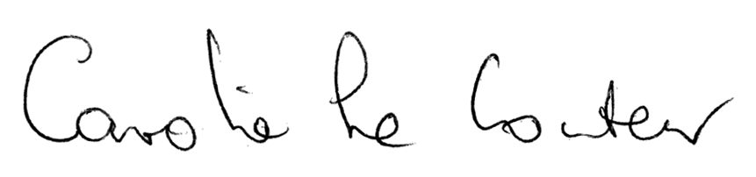
Caroline Le Couteur MLA
ACT Greens Member for Murrumbidgee
ACT Greens Spokesperson for Planning, Transport, City Services, Housing, Arts, Animal Welfare, Community Services, Women, Seniors and Social Inclusion

