What is the Best Mammal Emblem for the ACT?
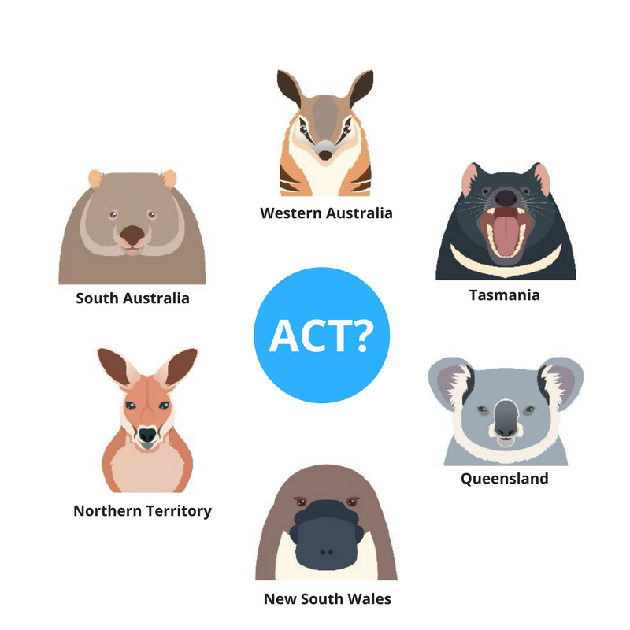

ACT Legislative Assembly Mammal Emblem Inquiry
The ACT Legislative Assembly is looking into a proposal for a mammal emblem for the ACT. ACT schools have been invited to read through the information package provided and answer a quick survey telling the Assembly which mammal you think should represent the ACT. Submission must be made by Friday, 23 March 2018, with the decision being presented to the Assembly in September 2018.

Existing ACT Emblems
On 26 May 1982, the Hon. Michael Hodgman, the then Minister for the ACT announced the Royal Bluebell as the Territory’s floral emblem. In 1996 the ACT undertook an inquiry into a bird or other animal emblem. This inquiry led to the selection of the Gang-Gang Cockatoo as the bird emblem for the ACT. The ACT, however, has yet to identify a mammal emblem.

Conservation and Biodiversity
The selection of mammal emblems has previously been used to advance conservation and efforts to increase biodiversity. Mammals that have been selected as emblems for Western Australia, Tasmania, New South Wales and Victoria were all relatively exclusive to their geographic area, as well as experiencing difficulty as a species. The opportunity can be used to highlight the plight of a particular species and promote the importance of conservation and biodiversity for the whole state or territory.

One example of how adopting a mammal emblem can actually have a huge impact on conservation effort is the Tasmanian devil. Following a public consultation process, Tasmania formally adopted the Tasmanian devil as their emblem on 22 May 2015. The Tassie devil is the world's largest surviving carnivorous mammal and is endangered within Tasmania, which is the only place it survives in the wild. Populations of the Tasmanian devil have been impacted over years by human activity, and now the aggressive devil facial tumour disease threatens the remaining population. The Tasmanian government noted in adopting the mammal as its emblem:
“The Devil is recognised across the world as uniquely Tasmanian and choosing it as our State emblem will help to promote the State around the world, as well as raising awareness of the difficult challenge the Devil faces in combating disease.”
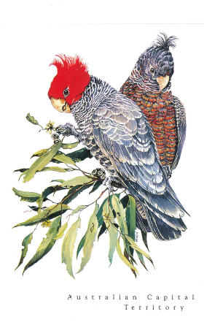

Things to Consider
In considering an emblem, you could focus on the following criteria:
- the emblem should be a native species, indigenous to the Territory;
- the species should be resident in urban and rural areas all-year round;
- the species’ meaning and relevance to the local environment should be balanced against its aesthetic qualities;
- the species should be distinctive and easily recognised, as well as easily seen and heard, photogenic and not be an agricultural pest;
- Canberrans should feel a special affinity for the species through familiarity;
- the species should have a special connection with the Territory over other places;
- the species’ conservation status, charisma and physical characteristics should be considered;
- advice should be sought from the ACT Parks and Conservation Service on the suitability of the species;
- the community should be involved in the selection process; and
- the emblem should not be used by another State or Territory.
- The 2015 ACT State of the Environment Report lists 47 mammals native to the ACT. You can find the list on page at https://regions.ala.org.au/States%20and%20territories/Australian%2520Capital%2520Territory#group=ALL_SPECIES&subgroup=&guid=&from=1850&to=2018&tab=speciesTab&fq=.

State and Territory Mammal Emblems
State | Mammal Emblem
New South Wales | Platypus
Queensland | Koala
Northern Territory | Red Kangaroo
Western Australia | Numbat
South Australia | Southern hairy-nosed wombat
Victoria | Leadbeater’s possum
Tasmania | Tasmanian Devil

Many states have other emblems such as fossils and gemstones. Western Australia became the first Australian State to adopt a fossil emblem. The idea came from a primary school, where school children just like you became involved in asking the government to agree to the idea

Submission Details:
Anyone who wishes can make a submission to the Committee. If you want to make your own submission please do so on the form and send back to:
The Committee Secretary
Standing Committee on Environment and Transport and City Services
Legislative Assembly for the ACT
GPO Box 1020
CANBERRA ACT 2601
Email: LACommitteeETCS@parliament.act.gov.au
Phone: 6205 0199

What do you think is the best Mammal Emblem for the ACT?
Make sure to check out the ACT Specific Mammals on the 2015 ACT State of the Environment Report list and let us know what you think is the best mammal emblem for the ACT
What are the reasons for this choice?

