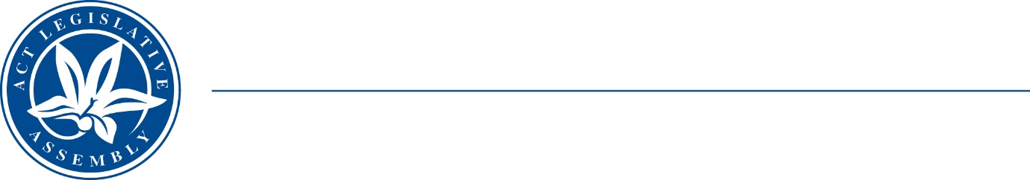
Standing Committee on Planning, Transport and City Services
Ms Jo Clay MLA (Chair), Ms Suzanne Orr MLA (Deputy Chair), Mr Mark Parton MLA

LEGISLATIVE ASSEMBLY
FOR THE AUSTRALIAN CAPITAL TERRITORY

MEDIA RELEASE
Third Public Hearing for EV inquiry
The Standing Committee on Planning, Transport and City Services will hold a third public hearing for its Inquiry into electric vehicle (EV) adoption in the ACT on Thursday, 15 June 2023.
The Committee will hear from Mr Shane Rattenbury MLA, Minister for Water, Energy and Emissions Reduction, and officials from the Environment, Planning and Sustainable Development Directorate.
The Committee Chair, Ms Jo Clay MLA, said: “Following the recent public hearing with Evoenergy, this third hearing is an opportunity for the Committee to discuss electrical grid capacity with the ACT Government”.
Members of the public are welcome to attend the hearing in the Prince Edward Island Room of the Legislative Assembly between 9.30 am – 10.00 am on Thursday, 15 June 2023. Proceedings will also be live-streamed on the Assembly website.
The Terms of Reference of the inquiry are available at: https://www.parliament.act.gov.au/parliamentary-business/in-committees/committees/ptcs/inquiry-into-ev-adoption
13 June 2023
STATEMENT ENDS.

For further information please contact:
Committee Chair, Ms Jo Clay MLA on (02) 6205 0131
Acting Committee Secretary, Ms Miona Ikeda on (02) 6205 0199 or at LACommitteePTCS@parliament.act.gov.au

