Standing Committee on Justice and Community Safety

Inquiry into the Freedom of Information Amendment Bills 2022

About the Committee

Establishing resolution
The Assembly established the Standing Committee on Justice and Community Safety on
2 December 2020.
The Committee’s areas of responsibility are:

- ACT Electoral Commission
- ACT Integrity Commission
- Gaming
- Minister of State (JACS reporting areas)
- Emergency management and the Emergency Services Agency
- Policing and ACT Policing
- ACT Ombudsman
- Corrective services
- Attorney-General
- Consumer affairs
- Human rights
- Victims of crime
- Access to justice and restorative practice
- Public Trustee and Guardian

You can read the full establishing resolution on our website.

Committee members
Mr Peter Cain MLA, Chair
Dr Marisa Paterson MLA, Deputy Chair
Mr Andrew Braddock MLA

Secretariat
Ms Kathleen de Kleuver, Committee Secretary
Ms Emma Weaver, Acting Assistant Secretary
Mr Alexander Hildyard, Administration Officer

Contact us
Mail Standing Committee on Justice and Community Safety
Legislative Assembly for the Australian Capital Territory
GPO Box 1020
CANBERRA ACT 2601
Phone (02) 6207 0524
Email LACommitteeJCS@parliament.act.gov.au
Website parliament.act.gov.au/parliamentary-business/in-committees

About this inquiry
The Freedom of Information Amendment Bill 2022 and Freedom of Information Amendment Bill 2022 [No 2] were presented in the Assembly on 21 September 2022, and referred to the Standing Committee on Justice and Community Safety (the Committee) as required by clause 5 of the establishing resolution. This clause allows committees to inquire into and report on bills within two months of their presentation.
The Committee resolved to undertake an inquiry into the Bills on 29 September 2022.
The Assembly resolved to extend the reporting date until 7 February 2023.

Terms of Reference
At its meeting on 2 December 2020 (amended 4 August 2022), the Legislative Assembly resolved that:
‘all bills presented to the Assembly stand referred to the relevant standing committee for inquiry and report within two months from the presentation of the bill, except for those bills introduced in the last sitting week of the calendar year where the committee shall report in two months. Within 21 days of the presentation of the bill in the Assembly, the committee must decide whether or not to undertake an inquiry, and shall inform the Speaker of its decision, the Speaker must then arrange for all members to be notified. In the event that the subject matter of the bill makes it unclear which committee it should be referred to, the Speaker will determine the appropriate committee.’
The Freedom of Information Amendment Bill 2022 and Freedom of Information Amendment Bill 2022 [No 2] were presented in the Assembly on 21 September 2022, and referred to the Standing Committee on Justice and Community Safety (the Committee). The Committee resolved to undertake an inquiry into the Bills.

Contents
About the Committee i
Establishing resolution i
Committee members i
Secretariat i
Contact us i
About this inquiry ii
Terms of Reference ii
Acronyms iv
Recommendations v
1. Background to the Inquiry 1
Conduct of the Inquiry 1
Acknowledgements 1
2. Freedom of Information Amendment Bill 2022 2
Background to the Bill 2
Proposed Amendments 2
Legislative Scrutiny 3
Key issues considered by the Committee 4
3. Freedom of Information Amendment Bill 2022 (No 2) 10
Background to the Bill 10
Proposed Amendments 10
Legislative Scrutiny 11
Concerns with the Bill 12
Conclusions 14
Appendix A: Submissions 15
Appendix B: Redacted Cabinet documents from New Zealand Parliament 16
Appendix C: Example of Cabinet decision summary for the week of 26 September 2022 17

Acronyms
Acronym | Long form
ACT | Australian Capital Territory
FOI | Freedom of Information
NZ | New Zealand
QLD | Queensland
HRA | Human Rights Act

Recommendations
Recommendation 1
The Committee recommends that the ACT Government amend the Freedom of Information Amendment Bill 2022, so that an application for review can be made before the information is published.
Recommendation 2
The Committee recommends that the ACT Government ensure the ACT Ombudsman is sufficiently resourced to manage any resulting increase in workload prior to commencement of the Freedom of Information Amendment Bill 2022.
Recommendation 3
The Committee recommends that the ACT Government demonstrate to the Assembly why the extension of time for processing applications is needed.
Recommendation 4
The Committee recommends that ACT Government and ACT Ombudsman work to produce guidance material on the public interest test in the Freedom of Information Amendment Bill 2022 for decision-makers, and that the explanatory statement references that guidelines will be developed to guide decision makers.
Recommendation 5
The Committee recommends that the ACT Government amend the proposed amendments to section 39 of the Freedom of Information Amendment Bill so the responsible Minister is to provide quarterly reports to the Assembly.
Recommendation 6
The Committee recommends that the ACT Government work with the applicant where a disability or vulnerability exists to ensure the information requested is given in an appropriate form that meets their needs.
Recommendation 7
The Committee recommends that after implementing the recommendations in this report, the Assembly pass the Freedom of Information Amendment Bill 2022.
Recommendation 8
The Committee recommends the Assembly does not pass the Freedom of Information Amendment Bill 2022 (No 2).

Background to the Inquiry

Conduct of the Inquiry
  - The Freedom of Information Amendment Bill 2022 and the Freedom of Information Amendment Bill 2022 (No 2) were both referred to the Committee on 21 September 2022 and 23 September respectively. In accordance with the resolution of establishment of the Standing Committee on Justice and Community Safety, the Bill was referred to the Committee for examination. On 29 September 2022, the Committee resolved to undertake an inquiry into both Bills concurrently.
  - The Committee issued a media release on 4 October 2022 inviting the community to participate in the inquiry by making a submission, which closed on 28 October 2022. A total of five submissions were received by the Committee. A list of all the submissions is provided in Appendix A.
  - The Committee also sought additional comments from the ACT Government in respect of issues raised on the Freedom of Information Amendment Bill 2022 by the ACT Ombudsman, and from Ms Elizabeth Lee MLA in respect of comments made by the ACT Government. These responses are also listed in Appendix A.
  - The Committee did not conduct a public hearing as part of the inquiry.
  - The Committee was granted a reporting date extension until 7 February 2023 by the Assembly on 24 November 2022.
  - The Committee met on 7, 14, and 21 December 2022 to consider the Chair’s draft report, which was adopted on the same day (with amendments), for tabling with the Chair to make a dissenting report.

Acknowledgements
  - The Committee thanks everyone who participated in, or otherwise assisted, this inquiry, including those that made submissions, ACT Government Ministers, directorate officials, statutory officers, Members of the Legislative Assembly, and Members’ staff.

Freedom of Information Amendment Bill 2022

Background to the Bill
  - The objective of this Bill is to amend the Freedom of Information Act 2016 to better access FOI applications and reviews to manage workflows to meet objectives of the Act.
  - The amendments were developed in consultation with key stakeholders, including;
      - All ACT Directorates;
      - Territory Records Office;
      - ACT Ombudsman;
      - ACT Human Rights Commission;
      - ACT Law Society;
      - ACT Bar Association.
  - The Bill was also considered by the Standing Committee on Justice and Community Safety (Legislative Scrutiny Role) (details below – see paragraph 3.6).

Proposed Amendments
  - The Bill will amend the Freedom of Information Act 2016 to make various amendments, including:
    - all information subject to legal professional privilege will be included as contrary to the public interest information (and hence information which can be withheld from release);
    - the range of information that is contrary to the public interest to release will be extended to include information held by the Inspector of Correctional Services relating to an examination or review by the inspector;
    - an applicant’s identity, circumstances and reason for seeking access to another person’s personal information will be included as relevant to whether it is in the public interest to release information;
    - the period in which an access application is suspended pending clarification of the scope of the application after which it may be no longer dealt with, will be reduced from three months to six weeks;
    - the period in which third parties can object to disclosure of their third-party information will be reduced from 15 to 10 working days;
    - the time in which an access application must be decided will be extended from 20 working days to 30 working days, and this will not include time waiting for an applicant’s response to a proposed refusal to deal with the application or Christmas shutdown days;
    - an application can be dealt with after 12 months, but not more than 24 months, after the access application is received, where the applicant agrees, and the application is dealt with progressively; and
    - access to government information can be provided in a form that is different to the form requested by the applicant where it is not reasonably practical to give access in the form requested and the applicant can still receive the information.

Legislative Scrutiny
  - The Standing Committee on Justice and Community Safety (Legislative Scrutiny Role) addressed the Freedom of Information Amendment Bill (2022) in Scrutiny Report 21, on 4 October 2022.
  - The Scrutiny Committee noted that:
The Bill includes various provisions which will further limit the right of access to government information currently provided by section 12 of the Act. These include extending the period in which an agency can respond to an access application (from 20 to 30 working days) and the circumstances which further extend this period and allowing an access application to no longer be dealt with after a clarification request has not been responded to for six weeks. The Bill will also allow information to be provided in a way different to that requested by the applicant.
These provisions may impinge on a person’s ‘freedom to seek, receive and impart information and ideas of all kinds … [in a] way chosen by him or her’ as part of the freedom of expression protected by section 16 of the HRA. Placing greater emphasis on a person to respond to an agency’s request for clarification or proposed refusal may also disproportionately impact on persons who are not readily contactable due to homelessness, incarceration, or illness. Providing information in an alternative form may impact vulnerable persons with limited digital or other access. The Bill may therefore limit the right to equality before the law protected by section 8 of the HRA.
The Bill will also allow a person’s identity, circumstances, and reasons for seeking access to information to be taken into account which considering if it is in the public interest to refuse to disclose the information. This may further restrict access to information, as well as potentially limiting a person’s privacy protected under section 12 of the HRA.
  - The Committee noted that these issues were addressed in the explanatory statement accompanying the Bill, and the statement characterises restrictions on the timeliness of access to information as being minor.
  - The Committee left it to the Assembly to make any assessment of these claims relating to the practical impact of the Bill on access to government information.
  - The Committee drew these matters to the attention of the Assembly but did not require a response from the Minister.

Key issues considered by the Committee

Schedule 3 – Open Access information a reviewable decision
  - The Bill proposes increasing the jurisdiction of the ACT Ombudsman to review decisions to make open access information publicly available under section 24(1) of the FOI Act.
  - The ACT Ombudsman state the proposed amendments to Schedule 3 would allow a person affected to apply to the ACT Ombudsman for a review of the decision to make open access information publicly available. Of note is that the amendments to section 74 would require an application for review to made within 20 working days after the day the information was released. Further, the ACT Ombudsman expresses concerns about the practicality of undertaking a retrospective review, as the information will already be publicly available. Their ability to resolve reviews with any level of satisfaction may be impaired, given the information had already been published.
  - The ACT Government noted the ACT Ombudsman’s concerns regarding retrospective reviews. However, the Government stated the purpose is to increase the review opportunities for people whose interests are affected by a decision to publish information on Open Access. It was further noted that the Government appreciates the reviews may not be resolved with satisfaction, particularly if the Ombudsman was to vary a decision when information was already publicly available as the review was considered stating:
Prompt submission of a review request, and conduct of the review by the Ombudsman, may ameliorate some of the practical shortcomings of these reviews that the Ombudsman foresees.

Committee Comment
  - The Committee notes the impracticality of the ACT Ombudsman conducting retrospective reviews in the circumstances above. Additionally, the Committee is concerned about the Ombudsman’s ability to resolve matters with satisfaction for the individual, particularly as the information could remain publicly available until after the review is finalised.
  - The Committee is of the view that it may not be reasonable for the Government to suggest individuals make prompt submissions of review requests as this may not always be possible. For example, an individual may not have access to technology to lodge a request, the individual may have a disability, mental, physical health issues that impair their ability to make a prompt request, or an individual may not be able to access the appropriate office to lodge a request due to reduced opening hours (for example) over holiday periods.
Recommendation
The Committee recommends that the ACT Government amend the Freedom of Information Amendment Bill 2022, so that an application for review can be made before the information is published.
  - The ACT Ombudsman commented on the potential increased workload for the office, due to increasing the scope of decisions that may be reviewed. The Ombudsman also stated that if they were not adequately resourced there may be either delay in these matters or delay elsewhere in the ACT Ombudsman’s responsibilities.
  - This was also supported by Professor Bruce Arnold:
There is value however in looking beyond formal change to the Act and ensuring that the government invests resources at the workforce level to ensure that the Objects of the Act are met rather than being eroded through under-resourcing.
  - The ACT Government stated they would continue to monitor the resourcing impact following the passage of the Bill.

Committee Comment
  - The Committee is of the view that if the ACT Government increases legislative responsibilities and workload for statutory office holders, they must be adequately resourced and staffed.
Recommendation
The Committee recommends that the ACT Government ensure the ACT Ombudsman is sufficiently resourced to manage any resulting increase in workload prior to commencement of the Freedom of Information Amendment Bill 2022.

Section 40 – Extend timeframe to decide
  - The Bill increases the initial time to decide access applications from 20 to 30 working days ‘to better reflect processing times under the Act and avoid the need to request small extensions that are granted in most instances.’ Data regarding the average processing times for processing FOI applications are included in the explanatory statement noting that averages exceeded 20 working days, but processing time averaged 27 days or less. The ACT Ombudsman’s submission notes that most (about 95 percent in the 2019-2020 Financial Year) applications are processed within 20 working days or in a timeframe agreed to by the access applicant.
  - The ACT Ombudsman described the extension process during recent Annual Reports hearings, acknowledging that FOI applications are complex. The ACT Ombudsman commented on negotiation during FOI applications, stating it takes time to determine what documents the applicant wants to access, as often they do not know what the directorate has, and that large volumes of documentation need to be considered. The Ombudsman went on to say that he thinks the time frames and processing times are challenging, even with an extension.
  - The ACT Government also commented these amendments may reduce the administration requirements associated with FOI extension requests. The ACT Government commented that in 2021-22 there were 264 applications for an extension in time from the applicant or the Ombudsman, and that six out of eight Directorates had an average processing time of 25 days or less.
  - During Annual Reports hearings, the ACT Ombudsman described the process for an agency to obtain an agreement for extension, including a request for extension, for an FOI application as a simple one.

Recommendation
The Committee recommends that the ACT Government demonstrate to the Assembly why the extension of time for processing applications is needed.

Section 17 – Public interest test
  - The Bill contains changes (new subsection 17 (3)) ‘to allow an applicant’s identity, circumstances and reason for seeking access to the information to be taken into account in the determination of whether information is contrary to the public interest to disclose, in circumstances where the applicant is seeking personal information that is not their own.’
  - The ACT Ombudsman tentatively supported this provision, commenting that the FOI Act already includes a range of protections that restrict the release or publication of personal information. The ACT Ombudsman further commented that they have reservations about the provision, noting there may be cases where access to personal information may allow irrelevant factors to be considered, which may undermine the public interest. The ACT Ombudsman states that, should the amendment be made, clear guidance should be provided on how personal information should be considered when undertaking the public interest test.
  - The ACT Government have supported this view stating they would work with the ACT Ombudsman to develop guidance material following the passing of the Bill.

Committee Comment
  - The Committee is of the view that given the possible risks to the public interest test, there is benefit in developing guidelines and this should be referenced in the explanatory statement.
Recommendation
The Committee recommends that ACT Government and ACT Ombudsman work to produce guidance material on the public interest test in the Freedom of Information Amendment Bill 2022 for decision-makers, and that the explanatory statement references that guidelines will be developed to guide decision makers.

Section 39 – Decision not made in time
  - The Bill makes changes to require ‘in circumstances where the Ombudsman is given notice that a decision relating to an application was not made within the time allowed under section, or extended under section 41 or 42, the relevant Minister must ensure that a copy of the notice is presented to the Legislative Assembly within six sitting days after the access application (including any review or appeal) is finally decided’ and ‘removes the obligation in section 39(4) to give notice to the Legislative Assembly of decisions not made in time if the Ombudsman extended the time for the respondent to decide the access application under section 78, or because the access application is only for personal information’.
  - The ACT Ombudsman does not support this amendment noting that currently, section 39(4) is an accountability measure, ensuring visibility of number of deemed refusals, and to confirm when the application as finally been decided.
  - The ACT Government responded saying the proposed amendment is only to remove the need for the Minister to report on deemed refusals of access to personal information. The ACT Government noted this information is compiled in the ACT Ombudsman’s Annual Reports that are tabled in each year. They further stated that given the privacy surrounding personal information, it is not possible to draft written notice to the Assembly that provides useful context or assists in scrutinising the application and processing.

Committee Comment
  - The Committee is of the view that section 39 provides valuable scrutiny and accountability for decisions not made in time. The Committee does not believe that it is appropriate that the oversight and accountability currently in section 39 is entirely relegated to the ACT Ombudsman’s Annual Reports.
Recommendation
The Committee recommends that the ACT Government amend the proposed amendments to section 39 of the Freedom of Information Amendment Bill so the responsible Minister is to provide quarterly reports to the Assembly.

Section 47 – Forms of access
  - The Bill makes changes to provide that ‘information may be given to the applicant in a form other than the form requested by the applicant, but only if it is not reasonably practicable for the respondent to give access in the form requested and the respondent is reasonably satisfied that the applicant can receive the information in the alternative form.’
  - The ACT Ombudsman stated they do not support this amendment:
…existing provisions already achieve an appropriate balance between the interests of respondent agencies and applicants by allowing for exceptions due to unreasonableness.
Applicants may request access in a particular form due to a disability or vulnerability. We remain concerned that access may be given in an alternative form without their agreement or consent.
  - The ACT Government commented that the amendment aims to give agencies flexibility in the form that access to information must be provided in, given the shift to remote work and paperless offices. They further stated that section 16 of the ACT Human Rights Act 2004 provides that a respondent must be reasonably satisfied that a person can receive the information in the alternative form. The Government suggests that individual’s right to seek and receive is protected information under section 16.

Committee Comment
  - The Committee is of the view that the existing provisions are appropriate and recognise that an applicant may request access in a particular form due to a disability or vulnerability.
Recommendation
The Committee recommends that the ACT Government work with the applicant where a disability or vulnerability exists to ensure the information requested is given in an appropriate form that meets their needs.

Freedom of Information Amendment Bill 2022 (No 2)

Background to the Bill
  - The Freedom of Information Bill 2022 (No 2) was introduced as a Private Members Bill by Ms Elizabeth Lee MLA, Leader of the Opposition, to create a proactive disclosure provision for the ACT Government to publicly release of Cabinet of records within 30 days of being considered by Cabinet with some exceptions. The explanatory statement states:
The bill has been modelled from the New Zealand Government’s proactive release of Cabinet information policy which has been in operation since 2018.
  - The explanatory statement comments the intent of the Bill is to make decisions of the Executive (Cabinet) more transparent and accountable, as the ACT is a unicameral jurisdiction without the checks and balances provided by an upper house.
  - The Standing Committee on Justice and Community Safety (Legislative Scrutiny Role) considered the bill (details below – see paragraph 2.5).

Proposed Amendments
  - According to the Explanatory Statement, this Bill will amend the Freedom of Information Act 2016 to make various amendments, including:
      - A definition of Cabinet records as:
        - a document given to Cabinet for its consideration or created for that purpose
        - an official record of Cabinet
      - A disclosure provision for the ACT Government to publicly release Cabinet records (as defined above) within 30 business days after being considered by Cabinet.
      - To exempt records that if published would reasonably be expected to:
        - endanger the life or physical safety of a person
        - be an unreasonable limitation on a person’s rights
        - prejudice an ongoing criminal investigation
        - disclose information contrary to the public interest, per schedule 1, and schedule 2 (s 2.2 of the Act).
      - Mitigations to be undertaken by the relevant Minister if a record is subject to exemptions, including, requirements to provide an explanation for a decision not to publish and consideration to publishing relevant factual material.
      - Exemptions where government intends to make the decision and related materials public within 50 days of the decision, or if it relates to a bill that will be presented to the Legislative Assembly.
      - An exemption for the publication of a Cabinet decision that would be an unreasonable limitation on a person’s rights under the Human Rights Act 2004 (HRA).

Legislative Scrutiny
  - The Standing Committee on Justice and Community Safety (Legislative Scrutiny Role) addressed the Freedom of Information Amendment Bill 2022 (No 2) in Scrutiny Report 21, on 4 October 2022. The Committee had no comments on the Bill.

Support for the Bill
  - Ms Elizabeth Lee MLA submitted that the changes in the Bill are needed the absence of an upper house that would normally provide checks and balances in a parliamentary setting. The explanatory statement refers to changes agreed to by the Queensland Government following recommendations in the report ‘Review of culture and accountability in the Queensland public sector’ by Professor Peter Coaldrake AO. Ms Lee noted Professor Coaldrake said that proactive release of documents provides greater public trust in governments, stating that the bill strikes the right balance between genuine cabinet confidentiality and the need for increased transparency and openness in decisions, noting that the bill contains several exemptions.
  - The Centre for Public Integrity supported the increased access to information in a timely fashion that the bill offers but proposed it should be in line with reforms being considered in Queensland (the Coaldrake Report):
… we recommend that Cabinet submissions, agendas, and decision papers be released online within 30 business days. This accords with Recommendation 2 of the recently published Coaldrake Report in Queensland.
  - Associate Professor Bruce Baer Arnold described the Bill as:
A commendable step forward in achieving the Objects (s 6) and ‘prodisclosure’ principle (s 9) of the Freedom of Information Act 2016 (ACT). It is salient given governance failures and the Territory’s unicameral legislature.
  - Professor Bruce Baer Arnold noted that the existing legislation would enable exclusions in respect of some matters where there was a public interest in it not being in the public domain.
Coaldrake report
  - The Review of Culture and accountability in the Queensland public sector by Professor Peter Coaldrake AO made 14 recommendations that were considered and endorsed by the Queensland cabinet on 4 July 2022, with a Taskforce to report back to Cabinet in September with a legislative reform package for introduction in Parliament. Recommendation three provides:
[t]hat the Department of Premier and Cabinet develop a policy, requiring all cabinet submissions, agendas, and decision papers (and appendices) to be proactively released and published online withing 30 business days of a final decision being taken by Cabinet, subject only to a number of reasonable exceptions that should be outlined in the policy.
  - The Queensland Government will be consulting with New Zealand in regards to implementation, noting that the recommendation differs to the model in the Bill.
  - An example of information that has been released in New Zealand is in Appendix B.

Concerns with the Bill
  - The ACT Government raised a number of concerns with the Bill, namely:
    - Confidentiality allows Ministers to discuss proposals frankly while developing a collective position, allowing consultation, compromise, and innovative approaches without increased public pressure and partisan criticism allowing the Government to consider a range of options to make decisions in the public interest.
    - The ACT is a nation leading regime in transparency of cabinet records because it:
      - Publishes summaries of cabinet decisions and Wellbeing Impact Assessment summaries shortly after cabinet meetings under section 23 of the Freedom of Information Act 2016 - see example of cabinet decision summaries in Appendix C.
      - Makes full Cabinet records available after 10 years under the Territory Records Act 2002.
      - Alerts the public to records that become available each Canberra Day under Part 2A of the Territory Records Act 2002.
    - The Private members bill differs from the New Zealand model that:
      - Releases information after the cabinet decision rather than 30 business days after consideration by Cabinet, noting that some issues can take several discussions to arrive at a final position.
      - Cabinet Appointments and Honours (APH) are explicitly excluded from release.
      - Due diligence must be undertaken before Cabinet material or key advice papers are proactively released
      - Allows for redactions, e.g., for ‘free and frank opinions’.
    - Cabinet decisions can be complex and interlinked with other policy discussions with may extend over several months.
    - The ACT Government also raised a number of other issues relating to the existing frameworks for release of documents, issues with using the FOI Act, resourcing requirements, and financial implications of an independent review by the ACT Ombudsman.

Review of decisions
  - The ACT Ombudsman commented in their submission that their office would not have a review function, however, a person may make a complaint under section 69 of the FOI Act.

Committee view
  - The Committee notes that transparency in cabinet decision making creates trust in government, noting that the ACT Government has made several reforms in this area.
  - The Committee notes that the model in the Bill differs from the models used in New Zealand and that recommended in the Coaldrake report and agreed to by the Queensland Government.
  - The Committee notes that the member sponsoring the Bill was asked by the Committee to respond to these concerns but did not address the concerns raised by the ACT Government in her letter.

Conclusions
Freedom of Information Amendment Bill 2022
  - The Committee believes that the issues raised by the ACT Ombudsman raise important issues regarding the ACT Government’s Freedom of Information Amendment Bill 2022.
  - The Committee considers that it was important to conduct this inquiry given the changes to the FOI Act and the need to ensure that proceedings are fair.
Recommendation
The Committee recommends that after implementing the recommendations in this report, the Assembly pass the Freedom of Information Amendment Bill 2022.
Freedom of Information Amendment Bill 2022 (No 2)
  - The Committee considers that it was important to conduct this inquiry given the significant amendments to the FOI Act regarding the release of Cabinet documents.
Recommendation
The Committee recommends the Assembly does not pass the Freedom of Information Amendment Bill 2022 (No 2).

Peter Cain MLA
Chair
February 2023

Appendix A: Submissions

No. | Submission by | Received | Published
001 | Centre for Public Integrity | 10/10/2022 | 01/11/2022
002 | Bruce Arnold | 24/10/2022 | 01/11/2022
003 | Ms Elizabeth Lee MLA | 26/10/2022 | 01/11/2022
003.1 | Ms Elizabeth Lee MLA | 21/11/2022 | 02/12/2022
004 | ACT Ombudsman | 28/10/2022 | 16/11/2022
005 | ACT Government | 07/11/2022 | 16/11/2022
005.1 | ACT Government | 25/11/2022 | 02/12/2022

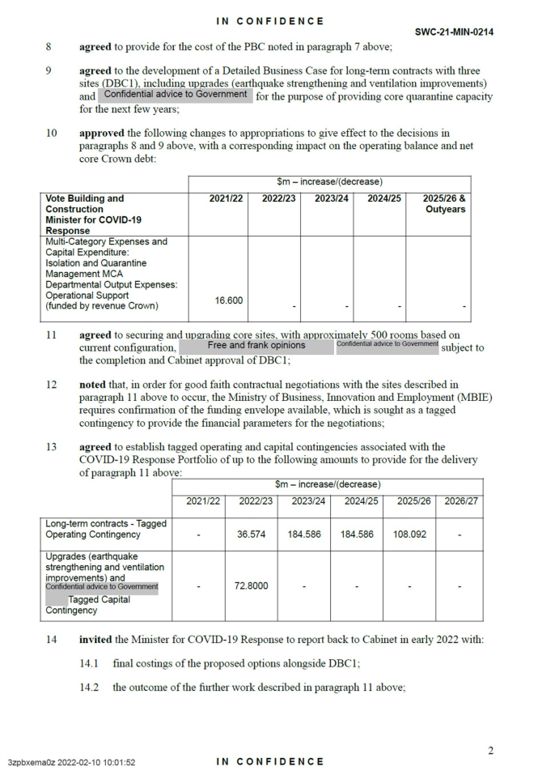
Appendix B: Redacted Cabinet documents from New Zealand Parliament

Appendix C: Example of Cabinet decision summary for the week of 26 September 2022
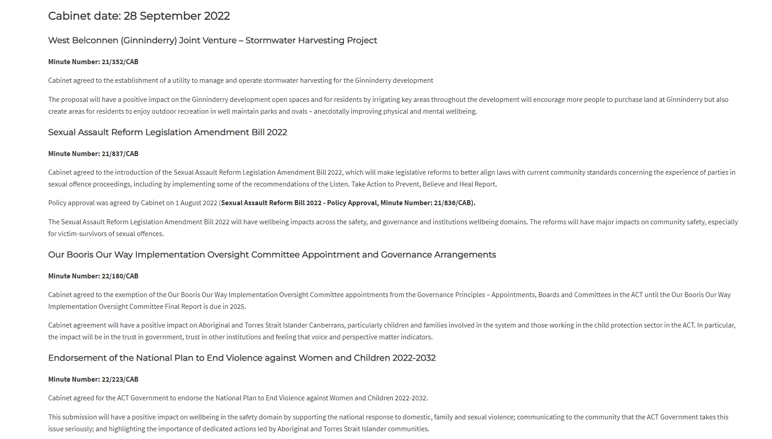

Standing Committee on Justice and Community Safety

Inquiry into the Freedom of Information Amendment Bills 2022

Dissenting report from

Peter Cain MLA

Dissenting report
I support Recommendations 1-7 in the Committee Report but for the reasons stated in [3.6] to [3.10] and below, I reject Recommendation 8. Instead, I recommend that the Assembly pass the Freedom of Information Amendment Bill 2022 (No 2).
I am especially persuaded on this view as Cabinet transparency is of utmost importance to the proper working of democracy and in a unicameral jurisdiction such as the ACT, more timely exposure of Cabinet records is warranted. The passage of this Bill would also bring ACT’s disclosure policy with respect to cabinet records into alignment with that of Queensland, also a unicameral jurisdiction, and New Zealand.
The Bill also ensures that records, whose release would not be in the public interest, are exempt from publication. (I note that the implementation of Recommendation 4 would ensure more transparency on when a disclosure is not in the public interest.)
This timelier release of Cabinet records is also consistent with the aims and intention of the Freedom of Information Act 2016, as stated, respectively, in sections 6 and 9:
6 Objects of Act
The objects of this Act are to—
(a) provide a right of access to government information unless access to the information would, on balance, be contrary to the public interest; and
(b) recognise the importance of public access to government information for the proper working of representative democracy; and
(c) enable the public to participate more effectively in government processes and to promote improved decision-making within government; and
(d) make the people and bodies that are responsible for governing the Territory more accountable to the public; and
(e) ensure that, to the fullest extent possible, government information is freely and publicly available to everyone; and
(f) facilitate and promote, promptly and at the lowest reasonable cost, the disclosure of the maximum amount of government information; and
(g) ensure that personal information held by the Territory is accurate, complete, up-to date and not misleading.
9 Promoting access to government information
It is the intention of the Legislative Assembly that this Act be administered with a pro-disclosure bias and discretions given under it be exercised as far as possible in favour of disclosing government information.

Accordingly, in opposing Recommendation 8:
- I recommend that after considering and responding to the recommendations in this report, the Assembly pass the Freedom of Information Amendment Bill 2022 (No 2).
- I would also like to make a recommendation very much in alignment with Recommendation 2 in the Committee Report:
  - I recommend that the ACT Government ensure that Directorates are sufficiently resourced to fulfil their statutory and service delivery targets prior to and following passage of the Bills.
This aligns with Professor Arnold’s comments at 2.16 that the government should ensure resources at the workforce level are adequate:
to ensure that the Objects of the Act are met rather than being eroded through under-resourcing.

Mr Peter Cain MLA
Chair
February 2023.

Minutes of proceedings, 24 November 2022, item 14, page 944
ACT Legislative Assembly, Minutes of Proceedings No. 68, 24 November 2022, p 944,
Freedom of Information Amendment Bill 2022, Explanatory Statement, p 2.
Standing Committee on Justice and Community Safety (Legislative Scrutiny Role), Report no. 21, October 2022, p 3.
Standing Committee on Justice and Community Safety (Legislative Scrutiny Role), Report no. 21, October 2022, p 3.
Standing Committee on Justice and Community Safety (Legislative Scrutiny Role), Report no. 21, October 2022, p 4.
Standing Committee on Justice and Community Safety (Legislative Scrutiny Role), Report no. 21, October 2022, p 4.
ACT Ombudsman, Submission 4, p 2.
ACT Ombudsman, Submission 4, p 2.
ACT Government – Response to Committee Letter p 3.
ACT Ombudsman, Submission 4, p 2.
Bruce Baer Arnold, Submission 2, p 2-3.
ACT Government – Response to Committee Letter p 3.
Freedom of Information Amendment Bill 2022, Explanatory Statement, p 1.
Freedom of Information Amendment Bill 2022, Explanatory Statement, p 3.
ACT Ombudsman, Submission 4, p 3.
Mr Iain Anderson, ACT Ombudsman, Committee Hansard, 2 November 2022, p 46-47.
ACT Government – Response to Committee Letter p 3.
Mr Iain Anderson, ACT Ombudsman, Committee Hansard, 2 November 2022, p 46.
Freedom of Information Amendment Bill 2022, Explanatory Statement, p 9.
ACT Ombudsman, Submission 4, p 3-4.
ACT Government – Response to Committee Letter p 4.
Freedom of Information Amendment Bill 2022, Explanatory Statement, p 10.
ACT Ombudsman, Submission 4, p 4.
ACT Government – Response to Committee Letter, p 5.
Freedom of Information Amendment Bill 2022, Explanatory Statement, p 12.
ACT Ombudsman, Submission 4, p 4.
ACT Government – Response to Committee Letter p 5.
Freedom of Information Amendment Bill 2022 [No 2], Explanatory Statement, p 2.
Freedom of Information Amendment Bill 2022 [No 2], Explanatory Statement, p 2.
Freedom of Information Amendment Bill 2022 [No 2], Explanatory Statement, p 2.
Standing Committee on Justice and Community Safety (Legislative Scrutiny Role), Report no. 21, October 2022, p 1.
Freedom of Information Amendment Bill 2022 [No 2], Explanatory Statement, p 2.
Standing Committee on Justice and Community Safety (Legislative Scrutiny Role), Report no. 21, October 2022, p 4.
Ms Elizabeth Lee, Submission 3, p 3-4.
Centre for Public Integrity, Submission 1, p. 1
Bruce Arnold, Submission 2, p 1.
Bruce Arnold, Submission 2, p 2.
The Honourable Annastacia Palaszczuk, The Honourable Dr Steven Miles, Taskforce to implement Coaldrake recommendations, Media Release, 4 July 2022.
Professor Peter Coaldrake AO, Let the sunshine in, Review of culture and accountability in the Queensland public sector, Final report, 28 June 2022.
The Honourable Annastacia Palaszczuk, The Honourable Dr Steven Miles, Taskforce to implement Coaldrake recommendations, Media Release, 4 July 2022.
ACT Government, Submission 5, p 2.
ACT Government, Submission 5, p 3.
ACT Government, Submission 5, p 4.
New Zealand Department of Prime Minister and Cabinet, CO (18) 4: Proactive Release of Cabinet Material: Updated Requirements, 24 October 2018, CO (18) 4: Proactive Release of Cabinet Material: Updated Requirements | Department of the Prime Minister and Cabinet (DPMC) (accessed 28 December 2022).
ACT Government, Submission 5, p 4.
ACT Government, Submission 5, p 4.
ACT Ombudsman, Submission 4, 1.
Ms Elizabeth Lee MLA, Submission 3.1, p 1.
Bruce Baer Arnold, Submission 2, p 3

