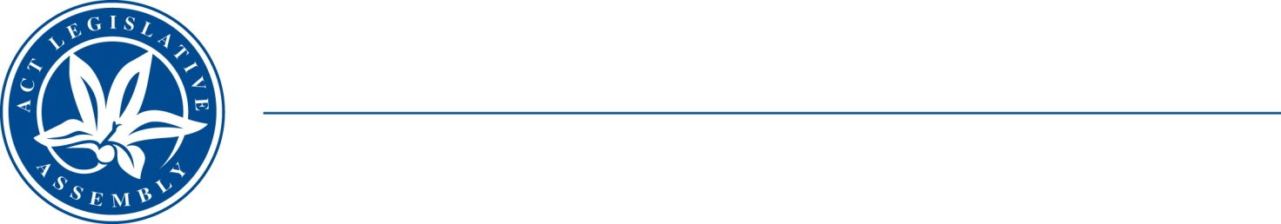
QoN No. 14
Committee Support
LEGISLATIVE ASSEMBLY
FOR THE AUSTRALIAN CAPITAL TERRITORY
Standing Committee on Education and Community Inclusion

Inquiry into Annual and Financial Reports 2021-2022

ANSWER TO QUESTION ON NOTICE

Asked by Elizabeth Kikkert MLA: To ask the Minister for Education and Youth Affairs

Reference: Youth Affairs, CSD Annual Report 2022, p.

In relation to: Youth InterACT Scholarships

1. Can the minister please provide a funding breakdown for the 43 scholarships, including what the purpose of each was?

Minister Berry: The answer to the Member’s question is as follows:–

Group Scholarships
No: | Scholarship Details | Scholarship Amount ($)
1 | F1 - Stem Competition | 1050
2 | Basketball Competition with The West Basketball Club | 1500
3 | Birrgai Outdoor Education Camp | 888
4 | CCCares Mindful Parenting Program | 1500
5 | Barista Group Project | 1250
6 | The Duke of Edinburgh Competition | 1500
7 | Band Farewell Performance at The Polish Club | 1500
8 | Netball NSW State Competition | 1500
9 | Mental Health Training Program | 1500

Individual Scholarships
No: | Scholarship Details | Scholarship Amount ($)
10 | Purchasing Sports Gear and Contributing to Training Fees for Australian Youth Volleyball Championship | 450
11 | Australian Volleyball Championship | 500
12 | Driving Lessons | 500
13 | 2022 National Fustal Championship | 500
14 | Driving Lessons | 500
15 | Mountain Bike Club fees and purchase gear | 480
16 | 3 Months Full Membership at Stockade Gym | 500
17 | Quantum Leap 2022 Performance | 495
18 | Driving Lessons | 500
19 | Driving Lessons | 500
20 | DBT Skills Awareness Course | 500
21 | Purchase work boots, tools and safety clothes | 500
22 | Basketball Competition fees | 500
23 | Talented sports program (TSP) fees | 500
24 | Driving Lessons | 500
25 | John Martin Country Basketball Tournament fees | 500
26 | 2022 Australian Track and Field Championship | 500
27 | State Level Gymnastics Training | 500
28 | Australian Youth Beach Volleyball Championship | 500
29 | Australian Youth Beach Volleyball Championship | 500
30 | Canberra Hawker Football Centre Fees | 500
31 | Australian Youth Beach Volleyball Championship | 500
32 | 2 Terms of Pottery Classes | 500
33 | Canoe Slalom (All States Coaching and Athlete Development Program) | 500
34 | The Act School Boys Under 12 Rugby League Australian Championships | 500
35 | Beach Volleyball Youth National Championship | 500
36 | Driving Lessons | 500
37 | Aerials classes- Wearhouse circus | 220
38 | To Participate in An Art Program | 500
39 | Regional Comets Cricket Academy training | 500
40 | To attend Two Medication Review Appointments at Citta Clinic | 500
41 | Online IT course with Harvard University | 500
42 | The Indoor Cricket National Championship in Victoria | 500
43 | The 2022 Ice Hockey Under 18 Women's World Championship in Turkey | 500
 | Total Amount Funded | $28,833

Approved for circulation to the Standing Committee on Education and Community Inclusion

Signature: Date:

By the Minister for Education and Youth Affairs, Yvette Berry MLA

