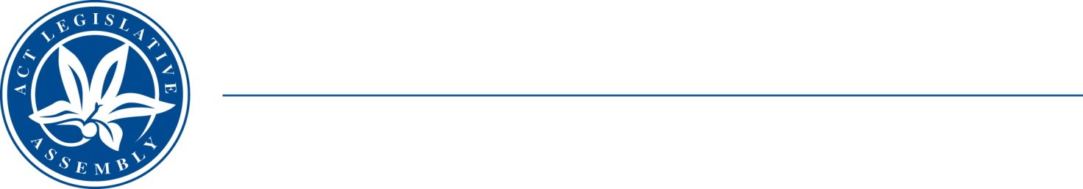
QoN No. 24
Committee Support
LEGISLATIVE ASSEMBLY
FOR THE AUSTRALIAN CAPITAL TERRITORY
Standing Committee on Health and Community Wellbeing

Inquiry into Annual and Financial Reports 2021-2022

ANSWER TO QUESTION ON NOTICE

Asked by MS LEANNE CASTLEY MLA:

Reference: Hearing on 1 November 2022, Annual Report of CHS

In relation to: Page 213, 214 ACT Health annual report 2021-22

- How much did the 2022-23 budget business case cost?
- Was this business case outsourced? if so, who conducted it?
- How long did the business case take from the business case being approved to completion?
- Did the business case look at other options in ACT for future or alternate hydrotherapy pools if so, what locations did it assess?

MINISTER STEPHEN-SMITH MLA: The answer to the Member’s question is as follows:
(1-3) The 2022-23 hydrotherapy pool business case was completed with the assistance of GHD, a global professional services, engineering, and architectural company. Over approximately two months, GHD undertook work that included the assessment of locations, the design of the facility and facilitation of workshops with consumers to inform the design – as well as the writing of the business case. The total GHD contract was $156,223.27 (GST exclusive).
(4) GHD’s work drew on the findings of earlier work which investigated co-locating a hydrotherapy pool at one of two existing aquatic facilities located at either Erindale or Tuggeranong. Through GHD’s investigations, it was determined to be more effective to construct a new hydrotherapy pool at Tuggeranong.

Approved for circulation to the Standing Committee on Health and Community Wellbeing

Signature: Date:

By the Minister for Health, Rachel Stephen-Smith MLA

