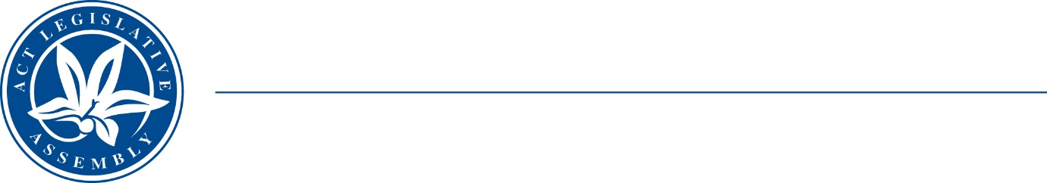
Standing Committee on Economy and Gender and Economic Equality
Ms Leanne Castley MLA (Chair), Ms Suzanne Orr MLA (Deputy Chair),
Mr Johnathan Davis MLA
Ms Caroline Le Couteur MLA

LEGISLATIVE ASSEMBLY
FOR THE AUSTRALIAN CAPITAL TERRITORY

Media Release

Extension of submission deadline

Inquiry into the future of the working week
The ACT Legislative Assembly’s Standing Committee on Economy and Gender and Economic Equality (the Committee) has extended its deadline for submissions to its inquiry into the future of the working week—to close of business 28 October 2022.
The Committee’s terms of reference are available on the Legislative Assembly website at: https://www.parliament.act.gov.au/parliamentary-business/in-committees/committees/egee/inquiry-into-the-future-of-the-working-week#tab1756231-1id
Information about how to make a submission is available at: https://www.parliament.act.gov.au/parliamentary-business/in-committees/Getting-involved
The Committee released a Discussion Paper on 16 June 2021 to assist individuals and organisations to prepare submissions to the inquiry. The Discussion Paper is available at: https://www.parliament.act.gov.au/parliamentary-business/in-committees/committees/egee/inquiry-into-the-future-of-the-working-week#tab1756231-8id
STATEMENT ENDS—3 May 2022
–––––––––––––––––––––––––––––––––––––––––––––––––––––––––––––––––––––––––––––––––––––––––
contacts: | Ms Leanne Castley MLA  (for comment on the inquiry) | Committee Chair | (02) 620 50283
contacts: | Dr Lee Kerr  (for further information) | Committee Secretary | (02) 620 50136

