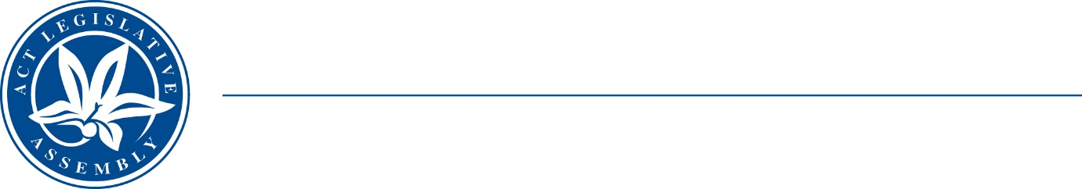
Standing Committee on Economy and Gender and Economic Equality
Ms Nicole Lawder MLA (Chair), Ms Suzanne Orr MLA (Deputy Chair),
Mr Johnathan Davis MLA
Ms Caroline Le Couteur MLA

LEGISLATIVE ASSEMBLY
FOR THE AUSTRALIAN CAPITAL TERRITORY

Media Release

Release of Discussion paper and Call for written submissions

Inquiry into the future of the working week
The ACT Legislative Assembly’s Standing Committee on Economy and Gender and Economic Equality (the Committee) will be announcing its call for written submissions to its inquiry into the future of the working week—Wednesday 16 June 2021.
Submissions should address some or all of the Terms of Reference. The call for submissions closes on Monday 1 November 2021. To coincide with its call for written submissions, the Committee will also be releasing a discussion paper on 16 June 2021.
‘When considering questions such as the future of the working week—the pivotal consideration is about time, that is, the amount of time we spend at work. Questions about the amount of time we spend at work are often couched in the context of decreased time at work, in the form of a shorter working week—such as, a four-day work week’, the Committee Chair, Ms Nicole Lawder MLA said.
The Chair noted, ‘while the Committee does not have a particular view at this time about what a four-day work week would look like and whether it is the future of work—arguments may be anticipated on both sides of the question as to whether a four-day work week is the future of the working week. On one hand, a negative view may see it as costly and unaffordable; difficult to implement in some industries and sectors; and unrealistic. On the other hand, there are arguments for working fewer hours. Some are economic. Some are about health and wellbeing, environmental sustainability and stronger communities. Some have to do with equity and equality’.
The Committee Chair added, ‘the Committee’s discussion paper is to assist individuals and organisations to prepare submissions to its inquiry. The Paper seeks to consider and provide contextual background for each of the terms of reference to assist submitters. Importantly, the paper and the Committee’s inquiry—is about having a public conversation about the future of the working week—in particular, the validity of the standard working week and whether it merits change to a four-day working week’.
‘The Committee encourages interested individuals and key stakeholder groups and organisations to make a written submission to this inquiry’, Ms Lawder MLA concluded. The Committee expects to commence holding public hearings in November/December 2021. Further information on the Inquiry is available from: https://www.parliament.act.gov.au/parliamentary-business/in-committees/committees/egee/inquiry-into-the-future-of-the-working-week.
MEDIA INVITATION—Committee members will be available for interview/comment:

Day | Date | Time | Meet
Wednesday | 16 June 2021 | 10:15am | Assembly Plaza precinct—220 London Circuit, adjacent to Members’ Entrance—ACT Legislative Assembly,  London Circuit, Civic

STATEMENT ENDS—Tuesday 15 June 2021
–––––––––––––––––––––––––––––––––––––––––––––––––––––––––––––––––––––––––––––––––––––––––
contacts: | Ms Nicole Lawder MLA  (for comment on the inquiry) | Committee Chair | (02) 620 50323
contacts: | Dr Andréa Cullen  (for further information) | Committee Secretary | (02) 620 50136

