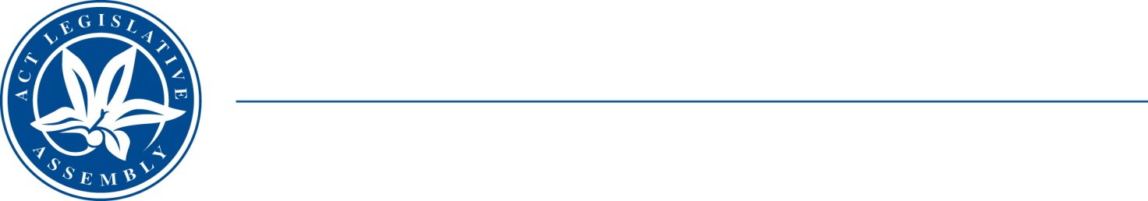
Standing Committee on Health and Community Wellbeing
Mr Johnathan Davis MLA (Chair), Mrs Elizabeth Kikkert MLA (Deputy Chair), Mr Michael Pettersson MLA

LEGISLATIVE ASSEMBLY
FOR THE AUSTRALIAN CAPITAL TERRITORY

Media Release

Assembly Health and Community Wellbeing Committee to conduct an inquiry on matters relating to the alcohol, tobacco and other drug service sector and drug harm reduction efforts

Johnathan Davis MLA, Chair of the Standing Committee on Health and Community Wellbeing, announced the start of its first inquiry for the 10th Assembly today.
Mr Davis noted that the Committee has accepted a petition requesting an inquiry into matters relating to the alcohol, tobacco and other drug service sector, including prevention/early intervention services and pathways as well as treatment/rehabilitation services. The petition was tabled by the Committee’s Deputy Chair, Elizabeth Kikkert MLA. The inquiry will seek to:
- identify current strengths and weaknesses in the sector;
- assess current and future demands; and
- recommend services, referral pathways and funding models that will better meet people’s needs.
The petition is on the Committee website at https://www.parliament.act.gov.au/parliamentary-business/in-committees/committees/hcw/inquiry-into-act-alcohol,-tobacco-and-other-drug-harm-reduction-policy-and-programs#tab1700519-7id
The Committee is also taking the opportunity to examine a wide range of issues that impact on the matters in the petition:
- The health and other social impacts of current policy, legislative, and criminal justice approaches to alcohol, tobacco, and other drug use in the ACT.
- The adequacy and implementation of the ACT Government’s current funding commitments to support drug treatment and other harm reduction services, including funding for community-based and community-controlled organisations.
- The availability and access to best practice drug education to enable and support prevention, early intervention, and community safety.
- The benefits and challenges of establishing a clinically supervised drug consumption site in the ACT.
- The issues and policy challenges (if any) for the ACT arising from the Australian Government’s alcohol, tobacco, and other drug use policy frameworks and commonwealth legislation.
- Best practice policy approaches and responses being undertaken in other jurisdictions, including internationally, to reduce alcohol, tobacco, and other drug harm.
- Other opportunities for the ACT to explore innovative responses to reducing harm.
- The impact and proposed evaluation of the ACT Drug Strategy Action Plan 2018–2021.
- Any other related matter.

The Committee will report on the results of the inquiry by the end of 2021.
The Chair of the Standing Committee, Johnathan Davis MLA, said today: ‘I strongly encourage anyone with experience, whether academic or personal, with a commitment to preventing, effectively treating and/or reducing the harm associated with alcohol, tobacco and other drugs to make a submission to this important inquiry’.
All Canberrans are invited to have their say on this important matter.
Written submissions are invited by cob Friday, 7 May 2021.
The Committee’s terms of reference are available on the Legislative Assembly website at: https://www.parliament.act.gov.au/parliamentary-business/in-committees/committees/hcw/inquiry-into-act-alcohol,-tobacco-and-other-drug-harm-reduction-policy-and-programs
Information about how to make a submission is available at: www.parliament.act.gov.au/in-committees/Getting-involved.

10 February 2021
STATEMENT ENDS.

For further information please contact:
Committee Chair, Johnathan Davis MLA on (02) 6205 0015
Committee Secretary, Andrew Snedden on (02) 620 50199 or at LACommitteeHCW@parliament.act.gov.au

