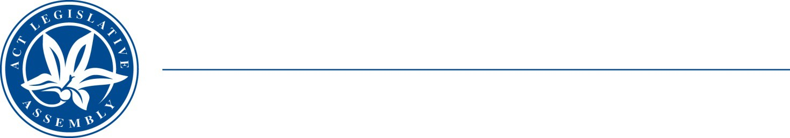

Legislative Assembly for the Australian Capital Territory

Invitation for Public Submissions
Inquiry into Amendments to the Electoral Act 1992
The Legislative Assembly established a Select Committee on Amendments to ACT Electoral Act 1992 on 20 March 2014. The Select Committee is to present its report on the inquiry by the end of June, 2014.

The Select Committee invites submissions from interested organisations and individuals to its inquiry. Submissions should address some or all the terms of reference, which are on the Select Committee’s website at http://www.parliament.act.gov.au/in- committees/select_committees/select-committee-on-amendments-to-the-electoral-act- 1992.

Prior to making a submission, it is suggested submitters familiarise themselves with the contents of Elections ACT’s Report on the ACT Legislative Assembly Election 2012 in relation to recommendations pertaining to the Electoral Act 1992 . A link to the report is on the Committee website.

A link to the High Court decision Unions NSW & Ors v State of NSW which has been referred to the Select Committee is also on the Committee website.

The Committee has extended the closing date for making written submissions. Submissions should be lodged by C.O.B. on Monday, 12 May 2014.

The Committee prefers all submissions to be lodged in electronic form, although handwritten submissions are acceptable. All submissions, including those sent electronically, should include an email address, a postal address and a telephone contact number.

Submissions should be forwarded to:

The Committee Secretary, Select Committee on Amendments to the Electoral Act 1992, Legislative Assembly for the ACT, GPO Box 1020, CANBERRA ACT 2601. Fax (02) 6205 0432
Email: committees@parliament.act.gov.au

For further information please contact the Select Committee Secretary, Ms Louise Gell, on (02) 6205 0435.

