

Alistair Davey, Brett Kaufmann, Roger Fisher and Susan Antcliff
Pegasus Economics
July 2024
Review of the ACT Budget 2024-25

Pegasus Economics • www.pegasus-economics.com.au • PO Box 449 Jamison Centre, Macquarie ACT 2614
Pegasus Economics is a boutique economics and public policy consultancy firm that specialises in strategy and policy advice, economic analysis, trade practices, competition policy, regulatory instruments, accounting, financial management and organisation development.
This report has been commissioned by the ACT Legislative Assembly’s Select Committee on Estimates 2024-2025 to assist the Committee in its deliberations in relation to the 2024-25 ACT Budget.
The views and opinions expressed in this report are those of the authors.
For information on this report please contact:
Name: Dr Alistair Davey
Telephone: + 61 2 6100 4090
Mobile: 0422 211 110
Email: adavey@pegasus-economics.com.au

Table of Contents
Executive Summary vi
1. Introduction 1
1.1 Purpose 1
1.2 Approach 1
1.3 Limitation of scope 1
2. Economic Forecasts 2
2.1 Overview 2
2.2 ACT Gross State Product and final demand 2
2.3 Employment 8
2.4 Wage price index 8
2.5 Consumer price index 9
2.6 Population growth 9
3. Fiscal Position 11
3.1 Operating Statement - Headline Operating Balance 11
3.2 Medium term forecasts 12
3.3 Measures of the ACT Government’s financial position 13
3.4 Cash Flow Statement – General Government 16
3.5 Comparisons with other States and Territories 16
3.6 Other measures of sustainability 19
4. Revenue 21
4.1 Overview 21
4.2 Tax reform and Own Source Revenue 23
4.3 Budget impact on cost of living 26
4.4 Dividends and income tax equivalents 27
4.5 Contributed assets 29
5. Expenses 30
5.1 Overview 30
5.2 Reasons for growth 32
5.3 Expenses by function 33
5.4 Expenses by economic type 35
6. New initiatives and wellbeing 38
6.1 Introduction 38
6.2 Reporting format for new initiatives 38
6.3 New initiatives 39
6.4 Reporting the cost of new initiatives 42
7. Infrastructure and capital 44
7.1 Overview 44
7.3 Asset Renewal Program 47
7.4 Works-In-Progress 47
7.5 Major Projects 48
7.6 Capital Works Reserve 48
7.7 Capital Works Program – Public Trading Enterprises 48
8. Assets and Liabilities 49
8.1 Overview 49
8.2 Net debt 49
8.3 Net financial liabilities 50
8.4 Net worth 52
8.5 Superannuation 52
9. Budget accounting, classification and valuation issues 58
9.1 Overview 58
9.2 Disclosure of key accounting policies 58
9.3 Superannuation return adjustment 59
9.4 Superannuation liability valuation and service costs 59
9.5 Service Concession Arrangements 60
9.6 Acquisition of Calvary Public Hospital and Clare Holland House 61
9.7 Technical adjustments 61
9.8 Concessional loans 62
10. Women’s Budget Statement 63
10.1 Introduction 63
10.2 Overall impressions 63
11. Housing Affordability and Provision of Public Housing 66
11.1 Housing Affordability 66
11.2 ACT public housing and population growth 67
11.2 Budget measures 68
Bibliography 70

Table 1: Current outcomes and economic estimates and forecasts in the 2024-25 ACT Budget, percentage change 2
Table 2: General Government Sector Headline Net Operating Balance 11
Table 3: General Government Sector Key Balance Sheet Measures 14
Table 4: Long-term credit rating as reported by States and Territories, 2023-24 19
Table 5: Dividends and Tax Equivalents 27
Table 6: Budget and forecast expenses 30
Table 7: New capital, expenses and revenue initiatives, Budget and forecast years, by primary domain ($000) 40
Table 8: New initiatives - Budget and forecast years, expenses, offsets, and savings ($000) 42
Table 9: Summary of Infrastructure Investment Program – 2024-25 to 2028-29 44
Table 10: Impact of a 1 percentage point decrease in the discount rate on superannuation liability 60
Table 11: Impact of a 1 percentage point decrease in the discount rate on superannuation expense 60

Figure 1: Comparison of Gross State Product (GSP) with Final Demand for the ACT – 2009-10 to 2022-23 ($ million) 3
Figure 2: Components of Final Demand for the New South Wales and ACT economies, year ended March 2024 5
Figure 3: Relative shares of ACT Final Demand – 2013-14 to 2023-24* 5
Figure 4: Percentage of ACT Final Demand made up by the Public Sector (Commonwealth and ACT Government) – 2013-14 to 2023-24* 6
Figure 5: Number of Businesses Operating in the ACT – June 2015 to June 2023 7
Figure 6: Business Survival Rate for All Businesses Operating at 30 June 2019 7
Figure 7: Business Survival Rate for New Business Start-Ups in 2020 8
Figure 8: ACT Government and Centre for Population ACT Population Growth Forecasts: 2023-24 to 2027-28 10
Figure 9: Contribution of Superannuation Return Adjustment to Headline Net Operating Balance 12
Figure 10: Forecast returns to surplus 13
Figure 11: Key balance sheet measures 15
Figure 12: Key balance sheet measures as a proportion of Gross State Product 16
Figure 13: Net debt, net financial liabilities and net worth comparison across jurisdictions 17
Figure 14: ACT interest expense as a proportion of ACT Government revenue and Gross State Product, 2014-15 (actual) to 2027-28 (forecast) 18
Figure 15: Estimated ACT Budget Revenue in the 2023-24 and 2024-25 ACT Budgets 22
Figure 16: Revenue Estimated Outcome 2023-24 and Forecast 2024-25 23
Figure 17: Composition of ACT Government Own-Source Taxation Revenue 24
Figure 18: Icon Water Net Profit After Tax 28
Figure 19: Expense forecasts as a proportion of GSP – 2019-20 to 2024-25 Budgets 31
Figure 20: Expense forecasts – 2019-20 to 2024-25 Budgets 32
Figure 21: Expenses by function – 2023-24 (est.) to 2027-28 34
Figure 22: Expenses by economic type – 2023-24 (est.) to 2027-28 35
Figure 23: Interest expenses as a proportion of Gross State Product, 2011-12 (actual) to 2027-28 (forecast) 37
Figure 24: Capital Works Program Forecasts 45
Figure 25: Net debt as a proportion of Gross State Product 50
Figure 26: Net financial liabilities as a proportion of Gross State Product 51
Figure 27: Net worth as a proportion of Gross State Product 52
Figure 28: Estimated Defined Benefit Superannuation Liabilities 54
Figure 29: Estimated Defined Benefit Superannuation Flows 54
Figure 30: Defined Benefit Superannuation Unfunded Liability and Investment Assets 56
Figure 31: Portion of Income Required to Service a New Mortgage and Rent for a Dwelling in Australian Capital Cities 66
Figure 32: ACT Population and the Provision of ACT Public Housing Dwellings 68

Executive Summary
Most of the ACT Budget economic forecasts appear reasonable. There may be some risk attached to the forecast for the Canberra CPI in 2024-25 which is lower than the most recent national forecast from the Reserve Bank of Australia. The main risk to the economic outlook comes from the broader national economy, particularly from interest rates and inflation, compounded by international geopolitical tensions. The population forecasts and projections presented by the ACT are on the high side based on forecasts for the Commonwealth Government by the Centre for Population.
Since the onset of the economic disruption caused by the COVID-19 pandemic, the ACT economy has generally become much less diverse and more dependent on the public sector, with the Commonwealth and ACT governments now accounting for around 56 percent of final demand, as compared to 53 percent pre-COVID.
The Budget forecasts a headline net operating deficit of $642.1 million in 2024-25, moving over the forward years to a surplus of $179.5 million by 2027-28. The position on operating cash is forecast to move into surplus in 2024-25 following cash deficits in recent Budgets. However, the total cash balance is forecast to be in deficit across the Budget and forward years.
Interest expenses show significant growth over the Budget and forward years. Interest expenses are now forecast to reach $514 million in 2024-25 and $832 million in 2027-28. The Budget forecast for interest expenses is $127 million higher than the estimated 2023-24 outcome and is forecast to increase by a further $318 million over the Budget and forward years.
A short-term increase in net debt can be a sensible response to adverse economic shocks, such as the COVID19 pandemic, and can be justified when investing in future wealth generating assets. However, continuing high levels of debt are undesirable as they impose debt servicing costs and can reduce future budget flexibility.
The Budget includes 166 new policy initiatives that involve a mix of capital, expense, and revenue. The new policy initiatives collectively represent $414 million of capital, $615 million expenses, and $224 million of revenue, in net terms, over four years.
Significant new investments are being made across most domains, with the largest new spending earmarked for the Health, Housing, Living Standards and Connectivity domains.
The Budget also includes funding for substantial major projects, infrastructure and capital works program across the Budget and forward years through the Infrastructure Investment Program, and the overarching ACT Infrastructure Plan. The program is over five years out to 2028-29. The ACT Government intends to invest $1.4 billion in 2024-25 and approximately $8.1 billion out to 2028-29.
Key projects include hospitals, health centres, schools, public housing, urban renewal, transport and roads, community and services, and climate action.
The ACT has a strong balance sheet, but that position is deteriorating over time. Despite the forecast return to surplus in 2026-27, net debt and net financial liabilities are continuing to grow through the forecast period while net worth is falling. The ACT has moved from the position of being a net creditor at the beginning of the last decade to having a substantial and increasing debt and interest burden in the Budget and forward years. The recent downgrade of the ACT credit rating is an indication of its weakened fiscal position.
Pegasus notes improvements in transparency in the current Budget Papers, including in relation to significant accounting policies and dividend policies. Consistent reporting of wellbeing initiatives in line with normal budget and accounting conventions would further improve transparency.

1. Introduction

1.1 Purpose
This report has been produced to assist the Select Committee on Estimates in its consideration of the 2024-25 ACT Budget.
The purpose of the report is to identify major features of the Budget that the Committee may wish to explore in its consideration of the Budget. The report does not express any judgement on the appropriateness of individual decisions reflected in the document. The focus of the report is on the reasonableness of assumptions used in construction of the Budget, elucidation of key features of the Budget and the consistency and transparency of the presentation of the Budget aggregates.
Additional comment has been provided in the report on issues specifically identified by the Committee.

1.2 Approach
The report is based on a desk-top review of the ACT Budget documentation presented to the Assembly on Tuesday 25 June 2024. We have also consulted other documentation in the public domain including Commonwealth Government Budget Papers, the Budget Papers of other States and the Northern Territory, and economic statements, previous ACT Budget documents, reports of the ACT Auditor-General, various Ministerial statements, Departmental reports and other research literature.
Pegasus was also given access to ACT Treasury officials at a meeting on 27 June 2024. ACT Treasury provided the opportunity to discuss aspects of the Budget and subsequently provided written answers to questions. Pegasus thanks the ACT Treasury officials for making this opportunity available to us, for their careful and considered answers to our questions and for their prompt responses. Our report is better for this engagement. Information provided by ACT Treasury is noted in the text.

1.3 Limitation of scope
In preparing advice for the Select Committee, Pegasus has relied on details contained in the Budget Papers, our independent research and analysis and other public sources.
Work was undertaken and a draft report provided within 10 days of the presentation of the Budget to the Legislative Assembly. These matters have constrained the extent and depth of analysis that could be undertaken.

2. Economic Forecasts
Most of the ACT Budget economic forecasts appear reasonable. There may be some risk attached to the forecast for the Canberra CPI in 2024-25 which is lower than the most recent national forecast from the Reserve Bank of Australia.
The main risk to the economic outlook comes from the broader national economy, particularly from interest rates and inflation, compounded by international geopolitical tensions.
The population forecasts and projections presented by the ACT Government are on the high side based on forecasts for the Commonwealth Government by the Centre for Population.

2.1 Overview
A summary of current economic trends alongside the economic estimates and forecasts contained in the 2024-25 ACT Budget are provided in Table 1 below.
Table 1: Current outcomes and economic estimates and forecasts in the 2024-25 ACT Budget, percentage change
Indicator | Current outcomes | 2023-24 Forecasts |  |  | 2024-25 Budget Forecast |  | 2025-26 Projection |  | 2026-27 Projection | 2027-28 Projection
Gross State Product¹ |  |  | 3 | 2¾ |  | 3¼ |  | 3½ |  | 3¾
State Final Demand^{1,2} | 2.4 |  | 2¼ | 2 |  | 2¾ |  | 3 |  | 3
Employment^{3,4} | 1.9 |  | 2 | 1¾ |  | 1¾ |  | 1¾ |  | 1¾
Wage Price Index^{2,3} | 3.2 |  | 4 | 3½ |  | 3½ |  | 3¼ |  | 3¼
Consumer Price Index^{2,3} | 3.3 |  | 3½ | 3 |  | 2¾ |  | 2½ |  | 2½
Population^{3,5} | 2.0 |  | 2 | 1¾ |  | 1¾ |  | 1¾ |  | 1¾
1. In year average terms.
2. Outcome to the end of March 2024.
3. Through the year.
4. Outcome in trend terms to the end of May 2024.
5. Outcome to the end of December 2024.
Sources: ACT Government (2024), Australian Bureau of Statistics (ABS) (2024, 2023b, 202c, 2023e, 2023f).

2.2 ACT Gross State Product and final demand
Gross domestic product (GDP) measures the value of goods and services that an economy produces in a period (Li & Gao, 2021, p. 2). Gross state product (GSP) is the equivalent of GDP for a region of a national economy (Australian Bureau of Statistics, 2021b). This measure can be produced for a region of any size whether a state, territory, or district. In the Australian context, it is compiled for the six states and two territories.
While GDP is published quarterly by the Australian Bureau of Statistics (ABS) as part of the national accounts, GSP is only available on an annual basis (Li & Gao, 2021, p. 1). This severely restricts the usefulness of GSP as an immediate and recent indicator of economic activity.
A less comprehensive indicator of economic activity is state final demand that measures consumption and investment spending by households and government sectors (Carr, Fernandes, & Rosewall, 2017, p. 2). State final demand differs from GSP in that it excludes international and interstate trade as well as the change in inventories. Unlike GSP that is only published annually, state final demand is published as part of the quarterly national accounts.
In the absence of quarterly GSP, state final demand offers the most readily available immediate indicator of economic activity within the ACT. As final demand contains most of the components of GSP, it is highly correlated with GSP that is outlined in Figure 1 below.
Figure 1: Comparison of Gross State Product (GSP) with Final Demand for the ACT – 2009-10 to 2022-23 ($ million)
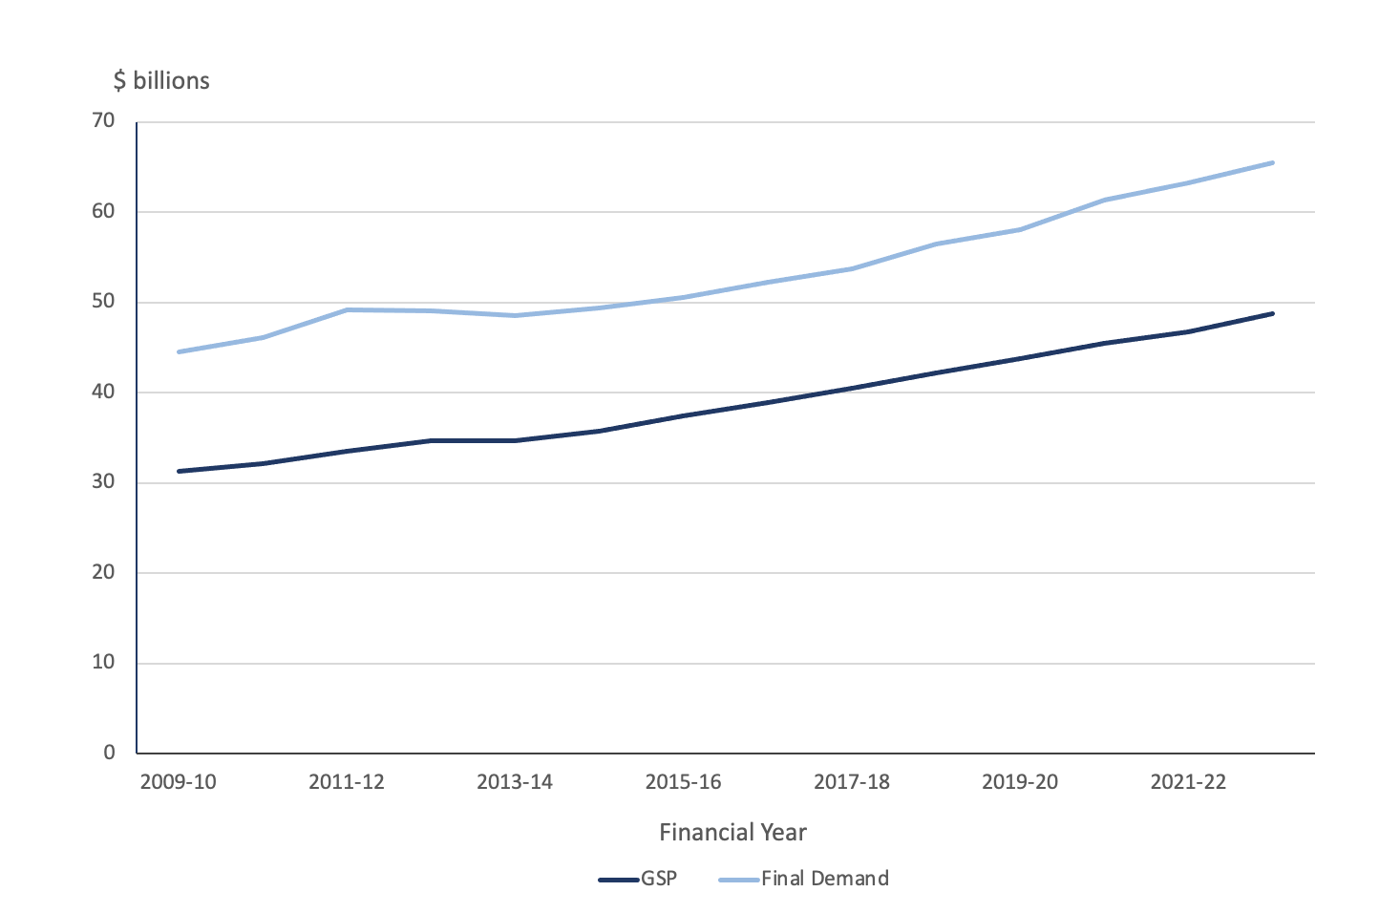
Source: ABS (2023).
The most recent national accounts released by the ABS (2024) relate to the March quarter 2024. ACT final demand grew by 1.1 percent in the March quarter 2024. This is a strong result primarily driven by a 1.9 percent increase in final consumption expenditure due to:
- 3.0 percent rise in government consumption due to a rise in national general government (2.6 percent) spending across a range of departments, as well as strength in ACT Government (5.0 percent) spending on across multiple departments.
- 0.4 percent rise in household consumption.
The strong growth in consumption expenditure was partially offset by falls in both private investment (a decrease of 2.2 percent) and public investment (a decrease of 4.6 percent). Major components of the fall in private investment were:
- 12.0 percent fall in total dwellings driven by new and used dwellings (-13.1 percent) and alterations and additions (-9.0 percent)
- 6.1 percent fall in ownership transfer costs
- These falls were partly offset by a 18.0 percent rise in total machinery and equipment driven by increased investment on IT equipment and vehicles.
Major components in the fall in public investment were:
- 3.7 percent fall in general government driven by reduced ACT Government (-10.9 percent) investment on buildings and road infrastructure.
- 15.9 percent fall in public corporations led by reduced ACT Government (-19.0 percent) investment.
In the year to the end of March 2024, overall private investment in dwellings has fallen by 10.1 percent, with investment in new and used dwellings down by 8.6 percent and investment in dwelling alternations and additions down by 16.8 percent. This suggests the tightening of monetary policy through the raising of the official cash rate by the Reserve Bank of Australia (RBA) has had an adverse impact on dwelling investment in the ACT. In relation to the national economy, overall private investment in dwellings has only fallen by 3.4 percent to the in the year to the end of March 2024, suggesting the tightening of monetary policy has had a more significant impact on overall dwelling investment in the ACT than it has had across the national economy.
Growth in final demand (in year average terms) for the year ending March 2024 was 2.4 percent, which is just a little higher than the Budget estimate for an increase in ACT final demand of 2¼ percent for 2023-24, although not incompatible. For 2024-25, growth in ACT final demand is forecast to rise by 2 percent, which is consistent with the Commonwealth Government (2024a, p. 53) budget forecast of growth in national final demand of 1¾ percent in 2024-25.
According to the ACT Government (2024, p. 345),the main risk to the economic outlook is the broader national economy dragging GSP growth and final demand in the ACT down with it, with specific risks associated with higher inflation and higher interest rates, as well as ongoing international geopolitical tensions (e.g. wars in the Ukraine and the Middle East):
The ACT economy continues to be exposed to uncertainty and risk from the broader national economy, particularly from interest rates and inflation, compounded by international geopolitical tensions. A key downside risk is that high inflation and interest rates could dampen aggregate demand in the ACT and/or the national economy more than expected.
The risks expressed by the ACT Government in relation to higher than expected inflation and interest rates would appear to be well founded given concerns were expressed the RBA could raise the official cash rate that sets interest rates following a higher than expected rise in the national consumer price index of 4 percent in the 12 months to May 2024 (Australian Bureau of Statistics, 2024d).
Pegasus has no reason to query the forecasts of ACT final demand of growth of 2 percent in 2024-25 and 2¾ percent in 2025-26, and projections of 3 percent in 2026-27 and 2027-28. Nor do we question the forecasts for GSP in 2024-25 and 2025-26 and the projections in the out-years.
As the seat of the Commonwealth Government, the ACT is heavily dependent on the consumption and investment decisions of the Commonwealth Government. This can be seen in Figure 2 below, which compares the four main components of the New South Wales (NSW) and ACT economies.
Figure 2: Components of Final Demand for the New South Wales and ACT economies, year ended March 2024
- New South Wales | - ACT
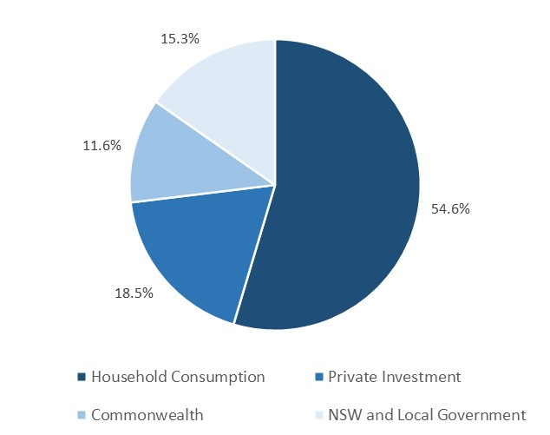 | 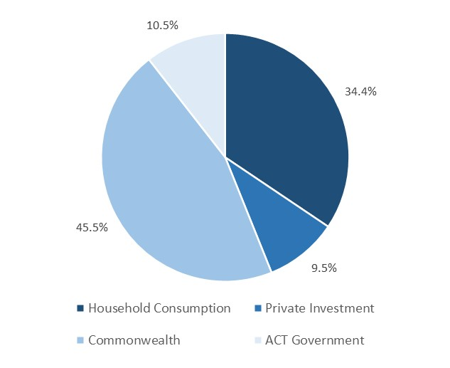
Source: ABS (2024).
In the year to the end of March 2024, the Commonwealth represented 45.5 percent of total demand in the ACT economy while household consumption represented 34.4 percent, private investment 9.5 percent, and 10.5 percent for the ACT Government.
The historical relative shares of ACT final demand are provided in Figure 3 below.
Figure 3: Relative shares of ACT Final Demand – 2013-14 to 2023-24*
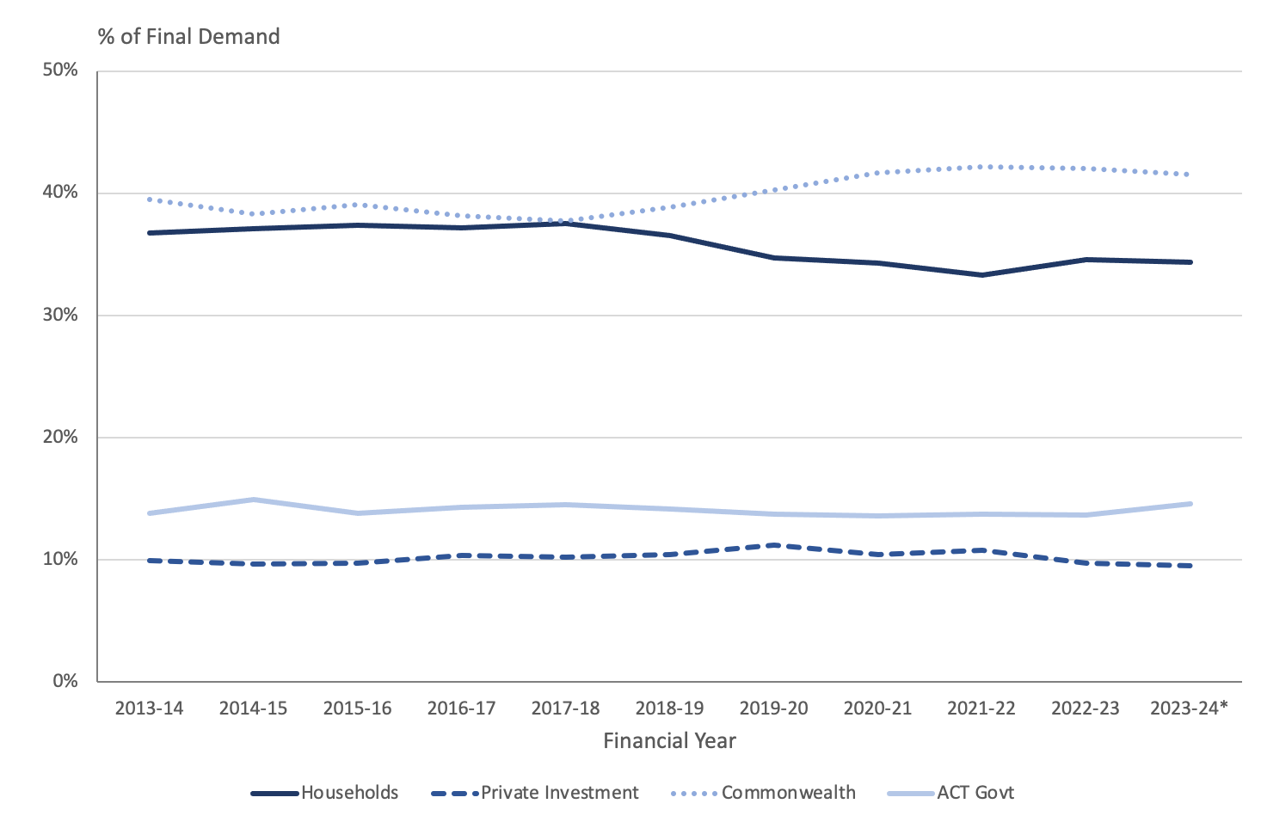
Source: ABS (2024).
* 2023-24 only includes the September and December quarters 2022, and the March quarter 2023.
Between 2019-20 and 2021-22 with the onset of COVID-19 pandemic, there was a contraction in household consumption that was largely offset by an expansion in expenditure by the Commonwealth Government. However, household consumption has not fully recovered back to its pre-COVID-19 pandemic levels. So far during 2023-24, there appears to be a substantial uptick in the relative contribution of the ACT Government to final demand, rising from 13.7 percent in 2022-23 to 14.6 percent in the first three quarters of 2023-24 while business investment has contracted from 9.8 percent to 9.5 percent over the same period.
Since the onset of the economic disruption caused by the COVID-19 pandemic, the ACT economy has generally become much less diverse and more dependent on the public sector, with the Commonwealth and ACT governments’ now accounting for around 56 percent of final demand, as compared to 53 percent pre-COVID. This is outlined in Figure 4 below.
Figure 4: Percentage of ACT Final Demand made up by the Public Sector (Commonwealth and ACT Government) – 2013-14 to 2023-24*
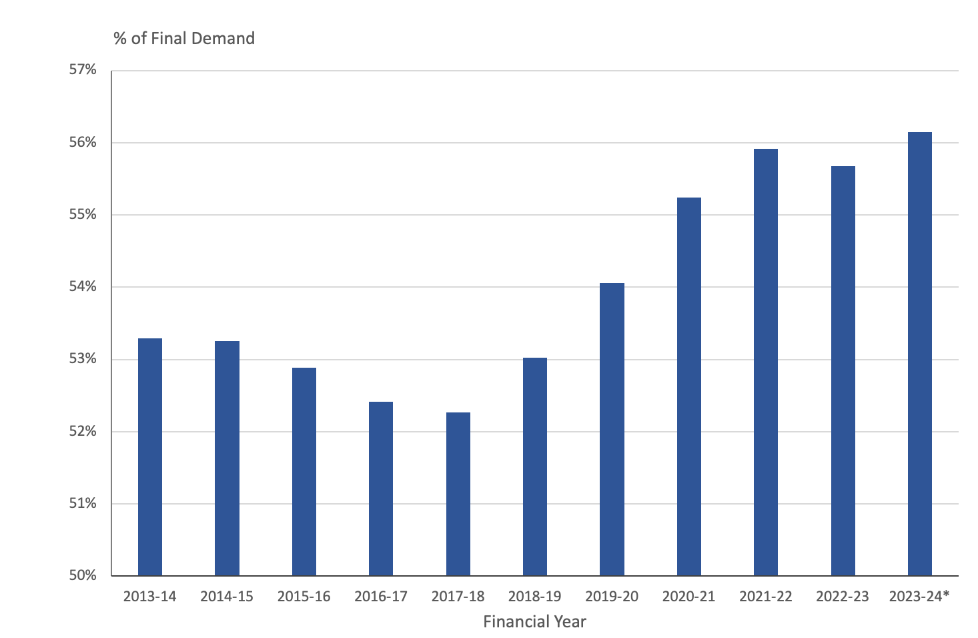
Source: ABS (2024).
* 2023-24 only includes the September and December quarters 2022, and the March quarter 2023.
2.2.1. Businesses in the ACT
Since coming out of the COVID-19 pandemic, the ACT has enjoyed some of the strongest growth in new businesses in the country. In 2020-21 the number of new businesses operating in the ACT grew by 1,732 for a total of 31,499, an increase of 5.8 percent which was the largest percentage growth in any state/territory. In 2021-22 the number of new businesses operating in the ACT grew by 2,276 for a total of 33,775, an increase of 7.2 percent which was the second largest percentage growth in any state/territory. In 2022-23 the number of new businesses operating in the ACT grew by 1,311, the largest percentage growth in any state/territory. This is outlined in Figure 5 below.
Figure 5: Number of Businesses Operating in the ACT – June 2015 to June 2023
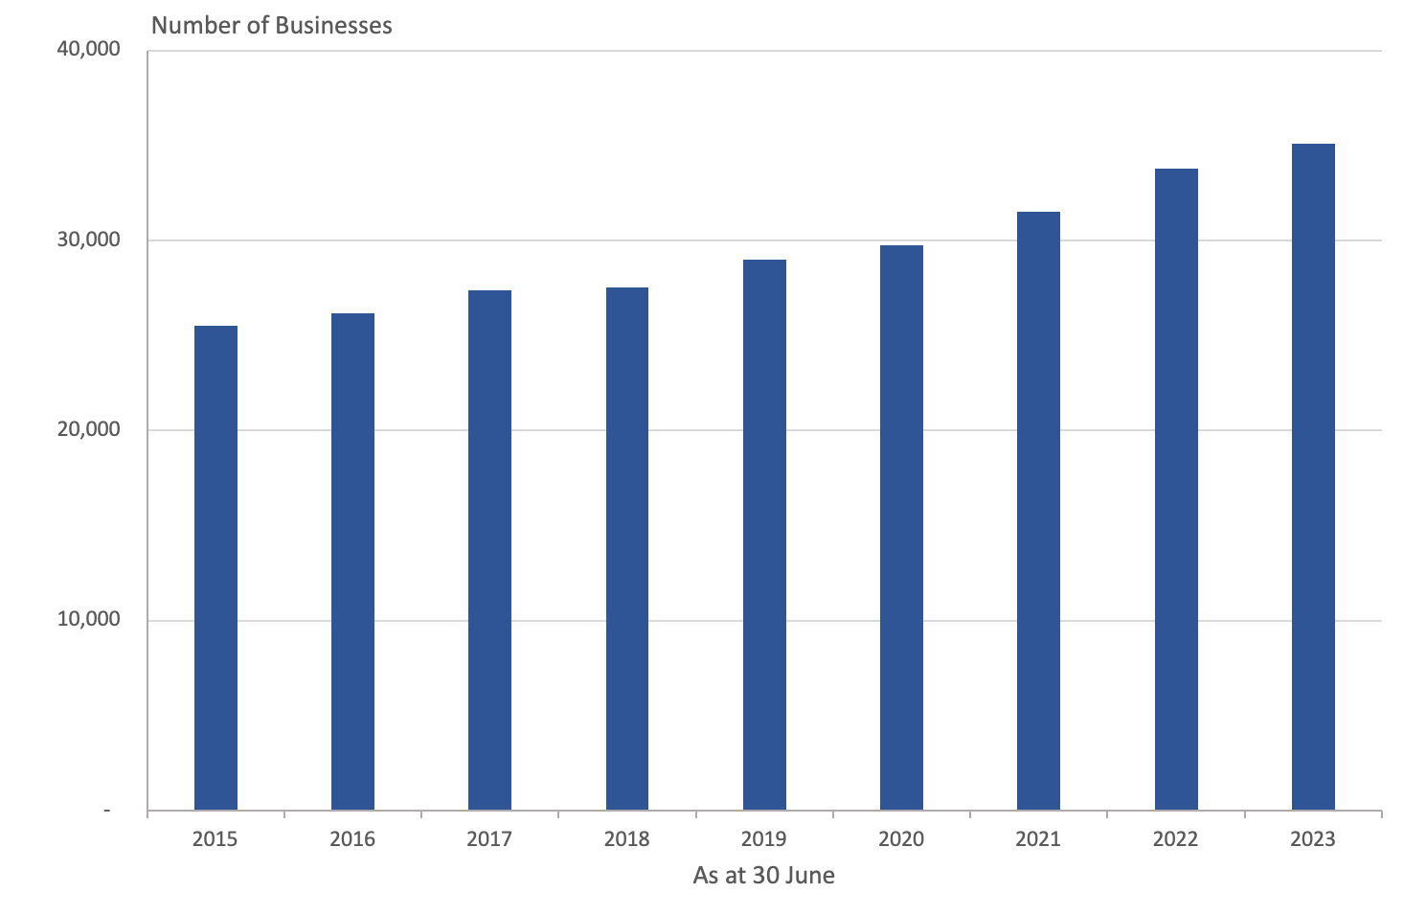
Source: ABS (2023a).
For all businesses that were operating as at 30 June 2019, the survival rate in the ACT is running slightly below the national average. This is outlined in Figure 6 below.
Figure 6: Business Survival Rate for All Businesses Operating at 30 June 2019
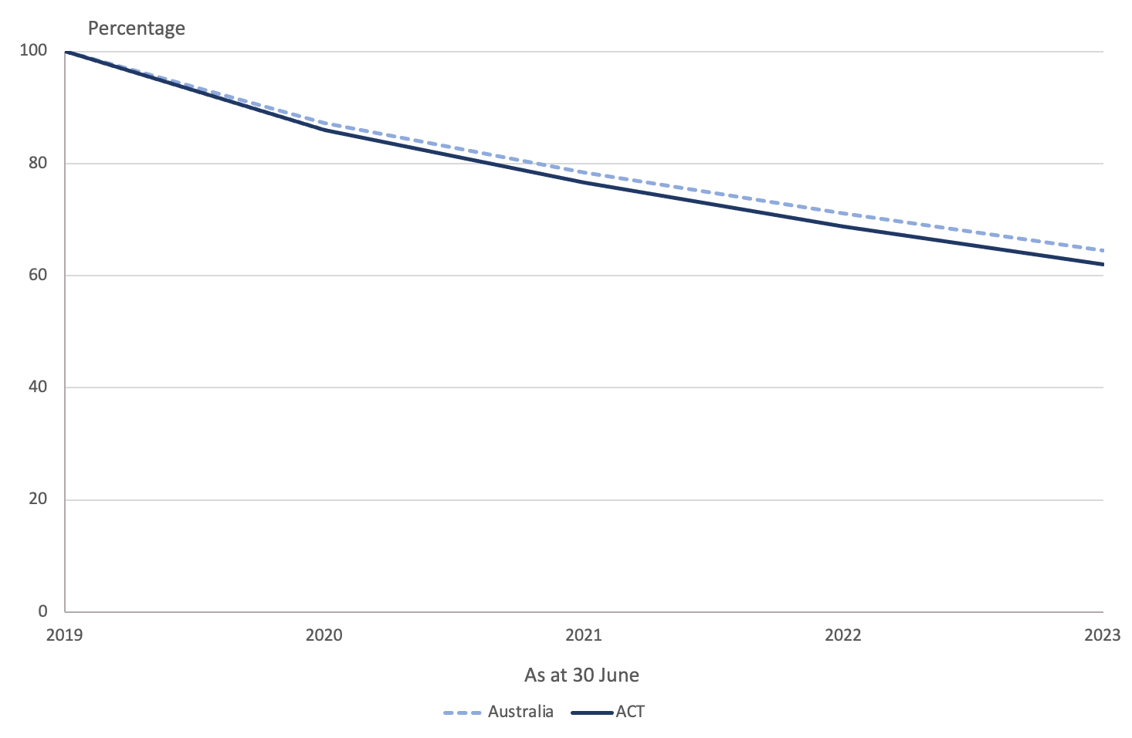
Source: ABS (2023a).
Similarly, the survival rate for new business start-ups in 2019-20 in the ACT is also running slightly below than the national average. This is outlined in Figure 7 below.
Figure 7: Business Survival Rate for New Business Start-Ups in 2020
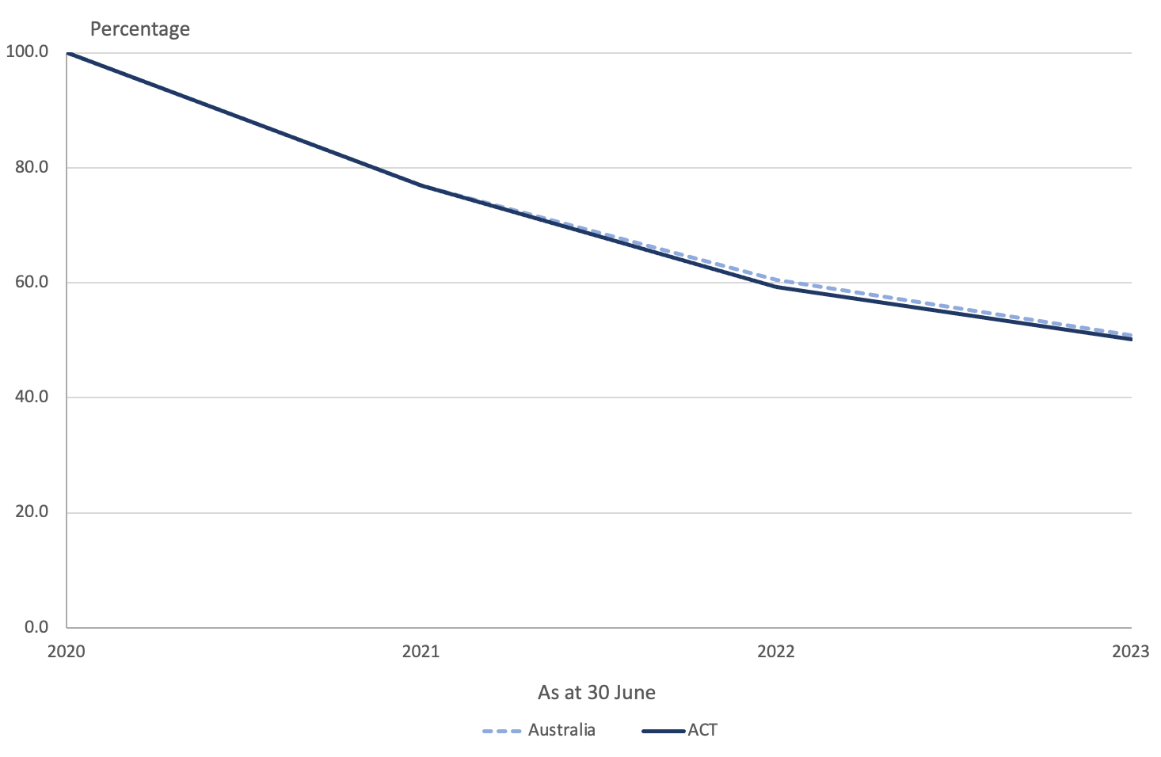
Source: ABS (2023a).
The available evidence suggests that conditions conducive for business survival in the ACT are similar to those prevailing across the rest of the country.

2.3 Employment
Employment growth through the year to the end of May 2023 for the ACT was running at 1.9 percent in trend terms (Australian Bureau of Statistics, 2024c). In the year to the end of May 2024, an additional 5,000 jobs had been added. This is running slightly above the 2024-25 ACT Budget estimate for employment growth of 1¾ percent in 2023-24 (ACT Government, 2024), although not incompatible with it.
In the 2024-25 ACT Budget, the ACT Government is forecasting a slight rise in employment to 2 percent in 2024-25 and a slight moderation in 2025-26 to 1¾ percent, with projections for growth of 1¾ percent in the out-years. Given employment by the Commonwealth Government (2024, p. 181) is expected to increase in 2024-25 by in excess of 17,000, and 38.1 percent of all Commonwealth Government employees are located in the ACT (Australian Public Service Commission, 2023, p. 32), a modest uptick in employment growth forecast for 2024-25 looks reasonable.

2.4 Wage price index
The Wage Price Index (WPI) is currently running at 3.2 percent through the year to the end of the March quarter 2023 (Australian Bureau of Statistics, 2024f), which is significantly below the ACT Budget estimate of 4 percent growth in the WPI for 2023-24. Given Commonwealth Government public service pay rises of around 4 percent were due to take effect from around mid-March 2024, and the APS constitutes around one quarter of the ACT workforce (Australian Public Service Commission, 2023, p. 32; Australian Bureau of Statistics, 2024c), an uptick in the WPI for the ACT in the June quarter of 2024 is possible, and the estimate of 4 percent in the WPI for 2023-24 not unreasonable.
The ACT Government (2024) is forecasting growth in the WPI of 3½ percent for both 2024-25 and 2025-26, with projections of growth for the out-years of 3¼ percent. The forecast for 2024-25 is consistent with the Commonwealth Government (2024a, p. 53) budget forecast of growth in the WPI for the nation in both 2024-25 and 2025-26 of 3¼ percent. It also consistent with the most recent enterprise bargaining pay offer by the Commonwealth Government across the entire Australian Public Service (APS) of a 3.8 percent pay increase as from March 2025, and 3.4 percent pay increase as from March 2026 (Riordan, 2023).
On this basis, forecasts and projections for wages growth appear reasonable.

2.5 Consumer price index
The percentage change for in the Consumer Price Index (CPI) for Canberra through the year to the end of the March quarter 2023 was 3.3 percent (Australian Bureau of Statistics, 2024b). This is consistent with the ACT Government (2024) budget estimate for growth in the CPI of 3½ percent in 2023-24.
The ACT Government (2024) is forecasting CPI growth for Canberra of 3 percent through the year to the end of June 2025, moderating to a forecast increase of 2¾ percent in 2025-26, with projected growth of 2½ percent in the further out-years. The ACT Budget forecast is consistent with the Commonwealth Government (2024a, p. 53) budget forecast for national CPI growth of 2¾ percent in 2024-25, and 2025-26. The Reserve Bank of Australia (RBA) (2024) is less optimistic on the immediate outlook for inflation, forecasting national CPI growth of 3.2 percent in 2024-25 before moderating to 2.6 percent in 2025-26. In light of the higher than expected rise in the national consumer price index of 4 percent in the 12 months to May 2024 (Australian Bureau of Statistics, 2024d), inflationary pressures in Australia may be more persistent than the Commonwealth Government has forecast and the RBA may be closer to the mark. However, it should be noted the monthly CPI is a much less comprehensive measure of consumer inflation than the quarterly CPI.
On this basis, the ACT Budget forecast for CPI growth in Canberra in 2024-25 and 2025-26 are not unreasonable in light of the Commonwealth Government forecasts, but the forecast for 2024-25 may be on the low side in light of the RBA forecast for 2024-25.

2.6 Population growth
Population growth for the ACT is currently running at 2.0 percent through the year to the end of December 2023 (Australian Bureau of Statistics, 2024e), which is consistent with the ACT Government (2024) budget forecast of population growth of 2 percent in 2023-24. However, it is slightly above the latest Commonwealth Government population forecast of growth of 1.7 percent in the ACT during 2023-24 (Centre for Population, 2024).
The ACT Government (2024) is forecasting the ACT population to continue to grow at 1¾ percent in both 2024-25 and 2025-26, with the projections for ACT population growth also running at 1¾ percent in the out-years.
The outlook for population growth presented by the ACT Government (2024) is generally slightly higher than those prepared for the Commonwealth Government by the Centre for Population (2024, p. 6). The difference between ACT Government and the Centre for Population ACT population growth forecasts is outlined in Figure 8 below.
Figure 8: ACT Government and Centre for Population ACT Population Growth Forecasts: 2023-24 to 2027-28
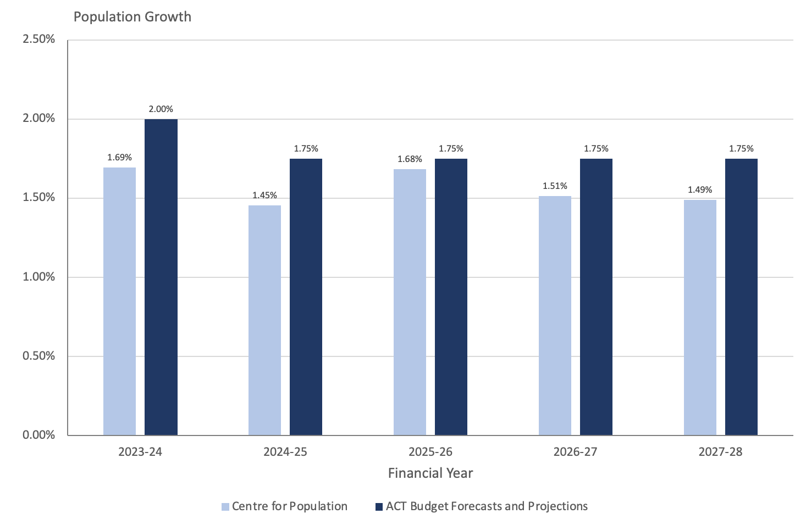
Sources: ACT Government (2024) and Centre for Population (2024).
While the population forecasts presented by the ACT Government may not be unreasonable, they may be on the high side based on forecasts by the Centre for Population.

3. Fiscal Position
The Budget forecasts a headline net operating deficit of $642.1 million in 2024-25, moving over the forward years to a surplus of $179.5 million by 2027-28.
The ACT has a strong balance sheet, but that position is deteriorating over time. Despite the forecast return to surplus in 2026-27, net debt and net financial liabilities are continuing to grow through the forecast period while net worth is falling.

3.1 Operating Statement - Headline Operating Balance
The Budget Papers present a headline net operating deficit of $624.1 million in 2024-25, improving over the forward years to a surplus of $179.5 million by 2026-27.
Table 2: General Government Sector Headline Net Operating Balance
Empty Cell | 2023-24  Est. outcome | 2024-25  Budget | 2025-26  Estimate | 2026-27  Estimate | 2027-28  Estimate
Empty Cell | $m | $m | $m | $m | $m
Revenue | 7,482.1 | 8,145.8 | 8,742.1 | 9,258.7 | 9,668.6
Expenses | 8,562.2 | 9,000.8 | 9,137.9 | 9,445.9 | 9,776.1
Superannuation return adjustment | 249.3 | 230.9 | 248.3 | 267.0 | 287.0
HEADLINE NET OPERATING BALANCE | -830.8 | -624.1 | -147.6 | 79.7 | 179.5
Source: ACT Government Budget 2024, Table 1.1.2
The forecast Headline Net Operating Balance in this year’s Budget is worse for each of the Budget and forward years than forecast in the 2023-24 Budget, and the return to surplus is one year later than previously forecast.
The ACT Government’s use of the Headline Net Operating Balance as a measure of the Government’s fiscal position is worth some consideration. Heads of State, Territory and Commonwealth Treasuries have agreed a Uniform Presentation Framework for Budget reporting (ACT Government, 2021, p.6). Financial statements consistent with these requirements are provided in Chapter 4 of the Budget Outlook under the heading GFS/GAAP Financial Statements.
On a net operating balance basis, which is closer to the fiscal measure used by other States, the ACT deficit would be around $855 million in 2024-25 and would not return to surplus at any point over the Budget and forward estimates (Table 4.1.1 of the 2024 Budget Outlook).
The ACT is unique in reporting its fiscal position in terms of the Headline Net Operating Balance. This measure is derived by adjusting the UPF operating balance to include an estimate of expected returns from the Territory’s Superannuation Provision Account. The impact of this adjustment on the reported Headline Operating Balance is shown in Figure 9 below.
Figure 9: Contribution of Superannuation Return Adjustment to Headline Net Operating Balance
Sources: ACT Government Budget Papers
The superannuation return adjustment reduces the reported headline net operating balance. In the years between 2016-17 and 2019-20 the superannuation return adjustment had the effect of moving the reported deficit to balance or close to balance. The underlying deficits in the pandemic years were so large that the adjustment did not make a material difference to the reported balance. However, as the Territory has improved its fiscal position, the superannuation return adjustment has had the effect of producing surpluses in the 2026-27 and 2027-28 years that under the agreed Uniform Presentation Framework would have been reported as deficits.
The ACT Government provides a detailed justification for its use of the HNOB in Box 3.1.1 on page 43 of the 2024 Budget Outlook. The Government points out that the NOB includes expenses associated with the Territory’s superannuation obligations, and the interest and dividend income associated with the financial assets set aside in the Superannuation Provision account but would exclude unrealised gains on those financial assets.
If the superannuation return adjustment is to be included in the reported fiscal balance, we would argue that it should not lead to a bias in outcomes. This would mean calculating the adjustment on an assumption that the total return on the assets of the Superannuation Provision Account is identical to the long-term discount rate used in valuing the liability. In the Budget year, this would imply a superannuation return adjustment of $83 million.
A more detailed discussion of accounting and classification issues in the Budget, including issues around the superannuation return adjustment, is provided at section 9 of this report.

3.2 Medium term forecasts
After a period of improvement as the ACT recovered from the COVID-19 pandemic, the medium-term outlook is worse than forecast in recent Budgets.
The long-term trend in the ACT has been for successive Budgets to promise improved fiscal positions in the forward years only to set out progressively worse forecasts in subsequent Budgets. The post-pandemic Budgets in 2022 and 2023 were an exception to that trend but the 2024-25 Budget returns to the profiles forecast in earlier years, with forecasts in the Budget and forward years worse than previously estimated.
Figure 10 below shows the Budget and forward estimates published in each year between 2012-13 and 2022-23. As can be seen, promised improvements in the budget position over the forward years have rarely materialised. In almost all cases, the Budget estimate in any year is worse than had been forecast in previous years.
Figure 10: Forecast returns to surplus
Sources: ACT Budget Papers
As the past few years have shown, Government Budgets are vulnerable to external events and unexpected shocks. The ACT Budget is particularly dependent on Commonwealth funding and general population growth. Past trends suggest that a return to surplus would require a shift in policy settings and a continuation of favourable economic circumstances. A return to surplus in the medium term cannot be assumed.

3.3 Measures of the ACT Government’s financial position
The ACT has a strong balance sheet, but that position is deteriorating over time.
The strength of the Government’s finances over the medium term can be assessed in terms of reported levels of net debt, net financial liabilities and net worth.
Table 3 below presents movements in these measures for the Budget and forward years. All of these indicators are deteriorating over time and are worse than forecast for the same years in last year’s Budget.
Table 3: General Government Sector Key Balance Sheet Measures
 | 2023-24  Est.  outcome | 2024-25  Budget | 2025-26  Estimate | 2026-27  Estimate | 2027-28  Estimate
 | $m | $m | $m | $m | $m
Net debt (excluding super) | 7,337.9 | 8,870.0 | 10,427.2 | 11,748.5 | 12,470.1
Net financial liabilities | 13,104.7 | 14,396.4 | 15,594.6 | 16,547.8 | 17,028.2
Net worth | 19,539.6 | 18,772.9 | 18,377.1 | 17,994.4 | 17,834.9
Source: ACT Budget 2024, Table F.9
The table shows that the Territory’s financial position is becoming more vulnerable over the Budget and forward years. Net debt is forecast to increase by 70 percent over the Budget and forward years compared to the expected 2023-24 outcome. After a period of measured improvement between 2019-20 and 2022-23 due to valuation effects, net financial liabilities are expected to grow over the Budget and forward years. Net worth, which is the broadest measure of the Territory’s financial position, is now expected to decline over each year.
While the key balance sheet measures can vary from year to year with changes in underlying assumptions, the long-term trend shows a continuing deterioration in the Territory’s indebtedness and financial obligations. This is illustrated in Figure 11 below.
Figure 11: Key balance sheet measures
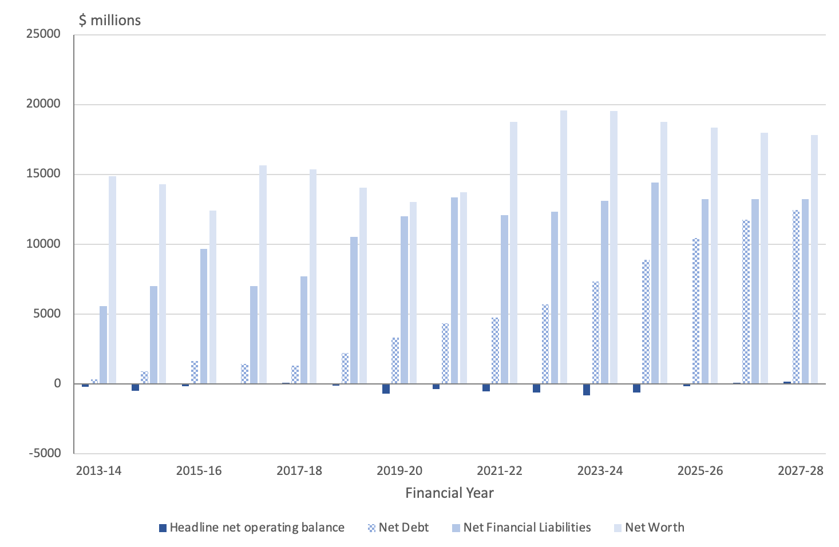
Source: ACT Budget Papers 2013 to 2024.
Note: From 2019-20, net debt includes the impact of accounting changes in relation to the treatment of leases. The ACT Government has indicated that for this reason net debt from 2019-20 is not directrly comparable to prior years.
Figure 11 shows that net financial liabilities will have more than tripled since 2013-14. Over the same time, net debt will have grown from around $312 million in 2013-14 to almost $9 billion in 2024-25 and over $12 billion by the end of the forecast period. The ACT Government was a net lender in 2011-12. Net worth has grown since 2013-14 but is now forecast to decline over the forward years.
When expressed as a proportion of Gross State Product, all the Territory’s key balance sheet measures are expected to deteriorate over the Budget and forward estimates period, as shown in Figure 12.
Figure 12: Key balance sheet measures as a proportion of Gross State Product
Source: ACT Budget Papers
Movements in these measures show a weakening of the ACT Government’s balance sheet and fiscal position over time.

3.4 Cash Flow Statement – General Government
In assessing the sustainability of the Government’s fiscal stance, it is relevant to also consider the cash position.
A surplus of $24.2 million in the Net Operating Cash Balance has been forecast for 2024-25. This follows an estimated deficit in operating cash for 2023-24 of $193.7 million. Further increasing surpluses are forecast for each of the out years (Budget Outlook 2024, p. 46 and Table 3.1.4)
However, the overall cash position, which includes cash investments in non-financial assets such as infrastructure and capital, is forecast to be in deficit in 2024-25 and each of the out years (Budget Outlook 2024, General Government Sector Statement of Cashflows, pp. 278-280). The estimated overall cash deficit for 2024-25 is $1.0 billion, with forecast deficits of $935 million, $790 million and $382 million in the out years.

3.5 Comparisons with other States and Territories
The ACT’s fiscal position has deteriorated, but still sits within the range reported by other States and Territories.
Figure 13 shows a comparison of the three key balance sheet measures for the ACT in comparison with other States and Territories.
Figure 13: Net debt, net financial liabilities and net worth comparison across jurisdictions
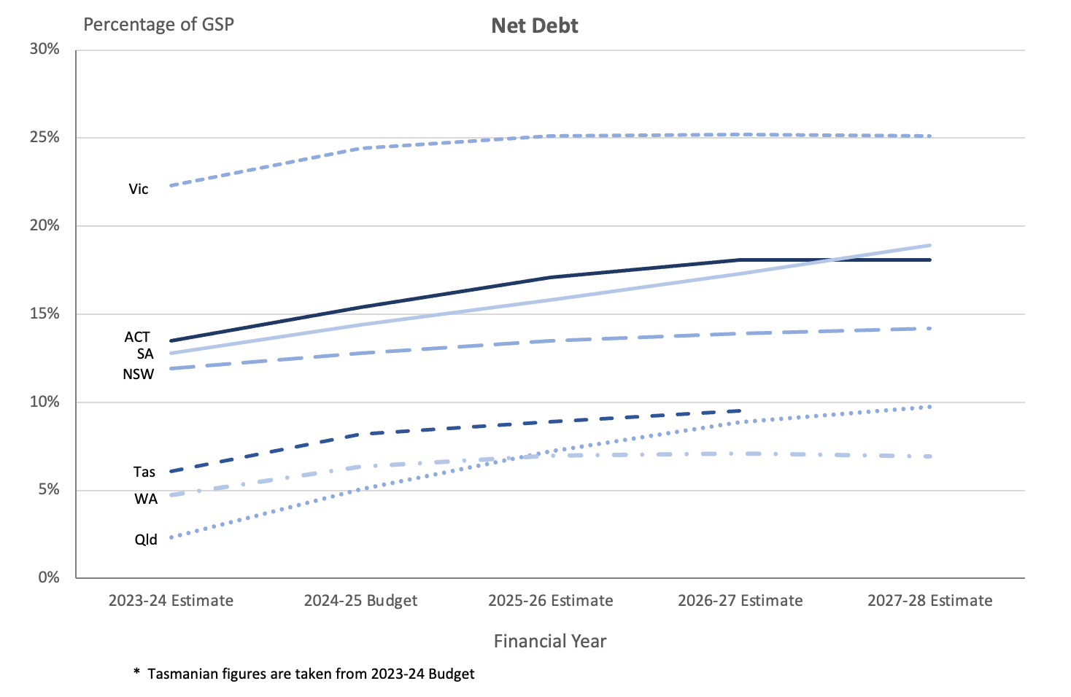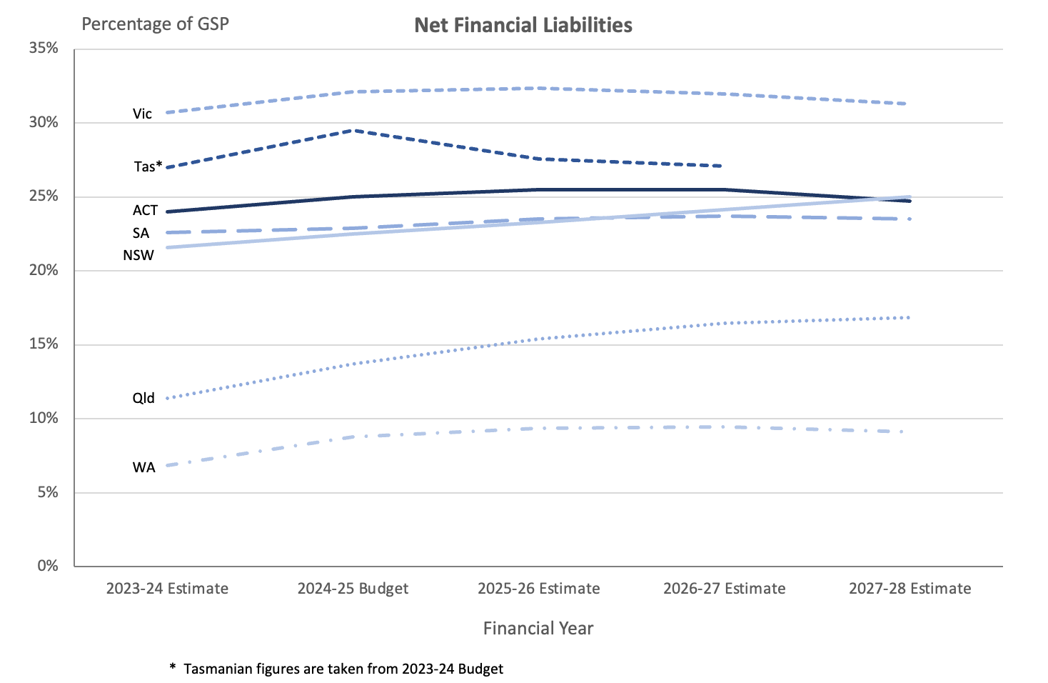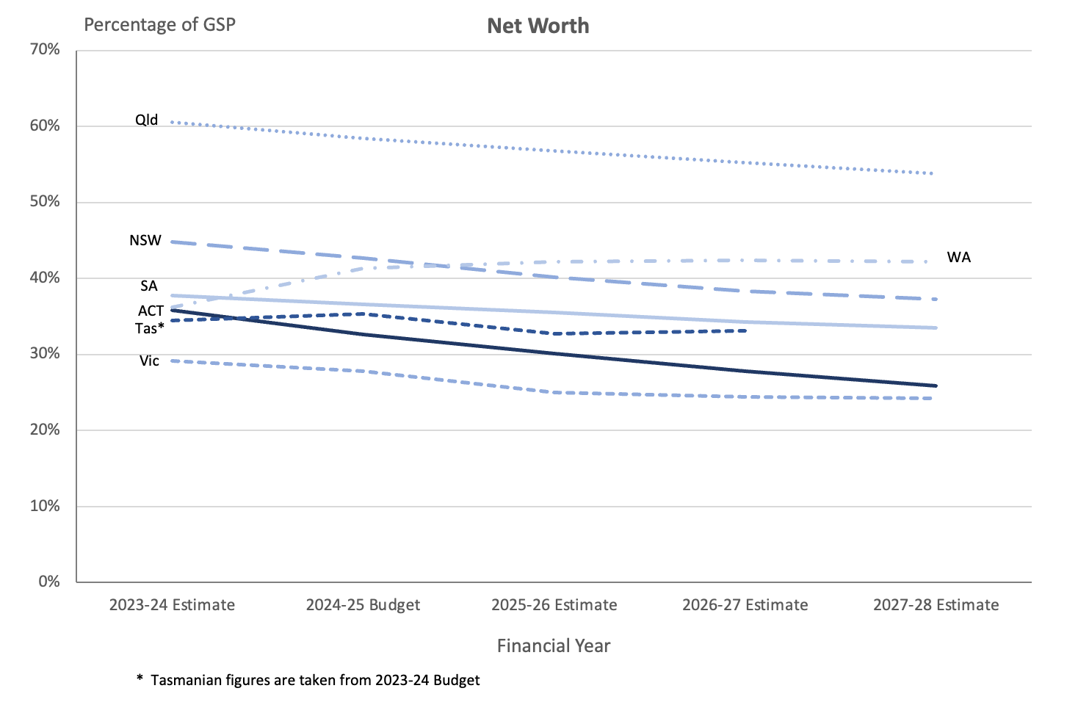
Sources: 2024-25 State and Territory Budget Papers, 2023-24 Tasmania Budget Papers.
Figure 13 shows that the ACT’s level of net debt as a proportion of GSP is around the middle of the range reported by other State and Territory governments and that, like other States and Territories, growth in net debt as a proportion of GSP appears to be moderating slightly into the forward years.
The ACT’s position on net financial liabilities is at the lower end of the range reported by other States and Territories and compares favourably with the larger States and the Northern Territory. ACT net financial liabilities have been growing in recent years, but the growth is expected to reverse by the end of the forward estimates period.
While the ACT’s net worth as a proportion of GSP is also within the range reported by other States and Territories, ACT net worth as a proportion of GSP is declining faster than any other State or Territory, moving from third highest in 2022-23 to second lowest in 2026-27.
One consequence of the increase in debt and other liabilities over time is that an increasing share of the ACT Budget and indeed the ACT economy overall is devoted to meeting the cost of servicing government borrowings and other liabilities. The following chart shows the growth in interest expense as a proportion of ACT Government revenue and Gross State Product.
Figure 14: ACT interest expense as a proportion of ACT Government revenue and Gross State Product, 2014-15 (actual) to 2027-28 (forecast)
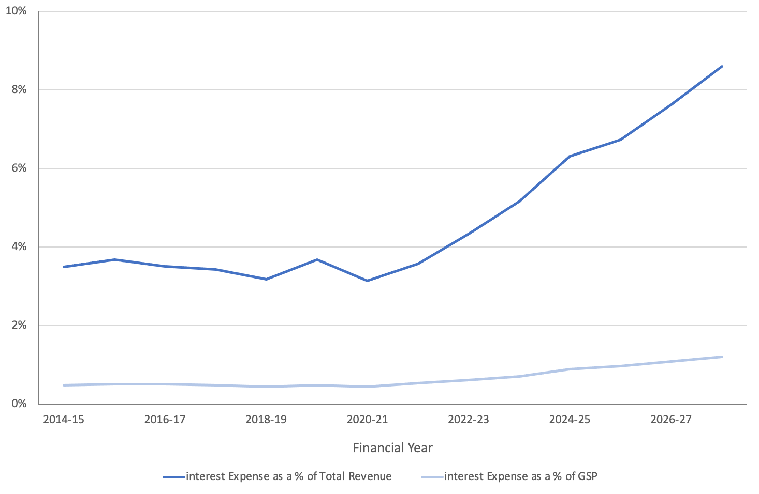
Source: ACT Consolidated Financial Statements, ACT Budget Outlook 2024
The credit rating of all State and Territory debt is assessed from time to time by independent ratings agencies. A credit rating is a measure of how risky a borrower is in terms of the borrower’s expected willingness and capacity to repay any debt on time. Higher credit ratings may lower the cost of borrowing and assist an entity in accessing financial markets.
The ACT's credit rating was downgraded during the 2023-24 financial year from AAA to AA+. Standard and Poor’s indicated that the downgrade reflects the Territory's slower than expected fiscal recovery from the pandemic.
The ratings agency was reported as saying that the ACT's total tax-supported debt as a proportion of operating revenues has grown significantly and is now much higher than for other 'AAA' rated jurisdictions. Standard and Poor’s noted that this ratio is similar to that of New South Wales and South Australia and higher than Queensland and Tasmania (Lindell, 2023).
The ACT still has a strong capacity to meet its long and short-term financial commitments, but the downgrade could be expected to slightly increase the ACT’s cost of borrowing.
Table 4 below sets out the credit ratings on long-term debt for all States and Territories. The table shows that the ACT now has a level of creditworthiness that is at about the level of other States. It is better than Victoria’s but not as strong as WA’s rating.
Table 4: Long-term credit rating as reported by States and Territories, 2023-24
Jurisdiction | S&P | Moody’s | Fitch
ACT | AA+ | n.a. | n.a.
NSW | AA+ | Aaa | AAA
Vic | AA (Stable) | Aa2 (Stable) | n.a.
Qld | AA+ (Stable) | Aa1 (Stable) | AA+
SA | AA+ (Stable) | Aa1 | AA+ (Stable)
WA | AAA (Stable) | Aaa (Stable) | n.a.
Tas | AA+ (Stable) | Aa2 (Stable) | n.a.
NT | Na | Aa3 (Stable) | n.a.
Source: State Budget Papers, State treasury and audit office websites.
Overall, the ACT’s financial position is within the range reported by other States and Territories.

3.6 Other measures of sustainability
Additional measures of the Territory’s financial position are also available. In financial audits, the ACT Auditor-General has employed measures such as:
- Assets to liabilities coverage;
- Short term assets to short term liabilities coverage; and
- Financial assets to liabilities coverage.
The benefit of these measures is that they provide an indication of the Territory’s capacity to meet its obligations over the short and medium-term.
The coverage of total assets to total liabilities falls over the Budget and forward years from about 1.69 times in 2024-25 to about 1.54 times in 2027-28.
The ratio of short-term assets to short term liabilities also deteriorates over the Budget and forward years.
Financial assets are forecast to exceed net financial liabilities by approximately 1.65 times in 2024-25 to approximately 1.43 times in 2027-28.
This analysis reinforces the suggestion that the ACT Government’s financial position is deteriorating over the medium term.
Net cash flows from operating activities are forecast to be positive for the Budget year and increase significantly across the forward years, primarily due to forecast increases in receipts from taxes, sales of goods and services, grants and contributions, dividends, and other receipts.
However, net cash flows from investments for policy purposes are forecast to be negative across the Budget and forward years.
An overall General Government cash deficit of $1 billion, and negative net cash from operations of $24.2 million, have been forecast for 2024-25.
These positions are forecast to improve over the forward years.
The ACT Government will be able to meet its immediate obligations over the Budget and forward estimates period, but the current fiscal trajectory is not sustainable over the long-term.

4. Revenue
Revenue is forecast to be $8,145 million in 2024-25, some $664 million higher than the expected outcome for 2023-24. Revenue rises over the forward years to $9,669 million by 2027-28.
The forecasts are $209 million lower in 2023-24 and $16 million lower in 2024-25 than previously estimated in the 2023-24 Budget. However, revenue is now estimated to be higher in the out-years than previously forecast.
In the 2012-13 Budget, the ACT Government committed itself to rebalancing its tax base by reducing and eventually eliminating stamp duty over a 20-year period and replacing the shortfall through an increase in the general rates system.
Notwithstanding the Government’s commitment to phasing out stamp duties and the phasing in of the new general rates system over the course of 20 years, it appears that the reduction in revenue from commercial and residential conveyances will far exceed the increase in general rates as an overall percentage of ACT Government own-source taxation revenue going out to 2027-28, which now includes the first two years of stage 4 of tax reform.
Revenue from payroll tax is now forecast to increase from 29.0 percent of ACT Government own-source taxation revenue in 2023-24 to 33.4 percent by 2027-28 – an overall increase of 4.4 percentage points. This is in marked contrast to the percentage of ACT Government own-source taxation revenue expected to be collected from general rates over the same period that declines slightly by 0.1 percentage points.

4.1 Overview
ACT revenue is forecast to be some $209 million lower in 2023-24 than previously forecast in the 2023-24 Budget (ACT Government, 2024, p. 203). The largest contributions to the fall in ACT revenue in 2023-24 over the 2023-24 Budget forecasts have come from:
- $62 million decrease in investment revenue
- $62 million decrease in gains from contributed assets
- $46 million decrease in own-source revenue
- $38 million decrease in dividend and income tax equivalent income
- $26 million decrease in Commonwealth Government grants
These decreases have been partially offset by a $50 million increase in the amount expected to be received from interest revenue in 2023-24 over the 2023-24 Budget forecast.
ACT Budget revenue is now estimated to be slightly lower in 2024-25 by $16 million than previously estimated in the 2023-24 Budget. However, ACT Budget revenue is now estimated to be higher in the out-years – by $111 million in 2025-26 and by $298 million in 2026-27. This is shown in Figure 15 below.
Figure 15: Estimated ACT Budget Revenue in the 2023-24 and 2024-25 ACT Budgets
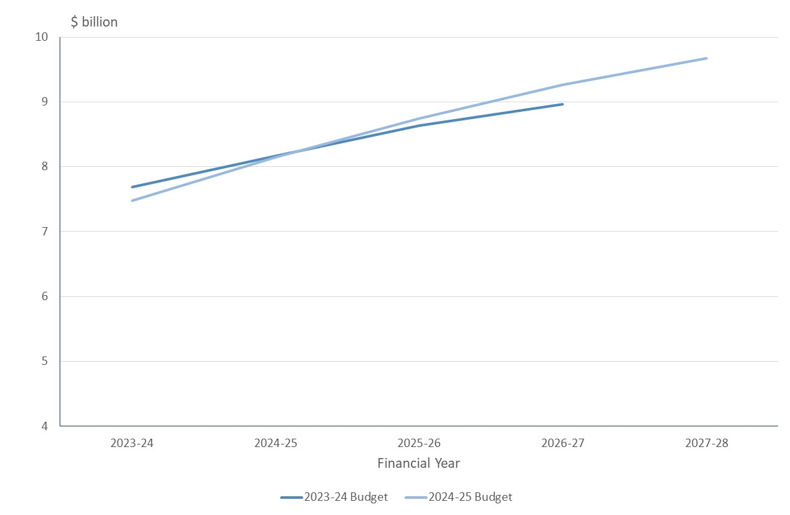
Source: ACT Government (2023, p. 222; 2024, p. 203).
In 2024-25, revenue is expected to increase by $664 million over the expected outcome for 2023-24 (ACT Government, 2024, p. 203). The largest contributors to the increase in revenue over the expected outcome in 2023-24 will come from:
- a $249 million increase in Commonwealth Government grants
- a $168 million increase in own-source revenue
- a $69 million increase in GST revenue
- a $58 million increase in investment revenue
- a $42 million increase in other revenue
- a $27 million increase in dividend and income tax equivalents income
- a $20 million increase in gains from contributed assets
A comparison of the revenue estimated outcome for 2023-24 and the revenue estimate for 2024-25 is provided in Figure 16 below.
Figure 16: Revenue Estimated Outcome 2023-24 and Forecast 2024-25
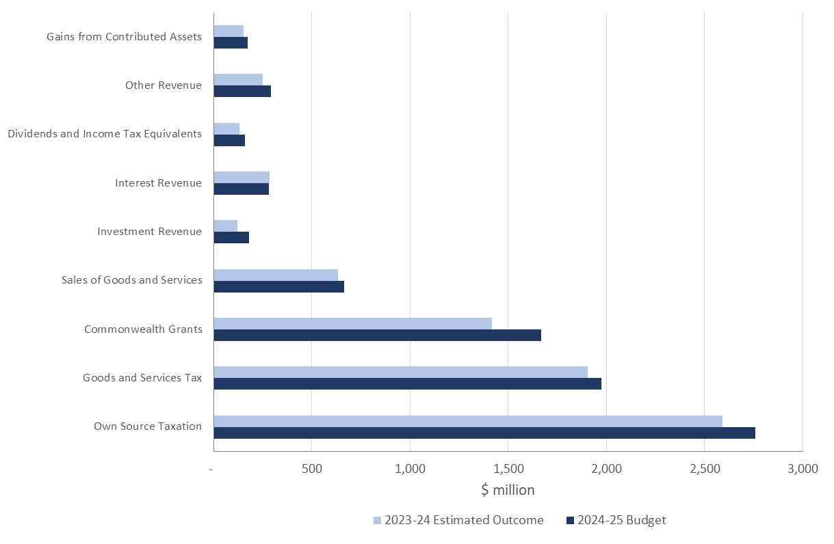
Source: ACT Government (2023, p. 222).
One item of revenue growth that has caught our attention is the category of fines within the category of ‘Other Revenue’. According to the Budget Papers, revenue from fines is expected to increase from an estimated $52 million in 2023-24, to an estimated $108 million by 2027-28 (ACT Government, 2024, p. 217). This is an increase in excess of 109 percent across the forward estimates. Fines includes monies collected from traffic offences arising from mobile detection cameras.

4.2 Tax reform and Own Source Revenue
In the 2012-13 Budget, the ACT Government committed itself to rebalancing its tax base through a process of gradually reducing and eventually eliminating various taxes on conveyances (sometimes referred to as stamp duty on the sale of land for residential and commercial purposes) over a 20-year period and replacing the shortfall through an increase in the general rates system. In relation to Conveyance Duty the ACT Government (2012, p. 46) commented at the time:
The Government will abolish Conveyance Duty over a 20-year period. Over the next five years, tax rates will be progressively reduced to phase out Conveyance Duty in the longer term.
The reduction in the marginal tax rate will focus on the lower tax brackets. …
The tax brackets and reduced tax rates will be applicable to both residential and commercial sector transactions.
In relation to general rates, the ACT Government (2012, p. 47) commented at the time:
The Government will improve the progressivity of the General Rates system with the introduction of a number of tax brackets and increasing marginal tax rates.
The phasing out of stamp duties and the phasing in of the new general rates system over the course of 20 years is being implemented in four stages to avoid a shock to the property market and to enable the change to be revenue neutral (Reardon & Hopkins, 2018, p. 4). Under stage 3, which commenced in 2021-22 and will run until 2025-26, rates are expected to increase on average by 3.75 percent per annum (ACT Government, 2021, p. 141).
Consistent with the objectives of the tax reform, the Budget shows own-source taxation revenue from general rates increasing over future years while revenue from commercial and residential conveyances is contracting. In nominal dollars, the increase in rates exceeds the decline in stamp duties. If you compare the estimates for 2023-24 as against 2027-28 (the last out-year of the forward estimates), while revenue from commercial and residential conveyances will fall by around $92 million, revenue from general rates will increase by $167 million (ACT Government, 2024, p. 204).
However, these changes in nominal amounts ignores the growth that could have been expected in both revenue sources over the period without the change in policy. Total own-source revenue is projected to grow by 6.6 percent per annum over the three forward years and were this rate of increase to apply to revenue from rates they would grow to around $980 million in 2027-28, which is only around $3 million less when compared to the Budget forecast. Conversely, stamp duties would have been expected to grow to around $366 million in 2027-28, so the projected outcome would represent a decline of only around $63 million once expected growth is taken into account.
As a result, when expressed as a percentage of total own-source revenue, the increase in rates is less than the decline in stamp duties as shown in Figure 17 below. The level of rates as an overall percentage of total own source revenue remains largely flat at just over 29 percent in 2024-25 and through into the out-years. On the other hand, payroll tax is expected to increase by more than the shortfall in both nominal dollars and as a percentage of total own-source revenue. Other own-source revenue, in aggregate, is also forecast to decline as a percentage of own-source revenue.
Figure 17: Composition of ACT Government Own-Source Taxation Revenue
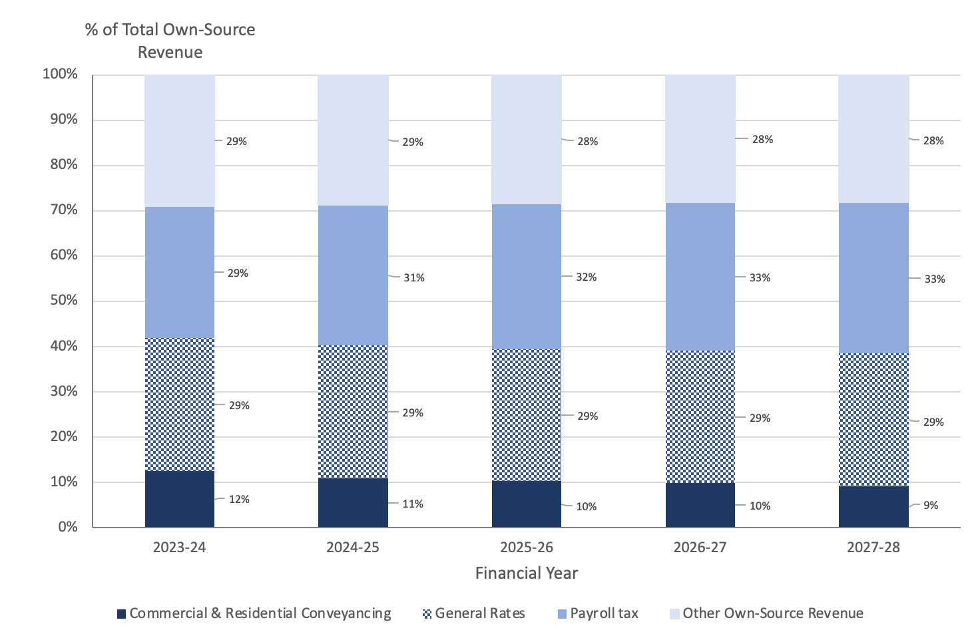
Source: ACT Government (2024, p. 204).
In other words, general rates are not rising quickly enough to replace the amount of revenue lost from changes in commercial and residential conveyance thresholds and rates. The forward estimates now include two years of stage 4 of tax reform, and yet the percentage of ACT Government own-source revenue in 2027-28 collected from general rates is now forecast to come in at 29.4 percent, which is less than the estimate for 2023-24 and only slightly higher than the estimate for 2024-25 during the last years of stage 3 of tax reform.
On the other hand, revenue from payroll tax is now forecast to increase from 29.0 percent of ACT Government own-source taxation revenue in 2023-24 to 33.4 percent by 2027-28 – an overall increase of 4.4 percentage points. This is in marked contrast to the percentage of ACT Government own-source taxation revenue expected to be collected from general rates over the same period that actually declines slightly by 0.1 percentage points.
If the ACT Government were intending to replace the amount of revenue lost from changes in commercial and residential conveyance thresholds and rates with increases in general rates, you would probably expect the overall amount of revenue collected from both sources would remain about the same in terms of an overall percentage of ACT Government own-source taxation revenue. However, this is not the case as the percentage of ACT Government own-source revenue from the combined commercial and residential conveyance thresholds and general rates actually falls across the years from an estimated 41.9 percent in 2023-24 to 39.0 percent in 2027-28. This leaves open two possibilities:
- either the ACT Government is backpedalling to some degree on its tax reform by not increasing rates sufficiently to make up for the reduction in stamp duty as an overall percentage of own-source taxation revenue
- or it is not being transparent as to its future intentions in relation to stage 4 of the tax reform even though two years from stage 4 are now supposedly included in the forward estimates.
Instead, the shortfall appears to be made up through an increasing reliance on payroll tax. In last year’s budget the ACT Government (2023, p. 120) also announced the introduction of a payroll tax surcharge for very large businesses from 2025-26.
It also needs to be borne in mind the ACT Government (2024, p. 205) has also downgraded its estimates for payroll tax due to changes in the Commonwealth Government’s employment practices which favours direct (not-taxable) employment over labour hire and contractors as the Commonwealth Government is not liable for payroll tax.
Payroll tax is levied on employers. Because payroll taxes are generally levied on all components of employee remuneration, they are designed to tax the value-added from labour (Henry, Harmer, Piggott, Ridout, & Smith, 2009a, p. 293). As such, payroll taxes are similar to the labour component of Australia’s personal income tax as well as the goods and services tax — they all generate revenue by reducing the real return from working.
Business organisations often assert that payroll tax is an impost on business rather than a payment by workers (Freebairn, Stewart, & Liu, 2015, p. 14). However, the long-term incidence and distributional effects of a selective payroll tax are very different to the statutory incidence. Large businesses pay the tax to government. The adjustment of the wage cost and of employment mean that most of the tax in a long run equilibrium is passed back to employees of both large and small businesses as a lower market wage than otherwise (or lower rate of wage increase over time). That is, all employees, including those employed by small business, bear most of the payroll tax levied on large business.

4.3 Budget impact on cost of living
The ACT Government (2024, pp. 181-190) addresses cost of living issues in its Cost of Living Statement contained in its Budget Outlook.
The ACT Government (2024, p. 185) indexes most of its taxes and fees each year in line with its forecast for the wage price index (WPI), expected to increase by 3½ percent in 2024-25. The ACT Government contends this ensures taxes and fees keep pace with the cost of providing Government services, while remaining affordable to the ACT community. The increase in general rates has previously been separately set to increase by 3.75 percent per annum under stage 3 of tax reform.
As a measure of consumer inflation, the Canberra CPI is forecast in 2024-25 to be 3 percent through the year. As the Canberra CPI is forecast to be running 50 basis points lower than the forecast increase in the WPI for the ACT, the ACT Government’s tax burden imposed on ACT residents is actually being increased during 2024-25 in real terms (or inflation adjusted terms). Based on the ACT Government’s economic forecast and projections in the out-years, this situation is likely to continue to persist.
While on average, ACT residents in the workforce should be able to offset ACT Government tax increases indexed to the ACT WPI through wage and salary increases, ACT residents whose primary source of income is social security benefits indexed to the national CPI could be relatively worse-off in real terms. However, potentially offsetting this additional impost upon such ACT residents is the additional ACT Government (2024, p. 187) support that provides a wide range of concessions to households and individuals to assist with living expenses such as general rates, conveyance duty, utility bills, driver licence fees, motor vehicle registration fees and public transport fares. Cost of living assistance measures provided by the ACT Government (2024, p. 181) include:
- providing an Electricity, Gas and Water Rebate of $800 to eligible recipients in 2024-25 (approximately 43,800 households)
- providing a one-off payment of $250 to apprentices and trainees, who tend to earn just above the threshold to qualify for Commonwealth financial assistance but are still lower income earners relative to others in Canberra with a lower level of assets or savings
- rebates of up to 50 per cent for pensioners on their general rates (capped at $750) and a $98 rebate for the Police, Fire and Emergency Services Levy
- full motor vehicle registration concessions for all eligible recipients (approximately 66,750 registrations)
- extending the Rent Relief Fund to assist those experiencing rental stress or financial hardship for a further year or until funds are expended
- increasing access to stamp duty concessions for first home buyers
- increasing the Future of Education Equity Fund in 2024 for families with financial hardship impacting access to and engagement in the education system for ACT students
- increasing the value of vouchers available through the Utilities Hardship Fund
- providing additional funding for community organisations, including Roundabout Canberra, Scouts ACT, Fearless Women and Women’s Health Matters to ensure their ongoing delivery of essential services to vulnerable Canberrans
- increasing funding support for emergency material, financial aid programs and food relief services;
- increasing assistance through the Taxi Subsidy Scheme
- raising the Funeral Assistance Scheme asset threshold for eligible recipients from $2,000 to $8,000.
The Budget Papers provide a number of household scenarios on the estimated impact of territory taxes and fees, and utility charges on households in 2024-25 as compared to 2023-24 (ACT Government, 2024, pp. 188-190). The scenarios show that every household is better-off, after taking into account increases in disposable income. The comparisons of the various household scenarios in 2023-24 and 2024-25 are conducted in nominal terms, rather than real (or inflation adjusted) terms. If the analysis were conducted in real terms, the apparent increase in net disposable income would be dramatically reduced. For example, the household scenario with a single parent living in Banks who is reportedly $790 better-off in 2024-25 compared to 2023-24, is really only around $37 better-off, in real terms.

4.4 Dividends and income tax equivalents
Total dividend revenue in 2024-25 is expected to be $110.4 million, an increase of $13.8 million from the 2023-24 Budget Estimated Outcome. Dividends are expected to increase in 2025-26 to $236.7 million, increasing across the out years to $262.9 million in 2027-28. The increases in dividends across the years are largely due to dividends from the Suburban Land Agency and ICON Water. Further details of these transactions are provided in Table 5 below.
Table 5: Dividends and Tax Equivalents
Empty Cell | 2023-24 | 2024-25 | 2025-26 | 2026-27 | 2027-28
Empty Cell | Est. Outcome | Budget | Estimate | Estimate | Estimate
Empty Cell | $'000 | $'000 | $'000 | $000 | $'000
Dividends | Empty Cell | Empty Cell | Empty Cell |  | Empty Cell
Dividends – Icon Water | 0 | 7,595 | 65,441 | 85,299 | 95,012
Dividends – CIT Solutions | 500 | 500 | 500 | 500 | 500
Dividends – Suburban Land Agency and City Renewal Authority | 96,075 | 102,292 | 170,758 | 225,260 | 167,395
Total Dividends | 96,575 | 110,387 | 236,699 | 311,059 | 262,907
Total Income Tax Equivalents | 34,494 | 48,007 | 100,956 | 150,926 | 125,632
Total Dividends and Tax Equivalents | 131,069 | 158,394 | 337,655 | 461,985 | 388,539
Source: ACT Government (2024, p. 216).
Tax equivalent revenue is forecast in 2024-25 to be $28 million, an increase of $13.5 million compared to the updated forecast for 2023-24.
Substantial increases in dividends are forecast across the out-years for both the Suburban Land Agency and ICON Water. The forecast for dividends from Icon Water in 2027-28 are 12.5 times higher than the Budget forecast for 2024-25.
Little explanation is provided in the Budget Outlook for these estimates. The Government has clarified the dividend policy that influences these estimates, which is a welcome increase in transparency, but no explanation is provided for the underlying changes in the business that has generated the increased profits on which the dividends have been paid.
ACT Treasury has advised that the forecast profits are only large relative to recent years, as can be seen in Figure 18 below.
Figure 18: Icon Water Net Profit After Tax
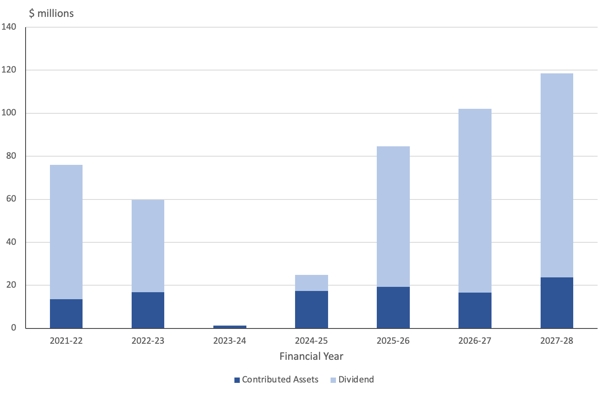
Source: ACT Treasury
Treasury has indicated that in recent years Icon Water profits have been subdued for two main reasons.
Firstly, a substantial investment by Icon to in-source a range of corporate services that had previously been outsourced to the joint venture partner. The associated investment negatively impacted expected net profit after tax in 2023-24 and forecast profit in 2023-24 but is projected to increase net profit after tax from 2025-26. There are also some climate-related impacts over the same period, with demand forecast to return to normal from 2024-25.
Secondly, Treasury has advised that the revenue from Icon’s energy joint venture investment is impacted by timing related to the Large-scale feed-in tariff scheme. Treasury has advised that there were significant over recoveries through the scheme in 2022-23, which, in line with the agreed scheme mechanisms, were utilised in 2023-24 and 2024-25 year to subsidise the customer receipts. The lower accounting revenue from this has resulted in lower dividends in those respective years, with normal returns expected from 2025-26.
While dividends expected from the Suburban Land Agency and City Renewal Authority are growing rapidly over the Budget and forward years, they are lower in 2023-24 to 2025-26 than forecast last year but are forecast to be higher in 2026-27 and relatively high again in 2027-28. Treasury has advised that forecast growth in the dividend in the forward years reflects projected increases in the supply of developable land to increase the stock of housing relative to forecast population growth.

4.5 Contributed assets
The Budget forecasts revenue from contributed assets of $173.3 million in 2024-25, an increase of $20.1 million from the 2023-24 Estimated Outcome.
There have been significant changes in the revenue estimates from the 2023-24 Budget. Gains from contributed assets other than Large-scale Generation Certificates increase significantly in 2025-26 and steadily decrease across 2026-27 and 2027-28. Gains from Large-scale Generation Certificates, are forecast to taper off over the forward years.

5. Expenses
Forecast expenses for 2024-25 of $9.0 billion are $438.6 million or 5.1 percent higher than the expected 2023-24 outcome.
Expenses are forecast to grow over the Budget and forward estimates period by 14.2 percent on the estimated outcome for 2023-24, an annual growth rate of 3.4 percent, but are still expected to fall as a proportion of GSP over the Budget and forward estimates period.
Growth in expenses over the Budget and forward estimates has been driven by new initiatives and technical adjustments to parameters, partly offset by savings measures.
Interest expenses show significant growth over the Budget and forward years. Interest expenses are now forecast to reach $514 million in 2024-25 and $832 million in 2027-28. The Budget forecast for interest expenses is $127.2 million higher than the estimated 2023-24 outcome and is forecast to increase by a further $318.3 million over the Budget and forward years.
High interest payments divert resources that could otherwise be directed to improved services and will constrain future budget flexibility.

5.1 Overview
Forecast expenses for 2024-25 of $9.0 billion are $438.6 million or 5.1 percent higher than the expected 2023-24 outcome and $415 million or 5.2 percent higher than forecast in last year’s budget.
Table 6 sets out the forecasts for aggregate expenses for the budget and forward years.
Table 6: Budget and forecast expenses
 | 2023-24  Est. Outcome | 2024-25  Budget | 2025-26  Estimate | 2026-27  Estimate | 2027-28  Estimate
 | $m | $m | $m | $m | $m
Expenses | 8,562.2 | 9000.8 | 9,137.9 | 9,445.9 | 9,776.1
Source: ACT Budget 2024, Table 3.1.1
The forecasts show growth over the period on the estimated outcome for 2023-24 of 14.2 percent, or an annual growth rate of 3.4 percent. This is higher than the rate of growth forecast in last year’s Budget and twice the rate of growth forecast in 2022.
Expenses are forecast to decline over the Budget and forward years as a proportion of GSP (ACT Budget 2024, p.195). However, the expense forecasts would still represent a higher proportion of GSP in each of the forward years than forecast in the 2022 and 2023 Budgets (ACT Budget 2022 and ACT Budget 2023, p. 216). Forecasts of a declining ratio of expenses to GSP that are subsequently revised upwards have been a feature of recent Budgets, as shown in Figure 19 below.
Figure 19: Expense forecasts as a proportion of GSP – 2019-20 to 2024-25 Budgets
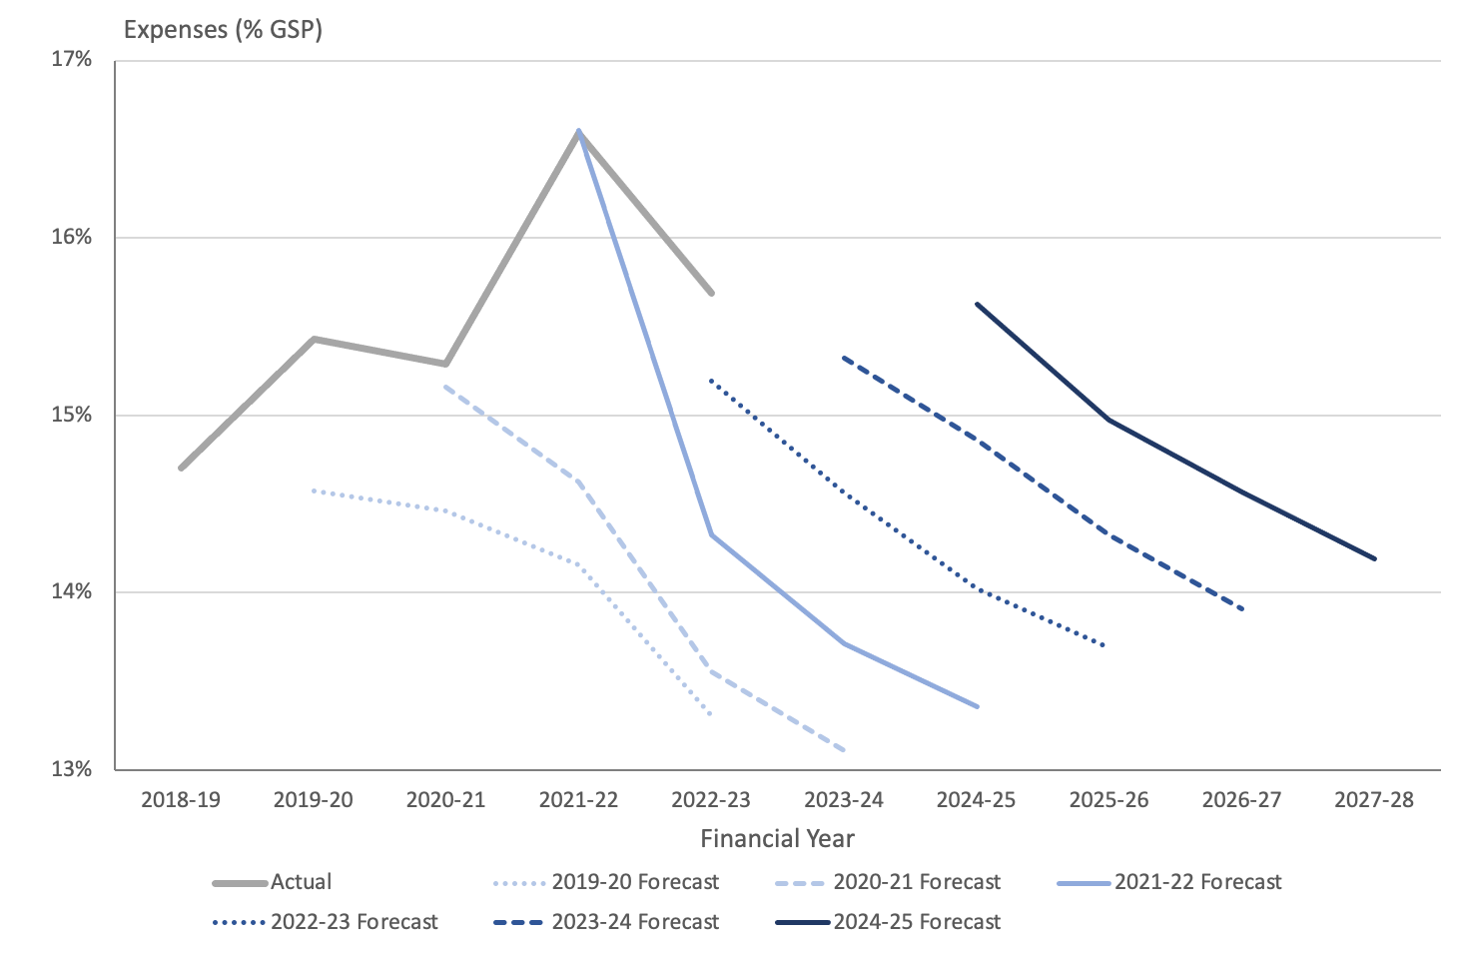
Source: ACT Budget Papers
The chart shows that since 2019-20, the ACT Government has consistently forecast falls in expenses as a proportion of GSP only to revise those estimates upwards in subsequent Budgets.
While forecasts of GSP can be influenced by many factors that might influence these ratios, forward estimates for expenses show a similar pattern when expressed in simple dollar terms. Figure 20 below shows forecasts of expenses since the 2019-20 Budget. In each year, the ACT Budget has presented relatively modest forecasts for expenses that have been revised upwards in each successive set of Budget forecasts.
Figure 20: Expense forecasts – 2019-20 to 2024-25 Budgets
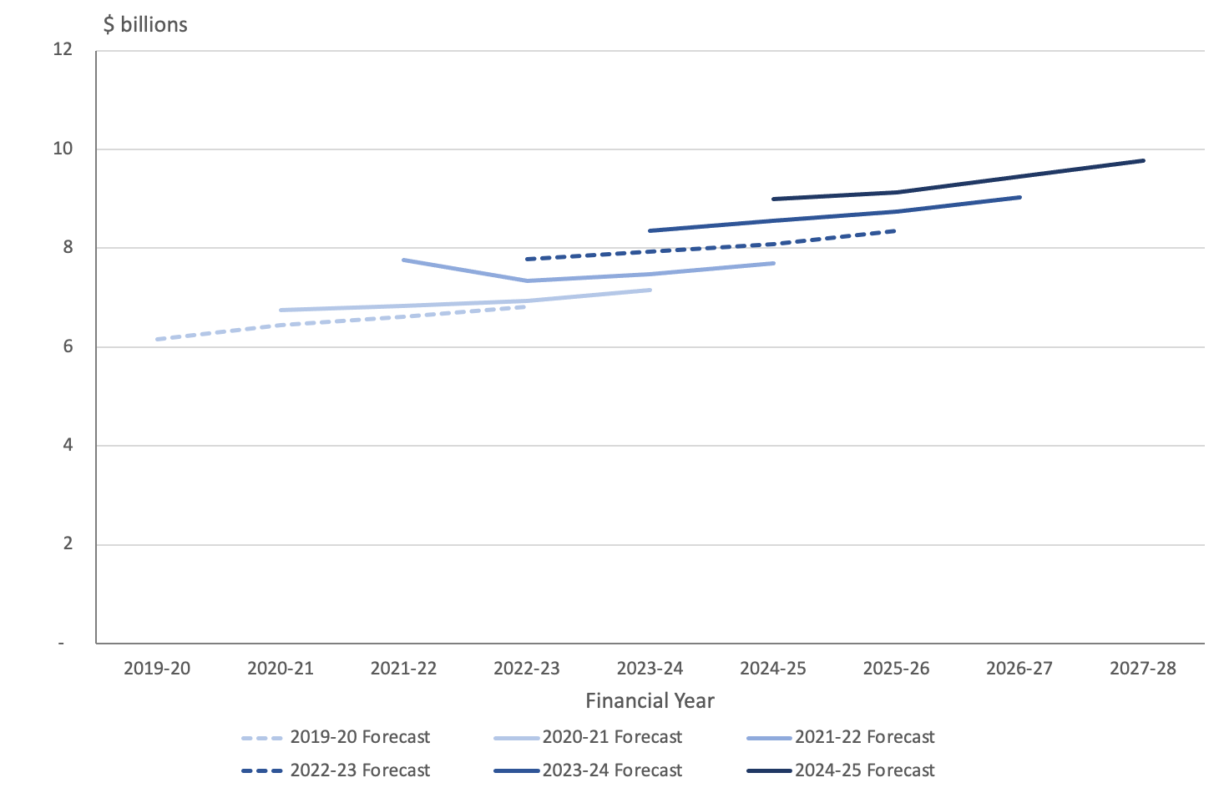
Sources: ACT Budget Papers
Based on this experience, the estimates for expenses in the forward years might be expected to be higher in future years than forecast in the current Budget, both in absolute terms and as a proportion of GSP.

5.2 Reasons for growth
The increase in the forecast level of expenses relative to the last Budget is largely due to new initiatives as set out in the Wellbeing statement, increases in the superannuation liability expense, insurance and interest expenses, and other technical adjustments previously announced in the 2023-24 Budget Review (2024 Budget, Table 3.1.3).
Growth in forecast expenses since the 2023-24 Budget Review is almost entirely due to new policy decisions announced in this Budget.
The major contributions to the growth in expenses across the forward estimates period are in general public services and education. Additional comment on growth in expenses by function is provided in section 5.3 below.
New initiatives announced in the Wellbeing statement reflect the Government’s stated priorities including housing, health, education, community supports and social inclusion.
Significant new expense initiatives in 2024-25 and beyond include:
- Boosting health service funding, $100.9 million over four years
- Digital health strategy, $78.4 million over four years
- Expanding paediatric services, $24.9 million over years
- Support for young people leaving the out of home care system, $10.0 million over four years
- Speeding and seat belt detection, $8.6 million over four years
- Next steps for kids, $8.0 million over four years
- Investing in frontline domestic and family violence services, $7.4 million over four years.
The expense components of housing measures in the Budget include:
- Improving building certification services, $2.9 million over four years
- Additional funding for homelessness services and programs, $2.5 million over four years
- Support for affordable home purchase scheme participants, $0.8 million over four years
- Funding for activities to support land release and development, $14 million over four years, fully offset
Many of the new initiatives, and many of the housing initiatives, have capital components. In addition, some housing initiatives announced in the Budget are outside the General Government sector. New capital investments in the Budget are discussed in sections 6 and 7 below.
Additional expense measures announced in the Wellbeing statement have been partly offset by savings measures. Expense offsets and savings in the Wellbeing statement total around $824 million over four years. These include $376 million offsets within the Health Funding Envelope and $354 million other expense offsets. The largest single savings measure involves whole of government savings of $81 million over four years. The Government has indicated that the savings will be achieved by agency heads but must have no impact on frontline services and explicitly excludes employee expenses, staff development and recruitment. This will be a significant challenge given that employee expenses alone account for almost half of total expenses.

5.3 Expenses by function
The Budget Papers include a presentation of expenses by the functions through which governments seek to achieve their objectives. This classification is widely employed in international financial reporting systems and allows trends in government outlays on functions or purposes to be compared between jurisdictions and over time.
In the ACT, General Government expenses are dominated by spending on health, education and general public services. Together, these functions account for around 70 percent of all government expenses. This is close to the level in last year’s Budget and is consistent with traditional patterns of spending in the ACT.
Figure 21: Expenses by function – 2023-24 (est.) to 2027-28
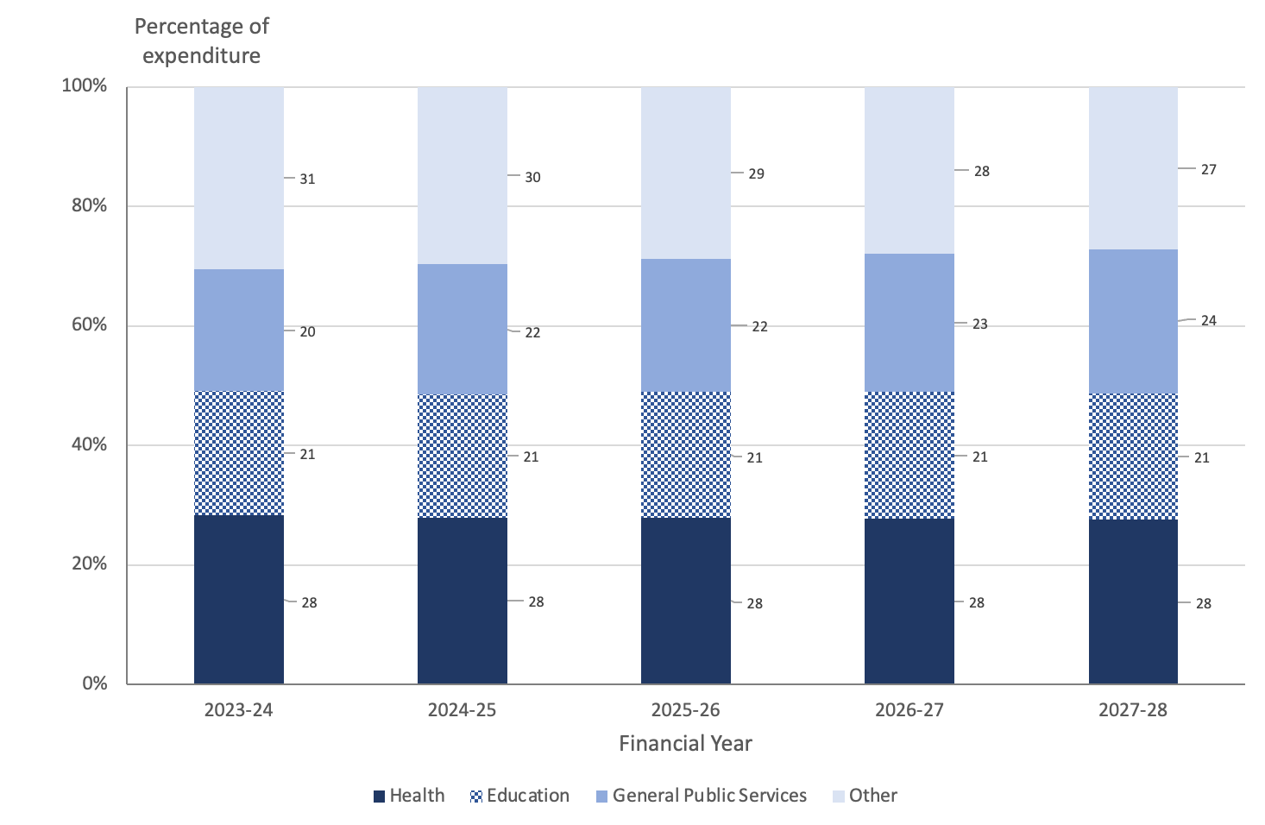
Source: ACT Budget Papers
The most significant areas of growth across the Budget and forward estimates period include general public services and education. Growth in the education function over the Budget and forward estimates is at about the level to be expected from growth in wages and prices. General public services have grown at a faster rate, with an annual average growth rate of 7.9 percent.
No explanation is provided for growth in general public services in the Budget Outlook. However, Treasury officials have advised that this category has increased between the 2023-24 and 2024-25 Budgets due to refinements in the allocation of administrative expenses for the Chief Minister, Treasury and Economic Development Directorate, particularly in relation to general personnel services and general public services. The increase is also attributed to higher interest expenses, which are reflected in the public debt transactions sub category. Further comment on the growth in interest expenses is provided in section 5.4 of this report.
Housing and community amenities are forecast to grow by a relatively modest 3.3 percent in 2024-25 over the estimated 2023-24 outcome, and then to fall by almost 12 percent to 2027-28. This is a surprising result in a priority area for Government.
However, it should be noted that some of the Government’s additional investments in public housing are being made through the Public Trading Enterprises sector, which is not included in General Government sector expense data. ACT Treasury has also drawn attention to the fact that some of the housing assistance announced in the Budget is reported in the social protection sub-function at p.287 of the Budget Outlook. Housing funding in that category is forecast to increase by $10 million in 2024-25 over the estimated outcome for 2023-24 but falls away over the forward estimates.
Further comment on housing assistance in the Budget is provided in section 11 below.
Forecasts for the environmental protection function are relatively stable across the Budget and forward years, but much higher in the out-years than forecast in last year’s Budget. At that time the surrender of Large-scale Generation Certificates (LGCs) was expected to be lower across the forward estimates period due to reducing forward prices for LGCs (ACT Government 2023 p.214 and p.357). No explanation for the change in the funding profile is provided in the Budget but Pegasus understands from ACT Treasury that the difference largely reflects increased funding for household waste collection, including the release of provisioned funding for new service contracts.

5.4 Expenses by economic type
Expenses can also be described in terms of the application or purpose of the payment.
Expenses by type for the ACT Government are dominated by salaries, superannuation and other employee related expenses, representing almost half of total expenses, as shown in Figure 22 below.
Figure 22: Expenses by economic type – 2023-24 (est.) to 2027-28
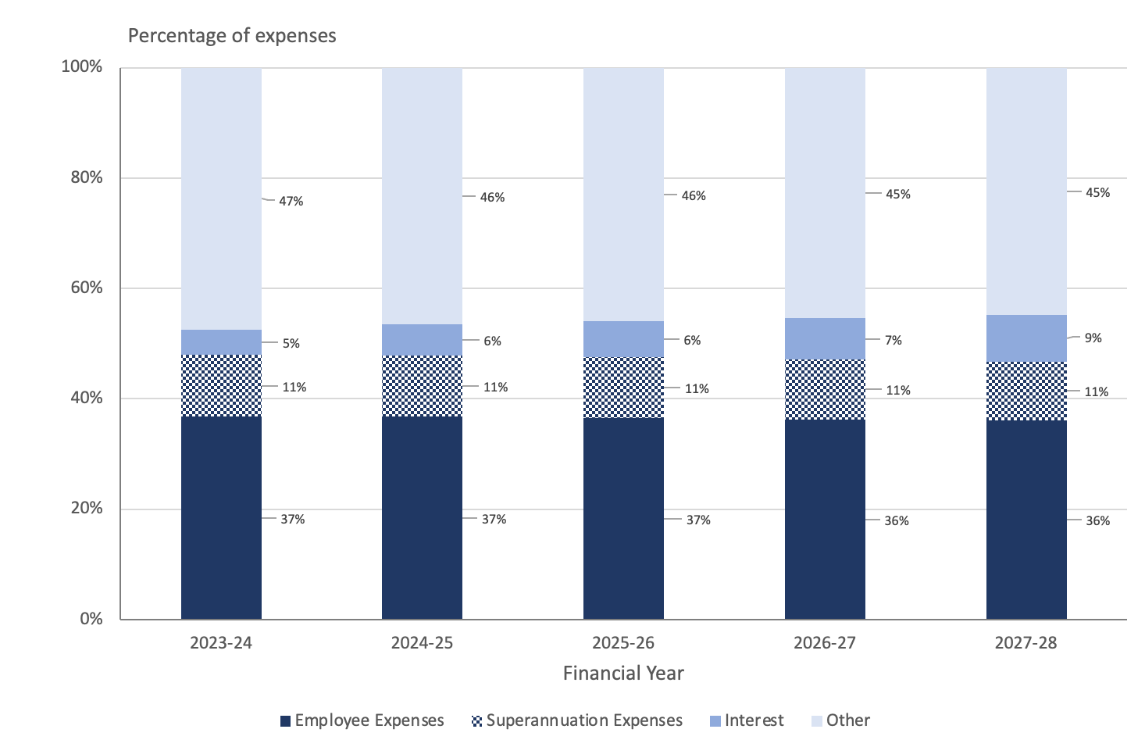
Source: ACT Government (2024).
Employee expenses are forecast to grow by 5.2 percent in 2024-25 over the expected outcome for 2023-24 and by around 2.9 percent a year over the Budget and forward years relative to the 2023-24 outcome. This represents a lower rate of year-on-year growth compared with last year and a return to rates of growth closer to those forecast in 2022.
Growth in forecasts for this item in 2023-24 were higher than in previous years partly due to the acquisition of Calvary Hospital (which was offset by reductions in Grants and purchased services) and the impact of Employee Bargaining outcomes in 2023-24. Those factors have been incorporated into the Budget and forward estimates. It is not possible to identify from the Budget Papers whether there are any other effects on expenses into the forward years arising from the acquisition of Calvary. However, officials have indicated to us that there are no significant impacts on expenses from the takeover beyond those identified in last year’s Budget. A discussion of issues associated with outstanding negotiations for compensation are provided on p.348 of the Statement of Risks.
Interest expenses show significant growth over the Budget and forward years. Interest expenses include interest on government borrowings and finance charges on leases and public private partnerships (Service Concessions). The Budget forecast for interest expenses is $127.2 million higher than the estimated 2023-24 outcome and is forecast to increase by a further $318.3 million over the Budget and forward years. This represents annual average growth over the Budget and forward years of 21.1 percent.
The Budget Outlook states on p.198 that the increase in interest expenses in the 2024-25 Budget over the 2023-24 estimated outcome is mainly due to the impact of higher interest rates.
The interest rate assumption in this year’s Budget is higher than last year’s, but this only accounts for part of the increase in interest expense. A number of factors have contributed to the overall increase in interest expenses: higher interest rate assumptions, growth in the volume of debt and changes over time in the borrowing profile. The ACT Treasury has also indicated that market conditions, including monetary policy settings and investor sentiment, can also impact on borrowing costs. The recent downgrade of the Territory’s credit rating could also be expected to increase the Government’s cost of borrowing. A credit rating is a measure of how risky a borrower is in terms of its expected willingness and capacity to repay any debt on time. A lower credit rating may increase the cost of borrowing and reduce an entities’ access to some financial products.
The Territory’s interest expense has grown as a share of GSP over the past decade, in line with growth in the Territory’s debt and other liabilities. Figure 23 below shows that interest expenses have more than doubled as a share of GSP over this period, with much of this growth occurring since 2020-21.
By 2027-28, interest payments are forecast to total reach $832.3 million, or 8.5 percent of total expenses, and more than 1.25 percent of GSP. In the last year in which the ACT Budget was in surplus, the interest expense was $185 million while in 2010-11, the interest expense was $86 million.
Figure 23: Interest expenses as a proportion of Gross State Product, 2011-12 (actual) to 2027-28 (forecast)
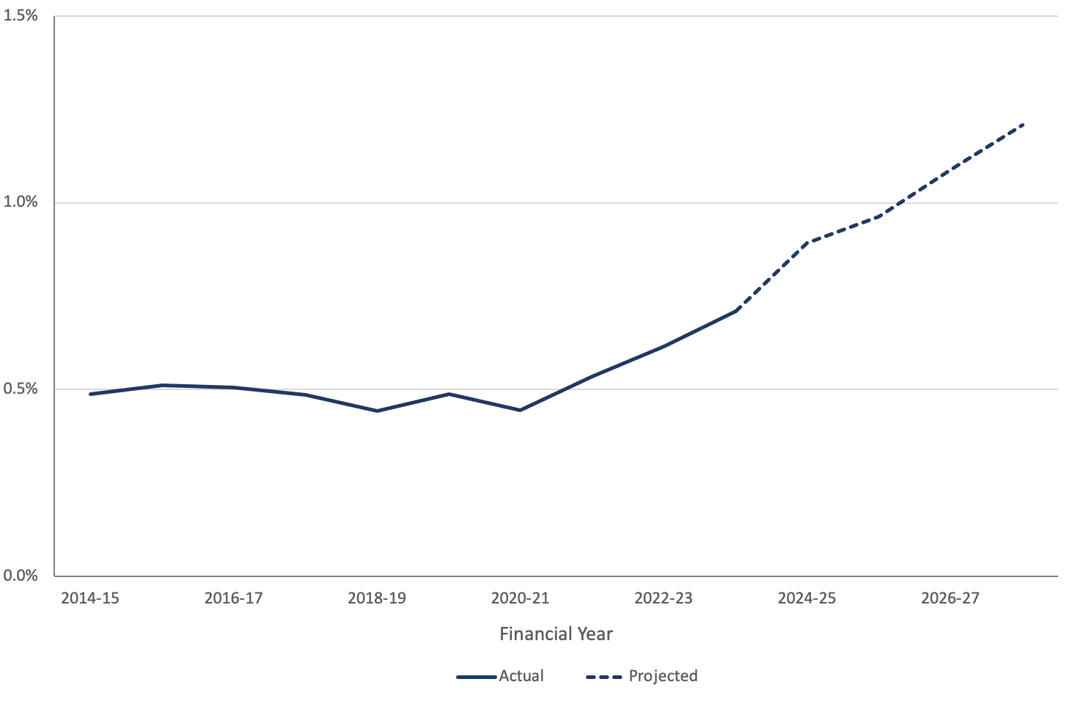
Source: ACT Budget Papers
The 2024 Budget Outlook at Table J.4 estimates that the increase or decrease in forecast borrowing interest expenses if the actual interest rate on projected new fixed rate borrowings and the interest cost on inflation linked bonds is 0.25 percentage point higher or lower than the budget interest rate assumption would add some $5 million to the deficit in 2024-25 and around $21 million in 2027-28. ACT Treasury has pointed out that while this provides an indication of the impact of movements in interest rates on interest expense, all other things equal, the actual interest expense is also impacted by the timing of borrowings.
The presentation of expenses by economic type illustrates the extent of the challenges in shifting the budget aggregates. Many of the ACT Government’s expenses are “locked in” to the extent that they are made up of payments which are not discretionary. Employee related expenses represent approximately half of total expenses. These costs are difficult to move downwards in the short to medium-term. Depreciation and amortisation expenses related to capital investment decisions represent another 6.7 percent of the total. Interest expenses on the Territory’s borrowings are expected to rise to 8.5 percent of expenses by 2027-28. These payments are an unavoidable first call for government spending.
Other categories of expenditure are discretionary in a technical sense but as they are more directly related to the level of services provided to the community, there are practical constraints on the extent to which payments can be reduced in the short to medium term. The amount of lock-in limits the scope for governments to reduce the level of public expenditure and improve the broader fiscal position in the short to medium term.

6. New initiatives and wellbeing
The Budget includes 166 new policy initiatives that involve a mix of capital, expense, and revenue. The new policy initiatives collectively represent $414 million of capital, $615 million expenses, and $224 million of revenue, in net terms, over four years.
New policy initiatives announced reported in the Budget are presented within a Wellbeing Framework. Significant new investments impact on most Wellbeing domains, with the Health, Housing, Living Standards and Connectivity domains receiving the largest shares of new funding. Most of the measures will however impact on more than one domain.
Significant savings that offset much of the cost of the new initiatives have been identified in the Budget. Against new expenses totalling $1.4 billion over the four years, some $824 million (excluding revenue) has been identified as offsets or savings. Against new capital projects totalling $787 million, offsets of $372 million have been identified.
The new wellbeing initiatives are presented using counting conventions that are different from other parts of the Budget. Clarity for readers, and Budget transparency, would be improved if these initiatives were presented using conventions consistent with other parts of the Budget Outlook.

6.1 Introduction
The 2024-25 Budget presents new expense, revenue and capital initiatives in terms of domains within the Government’s Wellbeing Framework.
The Wellbeing Framework seeks to supplement macroeconomic measures traditionally used in budgets with information based on broader measures of the quality of life, identified through community consultation.
The ACT is amongst a small number of jurisdictions that have sought to integrate Wellbeing Frameworks into their processes of policy development and budget decision-making. Pegasus provided more extensive background on the purpose and application of Wellbeing frameworks in its report on the 2023-24 Budget.
Information on Wellbeing initiatives in the Budget Outlook should be read in conjunction with the Wellbeing Statement, which provides additional information on the ACT approach to Wellbeing and the Wellbeing priority areas for 2024-25.

6.2 Reporting format for new initiatives
The Budget papers present the new policy initiatives in several different formats. All new policy initiatives are described in detail by Directorate or agency and set out in a summary table that shows the net cost of the initiative. Each initiative is attached to a primary wellbeing domain, though most initiatives will have impacts across several domains.
The Budget Outlook also describes the new initiatives across six categories, which broadly map against the wellbeing domains. These are:
- Health and community wellbeing –aligned to the wellbeing domain of Health;
- Education and life-long learning –aligned to the wellbeing domain of Education and life-long learning;
- Housing and home –aligned to the wellbeing domain of Housing and home;
- Community support, social inclusion and safety –aligned to aspects of the wellbeing domains of Social connection, Identity and belonging, Living standards and Safety;
- Environment, climate and transport –aligned to the wellbeing domains of Environment and climate; Access and connectivity; Time; and aspects of the Safety domain; and
- Jobs, sports, arts, culture and entertainment –aligned to the wellbeing domains of Governance and institutions, Economy, and aspects of Social connection, Identity and belonging and Living standards.
In addition, the Government has identified six priority areas where investment will make a particular difference to wellbeing. The identified priorities are:
- Housing
- Physical and mental health
- Women
- Early years
- Cost of living
- Addressing marginalisation and disadvantage.
There is some commonality between these categories. For example, health and housing items would map fairly easily across the reporting formats. However, some other items map across several different categories. It is therefore difficult in some cases to compare across the different reporting formats.
While all the individual initiatives are listed by Directorate and under the primary domain, neither the Budget Outlook nor the Wellbeing statement provide a comprehensive summary table that shows the total investment across the 12 domains, the six categories that approximate domains or against the six priority areas identified by the Government as worthy of investment.
This is a notable gap in transparency. Given the prominence attached to the Wellbeing Framework and the six priority areas for investment in the Budget documentation, it would be natural for a reader of the Budget or the general taxpayer to want to know how much of the Government’s new investment is being directed to each domain. We understand from ACT Treasury that the initiatives are not aggregated by domain because of a concern that many initiatives contribute to more than one domain. Aggregating to a single domain would risk under-stating the overall impact of the measures on each domain while aggregating to multiple domains risks overstating the value of the measures. At the same time, we note that a primary domain is attached to each measure in section 3.2 of the Budget Outlook.

6.3 New initiatives
The Budget includes 166 initiatives that involve a mix of capital, expense, and revenue components. The initiatives collectively represent, in net terms, and additional $414 million of capital, $615 million in expenses, and $224 million of revenue, over four years. In the absence of summary information in the Budget on the total new investment by domain, Pegasus has derived the following table from information provided on the individual measures in section 3.2 of the Budget Outlook. The table is intended to provide an indication of the magnitude of the measures attached to each primary domain. It does not necessarily capture the overall impacts of new initiatives on each domain, as many wellbeing initiatives will contribute to more than one domain. The table seeks to describe the new initiatives in terms of their net impact on the fiscal balance, rather than in terms of the “net cost of services”, as set out in Section 3.2 of the Budget Outlook, as reporting in terms of impact on the fiscal balance is more consistent with general Budget conventions.
Table 7: New capital, expenses and revenue initiatives, Budget and forecast years, by primary domain ($000)
Wellbeing Domain | Type | 2024-25  Estimate  $’000 | 2025-26  Estimate  $’000 | 2026-27  Estimate  $’000 | 2027-28  Estimate  $’000
Access & connectivity | Capital | 32,310 | 175 | 0 | 0
 | Expense | 10,976 | 3,638 | 3,366 | 3,680
 | Revenue | 300 | 150 | 0 | 0
Economy | Capital | 6,792 | 3,018 | -2,405 | 633
 | Expense | 8,821 | 6,015 | 3,755 | 4,009
 | Revenue | 28,070 | 38,109 | 49,343 | 61,296
Education & life-long learning | Capital | -1,177 | 17,290 | 5,131 | 4,900
 | Expense | 10,132 | 902 | 3,247 | 5,118
 | Revenue | 3,442 | 3,842 | 10,190 | 0
Environment and climate | Capital | -345 | -1,630 | -5,415 | 3,000
 | Expense | -16,113 | 3,207 | 765 | 7,871
 | Revenue | 409 | -304 | -983 | -1,092
Governance & institutions | Capital | 420 | 420 | 366 | 0
 | Expense | 2,328 | 8,226 | 7,366 | 1,363
Health | Capital | 29,920 | 11,584 | 23,766 | 48,413
 | Expense | 186,026 | 115,281 | 53,830 | 9,544
 | Revenue | 470 | 320 | 320 | 0
Housing and home | Capital | 6,210 | 9,776 | 21,680 | 21,414
 | Expense | 9,463 | 9,991 | 3,899 | 4,265
 | Revenue | -10,785 | -8,306 | -7,815 | -27,441
Identity and belonging | Capital | 560 | 513 | 0 | 0
 | Expense | 1,074 | 1,243 | 1,258 | 1,133
 | Revenue | 250 | 256 | 0 | 0
Living standards | Expense | 57,468 | 20,152 | 4,205 | 4,414
 | Revenue | 47,766 | 15,961 | 0 | 0
Safety | Capital | 26,871 | 23,204 | 0 | 0
 | Expense | 19,391 | 11,301 | 6,939 | 3,462
 | Revenue | 1,943 | -6,486 | 10,165 | 14,762
Social connection | Capital | 2,033 | 4,020 | 0 | 0
 | Expense | 1,730 | 1,311 | 993 | 880
Note: The primary domains are those attached to each measure in section 3.2 of the Budget Outlook. Totals shown in this table are net figures after offsets have been deducted. This table treats capital, expenses and revenue as separate categories, and presents an increase in capital, expenses or revenue as a positive number, consistent with general budget conventions. Section 3.2 by contrast sometimes presents aggregates of capital and expenses and in the list of measures generally nets revenue or provisions against expenses to produce a “net cost of services”. Totals in this table may vary slightly from aggregate numbers in Section 3.2.
Source: ACT Budget 2024, pp. 91-178.
Table 7 shows significant investments in the Health, Housing, Living Standards and Connectivity domains, which is consistent with the Government’s stated priorities. However, new investments in Identity and belonging and Social connection are relatively modest, even though these domains map fairly closely to some of the six priority areas for investment. The table also shows, for the second year running, a zero investment in the Time domain, though some measures attached to other domains, such as investments in public transport, could be expected to also contribute to this domain.
Major packages of initiatives include:
- Investing in public health care ($240.6 million expenses and $4.5 million capital over four years)
- Improving Canberra’s health infrastructure ($129.8 million, mostly capital, over four years)
- Boosting business and the economy ($14.0 million, $18.2 million capital and $19.9 million revenue over four years).
Other significant new measures include:
- Energy Bill Relief - Extension and Expansion ($64.0 million, funded through $63.7 million revenue from Commonwealth funding, p. 101)
- Ongoing delivery of the Digital Health Strategy ($78.5 million expenses and $3.1 million capital over four years, p.150)
- Payroll Tax Surcharge ($79.2 million over four years, all of which is revenue, p. 107)
- Reducing stamp duty for owner-occupiers ($73.9 million, all of which is revenue forgone, p. 110)
- Land Tax ($58.8 million, of which $53.9 million is revenue, p.106)
- Addressing Private Buildings Cladding ($6.2 million, and $47.5 million capital, all over four years, p.164)
- Investing in Public Housing Repairs and Maintenance ($51.2 million capital over four years, p.154)
- Rates ($40.2 million over four years, all of which is revenue, p.109)
- Delivering Light Rail Stage 2 – Agency Costs ($25.6 million capital and -$1.2 million expenses, over four years, p.166)
- Police, Fire and Emergency Services Levy and the Safer Families Levy ($22.9 million over four years, all of which is revenue, pp.107-108)
Significant savings that offset much of the cost of the new initiatives are identified in the measures descriptions. Against the new expenses totalling $1.5 billion over the four years, some $824 million (excluding revenue) has been identified as offsets or savings. Against new capital projects totalling $787 million, capital offsets of $372 million have been identified.
Further discussion of new capital initiatives is provided in section 7 of this report.
As total offsets and savings by domain are not identified in the Budget, Pegasus has derived Table 8 below showing expense offsets and savings attached to measures associated with each primary domain.

Table 8: New initiatives - Budget and forecast years, expenses, offsets, and savings ($000)
Wellbeing Domain | Type | 2024-25  Estimate  $’000 | 2025-26  Estimate  $’000 | 2026-27  Estimate  $’000 | 2027-28  Estimate  $’000
Access & connectivity | Offset | -16,511 | -16,243 | -15,766 | -15,802
Economy | Offset | -7,390 | -6,011 | -4,941 | -3,564
Education & life-long learning | Offset | -29,907 | -28,933 | -27,783 | -26,193
Environment and climate | Offset | -32,339 | -11,322 | -8,766 | -338
Governance & institutions | Offset | -11,213 | -10,040 | -6,407 | -6,572
 | Savings | -20,290 | -20,117 | -20,599 | -20,961
Health | Offset | -5,530 | -66,785 | -133,527 | -179,723
 | Savings | -171 | -176 | -180 | -185
Housing and home | Offset | -10,172 | -5,424 | -8,893 | -3,873
Identity and belonging | Offset | -511 | -413 | -415 | -417
Living standards | Offset | -240 | 0 | 0 | 0
Safety | Offset | -6,747 | -776 | -749 | -572
Social connection | Offset | -825 | 0 | 0 | 0
Note: The primary domains are those attached to each measure in section 3.2 of the Budget Outlook. This table includes expense offsets and savings. Offsets or savings against provisions or revenue have not been included. Totals in this table may vary slightly from aggregate numbers in Section 3.2.
Source: ACT Budget 2024, pp. 91-178.
Significant offsets and savings have been identified against the Health, Education and Governance and institutions domains. The largest single savings measure relates to a Whole of Government initiative to reduce spending on specified cost centres across a range of agencies and directorates. The measure is intended to have no impact on front line service delivery or employee expenses.
In many other cases where offsets and savings are identified, limited information is provided on how the offsets are to be achieved and their potential impacts on services.

6.4 Reporting the cost of new initiatives
Section 3.2 of the Budget Outlook and the Wellbeing statement employ protocols that are different from other parts of the Budget, which generally follow the Australian System of Government Finance Statistics.
The individual measures set out on pp 91-178 of the Budget Outlook are presented in terms of the “net cost of services”, which is intended to represent the overall cost to the Government of providing the service. The net cost of services is calculated by adding all the expense, expense provisions, revenue foregone and depreciation less any expense offsets, savings or revenue. This is different from the normal presentation of information in Australian Budgets, which treat revenue and expenses as separate items, and which generally focus on the impact on the fiscal balance rather than on the “net cost of services”. To the extent that a provision has already been included in the forward estimates, contemporary Budget and accounting practice would not normally count that provision again as a savings against a new measure.
By contrast, the headline figures provided in section 3.2 showing new spending against the six categories that broadly align to the wellbeing domains are gross estimates over four years, including a mix of capital, expense and revenue but excluding offsets and savings. The headline numbers represent the gross value of the measures committed in the Budget, but do not reflect the total net cost of the initiatives as set out in descriptions of the individual measures or the net impact on the Budget as described in other sections of the Budget papers.
The various presentations of the wellbeing initiatives are useful in understanding the frameworks which have informed Government decision-making, but the differences between these reporting frameworks, and the different counting conventions employed, make it difficult to assess the relative investment in each category and therefore the extent to which the Government has achieved its stated priorities.
Because different protocols are employed in section 3.2 from the rest of the Budget Outlook, there is no one-to-one correspondence between the presentation of the new wellbeing initiatives and the expense, revenue and capital figures reported elsewhere in the Budget Outlook.
Budget transparency, and clarity for readers, would be improved if consistent counting conventions were used throughout the Budget documents.

7. Infrastructure and capital
The Budget includes funding for substantial major projects, infrastructure and capital works program across the Budget and forward years through the Infrastructure Investment Program, and the overarching ACT Infrastructure Plan. The program is over five years out to 2028-29. The ACT government intends to invest $1.4 billion in 2024-25 and approximately $8.1 billion out to 2028-29.
Key projects include hospitals, health centres, schools, public housing, urban renewal, transport and roads, community and services, and climate action.

7.1 Overview
The Budget Papers indicate that the ACT Government (2024, p. 247) intends to invest $8.1 billion in infrastructure in the ACT over the next five years to 2028-29. The program is split between the General Government Sector (GGS) and the Public Trading Enterprise Sector (PTE).
Table 9 below summarises the infrastructure, capital works and investment program.
Table 9: Summary of Infrastructure Investment Program – 2024-25 to 2028-29
 | 2024-Allocation  $’000 | 2025-26 Allocation  $’000 | 2026-27 Allocation  $’000 | 2027-28 Allocation  $’000 | 2028-29 Allocation  $’000
New Capital Works | 36,138 | 15,596 | 3,035 | 2,307 | 0
Asset Renewal Program | 111,415 | 117,476 | 119,205 | 123,971 | 128,927
Works-in-progress | 1,233,101 | 997,122 | 747,469 | 861,009 | 50,628
Central Capital Provisions | 48,239 | 253,157 | 412,674 | 575,143 | 573,648
Total GGS Capital Works Program (including provisions) | 1,428,893 | 1,383,351 | 1,282,383 | 1,562,430 | 717,203
Capital Delivery Provision | -250,000 | -125,000 | 0 | 125,000 | 250,000
Total Capital Program Forecasts (including provisions) | 1,178,893 | 1,258,351 | 1,282,383 | 1,687,430 | 967,203
Public Trading Enterprises | 255,278 | 426,344 | 408,265 | 396,994 | 262,811
Total GGS and PTE Capital Program Forecasts (including provisions) | 1,434,171 | 1,684,695 | 1,690,648 | 2,084,424 | 1,230,014
Source: ACT Budget, Table 3.7.1
The Committee should note the Asset Renewal Program replaces the previous Better Infrastructure Fund.
Under the Infrastructure Investment Program, the Government has committed to over:
- $1.0 billion on health
- $1.1 billion on education and skills
- $2.0 billion on transport
- $540 million for entertainment, arts and sport
- $570 million for city services and community facilities
- $520 million for housing infrastructure, and
- $225 million for climate action and environment infrastructure.
7.2 Capital Works Program – General Government
The Capital Works Program forms the largest component of the Infrastructure Investment Program, with funding of $1.4 billion in 2024-25 and $6.4 billion over the five years to 2028-29. This includes:
- $36 million in 2024-25 and $57 billion over five years for new capital works
- $1.2 billion in 2024-25 and $3.9 billion over five years for works-in-progress
- $111.4 million in 2024-25 and $601 million over five years for the Asset Renewal Program, and
- $1.8 billion over five years for Central Capital Provisions.
These allocations include approximately $2.1 billion for health, education and skills infrastructure, $2 billion for transport and road investments, approximately $540 million for entertainment, arts and sport, $520 million for housing infrastructure, including social housing, $570 million for city services and community facilities, and $225 million for climate action.
The Capital Delivery Provision has a net zero impact over the five years to 2028-29.
This Budget reflects a total funding envelope of $6.4 billion over the five years, a slight reduction from the $6.5 billion forecast in 2023-24. The forecast capital spend increases over the Budget and forward years and then drops significantly in 2028-29. On the experience of previous years, the forecast spending in 2028-29 could be expected to be revised upwards in the future.
Trends in capital works program forecasts in the last five ACT Budgets are outlined in Figure 24 below.
Figure 24: Capital Works Program Forecasts
Source: ACT Budget Papers
Infrastructure Provisions increase substantially across the four forward years with a total funding envelope of $1.8 billion (Central Capital Provisions). The Central Capital Provisions sets aside funding for significant capital works projects for which budgets are yet to be settled, or which are commercially sensitive, including unallocated funding for the Asset Renewal Program. The Capital Delivery Provision re-profiles approximately 30 percent of the 2023-24 and approximately 28 percent of the 2024-25 Capital Works Program to the last three out-years.
The key elements of the General Government Capital Works Program for 2024-25 are (ACT Government, 2024, Chapter 3.2):
Health
The Budget provides over $1 billion across five years, including $920 million in 2024-25 ($700 million in public health care, $78 million in better community care and $131 million for health infrastructure).
- Continuing the transition of the new Northside Hospital to Canberra Health Services, refurbishments at Northside Hospital and a second endoscopy suite at Northside Hospital
- Health centres for Garran and Casey
- Nursery and neonatal intensive care for critically unwell children
- Palliative and cognitive impaired care
- Improve digital health services
- Expand mental health services, including the Step up, Step down home program
- Commencing the second phase of the Canberra Hospital master plan.
Education
The Budget provides approximately $1.8 billion across five years for new education and skills initiatives, and infrastructure.
- Public education and early childhood, $37 million
- New schools and refurbishments, $22 million
- Skills development, $41.0 million.
Housing
- Social housing, $108 million (in gross terms; that is, before offsets) over four years
- Affordable rental and home ownership through the Affordable Housing Project Fund, $20 million
- Housing choice and quality and land release, $80 million over four years.
In respect to social housing the Committee should note the ACT is to receive $157.4 million from the Australian Government over five years as part of its National Agreement on Social Housing and Homelessness arrangements.
Emergency Services
- Planning for a new emergency services site in Casey and improvements to police stations, $4.5 million.
Transport, Environment and Climate
Investments in infrastructure are approximately $500 million in 2024-25, including $71 million over four years for new transport initiatives, and $2.2 billion over five years.
- Sustainable Household Scheme, Vulnerable Household Energy Support Scheme and the Integrated Energy Plan, $190 million
- Protection of Canberra’s environment, $83 million
- 90 battery electric buses
- Duplication of Athllon drive
- Monaro Highway upgrade continuation
- Molonglo river bridge
- John Gorton drive extension
- Duplication of Pialligo and Yass roads
- Light Rail to Woden and William Hovell Drive upgrades
- Progress toward the Big Canberra Battery.
The Committee should note that some of these projects carry over from previous budgets.
Communities
For 2024-25 the Budget provides $47 million for community infrastructure.
- Upgrade of Phillip district enclosed oval
- Expansion of the Belconnen basketball stadium
- Funding for GIO stadium, Manuka oval and other district sports fields
- New Woden community centre.

7.3 Asset Renewal Program
The Asset Renewal Program provides Government agencies with an annual funding pool for works that extend the useful life or improve service delivery capacity of infrastructure assets. Pegasus notes this program replaces the Better Infrastructure Fund. For 2024-25, the Budget provides $111.4 million for projects. In summary, key allocations include (ACT Government, 2024, Appendix B, pp 295-299):
- Health, including remediation works and Canberra Health Services, $9.78 million
- Property upgrades and improved venues, $4.3 million
- CIT, $3.6 million
- Cultural, $707 thousand
- Community Service, $614 thousand
- Education, $32.6 million
- Justice, $6.9 million
- Environment, $1.7 million
- Major Projects, property upgrades, $7.4 million
- Transport, $42.3 million.

7.4 Works-In-Progress
A total of $1.2 billion is allocated for 2024-25 and a total of $3.9 billion across the five years. In summary, key components for 2024-25 include (ACT Government, 2024, Appendix C, pp 301 - 314):
- Health, including ACT Health and Canberra Health, $114.9 million
- Chief Minister, Treasury and Economic Development, $23.5 million
- City Renewal, $7.8 million
- Education, $180.7 million
- Environment, $16 million
- Housing, $120.7 million
- Justice, $42.7 million
- Major Projects Canberra, $320.2 million
- Transport, $306.5 million.
In summary, key projects include Light Rail phases 2A and 2B, CIT Woden Campus and Interchange, Canberra Hospital expansion, Northside hospital development, Healthcare services, Public transport ticketing system upgrade, Monaro highway upgrade, Digitising Government Services, school upgrades, Woden bus depot, and the Canberra Theatre Centre redevelopment.

7.5 Major Projects
Major Projects Canberra is responsible for delivering major infrastructure projects and to support other Government agencies deliver infrastructure work programs. For 2024-25 the total Infrastructure investment is not fully transparent, except for the Asset Renewal Program, $7.4 million, and Work-In-Progress of $320 million. Over 2024-25 and the out-years, the key projects include those indicated above.
Other major projects include: upgrades to public buildings, Canberra Theatre expansion, Light Rail Stages 2A and 2B, CIT Woden Campus and bus interchange, Canberra hospital expansion and design of the new Northside Hospital, better transport services between Belconnen and Gungahlin, and electrification of Government gas assets.
It appears that many of these projects are re-phased from previous Budgets.

7.6 Capital Works Reserve
In 2019 the ACT Government amended the Financial Management Act 1996 to introduce a new mechanism, the Capital Works Reserve, to allow agencies with multi-year allocations to manage their capital program by advancing funds during the financial year should their capital appropriation be exceeded. Funds drawn from the Reserve are deducted from the forward estimates for the project(s) concerned in later years. The 2024-25 Budget has allocated $285 million to the Reserve, with unused funds lapsing at the end of the financial year. The Treasurer is required to provide the Legislative Assembly with a reconciliation of any amounts approved for payment from the Reserve (under section 26 of the Financial Management Act 1996).
The Budget papers indicate the Reserve was not accessed in 2023-24.

7.7 Capital Works Program – Public Trading Enterprises
The Public Trading Enterprises (PTEs) capital works program is outside the Budget as each entity funds their projects from own-sourced revenue and borrowings. New works are projected in 2024-25 totalling $255 million and a total of $1.7 billion across the five years to 2028-29. The programs include:
- Cemeteries and Crematoria Authority, $0.4 million in 2024-25 and $6.6 million over five years
- City Renewal Authority, $9.3 million in 2024-25 and $13.9 million over five years
- Housing ACT, $24.2 million in 2024-25 and $124 million over five years
- Icon Water, $89 million in 2024-25 and $969 million over five years
- Suburban Land Agency, $132 million in 2024-25 and $635.7 million over five years.

8. Assets and Liabilities
Net debt and net financial liabilities are increasing across the Budget and forward years in absolute terms and as a proportion of GSP. Net worth is falling in absolute terms, with a marked decline across the forward years when measured as a proportion of GSP.
The ACT has moved from the position of being a net creditor at the beginning of the last decade to having a substantial and increasing debt and interest burden in the Budget and forward years.
The Government continues to make progress in building a pool of assets to cover its superannuation liability and on present trends could be expected to have fully funded the liability by the mid-2030s.

8.1 Overview
Net debt and net financial liabilities are forecast to rise over the Budget and forward estimates while net worth is forecast to decline over the same period. Net debt and net financial liabilities have been increasing over the past two decades. Net worth had been increasing until 2023-24 but is now forecast to decline over the Budget and forward estimates.

8.2 Net debt
Net debt represents the sum of deposits held, advances received and borrowings less the sum of cash and deposits, advances paid, investments, loans and placements but excludes super liabilities.
The ACT’s net debt in 2024-25 is higher in both absolute terms and relative to GSP than had been forecast in the 2023-24 Budget, and there is an upward trend over the forward estimates. In absolute terms, net debt in 2027-28 is forecast to be 70 percent higher than the estimated debt in 2023-24 and almost 14 times higher than in 2014-15.
The ratio of net debt to GSP is a broad indicator of a jurisdiction’s ability to meet its debt obligations and its medium-term financial sustainability. The Budget Papers forecast continued growth in this indicator, in line with the trend over the past decade, from an estimated 13.5 percent at the end of June 2024 to 18.1 percent by 30 June 2028.
Figure 25 illustrates the growth in net debt since 2010-11 as a percentage of the Gross State Product (GSP).
Figure 25: Net debt as a proportion of Gross State Product
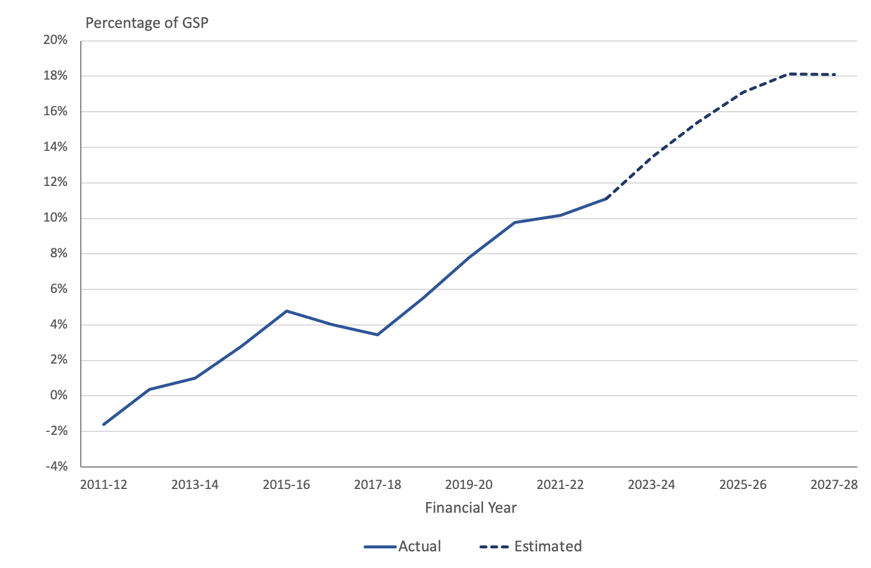Sources: Budget Outlook, Table F.9, ABS Catalogue Number 5220.0, Table 1
Note: From 2019-20, net debt includes the impact of accounting changes in relation to the treatment of leases. The ACT Government has indicated that for this reason net debt from 2019-20 is not directrly comparable to prior years.
The large increase in net debt to GSP in 2015-16 was related to the loan provided by the Commonwealth to support the Asbestos Eradication Scheme and a provision for the Light Rail Stage 1 project. The subsequent reduction in net debt reflected the effect of decisions to procure the Light Rail through a Service Concession arrangement, which removed the requirement to debt fund the capital cost of the project (ACT Government, 2015, p. 251; ACT Government, 2016, p. 288).
Growth in debt over the period has been driven by persistent Government deficits and a large infrastructure program. The ACT has gone from being a net creditor at the beginning of the last decade to having a substantial at the end of the forward estimates period.
A short-term increase in net debt can be a sensible response to adverse economic shocks, such as the COVID19 pandemic, and can be justified when investing in future wealth generating assets. However, continuing high levels of debt are undesirable as they impose debt servicing costs and can reduce future budget flexibility.

8.3 Net financial liabilities
Net financial liabilities is a broader measure than net debt as it includes significant liabilities other than borrowings, such as unfunded superannuation and long service leave entitlements, but excludes the value of equity held by the General Government sector in public corporations. Changes in net financial liabilities are therefore influenced by variations in the net debt figures discussed above.
The Territory’s net financial liabilities have increased since the 2023-24 Budget and are projected to continue to grow into the out-years. Net financial liabilities grew from $12.3 billion to $13.1 billion over the 2023-24 financial year, primarily due to an increase in the superannuation liability, and are estimated to reach $17.0 billion by 30 June 2028.
Relative to GSP, net financial liabilities are forecast to rise gradually over the period to 2026-27, and then decline slightly in the final out-year. The Budget Papers suggest that growth forecast in the ratio of net financial liabilities to GSP over the forward years is related to the increase in the unfunded superannuation liability. This is discussed further in the section below dealing with superannuation.
Figure 26 below illustrates the growth in net financial liabilities as a proportion of GSP since 2011-12.
Figure 26: Net financial liabilities as a proportion of Gross State Product
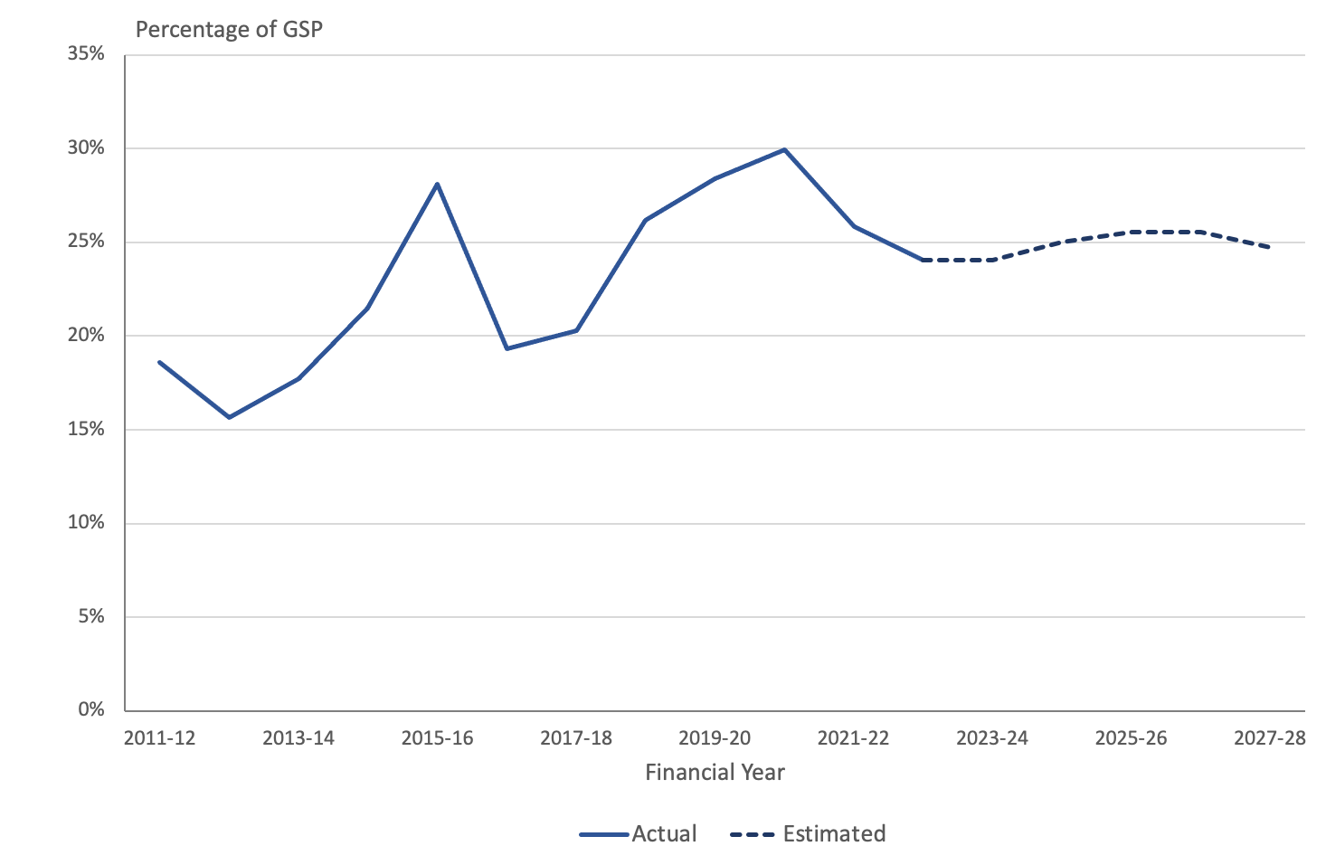
Sources: Budget Outlook, Table F.9, ABS (2023).
Figure 26 shows that while there has been some fluctuation in the ratio of net financial liabilities to GSP over time, the overall trend over the last decade has been upwards.
A spike in 2015-16 was related to a higher forecast superannuation liability and capital provisions to account for some capital projects that were subsequently procured through Service Concession arrangements (ACT Government, 2016, p. 289). A second peak over 2019 to 2021 largely reflected the lower discount rate used in valuing the superannuation liability, higher borrowings and changes in the accounting treatment of operating leases. The move to valuing the superannuation liability using the long-term discount rate of 5 percent per annum in the 2022-23 Budget led to a fall in net financial liabilities by 30 June 2022, while higher growth in GSP in 2022-23 resulted in a further fall. This downward trend is not projected to continue. Continued growth in the ratio of net financial liabilities to GSP is not desirable in terms of the sustainability of the ACT Government’s debt. The ACT Government has in the past argued that its borrowings should be looked at in the context of a growing economy and budget, rather than as absolute figures in isolation. However, as Figure 26 shows, growth in GSP is not projected to be sufficient to match the rise in net financial liabilities.

8.4 Net worth
Net worth is an economic measure of wealth that reflects the value of all financial and non-financial assets (such as land, plant and equipment) less liabilities, including superannuation liabilities.
This indicator is often regarded as the best measure of the sustainability and inter-generational equity of a jurisdiction’s fiscal position.
The ACT Government’s net worth is positive. The changes since 2011-12 mirror the experience for net financial liabilities. That is, when liabilities decrease, as occurred in 2021-22, net worth increases and vice versa. In nominal dollar terms net worth has increased from $13.8 billion as at 30 June 2012 to $19.5 billion as at 30 June 2024. Relative to GSP, however, there has been a downwards trend.
Figure 27 illustrates the change in net worth as a proportion of GSP since 2011-12.
Figure 27: Net worth as a proportion of Gross State Product
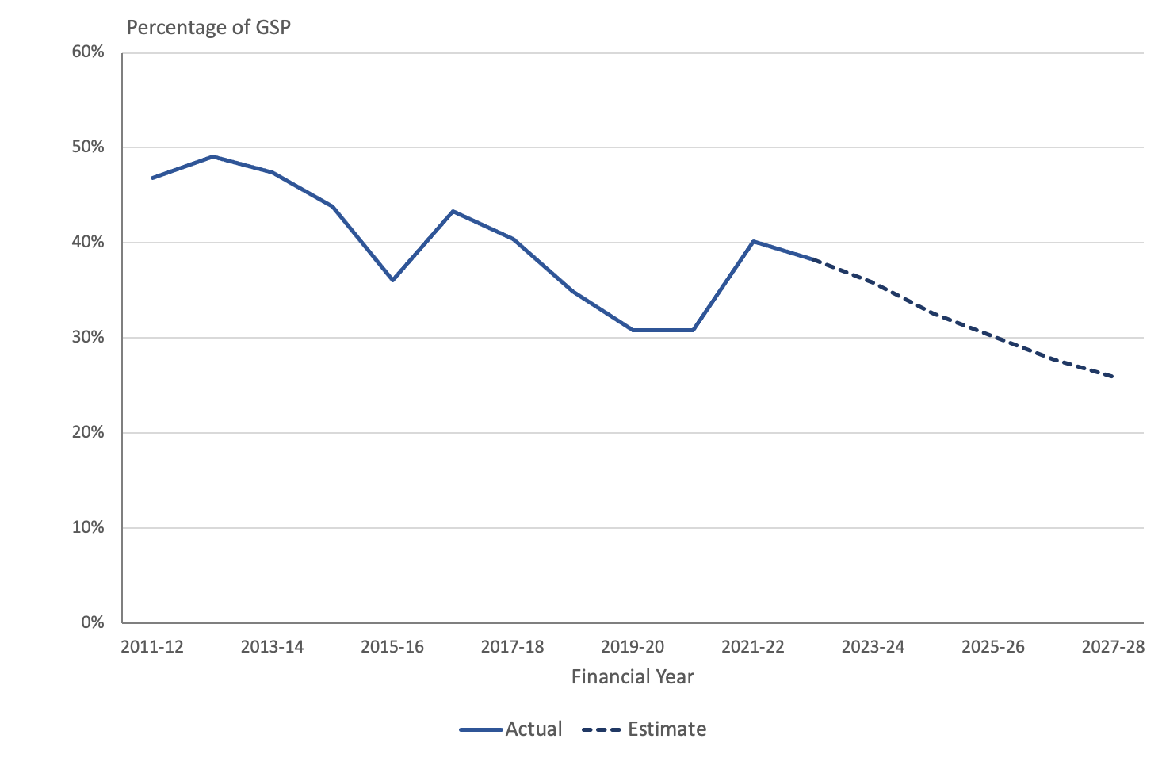
Sources: Budget Outlook, Table F.9, ABS Catalogue Number 5220.0, Table 1.
Figure 27 shows a fairly consistent long-term decline in the ACT Government’s net worth expressed as a proportion of GSP over the past decade. The ACT Government’s net worth has fallen from almost 50 percent of GSP in 2012-13 to about a third in 2024-25 and is forecast to continue to about a quarter of GSP in 2027-28. In the absence of corrective measures to improve the value of the ACT Government’s assets or reduce liabilities, that trend could be expected is to continue.

8.5 Superannuation
For new employees since 2005, the Government has made fortnightly payments to each employee’s designated superannuation fund under a defined contribution arrangement. There are no associated unfunded liabilities for these employees. However, the ACT continues to carry a significant liability associated with the superannuation entitlements of past and present employees who are members of the Commonwealth defined benefit superannuation schemes, the Commonwealth Superannuation Scheme (CSS) and the Public Sector Superannuation Scheme (PSS).
Approximately 5,300 current employees are members of these schemes. In addition, the ACT has liabilities in the two schemes in relation to a further 29,600 former ACT Government employees, including around 17,000 pensioners. Both the CSS and PSS schemes are closed to new members.
The Territory’s estimated defined benefit superannuation liability depends critically upon the discount rate used to calculate the present value of superannuation payments in future years and its relativity to the other financial assumptions regarding future salary growth, pension indexation and crediting rates. Demographic assumptions regarding exit rates and mortality will also impact on the estimated liability. For financial statement reporting, the discount rate is prescribed under the accounting standards (AASB 119) to be the market yield on Government bonds on the reporting date. This changes from year to year and leads to volatility in the estimated liability.
For forward estimates, therefore, long term financial assumptions are typically adopted to remove this source of volatility. Since the 2022-23 Budget, consistent financial assumptions have been adopted, which means that changes in the liability reflect deviations in actual experience from the assumptions previously adopted as well as changes in assumptions regarding future outcomes that take account of those changes in experience. In the interests of transparency, it is desirable that if long term financial assumptions are altered, estimates are produced on both the previous and new assumptions.
The liability estimates included in the current Budget, include the impact of changes in assumptions as a result of the triennial actuarial investigation of the ACT Government’s liability in respect of current and former members of the CSS and PSS. The most significant deviations from the previous projections of the liability arose from higher than expected pension indexation in 2022 (7 percent rather than the assumed CPI growth of 2.5 percent per annum) and changes to demographic assumptions, most notably to the rate of pension take-up among PSS members, which is now assumed to be 95 percent, up from 90 percent.
Around 95 percent of the estimated CSS liability of $2.8 billion relates to pensions in payment. This component of the liability is very sensitive to indexation rates and were the CPI to remain above 2.5 percent per annum assumed, the liability would increase more quickly than projected. By contrast, close to half of the estimated liability for the PSS, arises from those currently employed, either with the ACT Government or another agency . While increasing rates of pension take-up since the introduction of the PSS have had a substantial impact of scheme costs, there is limited scope for the pension take-up rate to increase further; the 5 percent who are currently not taking up the pension are likely to be selecting against the scheme. That is, the pension option is less valuable than the lump sum for this small group. Risks remain in relation to higher than anticipated salary increases and increasing invalidity rates but are likely to have a relatively small impact on the total liability.
Figure 28 shows the estimated superannuation liability for the Budget year and out-years from each of the last three Budgets. The liability has increased by around 10 percent from the 2023-34 Budget as a result of the changes in experience and assumptions.

Figure 28: Estimated Defined Benefit Superannuation Liabilities
Source: ACT Budget Papers
There are three flows associated with the superannuation liability. The projected service cost represents the additional liability arising from employee service during the year. The interest cost takes account of the fact that the accrued benefits that make up the liability are now one year closer to payment, and also leads to an increase in the liability. Benefit payments cover the cost of paying beneficiaries and reduce the total liability. The projections of these three flows are shown in Figure 29.
Figure 29: Estimated Defined Benefit Superannuation Flows
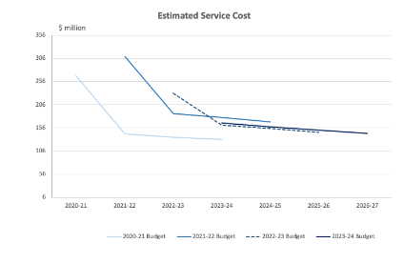
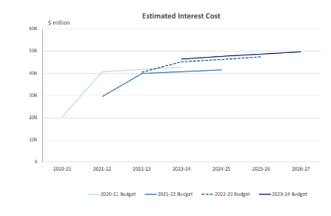
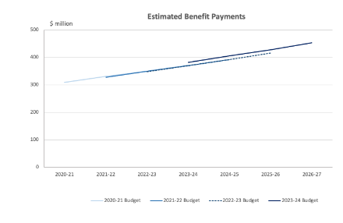
Source: ACT Budget Papers
The projected service cost (associated with the accrual of employee benefits) and interest cost (due to the unwinding of the discount rate as accrued benefits come closer to payment) are also sensitive to the financial assumptions. In the 2021-22 and 2022-23 Budgets, these costs were estimated for the Budget year using the market yield. As a result, the service cost was higher and the interest cost lower than the figures for the out-years which were derived using the long-term discount rate. With the move to using the long-term discount rate for the Budget year, the service cost and interest cost are more stable; the small increase in the service cost reflects the impact of the changes in demographic assumptions while the higher interest cost is a function of the increase in the estimated liability.
In contrast to the service and interest costs, projected benefit payments are relatively insensitive to changes in the valuation discount rate and, in the absence of changes in experience, are expected to change only slowly. The increase in the projected benefit payments observed in the 2023-24 Budget and again in the 2024-25 Budget represent a real increase in future outlays and are the practical manifestation of the growth in the estimated liability.
The ACT Government established a Superannuation Provision Account in 1991 as a vehicle for accumulating funds to meet the Territory’s unfunded defined benefit superannuation liability. As at 30 June 2024, the assets in the Account are estimated to cover 60% of the total superannuation liability and this proportion is expected to increase over the forward years as shown in Figure 30.
Figure 30: Defined Benefit Superannuation Unfunded Liability and Investment Assets
Source: ACT Budget Papers
The stated intention of successive Governments has been to achieve full coverage of liabilities by 2030. In practice, however, it has become increasingly apparent that this goal is unlikely to be met and the current Budget does not address the issue of when the liability will be extinguished.
Based on the existing trends in the funding percentage, we estimate that it will take around a decade before assets will be sufficient to cover the unfunded liability (estimated using the long-term financial assumptions and assuming that benefit payments continue to be funded from the Budget rather than the Account). Alternatively, based on the estimates of defined benefit liabilities and the assets in the Superannuation Provision Account as at 30 June 2024 together with projected benefit payments and accrued service costs over the next six years, the Account would need to achieve total investment returns of CPI plus 7.2 percentage points until 2030 to meet the goal of full funding. This compares with the target rate of return of CPI plus 4.75 percentage points and an achieved return of CPI plus 5.0 percentage points over the past 26 financial years. Thus, the prospect of extinguishing the unfunded liability by 2030 appears remote.
At the same time, and notwithstanding the increase in the projected benefit payments shown in the right-hand panel of Figure 29, there is no indication that the ACT will have any difficulties in meeting its unfunded superannuation obligations, which will emerge as a requirement to meet benefit payments over a period of more than 50 years.

9. Budget accounting, classification and valuation issues
Valuation effects, accounting treatments and timing issues continue to have large impacts on the budget aggregates and on the reported Budget balance.

9.1 Overview
The 2024-25 Budget reflects decisions on a number of accounting, classification and valuation issues.
The following sections provide comment on the budget accounting and classification issues that have material impacts on the Budget aggregates and how they are presented.

9.2 Disclosure of key accounting policies
The Budget financial statements, including the budget deficit, and associated tables, are presented in Chapter 4 of the principal Budget Paper (ACT Government, 2024, pp. 273-287). Section 4.1 relates to the General Government Sector (GGS) and Appendix D includes the financial statements for the ACT’s Public Trading Enterprises. Appendix E includes the Total Territory Consolidated Financial Statements which provides an accounting consolidation of the GGS and the Public Trading Enterprises.
The GGS statements have been prepared on the Australian Accounting Standards Board accounting standard AASB 1049 Whole of Government and General Government Sector Financial Reporting. AASB 1049, which forms the basis for the Australian Heads of Treasuries Uniform Presentation Framework, requires compliance with all other applicable accounting standards in the preparation of the statements.
In accordance with generally accepted budget reporting principles, Section 4.2 sets out revenues and expenses by economic type. These tables provide details and a level of granularity of the ACT’s revenue streams and expenses across the ACT’s key directorate functions. The total numbers can be reconciled with the estimates and forecasts set out in the revenue and expense section of the Budget (see particularly Tables 3.4.2 and Table 3.5.1).
Appendix G – “Basis of financial statement preparation” ACT Government, 2024, pp. 329-333) sets out the key accounting bases adopted in the preparation of the Budget financial statements. This section confirms that the financial statements have been prepared in accordance with AASB 1049, the Heads of Treasuries Uniform Presentation Framework, which is based on AASB 1049, and where applicable, the ABS Government Finance Statistics framework.
Appendix G also discloses several accounting policies and assumptions that relate to Service Concessions and Concessional Loans. The Service Concession disclosures relating to Light Rail Stage 2A, in particular, have been enhanced for 2024-25. However, there is no disclosure of the accounting policies adopted in respect of other key assets such as investments and loans, investments in other public sector entities, and produced and non-produced property plant and equipment, nor key liabilities such as advances received, borrowings, superannuation and employee compensation.
Typically, financial statements would be accompanied by a series of notes, describing the accounting policies and assumptions adopted and providing a breakdown of key financial statement items. By way of comparison, some other jurisdictions include a statement of the basis of accounting adopted, significant accounting policies and forecast assumptions and include disclosure of the likely impact of new or amended accounting standards applicable in the future.
Adopting such an approach would not only ensure consistency with other Australian jurisdictions, (including the Commonwealth), but would also enhance accountability and transparency for the users of the statements.

9.3 Superannuation return adjustment
As has been the case since 2006-07, the presentation of the headline net operating balance for 2024-25 includes an adjustment for long-term expected superannuation investment earnings.
The Government has argued that a superannuation return adjustment (SRA) is necessary in order to provide a fair measure of its fiscal position. While the Government Finance Statistics (GFS) reporting framework requires the inclusion of superannuation interest costs and other superannuation expenses in the operating balance, it only allows for interest income and dividends to be included as a transactional revenue item in the net operating balance, ignoring the capital growth on the assets in the Superannuation Provision Account (ACT Government, 2016, p 42). The ACT Treasury has indicated to us that inclusion of the SRA provides a better indication of the sustainability of the headline net operating balance.
We have noted in previous reports that there is an argument for allowing an offset to the reported interest cost to recognise the fact that the Government is holding assets in the Superannuation Provision Account to meet superannuation liabilities. In particular, calculating such an offset using the discount rate that has been used to estimate the liability would replicate the treatment of the interest cost in a partially funded superannuation scheme, to which the Territory arrangement is analogous. However, the Government has calculated the offset by assuming a return on the assets that exceeds the discount rate adopted in valuing the superannuation liabilities. Given that the SRA is included in the net operating balance, it effectively biases this key Budget indicator towards a more favourable outcome.
We remain of the view that if the SRA is to be included in the headline net operating balance, it should not lead to a bias in outcomes. This would mean calculating the SRA on an assumption that the total return on the assets of the Superannuation Provision Account is identical to the long-term discount rate used in valuing the liability. In the Budget year, this would imply an SRA of $83 million. Thus, using the projected long-term investment return rather than the long-term valuation discount rate of 5% per annum reduces the reported deficit by around $150 million.

9.4 Superannuation liability valuation and service costs
The discount rate used to calculate the present value of the Territory’s superannuation liability has a significant impact on the estimated value of the superannuation liability and related superannuation expenses.
It is also important to note that the Budget forecasts for the superannuation liability and associated expenses are calculated using a different discount rate from that used in reporting for the Territory’s financial statements. The Budget forecasts use a long-term discount rate while for financial reporting the prevailing Government bond rate is used.
The long-term discount rate utilised in the 2024-25 Budget is 5 per cent per annum. This is consistent with the rates used by the Commonwealth Government in the two most recent triennial actuarial reviews (as at 30 June 2020 and 30 June 2023) of the defined benefit schemes giving rise to the Territory’s liability. The inflation assumption is also consistent with that used for the triennial actuarial reviews.
Reporting at the end of the financial year in the financial statements is required under the Australian Accounting Standards (AASB 119) to be prepared on the basis of the yield on a suitable Commonwealth Government bond. The liability valuation as at 30 June 2023 utilised a discount rate assumption of 4.40 percent (ACT Budget 2024, p. 264). The Budget documents were prepared prior to 30 June 2024 and rather than using an estimate of the likely bond yields at that date, the liability and associated service costs have been estimated using the long-term discount rate of 5%.
The Reserve Bank of Australia increased the cash rate significantly in response to the spike in inflation in 2022 and 2023, and yields on 10 year Commonwealth Government bonds rose to almost 5 percent in November 2023, but subsequently fell and, for the last six months have been between 4 percent and 4.5 percent per annum. It would be expected, therefore, that the closing liability reporting in the financial statements for 2023-24 will be significantly higher than that included in the Budget documents.
Table J.6 in the Appendices to the Budget Outlook indicates that a 1 per cent decrease in the discount rate from the long-term budget assumption of 5 per cent would increase the estimated liability by $1.7 billion and an adjustment of this order could be expected.
Table 10: Impact of a 1 percentage point decrease in the discount rate on superannuation liability
 | 2024-25 | 2025-26 | 2026-27 | 2027-28
 | $’000 | $’000 | $’000 | $’000
Superannuation Liability | +1,707,000 | +1,714,000 | +1,716,000 | +1,714,000
Source: ACT Budget 2024, Table J.6
The lower discount rate will also have an impact on the service cost, which would be expected to be somewhat higher, with an offsetting reduction in the interest cost. Based on the figures reported in the Budget Outlook (ACT Government, 2023, p. 381), the net effect of these adjustments to the service and interest costs is a small increase in the superannuation expense as shown in Table 11 below. The changes in the superannuation expense are not material in the context of the overall liability.
Table 11: Impact of a 1 percentage point decrease in the discount rate on superannuation expense
 | 2024-25 | 2025-26 | 2026-27 | 2027-28
 | $’000 | $’000 | $’000 | $’000
Superannuation Expense | +12,000 | +7,000 | +2,000 | -3,000
Source: ACT Budget 2024, Table J.6
The application of a higher discount rate to the Budget estimate of the Territory’s superannuation liabilities will generally have the effect of decreasing the estimate of the superannuation liability and service costs. There is thus a trade-off between achieving consistency between budget and forward year figures and the need for a subsequent revision of the estimates when the final outcome for the year is known.
Further discussion of the impact of the changes in the superannuation liability is provided in section 7.5 on superannuation liabilities and section 3.3 on balance sheet measures of the fiscal position.

9.5 Service Concession Arrangements
The ACT Government is currently engaged in several Public Private Partnerships (PPP-Service Concession) projects: Light Rail Stages 1 and 2A, and the ACT Housing Asset Assistance Program (HAAP).
Since the 2020-21 Budget, the ACT Government has adopted the applicable accounting standard, AASB 1059 Service Concession Arrangements: Grantors.
AASB 1059 does not treat service concession arrangements as leases, but instead, requires the assets and liabilities to be recognized in the balance sheet and valued at current replacement cost, when the government gains control of these assets and liabilities, generally taken to be when the project becomes operational. Any intangible assets such as intellectual property rights, must be included in the aggregate of project assets. At the end of the construction contracts, the infrastructure will become ACT assets. This is taken to mean that once the projects are operational, the infrastructure is owned by the Territory. It is noted that Light Rail – Stage 1 became operational in April 2019. In December 2023 the ACT Government entered a service concession arrangement for Light Rail – Stage 2A.
Appendix G indicates in respect to Light Rail Stages 1 and 2A, the infrastructure will only become ACT assets at the end of these contracts (ACT Government, 2024, p.331), although the Government will make service payments over the life of the long-term contracts with the consortia. The term of these contracts and the schedule for taking these assets and liabilities on to the Territory’s balance sheets is not clear from the Budget documentation, although Appendix G suggests Stage 2A is out to 2038-39.
The ACT Treasury has confirmed that in respect to Light Rail Stage 2B, to Woden, the project is in planning status, with a financial contribution from the Commonwealth.

9.6 Acquisition of Calvary Public Hospital and Clare Holland House
The ACT Government publicly announced it was acquiring the Calvary Public Hospital (Calvary) for nil consideration in the lead up to the 2023-24 Budget. The Government subsequently announced the acquisition of Clare Holland House through mutual agreement. The effective date of acquisition of Calvary was 3 July 2023.
Pursuant to the Australian Accounting Standards, where an asset is acquired for nil consideration, no revenue is brought to account on initial recognition, but instead, the transaction is treated as a balance sheet only event and, as such, an asset is recognized together with a corresponding adjustment to equity. We understand that the acquisition was recognized in the General Government Sector balance sheet and statement of changes in equity with a date of effect 3 July 2023.
Apart from the asset, the transaction also includes the transfer of some staff to the ACT public sector. Relevant employee costs including salary and wages, leave entitlements and post-employment compensation (superannuation), and offsetting reductions in the purchase of services, were expensed in the 2023-24 Budget statements, with corresponding liabilities recognized in the General Government Sector financial statements.
In respect to the 2024-25 Budget, ACT Treasury indicated to us that there have been no significant additional impacts on the Budget and forward estimates since that time. They also confirmed that compensation/settlement of the transaction remains under negotiation. Conclusion of negotiations will impact the out years, as appropriately described in the Statement of Risks (ACT Government, 2024, p. 348).

9.7 Technical adjustments
The Budget Papers include technical adjustments that appear to indicate changes to previous decisions relating to the funding of programs and projects. The adjustments appear to move funding across years as well as changes to appropriations across years.
Whilst examples of this practice are not unusual in other jurisdictions; for instance, the re-phasing of appropriations and the movement of previous decisions to out years, the level of adjustments appears substantial.

9.8 Concessional loans
Concessional loans are arrangements where a lender, typically a government, provides a loan facility on terms and conditions more favorable than the prevailing market. Concessions can include involve lower or zero interest rates, interest free periods, and/or an extended maturity term. Appendix G indicates the ACT Government (2024, pp, 332-333) is providing concessional loans pursuant to its Sustainable Household Scheme.
The arrangement provides interest free loans to assist households with the upfront costs of installing equipment to enable emissions reductions. The accounting treatment outlined accords with the applicable accounting standard AASB 9 Financial Instruments.

10. Women’s Budget Statement
This year’s Women’s Budget Statement is much more focused on policy initiatives and programs specifically targeted and relevant to women than was the case with last year’s statement. The statement primarily provides an overview of existing ACT Government programs, illustrated with numerous case studies. New initiatives related to women are also included in the Wellbeing Statement, though they are not always identified as women’s programs.

10.1 Introduction
The Committee asked Pegasus to examine the Women’s Budget Statement. This section of the report responds to that request.

10.2 Overall impressions
The ACT Women’s Budget Statement (ACT Government, 2024a) provides an overview of policy initiatives and programs specifically targeted and relevant to women. The statement appears more clearly targeted to women’s programs than the comparable statement in last year’s Budget.
Within the statement itself, the main ACT Government programs and initiatives referred to are:
- Period Products and Facilities (Access) Act 2023 that commits the Government to providing period products free of charge at designated, accessible places across the ACT, including public schools and public health facilities. This is the first legislated support for free period products anywhere in Australia (page 7).
- The ACT Public Maternity System Plan 2022-2032 that sets out the ACT Government’s priorities for the next 10 years to ensure the public maternity system is best placed to meet the needs of women, pregnant people, their babies and families, and the workforce (page 8)
- The provision of $26 million over four years to invest in expansion of maternity services to continue to support safe care for women, pregnant people and their families, including the expansion of the Maternal Foetal Medicine Unit; the extension of the Maternity Assessment Unit to provide 24/7 services; increased resources for the Early Pregnancy Unit; and support for obstetrics and gynaecology services to meet growing demand page 9).
- The provision of $52 million to support emergency and elective surgery capacity and also funds additional elective surgeries across public and private hospitals, including operationalising a second endoscopy suite at North Canberra Hospital (page 9).
- The provision of $86 million over four years to ensure implementation of mandated minimum nurse and midwife to patient ratios (page 9).
- The provision of $233,000 in 2024-25 to continue delivering domestic and family violence training to Canberra Hospital staff and expanding the training to North Canberra Hospital staff through the Strengthening Health Responses to Family Violence (SHRFV) program (page 9).
- Continuation of the Children and Young People Equipment Loan Service (CAYPELS) with funding of $466,000 in 2024-25 (page 9)
- Expansion of paediatric services in line with the Child and Adolescent Clinical Services Plan 2023-2030 with support of $56 million over four years from 2024-25 and capital funding of $825,000 in 2024-25 (page 9).
- Provision of $10.408 million over three years from 2024-25 for frontline domestic, family, and sexual violence services to address rising demand and delivery costs for crisis response services, and to provide wraparound supports (page 11).
- Provision of $267,000 over four years from 2024-25 to enhance and improve the ACT Domestic and Family Violence (DFV) Death Review functions (page 11).
- Provision of $375,000 for training for ACT Policing and Courts to build knowledge and understanding of coercive control, developing online tools for assessing coercive control as well as a communications campaign (page 11).
- Provision of $506,000 over four years from 2024-25 to victim-survivors of domestic, family and/or sexual violence by strengthening Restorative Justice (page 12).
- Provision of an additional $299,000 in 2024-25 to enable the existing Restorative Justice Unit (RJU) database to be updated (page 12).
- Provision of $150,000 to implement the Capital of Equality Strategy’s First Action Plan (2024-26) to support inclusion and equality of LGBTIQA+ people (page 12).
- A further $150,000 has been allocated to expand the Capital of Equality Grants Program for one year (page 12).
- The Early Learning Connection program that supports women to build career pathways in early childhood education and will ease workforce pressures in the sector (page 13).
- The provision of $300,000 for the development of a Gender Equity Plan to increase diversity and gender balance in Transport Canberra’s workforce; and deliver improved facilities and amenities, including segregated or gender-neutral toilets on the network (page 15).
- The provision of $116,000 to support free registration of early childhood teachers with the Teacher Quality Institute for a period of 2 years (page 15).
- The provision of $146,000 for the Return to Work Program (page 15).
- Reference to the Growing and Renewing Public Housing Program that is discussed further in the next section (page 16).
- An increase in funding for the Affordable Housing Project Fund from $60 million to $80 million (page 17).
- The provision of $856,000 in 2024-25 to fund hotel accommodation brokerage for the Domestic Violence Crisis Service (DVCS) and OneLink (pages 17-18.
- The provision of $57 million to support maintenance and repairs for public housing (page 18).
- The provision of $28 million over three years from 2028-29 for the electrification of all feasible public housing in the ACT by 203 (page 18).
- The provision of $5.2 million over two years to support around 350 low-income owner-occupied households in the ACT who are unable to independently transition to electricity and more likely to be negatively affected by rising gas prices (page 18).
- Funding of $2.7 million over 2024-25 and 2025-26 has been provided to the ACT’s Community Legal Assistance Sector (page 21).
- The provision of $491,000 in funding to ensure ongoing delivery of essential services to vulnerable Canberrans (page 21).
- The provision of $7.2 million in 2024-25 for the new CIT Campus in Woden to ensure contemporary, flexible, smart teaching and learning environments while creating state of the art vocational educational spaces (page 21).
- The provision of $1.4 million in 2024-25 to continue the existing Flexible Transport services while a trial of a new booking application is taking place (page 21).
New policy initiatives affecting women are also included in the Wellbeing Statement, though they are not always identified as women’s programs.
The Women’s statement also contains numerous case studies, although the programs referred to are often small or trial programs. The case studies referred to in the statement related to:
- ACT community pharmacy Urinary Tract Infection (UTI) and Oral Contraceptive Pill (OCP) trial
- Transforming Reproductive Healthcare - ACT’s Accessible Abortion Scheme
- Family Violence Safety Action Program (FVSAP)
- Family Violence Response for Children (Heartfelt)
- New investment in frontline domestic, family, and sexual violence services
- Return to Work (RTW) Program
- Understanding Building and Construction Program
- Quality early childhood education for three-year-old children
- MacKillop House
- Court Navigator Program
- Health Justice Partnerships
- Female friendly changerooms.

11. Housing Affordability and Provision of Public Housing
Overall housing affordability has improved in light of recent falls in ACT house prices. While overall housing affordability in Canberra has improved, there is also evidence to suggest that lower income households are still struggling.
The stock of public housing in the ACT has not kept pace with ACT population growth, and has remained stagnant since 2018 while the ACT resident population has grown by almost 27 percent between 2011 and 2023. Even if the ACT Government is successful in adding another 400 public homes, it will still not keep pace with population growth.

11.1 Housing Affordability
According to the ACT Government (2024, p. 21), housing and rental affordability in the ACT remains relatively better than other jurisdictions predominantly as a result of higher household incomes. The ACT has the second highest level of average weekly ordinary time earnings for adults working full time across all states and territories (Australian Bureau of Statistics, 2024a). There is also independent analysis to suggest that housing affordability has improved in Canberra in relation to the other capital cities.
The ANZ Bank and CoreLogic (2024, p. 17) Housing Affordability Housing Affordability Report found that in the March quarter of 2024 the portion of income required to service a new mortgage for a dwelling in Canberra was the second lowest amongst the capital cities and the portion of income required to service rent for a dwelling was the lowest amongst the capital cities. This is outlined in Figure 31 below.
Figure 31: Portion of Income Required to Service a New Mortgage and Rent for a Dwelling in Australian Capital Cities
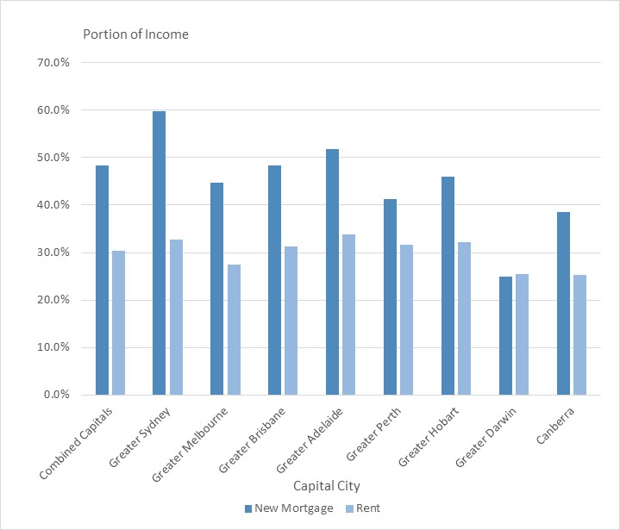
Source: ANZ Bank and CoreLogic (2024, p. 17).
Aside from relatively high incomes received by ACT residents compared with the rest of the nation, the other reason why housing affordability has increased in the ACT is due to the relative fall in dwelling property prices. While the value of dwellings in the ACT increased by 2.0 percent on average over the year to the end of May 2024, Canberra dwelling values are still-5.8 percent below the record high that was reached in May 2022 (CoreLogic, 2024, p. 17).
While overall housing affordability in Canberra has improved, there is also evidence to suggest that lower income households are still struggling. According to the 2023 Rental Affordability Index:
… low-income households face particularly unaffordable rents (such as the student sharehouse and hospitality worker household profiles), which are pushed up by the overall high-income earning workforce. Every suburb in the ACT is Unaffordable to Severely Unaffordable for the student sharehouse. For pensioners, both singles and couples, the entire territory is Severely to Extremely Unaffordable, despite the improvement in rental affordability seen over the last year. (SGS Economics and Planning Pty Ltd, 2023, p. 82).

11.2 ACT public housing and population growth
According to the ACT Government (ACT Government, 2024, p. 63):
A key priority of this Government is the improvement and growth of our public housing stock. Programs of work specifically related to this outcome include the Growing and Renewing Public Housing Program, which will deliver an additional 400 public homes and renew 1,000 public homes, and which has recently been expanded to include the delivery of between 55 and 65 additional public homes under the Commonwealth’s Social Housing Accelerator Program.
The ACT Audit Office (2024, p. 15) has recently observed that Canberra’s relatively high rent and property prices compared to other Australian capital cities means that Canberrans living on low incomes can be significantly disadvantaged in accessing housing, and that consequently demand for public housing in the ACT is high and increasing.
The available evidence suggests the stock of public housing in the ACT has not kept pace with ACT population growth and has remained largely stagnant since 2018 while the ACT resident population has grown by almost 27 percent between 2011 and 2023.
In 2019 the ACT Government embarked on an eight-year, $860 million Growing and Renewing Public Housing Program that is intended to deliver 1,400 new public housing homes in the ACT (ACT Audit Office, 2024a). To allow the construction of 1,000 new public housing homes to be built, Housing ACT is selling and redeveloping older, not fit-for-purpose public housing homes. Housing ACT will sell approximately 700 homes to raise revenue and demolish approximately 300 homes to allow for redevelopment of the land sites. The Growing and Renewing Public Housing Program will result in a net increase of 400 public housing homes by 2027, compared to the number existing in 2019.
While the ACT Government’s Growing and Renewing Public Housing Program is likely to increase the overall stock of public housing available in the ACT by the end of 2027, the supply of public housing is still unlikely to keep pace with the ACT population as observed recently by the ACT Audit Office (2024, p. 1):
Although there will be more public housing homes in the ACT by the end of the Program in 2027, the supply of public housing homes relative to the number of people living in the Territory will decrease, because the ACT’s population is increasing.
According to the ACT Audit Office (2024, p. 3), the number of homes per estimated resident population is expected to decrease: from 28 public housing homes for every 1,000 people living in the ACT in 2018 to approximately 24 public housing homes per 1,000 people in 2027.

Figure 32: ACT Population and the Provision of ACT Public Housing Dwellings
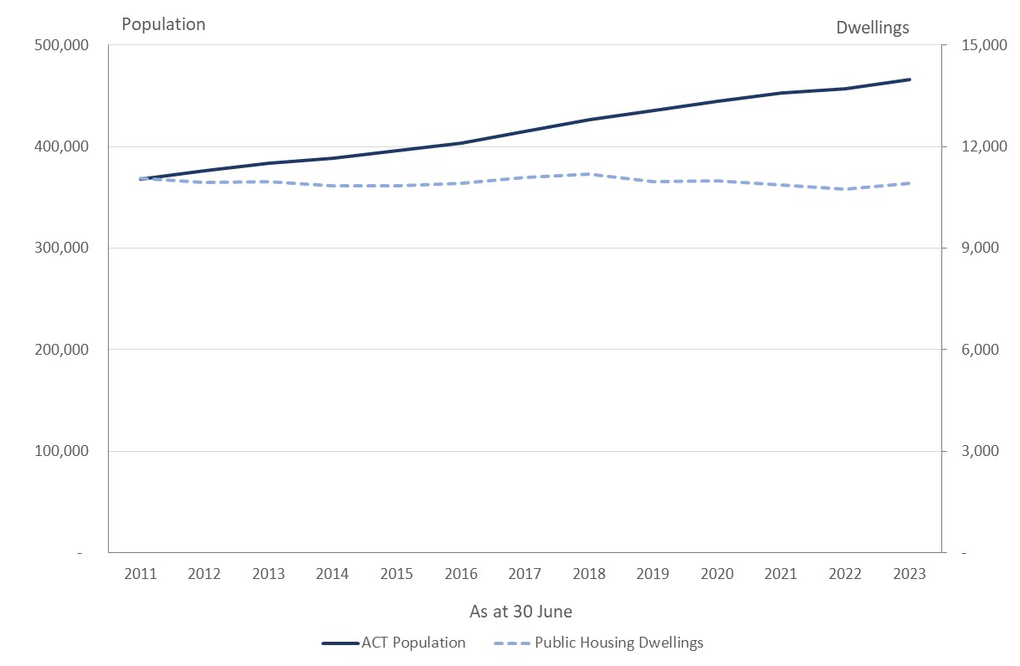
Sources: ABS (2024e) and Productivity Commission (2024).

11.2 Budget measures
The Budget includes a number of new measures to address housing affordability and access to social housing.
Measures to address access to affordable rental housing and home ownership include for initiatives, include:
- increasing the Affordable Housing Project Fund from $60 million to $80 million to expand the social and affordable housing stock in the ACT;
- reducing the lowest marginal conveyance duty tax rate for home buyers from 0.49 per cent to 0.4 per cent;
- increasing the Home Buyer Concession Scheme income eligibility threshold from $170,000 to $250,000, and the additional income allowance per child will increase from $3,330 to $4,600;
- temporarily increasing the property price thresholds for the Off-the-plan unit and RZ1 unit duty exemptions to $1 million, from 1 July 2024 to 30 June 2025;
- expanding the Disability Duty Concession Scheme and the Pensioner Duty Concession Scheme to provide a concession up to the duty on a $1 million purchase, from 1 July 2024;
- extending the operation of the Rent Relief Fund to assist vulnerable, low-income Canberrans experiencing rental stress or financial hardship, due to rising cost of living challenges; and
- introducing a new Severe Disability Duty Exemption to commence from 1 July 2025.
Measures to strengthen social housing assistance include:
- $51 million over four years to support Housing ACT to continue its growth and renewal of housing stock and support the growth of the ACT public housing portfolio;
- A net investment of $51.2 million over four years for repairs, maintenance and upgrades of public housing stock and maintenance and tenancy services; and
- $6.5 million over four years for the continued expansion of specialist homelessness service capacity, partially offset by $3.7 million previously provisioned in 2026-27 for expanded homelessness services.

Bibliography
ACT Audit Office. (2020). ACT Auditor-General's Report: Residential Land Supply and Release. Report No.4 / 2020, Canberra.
ACT Audit Office. (2024). Management of the Growing and Renewing Public Housing Program. ACT Auditor-General's Performance Audit Report, Canberra.
ACT Audit Office. (2024a). Management of the Growing and Renewing Public Housing Program. Media Release, 8 May.
ACT Government. (2012). Australian Capital Territory Budget 2012-13 Budget Paper No. 3: Budget Overview. Canberra.
ACT Government. (2013). Australian Capital Territory Budget 2013‐14 Budget Paper No. 3. Canberra.
ACT Government. (2014). Australian Capital Territory Budget 2014-15 Budget Paper No. 3. Canberra.
ACT Government. (2015). Australian Capital Territory Budget 2015-16 - Budget Paper No. 3 Budget Outlook. Canberra.
ACT Government. (2016). Australian Capital Territory Budget 2016-17 for Canberra - Budget Paper 3: Budget Outlook. Canberra.
ACT Government. (2018). Australian Capital Territory Budget 2017-18 Budget Review. Canberra.
ACT Government. (2018a). Australian Capital Territory Budget 2018-19 - Budget Paper 3: Budget Outlook. Canberra.
ACT Government. (2019). Australian Capital Territory Budget 2019-20 Building for the Future - Budget Paper 3: Budget Outlook. Canberra.
ACT Government. (2020). August 2020 Economic and Fiscal Update. Canberra.
ACT Government. (2021). Australian Capital Territory Budget 2020-21: Driving Canberra's Recovery - Budget Outlook. Canberra.
ACT Government. (2021a). Australian Capital Territory Budget 2021-22: Budget Outlook. Canberra.
ACT Government. (2022). ACT Housing Strategy: Growing and Renewing Public Housing Program. Canberra.
ACT Government. (2022a). 2022-23 Budget Outlook. Canberra.
ACT Government. (2022b). Australian Capital Territory Budget: Budget Statement I - Major Projects Canberra. Canberra.
ACT Government. (2023). 2023-24 Budget Outlook. Canberra.
ACT Government. (2024). 2024-25 Budget Outlook. Canberra.
ACT Government. (2024a). Australian Capital Territory Budget 2024-25: Women’s Budget Statement. Canberra.
ANZ Bank and CoreLogic. (2024). Housing Affordability Housing Affordability Report.
Australian Accounting Standards Board. (2010). AASB 9 - Financial Instruments. Melbourne.
Australian Accounting Standards Board. (2012). AASB 1049 - Whole of Government and General Government Sector Financial Reporting. Melbourne.
Australian Accounting Standards Board. (2016). AASB 16 - Leases. Melbourne.
Australian Accounting Standards Board. (2017). AASB 1059 Service Concession Arrangements: Grantor. Melbourne.
Australian Accounting Standards Board. (2018). AASB 2018-5 Amendments to Australian Accounting Standards – Deferral of AASB 1059. Melbourne.
Australian Bureau of Statistics. (2021b, July 9). History and purpose of gross state product. Retrieved from Australian Bureau of Statistics: https://www.abs.gov.au/statistics/detailed-methodology-information/concepts-sources-methods/australian-system-national-accounts-concepts-sources-and-methods/2020-21/chapter-21-state-accounts/history-and-purpose-gross-state-product
Australian Bureau of Statistics. (2023, November 21). Australian National Accounts: State Accounts. Retrieved from Australian Bureau of Statistics: https://www.abs.gov.au/statistics/economy/national-accounts/australian-national-accounts-state-accounts/latest-release
Australian Bureau of Statistics. (2023a, August 22). Counts of Australian Businesses, including Entries and Exits: July 2019 to June 2023. Retrieved from Australian Bureau of Statistics: https://www.abs.gov.au/statistics/economy/business-indicators/counts-australian-businesses-including-entries-and-exits/latest-release
Australian Bureau of Statistics. (2024, June 5). Australian National Accounts: National Income, Expenditure and Product: March 2024. Retrieved from Australian Bureau of Statistics: https://www.abs.gov.au/statistics/economy/national-accounts/australian-national-accounts-national-income-expenditure-and-product/latest-release
Australian Bureau of Statistics. (2024a, February 22). Average Weekly Earnings, Australia. Retrieved from Australian Bureau of Statistics: https://www.abs.gov.au/statistics/labour/earnings-and-working-conditions/average-weekly-earnings-australia/nov-2023
Australian Bureau of Statistics. (2024b, April 24). Consumer Price Index, Australia: March 2024. Retrieved from Australian Bureau of Statistics: https://www.abs.gov.au/statistics/economy/price-indexes-and-inflation/consumer-price-index-australia/mar-quarter-2024
Australian Bureau of Statistics. (2024c, June 13). Labour Force, Australia: May 2024. Retrieved from Australian Bureau of Statistics: https://www.abs.gov.au/statistics/labour/employment-and-unemployment/labour-force-australia/may-2024
Australian Bureau of Statistics. (2024d, June 26). Monthly Consumer Price Index Indicator. Retrieved from Australian Bureau of Statistics: https://www.abs.gov.au/statistics/economy/price-indexes-and-inflation/monthly-consumer-price-index-indicator/may-2024
Australian Bureau of Statistics. (2024e, June 13). National, state and territory population: December 2023. Retrieved from Australian Bureau of Statistics: https://www.abs.gov.au/statistics/people/population/national-state-and-territory-population/dec-2023
Australian Bureau of Statistics. (2024f, May 15). Wage Price Index, Australia: March 2024. Retrieved from Australian Bureau of Statistics: https://www.abs.gov.au/statistics/economy/price-indexes-and-inflation/wage-price-index-australia/mar-2024
Australian Government The Treasury. (2022, October 25). Measuring what matters. Retrieved from Australian Government The Treasury: https://treasury.gov.au/consultation/measuring-what-matters-2022
Australian Public Service Commission. (2023). State of the Service Report: 2022-23. Canberra.
Carr, T., Fernandes, K., & Rosewall. (2017). The Recent Economic Performance of the States. Reserve Bank of Australia Bulletin(March 2017), 1-12.
Centre for Population. (2024). Budget 2024-25: State and Territory Population Projections, 2023-24 to 2027-28. Canberra.
Commonwealth of Australia. (2024). Budget 2023-24: Agency Resourcing Budget Paper No. 4. Canberra.
Commonwealth of Australia. (2024a). Budget 2024-25: Budget Strategy and Outlook Budget Paper No. 1. Canberra.
CoreLogic. (2024). Monthly Housing Chart Pack: Juen 2024.
Freebairn, J., Stewart, M., & Liu, P. X. (2015). Reform of State Taxes in Australia: Rationale and Options. Melbourne: Melbourne School of Government.
Henry, K., Harmer, J., Piggott, J., Ridout, H., & Smith, G. (2009a). Australia’s future tax system: Report to the Treasurer, Part Two Detailed Analysis volume 1. Canberra: Commonwealth of Australia.
International Public Sector Accounting Standards Board. (2011). IPSAS 32 - Service Concession Arrangements: Grantor. London.
Li, B., & Gao, G. (2021). Estimating quarterly gross state product. Victoria’s Economic Bulletin, 5: June 2021, 1-11.
Lindell, J. (2023, September 8). S&P Global downgrades ACT's credit rating to AA+ after slower budget recovery. Retrieved from The Canberra Times : S&P Global downgrades ACT's credit rating to AA+ after slower budget recovery
Mercer Consulting (Australia) Pty Ltd. (2021). PSS and CSS Long Term Cost Report. Canberra: Department of Finance.
New Zealand Treasury. (2021, October 28). The Living Standards Framework (LSF) 2021. Wellington. Retrieved from New Zealand Treasury.
Productivity Commission. (2024, May 28). Report on Government Services 2024: Part G, Section 18 - Housing. Retrieved from Productivity Commission: https://www.pc.gov.au/ongoing/report-on-government-services/2024/housing-and-homelessness/housing
Read, M. (2024, June 26). August rate rise on the cards after inflation hits 4pc. Retrieved from The Australian Financial Review: https://www.afr.com/policy/economy/inflation-hits-six-month-high-raising-risk-of-a-rate-rise-20240626-p5jot7
Reardon, T., & Hopkins, D. (2018, February 15). Analysis ACT Tax reform Initiative. HIA National Outlook: A quarterly update on the housing & renovation industry - Summer Edition 2018, pp. 4-11.
Reserve Bank of Australia. (2024). Statement on Monetary Policy May 2024. Sydney.
Riordan, P. (2023, November 23). APS bargaining package of pay and conditions – final offer. Retrieved from Australian Public Service Commission: https://www.apsc.gov.au/aps-news/aps-bargaining-package-pay-and-conditions-final-offer#:~:text=The%20Commonwealth%20will%20improve%20its,as%20a%20one%2Doff%20payment.
SGS Economics and Planning Pty Ltd. (2023). Rental Affordability Index, November 2023. Canberra.

See Read (2024).
Definitions and further discussion of the application of these measures are provided in section 8 of this report.
Net disposable income in 2023-24 was converted into equivalent real 2024-25 income by increasing it by the forecast increase in the CPI for Canberra.
https://www.parliament.act.gov.au/__data/assets/pdf_file/0010/2250991/Pegasus-Report-ACT-Budget-2023-24-Final-7July23.pdf
https://www.parliament.act.gov.au/__data/assets/pdf_file/0010/2250991/Pegasus-Report-ACT-Budget-2023-24-Final-7July23.pdf
See Australian Accounting Standards Board (2010).
Unaffordable is where between 30 percent to 38 percent of income is spent on rent, Severely Unaffordable is where between 38 percent to 60 percent of income is spent on rent, and Extremely Unaffordable is where 60 percent or more of income is spent on rent (SGS Economics and Planning Pty Ltd, 2023, p. 82).

