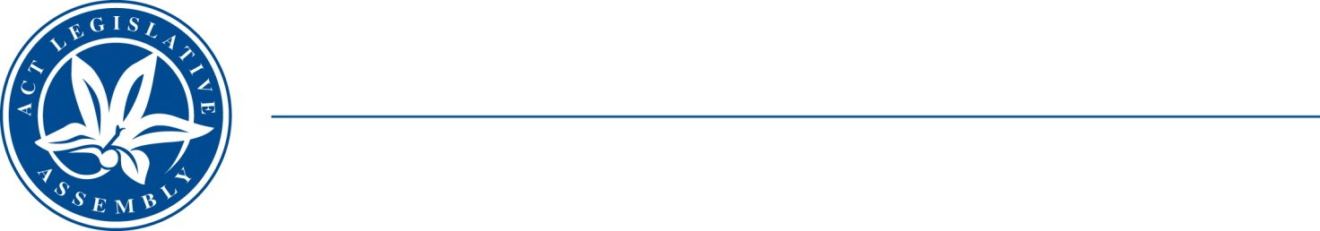
QoN No. 18
Committee Support
LEGISLATIVE ASSEMBLY
FOR THE AUSTRALIAN CAPITAL TERRITORY
Standing Committee on Education and Community Inclusion

Inquiry into Annual and Financial Reports 2021-2022

ANSWER TO QUESTION ON NOTICE

Asked by Elizabeth Kikkert MLA: To ask the Minister for Early Childhood Development

Reference: Early Childhood Development, CSD Annual Report 2022, p. 93
In relation to: Child Development Service and Stakeholders

1. Considering that the annual report states that the CDS met ‘with key stakeholders in early childhood early intervention service system to review the effective delivery of existing service models and referral pathways’ (p. 93), did the CDS meet in any way with staff from Marymead’s Autism Centre over the course of the year? a. If so, what was discussed? b. If not, why has input not been sought from this important stakeholder?
2. In addition to reviewing ‘existing service models and referral pathways’, has the government sought any input from stakeholders regarding new or innovative service models and/or referral pathways? If so, what has been discussed?

MINISTER Berry: The answer to the Member’s question is as follows:–

- The Child Development Service (CDS) met with many stakeholders in the early childhood early intervention service system who are key referrers to CDS in the last financial year. These meetings did not include Marymead as they are not a key referrer to CDS. However, CDS Social Workers, who are involved with families on the CDS autism assessment waiting list, frequently engage with Marymead to facilitate referrals between services.

- CDS seeks to continue to improve assessment and referral services for children aged 0-6 in the ACT. CDS participates in the Early Intervention Early Childhood Providers Forum, as part of this forum CDS provides updates on services offered, responds to questions and builds relationships with providers in the community.

Approved for circulation to the Standing Committee on Education and Community Inclusion

Signature: Date:

By the Minister for Early Childhood Development, Yvette Berry

