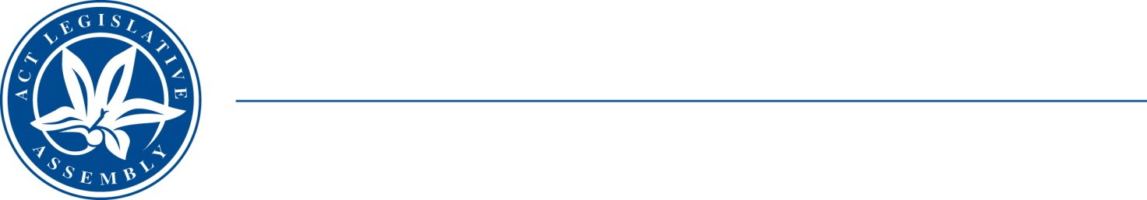
QToN No. 98
Standing Committee on Health and Community Wellbeing
Mr Johnathan Davis MLA (Chair), Mr James Milligan MLA (Deputy Chair), Dr Marisa Paterson MLA
LEGISLATIVE ASSEMBLY
FOR THE AUSTRALIAN CAPITAL TERRITORY
Standing Committee on Health and Community Wellbeing

Inquiry into Annual and Financial Reports 2021-2022

QUESTION TAKEN ON NOTICE

Asked by MR MARK PARTON MLA on 10 November 2022: MR GEOFF AIGNER took on notice the following question(s):

Reference: Hansard uncorrected proof transcript 10 November 2022, Page 177

In relation to: Instances of sub-letting in a Housing ACT asset

MR PARTON: All right. And just in closing, is it possible to take on notice the number of instances that sub-letting was found to have occurred in a Housing ACT asset in the last 12 months?

Mr Aigner: Absolutely—

MR PARTON: Thank you.

Mr Aigner: We will take that on notice, Mr Parton.

Minister Vassarotti: The answer to the Member’s question is as follows:–

During 2021-22, 1 instance of subletting was found to have occurred in a Housing ACT public housing property.

Approved for circulation to the Standing Committee on Health and Community Wellbeing

Signature: Date:
By the Minister for Homelessness and Housing Services, Minister Rebecca Vassarotti

