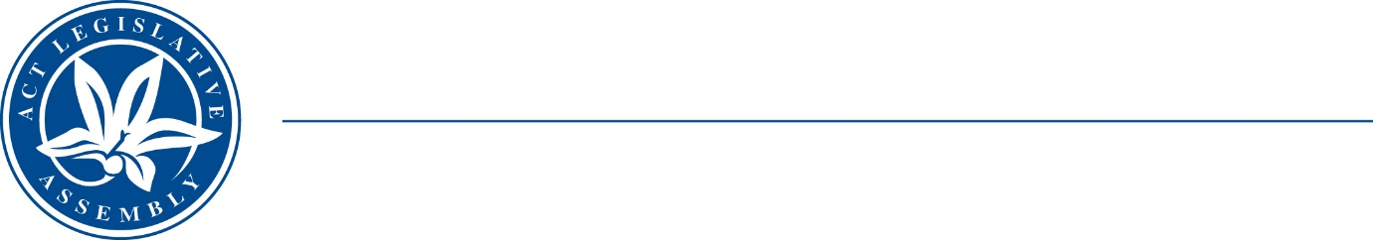
Standing Committee on Economy and Gender and Economic Equality
Ms Leanne Castley MLA (Chair), Ms Suzanne Orr MLA (Deputy Chair),
Mr Johnathan Davis MLA

LEGISLATIVE ASSEMBLY
FOR THE AUSTRALIAN CAPITAL TERRITORY

Media Release

Have your say on the future of the working week

Inquiry survey closing date extended to 16 December 2022
The ACT Legislative Assembly’s Standing Committee on Economy and Gender and Economic Equality (the Committee) has created a survey to assist with its Inquiry into the Future of the Working Week.
The survey is easily accessible and simple to complete. Interested members of the public are encouraged to participate and help enable the Committee to understand Canberran’s views on this important subject.
To have your say, please click here.
Members of the public can also make their own submission to the Committee.
Information about how to make a submission is available at: https://www.parliament.act.gov.au/parliamentary-business/in-committees/Getting-involved
The closing date for both the survey and for full submissions has now been extended to 16 December 2022.
The Committee’s terms of reference are available on the Legislative Assembly website at: https://www.parliament.act.gov.au/parliamentary-business/in-committees/committees/egee/inquiry-into-the-future-of-the-working-week#tab1756231-1id
A Discussion Paper is also available at: https://www.parliament.act.gov.au/parliamentary-business/in-committees/committees/egee/inquiry-into-the-future-of-the-working-week#tab1756231-8id

STATEMENT ENDS—31 October 2022
–––––––––––––––––––––––––––––––––––––––––––––––––––––––––––––––––––––––––––––––––––––––––
contacts: | Ms Leanne Castley MLA  (for comment on the inquiry) | Committee Chair | (02) 620 50283
contacts: | Ms Joanne Cullen  (for further information) | Committee Secretary | (02) 620 50435

