Draft variation No. 355 – Calwell Group Centre: Zone Changes and amendments to the Calwell Precinct Map and Code
Standing Committee on Planning and Urban Renewal
September 2019
Report 10

The Committee

Committee Membership
- Ms Caroline Le Couteur MLA Chair
- Ms Suzanne Orr MLA (until 23 August 2019) Deputy Chair (until 23 August 2019)
- Mr Mark Parton MLA Deputy Chair (from 28 August 2019)
- Mr Michael Pettersson MLA (from 24 August 2019)

Secretariat
- Ms Annemieke Jongsma Secretary
- Ms Lydia Chung Administrative Officer

Contact Information
Telephone 02 6205 1253
Post GPO Box 1020, CANBERRA ACT 2601
Email committees@parliament.act.gov.au
Website www.parliament.act.gov.au

Resolution of appointment

On 13 December 2016 the Legislative Assembly for the ACT, when it created Standing Committees for the Ninth Assembly, resolved at Part 1(f) of the Resolution that there would be a:
Standing Committee on Planning and Urban Renewal to examine matters relating to planning, land management, the planning process, amendments to the Territory Plan, consultation requirements, design and sustainability outcomes including energy performance and policy matters to support a range of housing options.

On the same day, the Legislative Assembly also resolved at Part 3 of the Resolution that:
If the Assembly is not sitting when the Standing Committee on Planning and Urban Renewal has completed consideration of a report on draft plan variations referred pursuant to section 73 of the Planning and Development Act 2007 or draft plans of management referred pursuant to section 326 of the Planning and Development Act 2007 the Committee may send its report to the Speaker, or, in the absence of the Speaker, to the Deputy Speaker, who is authorised to give directions for its printing, publication and circulation.

Terms of reference

In relation to a draft plan variation to the Territory Plan, section 73 (2) of the Planning and Development Act 2007 states:
The Minister may, not later than 20 working days after the day the Minister receives the draft plan variation, refer the draft plan variation documents to an appropriate Committee of the Legislative Assembly together with a request that the Committee report on the draft plan variation to the Legislative Assembly.

The Minister for Planning, Mr Mick Gentleman MLA, referred Draft Variation 355: Calwell Group Centre – Zone Changes and amendments to the Calwell Precinct Map and Code to the Standing Committee on Planning and Urban Renewal on 2 April 2019.

Acronyms
ACT | Australian Capital Territory
Cxx | Criteria
CFZ | Community Facilities Zone
CZx | Commercial Zone
DV | Draft Variation to the Territory Plan
EPSDD | Environment, Planning and Sustainable Directorate
PRZx | Urban Open Space
Rxx | Rule
RZx | Residential Zone
TSZx | Transport and Services

Table of Contents
The Committee i
Committee Membership i
Secretariat i
Contact Information i
Resolution of appointment iii
Terms of reference iii
Acronyms iv
Recommendations vii
1 Introduction 1
Conduct of the Inquiry 1
Acknowledgements 1
2 Planning in the Australian Capital Territory 2
3 The Draft Variation 5
The Sites 6
Changes to the Territory Plan 7
Consultation by Environment, Planning and Sustainable Development Directorate 13
Comments on Consultation 14
Understanding Of Draft Variation 14
4 Calwell Group Centre Master Plan 15
5 Key Issues 16
Rules and Criteria – Block 41 Section 787 16
Rules and Criteria – Block 12 Section 787, Calwell 22
Rules and Criteria – Other 26
6 Conclusion 28
Appendix A – Witnesses 29
Wednesday 29 May 2019 29
Appendix B – Submissions 30
Appendix C – Questions taken on Notice/ Questions on Notice 31

Recommendations
Recommendation 1
3.26 The Committee recommends that, subject to the following recommendations, Draft Variation 355: Calwell Group Centre – Zone changes and amendments to the Calwell Precinct Map and Code is approved.
Recommendation 2
3.27 The Committee recommends that the Environment, Planning and Sustainable Development Directorate consider a review of references to the Planning and Development Act 2007 in Draft Variation 355: Calwell Group Centre – Zone changes and amendments to the Calwell Precinct Map and Code.
Recommendation 3
4.7 The Committee recommends that the ACT Government finalises the development of master plans in a more timely fashion.
Recommendation 4
5.39 The Committee recommends that for redevelopment area A (as indicated in Figure 5 on page 24 of the Committee’s report), only, proposed Rule 1 is amended so that residential uses is permitted on the ground floor in areas where there is no designated primary active frontage.
Recommendation 5
5.40 The Committee recommends that redevelopment area B (as indicated in Figure 5 on page 24 of the Committee’s report), is extended as far as the western end of Blocks 12 and 29, Section 787, with rules and criteria included to protect solar access and protect future residents from amenity issues arising from the loading docks.
Recommendation 6
5.41 The Committee recommends that the ACT Government ensure that shadow diagrams are provided to the Committee and the ACT Community for all similar future variations.

Introduction

Conduct of the Inquiry
  - On 2 April 2019 pursuant to section 73 of the Planning and Development Act 2007 (the Act), the Minister for Planning and Land Management, Mr Mick Gentleman MLA, referred Draft Variation 355: Calwell Group Centre – Zone Changes and amendments to the Calwell Precinct Map and Code to the Planning an Urban Renewal (the Committee) for consideration and report to the Legislative Assembly (the Assembly).
  - The Committee circulated a media release announcing the inquiry on 15 April 2019 as well directly emailing those who had provided submissions to the public consultation process and others who may be affected by the draft variation. The Committee received one submission and this is listed at Appendix B.
  - The Committee held one public hearing and heard from six witnesses. A list of witnesses who appeared before the Committee is provided at Appendix A. The transcripts of proceedings are accessible at: http://www.hansard.act.gov.au/hansard/2017/comms/planning16a.pdf
  - There was one question taken on notice at the public hearing and one question on notice asked in relation to the hearing. These are listed in Appendix C. Answers to these questions are available on the inquiry webpage: https://www.parliament.act.gov.au/in-committees/standing-committees-current-assembly/standing-committee-on-planning-and-urban-renewal/draft-variation-to-the-territory-plan-no-355-calwell-group-centre

Acknowledgements
  - The Committee would like to thank the Minster for Planning and Land Management and officials from the Environment, Planning and Sustainable Development Directorate (the Directorate) for their time appearing before the Committee and responding to its questions.
  - The Committee would like to extend its thanks to those who took the time to make written submissions and to those witnesses who appeared before the Committee.

Planning in the Australian Capital Territory

Introduction
  - This chapter outlines the planning framework in the Australian Capital Territory (ACT) and briefly outlines the evolution of the Territory Plan from its inception, through a series of reviews and restructures.
  - The Australian Capital Territory (Planning and Land Management) Act 1988 (Cth) sets out the overarching legal framework for the planning of, and management of the land in, the Australian Capital Territory. It establishes the National Capital Authority, one of the functions of which is to prepare and administer a National Capital Plan. The objective of the National Capital Plan is to ensure that Canberra and the Territory are planned and developed in accordance with their national significance.
  - The Australian Capital Territory (Planning and Land Management) Act 1988 also provided for the ACT Legislative Assembly to make laws to establish a Territory planning authority, and to confer on that authority the function of preparing and administering a Territory Plan. These requirements were incorporated into the Interim Planning Act 1990 (ACT) and subsequently, with expanded environmental assessment and heritage provisions, into the Land (Planning and Environment) Act 1991 (ACT).
  - In 2008, as part of the reform of the ACT planning system, the Land (Planning and Environment) Act 1991 was replaced by the Planning and Development Act 2007 (the Act), which includes the provision for the Planning and Land Authority, and the Territory Plan.
  - The Territory Plan commenced operation on 31 March 2008 and provides the policy framework for the administration of planning in the ACT:
The object of the territory plan is to ensure, in a manner not inconsistent with the national capital plan, the planning and development of the ACT provide the people of the ACT with an attractive, safe and efficient environment in which to live, work and have their recreation.
  - Under section 50 of the Act, the:
Territory, the Executive, a Minister or a territory authority must not do any act, or approve the doing of an act, that is inconsistent with the territory plan.
  - The Act requires the Territory Plan to set out the planning principles and policies for effecting its objective in a way that gives effect to sustainability principles, including policies that contribute to achieving a healthy environment in the ACT.
  - The Territory Plan includes:
    - a statement of strategic directions;
    - a map;
    - objectives and development tables applying to each zone;
    - a series of general, development and precinct codes; and
    - structure plans and concept plans for the development of future urban areas.
  - The Territory Plan graphically represents the applicable land use zones under the following categories:
    - Residential;
    - Commercial;
    - Industrial;
    - Community Facility;
    - Parks and Recreation;
    - Transport and Services; and
    - Non-Urban.
  - Recognising that land use policies may change over time, the Act provides for variations to the Territory Plan, which are prepared by the Planning and Land Authority, currently under the auspices of the Directorate, for stakeholder consultation and comment.
  - Under the Act the Minister must refer a draft plan variation documents, within 5 working days of the notification of the public availability notice, to an appropriate committee of the ACT Legislative Assembly (the Assembly) for consideration and reporting.
  - The Minister must not take action in relation to the draft plan variation until the committee of the Assembly has reported on it; has decided not to report on it; has not informed the minister within 20 working days of the referral as to whether it will prepare a report; or the committee of the Assembly has not reported on the draft plan variation by the end of the period of six months starting the day after the day on which it was referred to the committee.
  - The Minister must take any recommendation of the committee into account before making his decision in relation to the draft plan variation. If the Minister approves it, the proposed plan variation and associated documents will be presented to the Assembly. Unless wholly or partially rejected by the Assembly, on a motion for which notice has been given within five sitting days of the plan variation being presented to the Assembly, the plan variation will commence on the date nominated by the Minister.

The Draft Variation
  - The Draft Variation to the Territory Plan 355 Calwell Group Centre (Calwell Draft Variation) seeks to vary the Territory Plan and incorporate the recommendations of the Calwell Group Centre Master Plan 2016 (Calwell Master Plan). It proposes changes to zones within the Calwell Group Centre and amendments to the Calwell precinct map and code that:
    - rezone part of block 41, section 787 from CZ3 to CZ1 to ensure the entire block in included in one zone;
    - rezone part of block 8, section 788 from TSZ to CFZ;
    - remove provisions allowing additional merit track commercial services uses in CZ1;
    - introduce a site specific building height allowance of up to four storeys towards the eastern edge of the centre; and
    - introduce new rules and criteria such as awnings on active building frontage; solar access and passive surveillance measures to improve public spaces, pedestrian places and thoroughfares.
  - The Calwell Draft Variation has interim effect.
  - As per Section 72 of the Planning and Development Act 2007 interim effect enables the provisions of Draft Variation No 355 to apply during the defined period which begins the day the Calwell Draft Variation given to the Minister is notified (notification day).
  - The effect of section 72 during the defined period means that the Territory, the Executive, a Minister or a territory authority must not do or approve anything that would be inconsistent with the Territory Plan as if it were amended by the draft variation. Where there is an inconsistency between provisions in the current Territory Plan and provisions in the draft variation, then the draft variation takes precedence for the extent of the inconsistency.
  - Interim effect will end on the day the earliest of the following happens:
i. the day the corresponding plan variation, or part of it, commences;
ii. the day the corresponding plan variation is rejected by the Legislative Assembly;
iii. the day the corresponding plan variation is withdrawn in accordance with a requirement under section 76 (2)(b)(v) or section 84 (5)(b);
iv. the period of 1 year after notification day ends.

The Sites
  - The area affected is the Calwell Group Centre which is located approximately 5 kilometres south east of Tuggeranong Town Centre. It is bounded by Johnson Drive to the north; Were Street to the west and south; and playing fields to the east.
  - The Calwell Group Centre consist of a central single storey commercial mall surrounded on three sides by surface car parking. A service station, sporting club and car wash are also nearby in separate stand-alone single storey buildings.
  - The following Territory Plan map zones currently apply to the Calwell Precinct:
Commercial Area:
    - Commercial Core - CZ1
    - Commercial Services - CZ3

Residential Area:
    - Residential Suburban - RZ1
    - Residential Suburban Core - RZ2
    - Residential Medium Density Residential - RZ4

Other:
    - Public Open Space - PRZ1
    - Transport - TSZ1
    - Services – TSZ2
    - Community Facility - CFZ
  - In addition to general codes that may apply the following codes currently apply to the Mawson Group Centre under the Territory Plan:
    - Commercial Zone development code;
    - Calwell precinct map and code;
    - Residential Zones development code;
    - Single Dwelling Housing Development code;
    - Multi-Unit Housing development code; and
    - Parks and Recreation Zone development code.

Changes to the Territory Plan

Changes to the Territory Plan Map
  - Land in the ACT is divided into sections and blocks.
  - Planning ‘zones’ are applied to land and the zoning determines what kind of development is allowed on the land.
  - As illustrated in Figure 1 and Figure 2 the Calwell Draft Variation would make changes to the existing Territory Plan Map, including:
    - rezone a portion of block 8 section 788 from TSZ2 Transport Services Zone to CFZ Community Facilities Zone; and
    - rezone a portion of block 41 section 787 from CZ3 Services Zone to CZ1 Core Zone.
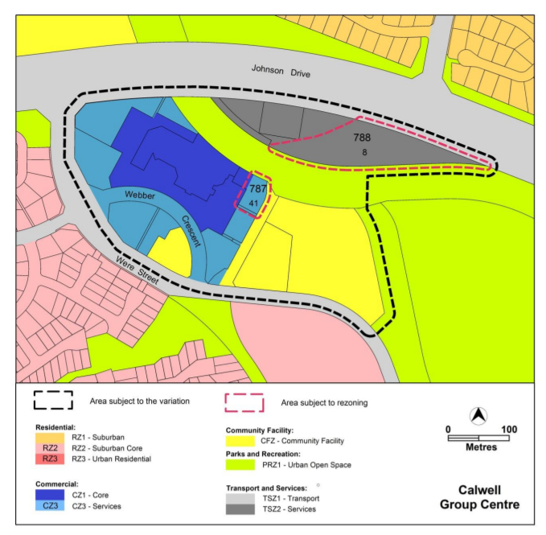
Figure 1: CURRENT CALWELL TERRITORY PLAN MAP
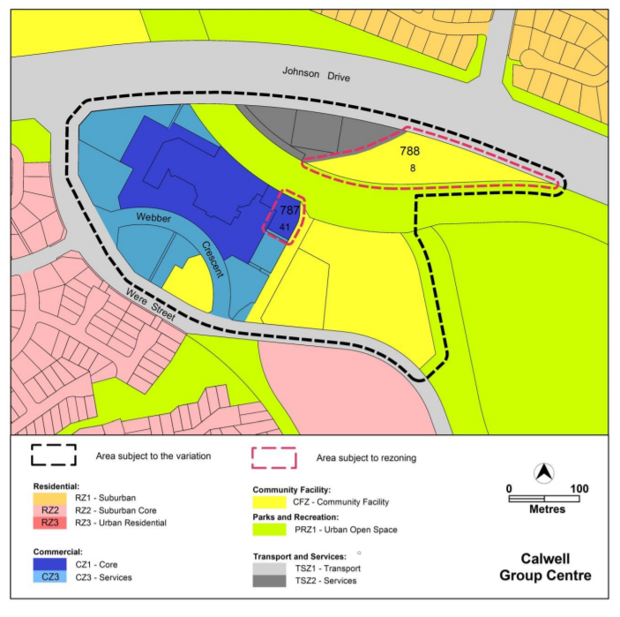
Figure 2: PROPOSED CALWELL TERRITORY PLAN MAP

Amendments to the Calwell Precinct Map and Code
  - Precinct maps identify areas where there are additional planning controls.
  - As outlined in the Territory Plan, Precinct codes provide additional planning, design and environmental controls for individual blocks and may also contain references to provisions in other codes.
  - Precinct codes contain additional rules and/or criteria for particular blocks or parcels identified on the precinct map, to be read in conjunction with the relevant development code. Each element has one or more rules and, unless the respective rule is mandatory, each rule has an associate criterion. Rules provide quantitative, or definitive, controls whereas criteria are chiefly qualitative in nature.
  - The Calwell Draft Variation would make changes to the existing Calwell precinct map and codes including:
    - remove the following additional merit track MT1 development from within the Commercial CZ1 Core Zone: industrial trades, municipal depot and store;
    - permit development up to four storeys over part of block 12 section 787 Calwell and block 41 section 787 Calwell;
    - nominate active frontage areas where development will be required to provide glazing, public access to buildings and awnings;
    - introduce setbacks for taller building elements to retain solar access to public spaces;
    - require residential development two storeys and above to provide balconies and windows to habitable rooms overlooking public spaces;
    - nominate pedestrian paths to be provided or retained as part of any development; and
    - specify design requirements for new buildings.

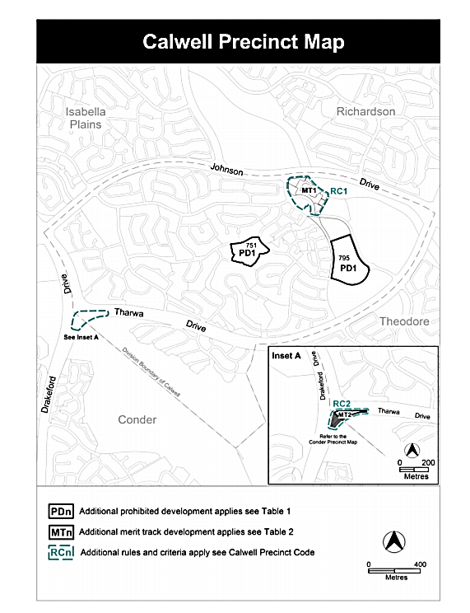
Figure 3: CURRENT CALWELL PRECINCT MAP

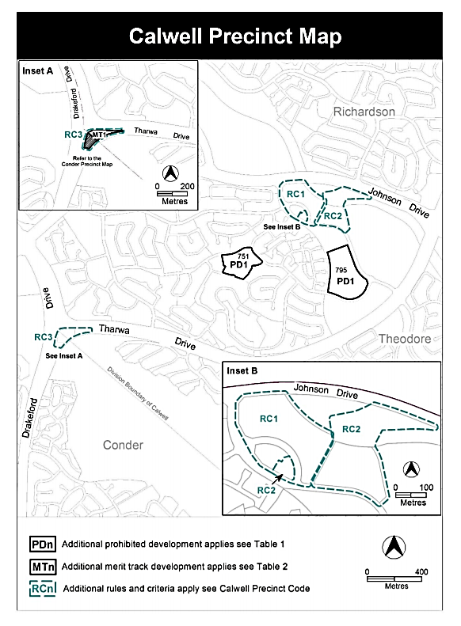
Figure 4: PROPOSED CALWELL PRECINCT MAP

Consultation by Environment, Planning and Sustainable Development Directorate
  - The Directorate released the Calwell Draft Variation for public comment on 10 August 2018. The closing date for comment was 24 September 2019.
  - The Directorate received 3 written submissions.
  - The key issues of public concern included:
    - Building heights;
    - Implications for redevelopment on block 41 section 787 Calwell;
    - Commercial services;
    - Planning process and consultation;
    - Car parking within the group centre;
    - Solar access to pedestrian pathways;
    - Plot ratio;
    - Focus on the Calwell group centre;
    - Community uses;
    - Playground and pedestrian path upgrades within the group centre; and
    - Upgrades and provisions for area outside the group centre
  - In response to public comments the following changes were made to the exhibited version of the Calwell Draft Variation:
    - Removal of ground floor residential uses at Calwell part of section 787 block 41 consistent with the recommendations of the Calwell master plan and upon advice of Transport Canberra and Community Services Directorate. This includes updates to proposed Rule 2 and Figure 1 of the Calwell precinct map and code;
    - Update of proposed criterion 5 of the Calwell precinct map and code to ensure reasonable solar access to surrounding publicly accessible areas;
    - Correction of reference to the public spaces on Figure 4; and
    - Clarification of the total width of the expanded public pedestrian path onto block 41 section 787 Calwell.
  - The Directorate’s report on the consultation was made available on their website.

Comments on Consultation
  - The Committee notes that given the large amount of planning reports, codes, plans and strategies, it can be extremely complicated for individuals and community organisations who wish to participate meaningfully in public consultation.
  - The Committee also noted the length of time it took for the Calwell Draft Variation to progress following public consultation. This was of concern to the Committee as it brought with it the risk of changes in community expectations, changes in population and demographics and new development considerations.

Understanding Of Draft Variation
  - The Territory Plan is a complex document. Draft variations to the Territory Plan can reflect this complexity and it can be difficult for lay persons to understand exactly what the existing rules are and how they will be changed by a draft variation.
  - The Committee notes that extensive sourcing and cross matching of relevant documentation is required to ascertain what has been amended in the Territory Plan or what is being referenced within the draft variation.
Recommendation 1
The Committee recommends that, subject to the following recommendations, Draft Variation 355: Calwell Group Centre – Zone changes and amendments to the Calwell Precinct Map and Code is approved.
Recommendation 2
The Committee recommends that the Environment, Planning and Sustainable Development Directorate consider a review of references to the Planning and Development Act 2007 in Draft Variation 355: Calwell Group Centre – Zone changes and amendments to the Calwell Precinct Map and Code.

Calwell Group Centre Master Plan
  - A master plan is a non-statutory document that sets out how a particular area can (as opposed to will) develop and redevelop into the future. It sets out objectives and strategies to manage development and change over time and defines what is important about a place and how its character and quality can be conserved, improved and enhanced.
  - In Canberra, the EPSDD prepares and periodically reviews master plans for all group centres, key transport corridors and areas adjacent to town centres.
  - The community and industry are engaged throughout the process, to ensure local issues and community values are considered.
  - Implementation of a master plan may involve:
    - Territory Plan variations;
    - Sale of territory owned land;
    - Capital works;
    - Realisation of industry opportunities identified within the master plan; and
    - Further community consultation.
  - The Calwell Group Centre Master Plan was prepared in response to actions outlined in the ACT Planning Strategy (2012) which included the need to investigate opportunities for urban intensification around the Calwell Group Centre.
  - Work began on the Calwell Group Centre Master Plan in 2015, with consultations beginning in May 2015. Following another round of community consultations in early 2016 the final Calwell Group Centre Master Plan was released in September 2016.
Recommendation 3
The Committee recommends that the ACT Government finalises the development of master plans in a more timely fashion.

Key Issues

Rules and Criteria – Block 41 Section 787
  - The Committee noted that the Calwell Draft Variation makes changes to the rules and criteria that are applicable to any development on Block 41, Section 787. This block currently operates as a car wash facility. This area is identified as Area A in Figure 5.
  - The lessee and Canberra Town Planning indicated that they had concerns about the application of built form controls that would apply to this block under the Calwell Draft Variation.

Commercial versus Residential Use
  - It was indicated to the Committee by the lease and Canberra Town Planning that there were significant concerns about the feasibility of any development on Block 41 with no residential allowed on the ground floor of any development in Area A. In their submission Canberra Town Planning indicated that:
The expression of development potential in Area A is unlikely to permit residential development at Block 41 given the other planning controls that dictate a very specific and narrow planning outcome that is unlikely to render a viable development outcome at the site.
  - The lessee and Canberra Town Planning indicated that their earlier investigations had indicated that development on the site had looked feasible about 12 months earlier, particularly with the ‘opportunities that could be ready for residential, looking towards the green space where the flood infrastructure and the pathways are, they get the passive surveillance and the like that we want into these spaces, and the really good interfaces.
  - However, they went on to state that:
We are not going to get that from commercial opportunities. We are really concerned that, even if we can make a building feasibly stack up on that site with a ground floor commercial space, we just will not be able to rent it. So you basically get for sale signs on your primary walkways into the space, or the areas where people potentially would really want to live and have some relief in looking over the green spaces adjacent.
  - The lessee and Canberra Town Planning emphasised the issues that would arise with more commercial space as ‘there is a lot of retail for the size of the centre and the catchment as it is already.’ They indicated that:
We had some concern that the extension of more retail space was potentially problematic. As Arthur said, it is cannibalising the offering that is there at the moment with further competition, and there is not an ability to really support that requirement.
  - In lieu of full residential use, Canberra Town Planning proposed the option of any development in Area A being commercially adaptive residential as:
Allowing commercially adaptable residential use captures the future potential for a building to be repurpose to commercial if required but will facilitate a development outcome in the Master Plan term that will support the Centre.
  - They went on to explain to the Committee that commercially adaptive residential:
It is quite a common concept that we see in land such as this. An example of where this has happened is up and down Anthony Rolfe Drive in Gungahlin, where, initially, when the critical mass of the centre did not support a larger commercial offering, you built a space that is initially allowed to be used for residential use but with the ability that, when the market forces change, it can be retrofitted, without breaking the building down, into commercial space.
On Anthony Rolfe, opposite the core Gungahlin town centre, the two and three-storey developments were initially designed as apartments. When you go there now they are small, often professional, suites. There are some beauty parlours and the like. When the critical mass in the centre becomes large enough to require that commercial services offering, it is able to translate it. The flipside is that we build it and it sits vacant until such time as it becomes viable. That is what happened to the Jamison centre on Eastern Valley Way. I think for a long time those ground floors were vacant, with “for sale” signs. They are just not a good outcome for space and outcome in the public realm.
  - The Directorate indicated that concerns about traffic noise and lights shining in residential windows were a notable factor in deciding against residential on the ground floor of any development on Block 41:
It was really for the street that is in front of it, and the traffic and trucks that use that area, and I suppose the amenity of the residents. If it is residential you are going to have windows to living areas. That is not considered as appropriate use for that situation with that traffic arrangement. That is what TCCS were raising.
  - The Directorate also indicated that the loading docks in combination with the traffic turning in the dead end were significant issues, particularly with the number of trucks:
There was the issue of the loading docks and consultation with the EPA about the noise, and issues of conflicting uses with residential and trucks turning, particularly given the beeping they make. It is a concern in a lot of commercial centres where you have that mix of uses. Their advice was that they would not support the higher residential in that north-western component.
  - It was also indicated in both the Calwell Draft Variation and in evidence given to the Committee that the removal of ground floor residential uses is consistent with the recommendations of the Calwell Master Plan.
I believe there was a lot of direct consultation through the master planning process, the development of the draft master plan and then the following steps, which is why, to begin with, the master plan recommended no residential at the base of the building on block 41. Following those discussions with the lessee, that was considered to have residential, and then we got the feedback. That is why it went out for consultation with residential in it, and then we got the feedback to say that it was not going to be supported.

Frontages
  - In terms of Building Design, Canberra Town Planning indicated that proposed Rule 6 as it applied to primary and secondary frontages would, for a mixed-use development, ‘result in an inefficient design that would be difficult to construct and therefore development of the site would not be feasible.’
  - Additionally they felt that the proposed Rule 14 would also cause issues in terms of design, stating:
The control as described remains overly prescriptive and this would prevent innovative design outcomes on the site which may make pursuit of redevelopment on Block 41 unfeasible, meaning future development of the Centre may not occur, especially with the prohibition of residential use at ground level at Block 41.
  - The Directorate explained that having all residential and an active frontage would not be viable and that the rules and criteria were ‘to take into consideration the issue of the viability of the development having commercial and then only one level of residential above:’
I think there was concern because of wanting to have the active frontage, not to just have a blank wall. That would be difficult with a residential development because people would not want people walking past, particularly since the space between the car park and the property boundary is very little. There are conflicts of views and people walking past, the need to not have blank walls. Well, you could not have a blank wall if it is residential anyway because that would make a horrible living environment.

Path
  - Canberra Town Planning also expressed concern about the requirement under Rule 12 to require the lessee to surrender part of their land to meet the requirement to have the pedestrian access path adjacent to Block 41 at the requisite width of 6 metres. In their submission they indicated that:
The 6 metre path will be the total distance between the north boundary of Block 33 Section 787 and the development on Block 41, this will require a minimum 2.2 metre setback for development on Block 41; land that is currently leased with development potential.
It appears unreasonable to require the Lessee to provide a 6m path within Block 41 along the circa 4m wide pathway block and remove development rights from this Block.
  - In further comments to the Committee, Canberra Town Planning indicated that while they believed the pedestrian link to the Centre is important they told planners that it was:
a real concern. We have got a block of land that we purchased off the government for commercial use and it appears that this plan variation is severing off some of that land which we are not being paid for but we are paying rates on it and have the quiet enjoyment of.
  - They also indicated to the Committee that they believed that:
Proposed pedestrian pathways would ordinarily be provided by TCCS unless the upgrade to the pathways is an off-site works requirement of a development application. In these circumstances the proponent would provide the necessary pathways to the standards required by TCCS.
  - In response the Directorate told the Committee that:
It is looking, particularly with developing the site, at the amenity of the pedestrians walking down that path. Six metres is the standard that is used for those sorts of paths. It is, I think, just over four at the moment. It was considered that that was going to have increased amenity. It was discussed during the master plan process and put into the variation.
  - When it was queried as to whether it was standard to require that public access ways be provided within privately leased land the Directorate indicated:
Yes, we have it in some of the other precinct codes. If they are getting an uplift of development on the site, they are providing something back; it might be provision of a road or something similar to that. In this case it is widening the existing path just to improve that amenity, particularly since otherwise it could have zero setback and seem like an alleyway. That increase to the width would improve that.

Building Height and Overshadowing
  - In their discussion with the Committee the lessee and Canberra Town Planning queried why any future development could not be consistently four storeys or even higher across the whole centre with appropriate management of impacts such as overshadowing:
It is an interesting concept in that we see in group centres developments of up to six storeys being considered and approved, and I think the opportunity to create activity in the centre with residential living is a really good idea. Why would we not, in appropriate areas, look at opportunities and abide by other impacts? Whether it is overshadowing and the like being properly managed, if it is okay for Giralang or it is okay for Curtin why would we not think the same…But it is a principle that if you are going to have more density in town we really should be looking at areas of high activity where these matters can be properly managed and not that that site be restricted.
  - In response the Directorate indicated that following consultation on the master plan, community comment had led to the reduction of the proposed height limit in Block 41 from six storeys to four storeys:
A range of building heights were considered during the development of the master plan. The master plan recommended building heights of 2-4 storeys in response to the need for solar access to public places and to minimise the bulk and scale of taller building elements. Six storey elements were considered as part of the master planning process but following community feedback and further consideration about the bulk and scale of the development in this scale of centre it was considered that lower heights were more appropriate.
  - In terms of there being a consistent four storeys across the whole block as opposed to half being four storeys and half being two storeys the Directorate indicated that:
It’s the same as for the rest of the centre. Looking at things like solar access and the impact on the centre as a whole, it was considered that the northern part of the site was more appropriate in not having a detrimental impact on the rest of the centre. So it reduces the height down because the rest of the centre will be two storeys as well.
If we had put four storeys across the whole centre, the public spaces to the south and to the street would have quite significant overshadowing from midwinter when we define it— between 9 am and 3 pm. Because of the orientation of the block, it would not give a welcoming public domain in that location. Basically, where the four-storey part is, the overshadowing it would create would be on the roof of the eventually two-storey building. Some of it is single-storey at the moment, of course. That would minimise that impact. Overshadowing from a two-storey building is not considered to be as significant as from a four-storey building.
  - When asked if they could view the relevant overshadowing diagrams the Committee was informed in an Answer to a Question on Notice that:
Shadow diagrams specific to the indicative development were not considered necessary during the Territory Plan variation process, as the impact of potential overshadowing from future development within the Calwell group centre was assessed as part of the master planning process. Locating taller building elements to the rear {north side) of the centre was recommended to minimise the impact of overshadowing onto existing and future public spaces at the front {southern end) of the existing shopping centre and to reduce the bulk and scale of the development when viewed from the front of the centre and from the public places.

Rules and Criteria – Block 12 Section 787, Calwell
  - The Committee noted that the Calwell Draft Variation makes changes to the rules and criteria that are applicable to any development on Block 12, Section 787. This area is identified as Area B in Figure 5.
  - The lessee and Canberra Town Planning indicated that they had concerns about the portion of the block earmarked for potential residential development under the Calwell Draft Variation.

Residential Use
  - Whilst the lessee and Canberra Town Planning were very supportive of residential in the centre they had significant concerns about the location identified by the Calwell Draft Variation in Block 12 which placed the residential area (Area B) primarily on top of the current Woolworths Supermarket (Woolies). Canberra Town Planning indicated in their submission that:
The location of Area B at Block 12 will not result in a development opportunity in the term of the master plan (15 years) given the tenancy arrangements with the anchor tenant. To realise the master plan development objective and potential expressed in area B, an alternative opportunity would be required.
  - The lessee and Canberra Town Planning told the Committee that their own earlier investigations indicated that Block 12 presented a primary opportunity for residential, however their assessment was that other parts of the Block were more suitable and are not affected by the long-term lease arrangement with Woolworths:
We explored opportunities to look under and around the loading dock, to potentially enclose that and build on top of that. It is on the club part of the site, which has got infinitely more chance of actually happening because we control the shorter leases, the space underneath, where that part is completely locked away. If we were to have a residential offering in the centre, that would be the area where we would think that was much more likely to happen.
  - They also informed the Committee that they had expressed these concerns to the relevant planners:
Our concerns at the time, which we expressed to the strategic planners, related to the investment that Woolworths has done recently in refurbishing the shop and signing long lease agreements which basically locked up the residential opportunity on top of the supermarket box for up to 20 years. So to have a master plan that has a component for residential that is a really good idea in the centre but is sitting at a 20-year horizon at least is semi-nonsensical.
We were at the time talking to the authority, saying, “That’s a good idea. There are other opportunities in the centre which, if we understand the issues in terms of overshadowing and this, that and the other, can be really easily managed. But if you insist on having the residential box on top of the supermarket, that is a bit of a problem, because we cannot get access to it because Woolworths will not allow us to build on top of them and we will not be able to access car parking underneath them as long as they are operating, and they have got a 10 to 15-year lease. So the master plan is all good and well, but that is not a realistic outcome.
  - The lessee and Canberra Town Planning indicated that despite these conversations they did not feel that their suggestions for alternate locations for residential were well received:
Once the draft master plan came out, we entered into a number of discussions with the authority to talk about our concerns, the commercial issues with having the B space shown on top of the block, and our opportunities on other parts of block 12. The matter of overshadowing, especially in the public forecourt and the play area, was expressed and we felt that we were able to demonstrate that there would be opportunities to mitigate that to either have no impact or very little impact. But even though we got hearings it appears that those considerations were not well received, for whatever reason, and they did not adopt those.
  - The lessee also felt that they were not consulted adequately about the location on Block 12 and did not understand the reasoning for the residential being placed on top of Woolworths:
I did ask the question of her: “Why are you putting it on top of Woolworths?” They said, “It is because of the overshadowing.” I said, “What overshadowing? There is no other high rise around. It is not going to affect anyone.”
  - Although no shadow diagrams were available the Directorate explained that overshadowing was a key factor in their decision making:
During the master plan process, where in the centre would be appropriate for higher buildings was looked at. The impact of overshadowing was taken into consideration. If it was too far to the south of those blocks, the overshadowing into the street and the public spaces would have been an issue. There is also the location of the loading docks and that issue of what is considered to be some incompatible uses with residential. It was a matter of going through any of the constraints on the site and then determining the places.
  - The Committee was also informed that the overshadowing was not the only factor taken into consideration when determining the location for the residential in the centre, including Block 12:
As I mentioned before, solar access, the loading docks, the loading areas, the traffic arrangements—all those things—were taken into consideration to work out practically whether you could do it and to avoid the conflict of uses. Yes, the centre was looked at as a whole. They were some of the areas that were determined to be able to have increased height without affecting the amenity of the centre.
  - In response to question from the Committee as to whether the community was informed about fact that the Woolies site was unlikely to be redeveloped soon because of the long-term lease and the recent renovations the Directorate also indicated that:
I do not believe that it was specifically mentioned. It was not said, “This is the time frame when that might happen.” But when master plans are put forward, in the discussion we have about them we say that this is a 15 or 20-year plan for the area. I do not believe it was specifically said that because it has already had a redevelopment this will not be happening soon, but the master plan would have talked about the need to look at the centre for the coming years.
  - During ongoing discussions about Block B, the Committee conveyed to the Directorate the perception of Canberra Town Planning and the lessee ‘that Strategic Planning in the EPSDD shows little interest in the commercial reality that underpin development of a Master Plan outcome on the said sites.’ In response the Directorate indicated:
I think the comment is unduly harsh. We look at these problems analytically. We sift through a number of different issues. Alix has talked about overshadowing. We also look at the current state of play within the centre and we look at the opportunity in the future to potentially stage development. It may mean that part of the centre is not functional whilst the area of uplift is being developed, but there is always that opportunity. We are trying to be practical. We are trying to look at ways that there could be an uplift, where that uplift is most appropriate and ways that the centre could still trade in some way, shape or form whilst redevelopment is occurring. We feel like we have a balance, where we have enabled that.

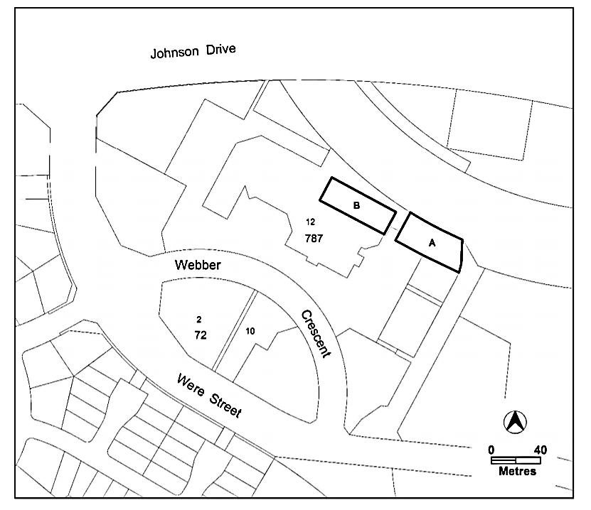
Figure 5: PROPOSED REDEVELOPMENT AREAS

Committee Comment
  - The Committee shares the concerns of the lessee that the proposed rules and criteria for the two redevelopment areas (marked A and B on Figure 5) do not provide enough development potential for redevelopment to occur.
  - Redevelopment area B is located above the supermarket. Given the layout of the centre and other planning rules, there is no clear alternative site the supermarket could be relocated into while redevelopment area B is re-built. Area B will therefore not be effective as currently outlined.
  - Redevelopment area A has more potential, however as it is earmarked for primary active frontage, any redevelopment would need to be mixed-use rather than residential. Given the ageing catchment population of the shopping centre, the Committee agrees with proponent that there is unlikely to be demand for more shopfronts in future.
  - As a result, the Committee believes that the rules and criteria applicable to both redevelopment areas need to be changed whilst still addressing issues of dwelling amenity, overshadowing, privacy, noise management and so on.
Recommendation 4
The Committee recommends that for redevelopment area A (as indicated in Figure 5 on page 24 of the Committee’s report), only, proposed Rule 1 is amended so that residential uses is permitted on the ground floor in areas where there is no designated primary active frontage.
Recommendation 5
The Committee recommends that redevelopment area B (as indicated in Figure 5 on page 24 of the Committee’s report), is extended as far as the western end of Blocks 12 and 29, Section 787, with rules and criteria included to protect solar access and protect future residents from amenity issues arising from the loading docks.
Recommendation 6
The Committee recommends that the ACT Government ensure that shadow diagrams are provided to the Committee and the ACT Community for all similar future variations.

Rules and Criteria – Other

Car Parking
  - Canberra Town Planning also expressed concern about the wording of Criteria 3 which it believed was ‘loosely defined’ and did not ‘provide certainty about the about the ongoing provision of publicly available parking within the Centre.’
The consideration of the criteria that says that the developer just needs to demonstrate that that is enough is, in our opinion, a really strong concern. It gives quite a strong opportunity. In terms of timing, the shops might go through a period where there are fewer tenants. Somebody may do a car parking assessment showing that only half the car park is used and leave those in a redevelopment.
  - Canberra Town Planning indicated that this presented concerns to the lessee of the Calwell Group Centre:
Without clarity on the protection of car parking, the Lessee of Section 787 is concerned that available parking (which is highly utilised) will be reduced by development of the carpark in the future – this is an important consideration for the centre and especially the anchor tenant that require both convenient and quantum of parking to service the use.
Many visitors to the Centre will choose alternative shopping centres in the area if convenient parking is not available, and this will be to the detriment of the Centre’s commercial viability which will result in a loss of amenity to the local residents in surrounding districts.
  - In their response the Directorate told the Committee that the:
…provision is an existing one. It is the same one that we have in all of the group centres, just saying that whatever car parking spaces might be taken up by development are to be replaced, as well as whatever the development is creating. There is a bit of flexibility if it meets the requirements of the parking code, but that would need to demonstrate that the parking needs of the centre are being met. It is consistent with other codes that we have.

Conclusion
  - The Committee has made six recommendations
  - The Committee would like to reiterate its thanks to the Minister, officials, witnesses and submitters who contributed their time and effort to this inquiry.

Ms Caroline Le Couteur MLA
Chair
27 August 2019

Appendix A – Witnesses

Wednesday 29 May 2019

    - Pieter van der Walt – Canberra Town Planning
    - Arthur Tsoulias
    - Amanda Flack
    - Mr Mick Gentleman MLA, Minister for Planning and Land Management
      - Ms Kathy Cusack, Executive Director, Planning Policy, EPSDD
      - Ms Alix Kaucz, Manager, Planning and Urban Design Policy, EPSDD

Appendix B – Submissions
Submission Number | Submitter | Received
01 | Canberra Town Planning | 20 May 2019

Appendix C – Questions taken on Notice/
Questions on Notice
Questions Taken on Notice 29 May 2019
No. | Hearing date | Asked by | Directorate/  Portfolio | Subject | Answer date
01 | 29 May 2019 | Ms Suzanne Orr MLA | EPSDD | Replication of section of multi-unit code | 13 June 2019

Questions on Notice relating to hearing on 29 May 2019
No. | Hearing date | Asked by | Directorate/  Portfolio | Subject | Answer date
01 | 31 May 2019 | Ms Caroline Le Couteur MLA | EPSDD | Replication of section of multi-unit code | 13 June 2019

Legislative for the ACT, Debates, 13 December 2016, Proof Transcript of Evidence, 10 March 2017, p.,40.
Legislative for the ACT, Debates, 13 December 2016, Proof Transcript of Evidence, 10 March 2017, p.,41.
Accessible at https://www.legislation.gov.au/Details/C2016C00482.
Australian Capital Territory (Planning and Land Management) Act 1988, sections 5 and 6.
Australian Capital Territory (Planning and Land Management) Act 1988, section 9.
Australian Capital Territory (Planning and Land Management) Act 1988, section 25.
Accessible at http://www.legislation.act.gov.au/a/1990-59/default.asp.
Accessible at http://www.legislation.act.gov.au/a/1991-100/default.asp.
Accessible at http://www.legislation.act.gov.au/a/2007-24/current/pdf/2007-24.pdf.
Planning and Development Act 2007, section 10.
Planning and Development Act 2007, section 46.
Planning and Development Act 2007, section 48.
Planning and Development Act 2007, section 50.
Planning and Development Act 2007, section 49.
Territory Plan, Accessible at https://www.legislation.act.gov.au/ni/2008-27/Current.
Planning and Development Act 2007, Part 5.3.
Under section 70 of the Planning and Development Act 2007, the planning and land authority must prepare a public availability notice advising that draft variation documents, which have been provided to the minister, are available for public inspection. This notice, which is a notifiable instrument, may be accessed via the ACT Legislation Register website at http://www.legislation.act.gov.au/.
Planning and Development Act 2007, section 73; The Standing Committee on Planning and Urban Renewal is currently the appropriate committee.
Planning and Development Act 2007, section 74.
Planning and Development Act 2007, section 73A.
Planning and Development Act 2007, section 73.
Planning and Development Act 2007, section 75.
Planning and Development Act 2007, subsection 76(3).
Planning and Development Act 2007, section 79.
Planning and Development Act 2007, section 83.
Draft Variation 355 Calwell Group Centre – recommended version, March 2019, p. 1. https://www.planning.act.gov.au/__data/assets/pdf_file/0010/1344691/DV355-recommended-to-the-Minister-s69.pdf
Draft Variation 355 Calwell Group Centre – recommended version, March 2019, p. 6. https://www.planning.act.gov.au/__data/assets/pdf_file/0010/1344691/DV355-recommended-to-the-Minister-s69.pdf
Draft Variation 355 Calwell Group Centre – recommended version, March 2019, p. 6. https://www.planning.act.gov.au/__data/assets/pdf_file/0010/1344691/DV355-recommended-to-the-Minister-s69.pdf
Draft Variation 355 Calwell Group Centre – recommended version, March 2019, p. 6. https://www.planning.act.gov.au/__data/assets/pdf_file/0010/1344691/DV355-recommended-to-the-Minister-s69.pdf https://www.planning.act.gov.au/__data/assets/pdf_file/0010/1344691/DV355-recommended-to-the-Minister-s69.pdf; Planning and Development Act 2007, section 72 (2).
Planning and Development Act 2007, section 72 (3)(b).
Draft Variation 355 Calwell Group Centre – recommended version, March 2019, p. 2. https://www.planning.act.gov.au/__data/assets/pdf_file/0010/1344691/DV355-recommended-to-the-Minister-s69.pdf
Draft Variation 355 Calwell Group Centre – recommended version, March 2019, p. 2. https://www.planning.act.gov.au/__data/assets/pdf_file/0010/1344691/DV355-recommended-to-the-Minister-s69.pdf
Draft Variation 355 Calwell Group Centre – recommended version, March 2019, p. 4. https://www.planning.act.gov.au/__data/assets/pdf_file/0010/1344691/DV355-recommended-to-the-Minister-s69.pdf
Draft Variation 355 Calwell Group Centre – public consultation version, August 2018, p. 6. https://www.planning.act.gov.au/__data/assets/pdf_file/0003/1344738/Att-A-DV355-Calwell-Notifiable-Instrument-public-consultation-notice-s63-and-s64-A14952987.pdf
Draft Variation 355 Calwell Group Centre – public consultation version, August 2018, p. 6. https://www.planning.act.gov.au/__data/assets/pdf_file/0003/1344738/Att-A-DV355-Calwell-Notifiable-Instrument-public-consultation-notice-s63-and-s64-A14952987.pdf
Draft Variation 355 Calwell Group Centre – recommended version, March 2019, p. 5. https://www.planning.act.gov.au/__data/assets/pdf_file/0010/1344691/DV355-recommended-to-the-Minister-s69.pdf
Draft Variation 355 Calwell Group Centre – recommended version, March 2019, p. 5-6. https://www.planning.act.gov.au/__data/assets/pdf_file/0010/1344691/DV355-recommended-to-the-Minister-s69.pdf
Draft Variation 355 Calwell Group Centre – Report on Consultation, February 2019, https://www.planning.act.gov.au/__data/assets/pdf_file/0011/1344674/Report-on-consultation.pdf
Master plans, http://www.planning.act.gov.au/tools_resources/legislation_plans_registers/plans/master_plans.
Master plans, http://www.planning.act.gov.au/tools_resources/legislation_plans_registers/plans/master_plans .
Master plans, http://www.planning.act.gov.au/tools_resources/legislation_plans_registers/plans/master_plans .
Master plans, http://www.planning.act.gov.au/tools_resources/legislation_plans_registers/plans/master_plans .
Calwell Group Centre Master Plan, September 2016, https://www.planning.act.gov.au/__data/assets/pdf_file/0009/983115/20160505-Calwell-Masterplan-Web.pdf
Calwell Group Centre Master Plan, September 2016, https://www.planning.act.gov.au/__data/assets/pdf_file/0009/983115/20160505-Calwell-Masterplan-Web.pdf; https://www.planning.act.gov.au/tools-resources/plans-registers/plans/master_plans/calwell_group_centre_master_plan
Canberra Town Planning, Submission 01.
Mr van der Walt, Transcript of Evidence, 29 May 2019, p. 3.
Mr van der Walt, Transcript of Evidence, 29 May 2019, p. 3.
Mr van der Walt, Transcript of Evidence, 29 May 2019, p. 3.
Canberra Town Planning, Submission 01.
Mr van der Walt, Transcript of Evidence, 29 May 2019, pp. 9-10.
Ms Kaucz, Transcript of Evidence, 29 May 2019, p. 14.
Ms Kaucz, Transcript of Evidence, 29 May 2019, p. 16.
Draft Variation 355 Calwell Group Centre – recommended version, March 2019, p. 5. https://www.planning.act.gov.au/__data/assets/pdf_file/0010/1344691/DV355-recommended-to-the-Minister-s69.pdf ;
Ms Kaucz, Transcript of Evidence, 29 May 2019, p. 16.
Canberra Town Planning, Submission 01.
Canberra Town Planning, Submission 01.
Ms Kaucz, Transcript of Evidence, 29 May 2019, p. 17.
Canberra Town Planning, Submission 01.
Mr van der Walt, Transcript of Evidence, 29 May 2019, p. 9.
Canberra Town Planning, Submission 01.
Ms Kaucz, Transcript of Evidence, 29 May 2019, pp. 14-15.
Ms Kaucz, Transcript of Evidence, 29 May 2019, p. 15.
Mr van der Walt, Transcript of Evidence, 29 May 2019, p. 7.
Ms Kaucz, Transcript of Evidence, 29 May 2019, p. 13.
Answer to Question On Notice No 1, answered 12 June 2019.
Ms Kaucz, Transcript of Evidence, 29 May 2019, p. 15.
Ms Kaucz, Transcript of Evidence, 29 May 2019, pp. 15-16.
Answer to Question On Notice No 1, answered 12 June 2019.
Canberra Town Planning, Submission 01.
Mr van der Walt, Transcript of Evidence, 29 May 2019, p. 4.
Mr van der Walt, Transcript of Evidence, 29 May 2019, p. 3.
Mr van der Walt, Transcript of Evidence, 29 May 2019, p. 5.
Mr Tsoulias, Transcript of Evidence, 29 May 2019, p. 5.
See Answer to Question On Notice No 1, answered 12 June 2019.
Ms Kaucz, Transcript of Evidence, 29 May 2019, pp. 12-13.
Ms Kaucz, Transcript of Evidence, 29 May 2019, p. 14.
Ms Kaucz, Transcript of Evidence, 29 May 2019, p. 16.
Canberra Town Planning, Submission 01.
Ms Cusack, Transcript of Evidence, 29 May 2019, p. 13.
Canberra Town Planning, Submission 01.
Mr van der Walt, Transcript of Evidence, 29 May 2019, p. 6.
Canberra Town Planning, Submission 01.
Ms Kaucz, Transcript of Evidence, 29 May 2019, p. 18.

