The Conduct of Mr Hanson MLA
Standing Committee on Administration and Procedure
august 2016
Report 11

Committee membership

Vicki Dunne MLA (Chair)

Jayson Hinder MLA

Shane Rattenbury MLA

Andrew Wall MLA

Secretariat

Tom Duncan (Secretary)

Janice Rafferty (Assistant Secretary)

Contact information

Telephone 02 6205 0173

Facsimile 02 6205 3109

Post GPO Box 1020, CANBERRA ACT 2601

Email admin.proc@parliament.act.gov.au

Website www.parliament.act.gov.au

Resolution of appointment

In 1995 the Legislative Assembly for the Australian Capital Territory (‘the Assembly’) amended Standing Order 16, which established the Standing Committee on Administration and Procedure (‘the Committee’).

Standing Order 16 authorises the Committee to inquire into and report on, among other things, the practices and procedure of the Assembly.

Terms of reference

Continuing resolution 5AA

COMMISSIONER FOR STANDARDS
This resolution provides for the appointment of a Legislative Assembly Commissioner of Standards.
Resolution agreed by the Assembly
31 October 2013 (as amended 9 June 2016)
COMMISSIONER FOR STANDARDS
That this Assembly requests the Speaker to appoint a Legislative Assembly Commissioner for Standards on the following terms:
- The Speaker must, after each Assembly is elected or whenever the office becomes vacant, appoint a Commissioner for the life of that Assembly and the period of three months after each election. The initial appointment is for the term of the 8th Assembly and the period of three months after the election at the conclusion of that term.
- Before appointing a Commissioner, the Speaker must consult with the Chief Minister, the Leader of the Opposition and Crossbench Members.
- The Commissioner may be dismissed only following a resolution of the Legislative Assembly resolving to require the Speaker to end the Commissioner’s appointment—
- for misbehaviour; or
- for physical or mental incapacity, if the incapacity substantially affects the exercise of the Commissioner’s functions.
However, a motion for such a resolution may only be debated after the Standing Committee on Administration and Procedure (‘the Committee’) has reported to the Assembly that it is satisfied that the Commissioner is unfit for the office or unable to fulfil the Commissioner’s functions.
- The functions of the Commissioner are to:
- investigate specific matters referred to the Commissioner—
- by the Speaker in relation to complaints against Members; or
- by the Deputy Speaker in relation to complaints against the Speaker; and
- report to the Standing Committee on Administration and Procedure.
(c) if the Assembly is not sitting when the Commissioner provides a report to the Committee, the Committee may send its report to the Speaker or, in the absence of the Speaker, to the Deputy Speaker, who is authorised to give directions for its printing, publication and circulation.
- Members of the public, members of the ACT Public Service and Members of the Assembly may make a complaint to the Speaker about a Member’s compliance with the Members’ Code of Conduct or the rules relating to the registration or declaration of interests.
- If the Speaker receives a complaint about a Member pursuant to paragraph (5) and the Speaker believes on reasonable grounds that—
- there is sufficient evidence as to justify investigating the matter; and
- the complaint is not frivolous, vexatious or only for political advantage;
the Speaker may refer the complaint to the Commissioner for investigation and report.
- Members of the public, members of the ACT public service and Members of the Assembly may make a complaint to the Deputy Speaker about the Speaker’s compliance with the Members’ Code of Conduct or the rules relating to the registration or declaration of interests.
- If the Deputy Speaker receives a complaint about the Speaker pursuant to paragraph (7) and the Deputy Speaker believes on reasonable grounds that—
- there is sufficient evidence to justify investigating the matter; and
- the complaint is not frivolous, vexatious or only for political advantage;
the Deputy Speaker may refer the complaint to the Commissioner for investigation and report.
- In exercising the functions of Commissioner the following must be observed:
- The Commissioner must not make a report to the Committee if the Member or the Speaker about whom the complaint was made has agreed that he or she has failed to register or declare an interest if —
- in the Commissioner’s opinion the interest involved is minor or the failure was inadvertent; and
- the Member concerned has taken such action to rectify the failure as the Commissioner may have required within any procedure approved by the Committee for this purpose.
- The Commissioner must not make a report to the Committee unless the Commissioner has—
- given a copy of the proposed report to the Member or the Speaker who is the subject of the complaint under investigation;
- the Member or the Speaker has had a reasonable time to provide comments on the proposed report; and
- the Commissioner has considered any comments provided by the Member or the Speaker.
- The Commissioner must report by 31 August each year to the Speaker on the exercise of the functions of the Commissioner.
- The Committee must review the operation of the Commissioner after two years following the initial appointment of the Commissioner and report to the Assembly in the last sitting period in 2016.
Continuing resolution 5
CODE OF CONDUCT
FOR ALL MEMBERS OF THE LEGISLATIVE ASSEMBLY
FOR THE AUSTRALIAN CAPITAL TERRITORY
This resolution provides for a code of conduct for Members of the Legislative Assembly.
Resolution agreed by the Assembly
25 August 2005 (amended 16 August 2006, 24 October 2013)
CODE OF CONDUCT FOR ALL MEMBERS OF THE LEGISLATIVE ASSEMBLY FOR THE AUSTRALIAN CAPITAL TERRITORY
The Members of the Legislative Assembly for the Australian Capital Territory acknowledge that, in a parliamentary democracy they cannot command, but must constantly strive to earn and maintain, the respect and support of those who have elected them to their positions of honour and privilege as Members.
In committing to this Code of Conduct, Members undertake, to the community and to one another, that the following principles shall guide their conduct as Members in all matters:
- Members should at all times act with integrity, honesty and diligence.
- Members should act only in the interests of, and with respect for, the people of the Australian Capital Territory and in conformity with all laws applicable in the Territory.
- Members should always act in the public interest, make decisions and choices on merit, and not seek to gain financial or other benefit for themselves, their family or friends.
- Members should be reasonably accessible to the people of the electorate they have been elected to serve, and should represent their interests conscientiously.
- Members should be transparent in, and accountable for, their decisions and actions, should avoid or appropriately resolve any actual or reasonably perceived conflicts of interest and should submit themselves to appropriate scrutiny.
- Members should make only proper use of those public resources to which they have access.
- Members should respect the dignity and privacy of individuals, and not disclose confidential information to which they have official access other than with consent or as permitted by law.
- Members should observe proper standards of parliamentary conduct, and observe respect for differences and fairness in their political dealings.
- Members should promote and support these principles by leadership and example, in order to maintain and support public trust and confidence in the integrity of the Assembly and the conduct by its Members of public business.
Consistent with the above principles, Members further undertake that they should:
- Actively seek to prevent any conflict of interest, or the perception of such a conflict, arising between their duties as a Member and their personal affairs and interests, take all reasonable steps to resolve any such conflict or perception of a conflict that does arise, and:
- comply with section 15 of the Australian Capital Territory (Self-Government) Act 1988 (Cwth);
- declare their pecuniary interests and ensure that their declaration is kept up to date pursuant to the resolution of the Assembly ‘Declaration of Private Interests of Members’ agreed to on 7 April 1992 (as amended or replaced from time to time). Include in the Member’s Statement of Registrable Interests all gifts, payments, fees, rewards or benefits valued at more than $100 received in connection with the Member’s functions as a Member; and
- disclose in a manner appropriate to the circumstances any other financial or non-financial interest that they may hold, or which they may be reasonably perceived to hold (other than as a member of the public or of a broad class of persons) which a reasonable observer, informed of that interest, might perceive as giving rise to a conflict of interest with the performance of the Member’s duty as a Member.
- Not solicit to undertake, or undertake, any activity as a Member in return for the provision, promise or expectation of any improper benefit to the Member or to another person.
- Take care to consider the rights and reputations of others before making use of their unique protection of parliamentary privilege consistent with the resolution of the Assembly ‘Exercise of freedom of speech’ agreed to on 4 May 1995 (as amended or replaced from time to time).
- Not use information received by them as a Member that is not in the public domain in breach of any obligation of confidence applicable to their receipt of that information, or improperly for the private benefit of themselves or another person.
- In their capacity as an employer on behalf of the Territory under the Legislative Assembly (Members’ Staff) Act 1989:
- familiarise themselves and comply with the terms and conditions on which their personal staff are engaged and with all applicable policies and practices (including those related to occupational health and safety, discrimination, harassment and bullying, equal employment opportunity and use of information technology);
- not employ a family member as defined in that Act;
- direct their personal staff to be mindful of the Member’s commitment to this Code of Conduct, and to assist the Member to comply with this Code of Conduct; and
- direct their personal staff to comply with any code of conduct applicable to those staff from time to time.
- In all their dealings with staff of the Assembly and members of the ACT Public Service:
- extend professional courtesy and respect; and
- recognise the unique position of impartiality and the obligations of Public Service officials.
- Only make a complaint about the compliance of another Member with this Code of Conduct where they believe there are reasonable grounds to suspect non-compliance and not make any such complaint that is frivolous or vexatious or only for political advantage.
- Cooperate fully with any official inquiry that may be commenced in connection with their compliance with this Code of Conduct, or that of another Member.

Table of contents
Committee membership i
Secretariat i
Contact information i
Resolution of appointment ii
Terms of reference ii
Recommendations vii
1 Introduction 1
2 Conduct of the Commissioner’s inquiry 1
3 The Commissioner’s findings 1
4 The Committee’s Recommendation 1
5 Commentary on the referral process 2
Appendix A Letters (2) from Ms Burch MLA to the Speaker 3
Appendix B Letter from the Speaker to the Commissioner 10
Appendix C Report of the Commissioner for Standards 12
Appendix D Dissenting Report—Mr Hinder MLA 17

Recommendations
Recommendation 1
4.2 The Committee recommends that no further action be taken in relation to this matter.
Recommendation 2
5.5 The Committee recommends that the Standing Committee on Administration and Procedure for the 9th Assembly reconsider the role of the Speaker and Deputy Speaker in the referral of a possible breach of the Code of Conduct to the Commissioner for Standards.

Introduction
          - On 10 and 11 August 2016 Ms Joy Burch MLA wrote to the Speaker to claim that Mr Hanson MLA had breached sections 7 and 15 of the Members’ Code of Conduct (see Appendix A). The matter was referred to the Commissioner for Standards, the Honourable Dr Ken Crispin QC, by the Speaker of the Legislative Assembly, Mrs Vicki Dunne MLA on 15 August 2016 (see Appendix B).
          - The Standing Committee on Administration and Procedure has now received a report from the Commissioner for Standards on his investigation into a complaint raised by Ms Burch.
          - A copy of the Commissioner’s report is published as Appendix C to this report.

Conduct of the Commissioner’s inquiry
          - The Commissioner’s investigation was conducted in accordance with the protocols adopted by the Standing Committee on Administration and Procedure on 24 March 2015. The Commissioner formed the view that there were no disputed factual issues to resolve and therefore did not call upon Mr Hanson to present any written argument.
          - The Commissioner contacted Dr Hall who advised that he had not known that excerpts from statements he had made were being used in electoral material.
          - Having considered all of the material he drafted a report which he sent to Mr Hanson. The Commissioner considered the response of Mr Hanson, and then forwarded a copy of his report to this Committee

The Commissioner’s findings
          - The Commissioner found as follows:
“28. I am not required to express any view about the validity Dr Hall’s opinion as to the need for a new emergency department at the Canberra Hospital or the weight that might be given to it in the context of competing priorities. My only role is to determine whether there are adequate grounds to support the complaint against the Leader of the Opposition. Having examined the substantive issues raised by the complaint, I have concluded that, even if he could be shown to have had some involvement in the production or use of the pamphlet, no breach of his duty could be substantiated.

29. I recommend that the complaint be dismissed.”.

The Committee’s Recommendation
          - The Committee, in accordance with continuing resolution 5AA, has considered the Commissioner’s report and concurs with his conclusion.

          - The Committee recommends that no further action be taken in relation to this matter.

Commentary on the referral process
          - During its deliberations the Committee discussed the referral process and the role of the Speaker as a “gatekeeper” in determining what matters get referred to the Commissioner.
          - The Continuing Resolution specifies that that Speaker may (emphasis added) refer a complaint to the Commissioner for investigation and report if the Speaker believes on reasonable grounds that–
(a) there is sufficient evidence as to justify investigating the matter; and
(b) the complaint is not frivolous, vexatious or only for political advantage
          - The Committee discussed that, when first considering the establishment of a Commissioner for Standards, it was more closely based on the UK model and the original proposal put to the Assembly was that all matters raised were referred to the Commissioner without any vetting. Subsequently, following a review of the Code of Conduct by the Ethics and Integrity Advisor, the model adopted by the Assembly put in place the role of the Speaker (or Deputy Speaker) as a filter so as to not overload the process with inappropriate claims.
          - The Committee was of the view that the issue of whether referrals were vetted by the Speaker (or Deputy Speaker) or were automatically referred to the Commissioner warranted further discussion.

          - The Committee recommends that the Standing Committee on Administration and Procedure for the 9th Assembly reconsider the role of the Speaker and Deputy Speaker in the referral of a possible breach of the Code of Conduct to the Commissioner for Standards.

Vicki Dunne MLA
Chair
August 2016

              - Letters (2) from Ms Burch MLA to the Speaker
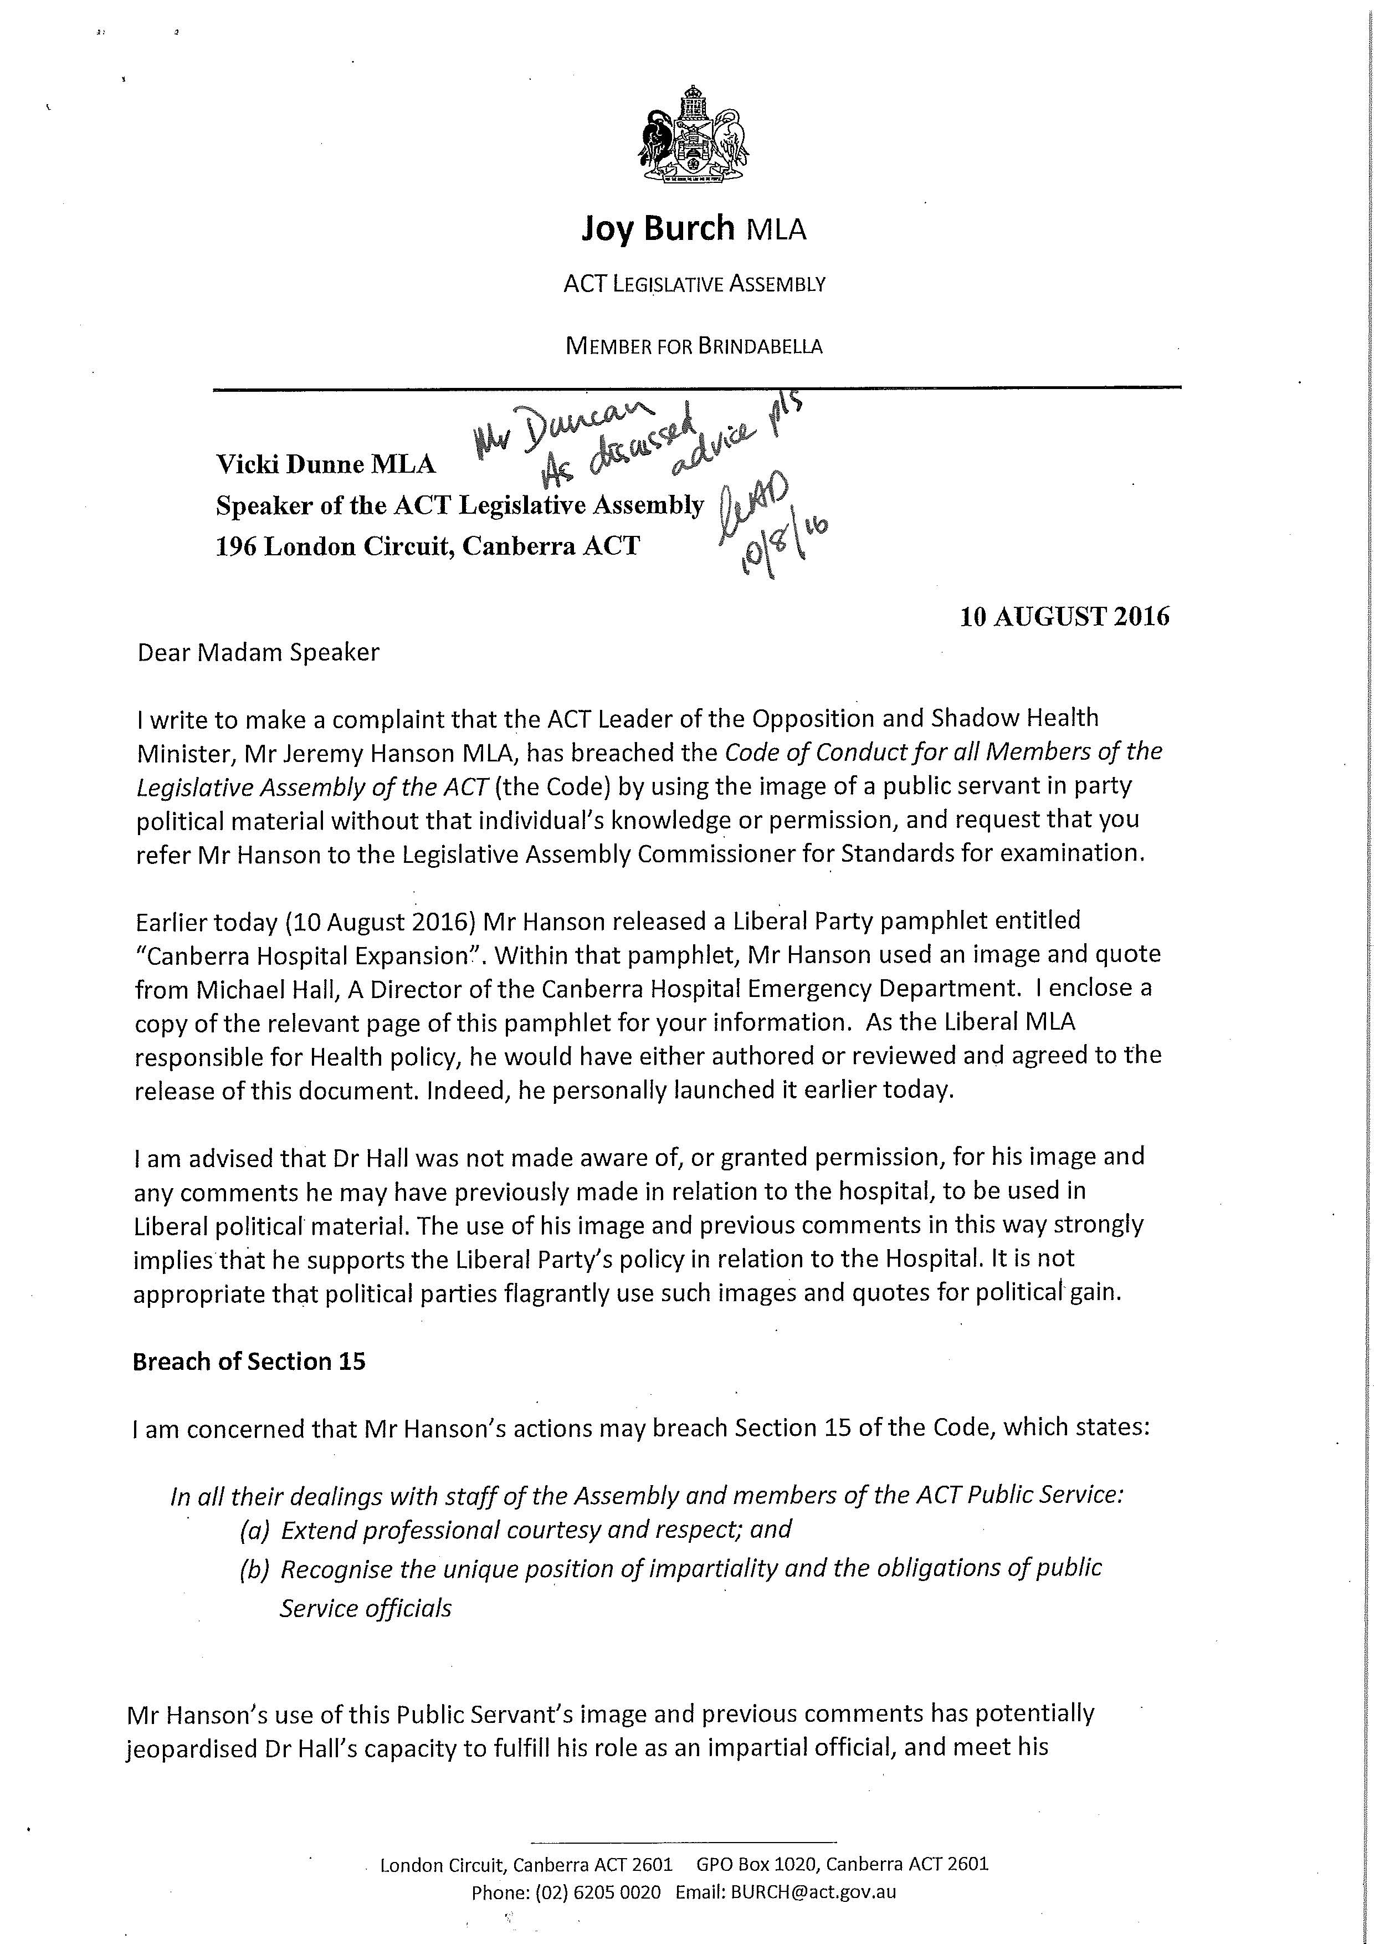

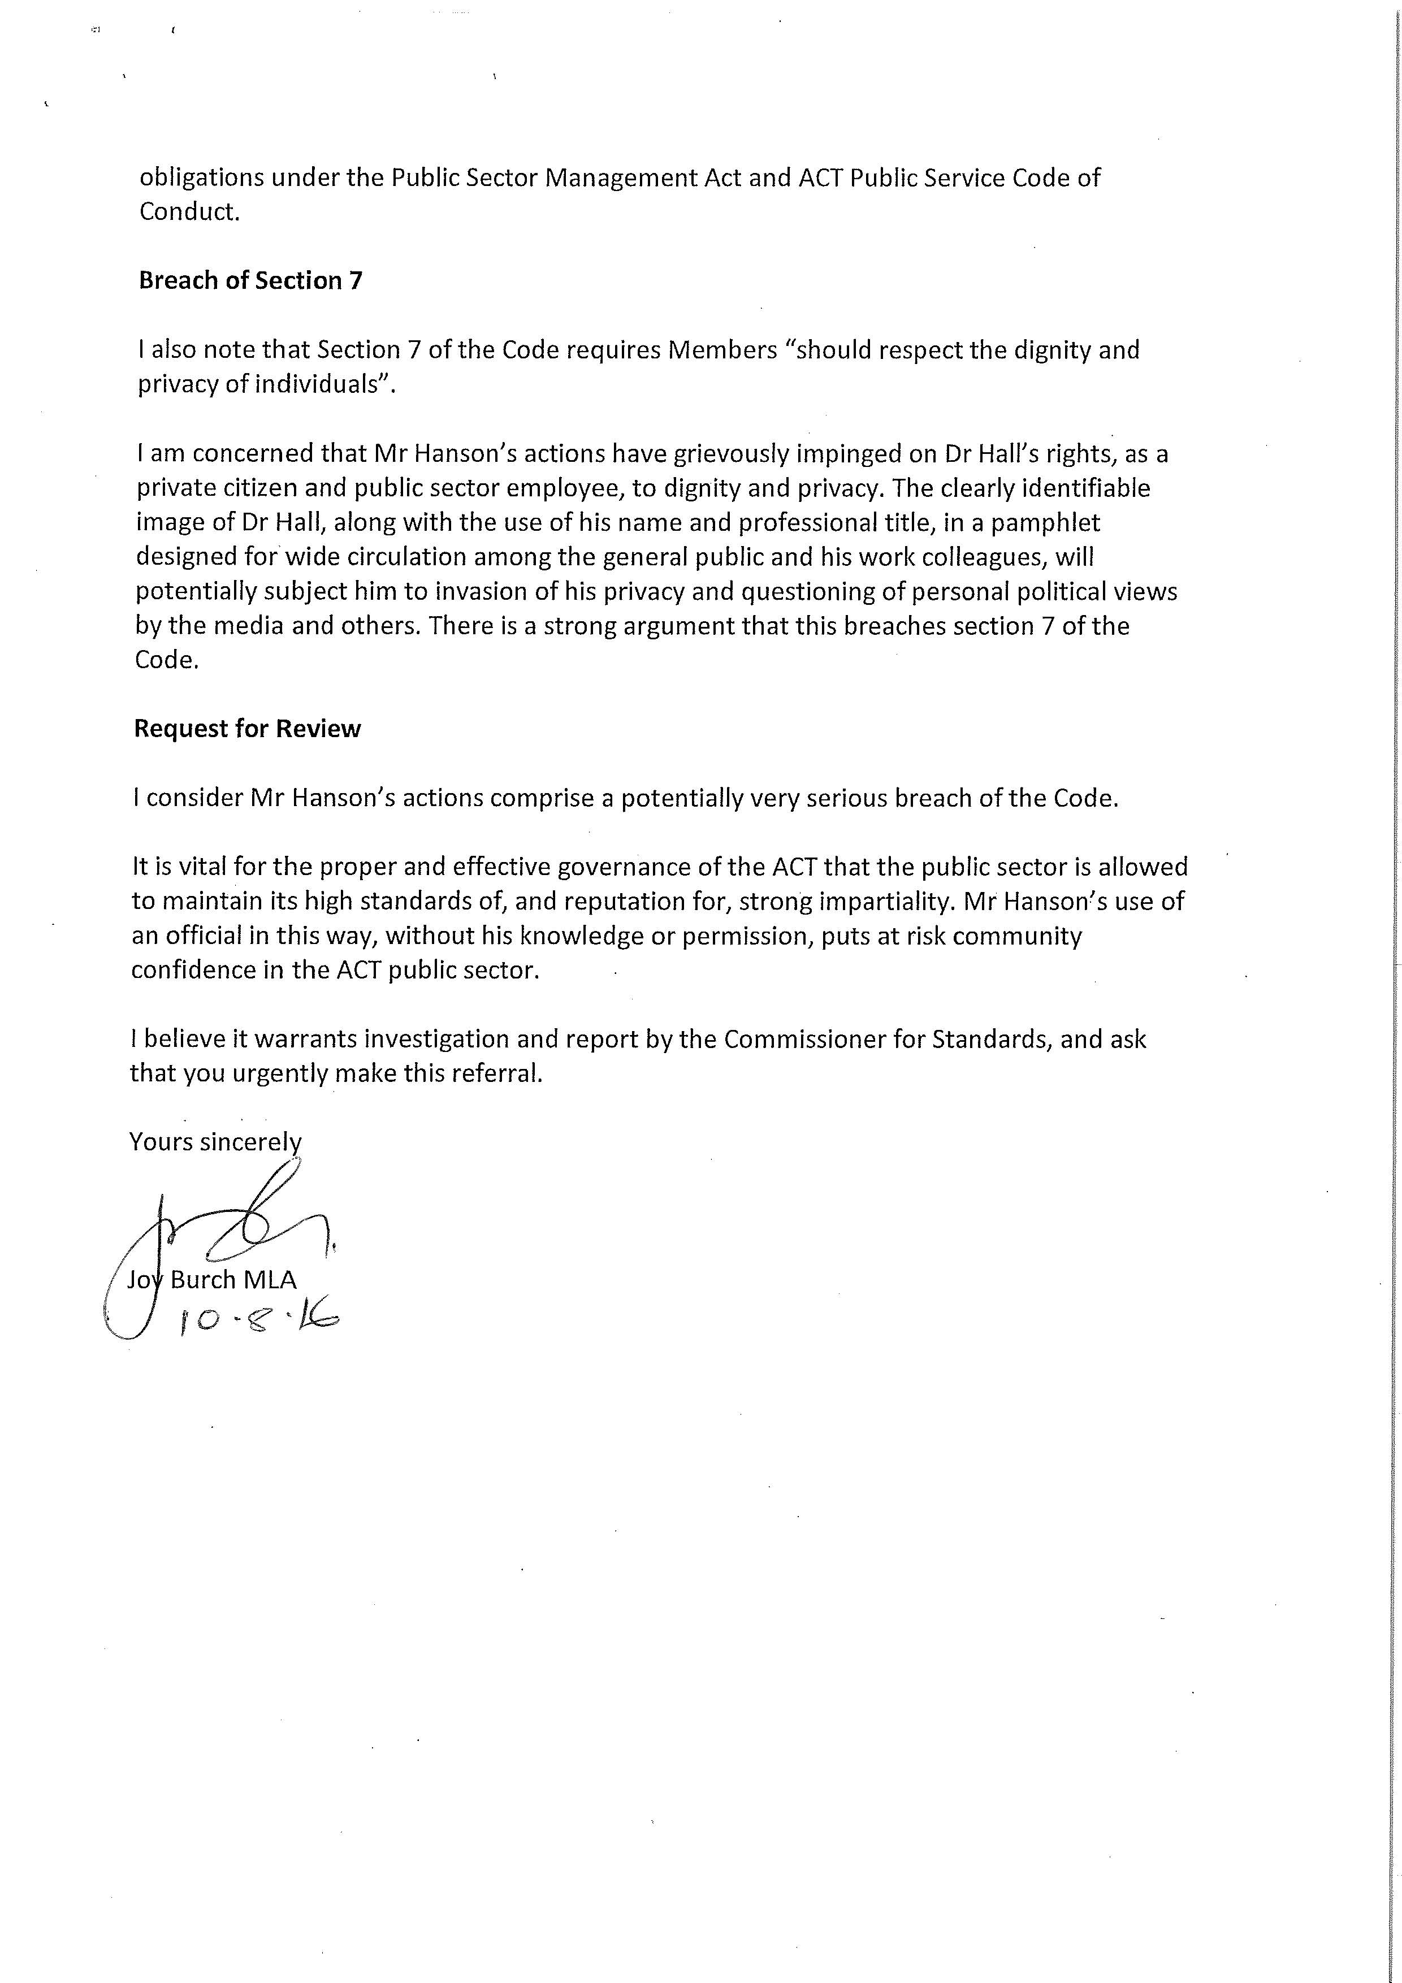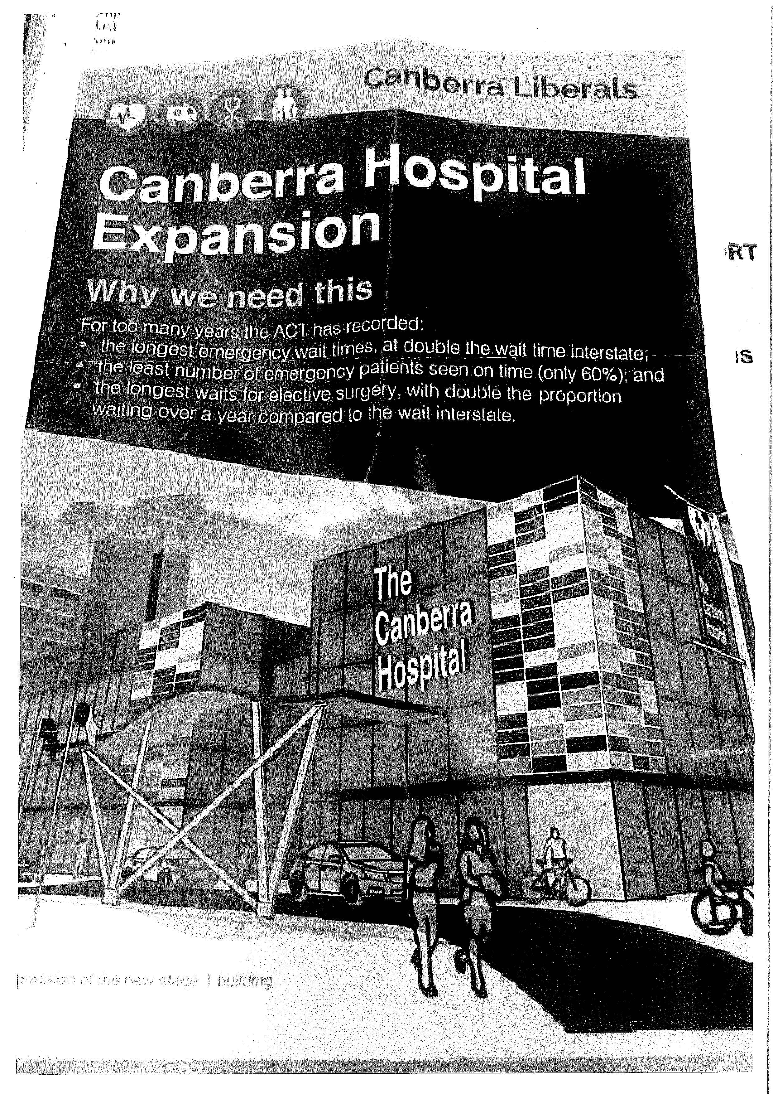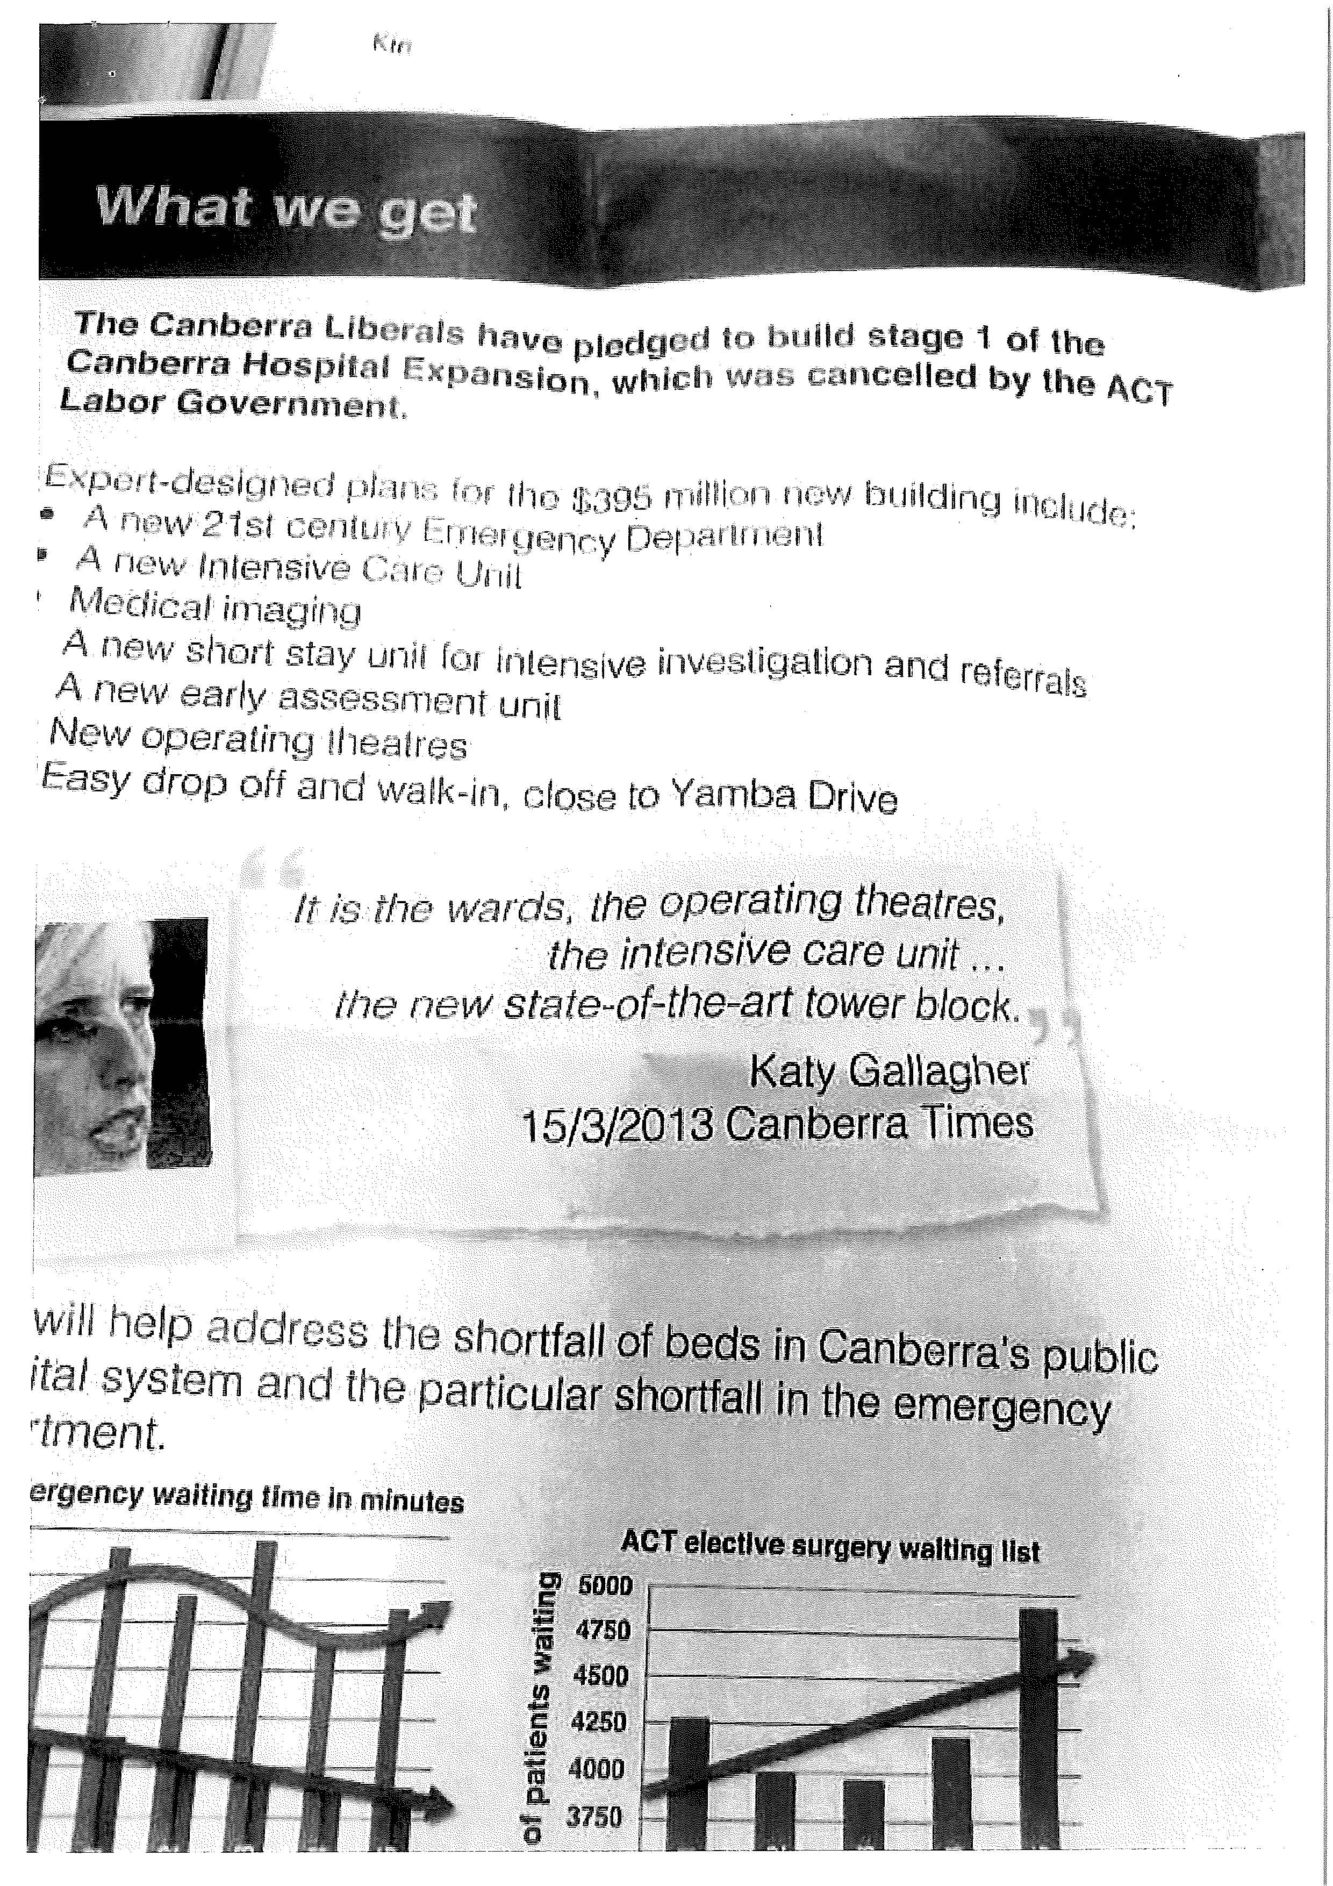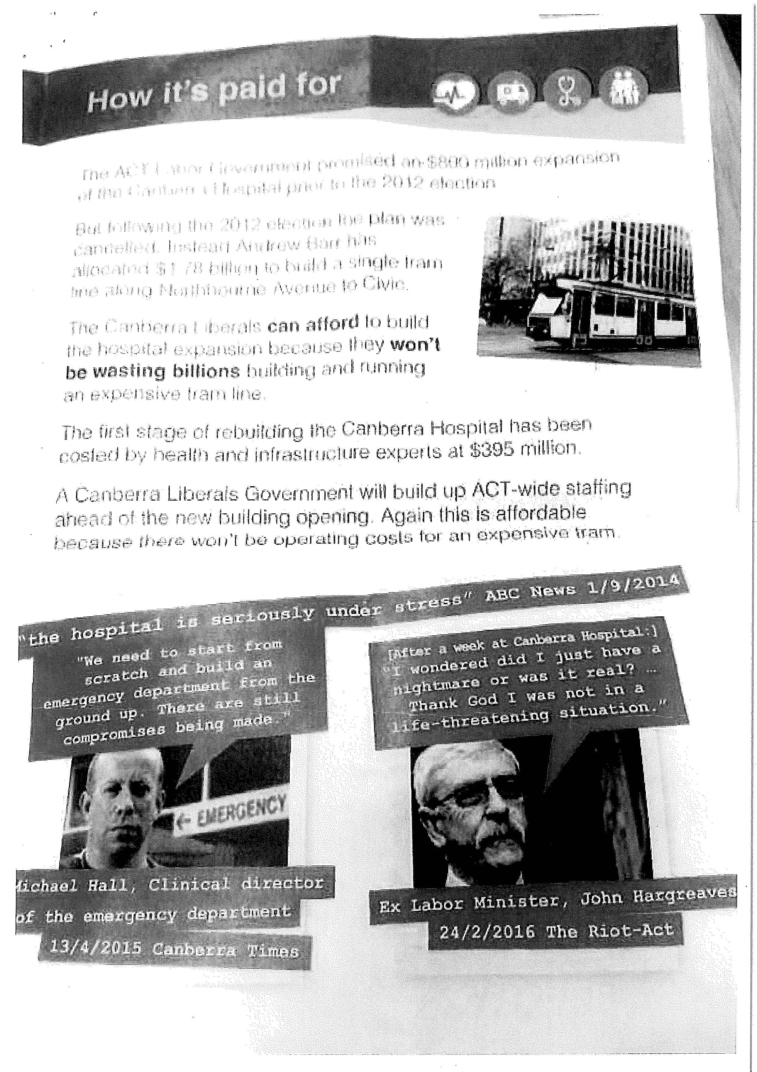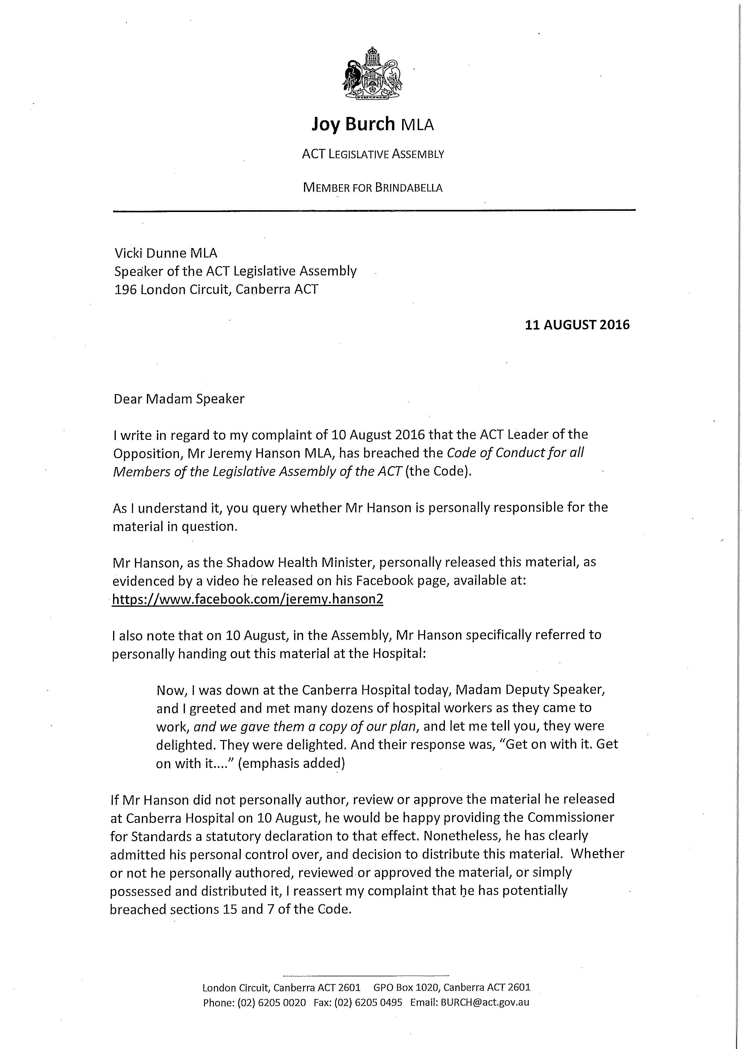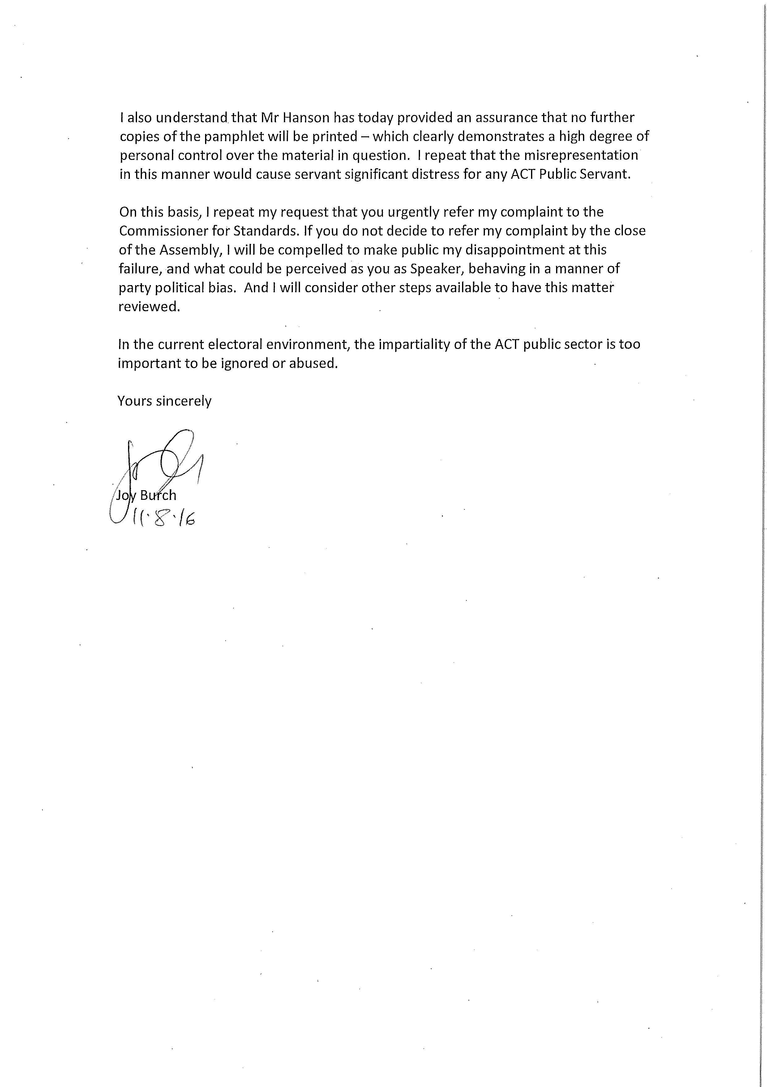
              - Letter from the Speaker to the Commissioner

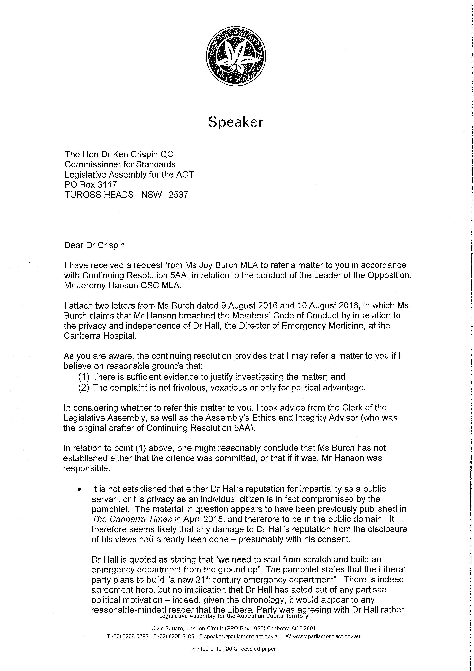
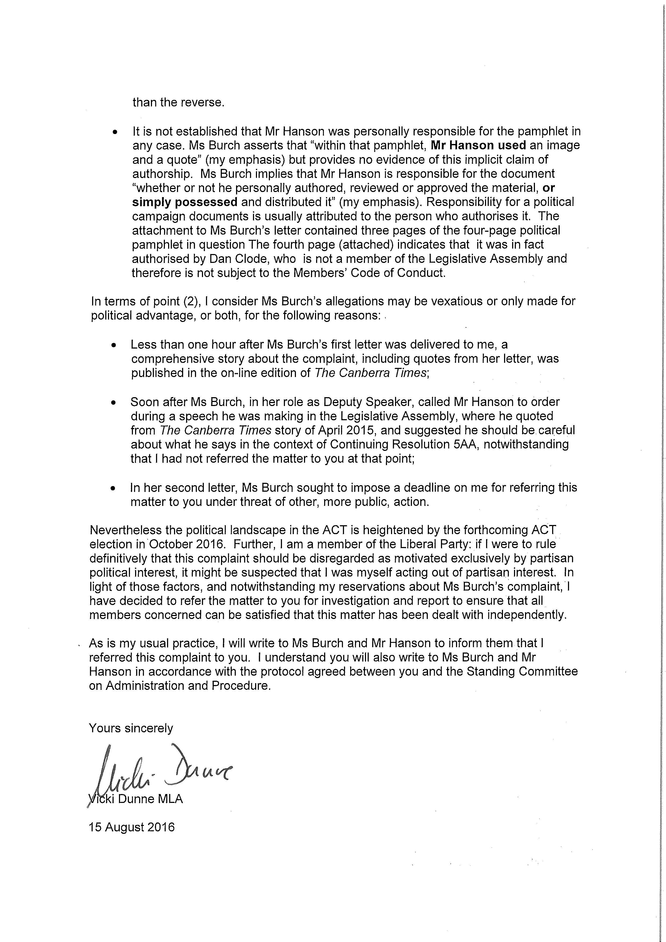
              - Report of the Commissioner for Standards

REPORT INTO A COMPLAINT AGAINST MR JEREMY HANSON CSC MLA, LEADER OF THE OPPOSITION OF THE AUSTRALIAN CAPITAL TERRITORY

Background

- On 10 August 2016 an electoral pamphlet, headed “Canberra Hospital Expansion”, was issued, purportedly by “Dan Clode for the Canberra Liberals. The pamphlet included two quotations attributed to Dr Michael Hall, Clinical Director of the Canberra Hospital’s emergency department.

- The first said simply, “the hospital is seriously under stress.” This was apparently taken from statements made by Dr Hall during the course of an ABC interview on 1 September 2014.

- The second was taken from a statement he made during a subsequent interview which was reported by the Canberra Times on 13 April 2015:

We need to start from scratch and build an emergency department from the ground up. There are still compromises being made.

The complaint

- The complaint was made by Ms Joy Burch MLA in a letter to the Speaker of the Legislative Assembly, Ms Vicki Dunne MLA, dated 10 August 2016. It suggested that the Leader of the Opposition, Mr Jeremy Hanson CSC MLA, may have committed breaches of sections (7) and/or (15) The Code of Conduct for all Members of the Legislative Assembly of the Australian Capital Territory (‘the Code’) by reason of his involvement in the production or use of the pamphlet. Ms Burch supported the complaint in a subsequent letter dated 11 August 2016.

- The complaint was referred to me by the Speaker by letter dated 15 August 2016.

The application of the Code

- Since the complaint relates to the publication and use of electoral material, there may be some perception that it should be dealt with by the Electoral Commission but, whilst section 10A (1) of the Electoral Act 1992 authorises the Commission to give the Speaker a report on anything relating to elections, it’s functions, as defined by section 7, do not extend to the investigation of complaints of this nature. There has been no suggestion of any breach of the provisions of Part 17 of the Act, which deals with electoral offences, and there is nothing in the Act that would seem to provide any reason for me to decline to investigate a complaint of this nature.

- The Code applies to Members of the Legislative Assembly who undertake that the principles expressed in it “shall guide their conduct as Members in all matters.” It does not apply to others who may be members or supporters of political parties but who have not themselves been elected to the Legislative Assembly. Hence, I am not required to express any opinion about the conduct of Dr Hall in making the comments attributed to him or that of Mr Clode in authorising the pamphlet, save insofar as their actions may be relevant to the complaint against the Leader of the Opposition.

- There is nothing in the Code to suggest that a Member of the Assembly should be taken to bear some vicarious responsibility for the actions of others who may have acted in a manner contrary to one of more of the principles therein expressed. The complaint, as amplified by the second letter, is based upon a contention that the Leader of the Opposition may himself have breached the Code by his involvement with the pamphlet, irrespective of whether “he personally authored, reviewed or approved the material, or simply possessed and distributed it”.

The investigation

- The role of the Commissioner is limited to investigating the matters referred to him or her by the Speaker and reporting to the Standing Committee on Administration and Procedure (‘the Committee’). It is for the Committee to determine whether the complaint has been substantiated in any respect and, if so, what consequences should ensue. However, since my report is intended to assist the Committee, I have taken the view that I should record my own impressions of the evidence and express my own opinion as to whether it is capable of substantiating any aspects of the complaint.

- The investigation was generally conducted in accordance with the protocol adopted by the Committee on 24 March 2015 which includes that statement:

It is the Commissioner’s intention to rely upon written material and not to hold any face to face discussions or otherwise receive oral evidence unless such a course proves necessary for the fair and satisfactory completion of a particular investigation.

- In other circumstances, it might have been necessary to begin by determining whether the Leader of the Opposition should be taken to bear some personal responsibility for the production and/or distribution of of the pamphlet. Had it been necessary to resolve this issue I would, of course, have written to him seeking clarification of any involvement he may have had and inviting him to make any comments he thought appropriate. However, in view of the conclusions I have reached in relation to the more substantive questions raised by the complaint, I have found it unnecessary to resolve this issue.

- The more substantive questions are simply raised by the words and image used in the pamphlet and there are no disputed factual issues to resolve. Having considered these questions in the light of the principles reflected in the relevant sections of the Code, I formed the view that the allegations could not be sustained and hence found it unnecessary to call upon the Leader of the Opposition to present any written argument. In adopting this course I was, of course, conscious of the fact that he would have the opportunity to comment on a draft of my report before it was finalised (as required by continuing resolution 5AA made by the Legislative Assembly on 31 October 2013).

- I did contact Dr Hall, who is now a senior staff specialist with ACT Health. He informed me that he had not known that excerpts from statements he made in 2014 and 2015 were to be used in electoral material. He explained that he had been asked to participate in the interview that occurred in 2014 to explain that The Canberra Hospital had a shortage of available beds and encourage people to consider other options than presentation to Emergency Department, He had been accompanied by the Deputy Director of the Canberra Hospital and officers of the ACT Health Directorate. The interview in 2015 had occurred in the context of an announcement about planned extensions to the emergency department and he was asked to describe ‘the virtues of the ED rebuild’. Prior to making the statement quoted in the pamphlet, he had explained the benefits of the then new design which he had described as exciting. Dr Hall stressed that he had never made an approach to the media or sought to actively criticise Health or government policy.

- A draft copy of this report was duly sent to the Leader of the Opposition on 18 August 2016. He responded on the following day but sought no amendment.

The alleged breaches

- I will deal with the suggested breaches of the Code on the assumption that the relevant conduct could be sheeted home to the Leader of the Opposition in some way, though, as I have mentioned, I found it unnecessary to resolve that issue.

Section (7)

- Section (7) provides that:

Members should respect the dignity and privacy of individuals, and not disclose confidential information to which they have official access other than with consent or as permitted by law.

- There has been no suggestion that the Leader of the Opposition inappropriately disclosed confidential material; this aspect of the complaint is based solely on the contention that the use of Dr Hall’s name, professional title and photographic image in a pamphlet intended for wide circulation involved a failure to respect his dignity and privacy.

- Section (7) recognises important principles that one might hope would be heeded by members of all Australian parliaments. However, I am not satisfied that they have been breached by the production and distribution of this pamphlet.

- The relevant passage and and image have not been used in a manner that is disparaging of Dr Hall in any way. On the contrary, the citation of his statements in support of the policy advocated in the pamphlet suggests that he is a person whose opinions are worthy of respect. Nothing is disclosed about him that was not revealed by the public statement he made in April 2015 and there is no reference to his personal life or political views.

- The citation of the excerpts from his earlier statements could lead to some media interest in him and perhaps even provoke questions about his political views, as Ms Burch apparently fears, but that is not, of itself, evidence of a failure to respect his dignity or privacy. The statements were not made not made by him as a private individual but as a government official addressing issues relating to his professional responsibilities. Public statements of this nature are likely to be quoted by others, especially when they relate to issues of public importance. That may have unexpected consequences for those making them, but it is an inevitable corollary of entering the public domain within an open society.

- Statements by public officials, including military leaders, police commissioners and auditors general, are frequently cited during political discussions in all Australian jurisdictions. That is entirely appropriate. It is a potentially important part of the democratic process and serves the public interest by ensuring that the issues they have raised may be properly considered and addressed. I do not accept that section (7) was intended to stifle or restrict political debate about such statements.

Section (15)

- In section (15) Members undertake that they should:

In all their dealings with staff of the Assembly and members of the ACT Public Service:
(a) extend professional courtesy and respect; and
(b) recognise the unique position of impartiality and the obligations of Public Service officials.

- The complaint alleges, in essence, that the citation of Dr Hall’s previous comments has potentially jeopardised his capacity to fulfil his role as an impartial official and comply with his obligations under the Public Sector Management Act and the ACT Public Service Code of Conduct.

- In my opinion these concerns are unwarranted. The passage in question does not question his integrity, professional ability or objectivity and there is no reason to imagine that it would alarm any of his patients. Pleas for further hospital facilities by senior medical officials are not novel and, in the absence of some obvious political imputation, are invariably seen as nothing more than attempts by conscientious doctors to obtain better facilities for their patients.

- There is no basis for concern that the citation in the pamphlet of statements properly made on earlier occasions might undermine his capacity to meet his obligations under the Public Sector Management Act or the ACT Public Service Code of Conduct.

- As section (15) recognises, public servants have a unique position of impartiality. Hence, they should not be normally drawn into political controversy. But this does not means that public statements made by senior officers in the course of their duties cannot later be cited by Members of the Assembly, whether during the course of election campaigns or otherwise. Of course, those who have made them should be dealt fairly, courteously and with due recognition of the possibility, that despite the public nature of their comments, they may have had no wish to become involved in political controversy. Nonetheless, even robust public debate may be in the public interest, especially when, as in this case, the comments are made by a senior official effectively making a case for the expenditure of substantial public funds.

- It is true that Dr Hall’s comments were quoted without his consent or knowledge but, in my opinion, section (15) should not be taken to prevent Members from citing relevant public statements without the consent or knowledge of those who made them. As former public official, once prone to making public statements that others sometimes found controversial, I understand that it may be disconcerting to find that one’s earlier comments have been revisited but, in the absence of some issue of copyright, one has to accept that others are entitled to refer to them and to debate the merits of the views expressed. The imposition of some obligation for Members to forewarn current or former officials of their intention to cite their earlier statements would inevitably hamper, if not restrict, political debate about matters that may be of real public importance. This was clearly not intended.

CONCLUSION

- I am not required to express any view about the validity Dr Hall’s opinion as to the need for a new emergency department at the Canberra Hospital or the weight that might be given to it in the context of competing priorities. My only role is to determine whether there are adequate grounds to support the complaint against the Leader of the Opposition. Having examined the substantive issues raised by the complaint, I have concluded that, even if he could be shown to have had some involvement in the production or use of the pamphlet, no breach of his duty could be substantiated.

- I recommend that the complaint be dismissed.

K. J. Crispin QC
Commissioner for Standards
18 August 2016

              - Dissenting Report —Mr Hinder MLA

Minority Report: to the Report of the Committee on Administration and Procedure:
This dissenting report refers to the Report of the Administration and Procedure Committee into the complaint by Ms Burch relating the allegations of a breach of the Members Code of Conduct by Mr Hanson referred to the Commission for Standards, Dr Ken Crispin QC.

Background:
- In the Westminster tradition of Parliamentary Democracy, of which the ACT Legislative Assembly is a part, the occupant of the Speakership of the Parliament is to remain impartial and above the political fray.

- In the ACT Legislative Assembly, the impartiality of the Speaker is in regards to their duty to refer complaints made under the Continuing Resolution 5AA to the Commissioner for Standards, complaints are forwarded when and as they are lodged by Members of the Assembly, or other qualifying complainants, under the resolution.

- In the life of the 8th Assembly the Speaker has received only three (3) complaints alleging a breach of the Code of Conduct from Members of the Assembly regarding other Members and has referred all 3. (It should be noted that the original motion that established 5AA initially proposed automatic referral of all complaints – this was amended to have the Speaker refer frivolous complaints to avoid a floodgates scenario. The small number of complaints – three during the 8th Assembly – suggests that this concern was unfounded and automatic referral may be appropriate.)

- The first two complaints referred by the Speaker this year were made by Canberra Liberal Members of the Assembly against Labor members of the Assembly. (Copies of the referral letters are annexured and marked (i) and (ii).

- These complaints were referred to the Commissioner for Standards by the Speaker without comment from the Speaker as to the merits of the complaints, only stating that the Speaker was satisfied that:

- There is sufficient evidence to justify investigating the matter; and
- The complaint is not frivolous, vexatious or only for political advantage.

- The third complaint of this Assembly, dated 9/8/2016 was made by a Labor Member of the Assembly against a Canberra Liberals Member and is the subject of this report. A copy of the Speaker’s referral letter is annexured and marked (iii).

- The Speaker is a member of the Canberra Liberals. This fact is stated by the speaker in her letter to the Commissioner (highlighted in annexure (iii). Had the third referral letter been identical to the first and second with these highlighted words added this dissenting report would be unnecessary.

Improper Process:

- In relation to each complaint the Clerk drafted letters of referral.

- Letters (i) and (ii) were sent by the Speaker to the Commissioner for Standards. The Clerk’s proposed letter three was discarded by the Speaker who instead personally drafted the letter reproduced as annexure (iii).

- The function of the Speaker in relation to 5AA is very clear. On receipt of a complaint the Speaker has two options:

  - to refer the matter to the Commissioner for Standards as per the threshold in paragraph [5] above; and
  - To dismiss the complaint because they are not satisfied that the complaint satisfied the threshold test.

- The Commissioner for Standards’ contract originates from the Speaker’s Office. The Commissioner is appointed by the Speaker.

- It is not open to the Speaker to refer a matter to the Commissioner for Standards, and in the same document give commentary on the merits of a complaint.

- The Speaker’s lengthy referral amounts to ‘drafting instructions’ and analysis to the Commissioner. The Speaker‘s actions put the Commissioner for Standards in an impossible position.

- The Commissioner’s ability to fairly and independently adjudicate a complaint is paramount. The Speaker’s choosing to ignore the Clerk’s recommended course of action appears to attempt to override that independence. The Speaker, his appointer, has analysed the facts, given evidence herself and stated how the evidence and complaint should be treated.

- Further, the way the Speaker has handled this complaint against a Liberal Member of the Assembly is demonstrably different to the process used for the previous two complaints. The Speaker’s subsequent actions in the media and public spheres were also dissimilar.

- This minority report wishes to put on record three (3) principle concerns relating to how this third complaint has been handled by the Speaker:

  - The Speaker’s presiding over and editorialising the matter in the referring letter to the Commissioner for Standards appears to attempt to compromise the Commissioner’s reasoning in evaluating the complaint.
  - The Speaker’s comments that the complaint is vexatious appear hypocritical, given the active attempts to change what can only be assumed was an entirely adequate referral letter drafted by the Clerk, particularly regarding the role of the media and her stated perception of this matter as a vexatious and/or politically motivated complaint.
  - Possible breaches of privilege surrounding the media’s premature knowledge of details surrounding this complaint.

- This report does not, in any way, cast doubt on Dr Crispin’s impartiality or professional integrity. His conduct and judicial conscience is beyond reproach. The Speaker’s actions that have intentionally and knowingly compromised the intended neutrality of the process. Consequently, the impression a reasonable person may have is that the investigation of the complaint was tainted before the Commissioner received it.

The Speaker’s handing of the referral to the Commissioner for Standards.
- Continuing Resolution 5AA of the ACT Legislative Assembly established the role of the Commissioner for Standards:
Paragraph (4) of Continuing Resolution 5AA States that the function of the Commissioner is to:
- Investigate specific matters referred to the Commissioner –
- By the Speaker in relation to complaints against members.

- Paragraph(6) of Continuing Resolution 5AA States:
If the Speaker receives a complaint about a Member pursuant to paragraph (5) and the Speaker believes on reasonable grounds that –
- There is sufficient evidence as to justify investigating the matter; and
- The complaint is not frivolous, vexatious or only for political advantage
The speaker may refer the complaint to the Commissioner for investigation and report.
- In addition to the appointment of the Commissioner for Standards in paragraph (1), the provision contained in paragraph (6) outlines the Speaker’s very limited function in this process. That function is to refer complaints that are not frivolous or vexatious, or to decline to refer the complaint.

- On 15th August 2015 the Speaker wrote to Dr Ken Crispin QC to refer a complaint made by Ms Burch, alleging a breach of the Member’s Code of Conduct against Mr Hanson.

- In the letter referring the matter, the Speaker made the following commentary:
“In relation to point (1) [of Paragraph (6) of Continuing Resolution 5AA] , one might reasonably conclude that Ms Burch has not established either that the offence was committed, or that if it was, Mr Hanson was responsible”
And:
“In terms of point (2) [of Paragraph (6) of Continuing Resolution 5AA], I consider Ms Burch’s allegations may be vexatious or only made for political advantage, or both... “
And:
“Nevertheless the political landscape in the ACT is heightened by the forthcoming ACT election in October 2016. Further, I am a member of the Liberal Party: if I were to rule definitively that this complaint should be disregarded as motivated exclusively by partisan political interest, it might be suspected that I was myself acting out of partisan interest... I have decided to refer the matter to you for investigation and report to ensure that all members concerned can be satisfied that this matter had been dealt with independently.”

- The drafting of the referral by the Speaker contained value-laden information. Such a referral was not an option available to the Speaker pursuant to Continuing Resolution 5AA. It is the Speaker’s only duty to refer, or, decline a matter.

- It is not in the ambit of the Speaker’s function to make commentary on the merits and to then refer the matter. The Commissioner for Standards now is in receipt of a tainted complaint for neutral and impartial evaluation in addition to forming an opinion on the complaint is now compromised. I note again that no such advice/opinion was offered with the two previous referrals.

- The independence of the Commissioner for Standards is central to the probity of any investigation by the Commissioner. It is crucial not only that the Commissioner is independent, but that he is seen to be independent and impartial in the carrying out of their duties.

- It is understand that once a complaint has been referred and the subject of the complaint has had an opportunity to respond, the Protocol for investigation against members adopted by the Standing Committee on Administration and Procedure on 24th March 2015 leaves all evidence gathering, investigation and evaluation in the hands of the Commissioner.

- There is no provision in the protocol for the Speaker to refer, purport to gather evidence, complain about the conduct of the complainant and to pass commentary on the matter received.
The earlier complaints:
- In relation to complaints brought against Labor members in the Legislative Assembly, Mr Barr and Ms Burch, the Speaker referred the complaints stating only the 5AA test that a referral occurred is evidence that the Speaker was satisfied. This report makes no comment on the Speaker’s determination in those matters but highlight again the dissimilar treatment of the third complaint.
- The Clerk drafted what is assumed were entirely adequate, succinctly worded and impartial referral letters for all three complaints. The first two were sent unaltered. The third was rejected and the Speaker drafted the letter attached as annexure (iii). This report submits that the Clerk’s letter was adequate and appropriate and that the Speaker has in taking the unprecedented step of rejecting the Clerk’s draft acted with impropriety by attempting to influence the findings and pervert the outcomes of the Commissioner’s investigation.

- This report contends that the Speaker has acted in a partisan manner in regards to her treatment of complaints made to the Commissioner for Standards.

The Speaker’s claims that Ms Burch’s complaint was ‘vexatious or only made for political advantage’.
- In the Speaker’s commentary on the complaint in the referral letter, the Speaker considers ‘Ms Burch’s allegations [to be] vexatious or only made for political advantage, or both...’, for the following reasons:
  - Less than one hour after Ms Burch’s first letter was delivered to me, a comprehensive story about the complaint, including quotes from her letter, was published in the on-line edition of the Canberra Times;
  - Soon after Ms Burch, in her role as Deputy Speaker, called Mr Hanson to order during a speech he was making in the Legislative Assembly, where he quoted from The Canberra Times story of April 2015, and suggested he should be careful about what he says is the context of Continuing Resolution 5AA, notwithstanding that I had not referred the matter to you at that point;
  - In the second letter, Ms Burch sought to impose a deadline on me for referring this matter to you under threat of other, more public action.

- This report does not consider claims of vexatiousness can be substantiated on those grounds and argues these grounds below in the order they appear.
The complaint’s publication in the media
- The Speaker claims that the allegations by Ms Burch are vexatious because media coverage of Ms Burch’s complaint appeared soon after the letter of complaint was delivered to the Speaker’s Office. This assertion is made in spite of the precedent set by the Speaker and Members of the Canberra Liberals in regards to the earlier complaints made against Ms Burch and Mr Barr and their instantaneous media coverage.

- A Canberra Times report on 18th February 2016 titled: Commissioner for standards likely to investigate Joy Burch affair – a complaint by Assembly members, states that Mr Hanson is “preparing a referral. “

This demonstrates that Mr Hanson was making comment to the media regarding the complaint against Ms Burch before the complaint had been delivered to the Speaker.

In relation to the complaint made against Ms Burch by Mr Hanson, media reported the referral on the same day the letter of complaint was received by the Speaker.

- In Mr Hanson’s 13th May 2016 letter to the Speaker requesting the referral of Mr Barr to the commissioner for standards, Mr Hanson admits to having altered the media to the fact he was making a referral before the letter of complaint was delivered to the Speaker. In his letter Mr Hanson says:

The ABC has reported that my request for a review by the Commissioner ... I refer to comments in the ABC article of 12 May 2016 Canberra Liberals call for Investigation into Chief Minister’s endorsement of Labor donor Dexar Group’

The ABC article mentioned published on the 12th May, the day before Mr Hanson delivered the letter of complaint to the Speaker says:
Opposition Leader Jeremy Hanson said he would refer the matter to the ACT's Commissioner for Standards Dr Ken Crispin QC... "Politicians do need to be very careful about avoiding conflicts of interest, or perceived conflicts of interest. Whether that's occurred in this case will be a matter for the Commissioner for Standards.
Mr Hanson’s complaint was in the media the day before he sent the letter of complaint to the Speaker. The Speaker did not consider this situation to contribute to any notion that the complaint was vexatious or made only for political advantage. Nor did the Speaker see fit to alter the Clerk’s referral letter to alert the Commissioner to Mr Hanson’s behaviour.
In relation to Ms Burch’s complaint, the Speaker has determined it is vexatious due to its appearing in the media after the letter of complaint was delivered to the Speaker.
This is a double standard regarding media coverage of matters to be referred to the Commissioner for Standards, and their importance to the Speaker as indications of vexatiousness, and I further question the Speaker’s impartiality toward these matters.
- For the reasons stated above it is clear that the Speaker applied one standard of vexatiousness and political behaviour to members of her own political party, and another, seemingly more stringent standard to complaints made by members of the Labor Party.

- This ground is clearly an attempt by the Speaker to justify the partisan handing of the complaint but cannot be sustained when examining the Speaker’s actions in similar circumstances. The inconsistent position of the Speaker in regards to media coverage of these matters place the integrity of investigations into doubt.
Ms Burch’s caution of Mr Hanson whilst in the Chair and Ms Burch’s second letter:
- The points 39(b) and 39(c) below in terms of vexatiousness do not in any way go to the subject matter of Ms Burch’s complaint against Mr Hanson.

- These points carry no veracity to contribute to a finding of vexatiousness as they are without either substance or context.

b. Ms Burch’s caution of Mr Hanson was on the advice of the Clerk. Ms Burch by then lodged a 5AA complaint that Mr Hanson may not have been aware of; and
c. Was not a threat but a request on the final sitting day of the Assembly for a time frame in which the complaint would be dealt with.

Possible Breach of Parliamentary Privilege.
- In this final section I would like to highlight a possible breach of parliamentary privilege for the committee’s consideration.

- On the 22nd August 2016 the Canberra Times repeated ‘Standards Commissioner dismisses Burch complaint about Liberal election flyer’ – this article reported that the complaint by Ms Burch had been dismissed.

- The Commissioner’s draft report was not before the meeting of the Administration and Procedure Committee until Thursday 25th August.

- The report of the dismissal was provided to the media before the committee met. The manner in which the media was alerted and the pre-emptive release of the report must be explained. Further, whether if it transpires that a breach of privilege has occurred, sanctions should be considered by the Committee.
Conclusion:
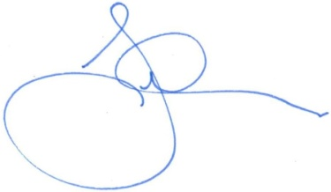
- Given the reasons above I do not agree to the recommendations in the report. Indeed in this instance the findings of the report should not be agreed with as the Speaker’s lack of impartiality has tainted the entire complaints process, and allowed the perception of the independence of the Commissioner for Standards to be questioned.

Jayson Hinder MLA
Member for Ginninderra

Annexure:
(i)
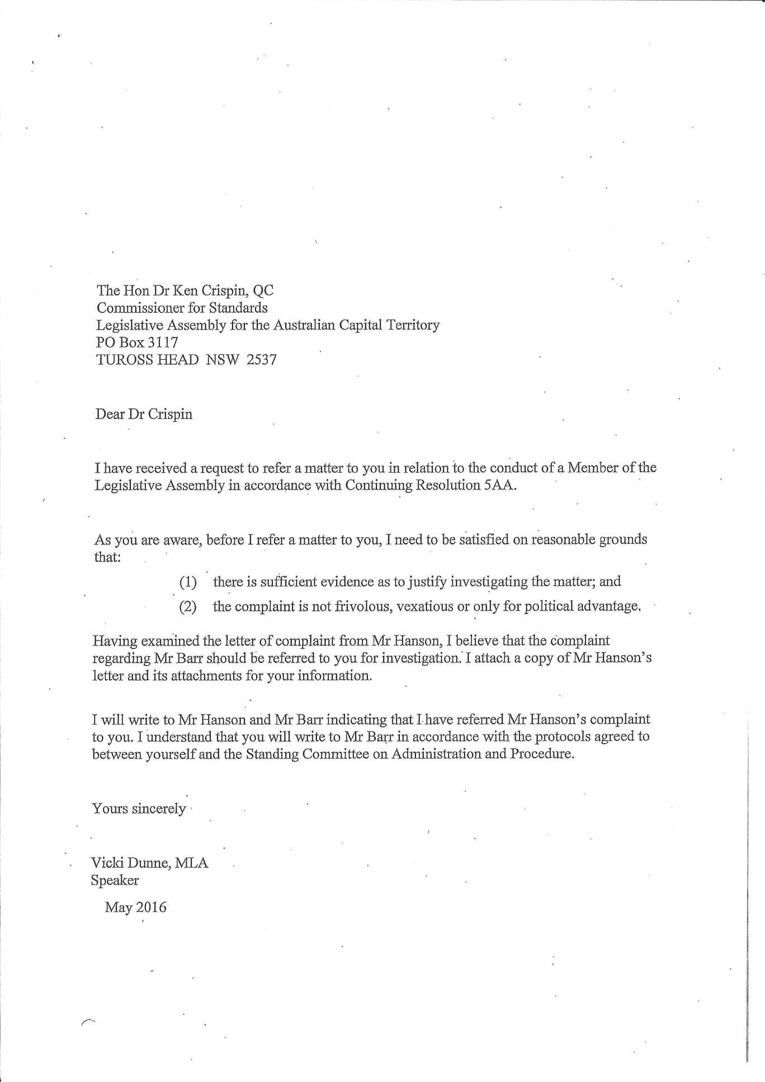

(ii) 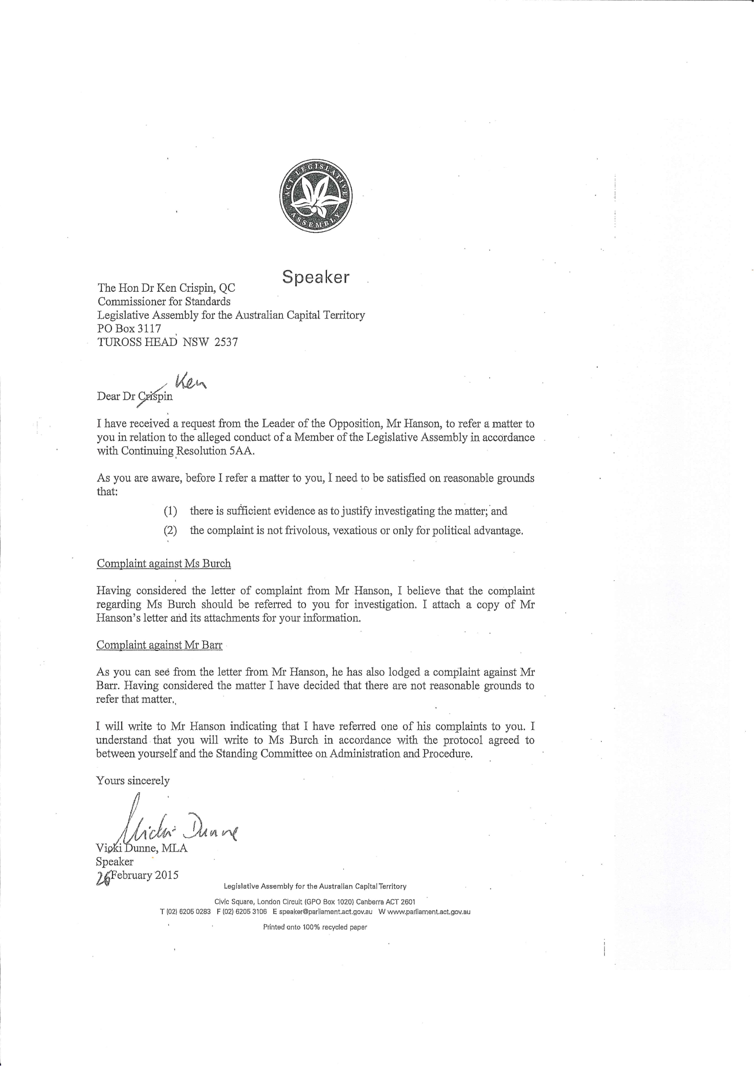
(iii)
